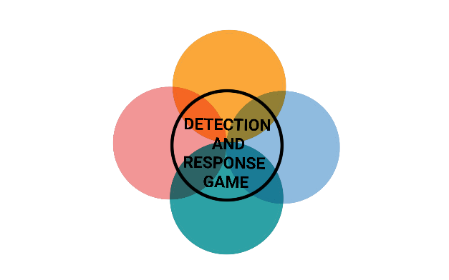

**IMPACT**



**IMPACT**



**IMPACT**



**IMPACT**



**INITIAL ACCESS**



**INITIAL ACCESS**



**INITIAL ACCESS**



**INITIAL ACCESS**



**IMPACT**



**IMPACT**



**IMPACT**



**IMPACT**

**SERVICE STOP**

The hacker stopped or disabled the email service to make it unavailable to all employees.

MITIGATION

Limit privileges of user accounts and groups

DETECTION

Monitor for edits for modifications to services and start up programs

**ACCOUNT ACCESS REMOVAL**

The hacker changed the passwords of all administrator accounts and logged off active users.

MITIGATION

2 factor authentication for user privilege changes

DETECTION

Monitor for large quantities of user privilege changes

**RESOURCE HIJACKING**

The hacker uses network resources to mine cryptocurrency with a crypto jacking script.

MITIGATION

Disable JavaScript

DETECTION

Monitor for common crypto mining software

**DATA DESTRUCTION**

The hacker has overwritten large amounts of files and folders on every Windows device outside of the Windows folder with randomly generated data.

MITIGATION

Diversify backups

DETECTION

Monitor for large quantities of file modifications



**INITIAL ACCESS**



**INITIAL ACCESS**



**INITIAL ACCESS**



**INITIAL ACCESS**

**NETWORK DENIAL OF SERVICE**

The Hacker performs a Network Denial of Service attack on the DNS.

MITIGATION

Filter Network Traffic

DETECTION

Network monitoring tools

**DATA ENCRYPTED FOR IMPACT**

The hacker encrypts large amounts of data in order to interrupt availability to system and network resources.

MITIGATION

Diversify backups

DETECTION

Monitor for large quantities of file modifications

**DEFACEMENT**

The hacker modifies the content of the company's official website in order to create a bad reputation.

MITIGATION

Diversify backups

DETECTION

Monitor websites for unplanned content changes

**DATA MANIPULATION**

The Hacker changes important product data to affect production.

MITIGATION

Encrypt Sensitive Information

DETECTION

Inspect important file hashes