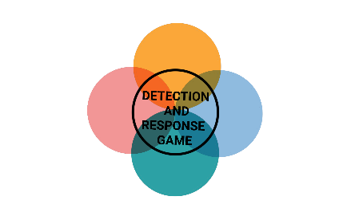**Name:**

|  |  |  |  |  |
| --- | --- | --- | --- | --- |
| **Initial Access** | **Privilege Escalation** | **Persistence** | **Lateral Movement, C2, Exfiltration** | **Impact** |
|  |  |  |  |  |
|  |  |  |  |  |
|  |  |  |  |  |

**Name:**

|  |  |  |  |  |
| --- | --- | --- | --- | --- |
| **Initial Access** | **Privilege Escalation** | **Persistence** | **Lateral Movement, C2, Exfiltration** | **Impact** |
|  |  |  |  |  |
|  |  |  |  |  |
|  |  |  |  |  |

**Name:**

|  |  |  |  |  |
| --- | --- | --- | --- | --- |
| **Initial Access** | **Privilege Escalation** | **Persistence** | **Lateral Movement, C2, Exfiltration** | **Impact** |
|  |  |  |  |  |
|  |  |  |  |  |
|  |  |  |  |  |