🛡️ ETHICAL HACKING
Beginner to Intermediate Guide
Learn How Hackers Think — and How to Stop Them
✅ Simple English | Step-by-Step | Visual Diagrams
Suitable for complete beginners, school students, and curious learners

📖 Introduction
Welcome to this guide! This book will teach you about ethical hacking in very simple words.
You do NOT need any experience. We start from zero.

🎯 What you will learn in this guide:

- What hacking is and why it exists
- How the internet and computers talk to each other
- How attackers break into systems
- How to defend against attacks
- Which tools ethical hackers use
- How to start your own journey in cybersecurity

📌 Important: This guide is for learning and protection only. Never hack systems you do not own or have permission to test.

Section 1: What is Ethical Hacking? 🤔

1.1 What is Hacking?
Hacking means finding weaknesses in a computer system or network.
Think of it like this: your house has a lock. Hacking is testing if that lock is strong or easy to break.

1.2 Two Types of Hackers
Term | Simple Meaning
Bad Hacker | Breaks into systems WITHOUT permission. Steals data. Goes to jail.
Ethical Hacker | Tests systems WITH permission. Finds bugs. Gets paid to help.
Script Kiddie | Uses tools made by others without understanding them. Not skilled.
White Hat | Another name for ethical hacker. Works legally.
Black Hat | Another name for bad hacker. Works illegally.

1.3 What Do Ethical Hackers Do?
Companies hire ethical hackers (also called penetration testers) to:
- Find security holes before real attackers do
- Test websites, apps, and networks
- Write reports about what they found
- Suggest how to fix the problems

🏆 Ethical hacking is a real career. It pays very well — often $80,000 to $150,000 per year!

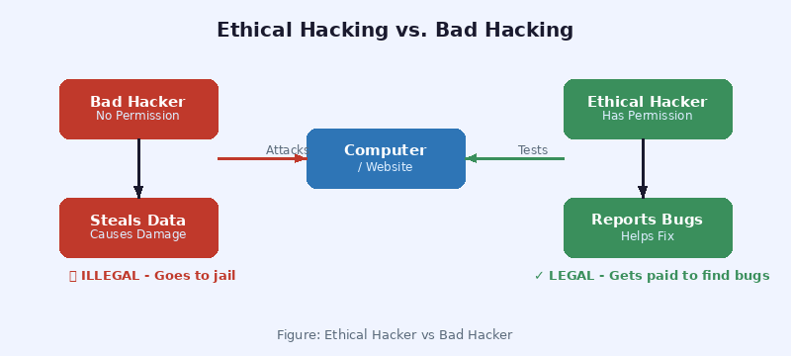
Figure 1.1: Ethical Hacker vs Bad Hacker

Section 2: Basic Networking Concepts 🌐

2.1 What is a Network?
A network is when two or more computers are connected together so they can share information.
The biggest network in the world is the Internet. It connects billions of computers!

2.2 Key Networking Terms

Term | Simple Meaning
IP Address | Your computer's address on the internet. Like your home address. Example: 192.168.1.1
DNS | Domain Name System. Translates 'google.com' into an IP address computers understand.
TCP/IP | Rules (protocols) that computers use to send data to each other.
Port | A door number on your computer. Port 80 = website traffic. Port 22 = SSH (remote login).
Router | A device that sends data from your computer to the internet.
Firewall | A security guard that blocks bad traffic and allows good traffic.
Packet | Data is broken into small pieces called packets before being sent.

2.3 How Data Travels (Simple Story)
Imagine you send a letter to a friend:
- You write the letter (your data)
- Put it in an envelope with their address (packet with IP address)
- Post office routes it (router/internet forwards it)
- Friend receives and reads it (server gets your request)
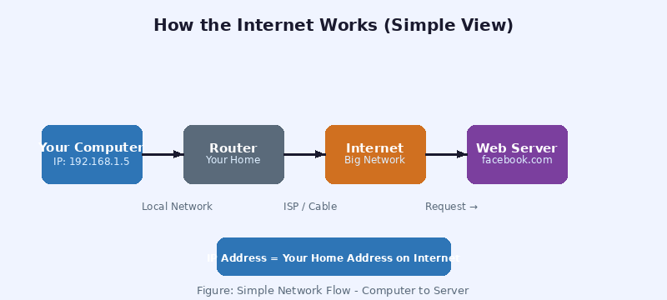
Figure 2.1: How Your Computer Connects to the Internet

2.4 Common Ports to Know

Term | Simple Meaning
Port 80 | HTTP — normal websites (not encrypted)
Port 443 | HTTPS — secure websites (encrypted with SSL)
Port 22 | SSH — secure remote login to a server
Port 21 | FTP — sending and receiving files
Port 3306 | MySQL — database connections
Port 23 | Telnet — old, unsafe remote login (avoid!)

Section 3: Operating Systems — Linux Basics 🐧

3.1 What is an Operating System?
An Operating System (OS) is the software that runs your computer. Examples:
- Windows — most home computers
- macOS — Apple computers
- Linux — servers, smartphones (Android), and ethical hackers!

3.2 Why Do Hackers Use Linux?
Ethical hackers mostly use Linux (especially Kali Linux) because:
- It's free and open source
- It comes with hundreds of hacking tools already installed
- It's very powerful and customizable
- Most servers on the internet run Linux

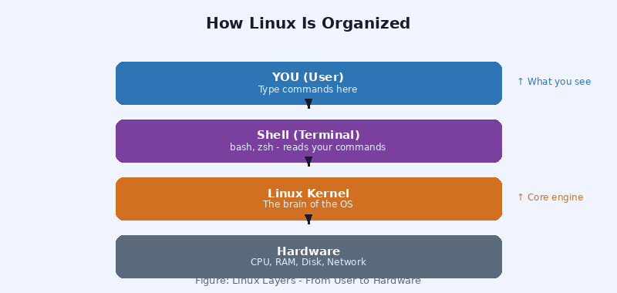
Figure 3.1: How Linux is Organized (Layers)

3.3 Basic Linux Commands
In Linux, you type commands in a window called the Terminal. Here are the most important ones:

Term | Simple Meaning
ls | Show files in the current folder. Like opening a drawer to see what's inside.
cd /home | Change directory (folder). Move to the /home folder.
pwd | Print Working Directory. Shows where you are right now.
cat file.txt | Read and display the contents of a file.
mkdir myfolder | Make a new folder called 'myfolder'.
rm file.txt | Delete a file. Be careful — there's no Recycle Bin!
sudo | Run a command as administrator (super user).
ifconfig | Show your computer's IP address and network info.
ping google.com | Check if you can reach a website. Like knocking on a door.
whoami | Show which user you are logged in as.

💡 Tip: Type a command and press Enter to run it. Use Tab key to auto-complete file names.

Section 4: How Hacking Works (Step by Step) 🔍

4.1 The 5 Phases of Hacking
Whether good or bad, all hackers follow a similar process. Understanding this helps you defend yourself.

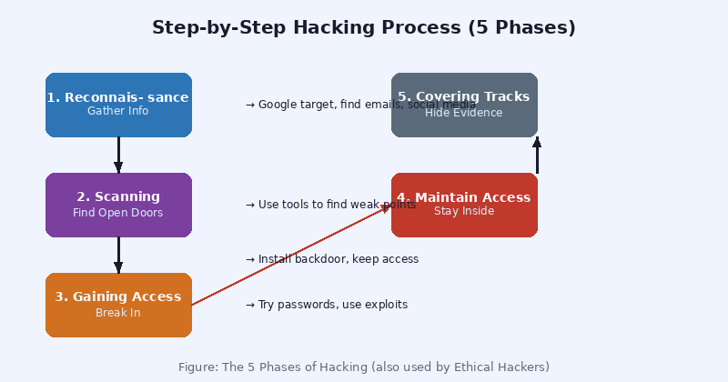
Figure 4.1: The 5 Phases of Hacking

Phase 1: Reconnaissance (Information Gathering)
The hacker first collects information about the target. This is like a spy doing research before a mission.
- Search Google for the target company
- Find email addresses and employee names on LinkedIn
- Look up what technology the website uses
- Find the IP address of their servers

🔧 Tools used: Google, Shodan, theHarvester, Maltego, WHOIS lookup

Phase 2: Scanning
Now the hacker scans the target to find open doors (ports) and weak points.
- Scan for open ports using Nmap
- Look for outdated software versions
- Check if any services have known vulnerabilities

🔧 Tools used: Nmap, Nessus, OpenVAS

Phase 3: Gaining Access
This is the actual 'breaking in'. The hacker tries to get inside the system.
- Try default usernames and passwords
- Use a known software vulnerability (exploit)
- Send phishing emails to trick users
- Try SQL injection on login pages

Phase 4: Maintaining Access
After getting in, the hacker wants to stay inside without being detected.
- Install a backdoor (secret way back in)
- Create a new hidden admin account
- Set up a reverse shell (remote control)

Phase 5: Covering Tracks
Bad hackers try to hide what they did. Ethical hackers document everything instead.
- Delete log files
- Clear browser history and command history
- Remove installed tools

📋 Ethical hackers DOCUMENT everything and give a full report to the company instead of hiding their actions.

Section 5: Common Attacks 💣

5.1 SQL Injection
Websites often store your information in a database. SQL Injection tricks the database into giving away secret information.

Simple Example: A login page asks for username and password. The attacker types special characters instead of a password:

Attack Input: ' OR 1=1 -- Translation: 'Give me access even if password is wrong, because 1=1 is always true!'

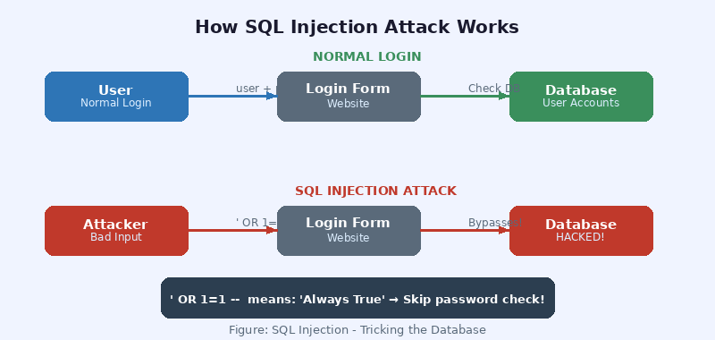
Figure 5.1: SQL Injection Attack Flow
- Always use parameterized queries (a safe way to write database code)
- Never show error messages that reveal database details
- Validate all user inputs

5.2 Cross-Site Scripting (XSS)
XSS lets an attacker hide harmful code inside a normal-looking website. When another user visits the page, the code runs on their computer.

Example: Attacker posts a comment with hidden JavaScript code. When you read the comment, the code steals your cookies (login session).

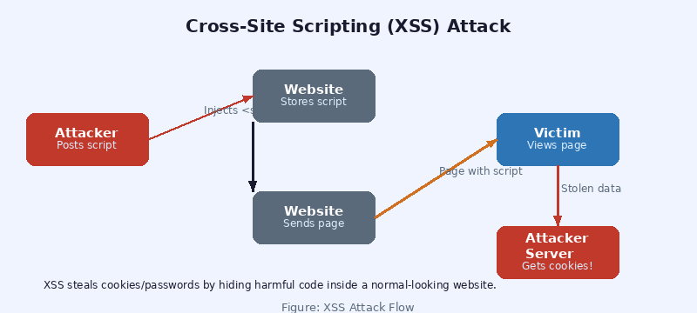
Figure 5.2: XSS Attack Flow

5.3 Man-in-the-Middle (MITM)
In a MITM attack, the attacker secretly sits between you and the website. They can read and even change your messages!

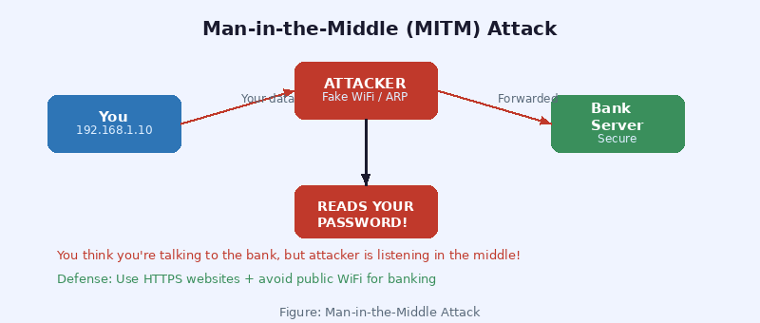
Figure 5.3: Man-in-the-Middle Attack
Common ways this happens:
- Fake WiFi hotspot at a coffee shop
- ARP Poisoning (tricks your network into routing traffic through attacker)
- Evil twin attack (fake access point with same name as real one)

🛡️ Protection: Always use HTTPS websites. Use a VPN. Avoid banking on public WiFi.

5.4 Password Guessing Attacks

Term | Simple Meaning
Brute Force | Try every possible password combination. Example: aaa, aab, aac... Takes long time.
Dictionary Attack | Try common words from a list. 'password', 'hello123', 'qwerty'... Very fast!
Credential Stuffing | Use leaked username+password lists from other hacked websites.
Phishing | Trick the user into typing their password on a fake website.

Section 6: Tools Used by Ethical Hackers 🔧
These are the most common tools you will learn to use. All are free and legal for testing systems you have permission to test.

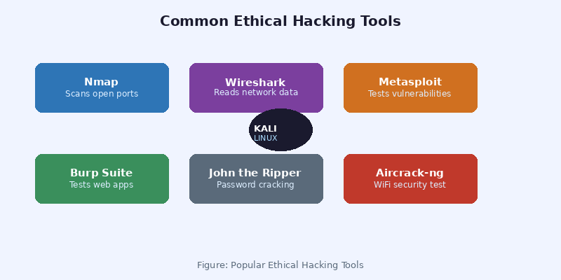
Figure 6.1: Popular Ethical Hacking Tools

6.1 Information Gathering Tools

Term | Simple Meaning
Nmap | Network scanner. Finds open ports and services on a target computer.
theHarvester | Collects emails, usernames, subdomains, and IPs about a target.
Shodan | Search engine for internet-connected devices (cameras, servers, etc.)
WHOIS | Finds who owns a domain name and their contact information.

6.2 Vulnerability & Exploitation Tools

Term | Simple Meaning
Metasploit | Framework with hundreds of pre-built exploits. Like a toolbox for testing vulnerabilities.
Burp Suite | Tests web application security. Intercepts traffic between browser and server.
Nikto | Scans websites for common vulnerabilities and misconfigurations.
SQLmap | Automatically tests for SQL injection vulnerabilities.

6.3 Password & Wireless Tools

Term | Simple Meaning
John the Ripper | Password cracking tool. Tests how strong hashed passwords are.
Hashcat | Very fast password cracker. Uses your GPU (graphics card) for speed.
Aircrack-ng | Tests WiFi network security. Can test WEP/WPA passwords.
Hydra | Tests login forms with a list of passwords (brute force).

6.4 Traffic Analysis

Term | Simple Meaning
Wireshark | Captures and reads all data packets on a network. Like reading mail.
tcpdump | Command-line network sniffer. Similar to Wireshark but text-based.

🖥️ Best Operating System for these tools: Kali Linux — it comes with all of them pre-installed!

Section 7: Website Security Basics 🌍

7.1 HTTP vs HTTPS — What's the Difference?
When you visit a website, your browser communicates using a protocol (set of rules).

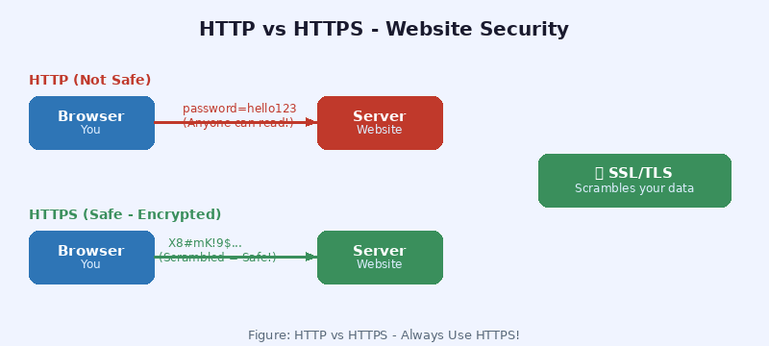
Figure 7.1: HTTP vs HTTPS — Always Use HTTPS!
Term | Simple Meaning
HTTP | HyperText Transfer Protocol. NOT encrypted. Anyone can read your data. Never use for passwords!
HTTPS | HTTP Secure. Data is encrypted. Safe for passwords, banking, shopping. Look for the 🔒 padlock.
SSL/TLS | The technology that makes HTTPS work. It scrambles your data so only the website can read it.
Certificate | A digital ID that proves a website is really who it says it is.

7.2 Common Website Vulnerabilities

Term | Simple Meaning
SQL Injection | Malicious code entered into input fields to manipulate the database.
XSS | Cross-Site Scripting. Injecting scripts into web pages viewed by other users.
CSRF | Cross-Site Request Forgery. Tricks a user's browser into making unwanted requests.
File Upload | Uploading malicious files (like PHP shells) to a web server.
Broken Auth | Weak login systems that can be bypassed or brute-forced.
Insecure Config | Default passwords not changed, unnecessary services running, debug mode on.

7.3 OWASP Top 10
OWASP (Open Web Application Security Project) publishes the 10 most common web security risks every year. Ethical hackers study this list carefully.
- Injection (SQL, LDAP, etc.)
- Broken Authentication
- Sensitive Data Exposure
- XML External Entities (XXE)
- Broken Access Control
- Security Misconfiguration
- Cross-Site Scripting (XSS)
- Insecure Deserialization
- Using Components with Known Vulnerabilities
- Insufficient Logging and Monitoring

📚 Website: owasp.org — Free resource to learn more about web security.

Section 8: Password Safety and Cracking 🔑

8.1 How Passwords are Stored
Good websites NEVER store your real password. Instead they store a hash — a scrambled version.

Example: Password: hello Hash stored: 5d41402abc4b2a76b9719d911017c592 Even if a hacker steals the database, they get only the hash — not the real password!

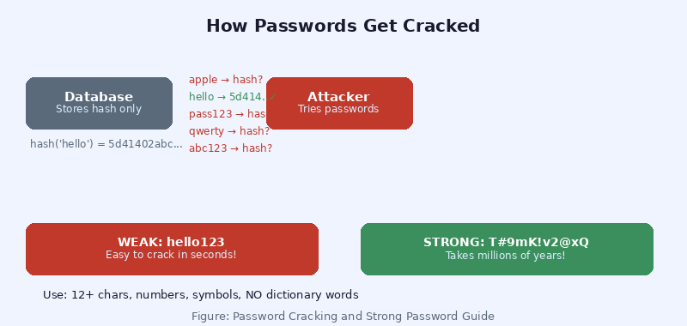
Figure 8.1: How Password Hashing and Cracking Works

8.2 Types of Password Attacks

Term | Simple Meaning
Brute Force | Try ALL combinations: aaa, aab, aac... Takes forever for long passwords.
Dictionary | Try common words from a wordlist file. Very fast for simple passwords.
Rainbow Table | Pre-computed hash lookups. Very fast if no salt is used.
Social Engineering | Trick people into revealing their password (phone calls, fake emails).

8.3 What Makes a Strong Password?
- At least 12 characters long
- Mix of UPPERCASE and lowercase letters
- Numbers (0-9)
- Special characters (!, @, #, $, %, ^, &)
- Does NOT use your name, birthday, or dictionary words
- Different password for every website

WEAK: password123 (cracked in under 1 second) STRONG: T#9mK!v2@xQ3 (would take millions of years to crack!)

8.4 Password Safety Tips
✅ Use a Password Manager (Bitwarden, 1Password) to remember complex passwords
✅ Enable Two-Factor Authentication (2FA) on all important accounts
✅ Check if your email was leaked at: haveibeenpwned.com
❌ Never reuse the same password on different sites
❌ Never share your password — not even with IT support!

Section 9: Intermediate Ideas 🚀

9.1 Privilege Escalation — Getting More Power
When a hacker first gets into a system, they usually only have limited access (like a normal user). Privilege escalation means finding ways to get administrator access.

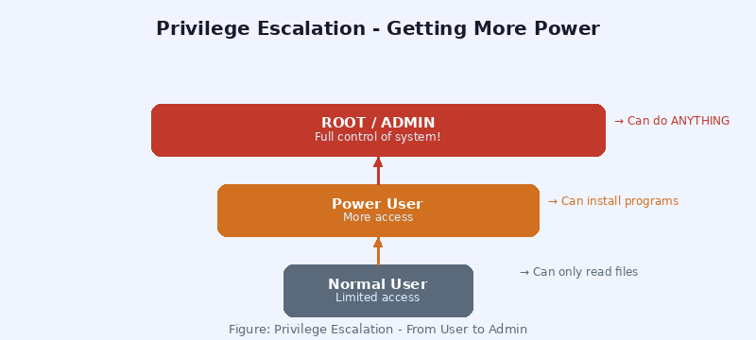
Figure 9.1: Privilege Escalation — From User to Root

Ways Privilege Escalation Happens:
- Exploiting a bug in a program that runs as administrator
- Finding a misconfigured file with too many permissions
- Weak sudo rules (e.g., user can run certain programs as root)
- Unpatched operating system vulnerabilities

🛡️ Defense: Keep software updated. Use least-privilege principle (give users only the access they need).

9.2 Reverse Shells — Remote Control
A reverse shell lets an attacker control your computer remotely — like having an invisible keyboard on your machine.

Normal shell: Attacker → connects to → Target (target must have open port) Reverse shell: Target → connects to → Attacker (bypasses firewall!) The target computer calls home to the attacker. This bypasses most firewalls because outgoing connections are usually allowed.

Common tools for reverse shells: Netcat (nc), Metasploit, PowerShell (Windows)

9.3 Information Gathering (OSINT)
OSINT = Open Source Intelligence. Gathering information from public sources without any hacking.

Term | Simple Meaning
Google Dorking | Using advanced Google searches to find sensitive files. Example: site:company.com filetype:pdf
Shodan | Search engine that finds internet-connected devices, servers, cameras with weak security.
LinkedIn | Find employee names, job titles, and technologies a company uses.
Wayback Machine | See old versions of websites that may reveal sensitive info.
theHarvester | Automated tool to collect emails and subdomains from public sources.
Maltego | Visual mapping tool to connect all gathered information.

📌 OSINT is completely legal because it only uses publicly available information.

9.4 Social Engineering
Social engineering attacks target humans, not computers. It's often easier to trick a person than to hack a system.

Term | Simple Meaning
Phishing | Fake email pretending to be from your bank, boss, or tech support asking you to click a link.
Spear Phishing | Targeted phishing that uses your name and personal details to seem real.
Vishing | Voice phishing — fake phone calls ('This is Microsoft support, your PC has a virus...').
Pretexting | Creating a fake identity or story to gain trust. 'I'm from IT, I need your password.'
Baiting | Leaving a USB drive in a parking lot hoping someone plugs it in.

Section 10: Security Protection Methods 🛡️

10.1 Firewall — Your First Line of Defense
A firewall is like a security guard at the door of your network. It checks every message coming in and going out.

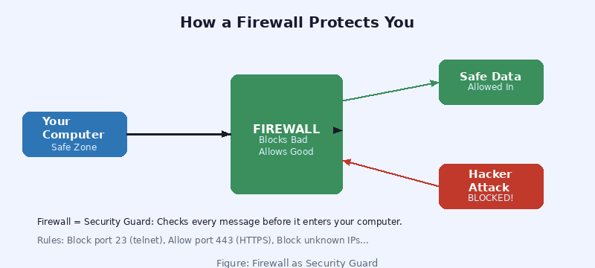
Figure 10.1: How a Firewall Protects Your Network
Term | Simple Meaning
Network Firewall | Hardware or software that filters traffic at the network level.
Web App Firewall | Specifically protects websites from SQL injection, XSS, and other web attacks.
Host Firewall | Built into your OS (like Windows Defender Firewall) — protects one computer.

10.2 Encryption
Encryption scrambles your data so only the right person can read it.
- HTTPS uses encryption so your passwords are scrambled in transit
- End-to-end encryption (used by WhatsApp) means even the app company can't read your messages
- Full disk encryption (BitLocker, VeraCrypt) protects data if your laptop is stolen

10.3 Two-Factor Authentication (2FA)
2FA adds a second step to login. Even if someone steals your password, they still can't get in.
- Step 1: Enter your password (something you know)
- Step 2: Enter a code from your phone (something you have)

Best 2FA apps: Google Authenticator, Authy, Microsoft Authenticator.

10.4 Keeping Systems Updated
Most successful attacks exploit OLD vulnerabilities that already have a fix (called a patch). Updating software closes these holes.
- Enable automatic updates on your phone and computer
- Update all apps and plugins (especially WordPress sites!)
- Replace old devices that no longer receive security updates

10.5 Backups
If you get hacked or infected with ransomware (malware that locks your files), backups save you.
✅ Follow 3-2-1 Rule: 3 copies, on 2 different media types, 1 stored offsite (cloud)
✅ Test your backups regularly — make sure they actually work!

10.6 Principle of Least Privilege
Give every user and program only the minimum access they need to do their job. Nothing more.
- Regular users should NOT be administrators
- Apps should only access files they need
- Databases should only be accessible from the web server, not from the internet

Section 11: How to Start Learning — Your Roadmap 🗺️
Here is a clear path to go from complete beginner to getting your first ethical hacking job or certification.

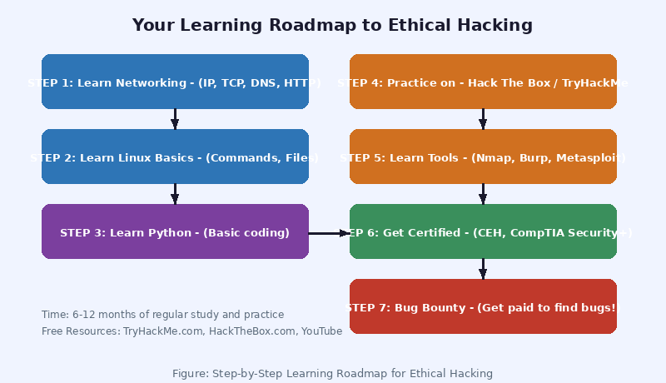
Figure 11.1: Your Step-by-Step Learning Roadmap

Step 1: Foundations (Month 1-2)
- Learn basic networking: IP addresses, TCP/IP, DNS, HTTP, ports
- Learn basic Linux: install Ubuntu or Kali Linux, practice commands
- Learn basic Python: variables, loops, functions, file reading
- Free resource: TryHackMe.com (beginner-friendly, guided learning)

Step 2: Core Hacking Concepts (Month 3-4)
- Study OWASP Top 10 web vulnerabilities
- Practice on DVWA (Damn Vulnerable Web Application) — a safe practice site
- Learn to use Nmap, Burp Suite, and basic Metasploit
- Complete beginner rooms on TryHackMe: 'Pre-Security', 'Jr Penetration Tester' paths

Step 3: Practice on Legal Platforms (Month 5-8)
- HackTheBox.com — real hacking challenges, beginner to expert
- TryHackMe.com — guided learning paths with videos
- PentesterLab.com — focus on web application hacking
- PortSwigger Web Security Academy (FREE) — best for web hacking

Step 4: Get Certified

Term | Simple Meaning
CompTIA Security+ | Good first certification. Covers security basics. Recognized worldwide.
CEH (Certified Ethical Hacker) | Popular ethical hacking certification by EC-Council.
OSCP | Offensive Security Certified Professional. Hard but highly respected. Hands-on exam.
eJPT | eLearnSecurity Junior Penetration Tester. Great beginner certification.

Step 5: Bug Bounty Programs
Once you have skills, you can earn real money finding bugs in companies' websites!
- HackerOne.com — largest bug bounty platform
- Bugcrowd.com — another popular platform
- Companies like Google, Facebook, Apple pay thousands for finding bugs

🏆 Google paid $10+ million in bug bounties in 2023. Real money for finding real bugs!

Section 12: Final Summary 🎓

What You Have Learned
Congratulations on completing this guide! Here is a quick summary of everything covered:

Term | Simple Meaning
Section 1 | Ethical hacking = legal hacking with permission. White hat vs black hat hackers.
Section 2 | Networks: IP addresses, ports, routers, DNS — how computers talk to each other.
Section 3 | Linux OS basics: terminal commands and how the system is organized.
Section 4 | 5 phases of hacking: Recon → Scan → Gain Access → Maintain → Cover Tracks.
Section 5 | 4 main attacks: SQL Injection, XSS, MITM, and Password attacks.
Section 6 | Key tools: Nmap, Metasploit, Burp Suite, Wireshark, John the Ripper.
Section 7 | Website security: HTTP vs HTTPS, OWASP Top 10 vulnerabilities.
Section 8 | Password safety: hashing, strong passwords, 2FA, password managers.
Section 9 | Intermediate: Privilege escalation, reverse shells, OSINT, social engineering.
Section 10 | Defense: firewalls, encryption, updates, backups, least privilege.
Section 11 | Roadmap: study path from beginner to certified ethical hacker.

Golden Rules of Ethical Hacking

1. Always get written permission before testing any system.
2. Only test what you are authorized to test. Nothing more.
3. Document everything you find and report it properly.
4. Never damage or destroy data during testing.
5. Keep all findings confidential. Never share client data.

Free Resources to Continue Learning

Term | Simple Meaning
TryHackMe.com | Best beginner platform. Guided learning with videos. Free tier available.
HackTheBox.com | Real hacking challenges. Community forums. Beginner to advanced.
PortSwigger Academy | portswigger.net/web-security — completely FREE web hacking course.
OWASP | owasp.org — free security standards and guides.
YouTube | Search: NetworkChuck, John Hammond, TCM Security — great free tutorials.
Kali Linux | kali.org — free download of the ethical hacking operating system.

🛡️ Stay Curious. Stay Legal. Stay Ethical.
The world needs more ethical hackers to make it safer.

