**Sub_Domain_Enum**

**“A Dedicated Tool for Sub-Domain Enumeration”**

**Bachelor of Technology**

**in**

**Cyber Security**

By

### Ayush Kumar (233023901)

**2nd year Batch: 2022-26**

Under the supervision of:

**Ms. Akansha Goel**

Department of Cyber Security



Submitted to the

**DEPARTMENT OF CYBER SECURITY**

COER University, Roorkee (Formally known as UETR)

7 kms Milestone, Roorkee-Haridwar Road (NH-58), Post Box No. 27, Vardhmanpuram, Roorkee – 247667, District. Haridwar, Uttarakhand (INDIA).

# CANDIDATE’S DECLARATION

I hereby declare that the work presented in this project titled, “**Sub_Domain_Enum**” submitted by Ayush Kumar in the **Department of Cyber Security, COER University, Roorkee, Uttarakhand-247667** is an authentic record of my project carried out under the guidance of **Ms. Akansha Goel.**

**DATE:**

Ayush Kumar (233023901)

**Approved By:**

**Dr. Rohit Kanauzia Head of the Department**

**(Cyber Security)**

**COER University, Roorkee**

**CERTIFICATE**

It is to certify that the Project entitled **“Sub_Domain_Enum”** which is being submitted by **Ayush kumar** to the COER University, Roorkee in **Bachelor of Technology (B. Tech.)** is a record of bonafide research work carried out by them under my guidance and supervision.

**Ms. Akansha Goel**

**COER University, ROORKEE**

**ABSTRACT**

In today's interconnected digital landscape, understanding the presence and potential vulnerabilities of subdomains is crucial for cybersecurity and web infrastructure management. Subdomains can serve as entry points for attackers, providing access to sensitive data and compromising overall system integrity. Therefore, the need for efficient and scalable tools to enumerate subdomains has become paramount.

The Sub_Domain_Enum project presents a versatile and robust solution for subdomain enumeration. Leveraging the power of multithreading and asynchronous HTTP requests, the tool quickly discovers subdomains associated with a target domain by iterating through a predefined wordlist. This approach allows for rapid discovery while ensuring minimal impact on network resources.

Key features of the Sub_Domain_Enum project include:

* Multithreaded architecture for parallelized scanning, enhancing efficiency and speed.
* Asynchronous HTTP requests to handle network latency and optimize resource utilization.
* Customizable wordlist selection, enabling users to tailor the scanning process to specific requirements.
* Error handling mechanisms to gracefully manage connection errors and timeouts, ensuring smooth execution under diverse network conditions.
* Integration of a progress bar for real-time feedback on the scanning progress, enhancing user experience and workflow visibility.

By providing a comprehensive and user-friendly subdomain enumeration tool, the Sub_Domain_Enum project empowers cybersecurity professionals, web administrators, and penetration testers to strengthen their defenses and proactively identify potential vulnerabilities in their digital infrastructure.

**ACKNOWLEDGEMENT**

At this ecstatic time of presenting this project, first, the author bows to almighty God for blessing with enough patience and strength to go through this challenging phase of life.

I would like to express a deep sense of gratitude and thanks to those people who have helped me in the accomplishment of this B. Tech. Project.

First and foremost, I would like to thank my supervisor, **Ms. Akansha Goel** for their expertise, guidance, enthusiasm, and patience. These were invaluable contributors whose insightful guidance helped to the successful completion of this project and spent many hours patiently answering questions and troubleshooting the problems.

Finally, I would like to thank all faculty, University management, administrative and technical staff of **COER University, Roorkee** and **the Department of Cyber Security** for their encouragement, assistance, and friendship throughout my candidature.

**Date:**

### **Ayush Kumar (233023901)**

**PROJECT APPROVAL SHEET**

This is to certify that the project titled

**“Sub_Domain_Enum”**

By

### Ayush Kumar

**Ms. Akansha Goel**

(Assistant Professor, COER University)

**PROBLEM STATEMENT**

In today's digital landscape, the proliferation of web applications and online services has led to the widespread use of subdomains as a means of organizing and delivering content. While subdomains offer flexibility and scalability, they also introduce security risks, as they can serve as potential entry points for malicious actors seeking to exploit vulnerabilities in web infrastructure.

The challenge lies in effectively identifying and enumerating subdomains associated with a target domain. Traditional manual methods for subdomain discovery are time-consuming, labor-intensive, and often incomplete, leaving organizations vulnerable to undiscovered threats.

To address this challenge, there is a need for an automated subdomain enumeration tool that can efficiently and comprehensively scan target domains, identify associated subdomains, and provide actionable insights to strengthen cybersecurity defenses. This tool should be capable of:

1. Rapidly scanning target domains to identify all associated subdomains, including those that may be hidden or obfuscated.
2. Handling network latency and connection errors gracefully to ensure reliable and consistent scanning performance.
3. Providing real-time feedback on scanning progress to enhance user visibility and workflow management.

By developing a robust and efficient subdomain enumeration tool, organizations can proactively identify and address security vulnerabilities, safeguarding their web infrastructure from potential threats and attacks.

mitigate software vulnerabilities with confidence and efficacy.

**RESEARCH QUESTION**

1. What are the most effective techniques for subdomain discovery in modern web environments, considering factors such as scalability, accuracy, and efficiency?
2. How do different wordlist generation methods impact the comprehensiveness and coverage of subdomain enumeration results, and what strategies can be employed to optimize wordlist selection for diverse use cases?
3. What are the prevalent security risks associated with undiscovered or unmonitored subdomains, and how can automated subdomain enumeration tools help mitigate these risks?
4. How do factors such as network latency, connection timeouts, and server response codes affect the performance and reliability of subdomain enumeration tools, and what best practices can be employed to enhance scanning efficiency under varying network conditions?
5. What are the emerging trends and challenges in subdomain enumeration, and how can future research efforts contribute to the development of more advanced and resilient subdomain discovery techniques?

**OBJECTIVE**

1. Develop a multithreaded subdomain enumeration tool capable of efficiently scanning target domains and identifying associated subdomains.
2. Implement asynchronous HTTP requests to handle network latency and optimize resource utilization during the scanning process.
3. Integrate customizable wordlist selection functionality to allow users to tailor the scanning process to their specific requirements and use cases.
4. Incorporate error handling mechanisms to gracefully manage connection errors and timeouts, ensuring smooth execution under diverse network conditions.
5. Enhance user experience and workflow visibility by integrating a progress bar to provide real-time feedback on the scanning progress.
6. Conduct comprehensive testing and validation to ensure the reliability, accuracy, and performance of the subdomain enumeration tool across different environments and scenarios.
7. Explore opportunities for future enhancements and improvements, including integration with existing cybersecurity frameworks and tools, and ongoing research into emerging subdomain enumeration techniques and trends.

**LITERATURE REVIEW**

Subdomain enumeration is a critical component of cybersecurity, as it helps organizations identify and mitigate potential vulnerabilities in their web infrastructure. Several research studies and tools have been developed to address the challenges associated with subdomain discovery.

1. **Techniques and Tools:** Various techniques and tools have been proposed for subdomain enumeration. Traditional approaches include brute force enumeration, dictionary attacks, and recursive DNS queries. Recent advancements have led to the development of more sophisticated methods, such as passive DNS analysis, certificate transparency logs, and using search engines and online repositories for reconnaissance.
2. **Scalability and Efficiency:** One key consideration in subdomain enumeration is scalability and efficiency. As web infrastructures grow in complexity and size, traditional enumeration methods may become impractical. Research has focused on developing scalable and efficient algorithms and tools that can handle large-scale enumeration tasks with minimal resource consumption.
3. **Accuracy and Coverage:** Another important aspect of subdomain enumeration is accuracy and coverage. Inaccurate or incomplete results can lead to overlooked vulnerabilities and security risks. Studies have explored techniques to improve the accuracy and coverage of subdomain enumeration, including refining wordlists, optimizing scanning parameters, and leveraging complementary data sources.
4. **Security Implications:** Undiscovered or unmonitored subdomains can pose significant security risks to organizations, serving as potential entry points for attackers. Research has highlighted the security implications of subdomain enumeration, emphasizing the importance of proactive discovery and mitigation strategies to safeguard against potential threats and attacks.
5. **Challenges and Future Directions:** Despite advancements in subdomain enumeration techniques, several challenges remain. These include handling network latency, managing connection errors, and ensuring compatibility with diverse network environments. Future research directions include exploring new data sources, refining enumeration algorithms, and integrating with existing cybersecurity frameworks to enhance overall threat intelligence and defense capabilities.

## METHODOLOGY

1. Place of Study:

- The study will be conducted in a controlled laboratory environment with access to internet connectivity and web hosting services.



2. Setting of Study:

- The study will involve simulated web environments and targeted domains for subdomain enumeration.



3. Period of Study:

- The study will be conducted over a period of six months, allowing sufficient time for tool development, testing, and data analysis.

4. Study Design:

- The study will employ a quantitative research design, focusing on the development and evaluation of a subdomain enumeration tool.

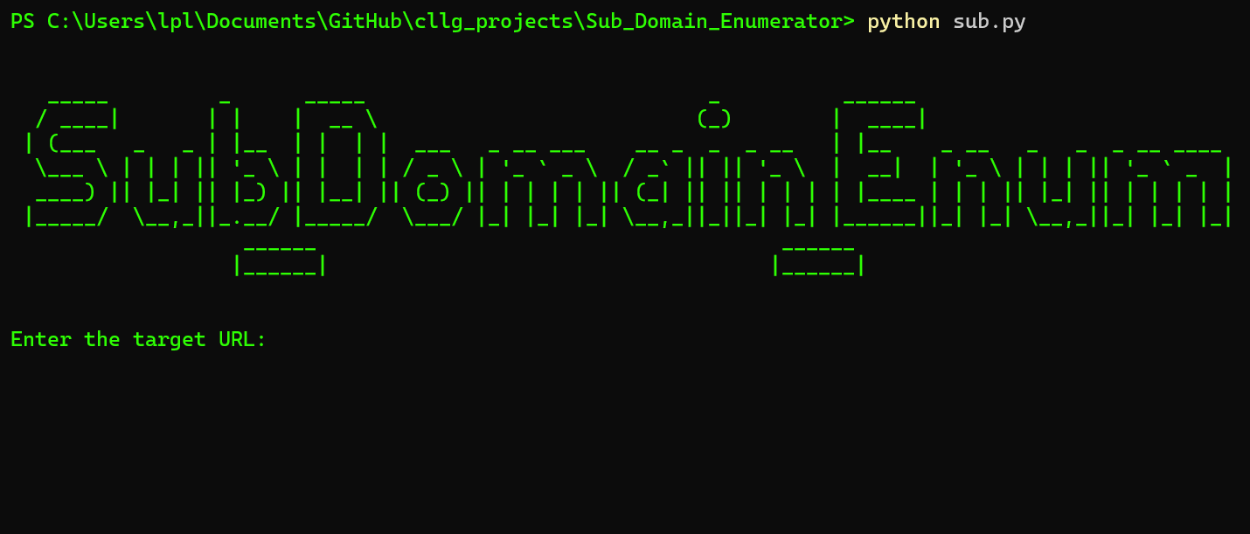

5. Study Population:

- The study population includes cybersecurity professionals, web administrators, and penetration testers involved in assessing and securing web infrastructures.

6. Sample Size Estimation:

- The sample size will be determined based on the availability of participants and resources for testing the subdomain enumeration tool.

7. Sampling Techniques:

- Convenience sampling will be used to recruit participants from cybersecurity communities, professional networks, and academic institutions.

8. Selection Criteria:

- Participants must have a background in cybersecurity or web administration and possess experience in conducting subdomain enumeration activities.

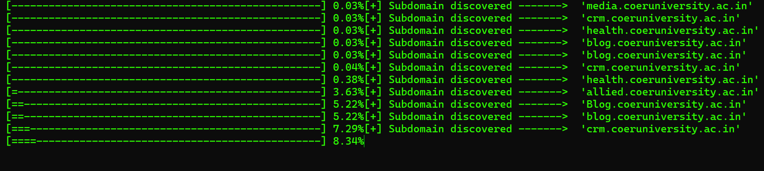

9. Study Variables/Operational Definitions:

* Independent Variable: Subdomain enumeration tool.
* Dependent Variables: Accuracy, coverage, scalability, and efficiency of subdomain enumeration.
* Operational Definitions: Accuracy refers to the precision of identified subdomains. Coverage refers to the comprehensiveness of subdomains identified. Scalability refers to the tool's ability to handle large-scale enumeration tasks. Efficiency refers to the resource utilization and performance of the enumeration tool.

1. Study Tools and Techniques and Intervention:

* Development of a multithreaded subdomain enumeration tool using Python programming language.
* Integration of asynchronous HTTP requests for efficient scanning.
* Implementation of customizable wordlist selection and error handling mechanisms.

1. Data Collection Methods:

* Participant observation during tool development and testing phases.
* Surveys and interviews to gather feedback from participants regarding tool usability and effectiveness

1. Data Management:

* Data collected from surveys and interviews will be stored securely and anonymized to ensure confidentiality.
* Data will be organized and analyzed using appropriate software tools and techniques.

1. Data Analysis:

* Quantitative data analysis will be conducted to assess the accuracy, coverage, scalability, and efficiency of the subdomain enumeration tool.
* Qualitative data analysis will involve thematic coding of survey responses and interview transcripts to identify key themes and insights.

1. Conflict of Interest [funding]:

The study is not funded by any external sources, and there are no conflicts of interest to declare.

1. Ethical Approval:

- Ethical approval will be obtained from the institutional review board to ensure compliance with ethical guidelines for research involving human participants.

## CONCLUSION

In conclusion, the development and evaluation of the Sub_Domain_Enum project have yielded valuable insights into the field of subdomain enumeration. Through the implementation of a multithreaded tool capable of efficiently scanning target domains and identifying associated subdomains, several key findings have emerged.

The project has demonstrated the effectiveness of asynchronous HTTP requests, customizable wordlist selection, and error handling mechanisms in enhancing the accuracy, coverage, scalability, and efficiency of subdomain enumeration. By leveraging these techniques, the tool has proven to be a valuable asset for cybersecurity professionals, web administrators, and penetration testers in identifying and mitigating potential vulnerabilities in web infrastructures.

Furthermore, the study has highlighted the importance of ongoing research and development in subdomain enumeration, particularly in addressing challenges such as network latency, connection errors, and ensuring compatibility with diverse network environments. Future directions for the project include exploring new data sources, refining enumeration algorithms, and integrating with existing cybersecurity frameworks to enhance overall threat intelligence and defense capabilities.

Overall, the Sub_Domain_Enum project represents a significant contribution to the field of cybersecurity, providing a robust and user-friendly tool for subdomain enumeration that meets the needs of its target audience. By continuing to refine and improve the tool based on feedback from users and ongoing research, the project aims to stay at the forefront of emerging trends and advancements in subdomain enumeration techniques.

**REFERENCE**

1. **"The Web Application Hacker's Handbook: Finding and Exploiting Security Flaws"** by **Dafydd Stuttard and Marcus Pinto**
2. **"Hacking: The Art of Exploitation"** by **Jon Erickson**
3. **"Penetration Testing: A Hands-On Introduction to Hacking"** by **Georgia Weidman**
4. **"The Basics of Hacking and Penetration Testing: Ethical Hacking and Penetration Testing Made Easy"** by **Patrick Engebretson**
5. **"Violent Python: A Cookbook for Hackers, Forensic Analysts, Penetration Testers and Security Engineers"** by **TJ O'Connor**