Q1: (a) : Use Google Docs to create a document containing the schedule of MCS-229 practical counselling sessions. Store it on Google Drive and share it with five friends who can view and Comment on it.
Step1. Go to docs.google.com and click on “blank document”.
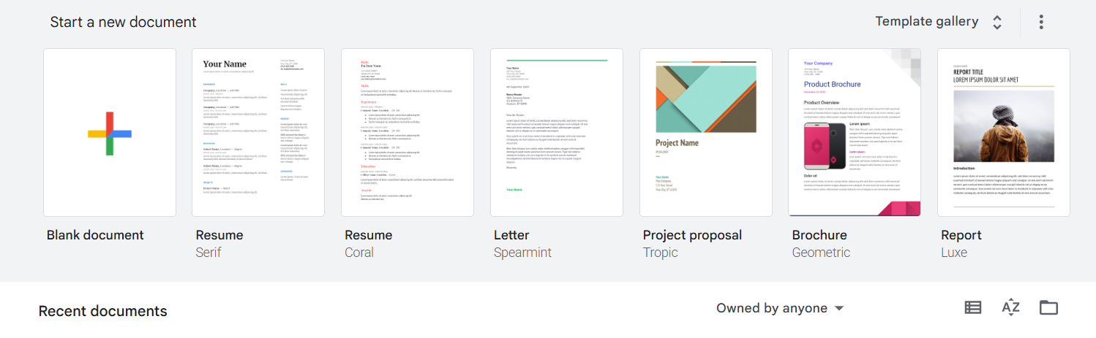
Step2. : Create the document titled “Schedule of MCSL-229 Practical Counselling Session “.
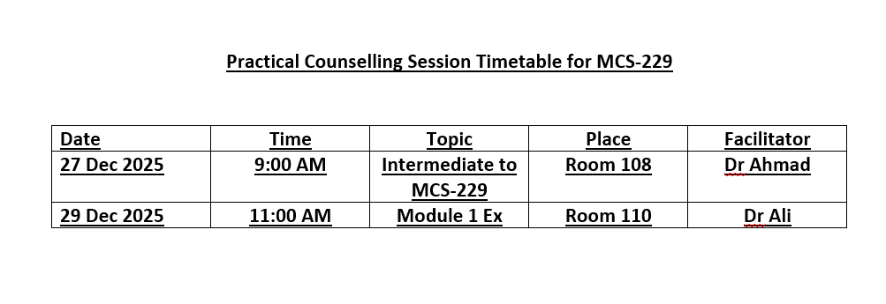
Step3: click on ‘File -> Download to save a copy.
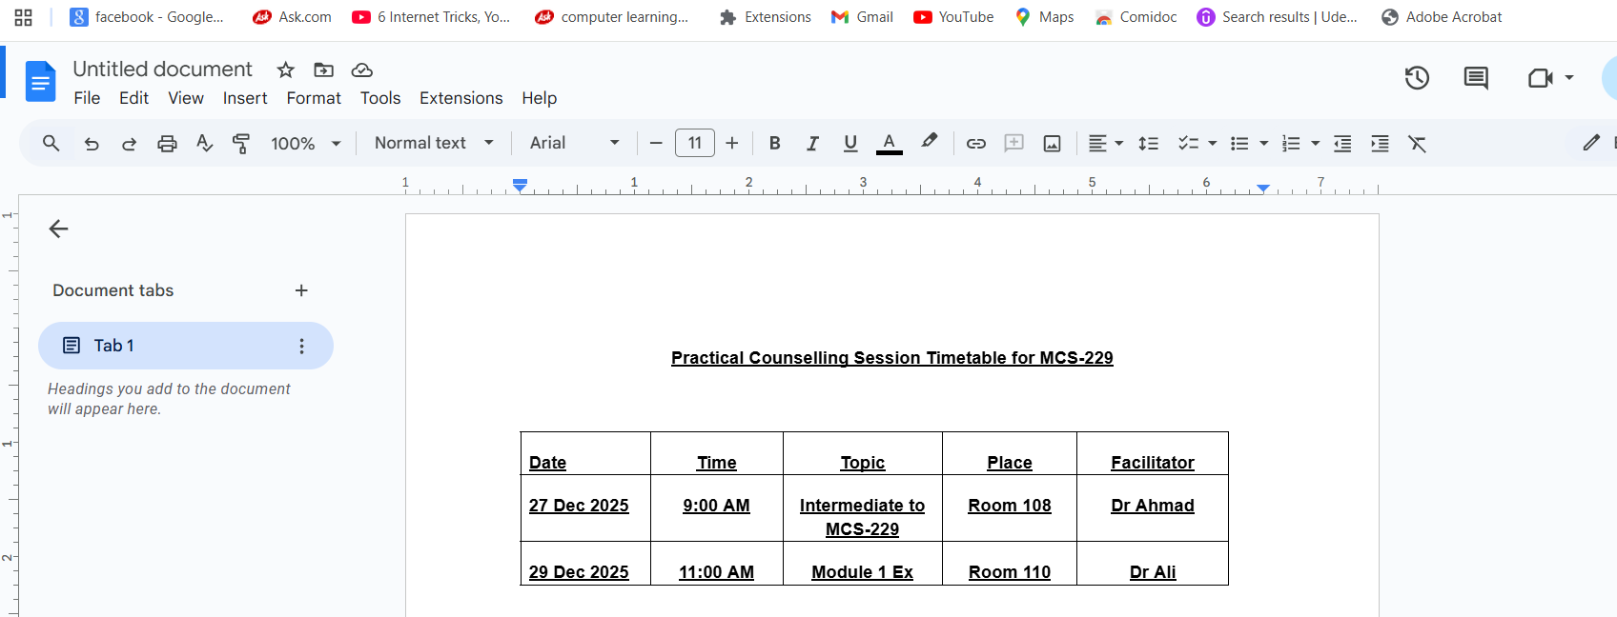
Step4: Open Google Drive and upload the saved document.
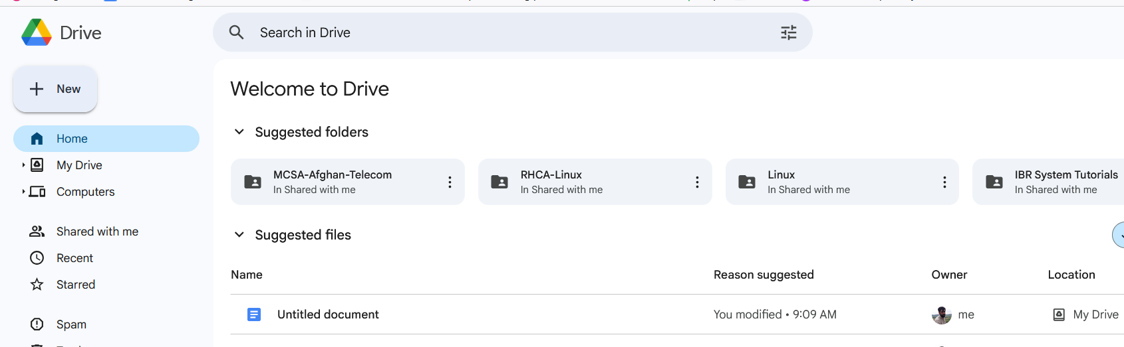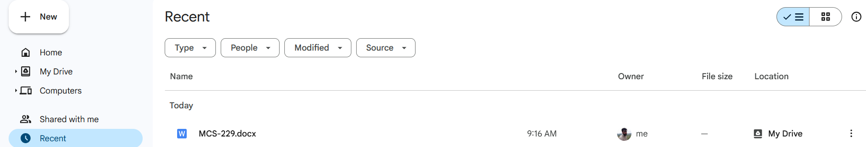
Step5: Right- click on the file in Drive and choose “Share”.
Step6: click on send to share the file with your friends.
- : Use Google Sheets and create a spreadsheet containing the yearly Salary details of 10 employees of a university under the headings – employee name, yearly basic salary, DA percentage, Provident fund deductions, Income Tax deduction, and net salary. You may use the following formulas for making the spreadsheet:

DA amount = DA percentage * yearly basic salary Provident fund = 8% of yearly basic salary Income Tax deduction is computed as: For yearly basic salary < 5,00,000 tax =0 For yearly basic salary >= 5,00,000 but <10,00,000 tax = 20% of (yearly basic salary – 5,00,000) For yearly basic salary >= 10,00,000 tax = 1,00,000 + 30% of (yearly basic salary – 10,00,000) Net Salary = yearly basic salary + DA amount – Provident fund – tax
Step1: Go to docs.google.com the select “sheets”.
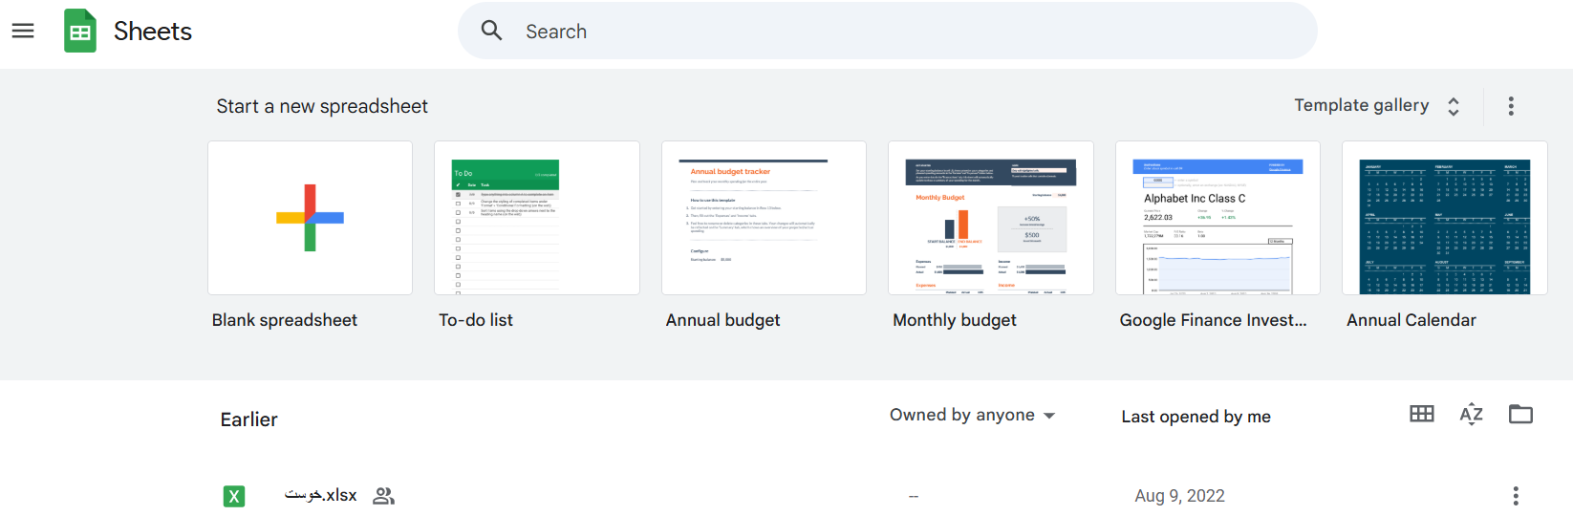
Step2 : Click on “ Blank Spreadsheet”.
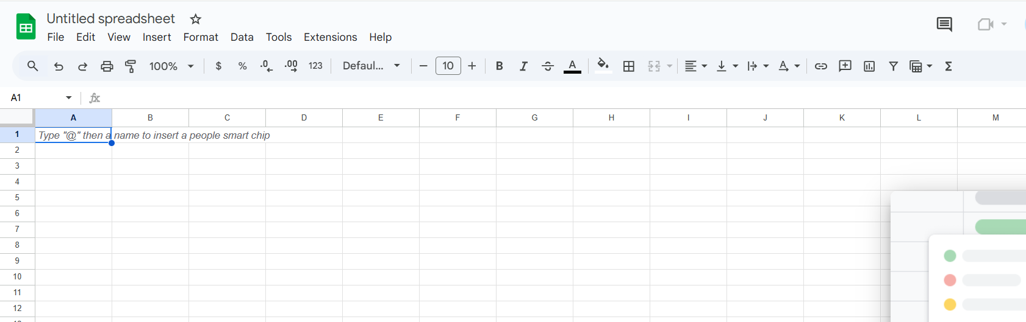
Step3: Create a spreadsheet with 10 employees including columns for Employee Name, Yearly Basic salary, DA% DA amount , provide fund , income tax, and Net salary, Use formulas:
- DA Amount <$500000 -> Tax = 0
- If $f500000 <= Salary < $1000000 -> Tax = 20% of ( Salary - $500000)
- If salary >= $1000000 -> Tax = $ 100000 + 30% of (salary - $1000000)
- Net salary = Yearly Basic + DA – PF – Tax
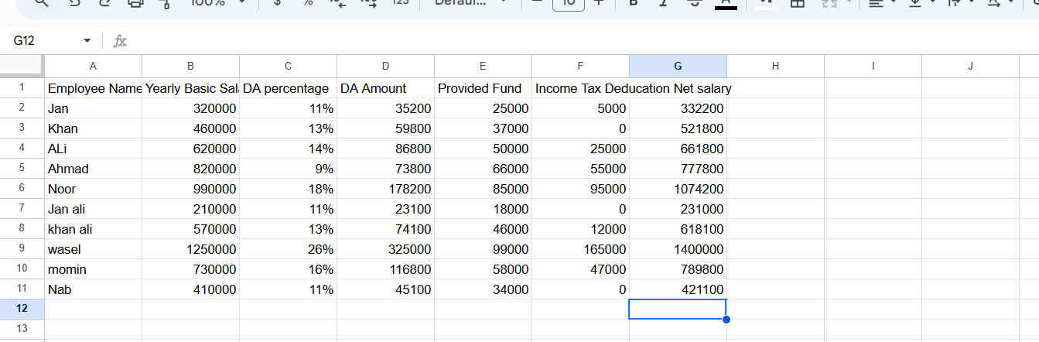
(c ) : . Use Google Slides and prepare nine slides on the topic “Platform as a Service (PaaS)” in a group of three students by sharing the Google Slides in your group in edit mode. Every group member should make three slides each and contribute to the slides of other members of her/his group.

Step1: open www.docs.google.com
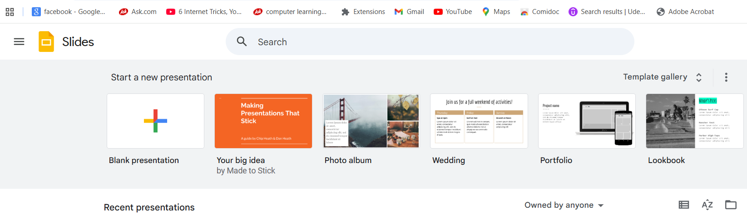
Step2: Open Slides:
Step 3: Click on blank presentation.
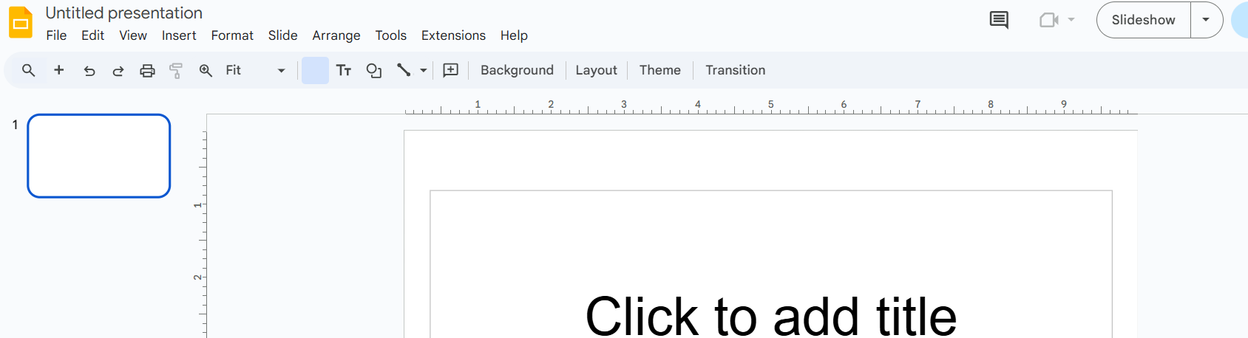
Step4: Now select them and create slides of “Platform as a Service (PaaS)”. (9 Slide).
Slide1:


Slide2:
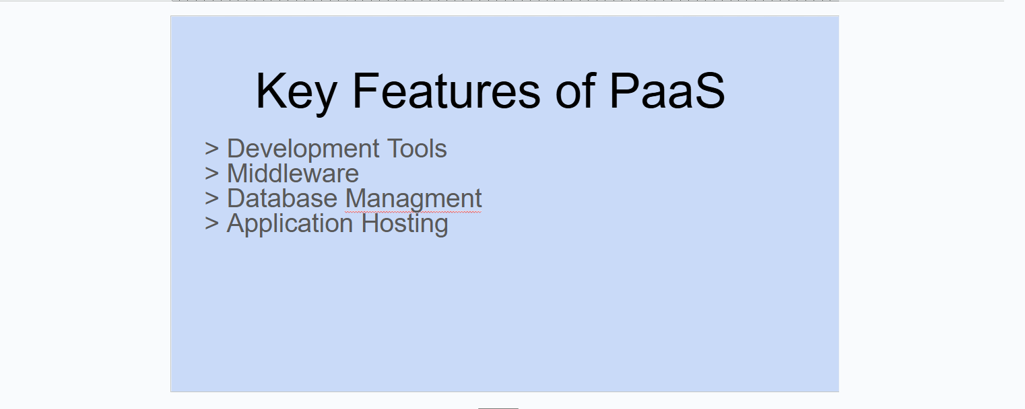
Slide3:
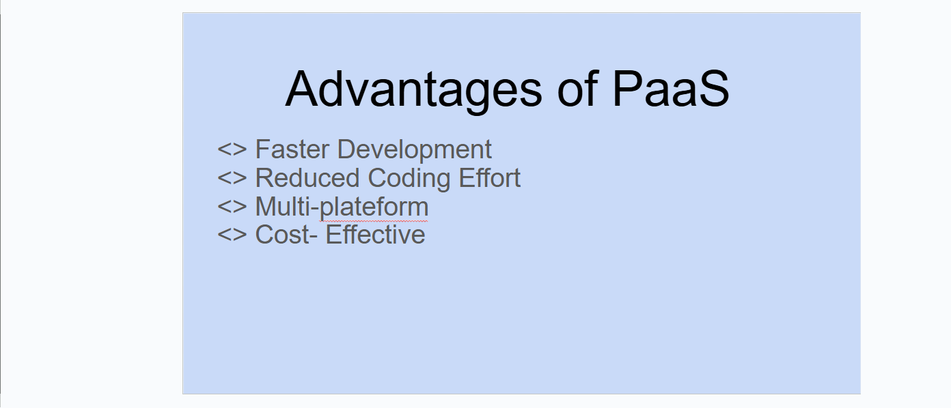
Slide4:
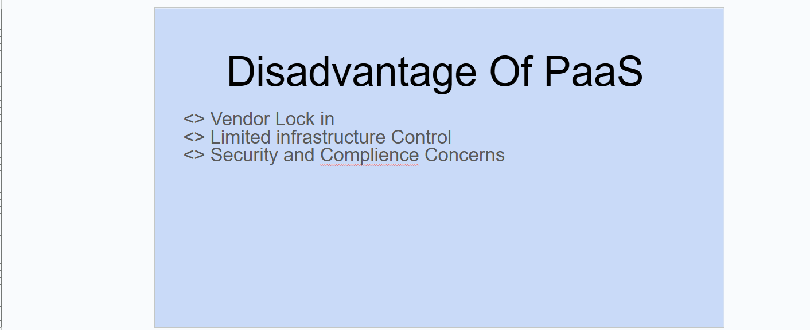
Slide5:
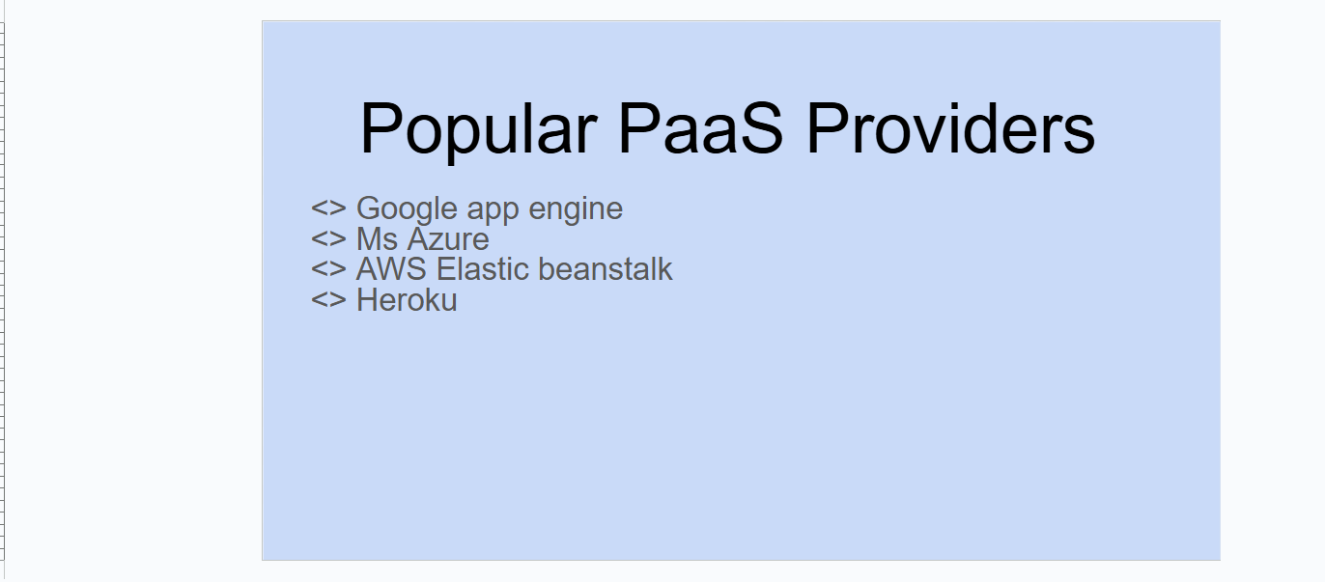
Slide6:
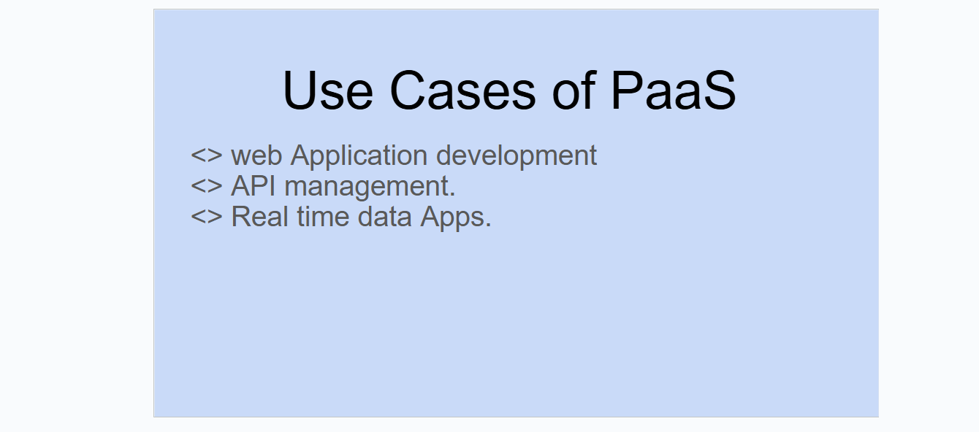
Slide7:
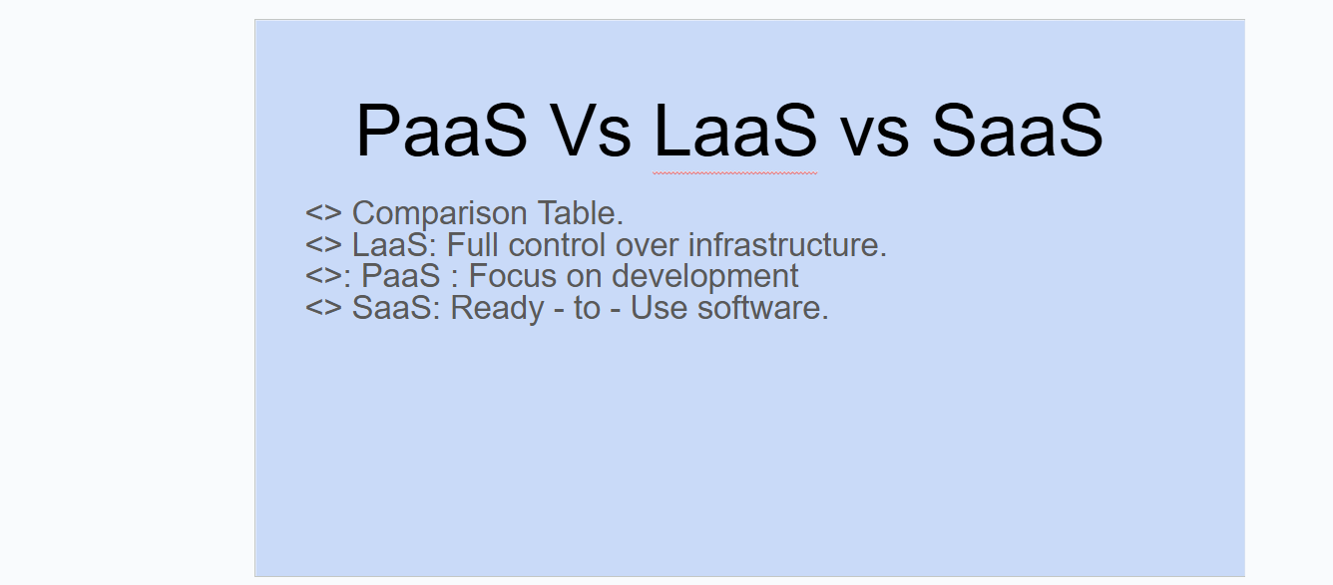
Slide8:
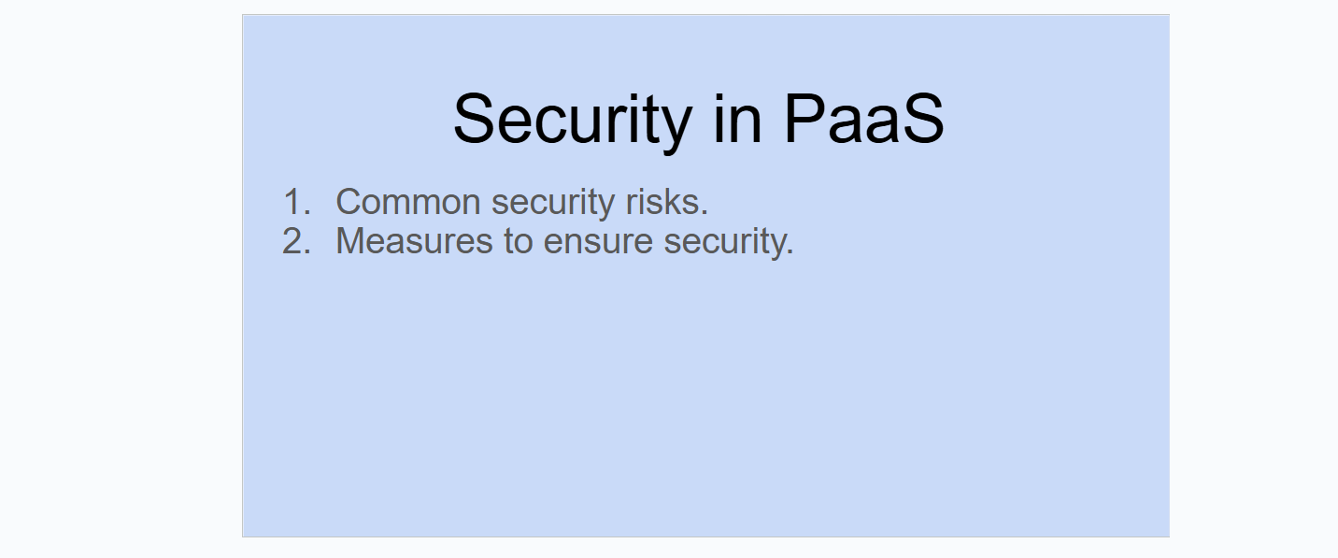
Slide9:

Step5: Now Share this presentation of three students in edit mode. Each student can create their slides based on their assigned topics and then the group can collaborate by reviewing and editing each other’s.
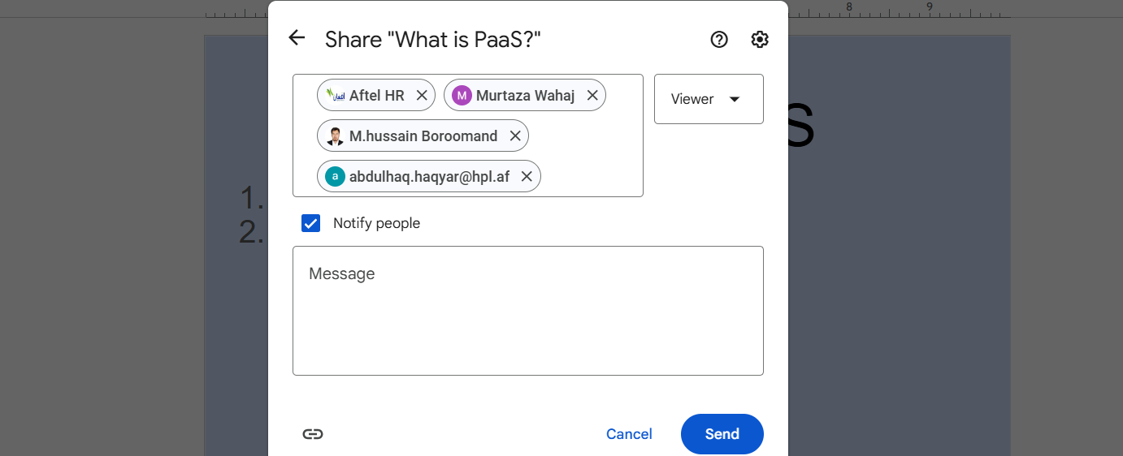

Q2: Explore JustCloud file storage solutions and cloud storage on AWS. Use only the trial versions.
Ans:
Exploring Justcloud and AWS cloud storage storage solutions using
- JustCloud Trail:
- Visit the JustCloud website.
- Sign up for a free trial account.
- Installallation of JustCloud Application.
Features:
- File Synchronization : upload files to Justcloud and see how they Sync across devices.
- Back up Options: Explore the backup settings.
- Storage Limits: we should check the storage limits and performance during the trial period.
User Interface and Experience :
- Ultimate backup space.
- Automated backup.

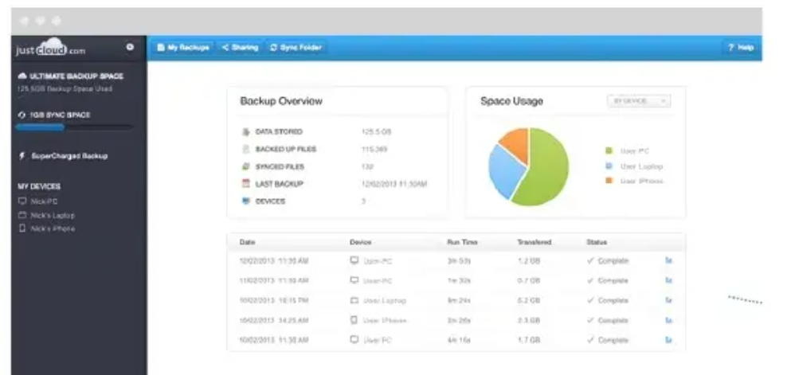
- Backup app your device.
- We should access files anywhere.
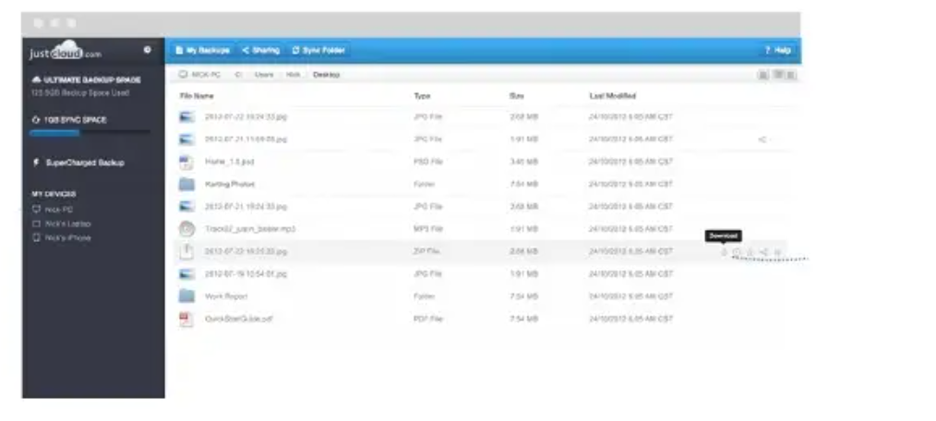
- We should share with friends.
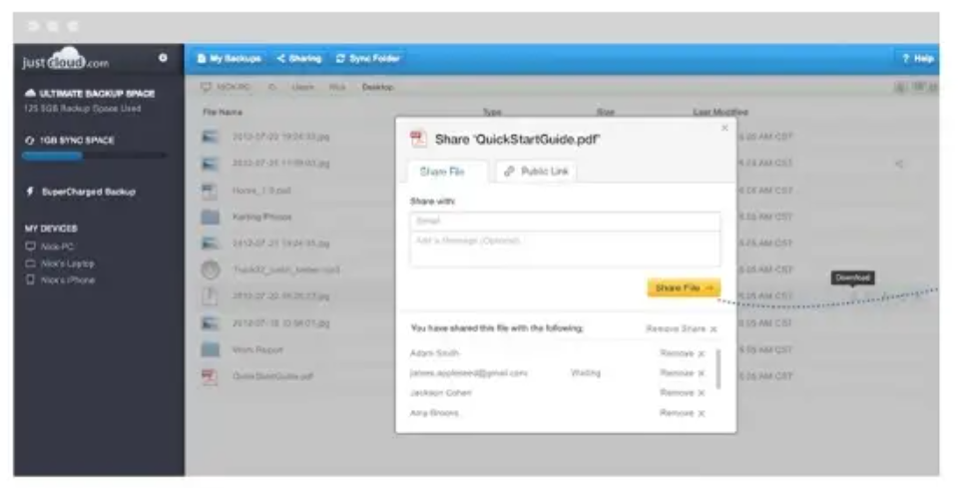

AWS Solutions:
- Visit AWS portal and sign up.

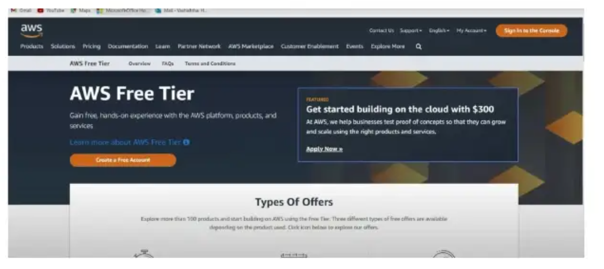

Sign-up on AWS:



- Now we try free Version by adding Credit /debit card.

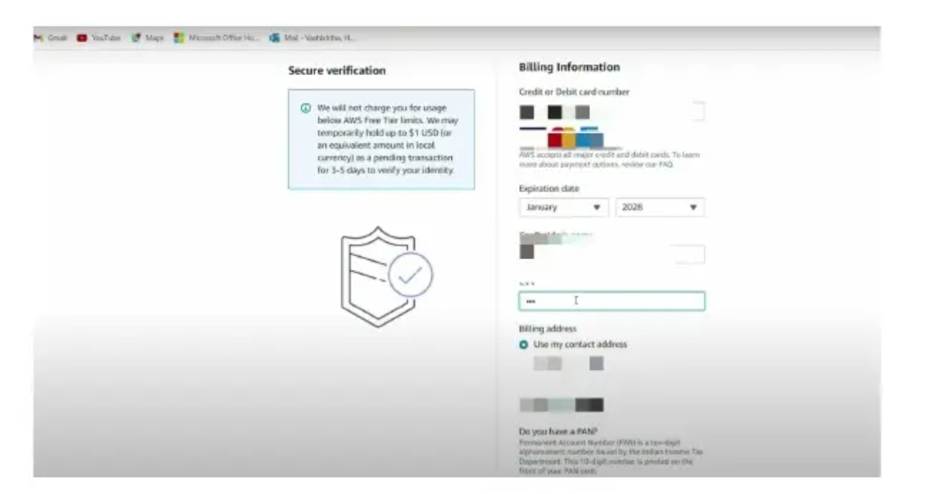

- Now we will explore free tier.
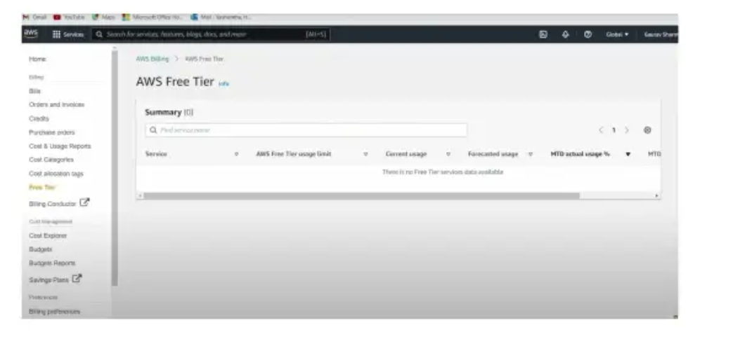
- Now we will try billing dashboard in free tier.

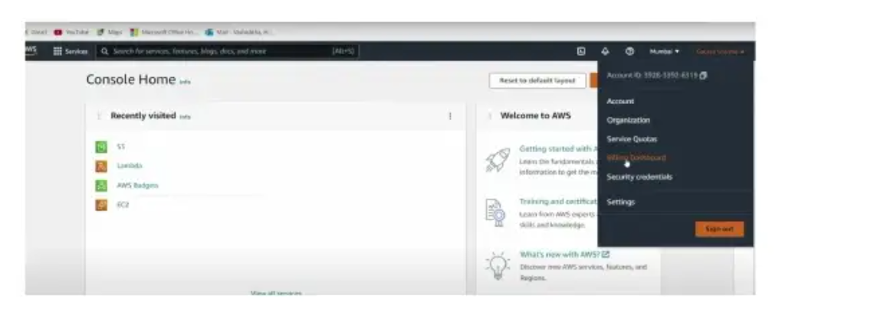

Q3:
Use Google App Engine to write a program to multiply two matrices. Deploy it on the Google cloud.
Step1: Login:

Step2: Use free trial and add payment method.
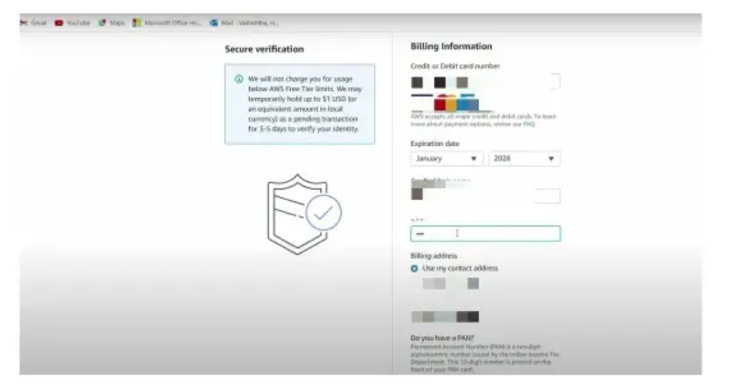

Step3: Start new project.
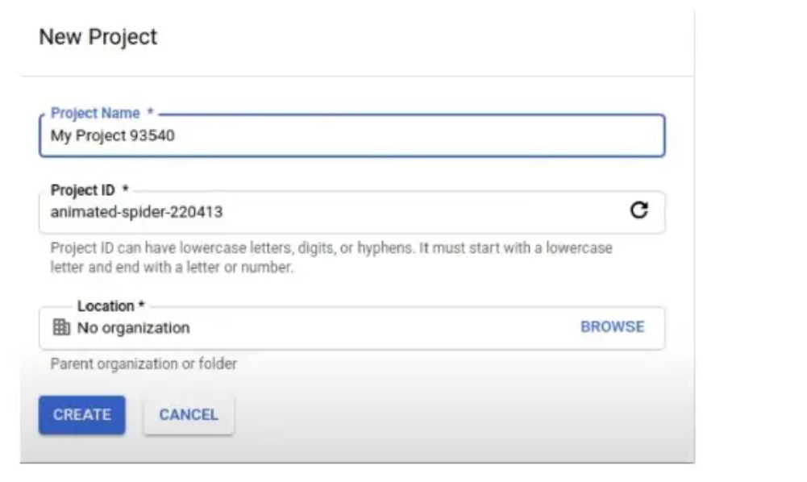
Write a program to multiply two matrices.

<!DOCYYPE html>
<html lang ="en">
<head>
<meta charset="UTF-8">
<meta name = "viewport" content ="width=device-width,
initial-scale=1.0">
<title> Document </title>
</head>
<body>

<?php
$matrix1 = [
[1, 2, 3]
[4, 5, 6]
];
$matrix2 = [
[7 , 8]
[9 , 10],
[ 11 , 12]
];
// now we will make a function to multiply tow matrix
function multiplymatrics ($matrix1 , $matrix2)
{
// now we will identify their rows and columns and their index value
$row1 = count ($matrix1);
$col1 = count ($matrix1 [0]);
$row2 = count ($matrix2);
$col2 = count ($matrix2[0]);
// Now checking of column in first column
matrix first row
if ($col1 != $row2) {
echo "matrix Multiplication is not possible . the number of columns of matrix 1 must
be equal to the number of rows
.\n";
return null;
}
// initialize the result matrix with zeros
$result = array_fill (0 , $row1, array_fill(0, $col2, 0));
// initialize i , j , & k
for ($i = 0; $i < $row1; $i++) {
for ($j=0; $j< $col2; $j++) {
// multiply elements with their index value
$result[$i] [$j] += $matrix1[$i] [$k] *
$matrix2 [$k] [$j];
}
}
}
return $result;
}
// Multiply the matrices (function call)
$result = multiplymatrices($matrix1, $matrix2);
// display the result
if ($result !== null) {
echo " Resultant Matrix after Multiplication: <br>";
} }
?>
</body>
</html>
Output:


Deploy it on the google cloud.
- Click on Manage all project.
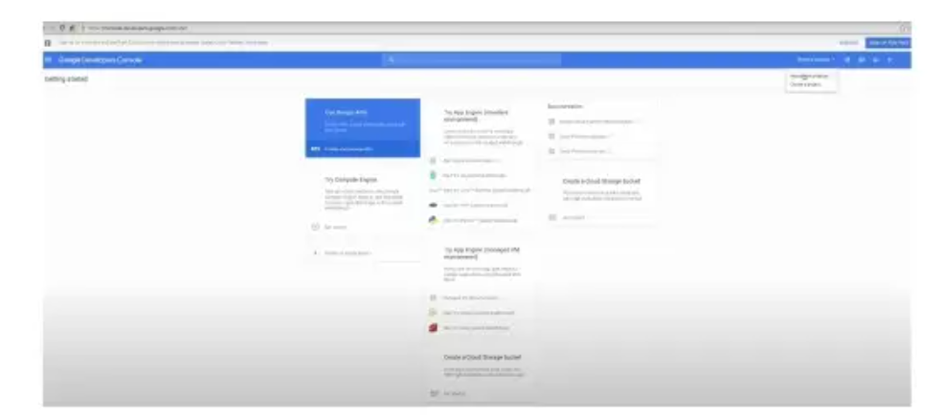
- Click on Compute Engine.

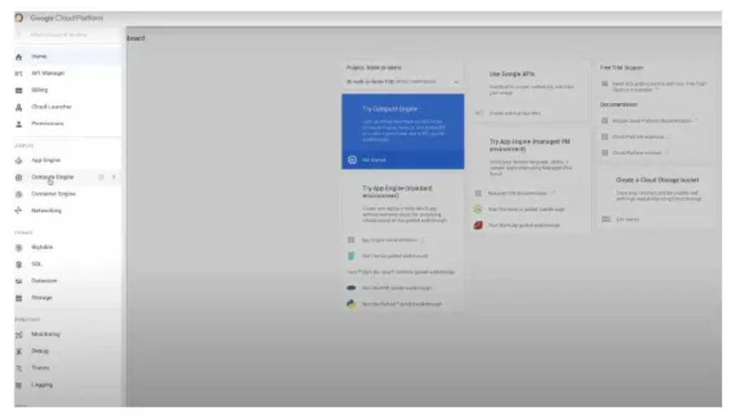
- Enable billing.
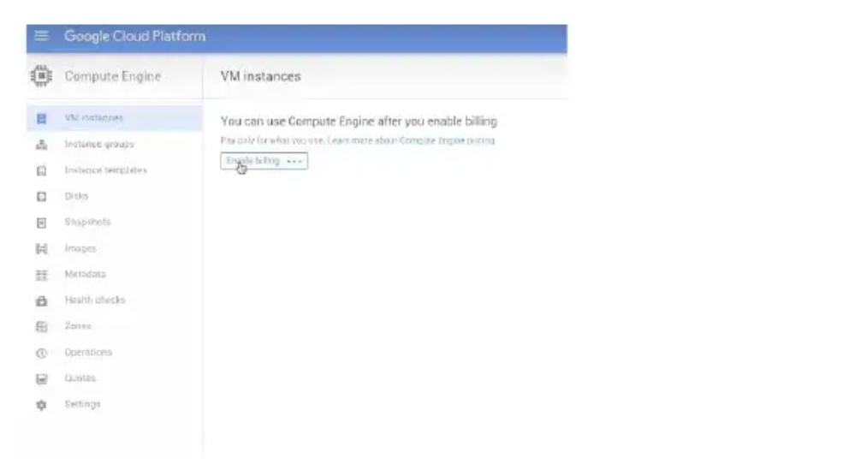

Section II: Data Science Lab:

Q1.
The height of 50 students of class X was measured in centimeters. The following table shows this data.
Perform the tasks (i) to (iv) using R programming.
#Height data
heights <- c(156, 155, 163, 151, 141, 160, 151,131,179,163,
165, 160, 158, 168, 158, 154, 162, 166,171, 141,
161, 159, 158, 156, 149, 145, 168, 171, 165, 145,
166, 167, 169, 156, 164, 146, 155, 164, 168, 172,
156, 163, 167, 157, 155, 145, 171, 164, 166, 195,)

# (i) Minimum and maximum height

min_height <- min(heights)
min_height <- max(heights)
cat("minimum height:", min_height, "\n")
cat("maximum height:", max_height, "\n")

#(ii) Find the percentage of students whose Heightis between 160 and 170 cm

count_160_170 <- sum(heights >= 160 & heights)) *100
cat("percentage of students with Height btw 160 and 170 cm:",
percentage_160_170, "\n")

#(iii) create and draw the frequency distribution with a histogram
hist(heights, breaks=5, col="lightblue", main="height distribution",
xlab="Height (cm)", ylab="frequency")
#(iv) Find the outlier of the data
boxplot(heights, main="boxplot of Heights", col="lightgreen",
ylab=" Height(cm)")
outliers <- boxplot.stats(heights) $out
cat("outliers in the data:", outliers , "\n")

Q2:
An organization collected the following data of its employees: “years in employment” and “ employee’s salary”. Use R programming to fit a linear regression line to predict the effect of years in employment on the employee’s salary. Also , predict the salary of an employee who is employed for 11 years.
Employee num | Years in Emp | Emp Monthly Sal in Thous Rs
1 | 10 | 149
2 | 8 | 120
3 | 12 | 150
4 | 7 | 110
5 | 6 | 100
6 | 5 | 90
7 | 9 | 130
8 | 8 | 110
9 | 3 | 80
10 | 4 | 85

Now we will write the R program to fit a linear regression model and predict the salary for an employee with 11 years of employment:
#data
years <-c(10,8,12,7,6,5,9,8,3,4)
salary <-c(149,120,150,110,100,90,130,110,80,85)
#create a linear regression model
model <- lm(salary ~ years)
#Summary of the model
Summary(model)
#predict salary for 11 years of employment
predicted_salary <- predict(model, data.frame(years=11))
cat("predicted salary for 11 years of employment:", predicted_salary, "thousand Rs\n")
#Plot the data and regression line
plot(years, salary, main="years vs salary regression", xlab="Years in Employment".
ylab="Salary (in thousand Rs)", pch=16, col="blue")
abline(model, col="red")

