

Indira Gandhi National Open University New Delhi
A SYNOPSIS ON
Supermarket Electronic Management System
MCSP-232

Submitted to Dehli 1 (COE)
In the partial fulfillment of the requirements for the degree of
Master of Computer Application (MCAOL)

Project Guide Submitted by:
Dr. Shekhar Kalakoti Mohammad Nabi Hemat
Phd MCAOL
E/No : 2353878752

Supermarket Electronic Management System
A Comprehensive Web-Based Solution

Table of Contents
Table Contents
1 . Project Title: 3
2 . Introduction: 3
2.1 System Objectives 3
2.2 Scope of the System 4
3. Tools Platform 4
3.1 Software platform 4
3.2 System Requirements 5
3.3 Software Requirements (Server) 5
3.4 Client Requirements 5
3.5 System Modules 6
3.6 Database Schema Design 6
3.7 Relationship Structure 6
3.8 Security Architecture 7
4 . Core Functional Modules 7
4.1 Product Management Module 7
4.2 Bill Management Module 7
4.3 Asset Management Module 8
4.4 User Management Module 8
4.5 Configuration Module 8
5. Technical Implementation Details 8
5.1 Business Logic Implementation 8
5.2 API Design and Implementation 9
5.3 Frontend Implementation 9
5.4 Deployment Architecture 9
6. Testing and Quality Assurance 9
6.1 Testing Strategy 9
6.2 Performance Testing 9
6.3 Security Testing 9
7. Results and Analysis 10
7.1 System Capabilities Achieved 10
7.2 User Acceptance and Feedback 10
7.3 Limitations and Constraints 10
8. Data Flow Diagram: 10
8.1 What is Data Flow Diagram (DFD) ? 10
8.2 DFD Level-0 (Context Diagram) 11
8.3 Level-1 Data Flow Diagram (DFD) 11
8.4 ERD Diagram 12
8.5 Use Case Diagram 14
8.6 Activity Diagrams 15
8.7 Class Diagram 16
9.8 Sequence Diagram 17
9. Installation Guide 18
9.1 Local Development Setup 18
10. Production Deployment 18
11. User Roles and Permissions Matrix 18
12. Database Schema Diagram 18
13. API Endpoint Documentation 19
14. User Interface Screenshots 19
15. Sample Reports 19
16. Conclusions and Future Work 19
16.1 Future Enhancements 20
16.2 Final Remarks 20
17. References / Bibliography 21

Table of Figures:

Fig 1DFD Level 0 SMEMS diagram 11
Fig 2 : DFD Level 1 SMEMS Diagram 12
Fig 3 : ER_Diagram for SMEMS System 13
Fig 4 : Use Case diagram for SMEMS System 14
Fig 5: Activity_diagram for SMEMS System 15
Fig 6: Class_diagram for SMEMS system 16
Fig 7: Sequence_diagram for SMEMS System 17

1 Synopsis Title:
This Synopsis presents the development and implementation of a comprehensive Supermarket Electronic Management System built using Django web framework. The system provides an integrated solution for managing multiple aspects of supermarket operations, including inventory management, billing, financial tracking, multi-organization support, and user management. The application is designed to handle complex business requirements such as purchase orders, sales transactions, payment processing, expense tracking, and asset management while supporting multiple organizations and locations with role-based access control.

2 Introduction:
The SuperMarket Electronic Management System (SMEMS) is designed to automate day-to-day supermarket operations including asset management, billing, products, stock control, loans, users, and organizational configuration. The system replaces traditional manual processes, improves accuracy, ensures real-time updates, and provides centralized control over supermarket activities.
This system is built for multi-branch supermarkets and supports organizational hierarchy, authentication, inventory lifecycle, financial assets, billing workflow, and reporting.

2.1 System Objectives
The primary objectives of this system are:

- Secure access: using to allow authorized users through login authentication.
- Generate reports: to generate daily, monthly and yearly reports of sales, stock and profit.
- Mange information: to maintain customer’s records, history and loyalty information’s.
- Save time and Cost: to save time and cost of the products.
- Decision Making: it is best for decision making.
- Reduce human errors: it will reduce the human errors.
- Improve billing efficiency: it is using to improve efficiency.
- To automate Supermarket Operations:
- TO support decision making.

2.2 Scope of the System
The system encompasses the following functional modules:
- Products & Stocks Management Module: Products, categories, units, stock management, and product details
- Billing & Sales Management Module: Purchase bills, sales bills, payment processing, receivable tracking
- Assets & Financial Accounts Management Module: Organizational assets, financial summaries, profit/loss statements
- Loans & Asset Summaries
- User Management Module: User registration, authentication, organization membership, role assignments
- Configuration Module: Organizations, locations, currencies, system settings
- Expenditure Module: Expense tracking and categorization
The system is built as a web-based application accessible through standard web browsers, deployed using PostgreSQL database backend, and designed for both local and cloud deployment scenarios.

3. Tools Platform
Software and Technologies to be used in this Project:

Software platform
Languages to be Used Front-end:
- HTML5
- CSS3
- JavaScript
- Bootstrap
- AJAX
- Template Engine
Back End Languages:
- Django 4.x (Python)
- PostgreSQL
API Framework
- Django REST Framework
Additional Libraries and Tools
- Jalali Date
- Django CORS Headers
- Pillow
- Whitenoise
- Gunicorn
- Django Heroku

System Requirements
- Hardware Requirements (Server)
- Processor: 2+ CPU cores
- RAM: 4GB minimum, 8GB recommended
- Storage: 50GB minimum, SSD recommended
- Network: 100Mbps bandwidth

Software Requirements (Server)
- Operating System: Linux (Ubuntu 20.04+) or Windows Server
- Python: 3.8 or higher
- PostgreSQL: 12 or higher
- Web Server: Nginx or Apache (for production)

Client Requirements
- Modern web browser (Chrome, Firefox, Safari, Edge)
- Internet connection (minimum 1Mbps)
- Screen resolution: 1024x768 minimum, 1920x1080 recommended

System Modules
The system follows the Model-View-Template (MVT) architectural pattern, which is Django's variation of the traditional MVC pattern:
- Models Layer
- Views Layer
- Templates Layer

Database Schema Design
Core Entities
- Organization
- User and Organization User
- Product
- Bill
- Stock

Relationship Structure
The relationship structure of SMEMS is the complete set of entity-to-entity connections that define how:
- Products relate to Categories and Stock
- Bills relate to Products and Assets
- Loans relate to Installments
- Users relate to Groups and Organizations
- Organizations relate to Country, Currency, and Location
This structure forms the core database design and UML structure of the supermarket management system.

SMEMS contains six major modules:
- Product & Stock Module
- Billing Module
- Asset Management Module
- Loan Module
- Authentication & Authorization Module
- Configuration Module
Each module has entities (tables/classes), and they link with each other through:
- One-to-many relationships
- Many-to-one relationships
- Many-to-many relationships
- Derived/summary relationships

Security Architecture
- Authentication
- Authorization
- Data Protection
- Session Management

4 Core Functional Modules

4.1 Product Management Module
- Product Catalog
- Category Management
- Unit Management
- Stock Management

4.2 Bill Management Module
- Bill Types and Structure
- Purchase Bill Processing
- Sales Bill Processing
- Payment and Receivable Tracking
- Bill Approval Workflow

4.3 Asset Management Module
- Asset Tracking
- Liability Tracking
- Receivables Management
- Financial Summary Tables
- Profit and Loss Statements

4.4 User Management Module
- User Registration and Authentication
- Role-Based Access Control
- Organization User Model

4.5 Configuration Module
- Organization Management
- Location Management
- Currency and Localization

5. Technical Implementation Details
- Database Optimization Techniques
- Indexing Strategy
- Query Optimization
- Transaction Management

Business Logic Implementation
- Stock Movement Tracking
- Profit Calculation
- Asset Summary Updates

API Design and Implementation
- RESTful API Structure
- Serialization

Frontend Implementation
- Responsive Design
- Dynamic Forms
- Reporting Interface

Deployment Architecture
- Development Environment
- Production Environment
- Configuration Management

Testing and Quality Assurance

Testing Strategy
- Unit Testing
- Integration Testing
- Functional Testing

Performance Testing
- Load Testing
- Query Performance Analysis

Security Testing
- Vulnerability Assessment
- Penetration Testing

Results and Analysis

System Capabilities Achieved
- Comprehensive Inventory Management
- Financial Transaction Processing
- Multi-Organization Support
- Performance Metrics

User Acceptance and Feedback
- Usability Evaluation
- Business Impact

Limitations and Constraints
- Current Limitations
- Scalability Considerations

8. Data Flow Diagram:

8.1What is Data Flow Diagram (DFD) ?
Data Flow Diagram (DFD) is a graphical representation of data flow in any system. It is capable of illustrating incoming data flow, outgoing data flow and store data. The DFD depicts both incoming and outgoing data flows and provides a high-level overview of system functionality. It is a relatively simple technique to learn and use, making it accessible for both technical and non-technical stakeholders.
Data Flow Diagram can be represented in several ways. The Data Flow Diagram (DFD) belongs to structured-analysis 1 tools. Data Flow diagrams are very popular because they help us to visualize the major steps and data involved in software-system processes.

DFD Level-0 (Context Diagram)
A Level-0 DFD (Context Diagram) for a SuperMarket Electronic Management System (SMEMS) is the highest-level data flow diagram.
It shows the entire supermarket system as one single process and represents:

- External entities (actors)
- Major data flows between those entities and the system
- The system as one black-box process
- No internal modules shown
- DFD Level 0 (Context Diagram): showing the system as a whole and its interactions with external entities.
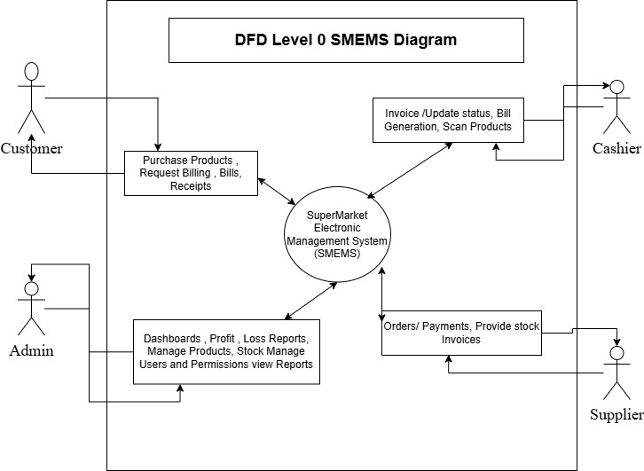
Fig 1DFD Level 0 SMEMS diagram

8.3 Level-1 Data Flow Diagram (DFD)
A Level-1 DFD for a SuperMarket Electronic Management System (SMEMS) takes the single process from Level-0 and breaks it into major subsystem processes.
This level shows internal modules and how data flows among them.

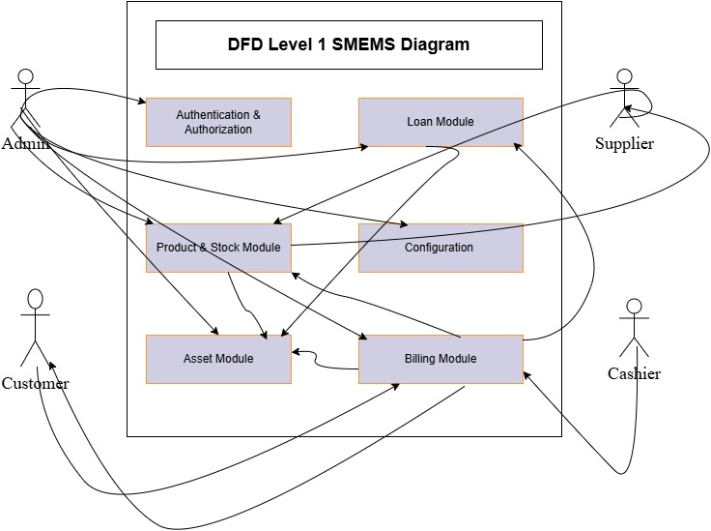
Fig 2 DFD Level 1 SMEMS Diagram

8.4 ERD Diagram
An ERD (Entity–Relationship Diagram) for a SuperMarket Electronic Management System (SMEMS) is a database modeling diagram that shows:
- Entities (tables)
- Attributes (fields)
- Relationships between entities
It describes how data is stored, linked, and structured within the supermarket management system.
The ERD helps you understand:
- How products, stocks, bills, users, loans, assets, and configurations are related
- How data flows across modules
- How tables connect via primary and foreign keys
- How to design the database schema
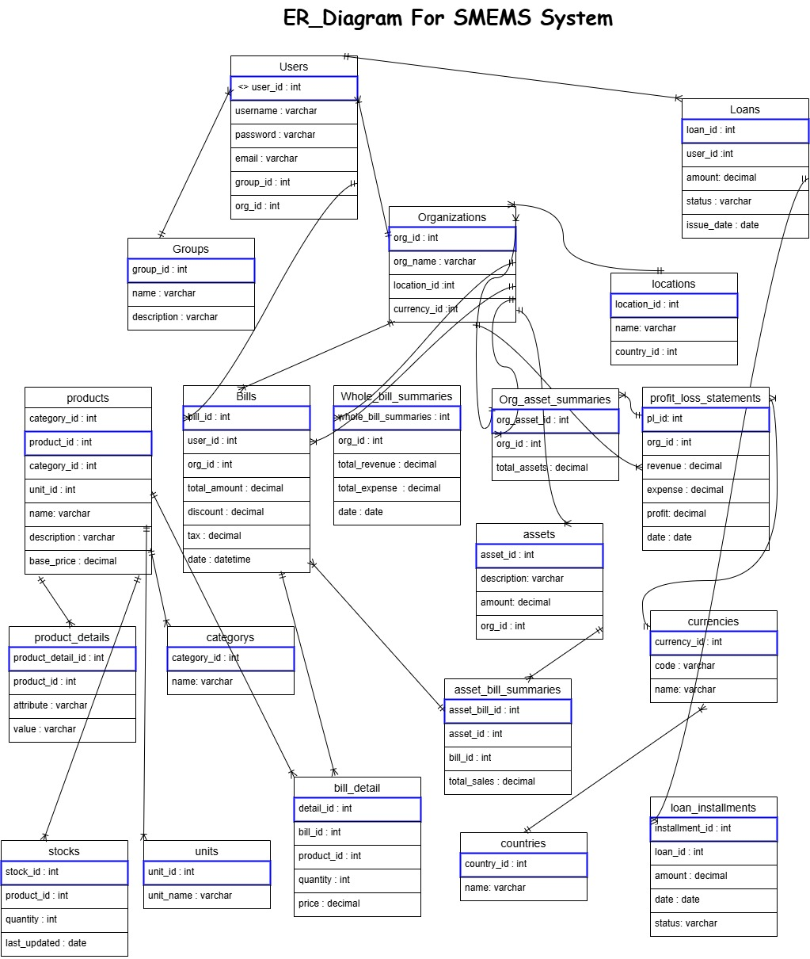
Fig 3 ER_Diagram for SMEMS System

8.5 Use Case Diagram
A Use Case Diagram is a visual representation that shows how different users (actors) interact with a system to achieve various goals or “use cases.” For a SuperMarket Electronic Management System (SMEMS), it depicts all the functionalities of the system and the roles of the users interacting with it.
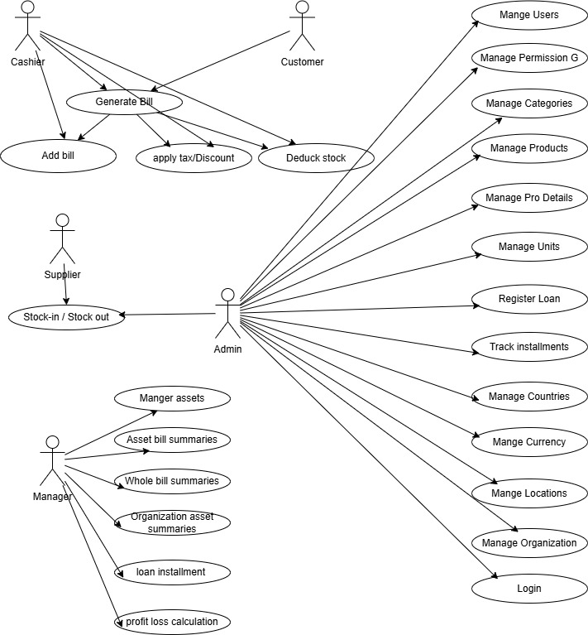
Fig 4 : Use Case diagram for SMEMS System

8.6 Activity Diagrams
An Activity Diagram for a SuperMarket Electronic Management System (SMEMS) shows the workflow of major processes such as billing, stock handling, asset tracking, authentication, configuration, and loan management. It visually represents how activities begin, the decisions involved, and how the workflow ends.
- Shows how processes flow in the supermarket system.
- Represents activities, decisions, parallel tasks, and end results.
- Helps understand how a user interacts with the system internally.
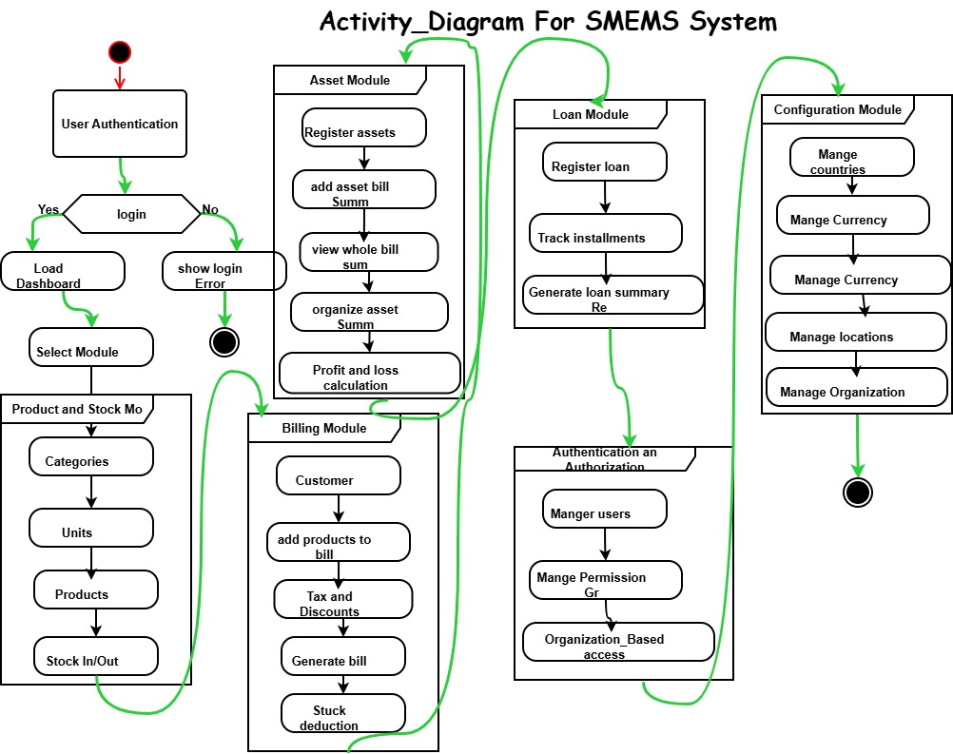
Fig 5: Activity_diagram for SMEMS System

Class Diagram
A Class Diagram for a SuperMarket Electronic Management System (SMEMS) is a structural UML diagram that shows the system’s:
- Entities (classes)
- Attributes
- Relationships
- Multiplicity (1..*, 0..1, etc.)
- Modules (Billing, Products, Stock, Asset, Loans, Auth, Configuration)
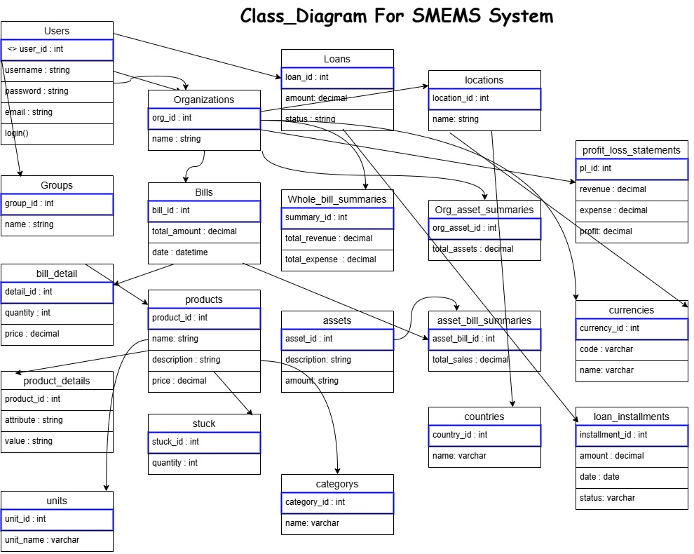
It is one of the most important diagrams in system design because it defines the database structure, system architecture, and application logic.
Fig 6: Class_diagram for SMEMS system

Sequence Diagram
A Sequence Diagram is a UML behavioral diagram that illustrates:
- Actors (User, Admin, Cashier, Supplier, etc.)
- System components (UI, Database, Inventory Module, Payment Module)
- Messages exchanged between them
- Order of execution from start to end
It focuses on “who talks to whom and in what order.”
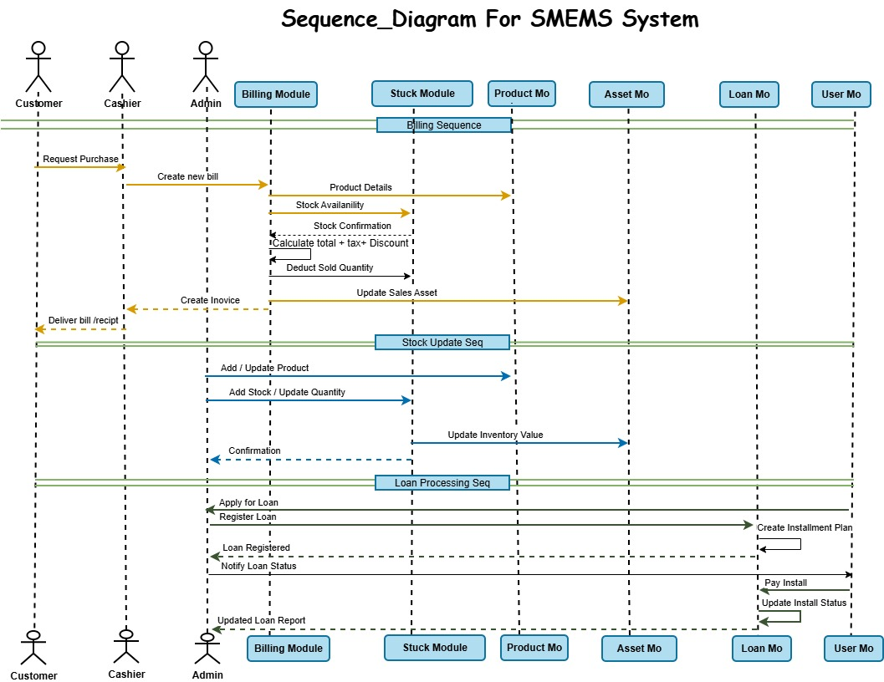
Fig 7: Sequence diagram for SMEMS System

9. Installation Guide

Local Development Setup
- Clone repository
- Create virtual environment: `python -m venv env`
- Activate environment: `env\Scripts\activate` (Windows) or `source env/bin/activate` (Linux/Mac)
- Install dependencies: `pip install -r requirements.txt`
- Configure database in settings.py
- Run migrations: `python manage.py migrate`
- Create superuser: `python manage.py createsuperuser`
- Start server: `python manage.py runserver`

10. Production Deployment
- Configure environment variables
- Set DEBUG=False
- Configure ALLOWED_HOSTS
- Set up PostgreSQL database
- Collect static files: `python manage.py collectstatic`
- Configure Gunicorn or Uwsgi
- Set up Nginx as reverse proxy
- Configure SSL certificates
- Set up automated backups

11. User Roles and Permissions Matrix
View Products, Create Products, Edit Products, Delete Products, Create Bills, Approve Bills, Cancel Bills, View Reports, Manage Users, System Settings, Financial Data

12. Database Schema Diagram
[Space reserved for Entity-Relationship Diagram showing all tables, relationships, and key fields]

13. API Endpoint Documentation
[Space reserved for comprehensive API documentation with request/response examples]

User Interface Screenshots
- [Space reserved for screenshots of key system interfaces:
- - Dashboard
- - Product Management
- - Bill Creation
- - Stock Management
- - Reports
- - User Management]

Sample Reports
- [Space reserved for sample report outputs:
- - Profit/Loss Statement
- - Inventory Valuation Report
- - Sales Summary Report
- - Outstanding Receivables Report
- - Purchase History Report]

Conclusions and Future Work
This thesis has presented the successful development and implementation of a comprehensive Supermarket Electronic Management System. The system integrates inventory management, financial tracking, multi-organization support, and user management into a unified web-based platform.
Key Achievements
Comprehensive Functionality: The system successfully handles all core supermarket operations from product catalog management to complex financial reporting.
Robust Architecture: The Django-based architecture provides security, scalability, and maintainability while following industry best practices.

Data Integrity: Through careful database design, transaction management, and signal-based updates, the system maintains data consistency across all modules.

User Experience: The intuitive interface and responsive design ensure accessibility for users with varying technical expertise.
Business Value: The system delivers measurable improvements in operational efficiency, accuracy, and decision-making capability.
The implementation demonstrates that modern web frameworks like Django, combined with thoughtful design and comprehensive testing, can deliver enterprise-grade solutions suitable for real-world business operations.

Future Enhancements
- Mobile Application Development
- Advanced Analytics and Reporting
- Integration Capabilities
- Advanced Features
- Performance Optimization
- Security Enhancements

Final Remarks
The Supermarket Electronic Management System represents a significant advancement in retail management technology, particularly for markets requiring multi-language and multi-calendar support. The successful implementation validates the chosen technology stack and architectural decisions.

The system's modular design and comprehensive API foundation provide a solid base for future enhancements. As businesses grow and requirements evolve, the system can be extended without fundamental architectural changes.

The project demonstrates that with careful planning, robust implementation, and thorough testing, it is possible to create complex enterprise systems that deliver real business value while maintaining code quality and maintainability.

This work contributes to the growing body of knowledge in enterprise software development and provides a practical example of Django framework capabilities in building production-grade business applications. The lessons learned and patterns established can guide future development efforts in similar domains.

17. References / Bibliography

1. Django Software Foundation. (2024). Django Documentation. https://docs.djangoproject.com/
2. PostgreSQL Global Development Group. (2024). PostgreSQL Documentation. https://www.postgresql.org/docs/
3. Django REST Framework. (2024). Django REST Framework Documentation. https://www.django-rest-framework.org/
4. Two Scoops Press. (2023). Two Scoops of Django 4.x: Best Practices for Django Web Development.
5. Mozilla Developer Network. (2024). Web Development Best Practices. https://developer.mozilla.org/
6. OWASP Foundation. (2024). OWASP Top Ten Web Application Security Risks. https://owasp.org/
7. Greenfeld, D. R., & Roy, A. (2023). Django Best Practices and Design Patterns.
8. Bootstrap Documentation. (2024). Bootstrap Framework. https://getbootstrap.com/docs/
9. Python Software Foundation. (2024). Python Documentation. https://docs.python.org/3/
10. Heroku Dev Center. (2024). Deploying Python and Django Apps on Heroku. https://devcenter.heroku.com/
11. Acharya, Kamal. SUPERMARKET MANAGEMENT SYSTEM
12. M.Bhuvaneshwari 1,#Mr.P.Anbumani 2 : ONLINE SUPERMARKET MANAGEMENT SYSTEM ISSN 2582-7421

