Site Name | Bagh Pol (TDF)

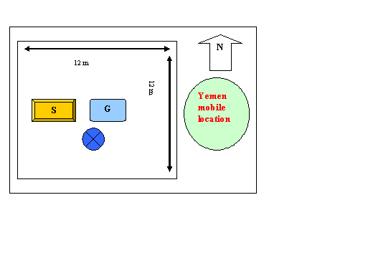

Zone | Heart | Site Code | TDF-

Contact | Abdul Qaiom
Telephone | Home
 | Office
 | Mobile | 0702794285
Address | Bagh Pol Farah City Farah Province

Survey Team
Name | Function
Javid Bahbodi | Farah AFTEL Manager
Abdul Jamil | Eng. MDF
Mohammad Taher | ATRA Representative

Geographical Info
GPS Coordinates (WGS 84) | N: 32.365260
 | E: 62.082649

Altitude GPS (± 11m) | 664

Building Height | Tower 30

Orientation Support
Date:
Validated By:
: Date July 21, 2019 D/12December 2004

S1 | 30 | 30m Tower light-Medium or Heavy
S2 | 120
S3 | 270
RBS

BSC
Category:
Site classification | GF-35m-ID-17.5KVA2

Province | District | Village
Farah  Kabul | Farah City | Bagh Pol
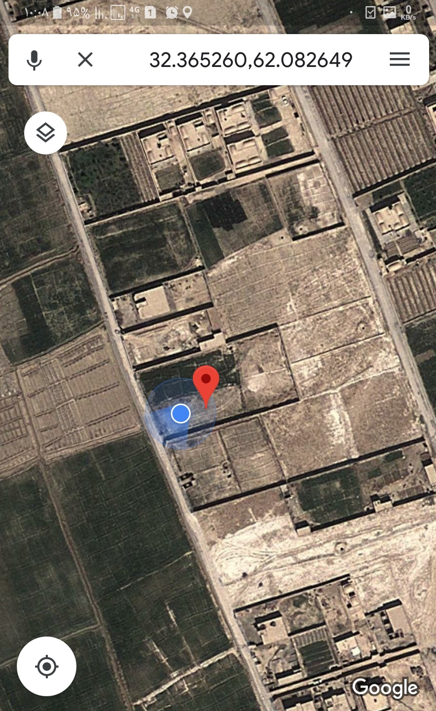

 |  | Street
Regions Covered | S1 | Bagh no
 | S2 | Bagh Pol
 | S3 | Sang Zor
 | RBS

Site location

Site Location

COVERAGE PREDICTION FOR SITE
PANAROMIC VIEW

