Site Name | Kafer Qala (TDF)

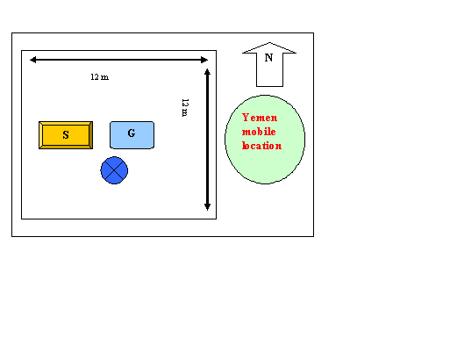

Zone | Heart | Site Code | TDF-FRH039

Contact | Saboor
Telephone | Home
 | Office
 | Mobile | 0786486484
Address | Kafer Qalah Farah City Farah Province

Survey Team
Name | Function
Javid Bahbodi | Farah Manager
Abdul Jamil | Eng. Technical
Mohammad Taher | ATRA Representative

Geographical Info
GPS Coordinates (WGS 84) | N: 32.323602
 | E: 62.160577

Altitude GPS (± 11m) | 664

Building Height | Tower 30

Orientation Support
Date:
Validated By:
: Date July 20, 2019 D/12December 2004

S1 | 30 | 30m Tower light-Medium or Heavy
S2 | 120
S3 | 270
RBS

BSC
Category:
Site classification | GF-35m-ID-17.5KVA2

Province | District | Village
Farah  Kabul | Farah City | Kafer Qala
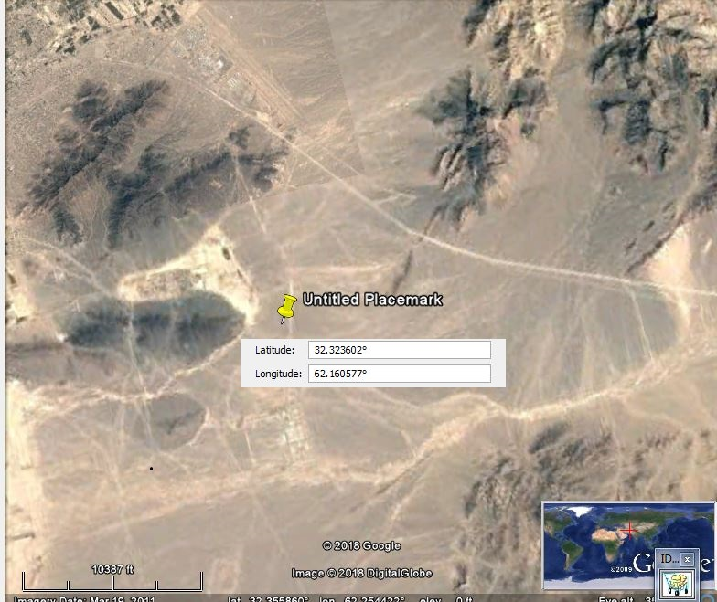

 |  | Street
Regions Covered | S1 | Stra tigi
 | S2 | Shafa khana Village
 | S3 | Lava Bass
 | RBS

Site location

Site Location
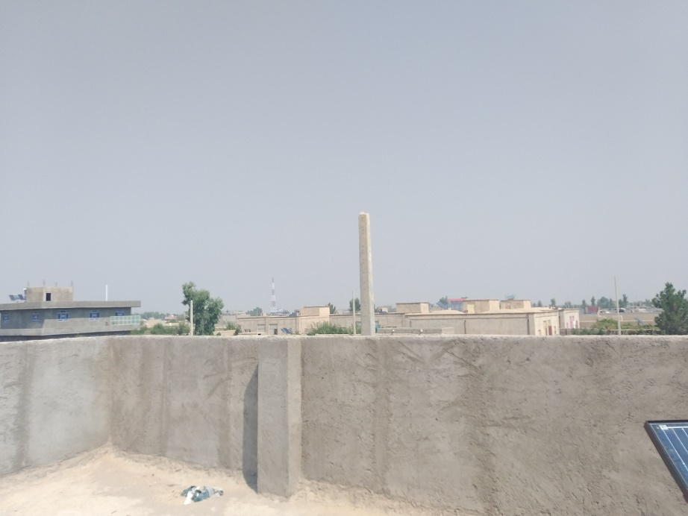 | 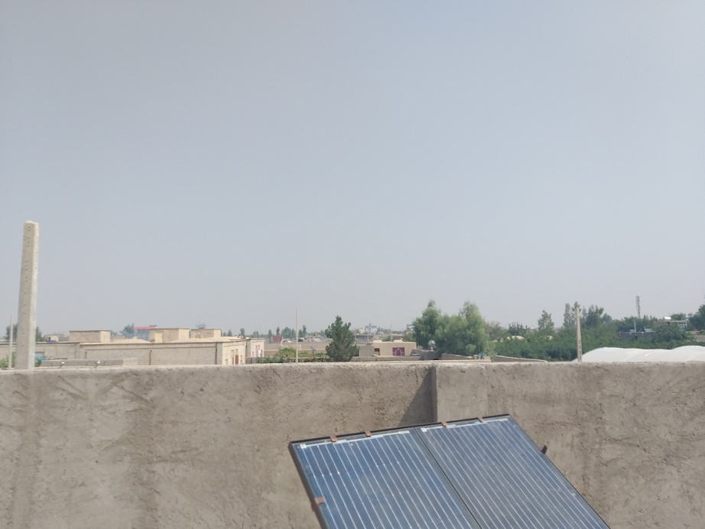  موقعيت سايت

COVERAGE PREDICTION FOR SITE

PANAROMIC VIEW

30 | 0
90 | 60

50 | 120
210 | 180

270 | 240
330 | 300

