

DESIGN AND IMPLEMENTATION OF A
GPS- AND LTE-BASED TRACKABLE
STUDENT IDENTIFICATION CARD
By
IWORIMA GOD’S DELIGHT
U19CO1011

Department of Computer Engineering,
Ahmadu Bello University, Zaria
2026

DESIGN AND IMPLEMENTATION OF A
GPS- AND LTE-BASED TRACKABLE
STUDENT IDENTIFICATION CARD
By
IWORIMA GOD’S DELIGHT
U19CO1011
delightiworima19@gmail.com
Supervised By
ENGR. M. O. MUHYIDDEEN

A Final Year Project Submitted to the Department of Computer Engineering, Ahmadu Bello University, Zaria in Partial Fulfillment of the Requirements for the Award of the Bachelor of Engineering (B.Eng) Degree in Computer Engineering
2026

DECLARATION
I declare that the work in this project report, entitled “Design and Implementation of a GPS- and LTE-Based Trackable Student Identification Card”, was carried out by me in the Department of Computer Engineering, Ahmadu Bello University, Zaria. The information derived from published and unpublished works has been acknowledged in the text and listed in the references. No part of this report has previously been presented for another degree or diploma at this or any other institution.

_________________________________ _____________________
Iworima God’s Delight Date
(U19CO1011)

CERTIFICATION
This project report, entitled “Design and Implementation of a GPS- and LTE-Based Trackable Student Identification Card” by Delight Iworima, U19CO1011, meets the regulations governing the award of the Bachelor of Engineering degree in Computer Engineering of Ahmadu Bello University, Zaria, and is approved for its contribution to knowledge and presentation.

_____________________ _____________________
Engr. M. O. Muhyiddeen Date
(Supervisor)

_____________________ _____________________
Dr. H. Bello-Salau Date
(Project Coordinator)

_____________________ _____________________
Dr. B. Yahaya Date
(Head of Department)

DEDICATION
This work is dedicated to God Almighty, my family, teachers and everyone whose support made my undergraduate education possible.

ACKNOWLEDGEMENT
I am grateful to God Almighty for the strength and opportunity to complete this project. I sincerely appreciate my supervisor, Engr. M. O. Muhyiddeen, for guidance, corrections and encouragement throughout the work. I also thank the academic and technical staff of the Department of Computer Engineering, Ahmadu Bello University, Zaria, for the knowledge and facilities that supported the project. My gratitude extends to my parents, family, classmates and friends for their patience, advice and practical assistance during development and testing.

ABSTRACT
A conventional student identity card proves identity but cannot report its location during an authorised search. This project presents a portable tracking prototype built around the LilyGO T-A7670E board, which combines an ESP32 controller, an A7670E LTE modem and Global Navigation Satellite System support. The device obtains accurate outdoor coordinates from satellites, retains the last reliable satellite position for a limited period when reception is interrupted, and uses a clearly labelled cellular-network estimate as a fallback. It sends location records through a web application programming interface to a Flask server, where SQLite stores the data. The firmware also keeps up to 20 unsent reports in non-volatile memory for later delivery after a temporary network failure. An Ahmadu Bello University-themed dashboard provides administrator authentication, student search by registration number, live tracking, recent positions, activity history, date- and session-based route playback, stop detection, geofence alerts, route export, system-health checks and hand-written OpenAPI documentation. All 17 automated backend functional and security tests passed. At the 30 August 2026 reporting snapshot, the physical card had produced 875 stored records: 205 satellite fixes, 241 retained fixes, 406 cellular estimates and 23 early unclassified records. For the latest recorded day, the route-processing method converted 79 quality-eligible satellite readings into 59 display points, rejected two implausible jumps, identified four stationary periods and calculated 49 m of movement. The developed hardware operates as a trackable ID-card-holder prototype. A production version would require a smaller custom circuit board, validated power and antenna design, encrypted deployment and institutional privacy controls.

TABLE OF CONTENTS
DECLARATION i
CERTIFICATION ii
DEDICATION iii
ACKNOWLEDGEMENT iv
ABSTRACT v
TABLE OF CONTENTS vi
LIST OF FIGURES ix
LIST OF TABLES x
LIST OF APPENDICES xi
LIST OF ABBREVIATIONS xii
CHAPTER ONE INTRODUCTION 1
1.1 Background 1
1.2 Project Motivation 2
1.3 Statement of the Problem 3
1.4 Aim and Objectives 4
1.4.1 Aim 4
1.4.2 Objectives 4
1.5 Project Organisation 4
CHAPTER TWO LITERATURE REVIEW 5
2.1 Introduction 5
2.2 Fundamental Concepts 5
2.2.1 Internet of Things Tracking Systems 5
2.2.2 Satellite Positioning 6
2.2.3 Cellular Communication and Fallback Position 6
2.2.4 Embedded Processing Platform 7
2.2.5 Server, Database and Real-Time Dashboard 8
2.3 Review of Related Works 9
2.4 Identified Research Gap 12
CHAPTER THREE MATERIALS AND METHOD 13
3.1 Introduction 13
3.2 Materials and Development Tools 13
3.2.1 Software Materials 13
3.2.2 Hardware Materials 15
3.3 System Architecture 16
3.4 Hardware Implementation 17
3.5 Firmware Method 18
3.5.1 Initialisation 19
3.5.2 Position Selection 19
3.5.3 Location Message 20
3.6 Backend and Database Method 21
3.7 Dashboard Method 22
3.8 Security and Privacy Method 23
3.9 Evaluation Procedure 24
CHAPTER FOUR RESULTS AND DISCUSSION 25
4.1 Introduction 25
4.2 Hardware and Firmware Results 25
4.3 Backend Test Results 26
4.4 Stored Telemetry Results 27
4.5 Route Playback, Distance and Speed 28
4.6 Dashboard Results 29
4.7 Discussion 31
CHAPTER FIVE SUMMARY CONCLUSION AND RECOMMENDATION 33
5.1 Summary 33
5.2 Limitations 33
5.3 Conclusion 34
5.4 Important Findings 34
5.5 Recommendations for Further Work 35
5.5.1 Miniaturisation and Production Development 35
5.5.2 Other Recommendations 37
REFERENCES 38
APPENDIX A MAJOR API ENDPOINTS 40
APPENDIX B PROTOTYPE HARDWARE AND SIGNAL CONNECTIONS 41
APPENDIX C SELECTED SOURCE CODE 42
C.1 Selected Firmware Code 42
C.2 Selected Backend Code 43

LIST OF FIGURES
Figure 3.1: Block diagram of the implemented tracking system 16
Figure 3.2: LilyGO T-A7670E R2 board, flat LTE antenna and ceramic GNSS antenna used in the prototype 18
Figure 4.1: Registered-student list and registration-number tracking entry point 30
Figure 4.2: Stored GPS route, playback controls and movement measurements for U19CO1011 31
Figure 5.1: Conceptual illustration of a possible miniaturised production tracker (design target; not fabricated or experimentally validated) 36

LIST OF TABLES
Table 3.1: Position-source selection process 19
Table 3.2: Main location message fields 20
Table 4.1: Hardware and firmware functional results 25
Table 4.2: Automated backend test results 26
Table 4.3: Distribution of stored location records 27
Table 4.4: Route-playback measurements from stored satellite data 28
Table 4.5: Implemented dashboard functions 29

LIST OF APPENDICES
APPENDIX A MAJOR API ENDPOINTS 40
APPENDIX B PROTOTYPE HARDWARE AND SIGNAL CONNECTIONS 41
APPENDIX C SELECTED SOURCE CODE 42

LIST OF ABBREVIATIONS
API: Application Programming Interface
BLE: Bluetooth Low Energy
CSV: Comma-Separated Values
ESP32: Espressif 32-bit microcontroller family
GNSS: Global Navigation Satellite System
GPS: Global Positioning System
HTTP: Hypertext Transfer Protocol
IoT: Internet of Things
JSON: JavaScript Object Notation
LTE: Long-Term Evolution cellular communication
NVS: Non-Volatile Storage
PDF: Portable Document Format
PDOP: Position Dilution of Precision; a satellite-geometry quality value
SIM: Subscriber Identity Module
SQL: Structured Query Language
UART: Universal Asynchronous Receiver-Transmitter

CHAPTER ONE
INTRODUCTION

1.1 Background
Student identification establishes a relationship between a person and an institution. In a university, the registration number is a stable identifier that can connect the visible card to an administrative record. Identification and location, however, answer different questions. A conventional card can show who its holder is, but it cannot tell an authorised officer where the card was last observed. This project investigates how an identification card holder can carry an electronic tracking device while retaining the registration number as the administrator's main point of reference.
The Internet of Things links identifiable physical objects to communication and information-processing services. Atzori et al. (2010) explain the importance of identification, sensing and networked information exchange in this model. Applied to this project, the physical object is the card device, the observation is a position report, and the application is the university tracking dashboard. The value of the system therefore depends on the complete path from the physical device to the person interpreting the information, rather than on the location receiver alone.
Satellite navigation provides one way of obtaining geographic coordinates outdoors. Its performance changes with satellite geometry, receiver quality, atmospheric effects and obstruction or reflection of the signal. Buildings can weaken reception even while the electronics remain powered (National Coordination Office for Space-Based Positioning, Navigation, and Timing, n.d.). A reporting system must consequently distinguish a newly measured position from an earlier position retained through a period of poor reception. Without that distinction, an apparently stable map marker can give a misleading impression that the holder has not moved.
Position acquisition also differs from communication. A receiver may obtain coordinates without a mobile data connection, but a remote dashboard cannot receive those coordinates until a communication path becomes available. Conversely, a modem may remain connected to the server while the satellite receiver has no acceptable fix. This project treats device connectivity, position source and position age as separate pieces of information. That separation is necessary when an administrator must decide how much confidence to place in a displayed location.
The LilyGO T-A7670E R2 platform was chosen because the required controller, cellular modem and associated interfaces are integrated on one board, with a GNSS-supported version available (LilyGO, n.d.-a; LilyGO, n.d.-c). The implemented firmware prefers an acceptable satellite fix, temporarily retains the last reliable fix when reception is interrupted, and uses a labelled cellular estimate as a fallback. These alternatives improve continuity of reporting, although they do not provide equal accuracy.
On the application side, the device identifier is associated with a student registration number. The backend stores accepted reports, and an authenticated administrator can search for the student, inspect the latest available position and replay earlier movement. The prototype uses one physical board assigned to U19CO1011 and four additional demonstration student records without devices. Its physical form is an identification-card-holder prototype; the development board is not claimed to meet the thickness of a conventional student card.

1.2 Project Motivation
The principal motivation is the need for useful location information during an authorised search for a missing or at-risk student in the context of insecurity in Nigeria. Public order and safety are recognised subjects of national statistical reporting (National Bureau of Statistics, 2024). In a university setting, a recent position and a traceable sequence of earlier reports could help security personnel identify where to begin enquiries or a physical search. The developed device supports that information need; the project does not establish that tracking alone prevents kidnapping or guarantees recovery.
A separate card device was considered because the availability of a particular student's phone cannot always be assumed. The phone may be discharged, unavailable or disconnected from an application. A dedicated tracker can have its own cellular connection and can remain associated with the university registration record. It nevertheless depends on the student carrying it, a functioning power supply and an available mobile network. These dependencies shape both the design and the limits of the claimed benefit.
A further motivation was to reduce the construction burden. Using separate controller, location, cellular and power boards would require more connections and more space. The integrated platform allowed development effort to focus on transmission reliability, correct student-device association, historical storage and a dashboard that can be explained during assessment. The project also provides a practical application of embedded programming, computer networking, database design and web development within a single Computer Engineering system.
Location records are sensitive. An institution should not treat the existence of a tracking capability as permission for unrestricted monitoring. IoT privacy and cybersecurity risks need to be considered throughout system use (National Institute of Standards and Technology, 2019). For this reason, the prototype separates the device reporting key from the administrator session and treats consent, authorised access, retention rules and secure deployment as requirements for any later institutional pilot.

1.3 Statement of the Problem
The problem addressed is the absence of an independent location-reporting function in a conventional student identity card. During an authorised search, knowledge of the student's registration number does not by itself reveal a recent location. A useful technical aid must connect a portable device to the correct student record and present information that security personnel can interpret, including whether a position is recent, retained or approximate.
The engineering difficulty extends beyond placing a receiver beside a card. Satellite reception can fail indoors; cellular communication requires a working SIM, data service and coverage; a laptop-hosted server can become unavailable; and repeated noisy measurements can create misleading route lines. An integrated solution must therefore acquire positions, communicate independently of a nearby computer, handle short interruptions, preserve original timestamps and prevent historical reports from being mistaken for current movement.
This project addresses those requirements using a GNSS/LTE development board and an authenticated web application. A demonstration distance of at least 200 m was set as an evaluation objective. That distance is the specified separation between the tracked device and the monitoring position, not the maximum range of LTE. The recorded results are evaluated separately from that target, because a formally measured 200 m trial was not documented in the available evidence. Precise indoor location, satellite communication outside mobile coverage and standard-card-thickness manufacturing remain outside the implemented prototype.

1.4 Aim and Objectives
This section states the overall aim and the three objectives used to organise the development and evaluation of the prototype. The objectives cover the embedded device, the web application and their end-to-end integration.

1.4.1 Aim
The aim of this project is to design and implement a portable student identification tracking prototype that acquires its location and transmits it over LTE to an authenticated real-time web dashboard.

1.4.2 Objectives
a) To develop integrated hardware and firmware on the LilyGO T-A7670E for satellite-position acquisition, cellular fallback and LTE transmission.
b) To develop a backend, database and Ahmadu Bello University-themed dashboard for student search, live location display, recent history, route playback and documented application programming interfaces.
c) To integrate and evaluate the end-to-end system, including source switching, data storage, authenticated access and operation over a distance of at least 200 m.

1.5 Project Organisation
This report is arranged in five chapters. Chapter One introduces the background, motivation, problem, aim and objectives. Chapter Two explains the fundamental concepts and critically reviews related studies. Chapter Three presents the materials and methods used to develop the device, backend and dashboard. Chapter Four presents and discusses the recorded results against the objectives. Chapter Five summarises the work, states its limitations and conclusions, identifies important findings and recommends further development. Appendices document the API, hardware connections and source implementation.

CHAPTER TWO
LITERATURE REVIEW

2.1 Introduction
This chapter reviews the concepts and earlier systems that informed the design. The discussion covers IoT tracking, satellite positioning, cellular communication, embedded controllers, server-side software, real-time dashboards and privacy. It then identifies the gap addressed by the developed prototype.

2.2 Fundamental Concepts
This section explains the principles needed to understand the tracking system before reviewing individual studies. It distinguishes identifying a device, acquiring its position, transporting a report and displaying that report. It also considers the effects of uncertainty, interrupted connectivity and access control, because these affect the interpretation of the final map.

2.2.1 Internet of Things Tracking Systems
An IoT tracking system assigns an identity to a physical device and transfers observations from that device to an application. Atzori et al. (2010) discuss identification, communication and information processing as related parts of IoT. A device identifier is therefore different from the observation it produces: CARD01 identifies this project's board, while a latitude, longitude and capture time describe one report made by that board.
The present design uses a device layer, a network layer and an application layer as a practical description of its operation. The device acquires and packages data, the network carries the package, and the application validates, stores and presents it. These are explanatory divisions of the implemented architecture, rather than three additional hardware modules. A failure in any layer can interrupt the final service, so successful firmware execution alone cannot establish successful tracking.
Two forms of tracking are relevant. Live reporting makes newly acquired observations available while communication is working. Historical tracking reconstructs movement from previously saved observations. The prototype provides both, but the small on-device queue only covers short interruptions. Its server database supplies the longer history after reports have been delivered.

2.2.2 Satellite Positioning
GNSS is the general term for satellite navigation systems, of which GPS is one example. A receiver uses satellite timing information to estimate its position and receiver-clock error. For an unconstrained three-dimensional solution, measurements from at least four satellites are normally required. The solution is an estimate, and signal geometry and propagation errors influence its quality (Sanz Subirana et al., 2011).
A clear view of the sky generally improves reception. Buildings, roofs and nearby reflective surfaces can obstruct or distort signals, which explains why an outdoor fix cannot be assumed to continue indoors (National Coordination Office for Space-Based Positioning, Navigation, and Timing, n.d.). Moving the device into better reception conditions improves the opportunity to obtain a fix; it does not guarantee a fixed acquisition time. In this project the modem is queried repeatedly, so a later acceptable satellite result can replace the fallback source.
Satellite count and position dilution of precision are quality indicators rather than direct measurements of horizontal error in metres. Dilution of precision describes how the geometry of the observations affects the position solution (Sanz Subirana et al., 2011). A low value alone does not establish a surveyed accuracy. In this project, at least four satellites and a positive reported dilution value no greater than 8 are used as engineering acceptance rules for retained fixes and route processing.
The thresholds were selected to reject visibly weak or implausible reports during development. They are not a calibration certificate for the receiver. The dashboard's plain-language quality labels help an administrator interpret the values, while the stored raw measurements remain available for later analysis. Retaining a coordinate for continuity also preserves the earlier measurement's uncertainty; it cannot measure movement that occurs after that coordinate was acquired.

2.2.3 Cellular Communication and Fallback Position
LTE carries packet data through a mobile operator's infrastructure. The SIM identifies the subscription, while the access point name selects the operator's data configuration. Registration on a network and establishment of a usable data session are separate requirements. The A7670 family supports cellular data functions and modem-command interfaces used for such applications (SIMCom Wireless Solutions, 2021).
The reporting range is consequently determined by usable cellular service and Internet reachability, rather than by a direct radio link to the supervisor's laptop. A 200 m demonstration is possible without the laptop receiving the board's radio signal directly: the board reaches the mobile network and the backend is reached through the configured Internet address. Neither a SIM being physically inserted nor an illuminated board proves that this complete path is available.
Cellular positioning uses information associated with the mobile network to provide an estimated location. Its uncertainty can differ substantially from that of an acceptable satellite fix. Jiménez-Martínez et al. (2025) investigate mathematical combinations of GNSS and cellular positions under different reception conditions. Their work supports considering complementary sources, but it does not establish that every modem-returned cellular estimate has the accuracy of their experimental system.
The implemented card uses source selection rather than the research paper's mathematical fusion methods. It reports a usable GNSS fix first, a recent held fix second and a cellular estimate when needed. The source label is retained through storage and presentation. A cellular marker may be far from the wearer, and connecting successive cellular estimates into a walking route would imply a level of precision that the measurements do not support.

2.2.4 Embedded Processing Platform
The embedded controller executes the reporting logic while the modem handles radio communication and, on the selected GNSS-supported version, satellite-location responses. The board's built-in serial connection allows the ESP32 to send commands and receive status information without assembling a separate controller-to-modem circuit. The official documentation identifies the supported board family and its hardware interfaces (LilyGO, n.d.-a; LilyGO, n.d.-b).
Working memory holds temporary program state, but it is lost when power is removed. ESP32 Preferences stores small values in non-volatile memory and retains them across resets and power loss (Espressif Systems, n.d.). The project uses that facility for its retained fix and limited unsent-report queue. Persistence is useful only if the age of a saved reading can still be assessed after restart; an old coordinate must not become a new measurement merely because it was loaded from flash.

2.2.5 Server, Database and Real-Time Dashboard
The backend provides a controlled boundary between embedded reports and administrator functions. Flask supplies explicit URL routes and request handling for the Python application (Pallets Projects, n.d.). An ingestion route receives device data, whereas student and route-history endpoints answer administrator queries. This separation makes it possible to apply device-key checks to reports and session checks to private browser functions.
SQLite is an embedded transactional database that does not require a separate database server (SQLite, n.d.). It suits the single-laptop prototype because installation, backup and inspection are straightforward. Python's sqlite3 interface supplies parameterised queries and transaction handling (Python Software Foundation, n.d.). The database records observations independently of whether the map is currently open, so closing a browser does not remove previously accepted locations.
Flask-SocketIO supports event-based communication between a server and connected clients (Grinberg, n.d.). In this project the browser first requests a snapshot, then receives later events. Those operations have different purposes: the initial query supplies existing state, while a live event announces a newly accepted report. A connected browser socket does not by itself prove that the physical card has obtained a fresh position.
Leaflet supplies browser map layers, markers and polylines (Agafonkin, 2023). The application places the device marker and processed route on those layers. The map library displays coordinates received from the backend; it does not independently locate the wearer. Likewise, satellite imagery is a background map style and does not mean that the tracker is communicating through a satellite network.
OpenAPI describes HTTP endpoints, request bodies, responses and authentication requirements in a structured specification (OpenAPI Initiative, 2020). The project's hand-written specification is displayed through Swagger UI. HTTP itself defines methods and status-code semantics, including the distinction between successful processing and client or server errors (Fielding et al., 2022). Those definitions make failed authentication or malformed data easier to diagnose without treating every failure as loss of satellite reception.

2.3 Review of Related Works
The following studies are reviewed in terms of the problem addressed, method used, reported outcome and relevance to the present project. The older implementations establish the device-to-server tracking pattern, while the more recent studies help assess cellular availability and indoor positioning. A reported limitation is distinguished from an achieved result throughout the review.
Alsadi (2013) developed a vehicle tracker to make a vehicle's position available at a monitoring station rather than relying on the owner's direct observation. The design separated vehicle and monitoring units and used a PIC18F452 controller, a GPS receiver and a GSM communication path. Location information was transferred using SMS or GPRS. The paper describes an implemented embedded arrangement that combines location acquisition with remote monitoring. This review does not assign a numerical accuracy or delay where none has been established from the inspected material. The two-unit architecture is a useful precedent for separating field hardware from monitoring software. Its vehicle focus does not establish a wearable form factor, student registration lookup or privacy arrangements for personal movement. The present project adopts the end-to-end reporting principle while reducing separate boards and linking the device to a student record.
Alquhali and Roslee (2018) investigated remote vehicle monitoring for theft and property-management applications. Their system used an Arduino Uno R3 with GPS and GSM hardware. An LCD displayed coordinates locally; ThingSpeak presented coordinate trends, while Freeboard provided a map view. The authors report successful real-time operation of the constructed tracking system. The combination of local display and remote visualisation showed how one measurement stream could support several interfaces. The architecture demonstrates the benefit of a map over latitude-and-longitude charts alone. However, its separate modules and local LCD introduce size and wiring requirements that are unsuitable for the intended card holder without redesign. Its vehicle workflow also differs from searching an institutional registration record. The present project concentrates those application functions in one authenticated dashboard and reports the origin of each position.
Khin and Oo (2018) developed a web-based vehicle tracker to make remotely acquired position information accessible on a browser map. The tracking unit combined an Arduino Uno R3, a SIM800A GSM module and a NEO-6M GPS module. HTTP carried reports over GPRS; PHP, MySQL and Google Maps supported storage and display. The paper presents a web interface displaying the vehicle location together with information including satellite count, speed and course. It demonstrates the device-to-database-to-map reporting chain. The study is closely relevant because its server retains incoming data rather than relying solely on SMS. However, it does not establish this project's retained-fix policy, authenticated student lookup or treatment of delayed reports. The developed card system applies the same general separation of acquisition, transport and presentation using an integrated LTE board and a Flask/SQLite backend.
Morallo (2021) presented a GPS/GSM vehicle tracker to help a user obtain a vehicle's remote coordinates. An Arduino Uno coordinated the receiver and a SIM900A GSM module. Coordinates were sent by SMS, after which the recipient could use Google Maps to inspect the location. The paper presents a working communication arrangement and identifies automatic map display as an improvement for future development. The reported workflow therefore depends on the user's interpretation of the transmitted coordinates. SMS reporting offers a simple path to a recipient, but it is less direct for browsing a continuous institutional history. The paper's vehicle-oriented claims should not be read as proof of precise indoor positioning. In the present work, automatic map updates, persistent records and playback are implemented within the browser application, while source labels communicate the limits of the underlying measurement.
Osman and Hassan (2024) examined GPS/GSM vehicle tracking as a way to monitor remotely located assets. The design used an Arduino Uno R3 to process GPS observations and coordinate a GSM module, with the intended reporting destination being a server or monitoring station. The paper explicitly reports that service-provider blockage prevented its GSM module from connecting to the cellular network. Its intended architecture must therefore be distinguished from a fully demonstrated live cellular service. This limitation is directly relevant to the card prototype: compatible hardware, an inserted SIM and correct software are insufficient if the operator does not permit a usable data connection. It supports testing network registration, data activation and an accepted server request as separate stages. The present report consequently distinguishes board power, network status, server delivery and availability of a fresh position.
Marquezan et al. (2024) introduced iLocator to address the difficulty of locating objects inside buildings where satellite navigation is unsuitable. The architecture combined off-the-shelf hardware, local communication and IoT software, with attention to modularity and low energy consumption. It did not depend on satellite navigation for indoor operation. The authors report experimental results supporting indoor object location and reliable communication in environments containing obstacles. No numerical room-level accuracy is transferred from that work to this prototype. The study shows that indoor tracking needs an appropriate local positioning design rather than simply a more attractive satellite map. Its environment and infrastructure differ from a self-contained GNSS/LTE card. It informs the recommendation to investigate building anchors, but the present prototype's cellular fallback is not presented as an implementation of iLocator.
Jiménez-Martínez et al. (2025) studied GNSS–cellular hybridisation to improve positioning when satellite reception is degraded. The work evaluated position-level and measurement-level combinations using smartphone observations in static outdoor, urban-canyon and indoor settings. The authors found that the position-level approach generally performed better than the measurement-level approach across the evaluated conditions. Their results support the value of complementary observations, with performance depending on environment and method. The experiment used a different receiver platform and mathematical processing from this project's modem-returned estimate. Its reported performance cannot be assigned to the LilyGO prototype. The card selects between sources and labels their origin; it does not reproduce the paper's fusion estimator. This distinction defines a realistic research opportunity for a later version without overstating what was implemented.

2.4 Identified Research Gap
The reviewed studies establish the feasibility of transferring satellite coordinates over cellular networks and displaying them remotely. Their application contexts differ: vehicle systems generally allow larger hardware, while indoor systems may require local infrastructure. The gap addressed in this work is the integration of a low-component card device with a searchable student record and an authenticated institutional dashboard. Position source, time and quality must remain visible when reception or communication changes.
The developed system joins registration-number lookup, source selection, a short retained fix, limited outage buffering and route playback. Its contribution is this particular integration and reporting workflow. Precise indoor tracking, a measured range trial, multi-device evaluation and a validated thin enclosure remain areas for further development.

CHAPTER THREE
MATERIALS AND METHOD

3.1 Introduction
The project was implemented as an end-to-end prototype. Development was divided according to the three objectives: the card hardware and firmware; the backend, database and dashboard; and integration with verification. This chapter explains the materials, architecture, algorithms and test method.

3.2 Materials and Development Tools
The materials were selected to implement the three project objectives with a small number of separate components. Software materials provide programming, communication, storage and presentation functions, while hardware materials provide processing, positioning, mobile connectivity and power. The following subsections explain their roles and the reasons for selection.

3.2.1 Software Materials
The software was divided into embedded firmware, backend processing and browser presentation. The selected dependencies keep those responsibilities visible and allow each stage to be checked separately. The following descriptions combine the software inventory with the design choices behind it.
Embedded C++ and Arduino IDE. The card program was written in embedded C++ and compiled for the ESP32 Wrover board profile. Arduino IDE provides firmware compilation, serial-port selection, uploading and serial monitoring. Serial diagnostics were used to distinguish modem response failures, network-registration failures and rejected HTTP requests. The ESP32 core supplies the board interfaces and Preferences storage used by the application.
Modem support and persistent storage. The LilyGO-compatible TinyGSM fork was selected for its A7670 support (LewisHe, n.d.). ArduinoHttpClient was included during development as an HTTP client dependency (Arduino, n.d.); the current firmware listing uses the modem's native HTTP command sequence for report submission. ESP32 Preferences retains the last accepted satellite checkpoint and the short queue of unsent reports across power loss (Espressif Systems, n.d.). These libraries supply device access; the source-selection and delivery policies remain part of the project firmware.
Python and Flask. Python was selected for readable request validation, database access and route-processing logic. Flask 3.0.3 defines the browser routes and backend endpoints, with explicit handlers that can be inspected and tested (Pallets Projects, n.d.). A separate virtual environment holds the pinned dependencies. Keeping the server in one application simplified demonstration deployment, although a production system would need a more structured service and operational configuration.
SQLite and the Python database interface. SQLite stores accepted device reports and supporting application state in a local database file. Its transactional operation and lack of a separate database service suit a small prototype (SQLite, n.d.). Python's built-in sqlite3 module provides the connection and parameterised query interface (Python Software Foundation, n.d.). The implementation associates readings with a card identifier and resolves that card through the configured demonstration student roster; it does not claim a complete institutional student-information database.
Live communication and mapping. Flask-SocketIO 5.3.6 and the Socket.IO JavaScript client 4.8.3 carry events to authenticated browser sessions. Leaflet 1.9.4 draws map layers, the position beacon and processed route geometry (Grinberg, n.d.; Agafonkin, 2023). The application loads its own interface logic separately from these libraries. Local library copies reduce dependence on external script delivery, although online map imagery still requires connectivity.
Interface construction and visual choices. HTML supplies the page structure, CSS supplies layout and appearance, and JavaScript handles user interaction and data updates. The existing design uses a sidebar, restrained university colours, IBM Plex Sans for interface text and IBM Plex Mono for selected technical values. The project excluded gradients and kept the overview free of a map so that system status and navigation remain easy to scan. Those are project design choices rather than results attributed to an external author.
API description, exports and local deployment. The hand-written OpenAPI 3.0.3 document describes routes, request fields, security and responses, while Flask-Swagger-UI 5.32.9 displays it interactively (OpenAPI Initiative, 2020). ReportLab 4.4.9 produces route reports; CSV export uses Python's csv module. The PowerShell launcher starts the local server and ngrok tunnel. The tunnel provides a reachable development address, but it does not acquire positions or replace the backend. Actual installed package pins are retained in the source-code appendix.

3.2.2 Hardware Materials
The hardware centres on one integrated development board, supported by the antennas, SIM and power arrangement. The following descriptions identify the physical components and their functions in the developed system.
Integrated controller and modem board. The principal component is the LilyGO T-A7670E R2 board with GNSS support. Its ESP32 controller runs the firmware and communicates with the onboard modem over UART. Integration reduces the number of separate module connections. The device used in the recorded prototype obtains satellite data through the modem interface; a separate NEO-6M board is not part of this implementation.
GNSS antenna. The supplied ceramic patch antenna is connected to the labelled GNSS socket. Its role is to receive the navigation signals used by the receiver, not to transmit reports to the dashboard. Placement was considered during outdoor operation because enclosure material, nearby objects and body shielding can affect reception. Satellite availability must be checked from returned data rather than inferred from the board being powered.
LTE antenna and SIM. The flat LTE antenna is attached to the cellular antenna connection, and an activated SIM with a data allowance supplies network access. The SIM's operator configuration is matched in firmware. The operator, antenna and local coverage all influence transmission. The LTE and GNSS antennas serve different radio functions and are not interchangeable.
Power, programming and enclosure. A USB-C data cable connects the board to the computer for programming and diagnostics. A power bank supplies the same interface during the reported outdoor tests. The compact power design specifies a flat 1S 3.7 V, 500 mAh LiPo cell with a 4.2 V full-charge limit. Its dimensions and connector polarity must match the actual holder and board. The card holder accommodates the electronic arrangement without compressing a pouch cell or obstructing the radio connections; endurance remains a property to be measured on the final fitted unit.

3.3 System Architecture
Figure 3.1 shows the direction of information flow through the system. Satellite observations or a cellular estimate enter the card firmware, which submits a labelled report through LTE and the Internet. The backend validates and stores the report before presenting it through administrator queries and live events. The database and browser are separate consumers of accepted data, so history remains available after the live device disconnects.
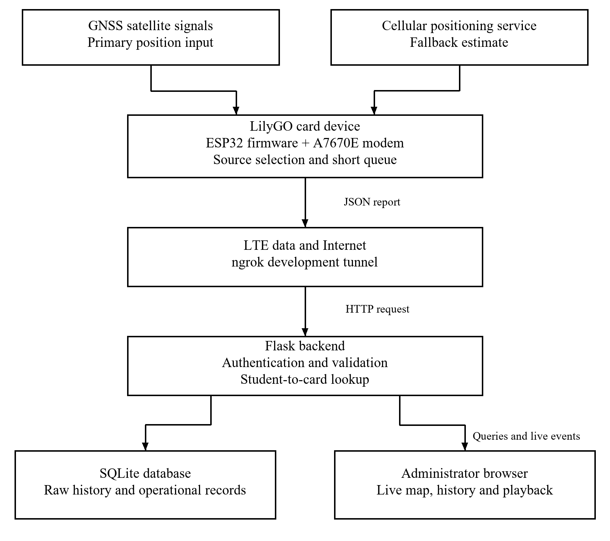
Figure 3.1: Block diagram of the implemented tracking system
The card is assigned the identifier CARD01. On the server, CARD01 is linked to the demonstration student U19CO1011. Four additional Computer Engineering student records are included to demonstrate registration-number search and list management, but they are intentionally unassigned because only one physical board is available. This separation proves that one backend can manage several students while tracking only the card that physically exists.
The forward data path begins when the card obtains a usable observation. Firmware packages its identity, coordinates, source and available quality information into JSON. The modem sends that package through the mobile operator and configured tunnel to the ingestion endpoint. The server validates it before storage. Accepted live data can then trigger an update to the administrator's browser; historical reports remain available through time-filtered queries.
Administrator actions follow a different path. A search uses the registration number to identify the student and assigned card. The browser then requests the latest state and subscribes for further updates. The existing /api/ping route checks status for the interface; it does not send an SMS or command that wakes a sleeping tracker. The implemented firmware reports periodically while powered. This distinction prevents the search screen from implying an unimplemented remote-control function.

3.4 Hardware Implementation
The T-A7670E was treated as the complete prototype controller rather than as one module among many. The ESP32 runs the program, communicates with the modem over UART, stores the most recent acceptable position in non-volatile memory, and prepares the JSON message. The A7670E registers on the LTE network, provides GNSS responses on the GNSS-supported modem version and transfers HTTP data. The supplied flat LTE antenna and square ceramic GNSS antenna are attached to their labelled connectors before radio operation. LilyGO's documentation confirms the ESP32-WROVER-E platform, A7670 model variations, USB-C power connection and labelled antenna interfaces (LilyGO, n.d.-a; LilyGO, n.d.-c). SIMCom's A7670 documentation provides the underlying modem hardware and command references (SIMCom Wireless Solutions, 2021).
The compact power design specifies a flat single-cell 3.7 V, 500 mAh lithium-polymer battery with a 4.2 V full-charge voltage and a high-discharge rating of 20C. The selected cell envelope is approximately 46 mm by 20 mm by 7 mm; its dimensions determine the clearance required beside the board. The voltage specification follows the board's single-cell battery requirements (LilyGO, n.d.-a). The measurements reported in Chapter Four were obtained using USB-C power from an external power bank. They demonstrate powered tracking and communication without establishing the endurance of the specified flat-cell arrangement. The development board and external antennas remain thicker than a conventional card, so production miniaturisation requires a custom circuit board and enclosure.
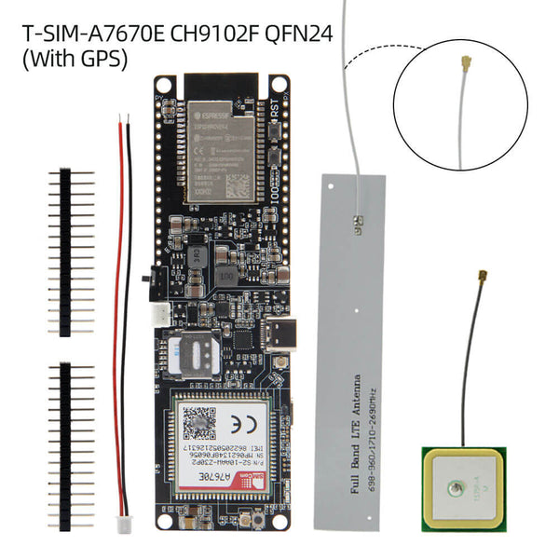
Figure 3.2: LilyGO T-A7670E R2 board, flat LTE antenna and ceramic GNSS antenna used in the prototype
Source: LILYGO T-SIM A7670E/G/SA R2 product page (LilyGO, n.d.-c).
Figure 3.2 shows the manufacturer-supplied board and antenna types used in the developed prototype. The flat LTE antenna supports cellular communication, while the square ceramic GNSS antenna receives navigation signals. Each connects to its labelled socket. The external battery lead belongs to the compact power design and requires confirmation of VBAT and ground polarity against the exact board revision.

3.5 Firmware Method
The firmware controls start-up, modem operation, position selection and report delivery. Its sequence is designed to keep searching for an acceptable satellite fix while supporting a labelled fallback and a short record of failed transmissions. The following subsections describe how the device starts, chooses a source and constructs its location message.

3.5.1 Initialisation
After power-up, the ESP32 starts serial communication, loads the saved last-good satellite position from non-volatile storage, restarts the modem when required, registers on the mobile network and opens the packet-data connection. The board then requests GNSS operation from the A7670E. Diagnostic messages are sent to the Arduino serial monitor so that modem registration, source selection and server responses can be observed during testing.
Initialisation was arranged to expose failures in stages. A successful serial response establishes communication with the modem, but the program still needs SIM readiness, network registration and a data session. GNSS is then enabled and queried. Using a staged procedure avoids interpreting an HTTP authentication failure as a receiver problem. It also makes the serial monitor useful for explaining the system during assessment.
Saved state is loaded before ordinary reporting resumes. A checkpoint includes its original time where available, so loading the coordinate does not reset its age. Network time helps establish an epoch-based reference after reboot. When a reliable age cannot be established, the display should not interpret a persisted value as an indefinitely current fix. The implemented timeout is a practical continuity policy rather than proof that the wearer remained stationary.

3.5.2 Position Selection
Table 3.1: Position-source selection process
Step | Decision | System action
1 | Read GNSS | Accept only a usable satellite fix
2 | Hold last good fix | Reuse it briefly when the satellite signal disappears
3 | Use cellular estimate | Fall back when there is no recent usable GNSS fix
4 | Transmit | Send source, coordinates, quality and time to the server
The position hierarchy prevents an old or weak fix from silently replacing good data. A new GNSS reading becomes the preferred position when it has valid coordinates, at least four satellites and a position-dilution value not greater than 8. It is saved as the last good fix. If a new acceptable satellite reading cannot be obtained, that saved position may be reported as gps_hold for up to 15 minutes. This preserves continuity through a brief indoor transition or signal interruption. After the hold expires, the modem's cellular estimate is reported as cell. The source label is included in every request.
The firmware saves a new reliable checkpoint to flash no more often than once in five minutes to avoid unnecessary repeated writes. Location reports are targeted at five-second intervals when network and modem operations complete normally. If the server or mobile connection is temporarily unavailable, the newest 20 reports can be held in flash and forwarded after communication returns. A forwarded report keeps its original capture time and is marked as buffered, so route playback remains in the correct order.
The queue is deliberately finite. At the nominal five-second reporting interval, twenty saved reports represent approximately one hundred seconds of samples if acquisition continues at that rate; modem delays can change the actual time span. When capacity is exceeded, older unsent reports can be displaced. The device therefore cannot preserve an unlimited journey while the laptop is off. Long-duration offline logging would require a larger file-based buffer or additional storage and a verified recovery protocol.
On reconnection, the distinction between capture time and arrival time becomes essential. Current observations provide the live state, while queued reports contribute to historical playback using their earlier capture times. The backend checks whether a report is delayed before allowing it to affect the live position. Without that rule, draining the queue could make a moving student appear to jump backwards along an old route.

3.5.3 Location Message
Table 3.2: Main location message fields
Field | Meaning | Example
card_id | Unique device identifier | CARD01
latitude | North-south coordinate in decimal degrees | 11.149096
longitude | East-west coordinate in decimal degrees | 7.659633
source | gps, gps_hold or cell | gps
satellites | Number of satellites used | 13
pdop | Reported satellite-geometry quality value | 2.4
batt_mv | Battery reading in millivolts; zero means the measurement is unavailable in the reported test configuration | 0
seq | Increasing device report number | 247
buffered | Shows that a saved report is being forwarded | false
captured_epoch | Original device capture time as Unix seconds | 1788091200
timestamp | Time recorded by the system | ISO 8601 value

3.6 Backend and Database Method
The Flask application exposes separate routes for browser pages, administrator APIs and the device-ingestion API. The card sends an HTTP POST request with a device key in the X-Device-Key header. The backend checks that the key is present, the card identifier exists, coordinates are within geographic limits and the source label is allowed. Accepted records are written to SQLite and emitted to authenticated Socket.IO clients. Invalid or excessive requests are rejected before storage.
The application resolves students through a configured demonstration roster and associates each assigned card with its telemetry. SQLite stores readings, device state and supporting operational data. Location records keep the card identifier, coordinates, source, satellite count, quality value and timestamps. Student lookup then selects the relevant card for latest-position queries, recent-history queries and time-ordered route reconstruction.
In the inspected implementation, the demonstration roster is configured in the backend source and maps registration numbers to card identifiers. Telemetry and other operational records are persisted in SQLite. An administrator query resolves the roster assignment before requesting the relevant card's readings. The four unassigned students can appear in search results without being shown as four additional online devices.
Validation occurs before insertion. Numeric coordinates must be finite and within geographic bounds, the source must belong to the allowed set, and an unknown card cannot add arbitrary records. The device key establishes permission to submit a report; it does not prove that a submitted coordinate is physically correct. Query limits and request-size limits reduce accidental or excessive processing. Parameterised SQL keeps data values separate from executable query structure.
Route processing operates on a derived copy of the stored satellite observations. It applies quality filtering, day and session separation, jump rejection, minimum spacing, smoothing and stationary-cluster handling before returning a route payload. Raw SQLite observations remain available independently of this display transformation.
The refinement stage separates visual presentation from measurement evidence. The original rows remain unchanged; the API constructs a processed sequence for playback. Poor-quality satellite points are excluded, gaps separate recording sessions, and distance and elapsed time are used to reject implausible jumps. Small changes are suppressed before quality-dependent exponential smoothing is applied. These operations improve readability but cannot reconstruct a true route from a grossly incorrect cellular estimate.
Distance between accepted coordinates is computed with the haversine calculation on a spherical Earth approximation. Segment speed follows from distance divided by elapsed time and conversion to kilometres per hour. The result is a derived estimate, affected by sample spacing, thresholds and receiver error. Stationary clusters are represented by an arrival and departure location so the application can preserve the stopped duration without drawing a knot of route lines.
The current code defines a 28 m stop radius, a minimum stationary duration of 90 seconds and an exit condition requiring three points outside the cluster. These are implementation parameters rather than universally valid movement rules. They should be tuned against independently measured walking and vehicle routes before operational use. The reported August route statistics are retained as a dated development snapshot and are not silently replaced by a new experiment.

3.7 Dashboard Method
The administrator first logs in, then uses a sidebar to open the overview, students, live tracking, activity, system health and API documentation pages. The students page supports registration-number search. Selecting U19CO1011 opens the live page, requests the current device record and listens for subsequent updates. The map distinguishes satellite, retained and cellular sources, while the telemetry panel uses plain-language quality labels. The activity page provides date and session selection, route playback, stop markers, direction indicators, distance and speed, geofence controls, and CSV or PDF export. Marker movement is animated between accepted updates so that the live display is easier to follow without changing the stored coordinates.
The live page distinguishes three states that can otherwise look similar: an active browser connection, a recently heard device and a recent position observation. A heartbeat can maintain device connectivity without introducing new coordinates. Source and age are shown with the location so that a retained fix is not interpreted as fresh indoor positioning. The map-follow control allows the administrator to inspect another area without each update forcing the view back to the beacon.
The activity view reads historical data independently of the live screen. Date and session selection prevent disconnected journeys from being drawn as one continuous movement. Playback advances through processed points in time order; exports use the same route payload. This keeps the displayed history, statistics and downloaded evidence consistent, while leaving the stored reports available for separate inspection.
The visual design uses Ahmadu Bello University green and gold, the university logo, IBM Plex Sans for interface text, IBM Plex Mono for technical values and restrained translucent surfaces. Gradients were excluded. The overview page intentionally contains no map so that the main dashboard remains focused on system status and navigation.

3.8 Security and Privacy Method
Administrator pages, sensitive APIs and Socket.IO connections require a logged-in session. The ingestion endpoint uses a separate device key because the embedded device does not use the browser login. Input length, coordinate range, allowed source values, query limits and request frequency are validated. These controls are appropriate for a local prototype, but they are not sufficient for unrestricted institutional deployment. National Institute of Standards and Technology (2019) identifies cybersecurity and privacy risk management as a core IoT requirement. A production design must therefore use encrypted transport, individual administrator accounts, auditable consent, role-based access and a stated retention policy.
For the demonstrated service, browser authentication and device authentication solve different problems. A logged-in session permits administrator queries, whereas the embedded key permits telemetry submission. Production deployment would need managed accounts and independently revocable device credentials. A shared demonstration account cannot provide individual accountability for searches or changes.
The current firmware uses HTTP for the modem's device endpoint because of the tested modem/tunnel TLS compatibility limitation. A key in an HTTP header authenticates the request but does not encrypt it. An HTTPS address used by an administrator does not automatically encrypt the separate device-to-tunnel leg. Secure transport must therefore be verified across the whole path before real student location data are deployed outside a controlled prototype setting.

3.9 Evaluation Procedure
Evaluation combined automated software tests, stored-data inspection and outdoor operation. Seventeen automated tests covered authentication, API documentation access, device-key validation, coordinate and source validation, battery validation, unknown cards, rate and query limits, buffered capture time, student-device mapping, valid record storage, stop detection, geofence alerts, route exports and the system-health endpoint. Database inspection counted records by source. The latest route-processing result was generated again from the stored physical-device data rather than copied from the dashboard screen.
The evaluation distinguishes functional evidence from measurement of performance. Accepted device records establish that communication and storage occurred; they do not provide a surveyed error distribution. Likewise, a passing authentication test establishes the behaviour covered by that test rather than proving that the whole application is secure. Conclusions are limited to the evidence produced by the documented checks.
The report retains the original 30 August 2026 result snapshot for consistency with the stored tables and screenshots. It does not invent a later range test, battery runtime or multi-device trial. The selected code excerpts in Appendix C illustrate the implemented acquisition, reporting and live/history handling. Dated results and current source parameters are identified separately so a reader can distinguish an experiment from a subsequent software refinement.

CHAPTER FOUR
RESULTS AND DISCUSSION

4.1 Introduction
This chapter presents the implemented prototype, the results obtained from each stage of the methodology, and an evaluation of those results against the three project objectives.

4.2 Hardware and Firmware Results
Table 4.1: Hardware and firmware functional results
Test item | Observed result | Status
USB-C power and programming | Board powered and accepted firmware through its USB-C interface | Passed
Modem communication | ESP32 exchanged commands with the A7670E modem | Passed
LTE registration | Device connected through the installed SIM and transmitted records | Passed
GNSS operation | GNSS-supported A7670E returned outdoor satellite fixes | Passed
Source reporting | gps, gps_hold and cell records appeared in the database | Passed
Persistent hold | Last acceptable satellite fix was stored for use after restart | Implemented
Store-and-forward | Up to 20 failed reports can be retained and resent with their capture times | Implemented
The integrated board removed the need to wire a separate ESP32, GPS receiver, GSM module and charger. Outdoor operation produced stable satellite fixes once the GNSS antenna had a useful view of the sky. Indoor operation did not provide the same guarantee because reinforced roofs and walls attenuate satellite signals. The fallback source allowed the dashboard to continue showing a position, but the source label and map accuracy must be explained to avoid treating a broad cellular estimate as an exact indoor fix.
Successful LTE registration and a server-accepted report demonstrate two distinct parts of the chain. The first shows that the modem reached an operator; the second shows that the configured Internet address, authentication and message format were accepted. The GNSS result demonstrates receiver operation under the outdoor conditions encountered. No numerical claim of horizontal accuracy is made because a surveyed reference path was not recorded.
The reported observations used USB-C and power-bank operation. The compact power design specifies a compatible flat cell, but the results presented here do not establish battery runtime, charging temperature or operating duration. These properties require measurements on the final fitted power system.

4.3 Backend Test Results
Table 4.2: Automated backend test results
No. | Automated test | Result
1 | Buffered report keeps its original capture time and bypasses the live-rate check | Passed
2 | API documentation and OpenAPI routes require authentication | Passed
3 | Crossing the configured geofence creates an alert | Passed
4 | System-health endpoint reports the backend and database state | Passed
5 | An implausible non-zero battery voltage is rejected | Passed
6 | Ingestion rate and history-query limits are enforced | Passed
7 | Invalid coordinates and source labels are rejected | Passed
8 | A missing device key is rejected | Passed
9 | An unknown card identifier is rejected before storage | Passed
10 | A logged-in administrator retains API access | Passed
11 | Route data can be downloaded as CSV and PDF | Passed
12 | Sensitive API routes reject unauthenticated access | Passed
13 | A Socket.IO connection requires an authenticated session | Passed
14 | A sustained stationary period is detected and its jitter is collapsed | Passed
15 | Student detail returns the correctly assigned physical card | Passed
16 | A valid card report is accepted and stored | Passed
17 | A zero battery value is treated as unavailable instead of as a fault | Passed
All 17 automated tests passed when the suite was run again on 30 August 2026. This is important because the visual dashboard alone cannot prove that the backend rejects invalid input, preserves captured times or protects private routes. The test suite provides repeatable evidence for those behaviours. The hand-written OpenAPI file is valid JSON and is served through the authenticated API documentation page.
The tests address representative positive and negative cases. Valid reports must be stored, whereas unknown cards, unsupported source labels and malformed coordinates must fail. Administrator endpoints and the live socket are checked separately from device ingestion. Delayed reports are tested against their original capture time so that later delivery does not rewrite the chronology of a route.
This evidence supports software repeatability within the local test environment. It does not cover every network outage, hardware reset or hostile input sequence, and it does not measure the radio subsystem. Accordingly, the seventeen passing cases are reported as the scope of the available automated suite rather than a percentage reliability figure for all field operation.

4.4 Stored Telemetry Results
Table 4.3: Distribution of stored location records
Position source | Number of records | Percentage
Satellite fix (gps) | 205 | 23.43%
Retained satellite fix (gps_hold) | 241 | 27.54%
Cellular estimate (cell) | 406 | 46.40%
Early unclassified records | 23 | 2.63%
Total | 875 | 100.00%
At the 30 August 2026 reporting snapshot, the database contained 875 physical-device records for CARD01, beginning on 25 July 2026. The large cellular share reflects periods when the receiver did not have a usable satellite view, particularly during indoor development. This result confirms why the dashboard must show the position source. It also shows that cellular fallback improves availability but does not solve precise indoor tracking.
Of the 205 satellite-labelled records, 186 met the final quality gate of at least four satellites and a positive signal-geometry value not greater than 8. Within that accepted group, the average satellite count was 12.54 and the average signal-geometry value was 4.37. The historical dataset also contains poor-quality early readings, including a value of 100, because raw evidence is retained. The current firmware does not save such a reading as the last good held position.
The distribution measures the composition of this development dataset, not the probability that a student will obtain a particular source during normal campus use. Indoor programming periods and the placement of the antenna influenced the samples. The retained-fix category represents repeated reporting of a prior accepted position and must not be added to the satellite category as if it were a set of independently acquired fixes.
The distinction between 875 stored records and 186 quality-eligible satellite records also shows why a large database is not sufficient evidence of good positioning. Timestamp, source and quality must be interpreted together. Keeping the raw rows enables later processing changes to be assessed without erasing the observations that led to the original conclusions.

4.5 Route Playback, Distance and Speed
Table 4.4: Route-playback measurements from stored satellite data
Metric | Latest refined prototype session
Route date | 29 August 2026
All stored satellite rows inspected | 205
Quality-eligible rows on selected day | 79
Rows in the selected multi-point session | 78
Final display points | 59
Implausible jumps rejected | 2
Separate route segments | 1
Stationary periods detected | 4
Calculated movement | 49 m
Processed duration | 556 s
Calculated average moving speed | 4.3 km/h
Maximum accepted speed | 9.4 km/h
The activity page replayed the stored points in capture-time order. The current method first removes poor-quality readings, splits recording sessions, rejects impossible jumps, removes changes below 4 m and smooths the remaining display points. The 10 m movement threshold is then applied to travelled-distance calculation, while the original rows stay unchanged in SQLite. This produced a coordinated route from real device data instead of the earlier zigzag display. The resulting 49 m describes the selected development session and is not used as evidence of a formally measured 200 m trial.
The selected session contained four stationary periods lasting a combined 515 s. Removing those periods from the average-speed basis produced a walking-scale value of 4.3 km/h, while the maximum accepted value was 9.4 km/h. These values show why stop detection and outlier rejection are necessary: without them, satellite wander and jumps would exaggerate both distance and speed.
Smoothing reduces display variation but introduces a trade-off. Stronger smoothing can make a stationary marker calmer while delaying the apparent response to a real turn. Spacing thresholds can suppress false motion but may also omit very short genuine movements. For that reason, the 49 m output is a processed estimate for the selected session and should not be described as a ground-truth distance or a measured positioning accuracy.
The later stationary-display refinement addresses the case in which a powered card remains in one place for several minutes. Clustered reports are shown with one representative beacon and arrival/departure timing rather than many crossing lines. The improvement concerns presentation and derived movement; it does not increase receiver precision or move the raw records onto a road.

4.6 Dashboard Results
Table 4.5: Implemented dashboard functions
Feature | Implemented behaviour | Result
Administrator login | Protects dashboard, APIs, documentation and live socket | Implemented
Student list and search | Five demonstration students; search by registration number | Implemented
Tracked student | U19CO1011 linked to physical CARD01 | Implemented
Live map | Marker, source indicator, telemetry and recent locations | Implemented
Activity | Date/session selection, refined route, stops, playback, speed and distance | Implemented
Route export | Downloads processed route evidence as CSV or an ABU-styled PDF report | Implemented
Geofence alerts | Stores a campus boundary and reports entry or exit events | Implemented
System health | Checks backend, database, tunnel information and required static files | Implemented
API documentation | Hand-written OpenAPI 3.0 specification in Swagger UI | Implemented
Overview | Status cards and navigation without a distracting map | Implemented
The dashboard completed the identity-to-location workflow. An administrator can find the student by registration number instead of knowing the card identifier. The live page then resolves the assigned device, loads its most recent records and receives new records in real time. The five-student dataset demonstrates list and search behaviour without falsely implying that five physical devices are present.
The interface also makes the one-device limitation visible. A student without an assigned card remains a registered demonstration record rather than an online tracker. This avoids confusing application capacity with the number of built units. The overview summarises status, while the separate tracking and activity pages support focused inspection of current and historical information.
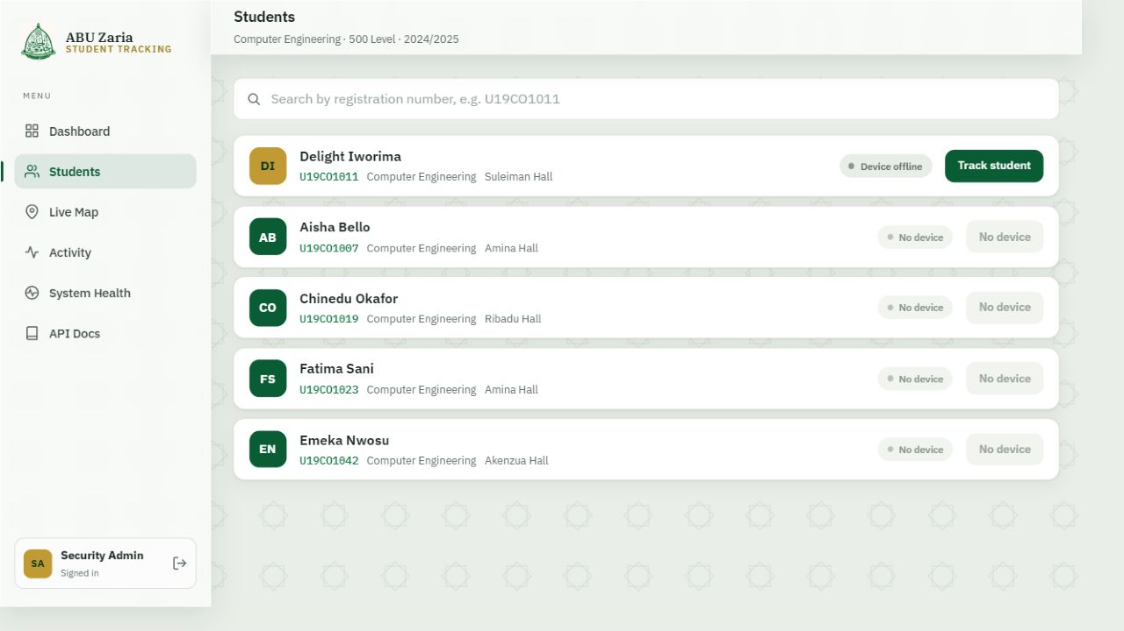
Figure 4.1: Registered-student list and registration-number tracking entry point
Figure 4.1 shows the registered-student page of the implemented Flask dashboard. Five Computer Engineering demonstration records appear in the list, but only U19CO1011 is linked to physical card CARD01. Registration-number search supplies the entry point to tracking, while unassigned records demonstrate list management without implying the existence of additional devices.
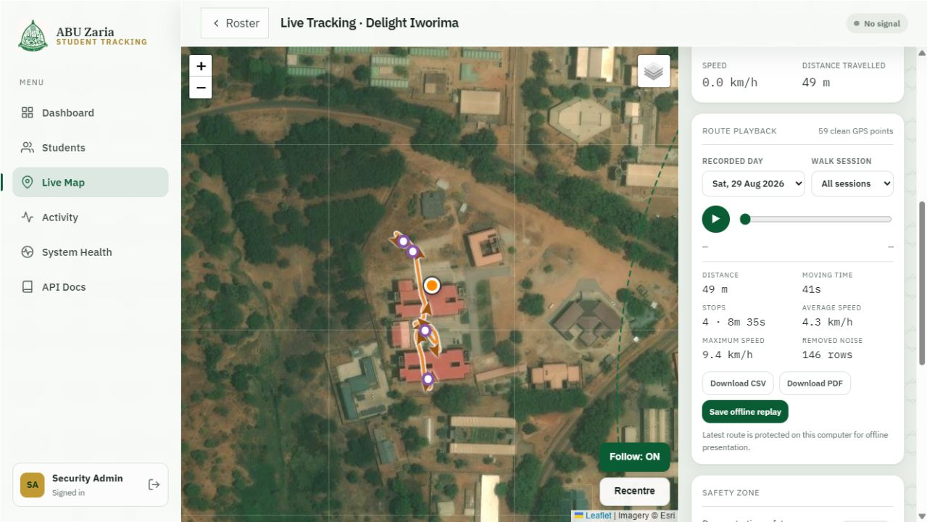
Figure 4.2: Stored GPS route, playback controls and movement measurements for U19CO1011
Figure 4.2 shows the stored satellite route and the activity controls used for replay. It presents processed movement, timing and export information derived from the physical card records. The no-signal label records the device state at the time the screenshot was taken; the historical route remains accessible from SQLite even when a fresh report has not arrived.

4.7 Discussion
The strongest result is that the entire chain works with one main board: physical position acquisition, mobile transmission, temporary on-device buffering, backend validation, persistent storage, authenticated access and live presentation. The 17 software tests demonstrate predictable backend behaviour, and the 875-record database snapshot proves that the application processes data from the physical modem rather than only generated demonstration coordinates.
The results also expose the limits of the design. GNSS is highly accurate outdoors when reception is good, but a card carried under clothing or inside a building may lose direct satellite visibility. The retained position is useful only for a short interruption and does not mean the student remains at that exact point. Cellular position keeps the system responsive but can be far from the actual location. A phone appears more accurate indoors because it may combine GNSS, Wi-Fi databases, cellular measurements, motion sensors and a large commercial positioning service. Reproducing that capability would require extra sensors, infrastructure, permissions and software beyond this prototype.
The developed hardware establishes the tracking functions in an identification-card-holder form. Its development board, external antennas and specified flat-cell arrangement exceed standard card thickness. The reported tests used USB-C power from an external power bank. A production card requires smaller electronics and enclosure design based on measured components.
Against the first objective, outdoor GNSS reports, LTE delivery and explicit fallback labels demonstrate the principal embedded functions. Against the second, student search, persistence, route queries, exports and API documentation demonstrate the application workflow. The integration objective is supported by end-to-end operation and automated checks, but its measured 200 m requirement remains unverified. The report therefore describes that objective as partially evaluated rather than claiming complete fulfilment.
The practical contribution is an explainable prototype for a defined university use case. It combines identification lookup with traceable location evidence and shows the failure conditions that affect interpretation. Its results justify further engineering and a carefully governed pilot, rather than immediate deployment as an emergency-response guarantee.

CHAPTER FIVE
SUMMARY CONCLUSION AND RECOMMENDATION

5.1 Summary
This project investigated a student identification tracker as an information aid for authorised searches in a university setting. The work joined a portable embedded device to a web application so that an administrator could use a registration number to retrieve a card's latest report and movement history. The implementation used an integrated LilyGO GNSS/LTE board, embedded C++ firmware, a Flask backend, SQLite storage and a browser dashboard.
The hardware and firmware work covered modem control, satellite acquisition, source selection, a time-limited retained fix and a small persistent transmission queue. The software work covered validation, student-device association, authenticated access, live updates, route refinement and documented endpoints. Integration was examined through physical-device records, automated backend checks and the dated playback dataset presented in Chapter Four.
At the documented snapshot, seventeen backend tests passed and 875 physical-device records were stored. A selected development session produced 59 processed display points and 49 m of calculated movement, with two implausible jumps excluded and four stationary periods identified. These values describe that dataset and processing run. A formally measured 200 m trial, battery endurance and an ISO-thickness card were not established by the reported work.

5.2 Limitations
a) Satellite positioning is primarily an outdoor technology; roofs, walls, card orientation and surrounding structures can delay or prevent a reliable fix.
b) The cellular fallback is an estimate and may be considerably less accurate than a good satellite fix.
c) The development board, external antennas and selected flat-battery arrangement are not as thin as a standard wallet card; the current object is best described as a card-holder prototype.
d) The demonstration uses one physical card and five software student records, so multi-device radio behaviour was not evaluated.
e) The ngrok demonstration tunnel uses the configured prototype transport. Production use requires enforced TLS, secure key storage, individual accounts and privacy governance.
f) A formally measured 200 m trial was not completed. Battery endurance, charging temperature, impact resistance, waterproofing and long-term cellular data cost were not characterised by the reported tests.

5.3 Conclusion
The work demonstrates that an integrated GNSS/LTE development platform can support the complete reporting path from a portable card-holder device to a searchable university dashboard. Its main contribution is the connection between device observations and a student identity record, with the position source and historical context available for interpretation. It therefore provides a foundation for location assistance during an authorised search.
The first two objectives were demonstrated through embedded reporting and application functions. The integration objective was supported by physical-device data and software tests, but the specified measured-distance evaluation remains incomplete. The prototype also has clear reception, coverage, power, size and privacy limitations. Further work should validate those properties before a claim of routine institutional readiness is made.

5.4 Important Findings
a) An integrated ESP32, LTE and GNSS development board reduces the component and wiring burden enough to make a complete tracking demonstration practical within a short project period.
b) Location availability and location accuracy are different. Cellular fallback improves availability, but only a source label and quality checks prevent the user from assuming false precision.
c) A short persisted hold of the last good satellite fix gives smoother behaviour through brief reception loss, while an age limit prevents the system from presenting an indefinitely stale point as current.
d) Route quality checks, session separation, jump rejection and smoothing are necessary because raw satellite readings can otherwise create false zigzags, distance and speed.
e) Keeping temporary failed reports on the card preserves evidence through a short server or mobile-network interruption without changing their original capture times.
f) Automated backend tests add evidence that authentication and input validation work; a polished dashboard alone cannot prove those controls.

5.5 Recommendations for Further Work
The recommendations follow the observed limitations of the prototype. Priority should be given to validating the installed power system and field performance, securing the reporting path and then reducing the hardware size. Recommended dimensions and additional radio capabilities are development targets that require their own design and testing.

5.5.1 Miniaturisation and Production Development
The implemented LilyGO board was selected to prove the complete tracking process quickly and with few separate parts. It is a development platform, however, and its board outline, antenna connectors, external antennas and selected flat-battery arrangement prevent it from becoming a normal thin identification card simply by adding a shell. ISO/IEC 7810 defines the physical characteristics of standard identification cards, including the ID-1 format used for bank and student cards (International Organization for Standardization, 2019). The present prototype should therefore be described as a trackable ID-card holder rather than as an ISO-thickness card.
A smaller production version could place only the required controller, LTE/GNSS modem, SIM or eSIM interface, protected flat lithium-polymer battery, charging and power-management circuits, and carefully tuned antennas on a custom printed circuit board. The concept in Figure 5.1 shows a 33 mm by 22 mm board and a 38 mm by 26 mm by 6.5 mm enclosure as an illustrative target. These dimensions were not measured from a fabricated unit and are not claimed as achieved results. The optional Wi-Fi, Bluetooth, motion sensor, eSIM and emergency-button labels shown in the concept are possible later additions; they are not all present in the current prototype. Making the device still smaller would reduce available battery space and make antenna efficiency, heat, radio certification, assembly and repair more difficult.
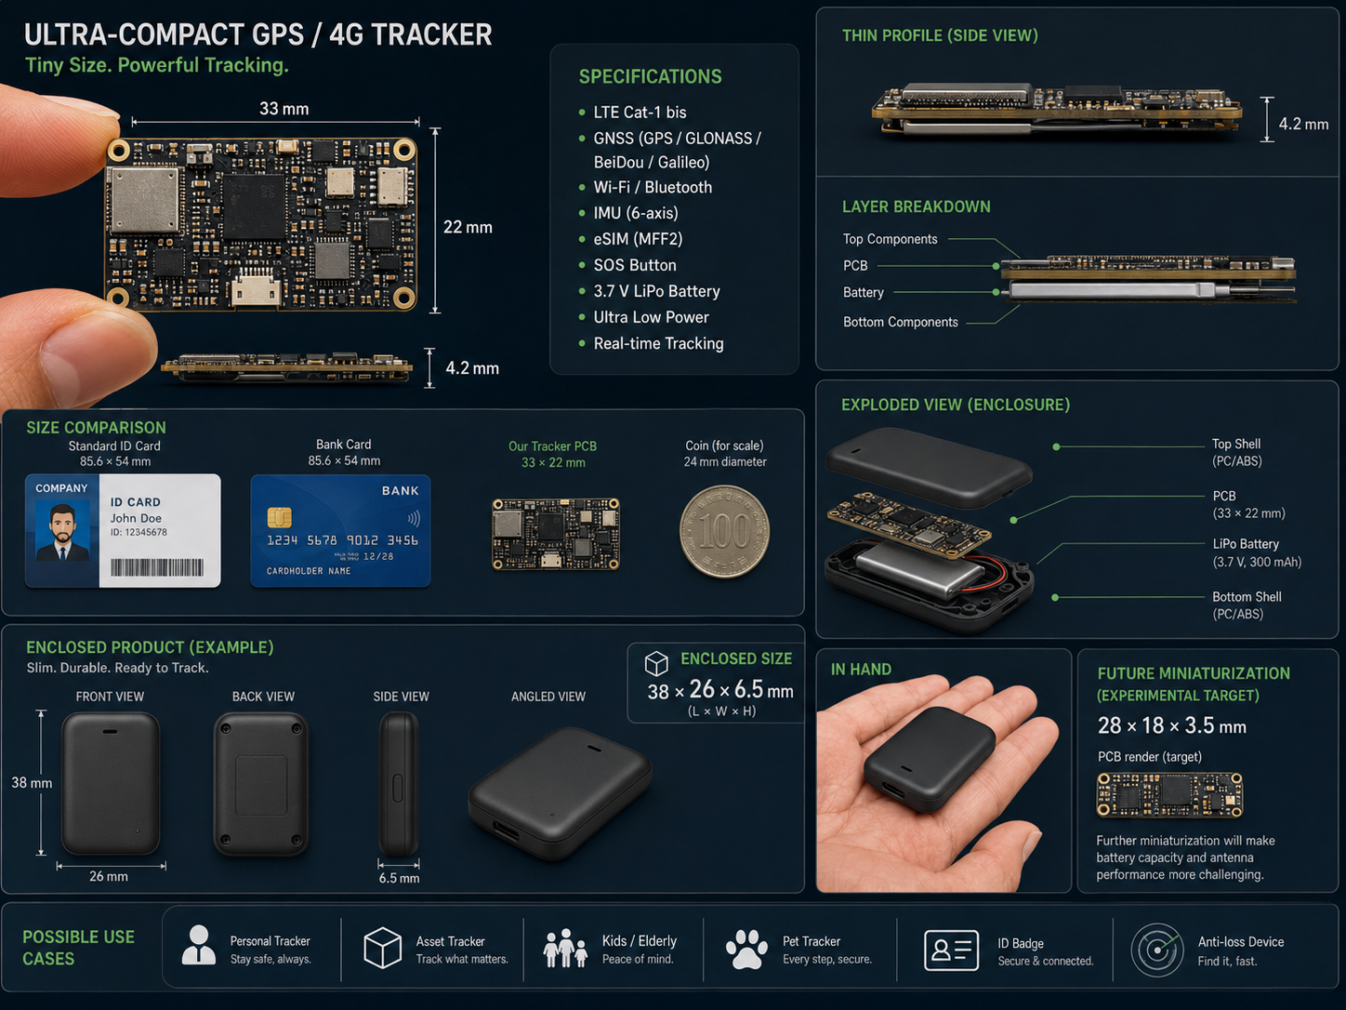
Figure 5.1: Conceptual illustration of a possible miniaturised production tracker (design target; not fabricated or experimentally validated)

5.5.2 Other Recommendations
a) Develop the recommended custom printed circuit board only after electrical design review, antenna layout work, power-budget calculation and physical measurement of the selected protected battery and connectors.
b) Add Bluetooth Low Energy or Wi-Fi anchor points in selected buildings for room- or zone-level indoor location while retaining GNSS outdoors.
c) Deploy the backend on a permanent HTTPS service and replace shared demonstration credentials with role-based institutional accounts, audit logs and a retention policy.
d) Evaluate battery endurance, charging safety, thermal behaviour, enclosure radio performance and repeatable route accuracy.
e) Test multiple physical cards concurrently and add device provisioning, key rotation, lost-card revocation and maintenance status.
f) Adopt a formal consent and authorisation process so that tracking is used only for legitimate, disclosed university purposes.

REFERENCES
Agafonkin, V. (2023). Leaflet (Version 1.9.4) [Computer software]. https://leafletjs.com/
Alquhali, A. H. Y., & Roslee, M. B. (2018). A novel real-time vehicle tracking system using Arduino. Engineering International, 6(2), 93–106. https://doi.org/10.18034/ei.v6i2.228
Alsadi, A. S. H. (2013). The development of embedded GPS-GSM based real time vehicle tracking system. Engineering and Technology Journal, 31(10), 1982–1999. https://doi.org/10.30684/etj.31.10a13
Arduino. (n.d.). ArduinoHttpClient (Version 0.6.1) [Computer software]. GitHub. Retrieved August 30, 2026, from https://github.com/arduino-libraries/ArduinoHttpClient
Atzori, L., Iera, A., & Morabito, G. (2010). The Internet of Things: A survey. Computer Networks, 54(15), 2787–2805. https://doi.org/10.1016/j.comnet.2010.05.010
Espressif Systems. (n.d.). Preferences. Arduino ESP32 documentation. Retrieved October 21, 2026, from https://docs.espressif.com/projects/arduino-esp32/en/latest/api/preferences.html
Fielding, R., Nottingham, M., & Reschke, J. (2022). HTTP semantics (RFC 9110). Internet Engineering Task Force. https://www.rfc-editor.org/rfc/rfc9110.html
Grinberg, M. (n.d.). Flask-SocketIO documentation. Retrieved August 30, 2026, from https://flask-socketio.readthedocs.io/en/latest/
International Organization for Standardization. (2019). ISO/IEC 7810:2019: Identification cards—Physical characteristics (4th ed.). https://www.iso.org/standard/70483.html
Jiménez-Martínez, M. J., Zabala Haro, M., Martín Furonés, Á., & Anquela Julián, A. (2025). A GNSS–cellular network hybridization strategy for robust positioning. Applied Sciences, 15(11), 6300. https://doi.org/10.3390/app15116300
Khin, J. M. M., & Oo, N. N. (2018). Real-time vehicle tracking system using Arduino, GPS, GSM and web-based technologies. International Journal of Science and Engineering Applications, 7(11), 433–436. https://doi.org/10.7753/IJSEA0711.1006
LewisHe. (n.d.). TinyGSM fork (Version 1.0.0) [Computer software]. GitHub. Retrieved August 30, 2026, from https://github.com/lewisxhe/TinyGSM-fork
LilyGO. (n.d.-a). LilyGO A7670X ESP32 version [Hardware documentation]. GitHub. Retrieved August 30, 2026, from https://github.com/Xinyuan-LilyGO/LilyGo-Modem-Series/blob/main/docs/en/esp32/a7670-esp32/README.MD
LilyGO. (n.d.-b). LilyGo-Modem-Series [Computer software and hardware documentation]. GitHub. Retrieved August 30, 2026, from https://github.com/Xinyuan-LilyGO/LilyGo-Modem-Series
LilyGO. (n.d.-c). T-SIM A7670E/G/SA R2 [Product page]. Retrieved September 1, 2026, from https://lilygo.cc/products/t-sim-a7670e
Marquezan, L., Gamboa Peñaloza, E. A., de Oliveira Evald, P. J. D., Hernandez Cely, M. M., Rossi, M. L., & de Lima, S. (2024). iLocator—A low cost IoT-based hybrid architecture for tracking and locating objects in indoor environments. Internet of Things, 28, 101369. https://doi.org/10.1016/j.iot.2024.101369
Morallo, N. T. (2021). Vehicle tracker system design based on GSM and GPS interface using Arduino as platform. Indonesian Journal of Electrical Engineering and Computer Science, 23(1), 258–264. https://doi.org/10.11591/ijeecs.v23.i1.pp258-264
National Bureau of Statistics. (2024). Social statistics report 2023. https://nigerianstat.gov.ng/pdfuploads/SOCIAL%20STATISTICS%20REPORT%202023%20Final.pdf
National Coordination Office for Space-Based Positioning, Navigation, and Timing. (n.d.). GPS accuracy. GPS.gov. Retrieved August 30, 2026, from https://www.gps.gov/gps-accuracy
National Institute of Standards and Technology. (2019). Considerations for managing Internet of Things (IoT) cybersecurity and privacy risks (NISTIR 8228). https://doi.org/10.6028/NIST.IR.8228
OpenAPI Initiative. (2020). OpenAPI specification (Version 3.0.3). https://spec.openapis.org/oas/v3.0.3
Osman, M. E. A., & Hassan, H. (2024). GPS and GSM-based vehicle tracking system. Progress in Engineering Application and Technology, 5(1), 23–31. https://doi.org/10.30880/peat.2024.05.01.003
Pallets Projects. (n.d.). Flask documentation. Retrieved August 30, 2026, from https://flask.palletsprojects.com/en/stable/
Python Software Foundation. (n.d.). sqlite3—DB-API 2.0 interface for SQLite databases. Python documentation. Retrieved October 21, 2026, from https://docs.python.org/3/library/sqlite3.html
Sanz Subirana, J., Juan Zornoza, J. M., & Hernández-Pajares, M. (2011). Positioning error. Navipedia, European Space Agency. https://gssc.esa.int/navipedia/index.php?title=Positioning_Error
SIMCom Wireless Solutions. (2021). A7670 series hardware design (Version 1.03). https://www.simcom.com/product/A7670X.html
SQLite. (n.d.). About SQLite. Retrieved August 30, 2026, from https://www.sqlite.org/about.html

APPENDIX A
MAJOR API ENDPOINTS
Method | Path | Purpose | Access
POST | /api/ingest | Accept and validate a card location report | Device key
POST | /api/heartbeat | Update online state when no new position is available | Device key
GET | /api/students | List and search students | Admin session
GET | /api/student/{reg_no} | Return one student, assigned card and latest state | Admin session
GET | /api/student/{reg_no}/recent | Return the five most recent separated positions | Admin session
GET | /api/student/{reg_no}/track | Return refined route, stops and statistics | Admin session
GET | /api/student/{reg_no}/track.csv | Download the processed route as CSV | Admin session
GET | /api/student/{reg_no}/report.pdf | Download a printable route report | Admin session
GET/POST | /api/geofence | Read or change the demonstration boundary | Admin session
GET | /api/alerts | Return stored geofence alerts | Admin session
GET | /api/system/health | Check backend, database, tunnel and local assets | Admin session
GET | /openapi.json | Return the hand-written API specification | Admin session
GET | /docs | Display interactive API documentation | Admin session

APPENDIX B
PROTOTYPE HARDWARE AND SIGNAL CONNECTIONS
The table identifies the developed prototype's external connections and firmware-controlled pins. Controller-to-modem links are already routed on the board; external assembly connects the antennas, SIM and power supply. Pin assignments must match the exact board revision (LilyGO, n.d.-a).
Connection | Implementation note
USB-C | Programming, serial monitoring and prototype power from computer or power bank
LTE antenna connector | Connect the supplied LTE antenna before network transmission
GNSS antenna connector | Connect the GNSS antenna and place it with a useful sky view
SIM holder | Insert an activated LTE-capable SIM with available data
ESP32 ↔ A7670E UART | Already routed on the development board and controlled by firmware
Battery connector | External input for the specified 3.7 V, 500 mAh single-cell LiPo; match polarity, protection, current capability and physical fit to the board and holder
ESP32 GPIO26 and GPIO27 | UART transmit and receive definitions used by the firmware to communicate with the onboard modem
ESP32 GPIO12 | Modem power-enable control; driven high by the firmware
ESP32 GPIO4 | Modem power-key control used by the firmware
ESP32 GPIO5 | Modem reset control used by the firmware
ESP32 GPIO35 | Battery ADC pin defined in the source; an unavailable battery reading must not be interpreted as a tested state-of-charge measurement
Battery connection requirements: confirm VBAT/GND polarity, wiring, clearance and current capability before connection with the board unpowered. Do not connect an 18650 simultaneously. The documented tests used USB-C power; flat-cell endurance and charging temperature require separate measurement.

APPENDIX C
SELECTED SOURCE CODE
Selected firmware and backend excerpts illustrate the main tracking operations. Line numbers refer to the source files. Surrounding declarations and helper routines are omitted, so these excerpts are not standalone programs.

C.1 Selected Firmware Code
Listing C.1: Satellite-fix quality and retained position
This fragment accepts a satellite position only when its quality value and satellite count pass the configured limits. It records the accepted position and its capture time for later continuity; retaining a position does not measure new movement indoors.
Source: firmware/card/card.ino, lines 534–544.
0534 bool goodEnough = (hdopVal > 0 && hdopVal <= GPS_HOLD_MAX_PDOP)
0535 && (sats >= GPS_HOLD_MIN_SATS);
0536 if (goodEnough) {
0537 src = "gps";
0538 located = true;
0539 haveGpsHold = true;
0540 holdLat = lat; holdLng = lng; holdSats = sats; holdPdop = hdopVal;
0541 holdMs = millis();
0542 // GPS gives us true UTC, so the fix's age stays correct across reboots.
0543 holdEpoch = (gy > 2020) ? toEpoch(gy, gmo, gd, gh, gmi, gs) : bestEffortEpoch();
0544 capturedEpoch = holdEpoch;
Listing C.2: Forwarding saved reports
Saved reports are marked as historical before transmission. A queued report is removed only after a successful server response; a failed response leaves it available for another attempt.
Source: firmware/card/card.ino, lines 445–457.
0445 void flushQueuedPackets() {
0446 if (!modem.isGprsConnected()) return;
0447 for (int sent = 0; sent < QUEUE_FLUSH_PER_CYCLE; sent++) {
0448 String packet;
0449 if (!peekQueuedPacket(packet)) return;
0450 String bufferedPacket = markPacketBuffered(packet);
0451 Serial.printf("Forwarding saved packet (%d waiting)...\n", queuedPacketCount());
0452 int status = postJson(RESOURCE, bufferedPacket.c_str());
0453 Serial.printf(" saved packet response: %d\n", status);
0454 if (!postSucceeded(status)) return;
0455 removeQueuedPacket();
0456 }
0457 }

C.2 Selected Backend Code
Listing C.3: Device authentication and request checks
The opening part of the ingestion endpoint checks the device key, required JSON fields, registered card and position-source label. Coordinate and optional-field validation follow in the complete handler.
Source: backend/app.py, lines 1479–1496.
1479 @app.route("/api/ingest", methods=["POST"])
1480 def ingest():
1481 """Accept an authenticated and validated position from the LilyGO card."""
1482 supplied_key = request.headers.get("X-Device-Key", "")
1483 if not DEVICE_API_KEY or not hmac.compare_digest(supplied_key, DEVICE_API_KEY):
1484 return jsonify({"error": "invalid device credentials"}), 401
1485
1486 data = request.get_json(silent=True)
1487 if not data or not all(k in data for k in ("card_id", "lat", "lng")):
1488 return jsonify({"error": "body must contain card_id, lat and lng"}), 400
1489
1490 card_id = str(data["card_id"]).strip()
1491 if card_id not in CARD_TO_REG:
1492 return jsonify({"error": "unknown card_id"}), 403
1493
1494 source = data.get("src")
1495 if source not in VALID_POSITION_SOURCES:
1496 return jsonify({"error": "src must be gps, gps_hold, ble, cell or test"}), 400
Listing C.4: Storage and live-history separation
Accepted reports are stored before publication. Current reports produce a live-location event, while delayed reports produce a history-sync event. This prevents an old report from being presented as newly observed movement.
Source: backend/app.py, lines 311–330.
0311 def handle_reading(raw: dict):
0312 """Shared by both the real serial reader and the simulator so the two
0313 code paths are guaranteed to produce identical events for the dashboard."""
0314 if "error" in raw or "status" in raw:
0315 print("[position source]", raw)
0316 return
0317 raw["ts"] = datetime.now(timezone.utc).isoformat()
0318 store_reading(raw)
0319 store_device_status(raw)
0320 # Tag the live event with the student this card belongs to, so the track
0321 # page can filter updates by registration number.
0322 raw["reg_no"] = CARD_TO_REG.get(raw.get("card_id"))
0323 if not raw.get("buffered"):
0324 evaluate_geofence(raw)
0325 socketio.emit("location_update", raw)
0326 else:
0327 socketio.emit("history_synced", {
0328 "card_id": raw.get("card_id"),
0329 "reg_no": raw.get("reg_no"),
0330 })

