Project Title SIID 01
Design and Implementation of a GPS and LTE Based Trackable Student Identification Card
Student Safety and Emergency Location Support
Project Summary Submitted to the Office of the Vice Chancellor
Delight Iworima U19CO1011
Department of Computer Engineering
Ahmadu Bello University Zaria
September 2026
Overview
SIID-01 is a low-cost student safety and identification prototype that allows an authorised university administrator to locate a registered tracking device during an emergency or approved search. It combines satellite positioning, 4G mobile-data communication, authenticated student-device linking, stored movement records and a live web dashboard. The current prototype uses one GPS-enabled LilyGO T-A7670E development board and demonstrates the complete path from the physical device to the administrator's map.
Problem Statement
• Problem: A conventional student identity card proves identity but cannot help security personnel determine a student's recent location during kidnapping, disappearance, medical distress or another serious safety incident.
• Who it affects: Students and their families, campus security units and university management, particularly in Nigeria's present security environment where delayed location information can slow an emergency response.
• Solution: SIID-01 links a student's registration number to an authorised tracking device, reports outdoor satellite coordinates through the mobile network, clearly labels approximate cellular fallback positions and presents the latest usable information on a controlled administrator dashboard.
How It Works
The LilyGO board contains the ESP32 controller, A7670E 4G modem, SIM interface, satellite-positioning support and USB-C power circuitry on one printed circuit board. Firmware written in C++ controls the modem, selects the best available position and sends a small authenticated data record to the university dashboard.
• GNSS receiver and active antenna obtain accurate outdoor coordinates from navigation satellites.
• When a fresh satellite fix is temporarily unavailable, the firmware may retain the last reliable fix for a limited period; an approximate cellular-network position is used only as a clearly labelled fallback.
• The 4G modem and nano-SIM send the card identifier, coordinates, time and quality information through an HTTP application programming interface.
• Up to 20 unsent reports can be kept in the device's non-volatile memory and transmitted after temporary mobile-network failure.
• A Flask server validates the device key, links CARD01 to student U19CO1011, and stores accepted reports in an SQLite database.
• Socket.IO pushes new readings to the browser, while Leaflet and OpenStreetMap display the live position and movement history.
• The route-processing method removes poor readings, rejects impossible jumps, groups separate walks and replaces stationary zigzags with stop markers.
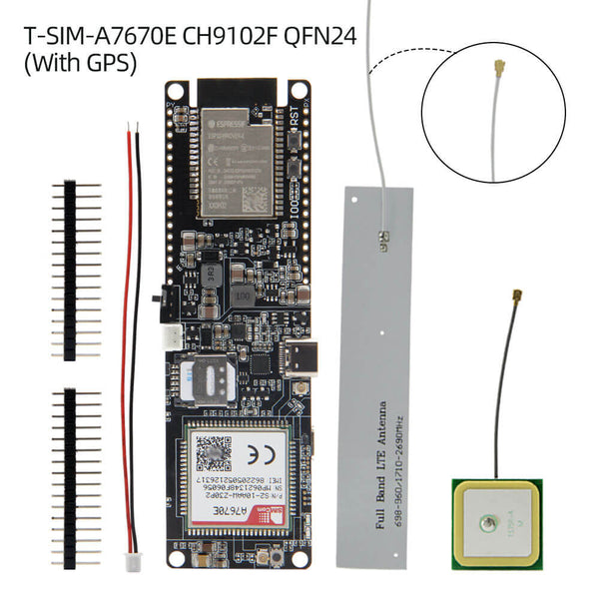
Figure 1: GPS-enabled LilyGO T-A7670E board with the supplied LTE and GNSS antennas used for the prototype. Source: LilyGO supplier product imagery.
Innovation and Novel Features
The project combines student identification and authorised emergency tracking in one working system. Its main contribution is not a new satellite receiver; it is the practical integration of a low-part-count tracking board, identity-based search, hybrid position reporting, interruption buffering, real-time web updates and route refinement designed for a Nigerian university environment. The map always distinguishes satellite, retained and cellular positions so an administrator can judge the reliability of what is displayed.
Potential Commercial Applications
The system could be developed into an opt-in student safety badge for universities and boarding schools, a field-trip or industrial-training safety device, an emergency locator for staff working in higher-risk areas, or a compact tracker for institutional assets. Any human-tracking use must include informed consent, limited access and a documented emergency-use policy.
Target Users and Market
Primary institutional users include university security divisions, student-affairs departments, campus health services, boarding schools and authorised emergency-response teams. The people carrying the device would be students or staff who enrol voluntarily or are covered by an approved institutional safety programme.
Potential Investors and Partners
Potential collaborators include Ahmadu Bello University management, the Security Division, Directorate of Information and Communication Technology, Student Affairs Division, Nigerian mobile-network operators, embedded-electronics manufacturers, local printed-circuit-board and enclosure producers, technology incubators, research funds and responsible social-impact investors.
Proposed Market Entry Strategy
The recommended path begins with a controlled university pilot involving consenting volunteers. The pilot should measure outdoor accuracy, mobile-network reliability, battery endurance, enclosure strength and response procedures. Results would guide a smaller custom board and secure hosted service, followed by privacy review, carrier and radio approvals, a five-unit field trial, low-volume manufacture and partnership with educational institutions.
Estimated Commercialisation Stage
[ ] Idea or Concept
[ ] Functional Prototype
[X] Tested Prototype
[ ] Field Tested Prototype
[ ] Market Ready Prototype
[ ] Already Commercialised
Current Features
• One integrated LilyGO T-A7670E board with ESP32, 4G LTE modem, nano-SIM support, GNSS and USB-C power.
• Outdoor satellite positioning with a limited last-good-position hold and labelled cellular fallback.
• Authenticated device-to-server reporting through a public ngrok demonstration tunnel.
• Administrator login, five-student demonstration register and registration-number search.
• Live tracking for U19CO1011, the student linked to the single physical CARD01 device.
• Five recent positions, activity history, day and session route replay, speed, distance, stop detection and geofence alerts.
• Route smoothing that rejects implausible jumps and avoids drawing repeated zigzag lines while the device is stationary.
• System-health page, downloadable records and written OpenAPI documentation for the backend.
• Store-and-forward buffering when the mobile network is temporarily unavailable.
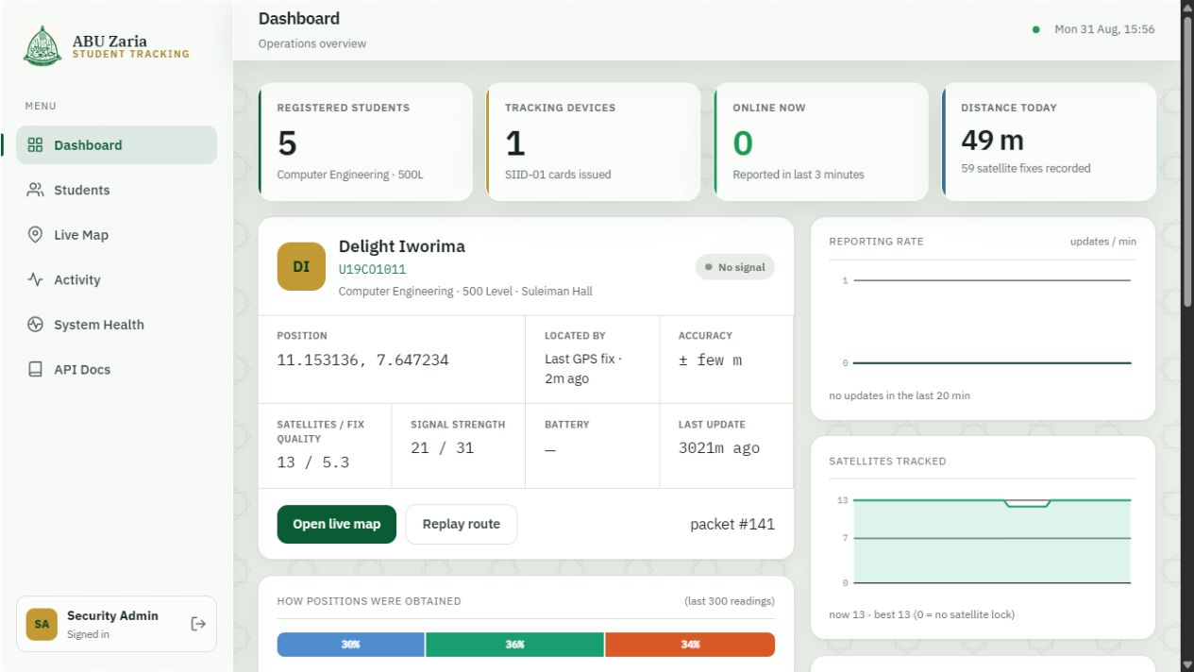
Figure 2: Implemented Ahmadu Bello University themed administrator dashboard showing the registered device and latest tracking information.
Cost and Durability
The present prototype has an estimated hardware cost of approximately ₦60,000, depending mainly on the imported LilyGO board price. This estimate includes the all-in-one board, supplied antennas, SIM and basic housing materials, but excludes the laptop, an already-owned power bank, internet service and development labour. Using one integrated board kept the cost and wiring much lower than a design built from separate controller, GPS, modem and charging modules.
Component Group | Included Items | Share of Cost
Tracking and control | LilyGO T-A7670E board containing ESP32, A7670E modem, SIM interface, GNSS support and charger | Largest share
Radio and positioning | LTE flat antenna and active GNSS antenna supplied with the board | Included with board
Connectivity | 4G nano-SIM and small mobile-data allowance | Small recurring cost
Power | USB-C cable and external power bank for the demonstrated prototype | Existing equipment
Housing and assembly | Temporary holder or 3D-printed shell, fasteners and consumables | Remaining balance
Software | Flask, SQLite, Socket.IO, Leaflet, OpenStreetMap and browser interface | Open-source tools
Table 1: Cost groups for the implemented SIID-01 prototype
The development board is suitable for proving functionality but is longer and thicker than a normal bank-card-sized identity card. Exposed antenna cables and connectors can be damaged by bending or impact, and the prototype is not weather-sealed. The power-bank arrangement is reliable for demonstrations but too bulky for daily use. A production version therefore requires a purpose-designed board, protected flat battery, strain relief and an impact-resistant sealed enclosure.
Societal and Market Impact
• Provides authorised responders with a recent location and movement history during a serious student-safety incident.
• Supports faster, evidence-based search decisions instead of relying only on phone calls or eyewitness reports.
• Demonstrates a locally developed, comparatively low-cost safety platform that can be adapted to Nigerian institutions.
• Creates opportunities for local electronics assembly, enclosure production, software support and university-industry collaboration.
• Shows that safety technology can include privacy safeguards by limiting tracking access, recording administrator actions and separating precise satellite fixes from approximate network estimates.
The device should support emergency response rather than continuous secret surveillance. Institutional deployment would require informed consent, a clear activation policy, limited retention of movement data, role-based access and independent oversight.
Priority Technical Improvements
Subsystem | Current Prototype | Proposed Upgrade
Main electronics | LilyGO development board | Custom compact PCB using a certified low-power cellular, GNSS and satellite-capable module
Remote connectivity | 4G terrestrial network only | LTE-M or NB-IoT with non-terrestrial satellite backup where supported by the selected carrier
Indoor location | Approximate cellular-network estimate | Bluetooth or Wi-Fi anchors in selected buildings for room- or zone-level location
Power | External USB power bank | Protected flat LiPo battery, charge controller, fuel gauge and low-power reporting schedule
Data security | Demonstration ngrok tunnel and administrator account | Permanent HTTPS service, per-device keys, key rotation, role-based access, audit logs and encrypted backups
Enclosure | Temporary holder around the development board | Impact-resistant, weather-sealed badge enclosure with protected antennas and USB-C access
Testing | Functional outdoor and software tests | Measured 200 m walk, battery-runtime test, indoor-zone trial, drop test and weather-resistance test
Table 2: Priority improvements required for a production-oriented tracker
Cost Implications of Proposed Improvements
The following figures are planning estimates for the first miniaturised research prototype, not final supplier quotations. The first unit is expensive because circuit-board setup, importation, spare parts, antenna work and design corrections cannot yet be spread across many units.
Upgrade Item | Estimated Cost
Low-power cellular, GNSS and satellite-capable controller or module | About ₦35,000
Four-layer custom PCB fabrication and assembly | ₦100,000 - ₦150,000
Cellular or satellite and GNSS antennas | ₦25,000 - ₦45,000
Protected flat LiPo battery and power-management components | ₦20,000 - ₦35,000
eSIM or SIM interface, USB-C, connectors and small components | ₦15,000 - ₦30,000
Durable custom enclosure | ₦15,000 - ₦30,000
Shipping, importation, spare boards and rework | ₦100,000 - ₦160,000
Prototype design, assembly and test contingency | ₦40,000 - ₦65,000
Table 3: Indicative cost of the proposed miniaturised hybrid prototype
The resulting first prototype is estimated at ₦350,000 to ₦550,000; approximately ₦450,000 is a practical single planning figure. If 100 or more units are eventually manufactured after the design is stable, the hardware target is approximately ₦90,000 to ₦150,000 per unit. Satellite service subscriptions, professional radio design, regulatory testing and commercial certification are not included.
A five-unit university pilot is expected to require approximately ₦1.2 million to ₦1.6 million because the initial circuit-board and enclosure setup can be shared across the batch. This amount includes low-volume hardware, spares, assembly and field-test logistics, but excludes full commercial certification and recurring satellite-network fees.
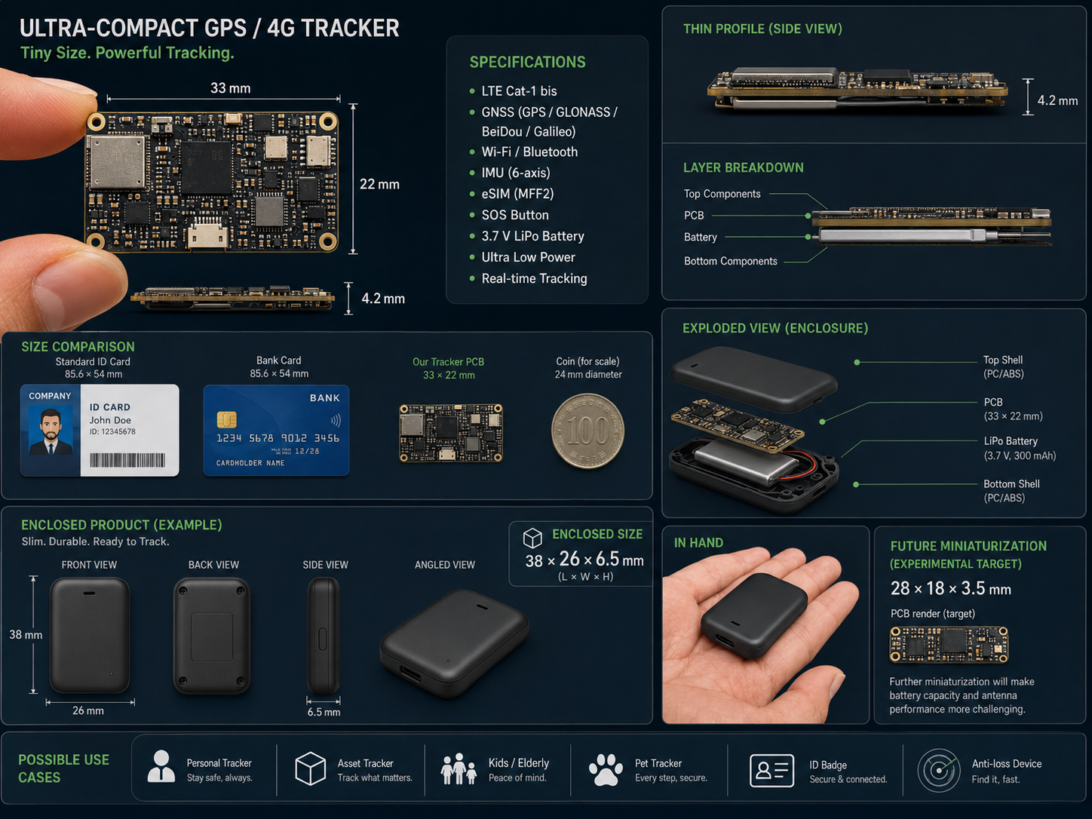
Figure 3: Illustrative concept for a future miniaturised tracker. The dimensions and optional features shown are design targets, not measurements of the implemented prototype.
Support Requested from the University
• Materials and equipment: compact cellular or satellite development hardware, custom PCB fabrication, protected batteries, antenna samples, enclosure materials and access to suitable soldering and measurement tools.
• Laboratory access: continued embedded-systems laboratory use, controlled outdoor measurement routes, indoor anchor testing, battery monitoring and mechanical enclosure testing.
• Mentorship: support from embedded-systems, radio-frequency, cybersecurity, product-design and data-protection specialists.
• Funding: approximately ₦1.2 million to ₦1.6 million to design, assemble and field-test a five-unit miniaturised pilot with consenting users.
• Institutional pilot: collaboration with the Security Division, Directorate of Information and Communication Technology, Student Affairs Division and university legal or ethics advisers to define emergency activation, access and data-retention rules.
• External connections: introductions to mobile-network operators, satellite Internet-of-Things partners, PCB manufacturers, enclosure producers, research funds and responsible investors.
Vision and Conclusion
The goal is to develop SIID-01 from a final-year prototype into a practical, opt-in university safety device that can help authorised responders act faster during a serious incident. The realistic path is staged: complete controlled performance measurements, strengthen security and privacy controls, design the smaller hardware, build a five-unit pilot, test with consenting users, and only then pursue certification and wider manufacture.
SIID-01 already demonstrates a complete working chain: the physical card obtains location information, the mobile network carries it to the server, the backend verifies and stores it, and the dashboard links it to a searchable student record. The proposed future version addresses the present size, power and no-network limitations without misrepresenting features that have not yet been built.
Additional Remarks
The implemented system has been demonstrated using a real LilyGO board, a live SIM connection and genuine satellite and cellular readings. The documented evaluation contained 875 physical-device location records, and all 17 automated backend functional and security tests passed. One physical card is assigned to U19CO1011; four additional student entries demonstrate how the administrative system can scale beyond a single user.
Prepared by
Delight Iworima U19CO1011
Department of Computer Engineering
Ahmadu Bello University Zaria
__________________________________________
Supervisor

