

DESIGN AND IMPLEMENTATION OF A
GPS- AND LTE-BASED TRACKABLE
STUDENT IDENTIFICATION CARD
By
IWORIMA GOD’S DELIGHT
U19CO1011

Department of Computer Engineering,
Ahmadu Bello University, Zaria
2026

DESIGN AND IMPLEMENTATION OF A
GPS- AND LTE-BASED TRACKABLE
STUDENT IDENTIFICATION CARD
By
IWORIMA GOD’S DELIGHT
U19CO1011
delightiworima19@gmail.com
Supervised By
ENGR. M.O MUHIDDEEN

A Final Year Project Submitted to the Department of Computer Engineering, Ahmadu Bello University, Zaria in Partial Fulfillment of the Requirements for the Award of the Bachelor of Engineering (B.Eng) Degree in Computer Engineering
2026

DECLARATION
I declare that the work in this project report, entitled “Design and Implementation of a GPS- and LTE-Based Trackable Student Identification Card”, was carried out by me in the Department of Computer Engineering, Ahmadu Bello University, Zaria. The information derived from published and unpublished works has been acknowledged in the text and listed in the references. No part of this report has previously been presented for another degree or diploma at this or any other institution.

CERTIFICATION
This project report, entitled “Design and Implementation of a GPS- and LTE-Based Trackable Student Identification Card” by Delight Iworima, U19CO1011, meets the regulations governing the award of the Bachelor of Engineering degree in Computer Engineering of Ahmadu Bello University, Zaria, and is approved for its contribution to knowledge and presentation.

DEDICATION
This work is dedicated to God Almighty, my family, teachers and everyone whose support made my undergraduate education possible.

ACKNOWLEDGEMENT
I am grateful to God Almighty for the strength and opportunity to complete this project. I sincerely appreciate my supervisor, Engr. M.O Muhuiddeen, for guidance, corrections and encouragement throughout the work. I also thank the academic and technical staff of the Department of Computer Engineering, Ahmadu Bello University, Zaria, for the knowledge and facilities that supported the project. My gratitude extends to my parents, family, classmates and friends for their patience, advice and practical assistance during development and testing.

ABSTRACT
A conventional student identity card proves identity but cannot report its location during an authorised search. This project presents a portable tracking prototype built around the LilyGO T-A7670E board, which combines an ESP32 controller, an A7670E LTE modem and Global Navigation Satellite System support. The device obtains accurate outdoor coordinates from satellites, retains the last reliable satellite position for a limited period when reception is interrupted, and uses a clearly labelled cellular-network estimate as a fallback. It sends location records through a web application programming interface to a Flask server, where SQLite stores the data. The firmware also keeps up to 20 unsent reports in non-volatile memory for later delivery after a temporary network failure. An Ahmadu Bello University-themed dashboard provides administrator authentication, student search by registration number, live tracking, recent positions, activity history, date- and session-based route playback, stop detection, geofence alerts, route export, system-health checks and hand-written OpenAPI documentation. All 17 automated backend functional and security tests passed. At the 30 August 2026 reporting snapshot, the physical card had produced 875 stored records: 205 satellite fixes, 241 retained fixes, 406 cellular estimates and 23 early unclassified records. For the latest recorded day, the route-processing method converted 79 quality-eligible satellite readings into 59 display points, rejected two implausible jumps, identified four stationary periods and calculated 49 m of movement. These results prove the complete device-to-dashboard path, but they are not presented as a controlled 200 m range test; that final measured trial remains to be recorded. The present hardware is therefore described honestly as a trackable ID-card-holder prototype. A production version would require a smaller custom circuit board, validated power and antenna design, encrypted deployment and institutional privacy controls.
Keywords: student identification card, GNSS, LTE, ESP32, Flask, real-time tracking, Internet of Things

TABLE OF CONTENTS
DECLARATION i
CERTIFICATION ii
DEDICATION iii
ACKNOWLEDGEMENT iv
ABSTRACT v
TABLE OF CONTENTS vi
LIST OF FIGURES ix
LIST OF TABLES x
LIST OF APPENDICES xi
LIST OF ABBREVIATIONS xii
CHAPTER ONE INTRODUCTION 1
1.1 Background 1
1.2 Project Motivation 2
1.3 Statement of the Problem 2
1.4 Aim and Objectives 2
1.4.1 Aim 2
1.4.2 Objectives 3
1.5 Project Organisation 3
CHAPTER TWO LITERATURE REVIEW 4
2.1 Introduction 4
2.2 Internet of Things Tracking Systems 4
2.3 Satellite Positioning 4
2.4 Cellular Communication and Fallback Position 5
2.5 Embedded Processing Platform 5
2.6 Server, Database and Real-Time Dashboard 5
2.7 Review of Related Works 6
2.8 Identified Research Gap 7
2.9 Chapter Summary 7
CHAPTER THREE METHODOLOGY 8
3.1 Introduction 8
3.2 Materials and Development Tools 8
3.3 Software Stack and Design Choices 9
3.4 System Architecture 10
3.5 Hardware Implementation 10
3.6 Firmware Method 11
3.6.1 Initialisation 11
3.6.2 Position Selection 12
3.6.3 Location Message 12
3.7 Backend and Database Method 13
3.8 Dashboard Method 13
3.9 Security and Privacy Method 14
3.10 Evaluation Procedure 14
CHAPTER FOUR RESULTS AND DISCUSSION 16
4.1 Introduction 16
4.2 Hardware and Firmware Results 16
4.3 Backend Test Results 17
4.4 Stored Telemetry Results 18
4.5 Route Playback, Distance and Speed 19
4.6 Dashboard Results 20
4.7 Evaluation Against the Objectives 23
4.8 Discussion 23
CHAPTER FIVE CONCLUSION 24
5.1 Conclusion 24
5.2 Limitations 24
5.3 Important Findings 25
5.4 Recommendations for Further Work 25
5.4.1 Proposed Miniaturised Production Version 25
5.4.2 Other Recommendations 27
REFERENCES 28
APPENDIX A MAJOR API ENDPOINTS 30
APPENDIX B PROTOTYPE HARDWARE AND SIGNAL CONNECTIONS 31
APPENDIX C DEMONSTRATION CHECKLIST 32
APPENDIX D CONTROLLED FIELD-TEST RECORD 33

LIST OF FIGURES
Figure 3.1: End-to-end architecture of the proposed tracking system 10
Figure 3.2: LilyGO T-A7670E R2 board, flat LTE antenna and ceramic GNSS antenna used in the prototype 11
Figure 3.3: Position-source selection process 12
Figure 4.1: Registered-student list and registration-number tracking entry point 21
Figure 4.2: Stored GPS route, playback controls and movement measurements for U19CO1011 22
Figure 5.1: Conceptual illustration of a possible miniaturised production tracker (design target; not fabricated or experimentally validated) 26

LIST OF TABLES
Table 2.1: Summary of selected related works 6
Table 3.1: Materials and tools used 8
Table 3.2: Main software technologies used in the implemented system 9
Table 3.3: Main location message fields 13
Table 4.1: Hardware and firmware functional results 16
Table 4.2: Automated backend test results 17
Table 4.3: Distribution of stored location records 18
Table 4.4: Route-playback measurements from stored satellite data 19
Table 4.5: Implemented dashboard functions 20
Table 4.6: Objective-by-objective evaluation 23

LIST OF APPENDICES
APPENDIX A MAJOR API ENDPOINTS 30
APPENDIX B PROTOTYPE HARDWARE AND SIGNAL CONNECTIONS 31
APPENDIX C DEMONSTRATION CHECKLIST 32
APPENDIX D CONTROLLED FIELD-TEST RECORD 33

LIST OF ABBREVIATIONS
Abbreviation | Meaning
API | Application Programming Interface
BLE | Bluetooth Low Energy
CSV | Comma-Separated Values
ESP32 | Espressif 32-bit microcontroller family
GNSS | Global Navigation Satellite System
GPS | Global Positioning System
HTTP | Hypertext Transfer Protocol
IoT | Internet of Things
JSON | JavaScript Object Notation
LTE | Long-Term Evolution cellular communication
NVS | Non-Volatile Storage
PDF | Portable Document Format
PDOP | Position Dilution of Precision; a satellite-geometry quality value
SIM | Subscriber Identity Module
SQL | Structured Query Language
UART | Universal Asynchronous Receiver-Transmitter

CHAPTER ONE
INTRODUCTION

1.1 Background
Student identity cards are routinely used to show that a person belongs to an institution. They support access control, examination identification, library services and other administrative activities. Their normal function, however, stops at visual or electronic identification. If a student or the card needs to be located, an ordinary card cannot provide a current position or a record of movement.
The Internet of Things provides a practical way to connect a physical object to software through sensing, communication and data processing. An IoT device typically observes a physical condition, transfers a message over a network and makes the information available to an application (Atzori et al., 2010). In a tracking system, the observed condition is location. Satellite positioning can provide useful outdoor coordinates, while a cellular modem can carry those coordinates to a remote server without requiring the device to remain near the administrator's computer.
This project combines those functions in a student identification tracking prototype. The LilyGO T-A7670E board was selected because its ESP32 controller, A7670E LTE modem, SIM interface, USB-C power interface and supported satellite receiver are integrated on one development board. This reduces the number of separate modules and connections required for a time-limited student project. The server and dashboard then link the card identifier to a student record and present the latest location in a form that an administrator can understand.
GPS.gov reports that civilian GPS performance depends on satellite geometry, signal blockage, atmosphere and receiver quality, and that buildings can block or reflect signals (National Coordination Office for Space-Based Positioning, Navigation, and Timing, n.d.). For that reason, this design does not pretend that one technology gives phone-like accuracy everywhere. It uses a clear source hierarchy: a reliable satellite fix is preferred outdoors; the last good fix may be reused for a short period; and a cellular estimate is used when satellite information is unavailable.

1.2 Project Motivation
The project was motivated by the gap between student identification and location awareness. A university may be able to confirm a student's identity from a card, yet still have no technical support for finding the person during an authorised search. This need is more serious in the context of public-order and internal-security concerns in Nigeria, which the National Bureau of Statistics treats as an important area for national decision-making (National Bureau of Statistics, 2024). During an authorised search for a missing or at-risk student, the last reported position and recent route may help campus security decide where to begin. The prototype is an information aid; it is not a guarantee of personal safety and does not replace emergency services.
A second motivation was practical feasibility. A design assembled from many independent modules would increase wiring errors, power problems, enclosure size and troubleshooting time. Selecting an integrated board made it possible to concentrate on the complete system: acquiring a position, sending it over the mobile network, storing it, applying access controls and presenting it through a useful dashboard.

1.3 Statement of the Problem
Conventional student identity cards provide identification but do not provide location information. Existing phone-based location services cannot be assumed because a student may not have a charged phone, may not grant the application access, or may not be carrying the registered phone. A separate tracking prototype therefore requires a compact location receiver, independent wide-area communication, a server that connects the device to the correct student record, and a secure interface for authorised users. The engineering problem is to implement these functions with few components while maintaining reliable data flow and presenting the result clearly over a demonstration distance of at least 200 m.

1.4 Aim and Objectives

1.4.1 Aim
The aim of this project is to design and implement a portable student identification tracking prototype that acquires its location and transmits it over LTE to an authenticated real-time web dashboard.

1.4.2 Objectives
- To develop integrated hardware and firmware on the LilyGO T-A7670E for satellite-position acquisition, cellular fallback and LTE transmission.
- To develop a backend, database and Ahmadu Bello University-themed dashboard for student search, live location display, recent history, route playback and documented application programming interfaces.
- To integrate and evaluate the end-to-end system, including source switching, data storage, authenticated access and operation over a distance of at least 200 m.

1.5 Project Organisation
This report is arranged in five chapters. Chapter One introduces the project, its motivation, problem, aim and objectives. Chapter Two explains the technical ideas and reviews related tracking systems. Chapter Three presents the hardware, software and development method. Chapter Four reports and discusses the implementation and test results. Chapter Five states the conclusion, limitations, important findings and recommendations for further work.

CHAPTER TWO
LITERATURE REVIEW

2.1 Introduction
This chapter reviews the concepts and earlier systems that informed the design. The discussion covers IoT tracking, satellite positioning, cellular communication, embedded controllers, server-side software, real-time dashboards and privacy. It then identifies the gap addressed by the proposed prototype.

2.2 Internet of Things Tracking Systems
Atzori et al. (2010) describe the Internet of Things as an environment in which uniquely identifiable objects communicate and cooperate through networked infrastructure. A tracking application follows this model closely: the physical device has an identity, sensors or receivers produce observations, a network transfers messages, and software converts the messages into useful information. The present system treats each card as a device with a card identifier and associates that identifier with a student record on the server.

2.3 Satellite Positioning
A GNSS receiver estimates its position from signals transmitted by multiple satellites. The receiver needs a clear enough view of the sky to obtain and maintain a fix. The reported latitude and longitude are not perfect: accuracy is affected by the number and arrangement of visible satellites, reflected signals, signal blockage and receiver conditions. GPS.gov states that open-sky performance is normally much better than performance near buildings or indoors (National Coordination Office for Space-Based Positioning, Navigation, and Timing, n.d.). This makes GNSS suitable as the primary outdoor source but unsuitable as the only indoor guarantee.
The receiver reports quality information in addition to coordinates. Satellite count shows how many satellites contributed to a fix. Position dilution of precision describes how satellite geometry can magnify measurement error: a smaller value generally indicates better geometry. In this work, firmware accepts a satellite fix for the retained-position mechanism only when at least four satellites are available and the reported position dilution value is not greater than 8. The dashboard uses the plain label “signal geometry” so that a non-specialist can explain it without relying on an abbreviation.

2.4 Cellular Communication and Fallback Position
LTE provides wide-area data communication through a mobile network. The modem uses a SIM card to register on the network and can then send an HTTP request to the server. This differs from Bluetooth or Wi-Fi, which require a nearby receiver or access point. The A7670E modem therefore supports a self-contained outdoor demonstration over 200 m and, subject to network coverage, much greater distances.
A cellular network may also return an approximate position based on network information. Such a position can be available where satellite reception is weak, but it is usually less precise than a good satellite fix. Jiménez-Martínez et al. (2025) show why satellite and cellular sources can complement each other, while also demonstrating that their measurement qualities differ. The present prototype exposes the source of every reading so that the map never presents a cellular estimate as if it were an exact satellite fix.

2.5 Embedded Processing Platform
The ESP32 is a programmable microcontroller platform with processing, serial communication and non-volatile storage capabilities. On the LilyGO T-A7670E, the ESP32 communicates with the A7670E modem through a serial interface and controls network registration, satellite queries and HTTP transmission. The official LilyGO documentation identifies versions of the T-A7670 series that combine an ESP32-WROVER-E, an A7670 LTE Cat-1 modem and GNSS support (LilyGO, n.d.-a; LilyGO, n.d.-b). The integration reduces inter-board wiring and makes the prototype straightforward to power through USB-C.

2.6 Server, Database and Real-Time Dashboard
A tracker becomes useful only when its messages can be validated, stored and displayed. Flask was selected as the Python web framework because it supports a small, understandable backend while allowing routes, authentication and templates to remain explicit (Pallets Projects, n.d.). SQLite stores the demonstration data in one file and provides transactional SQL without a separate database service (SQLite, n.d.). Flask-SocketIO pushes newly accepted locations to connected browsers so that the map can update without repeated manual refreshes (Grinberg, n.d.).
Leaflet provides the interactive map, markers and route layers in the browser (Agafonkin, 2023). The API is described in an OpenAPI 3.0 document, which states the available paths, inputs, authentication and responses in a machine-readable format (OpenAPI Initiative, 2020). The project deliberately keeps the written API specification visible during the defence because it demonstrates backend design and provides a basis for testing.

2.7 Review of Related Works
Research prototypes commonly combine a satellite receiver, a GSM or cellular modem and a web application. The systems differ in integration level, communication method, fallback strategy, user interface and intended object. Table 2.1 summarises representative works.
Study | Main approach | Strength | Gap relative to this project
Alsadi (2013) | Embedded GPS-GSM vehicle tracker | Demonstrated real-time vehicle reporting | Vehicle focus; limited student identity and dashboard workflow
Alquhali and Roslee (2018) | Arduino vehicle tracker | Low-cost embedded implementation | Separate modules increase wiring and size
Khin and Oo (2018) | GPS, GSM and web technologies | Complete device-to-web path | No explicit short-term position hold or student search
Morallo (2021) | Arduino GPS/GSM vehicle tracker | Practical interface design | No integrated institution dashboard or API documentation
Osman and Hassan (2024) | GPS/GSM vehicle tracking | Recent implementation and evaluation | Vehicle use case; does not address card-device mapping
Marquezan et al. (2024) | Hybrid indoor IoT location architecture | Shows value of indoor infrastructure | Requires infrastructure beyond the minimal prototype
Jiménez-Martínez et al. (2025) | GNSS and cellular hybridisation | Explains robustness from multiple sources | Positioning research rather than a complete student-card system

Table 2.1: Summary of selected related works

2.8 Identified Research Gap
The reviewed systems establish that satellite coordinates can be transferred through cellular networks and displayed on the web. Most concentrate on vehicles, use several separate modules, or do not connect device identity to a searchable institutional record. Indoor-oriented systems often require installed anchors or additional radio infrastructure. The gap addressed here is therefore a low-component student-card prototype that joins an integrated GNSS/LTE board to an authenticated university-style dashboard, exposes the quality and source of each location, retains the last good satellite fix during brief signal loss, and supports route replay for a repeatable demonstration.

2.9 Chapter Summary
Satellite positioning provides the preferred outdoor coordinates, LTE provides independent data transfer, and cellular positioning supplies only a coarse fallback. An ESP32-based integrated board reduces component count, while a Flask, SQLite, Socket.IO and Leaflet software stack provides storage and real-time presentation. These findings guided the methodology in Chapter Three.

CHAPTER THREE
METHODOLOGY

3.1 Introduction
The project was implemented as an end-to-end prototype. Development was divided according to the three objectives: the card hardware and firmware; the backend, database and dashboard; and integration with verification. This chapter explains the materials, architecture, algorithms and test method.

3.2 Materials and Development Tools
Item | Role in the prototype | Reason for selection
LilyGO T-A7670E with GNSS | Controller, satellite receiver, LTE modem, SIM and USB-C power interface | Combines the main electronic functions on one board
LTE SIM card | Mobile network registration and data transfer | Permits independent wide-area communication
LTE antenna | Cellular signal reception and transmission | Required for stable modem operation
GNSS antenna | Satellite signal reception | Required for reliable outdoor fixes
USB-C cable / power bank | Programming and demonstration power | Available and adequate for prototype testing
Arduino IDE | Firmware editing, compilation and flashing | Direct ESP32 board support and serial monitor
Python and Flask | Backend API, authentication and web pages | Readable server code and rapid implementation
SQLite | Persistent telemetry and student records | No separate database service required
HTML, CSS and JavaScript | Administrator interface | Runs in a standard web browser
Leaflet and Socket.IO | Map and live browser updates | Suitable for real-time location display

Table 3.1: Materials and tools used

3.3 Software Stack and Design Choices
Technology or library | Version used | Purpose and reason
Arduino IDE and Espressif ESP32 core | ESP32 core 3.3.11 | Compiles and flashes the embedded C++ firmware to the ESP32.
LilyGO TinyGSM fork | 1.0.0 | Sends modem commands and supports the A7670 family used on the board.
ArduinoHttpClient | 0.6.1 | Builds the HTTP requests sent from the card to the backend.
ESP32 Preferences | Included with ESP32 core | Stores the last reliable fix and unsent reports in non-volatile flash memory.
Flask | 3.0.3 | Defines the web pages, login flow and application programming interface routes.
Flask-SocketIO / Socket.IO client | 5.3.6 / 4.8.3 | Pushes a newly accepted location to an already-open browser page.
Flask-Swagger-UI and OpenAPI | 5.32.9 / 3.0.3 | Displays the hand-written description of the backend endpoints.
SQLite | Python built-in driver | Stores students, device status, readings, alerts and geofence settings in one local database file.
Leaflet | 1.9.4 | Draws the map, source markers, route lines, stops and direction indicators.
ReportLab | 4.4.9 | Creates the downloadable route report in PDF format.
HTML, CSS and JavaScript | Browser standards | Builds the interface without a large front-end framework, keeping the demonstration easy to run and explain.

Table 3.2: Main software technologies used in the implemented system
The stack was selected to keep each part visible and explainable. Embedded C++ controls the board; Python handles backend rules and storage; and ordinary browser technologies present the interface. The project uses a local copy of its map and live-update libraries so the main dashboard interface can still load if a content-delivery network is unavailable. Online map tiles may still require Internet access, while an included campus fallback graphic supports a limited offline view.
On the embedded side, the LilyGO-compatible TinyGSM fork supplies A7670 modem support (LewisHe, n.d.), while ArduinoHttpClient constructs the HTTP messages (Arduino, n.d.). These two libraries avoid rewriting low-level modem and HTTP handling while leaving the project's position-selection, buffering and reporting rules in the student-written firmware.

3.4 System Architecture
POSITION  GNSS fix or cellular fallback | SMART CARD  ESP32 + A7670E modem | SERVER  Flask API + SQLite | DASHBOARD  Search, map, history and replay
Figure 3.1: End-to-end architecture of the proposed tracking system
The card is assigned the identifier CARD01. On the server, CARD01 is linked to the demonstration student U19CO1011. Four additional Computer Engineering student records are included to demonstrate registration-number search and list management, but they are intentionally unassigned because only one physical board is available. This separation proves that one backend can manage several students while tracking only the card that physically exists.

3.5 Hardware Implementation
The T-A7670E was treated as the complete prototype controller rather than as one module among many. The ESP32 runs the program, communicates with the modem over UART, stores the most recent acceptable position in non-volatile memory, and prepares the JSON message. The A7670E registers on the LTE network, provides GNSS responses on the GNSS-supported modem version and transfers HTTP data. The supplied flat LTE antenna and square ceramic GNSS antenna are attached to their labelled connectors before radio operation. LilyGO's documentation confirms the ESP32-WROVER-E platform, A7670 model variations, USB-C power connection and labelled antenna interfaces (LilyGO, n.d.-a; LilyGO, n.d.-c). SIMCom's A7670 documentation provides the underlying modem hardware and command references (SIMCom Wireless Solutions, 2021).
For development and the final demonstration, the board is powered through its USB-C port from an external power bank. No flat lithium-polymer or 18650 battery is fitted to the tested prototype because a suitably thin protected cell was not available. The unused battery connector is therefore left disconnected. The current development board and its external antennas are thicker and wider than a standard bank card. A truly wallet-sized product would require a custom printed circuit board rather than simply placing this development board in a thin shell.
Figure 3.2 shows the exact manufacturer-supplied board and antenna types used in the prototype. The long rectangular part is the flat LTE antenna for mobile communication, while the small square ceramic patch is the GNSS antenna for satellite reception. Both connect to the labelled antenna sockets on the board. The loose pin headers and battery lead visible in the package photograph are not required for the tested USB-C power-bank arrangement.
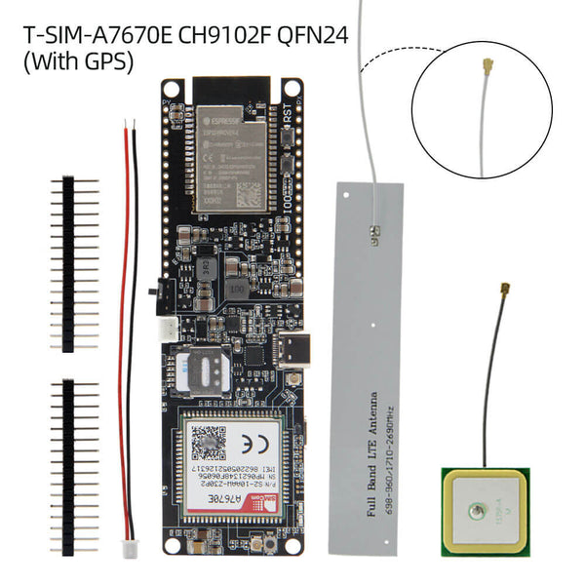
Figure 3.2: LilyGO T-A7670E R2 board, flat LTE antenna and ceramic GNSS antenna used in the prototype
Source: LILYGO T-SIM A7670E/G/SA R2 product page (LilyGO, n.d.-c).

3.6 Firmware Method

3.6.1 Initialisation
After power-up, the ESP32 starts serial communication, loads the saved last-good satellite position from non-volatile storage, restarts the modem when required, registers on the mobile network and opens the packet-data connection. The board then requests GNSS operation from the A7670E. Diagnostic messages are sent to the Arduino serial monitor so that modem registration, source selection and server responses can be observed during testing.

3.6.2 Position Selection
Step | Decision | System action
1 | Read GNSS | Accept only a usable satellite fix
2 | Hold last good fix | Reuse it briefly when the satellite signal disappears
3 | Use cellular estimate | Fall back when there is no recent usable GNSS fix
4 | Transmit | Send source, coordinates, quality and time to the server
Figure 3.3: Position-source selection process

The position hierarchy prevents an old or weak fix from silently replacing good data. A new GNSS reading becomes the preferred position when it has valid coordinates, at least four satellites and a position-dilution value not greater than 8. It is saved as the last good fix. If a new acceptable satellite reading cannot be obtained, that saved position may be reported as gps_hold for up to 15 minutes. This preserves continuity through a brief indoor transition or signal interruption. After the hold expires, the modem's cellular estimate is reported as cell. The source label is included in every request.
The firmware saves a new reliable checkpoint to flash no more often than once in five minutes to avoid unnecessary repeated writes. Location reports are targeted at five-second intervals when network and modem operations complete normally. If the server or mobile connection is temporarily unavailable, the newest 20 reports can be held in flash and forwarded after communication returns. A forwarded report keeps its original capture time and is marked as buffered, so route playback remains in the correct order.

3.6.3 Location Message
Field | Meaning | Example
card_id | Unique device identifier | CARD01
latitude | North-south coordinate in decimal degrees | 11.149096
longitude | East-west coordinate in decimal degrees | 7.659633
source | gps, gps_hold or cell | gps
satellites | Number of satellites used | 13
pdop | Reported satellite-geometry quality value | 2.4
batt_mv | Battery reading in millivolts; zero because no battery is fitted to the tested prototype | 0
seq | Increasing device report number | 247
buffered | Shows that a saved report is being forwarded | false
captured_epoch | Original device capture time as Unix seconds | 1788091200
timestamp | Time recorded by the system | ISO 8601 value
Table 3.3: Main location message fields

3.7 Backend and Database Method
The Flask application exposes separate routes for browser pages, administrator APIs and the device-ingestion API. The card sends an HTTP POST request with a device key in the X-Device-Key header. The backend checks that the key is present, the card identifier exists, coordinates are within geographic limits and the source label is allowed. Accepted records are written to SQLite and emitted to authenticated Socket.IO clients. Invalid or excessive requests are rejected before storage.
The database contains student, card and location relationships. A student may exist without an assigned device, while a physical card is linked to one student for the demonstration. Location records keep the card identifier, coordinates, position source, satellite count, quality value and timestamp. The design supports latest-position queries, recent-history queries and time-ordered route reconstruction.
Route processing never overwrites the original database evidence. It first accepts only satellite rows with at least four satellites and a positive quality value not greater than 8. It groups readings by Lagos calendar day, starts a new session after a gap longer than three minutes, removes isolated one-point sessions when a real walk exists, rejects an implausible jump using distance, time and quality, removes changes below 4 m, and applies quality-dependent exponential smoothing to the remaining display points. Distance is then calculated with the haversine formula, while changes below 10 m do not add travelled distance. The same processed data support stop detection, CSV export and the PDF route report.

3.8 Dashboard Method
The administrator first logs in, then uses a sidebar to open the overview, students, live tracking, activity, system health and API documentation pages. The students page supports registration-number search. Selecting U19CO1011 opens the live page, requests the current device record and listens for subsequent updates. The map distinguishes satellite, retained and cellular sources, while the telemetry panel uses plain-language quality labels. The activity page provides date and session selection, route playback, stop markers, direction indicators, distance and speed, geofence controls, and CSV or PDF export. Marker movement is animated between accepted updates so that the live display is easier to follow without changing the stored coordinates.
The visual design uses Ahmadu Bello University green and gold, the university logo, IBM Plex Sans for interface text, IBM Plex Mono for technical values and restrained translucent surfaces. Gradients were excluded. The overview page intentionally contains no map so that the main dashboard remains focused on system status and navigation.

3.9 Security and Privacy Method
Administrator pages, sensitive APIs and Socket.IO connections require a logged-in session. The ingestion endpoint uses a separate device key because the embedded device does not use the browser login. Input length, coordinate range, allowed source values, query limits and request frequency are validated. These controls are appropriate for a local prototype, but they are not sufficient for unrestricted institutional deployment. NIST (2019) identifies cybersecurity and privacy risk management as a core IoT requirement. A production design must therefore use encrypted transport, individual administrator accounts, auditable consent, role-based access and a stated retention policy.

3.10 Evaluation Procedure
Evaluation combined automated software tests, stored-data inspection and outdoor operation. Seventeen automated tests covered authentication, API documentation access, device-key validation, coordinate and source validation, battery validation, unknown cards, rate and query limits, buffered capture time, student-device mapping, valid record storage, stop detection, geofence alerts, route exports and the system-health endpoint. Database inspection counted records by source. The latest route-processing result was generated again from the stored physical-device data rather than copied from the dashboard screen.
The final controlled distance test should place the server online through the ngrok tunnel, power the card from a power bank, obtain a good outdoor GNSS fix, walk a measured route of at least 200 m and observe live updates on another network. The start point, end point, source, number of updates, elapsed time, measured route distance and any interruption should be recorded in Appendix D. Historical data are reported separately in Chapter Four and are not substituted for this controlled record.

CHAPTER FOUR
RESULTS AND DISCUSSION

4.1 Introduction
This chapter presents the implemented prototype and evaluates the results against the three project objectives. Proven results are stated separately from observations that still require a controlled demonstration measurement.

4.2 Hardware and Firmware Results
Test item | Observed result | Status
USB-C power and programming | Board powered and accepted firmware through its USB-C interface | Passed
Modem communication | ESP32 exchanged commands with the A7670E modem | Passed
LTE registration | Device connected through the installed SIM and transmitted records | Passed
GNSS operation | GNSS-supported A7670E returned outdoor satellite fixes | Passed
Source reporting | gps, gps_hold and cell records appeared in the database | Passed
Persistent hold | Last acceptable satellite fix was stored for use after restart | Implemented
Store-and-forward | Up to 20 failed reports can be retained and resent with their capture times | Implemented
Table 4.1: Hardware and firmware functional results

The integrated board removed the need to wire a separate ESP32, GPS receiver, GSM module and charger. Outdoor operation produced stable satellite fixes once the GNSS antenna had a useful view of the sky. Indoor operation did not provide the same guarantee because reinforced roofs and walls attenuate satellite signals. The fallback source allowed the dashboard to continue showing a position, but the source label and map accuracy must be explained to avoid treating a broad cellular estimate as an exact indoor fix.

4.3 Backend Test Results
No. | Automated test | Result
1 | Buffered report keeps its original capture time and bypasses the live-rate check | Passed
2 | API documentation and OpenAPI routes require authentication | Passed
3 | Crossing the configured geofence creates an alert | Passed
4 | System-health endpoint reports the backend and database state | Passed
5 | An implausible non-zero battery voltage is rejected | Passed
6 | Ingestion rate and history-query limits are enforced | Passed
7 | Invalid coordinates and source labels are rejected | Passed
8 | A missing device key is rejected | Passed
9 | An unknown card identifier is rejected before storage | Passed
10 | A logged-in administrator retains API access | Passed
11 | Route data can be downloaded as CSV and PDF | Passed
12 | Sensitive API routes reject unauthenticated access | Passed
13 | A Socket.IO connection requires an authenticated session | Passed
14 | A one-minute stationary period is detected as a stop | Passed
15 | Student detail returns the correctly assigned physical card | Passed
16 | A valid card report is accepted and stored | Passed
17 | A zero battery value is treated as unavailable instead of as a fault | Passed
Table 4.2: Automated backend test results

All 17 automated tests passed when the suite was run again on 30 August 2026. This is important because the visual dashboard alone cannot prove that the backend rejects invalid input, preserves captured times or protects private routes. The test suite provides repeatable evidence for those behaviours. The hand-written OpenAPI file is valid JSON and is served through the authenticated API documentation page.

4.4 Stored Telemetry Results
Position source | Number of records | Percentage
Satellite fix (gps) | 205 | 23.43%
Retained satellite fix (gps_hold) | 241 | 27.54%
Cellular estimate (cell) | 406 | 46.40%
Early unclassified records | 23 | 2.63%
Total | 875 | 100.00%

Table 4.3: Distribution of stored location records

At the 30 August 2026 reporting snapshot, the database contained 875 physical-device records for CARD01, beginning on 25 July 2026. The large cellular share reflects periods when the receiver did not have a usable satellite view, particularly during indoor development. This result confirms why the dashboard must show the position source. It also shows that cellular fallback improves availability but does not solve precise indoor tracking.
Of the 205 satellite-labelled records, 186 met the final quality gate of at least four satellites and a positive signal-geometry value not greater than 8. Within that accepted group, the average satellite count was 12.54 and the average signal-geometry value was 4.37. The historical dataset also contains poor-quality early readings, including a value of 100, because raw evidence is retained. The current firmware does not save such a reading as the last good held position.

4.5 Route Playback, Distance and Speed
Metric | Latest refined prototype session
Route date | 29 August 2026
All stored satellite rows inspected | 205
Quality-eligible rows on selected day | 79
Rows in the selected multi-point session | 78
Final display points | 59
Implausible jumps rejected | 2
Separate route segments | 1
Stationary periods detected | 4
Calculated movement | 49 m
Processed duration | 556 s
Calculated average moving speed | 4.3 km/h
Maximum accepted speed | 9.4 km/h

Table 4.4: Route-playback measurements from stored satellite data

The activity page replayed the stored points in capture-time order. The current method first removes poor-quality readings, splits recording sessions, rejects impossible jumps, removes changes below 4 m and smooths the remaining display points. The 10 m movement threshold is then applied to travelled-distance calculation, while the original rows stay unchanged in SQLite. This produced a coordinated route from real device data instead of the earlier zigzag display. The resulting 49 m is not presented as a controlled range result because it is a development walk rather than a deliberately measured 200 m route.
The selected session contained four stationary periods lasting a combined 515 s. Removing those periods from the average-speed basis produced a walking-scale value of 4.3 km/h, while the maximum accepted value was 9.4 km/h. These values show why stop detection and outlier rejection are necessary: without them, satellite wander and jumps would exaggerate both distance and speed.

4.6 Dashboard Results
Feature | Implemented behaviour | Result
Administrator login | Protects dashboard, APIs, documentation and live socket | Implemented
Student list and search | Five demonstration students; search by registration number | Implemented
Tracked student | U19CO1011 linked to physical CARD01 | Implemented
Live map | Marker, source indicator, telemetry and recent locations | Implemented
Activity | Date/session selection, refined route, stops, playback, speed and distance | Implemented
Route export | Downloads processed route evidence as CSV or an ABU-styled PDF report | Implemented
Geofence alerts | Stores a campus boundary and reports entry or exit events | Implemented
System health | Checks backend, database, tunnel information and required static files | Implemented
API documentation | Hand-written OpenAPI 3.0 specification in Swagger UI | Implemented
Overview | Status cards and navigation without a distracting map | Implemented

Table 4.5: Implemented dashboard functions

The dashboard completed the identity-to-location workflow. An administrator can find the student by registration number instead of knowing the card identifier. The live page then resolves the assigned device, loads its most recent records and receives new records in real time. The five-student dataset demonstrates list and search behaviour without falsely implying that five physical devices are present.
Figures 4.1 and 4.2 are screenshots from the implemented Flask dashboard using the records stored from physical card CARD01. Figure 4.1 shows the five demonstration students and the single student linked to the board. Figure 4.2 shows the processed satellite route, route-playback controls, distance, moving time, stops, speed and export functions. The no-signal label visible in the route screenshot records the honest device state at the time the screenshot was taken; the historical route remains available from SQLite even when no fresh report has arrived.
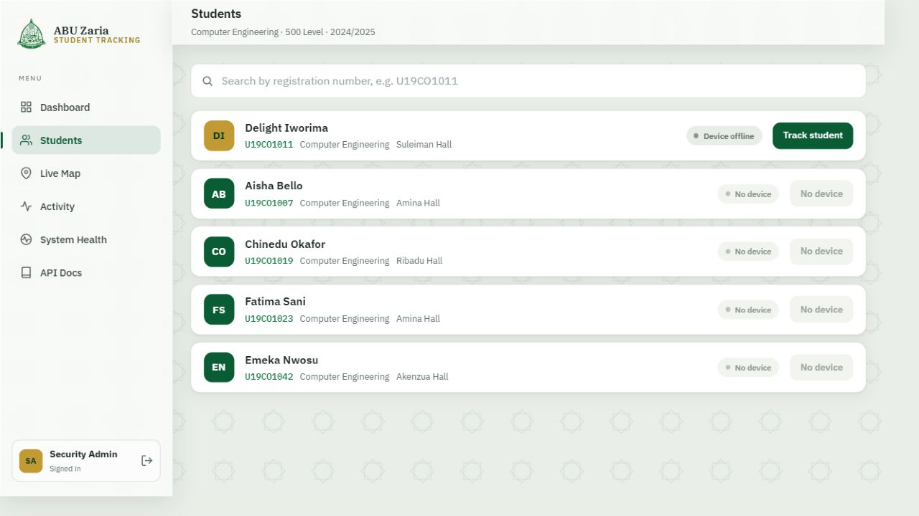
Figure 4.1: Registered-student list and registration-number tracking entry point
Source: Author's screenshot of the implemented system (2026).
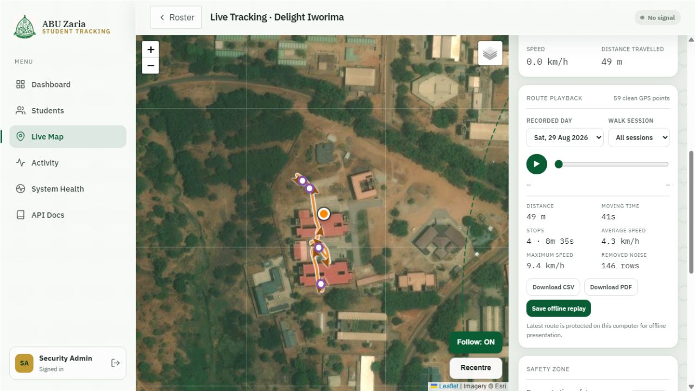
Figure 4.2: Stored GPS route, playback controls and movement measurements for U19CO1011
Source: Author's screenshot of the implemented system (2026).

4.7 Evaluation Against the Objectives
Objective | Evidence | Status
1. Hardware and firmware | Integrated T-A7670E acquired GNSS/cellular positions and transmitted LTE records | Achieved
2. Backend and dashboard | Authenticated search, map, refined replay, stops, alerts, exports, health and API docs | Achieved
3. Integration and ≥200 m operation | End-to-end physical-device operation verified; controlled ≥200 m form pending | Pending field test

Table 4.6: Objective-by-objective evaluation

4.8 Discussion
The strongest result is that the entire chain works with one main board: physical position acquisition, mobile transmission, temporary on-device buffering, backend validation, persistent storage, authenticated access and live presentation. The 17 software tests demonstrate predictable backend behaviour, and the 875-record database snapshot proves that the application processes data from the physical modem rather than only generated demonstration coordinates.
The results also expose the limits of the design. GNSS is highly accurate outdoors when reception is good, but a card carried under clothing or inside a building may lose direct satellite visibility. The retained position is useful only for a short interruption and does not mean the student remains at that exact point. Cellular position keeps the system responsive but can be far from the actual location. A phone appears more accurate indoors because it may combine GNSS, Wi-Fi databases, cellular measurements, motion sensors and a large commercial positioning service. Reproducing that capability would require extra sensors, infrastructure, permissions and software beyond this prototype.
The current hardware validates the concept but is not yet a normal wallet card. The development board, attached antennas and USB-C power-bank arrangement need more thickness than an ISO-sized plastic card. The honest engineering conclusion is that the demonstrator is a trackable ID-card holder prototype. A production card requires custom electronics and mechanical design after exact component measurements.

CHAPTER FIVE
CONCLUSION

5.1 Conclusion
This project designed and implemented a GPS- and LTE-based trackable student identification prototype using a LilyGO T-A7670E board and a real-time web application. The device acquired outdoor satellite positions, retained the last acceptable fix through brief signal loss, used a clearly labelled cellular estimate as fallback, buffered temporary transmission failures and sent records through LTE. The Flask backend validated and stored the data in SQLite, while the administrator dashboard linked the physical card to a searchable student record and provided live mapping, refined route playback, stop detection, distance, speed, geofence alerts, exports, system-health checks and API documentation.
All 17 automated backend tests passed, and the reporting snapshot contained 875 physical-device records. The latest route-processing run produced 59 coordinated display points, rejected two implausible jumps and detected four stationary periods from the selected development session. These results verify the major hardware and software functions. The remaining acceptance step is a controlled route of at least 200 m using the result form supplied in this report. Overall, the work demonstrates that a low-component integrated board can support a credible end-to-end student-tracking prototype, provided that satellite, cellular, privacy and physical-size limitations are stated clearly.

5.2 Limitations
- Satellite positioning is primarily an outdoor technology; roofs, walls, card orientation and surrounding structures can delay or prevent a reliable fix.
- The cellular fallback is an estimate and may be considerably less accurate than a good satellite fix.
The development board, external antennas and USB-C power-bank arrangement are not as thin as a standard wallet card; the current object is best described as a card-holder prototype.
- The demonstration uses one physical card and five software student records, so multi-device radio behaviour was not evaluated.
- The ngrok demonstration tunnel uses the configured prototype transport. Production use requires enforced TLS, secure key storage, individual accounts and privacy governance.
A dedicated battery was not fitted, and power-bank endurance, impact resistance, waterproofing and long-term cellular data cost were not characterised in a controlled laboratory study.

5.3 Important Findings
1. An integrated ESP32, LTE and GNSS development board reduces the component and wiring burden enough to make a complete tracking demonstration practical within a short project period.
2. Location availability and location accuracy are different. Cellular fallback improves availability, but only a source label and quality checks prevent the user from assuming false precision.
3. A short persisted hold of the last good satellite fix gives smoother behaviour through brief reception loss, while an age limit prevents the system from presenting an indefinitely stale point as current.
4. Route quality checks, session separation, jump rejection and smoothing are necessary because raw satellite readings can otherwise create false zigzags, distance and speed.
5. Keeping temporary failed reports on the card preserves evidence through a short server or mobile-network interruption without changing their original capture times.
6. Automated backend tests add evidence that authentication and input validation work; a polished dashboard alone cannot prove those controls.

5.4 Recommendations for Further Work

5.4.1 Proposed Miniaturised Production Version
The implemented LilyGO board was selected to prove the complete tracking process quickly and with few separate parts. It is a development platform, however, and its board outline, antenna connectors, external antennas and USB-C power-bank arrangement prevent it from becoming a normal thin identification card simply by adding a shell. ISO/IEC 7810 defines the physical characteristics of standard identification cards, including the ID-1 format used for bank and student cards (International Organization for Standardization, 2019). The present prototype should therefore be described as a trackable ID-card holder rather than as an ISO-thickness card.
A smaller production version could place only the required controller, LTE/GNSS modem, SIM or eSIM interface, protected flat lithium-polymer battery, charging and power-management circuits, and carefully tuned antennas on a custom printed circuit board. The concept in Figure 5.1 shows a 33 mm by 22 mm board and a 38 mm by 26 mm by 6.5 mm enclosure as an illustrative target. These dimensions were not measured from a fabricated unit and are not claimed as achieved results. The optional Wi-Fi, Bluetooth, motion sensor, eSIM and emergency-button labels shown in the concept are possible later additions; they are not all present in the current prototype. Making the device still smaller would reduce available battery space and make antenna efficiency, heat, radio certification, assembly and repair more difficult.
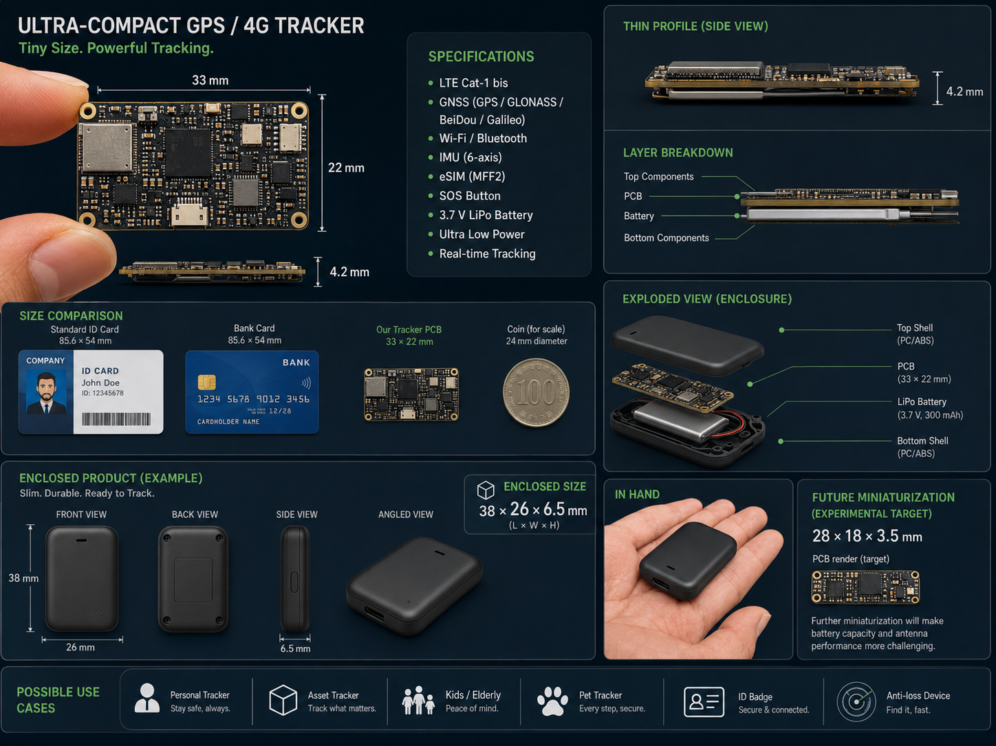
Figure 5.1: Conceptual illustration of a possible miniaturised production tracker (design target; not fabricated or experimentally validated)
Source: Author's conceptual illustration prepared for this project (2026).

5.4.2 Other Recommendations
- Develop the proposed custom printed circuit board only after electrical design review, antenna layout work, power-budget calculation and physical measurement of the selected protected battery and connectors.
- Add Bluetooth Low Energy or Wi-Fi anchor points in selected buildings for room- or zone-level indoor location while retaining GNSS outdoors.
- Deploy the backend on a permanent HTTPS service and replace shared demonstration credentials with role-based institutional accounts, audit logs and a retention policy.
- Evaluate battery endurance, charging safety, thermal behaviour, radio performance inside the enclosure and repeated controlled route accuracy.
- Test multiple physical cards concurrently and add device provisioning, key rotation, lost-card revocation and maintenance status.
- Adopt a formal consent and authorisation process so that tracking is used only for legitimate, disclosed university purposes.

REFERENCES
Agafonkin, V. (2023). Leaflet (Version 1.9.4) [Computer software]. https://leafletjs.com/
Alquhali, A. H. Y., & Roslee, M. (2018). A novel real-time vehicle tracking system using Arduino. Engineering International, 6(2), 93–106. https://doi.org/10.18034/ei.v6i2.228
Alsadi, A. S. H. (2013). The development of embedded GPS-GSM based real time vehicle tracking system. Engineering and Technology Journal, 31(10), 1982–1999. https://doi.org/10.30684/etj.31.10a13
Arduino. (n.d.). ArduinoHttpClient (Version 0.6.1) [Computer software]. GitHub. Retrieved August 30, 2026, from https://github.com/arduino-libraries/ArduinoHttpClient
Atzori, L., Iera, A., & Morabito, G. (2010). The Internet of Things: A survey. Computer Networks, 54(15), 2787–2805. https://doi.org/10.1016/j.comnet.2010.05.010
Grinberg, M. (n.d.). Flask-SocketIO documentation. Retrieved August 30, 2026, from https://flask-socketio.readthedocs.io/en/latest/
International Organization for Standardization. (2019). ISO/IEC 7810:2019: Identification cards—Physical characteristics (4th ed.). https://www.iso.org/standard/70483.html
Jiménez-Martínez, M. J., Zabala Haro, M., Martín Furonés, Á., & Anquela Julián, A. (2025). A GNSS–cellular network hybridization strategy for robust positioning. Applied Sciences, 15(11), 6300. https://doi.org/10.3390/app15116300
Khin, J. M. M., & Oo, N. N. (2018). Real-time vehicle tracking system using Arduino, GPS, GSM and web-based technologies. International Journal of Science and Engineering Applications, 7(11), 433–436. https://doi.org/10.7753/IJSEA0711.1006
LewisHe. (n.d.). TinyGSM fork (Version 1.0.0) [Computer software]. GitHub. Retrieved August 30, 2026, from https://github.com/lewisxhe/TinyGSM-fork
LilyGO. (n.d.-a). LilyGO A7670X ESP32 version [Hardware documentation]. GitHub. Retrieved August 30, 2026, from https://github.com/Xinyuan-LilyGO/LilyGo-Modem-Series/blob/main/docs/en/esp32/a7670-esp32/README.MD
LilyGO. (n.d.-b). LilyGo-Modem-Series [Computer software and hardware documentation]. GitHub. Retrieved August 30, 2026, from https://github.com/Xinyuan-LilyGO/LilyGo-Modem-Series
LilyGO. (n.d.-c). T-SIM A7670E/G/SA R2 [Product page]. Retrieved September 1, 2026, from https://lilygo.cc/products/t-sim-a7670e
Marquezan, L., Gamboa Peñaloza, E. A., de Oliveira Evald, P. J. D., Hernandez Cely, M. M., Rossi, M. L., & de Lima, S. (2024). iLocator—A low cost IoT-based hybrid architecture for tracking and locating objects in indoor environments. Internet of Things, 28, 101369. https://doi.org/10.1016/j.iot.2024.101369
Morallo, N. T. (2021). Vehicle tracker system design based on GSM and GPS interface using Arduino as platform. Indonesian Journal of Electrical Engineering and Computer Science, 23(1), 258–264. https://doi.org/10.11591/ijeecs.v23.i1.pp258-264
National Bureau of Statistics. (2024). Social statistics report 2023. https://nigerianstat.gov.ng/pdfuploads/SOCIAL%20STATISTICS%20REPORT%202023%20Final.pdf
National Coordination Office for Space-Based Positioning, Navigation, and Timing. (n.d.). GPS accuracy. GPS.gov. Retrieved August 30, 2026, from https://www.gps.gov/gps-accuracy-0
National Institute of Standards and Technology. (2019). Considerations for managing Internet of Things (IoT) cybersecurity and privacy risks (NISTIR 8228). https://doi.org/10.6028/NIST.IR.8228
OpenAPI Initiative. (2020). OpenAPI specification (Version 3.0.3). https://spec.openapis.org/oas/v3.0.3
Osman, M. E. A., & Hassan, H. (2024). GPS and GSM-based vehicle tracking system. Progress in Engineering Application and Technology, 5(1), 23–31. https://doi.org/10.30880/peat.2024.05.01.003
Pallets Projects. (n.d.). Flask documentation. Retrieved August 30, 2026, from https://flask.palletsprojects.com/en/stable/
SIMCom Wireless Solutions. (2021). A7670 series hardware design (Version 1.03). https://www.simcom.com/product/A7670X.html
SQLite. (n.d.). About SQLite. Retrieved August 30, 2026, from https://www.sqlite.org/about.html

APPENDIX A
MAJOR API ENDPOINTS
Method | Path | Purpose | Access
POST | /api/ingest | Accept and validate a card location report | Device key
POST | /api/heartbeat | Update online state when no new position is available | Device key
GET | /api/students | List and search students | Admin session
GET | /api/student/{reg_no} | Return one student, assigned card and latest state | Admin session
GET | /api/student/{reg_no}/recent | Return the five most recent separated positions | Admin session
GET | /api/student/{reg_no}/track | Return refined route, stops and statistics | Admin session
GET | /api/student/{reg_no}/track.csv | Download the processed route as CSV | Admin session
GET | /api/student/{reg_no}/report.pdf | Download a printable route report | Admin session
GET/POST | /api/geofence | Read or change the demonstration boundary | Admin session
GET | /api/alerts | Return stored geofence alerts | Admin session
GET | /api/system/health | Check backend, database, tunnel and local assets | Admin session
GET | /openapi.json | Return the hand-written API specification | Admin session
GET | /docs | Display interactive API documentation | Admin session

APPENDIX B
PROTOTYPE HARDWARE AND SIGNAL CONNECTIONS
Connection | Implementation note
USB-C | Programming, serial monitoring and prototype power from computer or power bank
LTE antenna connector | Connect the supplied LTE antenna before network transmission
GNSS antenna connector | Connect the GNSS antenna and place it with a useful sky view
SIM holder | Insert an activated LTE-capable SIM with available data
ESP32 ↔ A7670E UART | Already routed on the development board and controlled by firmware
Battery connector | Not used in the tested prototype; leave disconnected while powering through USB-C from the power bank

Safety note: no battery is connected in the tested prototype. Power is supplied from a power bank through USB-C, and the unused battery connector is left disconnected. Any future battery work must confirm the exact board revision, polarity, protection and charging arrangement and should be carried out by a competent technician with the board unpowered.

APPENDIX C
DEMONSTRATION CHECKLIST
☐ Charge the power bank and confirm the USB-C cable can carry data and power.
☐ Attach the LTE and GNSS antennas to the correct labelled connectors.
☐ Confirm the SIM has data service and the firmware contains the correct access point and server URL.
☐ Double-click START_DEMO.cmd and wait for the backend and ngrok checks to complete.
☐ Open System Health and confirm that the backend, SQLite database and required local files are available.
☐ Confirm that the public ngrok address matches the static address already stored in the firmware; re-flash only if that configuration actually changes.
☐ Power the card outdoors and wait for a fresh gps source before entering the room.
☐ Log in, search U19CO1011, open live tracking and confirm the timestamp changes.
☐ Show recent locations, source labels, satellite count and signal geometry.
☐ Open Activity, choose the saved date/session, replay the route, and point out the stop markers and refined line.
☐ Download the CSV or PDF route report as repeatable evidence.
☐ Open API Docs and explain the device-key header and location endpoint.
☐ Keep a saved route available in case live cellular coverage is slow during the defence.
☐ Do not claim precise indoor tracking or wallet-card thickness with the present prototype.

APPENDIX D
CONTROLLED FIELD-TEST RECORD
Field | Recorded value
Tester
Date and time
Test location
Independent route measurement
Starting coordinate and source
Ending coordinate and source
Number of received updates
Dashboard calculated distance
Longest update interruption
Recovery observed
Overall result and remarks

Recommended acceptance criterion: the card remains powered, the server receives multiple valid records during a measured route of at least 200 m, and the dashboard displays the latest position without manual database editing. Record the position source so that a cellular estimate is not graded as satellite accuracy.

