0NF (Unnormalized)
Data can be considered unnormalized if it follows any of the following characteristics:
- Repeating Groups
- Non-atomic data
- No primary key
- Redundant data
- Anomalies inserting or updating data
- Redundant data
Below is an example of unnormalized data for our games marketplace where all the data is contained within a single table:
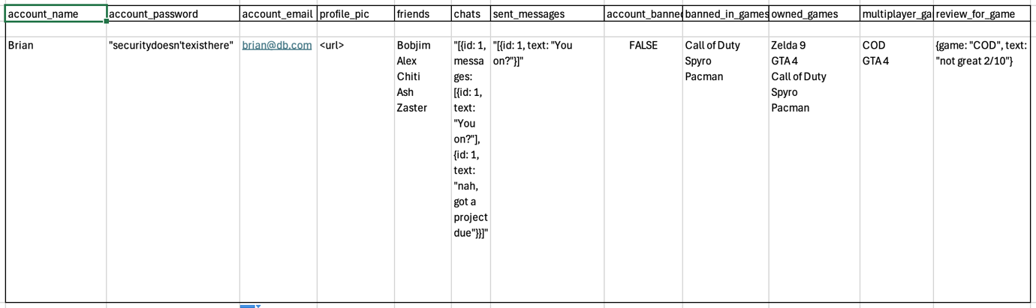
Apart from being in a single table, it has multiple characteristics on unnormalized data, for example it contains several examples of repeating groups where games are referenced alongside non-atomic data types in the chats, sent_messages and review_for_game column. There is also no primary key. A simple ERD is shown below.
