1NF (1st Normal Form)

1st Normal Form is the first stage of normalization, and has the following characteristics:
- Uniquely Identifiable rows
- Atomicity, each attribute is an atomic value
- No repeating groups

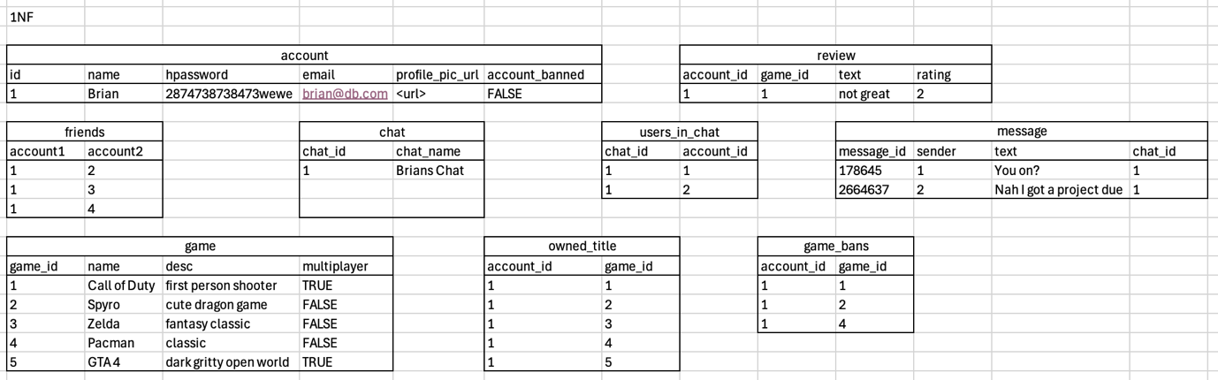
As you can see a lot of changes were made between this and the original un-normalised format. Due to many of the columns containing a lot of non-atomic data, many were split into other tables to ensure that this requirement was met, An issue I also came across was how to store friend relations, this was resolved with a “Junction” table <REFERENCE> which was also useful when trying to keep track of which users are in a chat whilst keeping the data atomic.

<ERD Here>

