Introduction
WC - 63
This report will cover the implementation of my database design from part one, the database is responsible for storing the data of a new online video games marketplace, positioning itself as a competitor to “Steam”. This report will cover the initial implementation and conversion from a logical entity relationship diagram (ERD), various queries performed on test data and the challenges during this process. To write queries, scripts and interact with the database MySQL Workbench was used.

Implementing the ERD into a Functional Database
WC
Before I begin, a quick note that my script and data was performed on a dockerized instance of MySQL rather than a local instance directly, in situations where this is relevant, I will show how it was done in this situation and on a local instance.
The ERD was mostly accurate however was missing some information such as in the ‘message’ table there was no field for the actual content of the message, this was added before continuing. MySQL workbench was once used to visualize a final ERD before continuing, this can be updated and used to create scripts and schemas that can be used directly on the database, saving time.
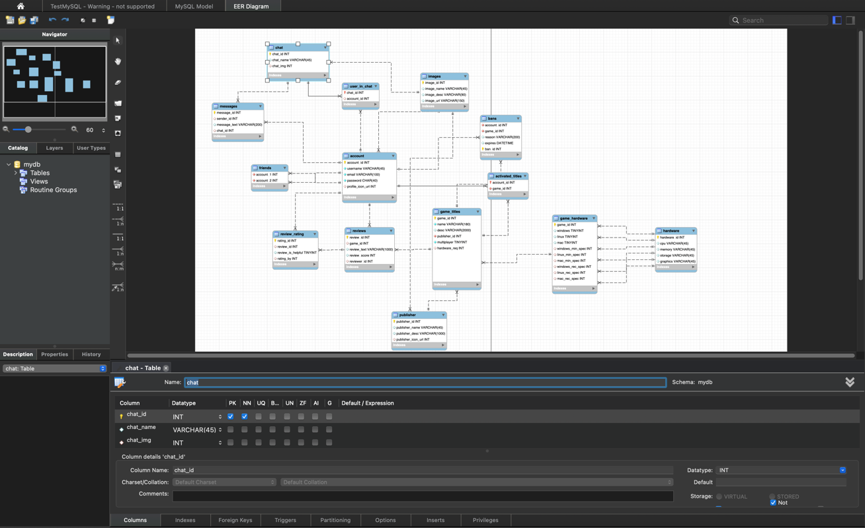
An example of what the creation script for the account table is shown below, including how to drop and then use the database (named marketplace),
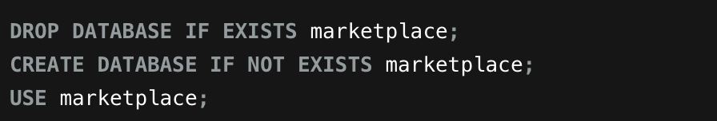
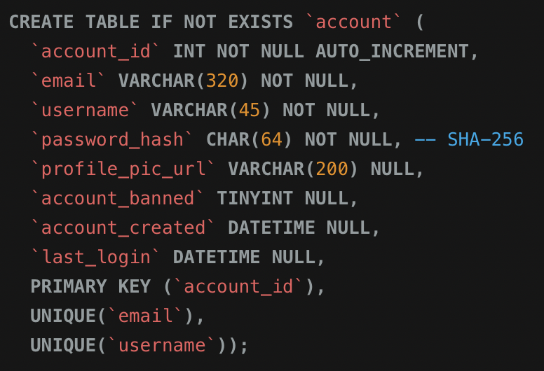
Constraints were added to the “account_id” to designate it as the primary key for this table which also creates an index for it by default, ‘UNIQUE’ constraints were added to the ‘email’ and ‘username’ columns to ensure that

