1NF (1st Normal Form)

1st Normal Form is the first stage of normalization, and has the following characteristics:
- Uniquely Identifiable rows
- Atomicity, each attribute is an atomic value
- No repeating groups

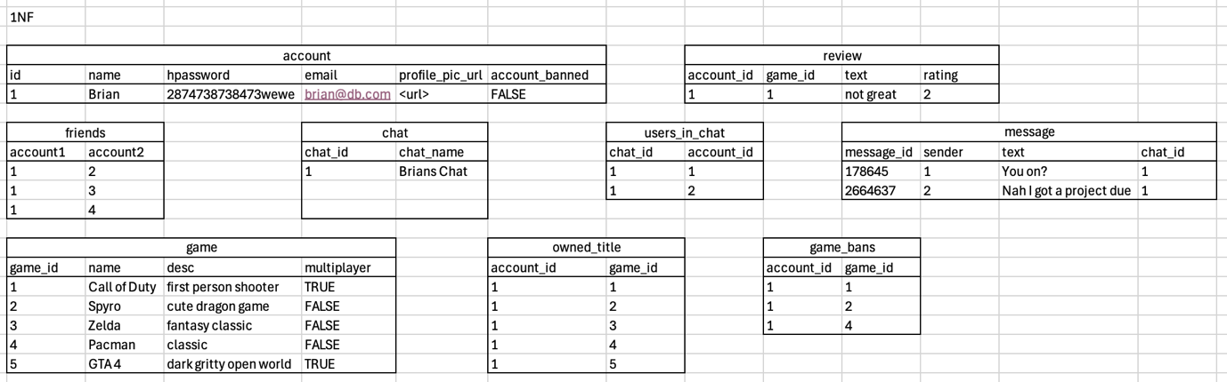
As you can see a lot of changes were made between this and the original un-normalised format. Due to many of the columns containing a lot of non-atomic data, many were split into other tables to ensure that this requirement was met, An issue I also came across was how to store friend relations, this was resolved with a “Junction” table <REFERENCE> which was also useful when trying to keep track of which users are in a chat whilst keeping the data atomic.

<ERD Here>

UPDATED NEED TO REWRITE
1. Atomic Values:
• Each field now contains only a single piece of data.
• For example, in the Friends Table, friendships are stored in separate rows rather than a single column containing multiple names.
2. Repeating Groups Eliminated:
• Instead of storing all owned games, banned games, or messages in a single field, they are now separated into dedicated tables (e.g., Owned Games Table, Game Bans Table, Messages Table).
3. Primary Keys Introduced:
• Each table now has a unique identifier, ensuring that every row can be referenced correctly.
• Example: account_id in the Accounts Table, game_id in the Game Table, message_id in the Messages Table.
4. Proper Relationship Handling:
• Many-to-Many relationships (such as Friends and Owned Games) are handled via junction tables (Friends Table, Owned Games Table).
• This avoids duplication and ensures relational integrity.

1NF Explanation for the Report

The First Normal Form (1NF) ensures that all data is stored in an atomic format, removing any repeating groups. In this database design, relationships such as friends, owned games, and banned games are moved into separate tables, ensuring each column contains only atomic values. Additionally, the Messages Table and Reviews Table now store individual records instead of nested or grouped data. By structuring the database this way, we improve data integrity, consistency, and scalability, which will facilitate further normalization into 2NF and beyond.
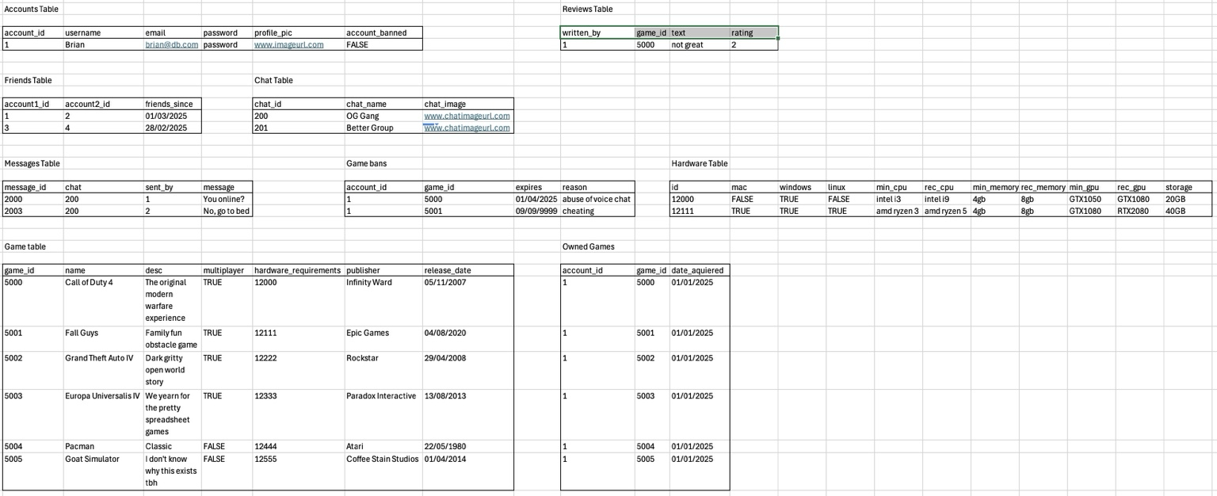

2NF
The Second Normal Form (2NF) ensures that all non-key attributes fully depend on the entire primary key, preventing partial dependencies. In this database design, each table either has a single-column primary key (e.g., Accounts, Games, Messages, Hardware) or a composite primary key (e.g., Friends, Game Bans, Owned Games) where all attributes depend on both parts of the key. Because of this, the database already meets 2NF requirements, ensuring data integrity, consistency, and better scalability for future expansions. The next step in the normalization process is 3NF, which focuses on removing transitive dependencies.
3NF
The Third Normal Form (3NF) ensures that all attributes depend only on the primary key and removes any transitive dependencies, which could cause data redundancy. In this database, every table has been structured so that no non-key attribute is dependent on another non-key attribute. For example, in the Game Table, the hardware_requirements attribute is properly referenced using an ID rather than storing redundant data directly. Similarly, the Reviews Table stores review_id as a unique identifier, ensuring that text and rating depend only on it. Because of these structural choices, the database already meets the 3NF requirements, making it more efficient, easier to maintain, and free from unnecessary duplication. The next step in normalization is Boyce-Codd Normal Form (BCNF), which further refines dependencies.
BCNF
The Boyce-Codd Normal Form (BCNF) ensures that every determinant is a candidate key, eliminating any remaining functional dependencies that could cause data redundancy. In this database design, all tables have been properly structured to ensure that each non-key attribute depends only on the primary key. The Game Bans Table was refined further by introducing a Ban Reasons Table, ensuring that ban reasons are no longer dependent on game_id alone, but are instead uniquely identified by a ban_id key. With this refinement, the database is now fully normalized to BCNF, making it more efficient, scalable, and free from unnecessary duplication.
