School of Engineering, Arts, Science and Technology
Relational Databases: IMPLEMENTATION
S183038
Word Count: 1084

Table of Contents
Introduction 2
Setting up an instance of MySQL 2
Creating the schema 3
Testing with data and querying 7
Challenges and Problem solving 8
Conclusion 9
References 9

Introduction
WC: 99
This report documents the implementation of the relational database designed in part one. The database is responsible for storing and managing the data of a new online video game marketplace, positioned as a competitor to existing platforms such as “Steam”. The report covers the process of converting the logical Entity Relationship Diagram (ERD) into a fully functional MySQL database, alongside the testing and execution of various SQL queries on scripted test data. MySQL Workbench and JetBrains Data Grip were used for database design, query writing, and interacting with the database environment during development and testing (Oracle, 2025; JetBrains, 2025).

Setting up an instance of MySQL
WC: 113
To begin the process of converting my ERD into a functional database, an instance of MySQL was set up within a Docker container using the script shown below:
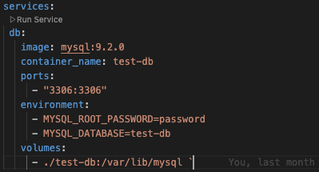
Figure 1: docker-compose.yml (Used to launch a Dockerized MySQL instance)

This approach also enabled me to keep the version of MySQL consistent, which is important going forward, as future version changes could introduce compatibility issues or even break functionality. It also allowed me to work across multiple machines without needing to install MySQL locally, as containerised environments ensure repeatable deployments and version control (Merkel, 2014). Where relevant, this report will discuss the differences that containerisation introduced in certain operations, and explain how the same tasks can also be performed on a MySQL instance running locally.

Creating the schema
WC: 364
The ERD produced in part one was largely accurate; however, during implementation, several changes and additions were made. For example, the message table was missing a field to store message content, which was added before proceeding. Additional attributes such as active_account and deleted_on were added to the account table to support soft deletion of user accounts for legal or data retention purposes, in line with GDPR requirements for the right to erasure (Information Commissioner’s Office, 2021). MySQL Workbench was used to visualise the updated ERD and served as a reference when building the schema.
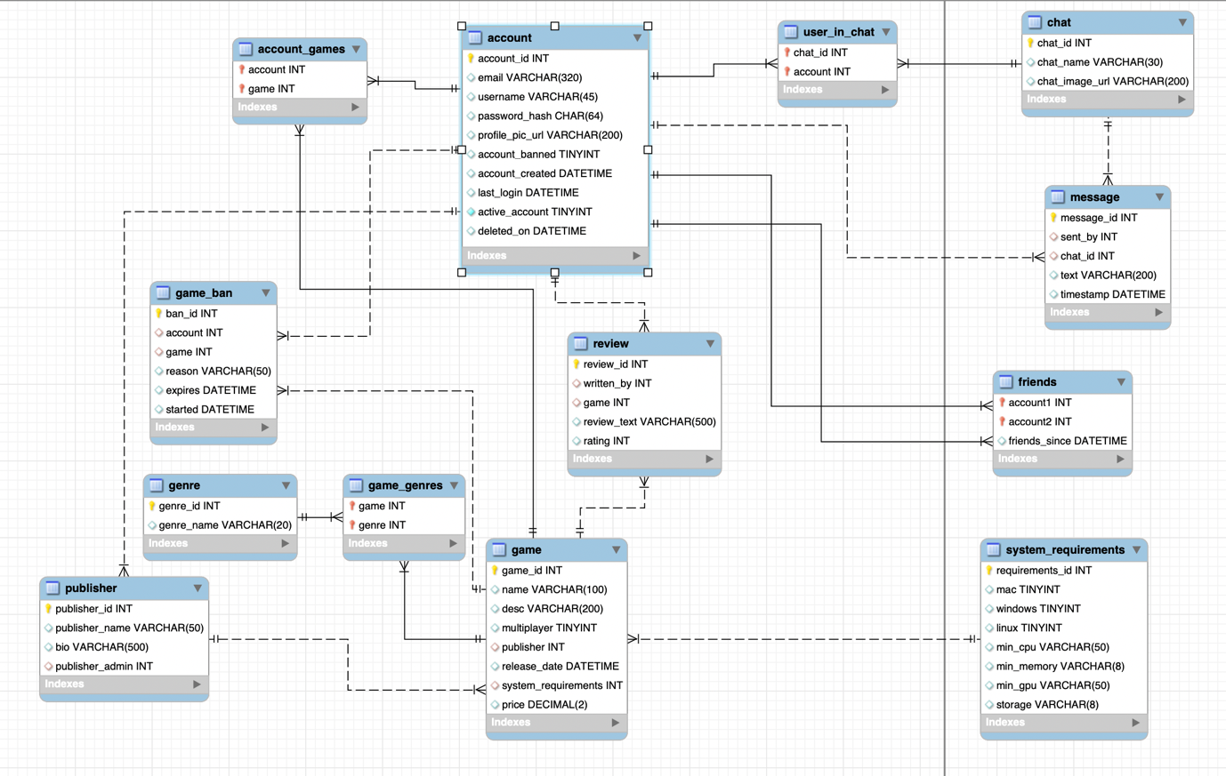
Figure 2: Finalised ERD for the Marketplace Database (From MySQL Workbench)

The schema was created incrementally, beginning with core entities such as account, followed by dependent tables like publisher, game, and review, which rely on foreign keys. To avoid constraint errors, parent tables were created before any child tables referencing them, as stipulated in the MySQL documentation (Oracle, 2024).
A public_account view was introduced to expose non-sensitive profile data while hiding private information such as email addresses and password hashes, making it useful for limiting the scope of data being retrieved. (Vanier et al., 2019, p. 234)
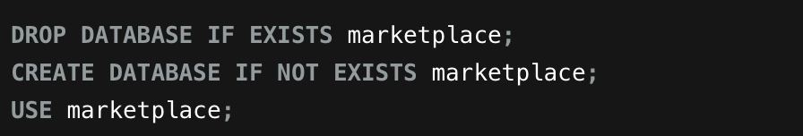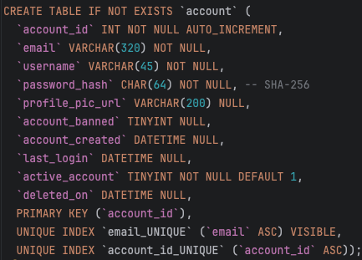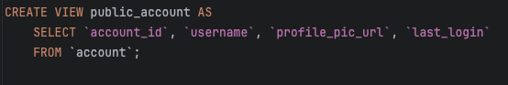
Figure 3: Snippet from final schema, showing how the database is created, along with the account table.

Indexes were applied to improve query performance, particularly on foreign key columns and fields requiring uniqueness, such as email, username, and publisher_id. Additional indexes were created on frequently queried columns like publisher_admin in the publisher table and written_by in the review table to enhance join efficiency (Vanier et al., 2019, pp. 48–49)

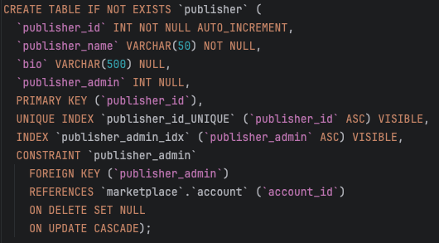
Figure 4: Publisher create script snippet, showing index on the publisher ID column / foreign key for more efficient joins.

Several stored procedures were developed to encapsulate common operations, including updating profile pictures, retrieving friends, and finding shared or unowned games. More complex logic was handled using Common Table Expressions (CTEs) with WITH ... AS (...) syntax to simplify multi-step queries and improve readability. These procedures also made use of joins, subqueries, and the public_account view (Vanier et al., 2019, pp. 6, 233–234).

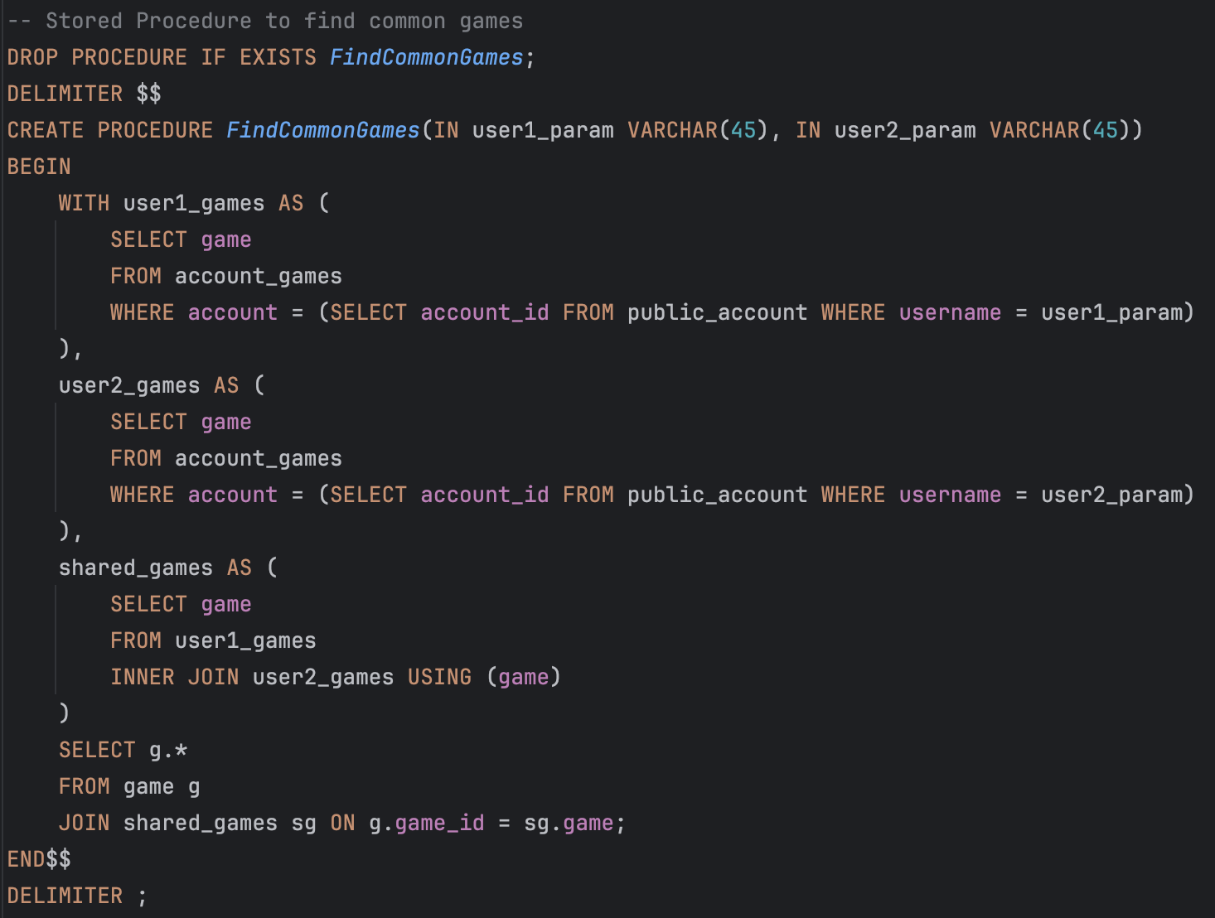
Figure 5: More complex stored procedure using WITH …AS syntax, used to find common games owned between two different players.

Role-based access control was implemented using MySQL GRANT statements. Three roles were defined: market_admin (full privileges, localhost-only access), app_user (read/write access), and readonly_user (read-only access). This allowed for more secure and maintainable permission management in a multi-user environment, aligning with MySQL 8’s support for user-defined roles and privilege assignment. Referential integrity was enforced using foreign keys with appropriate cascading actions. For example, ON DELETE CASCADE was used for review and account_games, while ON DELETE SET NULL was applied to fields like publisher_admin, where retaining historical context was important (Vanier et al., 2019, pp. 233–236).
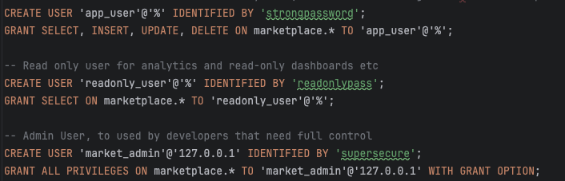
Figure 6: User roles within the create schema

Testing with data and querying
WC: 258
Realistic test data was created to support development and validate database functionality. An initial set of manually crafted records covered key scenarios, including users owning multiple games, publishers managing several titles, and reviews with varied ratings. This data included meaningful values such as usernames, profile pictures, descriptive game details, and system requirements.
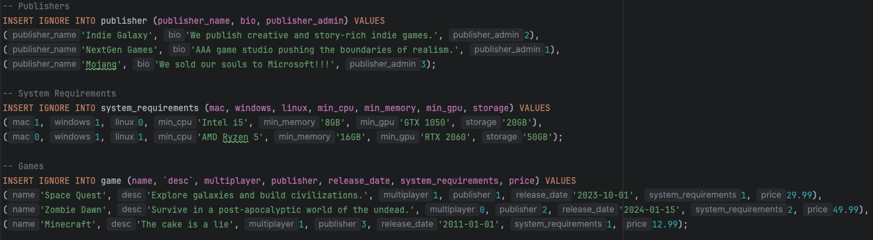
Figure 7: Snippet of manually crafted test data for account, game, and review tables.

To scale the dataset, a Python script using the Faker library was used to generate over 100 accounts, 50 games, 10 publishers, and hundreds of related records, such as reviews, friendships, chat messages, and game ownership data. Data complexity was increased through special characters, varied data types, and enforced foreign key constraints to maintain referential integrity.
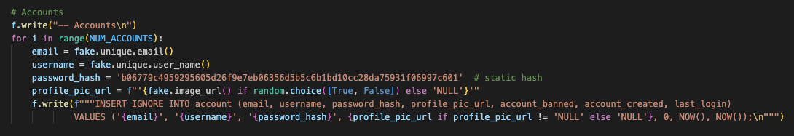
Figure 8: Snippet from Python test data generation script using Faker to generate accounts.
A range of SQL queries were written to test functionality and performance, including SELECT statements with JOINs, subqueries, and Common Table Expressions (CTEs) for more complex logic. Aggregate functions such as COUNT() were used to generate meaningful results. Query performance was analysed using EXPLAIN, confirming efficient use of indexes on key fields like username, email, and foreign keys. As shown in Figure 9, the execution plan demonstrates index usage on the account_games and account tables, with MySQL using keys such as PRIMARY and username, significantly reducing the number of rows scanned and improving performance. (Vanier et al., 2019, pp. 42–44, 66–67)
Figure 9: Screenshot of EXPLAIN plan showing use of indexes in query execution.

Data export and backup were automated using a Python script that ran mysqldump within the Docker container using docker exec, saving the output to a .sql file on the host machine. On a local installation of MySQL, the same process could be performed directly using:
`mysqldump -u root -p marketplace > marketplace_dump.sql`
and restored using:
`mysql -u root -p marketplace < marketplace_dump.sql`

ALTER TABLE statements were used during development to adapt the schema, and queries were incrementally tested to verify correctness and data integrity. Once confirmed, the changed where applied to the create script.

Challenges and Problem solving
WC: 127
Several challenges were encountered during development, particularly around maintaining referential integrity when inserting test data. Early attempts to insert records without considering foreign key dependencies led to constraint violations. This was resolved by ordering inserts carefully — creating parent records (e.g., account, publisher) before dependent tables like game or review.
Data type mismatches also caused errors, especially when inserting NULL values or exceeding defined VARCHAR lengths. These were resolved through validation and, where necessary, adjusting the schema.
Debugging was primarily carried out using JetBrains DataGrip, supported by incremental testing of queries. DataGrip provided an advanced query editor and better integration with my development environment compared to MySQL Workbench. Additionally, the SHOW WARNINGS and SHOW GRANTS commands were particularly useful for diagnosing permission-related issues and resolving errors during testing.

Conclusion
WC: 123
Overall, a fully functional database that covers the original requirements set out in part one was developed. Decisions such as enforcing foreign keys, applying cascading behaviours appropriately, and using indexing on frequently queried fields helped data integrity and ensuring efficient query performance. The use of views and stored procedures provided a secure and maintainable way to encapsulate database logic and protect sensitive data.
Future improvements could include expanding security features, such as implementing password salting and additional input validation. As the database scales, further performance optimisations could be made my analysing index usage and optimising were appropriate. Additionally, the automated data generation process could also be extended to simulate more complex user behaviour and larger datasets to support load testing or analytics requirements.

References

- Beaulieu, A., 2009. Learning SQL. 2nd ed. Sebastopol, CA: O’Reilly Media, p.231.
- Elmasri, R. and Navathe, S.B., 2015. Fundamentals of Database Systems. 6th ed. Boston: Pearson, pp.633–639.
- Hamidi, A., Hamraz, A.R. and Rahmani, K., 2024. Database security mechanisms in MySQL. Afghanistan Research Journal - Natural Science, 4(1), pp.1–9. Available at: https://www.arj.af/index.php/arj/article/view/66 [Accessed 13 Apr. 2025].
- Information Commissioner’s Office (ICO), 2021. Right to erasure (‘right to be forgotten’). [online] Available at: https://ico.org.uk/for-organisations/uk-gdpr-guidance-and-resources/individual-rights/individual-rights/right-to-erasure/ [Accessed 13 Apr. 2025].
- JetBrains, 2025. DataGrip. Available at: https://www.jetbrains.com/datagrip/ [Accessed 13 Apr. 2025].
- Merkel, D., 2014. Docker: Lightweight Linux containers for consistent development and deployment. Linux Journal, 2014(239), pp.2–2. Available at: https://www.linuxjournal.com/content/docker-lightweight-linux-containers-consistent-development-and-deployment [Accessed 13 Apr. 2025].
- Oracle, 2024. MySQL 8.0 Reference Manual: 15.1.20.5 FOREIGN KEY Constraints. [online] Available at: https://dev.mysql.com/doc/refman/8.0/en/create-table-foreign-keys.html [Accessed 13 Apr. 2025].
- Oracle, 2025. MySQL Workbench. Available at: https://www.mysql.com/products/workbench/ [Accessed 13 Apr. 2025].
- Vanier, E., Shah, B. and Malepati, T., 2019. Advanced MySQL 8: Discover the Full Potential of MySQL and Ensure High Performance of Your Database. Birmingham: Packt Publishing. Available at: http://ebookcentral.proquest.com/lib/ucsl/detail.action?docID=5675584 [Accessed 17 Apr. 2025].

Appendix

Appendix A: Output from running create script
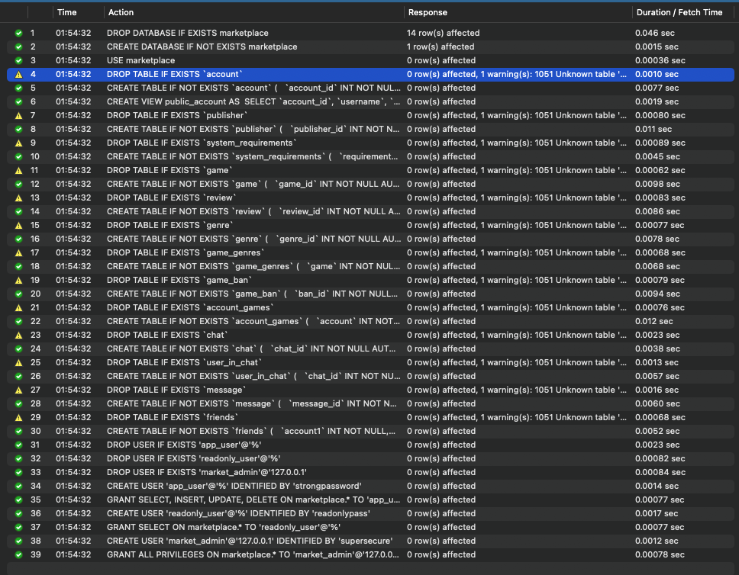

Appendix B: Output from running basic test data insert
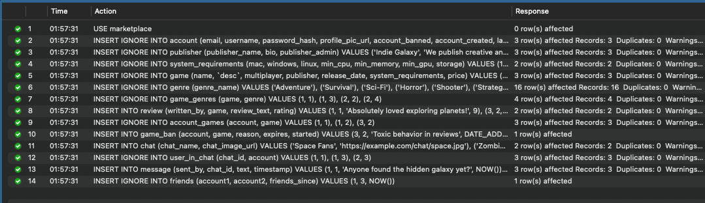

Appendix C: Output from running generated test data insert
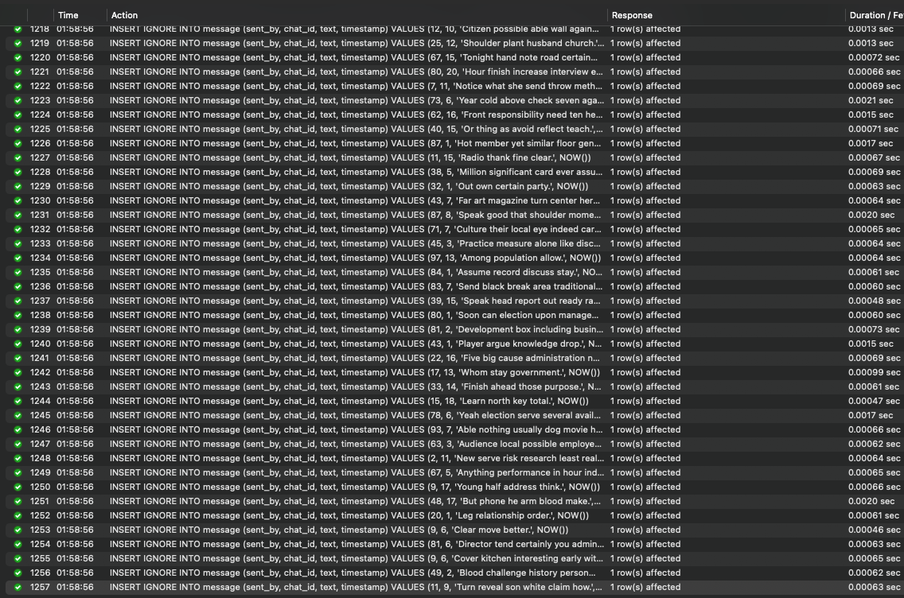

Appendix D: Output from running create stored procedures
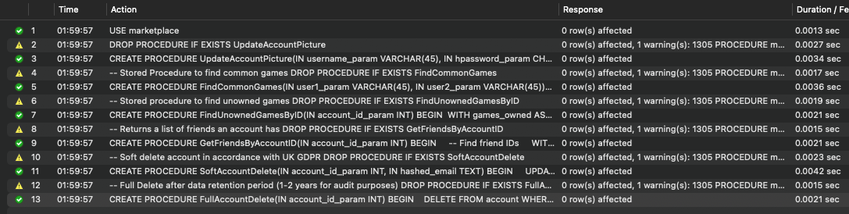

Appendix E: Console output showing successful run of select queries
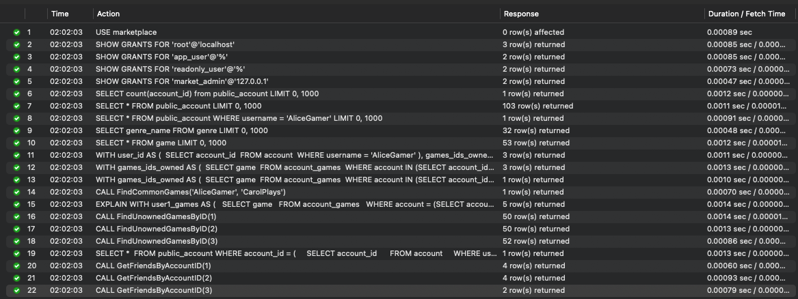

Appendix F: Result of stored procedure call

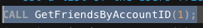

Appendix G: Output from running update queries
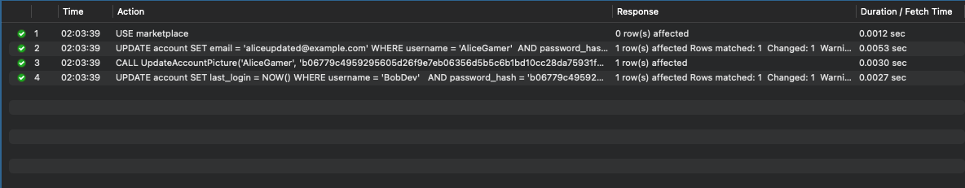

Appendix H: Output from running delete queries
