**TECHNOLOGY DESIGN**

**SYSTEM MENU**

In the system Menu, the user will have a choice if they want to buy products immediately, view the product first, view customers and the inventory of the online clothing store.

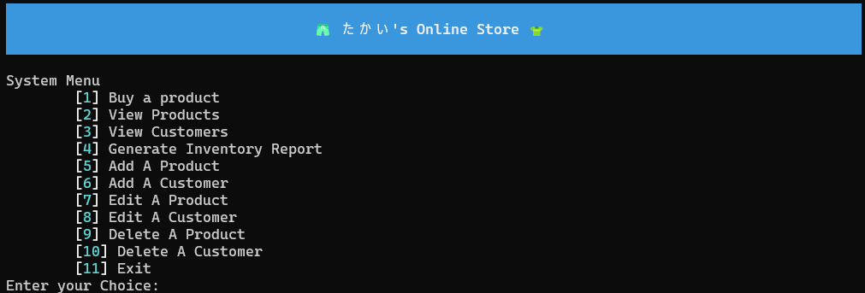

**BUY A PRODUCT**

If the user's choice is [1] buy a product from the online clothing store, the system will generate and ask the user of what specific product will they bought based on the given number of the clothes or product and how many will they get. The system will ask what is the user's ID for information and lastly, it will calculate the total amount of payment based on the clothes they picked.

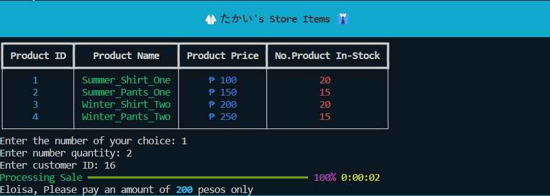

**ADD A CUSTOMER**

When the user's choice is [6] the system will ask the user what ID will be assigned to the new Customer, what will be the name and the address. Then it will be processed and then stored in the c_customer dictionary.

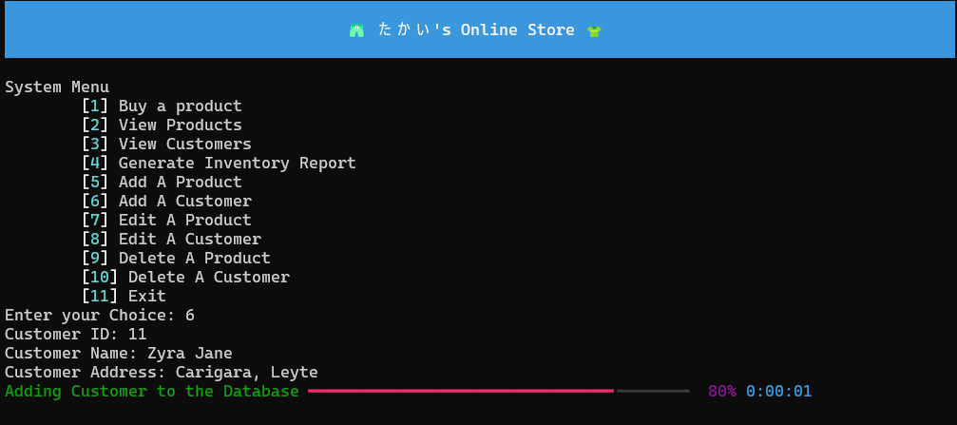

**EDIT A PRODUCT**

When the user's choice is [7] the system will ask the user for the ID number of the product that will be edited, then it will ask for the new name, price and stock. If left blank, then the information that is already assigned will not be tampered.

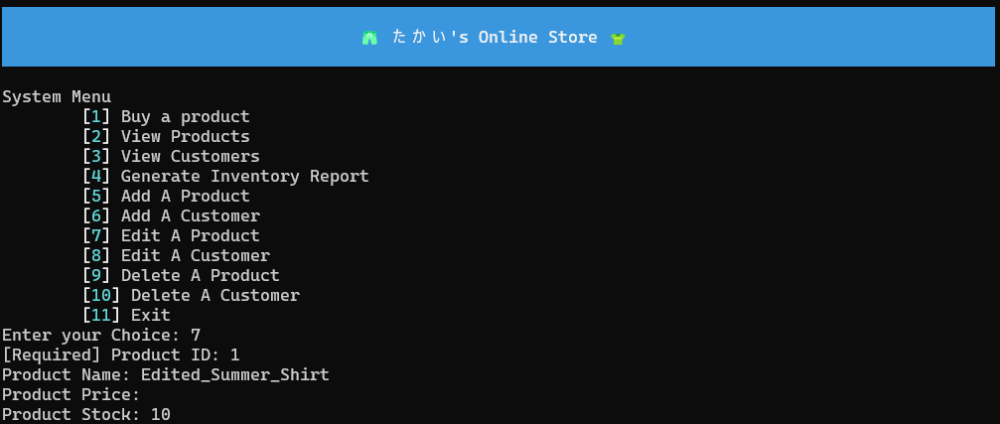

**DELETE A CUSTOMER**

When the user's choice is [10] the system asks the user what Customer to delete in the dictionary based on the Customer’s ID.

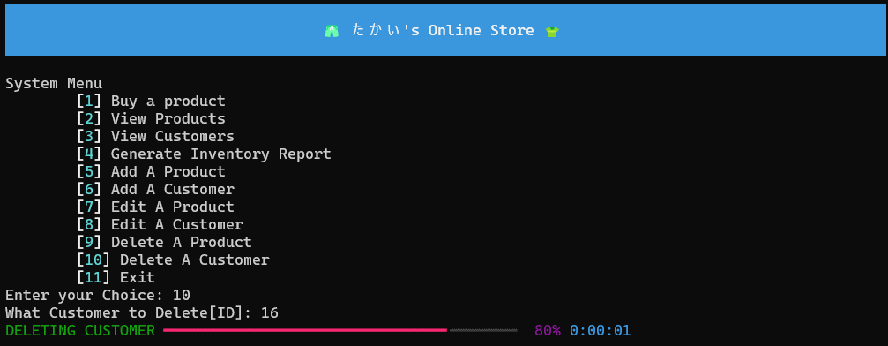

**EXIT**

When the user's choice is [11] the system will generate “Thank You! Come again” on the screen as a sign of closing the online store.

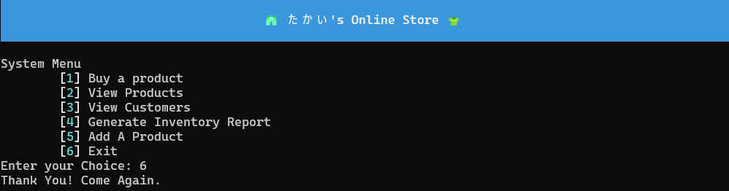



**EDIT A CUSTOMER**

When the user's choice is [8] the system will ask the user what Customer information to edit based on its ID. Then it then asks for the new Customer name and new customer address, if left black, nothing will be edited.

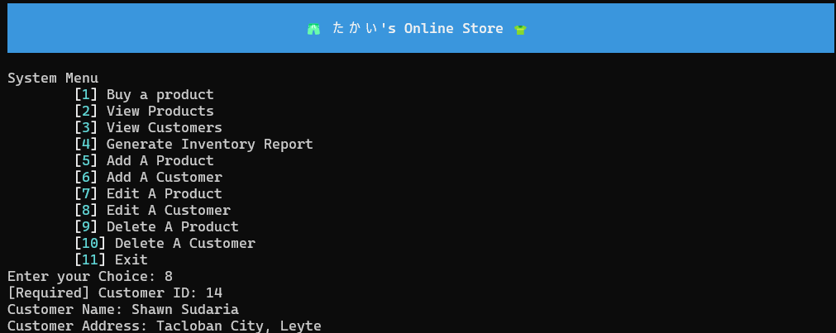

**DELETE A PRODUCT**

When the user's choice is [9] the system will ask the user what product to delete based on the unique product number assigned to each product.

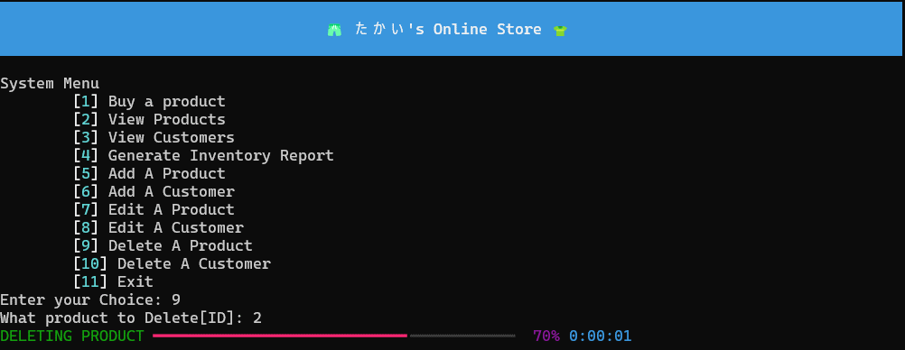

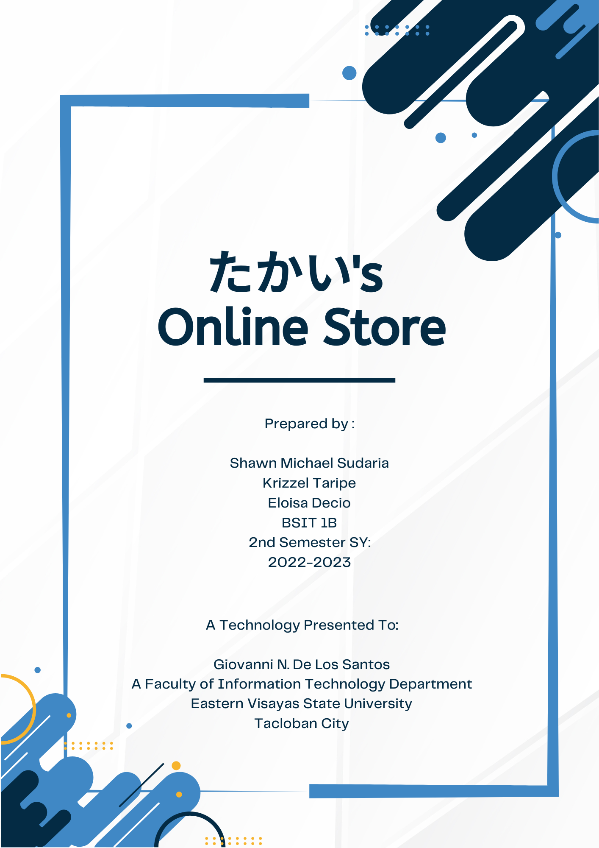



**INVENTORY**

When the user's choice is [4] Generate Inventory Report, the system will allow the user to see the customer's ID, the customer's payment, the customer's choice of product and also generate the no. of products left on the online store and the no. of clothes sold.

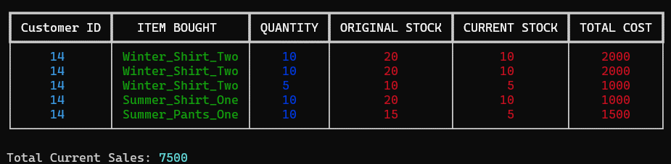

**ADD A PRODUCT**

When the user's choice is [5] the system will generate 3 input prompts for getting product information from the user.

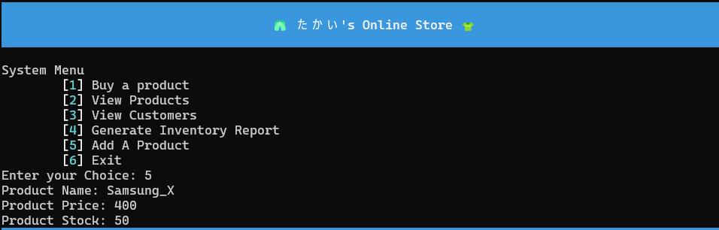





**VIEW PRODUCT**

When the user's choice is [2] view product from the online clothing store, the system will generate and let the user view the available products or clothes from the store with their corresponding price and no. of stock

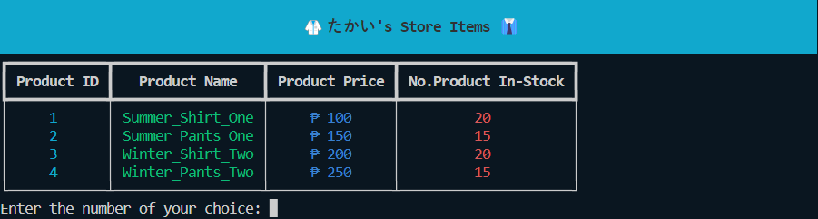

**View Customer**

When the user choice is [3] view the customers of the store, the system will generate the information of the customers like the customer's ID, customer's Name and the customer's Address.

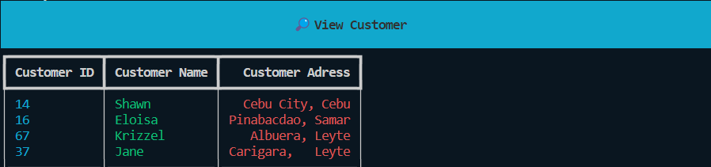



**Rationale**

Our system is called "たかい's Online Store" which translates to Expensive Online Store. Online clothing stores have become increasingly popular due to their convenience and accessibility. たかい's Online Store offer customers a wide range of clothing options, competitive pricing, personalized recommendations, and hassle-free returns. With the ability to shop from the comfort of their homes, customers can easily explore different styles, find unique pieces, and make fashion choices that suit their preferences and budget.

**Objectives**

- To help customers an easy online shopping of clothes

- To help the small businesses manage their online business through getting an easy inventory result

- To give the customers a hassle-free online shopping that suits their personalities

**Significance**

Online Clothing stores lies in their transformative impact on the fashion industry and consumer shopping habits. They have revolutionized the way people buy clothes by providing convenience, accessibility, and a vast array of choice. Online clothing stores have empowered customers to explore diverse fashion options, compare prices, and make informed decisions from anywhere at any time. Additionally, they have created opportunities for emerging designers and small businesses to reach a global audience, fostering creativity and diversity in the fashion landscape. Furthermore, online clothing stores have contributed to the growth of sustainable fashion practices by promoting eco-friendly options and transparent supply chains. Overall, the significance of online clothing stores is evident in their ability to enhance the shopping experience, foster innovation, and shape the future of the fashion industry.