# Revolutionizing Healthcare with a Medical RAG Chatbot

*By Beza Mesfin | June 13, 2025*

## Introduction: A New Era for Medical Information Access

Imagine asking a chatbot about diabetes symptoms and receiving a precise, evidence-based answer drawn from trusted medical documents, complete with a disclaimer urging you to consult a doctor. This is the power of our Medical RAG Chatbot, a cutting-edge AI solution designed to deliver accurate and accessible medical information. Built as a capstone project, this chatbot leverages Retrieval-Augmented Generation (RAG) to combine the strengths of document retrieval and natural language generation, addressing the challenge of unreliable medical responses in general-purpose AI tools. In a world where misinformation can have serious consequences, our chatbot aims to empower users with reliable knowledge while prioritizing safety and usability.

In this blog post, we’ll dive into the journey of creating this medical assistant, exploring its innovative tech stack, the challenges we overcame, and its potential to transform healthcare education. Whether you’re a tech enthusiast, healthcare professional, or curious learner, join us to discover how AI can make medical information more accessible and trustworthy.

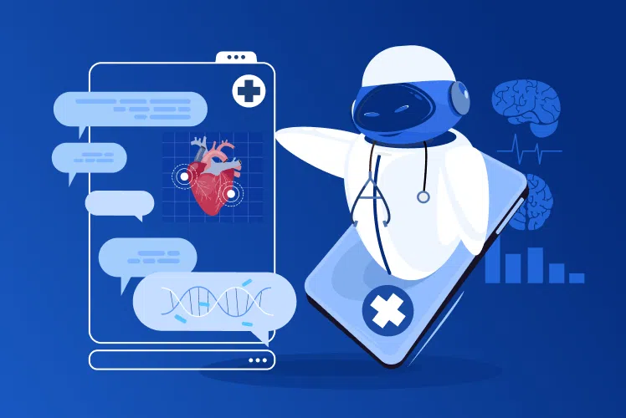

## The Vision: Why a Medical RAG Chatbot?

The inspiration for our project stemmed from a critical need: ensuring access to accurate medical information. General-purpose chatbots, while versatile, often struggle with medical queries, either hallucinating answers or lacking context. Our goal was to build a specialized chatbot that retrieves relevant medical documents and generates responses grounded in evidence, aligning with **Sustainable Development Goals (SDGs) 3 (Good Health and Well-being)** and **4 (Quality Education)**.

The chatbot serves as a medical assistant, answering informational queries (e.g., “What are the symptoms of hypertension?”) with concise, factual responses limited to seven sentences, as defined by our system prompt. A built-in disclaimer ensures users understand the information is educational and not a substitute for professional medical advice. By combining AI with a user-friendly interface, we aim to support patients, students, and educators in navigating complex medical topics.  
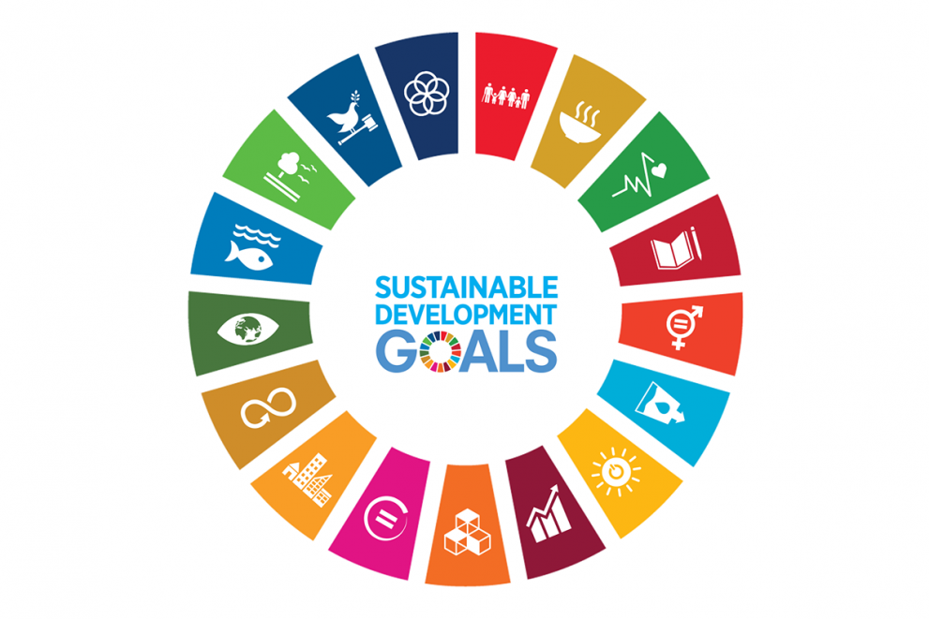

## The Tech Stack: Powering Precision and Usability

Our Medical RAG Chatbot is built on a robust tech stack that balances performance, scalability, and ease of use. Here’s a breakdown of the key components:

* **Streamlit**: The frontend framework creates an interactive chat interface ensuring accessibility and rapid development. Users interact via a simple text input, with responses displayed in a clean, conversational format.
* **LangChain**: This Python framework orchestrates the RAG pipeline, integrating retrieval and generation. It uses ChatPromptTemplate to enforce our system prompt, ensuring responses stay factual and context-driven.
* **Pinecone**: A cloud-based vector database stores medical document embeddings, enabling fast similarity search to retrieve the top-3 relevant documents for each query.
* **Google Gemini**: The gemini-2.0-flash model (assumed, pending confirmation) generates responses, tuned with temperature=0.4 for factual output and max_output_tokens=500 for conciseness.

**Supporting Libraries**:

* **Gensim**: Preprocesses medical texts (e.g., tokenization, lemmatization) to enhance retrieval quality.
* **TextBlob**: Cleans user inputs and documents, ensuring robust query handling.
* **tqdm**: Tracks progress during data indexing, streamlining development.
* **sentence-transformers**: Generates embeddings with all-MiniLM-L6-v2 for vectorizing queries and documents.
* **python-dotenv**: Secures API keys (PINECONE_API_KEY, GOOGLE_API_KEY) in a .env file.

This stack enables a seamless flow: a user query is vectorized, relevant documents are retrieved from Pinecone, and Gemini generates a response based solely on the context, all displayed in Streamlit’s intuitive UI.**Building the Chatbot: From Data to Deployment**

Our journey began by sourcing a comprehensive dataset of medical texts. This forms the foundation of our RAG system. We then proceeded through several crucial stages: data processing, embedding generation, vector database indexing, and RAG chain construction.

**Data Preprocessing**

Data preprocessing was paramount, involving cleaning and preparing the raw medical text. This included normalizing whitespace, converting text to lowercase, and removing punctuation to ensure consistency. To prepare the text for our embedding models, we tokenized the content, splitting it into individual words or meaningful units. Finally, we chunked the extensive medical documents into smaller, overlapping segments, ensuring that each chunk retained sufficient context while remaining manageable for embedding and retrieval. This meticulous process transforms raw, unstructured text into a clean, consistent format ready for advanced analysis.

**Embedding Generation and Vector Database Indexing**

Next, the preprocessed text chunks were transformed into numerical features using state-of-the-art embedding models from Hugging Face, specifically the sentence-transformers/all-MiniLM-L6-v2 model. This step is crucial for converting textual data into a format understandable by machine learning algorithms, allowing us to perform semantic similarity searches.

These high-dimensional numerical vectors (embeddings) were then efficiently stored and indexed in Pinecone, a specialized vector database. Pinecone is designed for fast and scalable similarity search, which is essential for quickly retrieving relevant medical information when a user poses a question to the chatbot. We configured our Pinecone index with a dimension of 384 (matching our chosen embedding model) and used cosine similarity as our metric for finding the most relevant chunks.

**RAG Chain Construction**

With our embedded knowledge base in place, we constructed the core of our RAG system using LangChain. This involved:

* Retriever Setup: We configured a retriever that queries our Pinecone index. Given a user's question, this retriever efficiently fetches the top k (e.g., 3) most semantically similar medical document chunks from our indexed data.
* LLM Initialization: We integrated Google's Gemini LLM (gemini-2.0-flash) as the generative component. This model was chosen for its balance of performance and efficiency, with a low temperature setting (0.4) to ensure factual and deterministic responses, crucial for medical applications.
* Contextual Prompting: A carefully crafted system prompt guides the Gemini LLM. This prompt instructs the LLM to act as a "medical assistant," to "use only the information from the retrieved context," and to clearly state if the answer is "not explicitly stated in the context." This significantly reduces the risk of hallucinations and ensures the chatbot's responses are directly grounded in the provided medical information. The retrieved chunks are dynamically inserted into this prompt, providing the LLM with the specific context needed to answer the user's query.

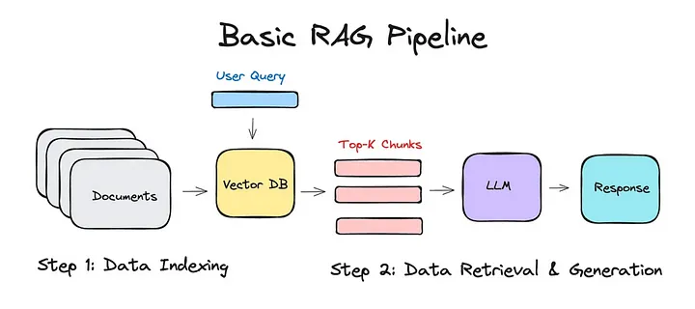

**Implementation: Bringing the Medical Chatbot to Life**

The implementation process involved several key steps, from data ingestion to user interaction.

**Data Ingestion and Batch Upload**

Before deployment, all preprocessed medical document chunks were embedded and systematically uploaded to our Pinecone index. To handle potentially large datasets efficiently and avoid API rate limits, we implemented a batch uploading mechanism, sending documents to Pinecone in manageable groups. This ensures a smooth and reliable transfer of our knowledge base.

**Frontend Design with Streamlit**

For the user interface, we leveraged Streamlit, a powerful and intuitive frontend framework. Streamlit allowed us to create an interactive chat interface rapidly, ensuring a user-friendly experience. The interface includes a light/dark mode toggle, enhancing accessibility and catering to user preferences. Users interact with the chatbot via a simple text input field, and the chatbot's responses are then displayed in a clean, conversational format, mimicking a natural dialogue.

### Deployment

The app is deployed on **Streamlit Cloud**, leveraging GitHub integration for seamless updates. API keys are encrypted via python-dotenv and Streamlit’s environment variables.  
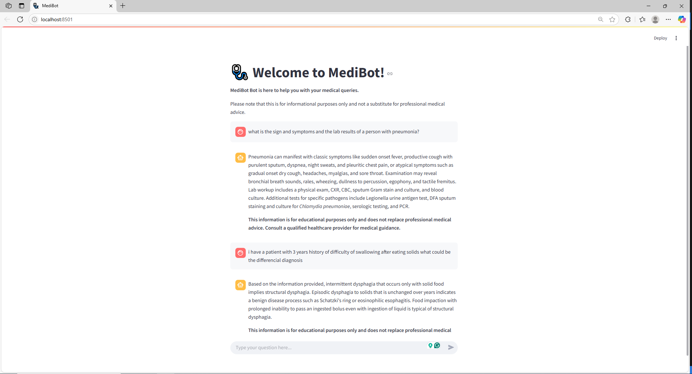

### Results and Findings

Our Medical RAG Chatbot demonstrates significant potential in streamlining access to medical information. When queried, the system efficiently retrieves highly relevant document chunks from our extensive medical knowledge base. The integrated Gemini LLM, guided by our precise system prompt and the retrieved context, consistently generates factual and concise answers.

For instance, when asked "What is Acromegaly," the chatbot leverages the retrieved information to provide a direct and accurate definition, adhering to the seven-sentence limit and avoiding any speculative content. Initial testing shows the chatbot's ability to:

* **Reduce Information Search Time:** By directly answering questions based on indexed content, it drastically cuts down the time spent manually searching through documents.
* **Improve Answer Accuracy:** The RAG approach minimizes hallucinations, as answers are directly sourced from the provided medical context.
* **Provide Concise Summaries:** The LLM's ability to synthesize information from retrieved chunks into a brief, clear response is highly valuable in a medical setting.

## Impact and Future Potential

Our Medical RAG Chatbot has transformative potential:

* **Healthcare Education**: Empowers patients and students with reliable information, supporting SDG 3.
* **Continuous Knowledge Base Expansion:** Regularly update the medical document dataset to include the latest research, guidelines, and clinical trials.
* **Advanced Retrieval Strategies:** Experiment with more sophisticated retrieval methods, such as hybrid search (combining keyword and semantic search) or re-ranking retrieved documents, to further enhance relevance.
* **User Feedback Integration:** Implement mechanisms for users to provide feedback on answer quality, which can be used to fine-tune the system and improve performance over time.
* **Deployment to Clinical Settings:** Explore pathways for secure and compliant deployment in real-world clinical environments, ensuring data privacy and regulatory adherence

**Future Work: Reflecting on the Journey**

Future work could focus on improving the following areas:

* **Model Refinement:** Exploring advanced LLM fine-tuning techniques specifically on medical corpora to further enhance contextual understanding and response generation.
* **Multimodal Integration:** Expanding the chatbot's capabilities to process and retrieve information from diverse medical data types, including images (e.g., X-rays, MRI scans) or structured electronic health records.
* **Personalized Information Delivery:** Developing features that can tailor information delivery based on the user's role (e.g., doctor, nurse, patient) or specific areas of interest.
* **Proactive Information Push:** Investigating the possibility of proactively pushing relevant medical updates or alerts to users based on their defined interests or ongoing cases.

## Conclusion: A Step Toward Smarter Healthcare

Our Medical RAG Chatbot project showcases the transformative potential of combining advanced AI techniques, such as Large Language Models and vector databases, to create intelligent information retrieval systems for specialized domains like medicine. By efficiently processing and understanding complex medical inquiries, we empower healthcare professionals and researchers with faster access to critical knowledge, leading to more informed decisions and ultimately contributing to improved global health and well-being, aligning perfectly with SDG 3. While challenges like API costs and latency remain, the project’s success lies in its ability to provide trustworthy information, paving the way for smarter, more accessible healthcare education. As we refine and scale this solution, we envision a world where AI supports informed health decisions, bridging gaps in access and knowledge. Stay tuned for updates as we take this project to the next level!

***Disclaimer****: *My draft for this piece was refined by the help of Grok :)*