[INSTITUTION NAME]
[DEPARTMENT NAME]
[DEGREE / PROGRAM NAME]
PROJECT REVIEW 1

SHADERMESH
  - A Decentralized Marketplace for Renting Compute
A Proposal and Design Report
Course | [COURSE CODE AND COURSE TITLE]
Faculty Guide | [FACULTY GUIDE NAME AND DESIGNATION]
Submitted by | [STUDENT NAME(S) AND ROLL NUMBER(S)]
Academic Year | [2026-2027]
Submission Date | [DD MONTH YYYY]

Table of Contents
Right-click and select Update Field.

Abstract
Graphics processing unit capacity is increasingly required for large language model inference, fine-tuning, rendering, simulation, and other parallel workloads. Access to this capacity is concentrated in centralized cloud platforms, while useful hardware in personal workstations, laboratories, and small organizations can remain underutilized. Direct rental between independent owners and requesters is difficult because both parties need guarantees concerning payment, availability, advertised hardware, and service failure.
ShaderMesh is proposed as a decentralized marketplace for renting containerized compute. Ethereum acts as the trust, coordination, and settlement layer, while the actual computation runs off chain on provider machines. Providers register, stake a utility token, publish hardware listings, and receive an attestation record. Requesters open time-based leases and fund smart-contract escrow. The intended rental policy releases escrow only for intervals with timely availability evidence; a missed deadline permits termination, refund, and slashing. Managed large language model inference is exposed through an OpenAI-compatible gateway. A separate verifiable-task design uses result commitments, re-execution, disputes, and slashing.
The initial prototype includes Solidity contracts, a Python provider agent, constrained Docker execution, a TypeScript event indexer and inference gateway, a Next.js dashboard, and a local Docker Compose environment. The current implementation demonstrates real local-chain transactions and lease-bound containers, while hardware identities and model responses remain controlled demo inputs. The proposed next stage is a multi-laptop deployment using NVIDIA hardware and Sepolia, with accepted workload manifests, timely per-interval availability evidence, and randomized commit-reveal verification. The current prototype uses the latest provider heartbeat for settlement and voluntary plaintext challenge votes; these mechanisms validate the state machines but are not yet production-grade trust guarantees.
Keywords: decentralized compute, GPU rental, Ethereum, smart contracts, escrow, staking, slashing, LLM inference, Docker, optimistic verification

Abbreviations
Term | Meaning
API | Application Programming Interface
CID | Content Identifier
EVM | Ethereum Virtual Machine
GPU | Graphics Processing Unit
IPFS | InterPlanetary File System
LLM | Large Language Model
PoS | Proof of Stake
RPC | Remote Procedure Call
SLA | Service Level Agreement
TEE | Trusted Execution Environment

1. Introduction

1.1 Background
Modern artificial intelligence systems depend heavily on parallel compute. LLM inference, model fine-tuning, image generation, scientific simulation, and rendering all benefit from GPUs. Centralized cloud providers make this hardware available, but access is governed by a single operator, fixed platform policies, and centrally administered billing. At the same time, capable GPUs in gaming computers, workstations, laboratories, and small data centers may remain idle for significant periods.
A peer-to-peer compute market could connect this unused supply with requesters. However, the market participants may not know or trust each other. A requester needs confidence that the advertised hardware exists, the service remains available, and unused funds can be recovered. A provider needs confidence that completed service will be paid. A neutral mechanism is also needed to record reputation and apply penalties when an agreed SLA is violated.

1.2 Problem Statement
The problem addressed by ShaderMesh is the absence of a transparent and programmable settlement layer for renting independently owned compute. Existing centralized marketplaces can match supply and demand, but they control account approval, billing, service records, and dispute outcomes. Fully decentralized designs face a second problem: arbitrary computation is expensive to reproduce and cannot generally be verified on chain. Interactive workloads such as an LLM session are also non-deterministic and time-sensitive.
ShaderMesh therefore separates computation from settlement and distinguishes between two types of trust. A time-based rental is secured through availability evidence, attestation, provider stake, reputation, and SLA penalties. A deterministic task is secured through result commitments and optimistic re-execution. The project does not claim that every computation can be proven correct. It selects a trust model according to the type of workload.

1.3 Relevance of Blockchain and Cryptocurrency
Blockchain is relevant because the parties require shared economic state without appointing one of them as the trusted administrator. Smart contracts can hold prepaid funds, bond provider stake, apply a public state machine, and release or refund funds according to deterministic rules. Transactions provide an auditable record of listings, leases, heartbeats, settlement, reputation updates, and slashing.
The blockchain does not execute GPU workloads. Repeating such computation across Ethereum validators would be prohibitively expensive and unnecessary. Ethereum is used only for the parts that require consensus. Provider agents, inference servers, storage, and indexing remain off chain. The SMESH token is a prototype utility token for escrow, stake, and rewards. It is not presented as an investment asset.

1.4 Scope
The primary scope is time-based rental of GPU or CPU capacity, including managed LLM inference. The retained secondary scope is deterministic task execution, such as rendering or batch work, where sampled re-execution is meaningful. The initial prototype targets a local Ethereum devnet and a small network of provider machines. Sepolia deployment is the next public test stage.

2. Objectives and Motivation

2.1 Objectives
1. Design and implement an Ethereum-based compute marketplace with provider listings, time-based leases, escrow, interval settlement, refunds, and SLA termination.
2. Create a provider security model based on staking, hardware attestation, signed availability reports, public reputation, and slashing for defined failures.
3. Support AI workloads through a provider-hosted OpenAI-compatible inference endpoint and a path toward raw GPU container rental.
4. Retain a verifiable-task mode for deterministic workloads using commitments, re-execution, disputes, and economic penalties, then harden it with randomized challenger selection.
5. Deliver and evaluate a reproducible multi-component prototype with smart-contract tests, constrained workload execution, APIs, a dashboard, and a multi-laptop test plan.

2.2 Motivation and Need
The project is motivated by three practical needs. First, smaller users need more flexible access to compute than conventional cloud purchasing models always provide. Second, independent hardware owners need a way to monetize spare capacity without relying entirely on a marketplace operator's private ledger. Third, a blockchain course project should demonstrate why distributed consensus is useful rather than placing ordinary application data on chain without justification.
ShaderMesh exercises token accounting, escrow, staking, access control, event-driven services, reputation, state machines, and adversarial incentives. It also exposes the limitations of blockchain honestly: contracts can enforce economic rules, but they cannot directly observe a GPU or determine whether a subjective LLM response is correct.

3. Literature Survey
The survey uses primary papers where available and official project documentation for systems whose current operation has changed after their original publications. Sources were accessed on 16 September 2026.
Work | Existing approach | Limitation or gap relevant to ShaderMesh
Ethereum, Buterin (2014) [1] | General smart contracts encode shared state transitions, tokens, and escrow. | Replicated EVM computation is unsuitable for bulk GPU workloads, so execution must remain off chain.
Golem [2] | Matches requester demands with provider offers and executes work in VM or WASM environments with usage payments. | Payment and execution workflows do not by themselves provide a single general solution for hardware attestation, rental SLA enforcement, and deterministic-result disputes.
Truebit, Teutsch and Reitwiessner (2019) [3] | Uses an interactive verification game to reduce a disputed computation to a small step that can be checked on chain. | It requires reproducible computation and active verifiers, so it does not prove availability or quality for interactive GPU leases.
Livepeer, Petkanics and Tang (2017) [4] | The whitepaper proposes staking, signed work receipts, and probabilistic verification for decentralized video transcoding. | Its proposed verification and workflow are specialized for video; re-execution also adds significant cost.
iExec Proof-of-Contribution [5] | Coordinates off-chain computing with on-chain payment and current TEE-backed attestation. | Security depends on a trusted hardware and attestation stack rather than hardware-independent verification.
Akash Network [6] | Provides a decentralized exchange for container-oriented infrastructure using a Cosmos-based network. | Its core design focuses on deployment and resource matching rather than deterministic result adjudication.
Render Network [7] | Pools GPU capacity for rendering and extends access through workload-specific compute clients. | General workloads require client-specific integration rather than one uniform rental and verification policy.
Filecoin, Protocol Labs (2017) [8] | Uses collateral and proofs to establish storage possession and persistence over time. | Storage proofs do not establish correct execution or interactive service quality, but provide a useful economic analogue.
vLLM, Kwon et al. (2023) [9] | Uses PagedAttention and continuous batching for efficient LLM serving through an OpenAI-compatible interface. | It is an inference runtime, not a marketplace, payment, attestation, or dispute system.
Vast.ai [10] | Operates a marketplace for community and data-center GPUs with templates, benchmarks, reliability history, SSH, and hosted services. | Trust, verification, billing, and dispute handling remain platform-administered rather than enforced by public smart contracts.

3.1 Survey Synthesis
Prior work establishes the feasibility of programmable settlement, decentralized resource markets, probabilistic verification, hardware attestation, and optimized inference. ShaderMesh's defensible design contribution is their integration under two explicit trust models. Non-replayable rentals use streamed escrow and availability-oriented controls. Deterministic jobs use optimistic verification. Both use a common staking and reputation layer.
This design does not remove all trust. Heartbeats need independent observation to become strong availability evidence, hardware attestation depends on the verifier, and sampled checking depends on independent challengers and suitable comparison rules. These limitations are included in the prototype roadmap rather than hidden behind a general claim of "verifiable AI."

4. Existing System and Identified Gap

4.1 Current Methods
The dominant method is centralized cloud rental. A customer selects an instance from a cloud or GPU marketplace, accepts the operator's account and billing rules, and accesses the machine using an API, SSH, notebook, or managed service. Community GPU marketplaces widen supply, but platform servers still perform identity checks, listing verification, billing, and dispute handling.
Decentralized compute systems use different approaches. Some match container deployments through a blockchain market. Some specialize in rendering or video. Others verify deterministic execution through replication, challenge games, or trusted hardware. These systems demonstrate useful components but make different tradeoffs concerning generality, cost, and trust.

4.2 Problems and Limitations
- A centralized operator can change prices, suspend accounts, or control dispute outcomes.
- Billing and reliability histories may be held in a private database.
- Replicating every workload is expensive and does not suit interactive services.
- Hardware attestation can introduce a separate trusted authority or specialized hardware.
- Exact output comparison fails for many GPU and LLM workloads.
- Public provider machines create security risks for both renter data and provider hosts.
- Blockchains cannot directly observe off-chain availability without signed reports, probes, or trusted measurement services.

4.3 Identified Gap
The identified gap is a transparent compute-rental agreement that supports streamed escrow and SLA penalties while also retaining a distinct verification path for workloads that are actually checkable. The architecture must keep funds and deterministic rules on chain, keep compute off chain, and avoid claiming that one verification mechanism applies to every workload.
Figure 1 places ShaderMesh between the two market participants and the external consensus and storage systems. Each arrow states both the relationship and its protocol.
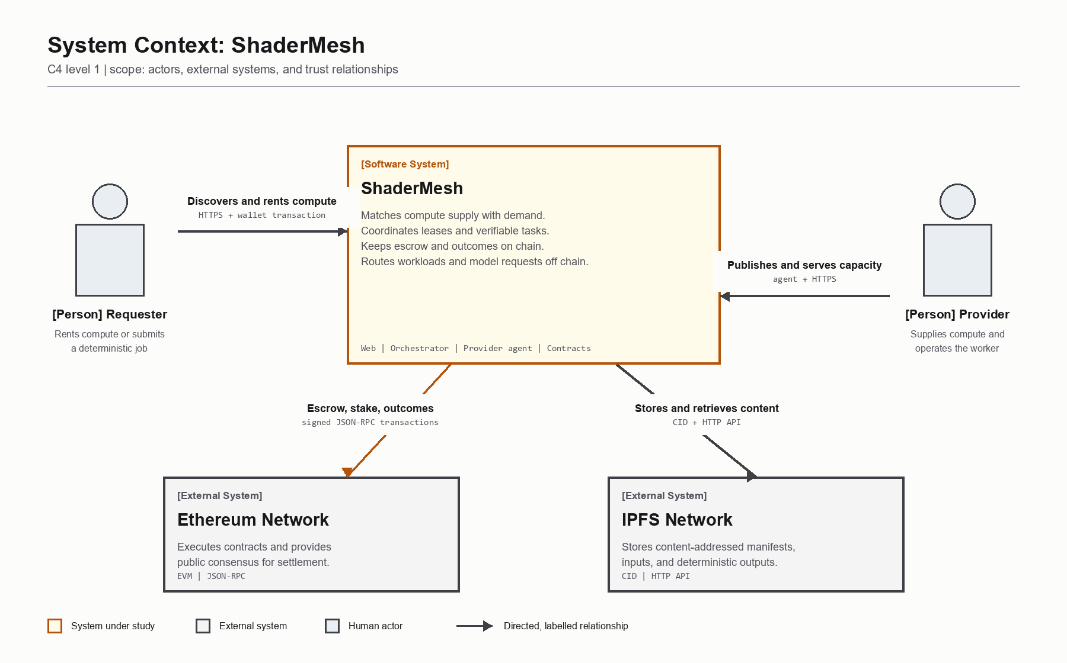
Figure 1. C4 system context diagram for ShaderMesh

5. Proposed System

5.1 Overview
ShaderMesh consists of an Ethereum contract layer, provider agents, an orchestrator, storage, and a requester-facing web application. Providers stake SMESH and publish listings containing price, interval, duration limits, region, GPU details, and supported models. A requester selects a listing and deposits the total lease budget into the RentalMarket contract.
The provider agent observes leases assigned to its address. For a supported workload, it creates a constrained Docker container and monitors its health. It signs heartbeat transactions while the service remains active. Settlement releases payment for served intervals. An early end refunds unused escrow. If the heartbeat deadline and grace period pass, the lease can be terminated and the provider's bond can be slashed to the renter.
This is the target rental policy. The v0 contract stores only the latest provider heartbeat. A late heartbeat can therefore extend coverage across earlier silent intervals if termination has not already been called. Timely per-interval evidence, independent probes, and bounded settlement are required before this mechanism can provide a strong availability guarantee.

5.2 Managed Inference
A provider may advertise models and expose an OpenAI-compatible endpoint. The orchestrator reads indexed listings, selects a suitable provider, forwards a request, and returns the response with route and usage information. This interface allows an application to use ShaderMesh similarly to a conventional model API. Payment-gated per-token settlement and independent health probes remain future hardening tasks.

5.3 Verifiable Tasks
For a deterministic job, the requester posts work and escrow. A provider claims a task and bonds stake, executes the pinned workload, stores the output, and submits a hash commitment and CID. The v0 contract allows any eligible provider except the submitter to cast one plaintext hash vote. After the voting window, a simple majority and configurable quorum determine the outcome; the default quorum is one. The target design adds randomized challenger selection, commit-reveal, challenger rewards, and a safer quorum policy. Approximate GPU outputs also require a defined perceptual comparison policy rather than naive byte equality.

5.4 Advantages
- Funds are controlled by contracts rather than the orchestrator or provider agent.
- Streamed settlement is designed to limit renter exposure and pay providers for served intervals.
- Provider collateral creates a direct economic consequence for defined SLA failures.
- Listings, outcomes, and reputation are publicly auditable.
- The compute layer remains general because workloads execute in containers.
- Managed inference uses a familiar API rather than requiring every requester to manage a model.
- Separate rental and task modes avoid false claims about verification of non-deterministic work.

6. Blockchain Design

6.1 Blockchain Type and Consensus
ShaderMesh uses a public blockchain architecture. Development uses a local Hardhat Ethereum network, and the intended public prototype uses Sepolia. A later deployment could use an Ethereum-compatible layer 2 to reduce transaction costs. A private or consortium chain is not selected because the purpose is neutral settlement among providers and requesters that may not share an administrator.
The application inherits Ethereum's proof-of-stake consensus. ShaderMesh does not define a new base-layer consensus algorithm. Its contribution is an application-layer protocol implemented by smart contracts and off-chain agents.

6.2 Smart Contracts
Contract | Responsibility
SmeshToken | ERC-20 utility token, local/testnet faucet, payments, stake, and rewards.
ProviderRegistry | Registration, active status, capabilities, stake, bonded stake, attestation, reputation, and authorized slashing hooks.
RentalMarket | Listings, lease escrow, provider bonds, heartbeats, interval settlement, extension, end, refund, and SLA termination.
JobMarket | Deterministic job escrow, task claiming, deadlines, submission, payment, and reassignment.
Verification | Challenges, result comparison flow, dispute resolution, rewards, and slashing for verifiable tasks.

The contracts use Solidity 0.8.24 and OpenZeppelin components [11] including ERC-20, ownership, reentrancy protection, and safe token transfers. Registry economic mutations are limited to authorized protocol contracts. Off-chain services cannot directly move escrow.

6.3 Token Use
SMESH is applicable to the prototype as a utility and test token. It provides one accounting unit for rental payment, provider stake, lease bonds, and challenge rewards. A testnet faucet reduces setup friction. The dashboard currently presents a demonstration peg of 1 SMESH to 1 USD. This is not a market price, stablecoin mechanism, or investment claim. A production design could instead use a stablecoin to reduce exchange-rate risk.

6.4 On-Chain and Off-Chain Boundary
On chain: balances, escrow, listings, lease state, stake, bonds, settlement, reputation outcomes, and dispute decisions. Off chain: Docker execution, GPU access, model serving, content storage, event indexing, API routing, and user-interface rendering. This boundary minimizes gas cost while keeping value movement deterministic and auditable.

7. System Architecture and Modules

7.1 Logical Architecture
Figure 2 expands the system into deployable applications and data stores. Amber identifies the on-chain value authority; it is not used as decoration or as the only carrier of meaning.
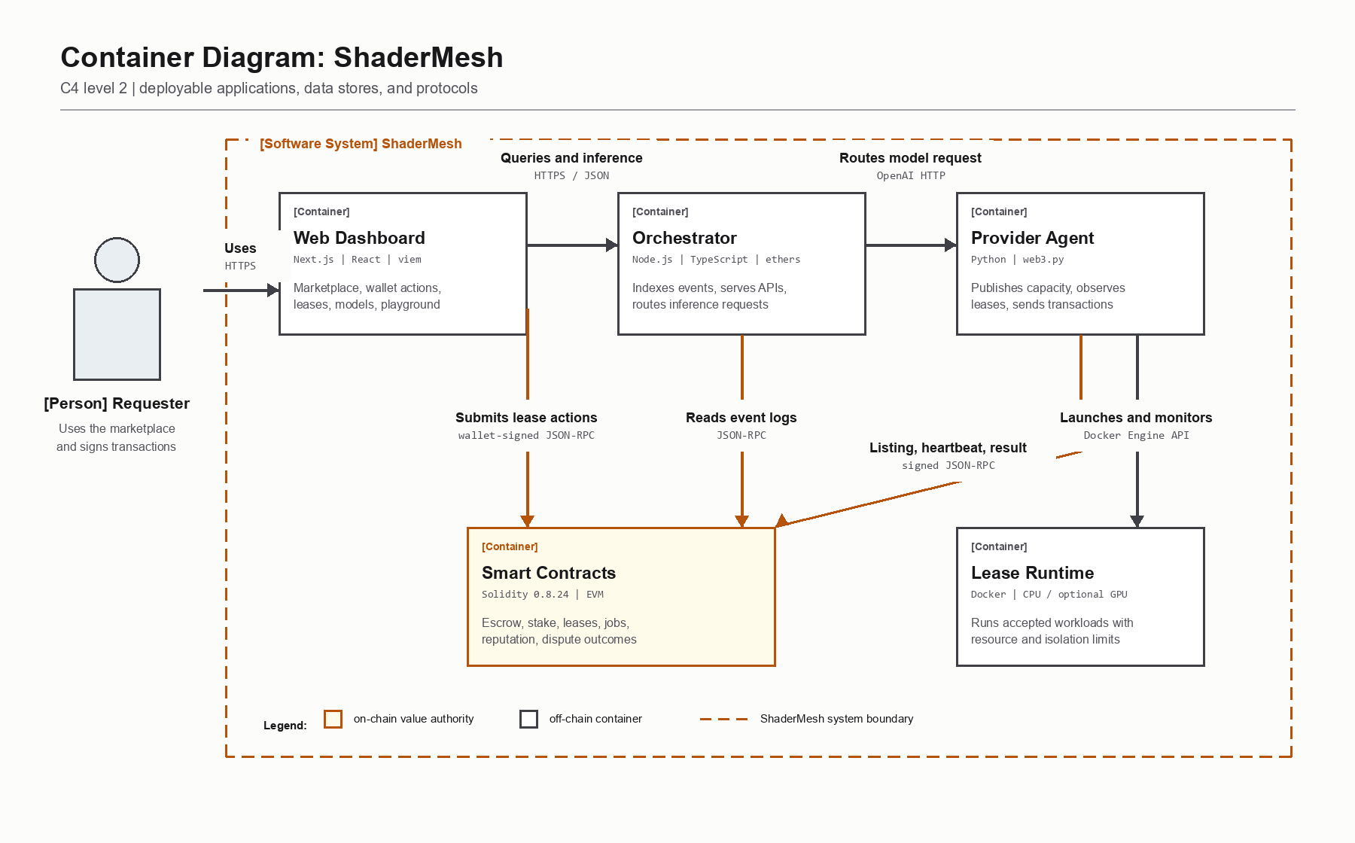
Figure 2. C4 container diagram for ShaderMesh

7.2 Major Modules
1. Token module: provides the prototype payment and staking asset.
2. Provider registry: stores provider identity, capability declarations, stake, attestation, reputation, and bonded balances.
3. Rental market: implements the primary time-based rental state machine and escrow.
4. Verifiable-task market: manages deterministic task posting, claiming, and payment.
5. Verification module: handles optimistic challenges and economic penalties.
6. Provider agent: registers and stakes, creates listings, discovers leases, launches constrained containers, monitors health, sends heartbeats, and serves model requests.
7. Orchestrator and gateway: reconstructs state from events, provides read APIs, routes inference, and coordinates deterministic task splitting and stitching.
8. Storage: uses content-addressed storage for large manifests, inputs, and outputs where applicable, while only references and commitments are placed on chain.
9. Web dashboard: supports wallet connection, listing discovery, lease actions, lease monitoring, model discovery, and an inference playground.
10. Simulator: evaluates deterministic-task spot-check cost and cheating deterrence for a homogeneous cheating probability with perfect honest challengers. Availability, heterogeneous populations, and collusion remain planned extensions. It is not part of settlement.

8. Methodology and Workflow

8.1 Development Methodology
The project follows an iterative, contract-first approach:
1. Define actors, assets, trust assumptions, and state transitions.
2. Implement contract invariants and tests before connecting off-chain services.
3. Build provider and requester helpers against a real local chain.
4. Add constrained execution, inference, event indexing, and APIs.
5. Integrate the dashboard and wallet-signed actions.
6. Test honest operation and failure paths, including refunds and slashing.
7. Move from a single-machine environment to multiple provider laptops and Sepolia.
8. Evaluate gas use, uptime enforcement, verification cost, and operational limitations.

8.2 Rental Workflow
1. A provider obtains SMESH, registers capabilities, and stakes collateral.
2. An authorized attester records a hardware assessment.
3. The provider creates a listing with price and duration limits.
4. A requester approves token spending and opens a funded lease.
5. The provider agent starts or exposes the agreed workload.
6. Healthy service produces provider-signed heartbeat transactions.
7. Settlement releases payment for covered intervals.
8. The requester ends normally, or anyone terminates after a missed deadline.
9. The contract refunds unused escrow and unbonds or slashes provider collateral.
In v0, a heartbeat updates one lastHeartbeat value and may retrospectively cover elapsed intervals. The hardened workflow will reject late coverage or require separately verifiable, timely evidence for each payable interval.
Figure 3 shows the order of calls, events, workload startup, recurring heartbeats, settlement, and the two lease outcomes. Solid and dashed lines have distinct meanings stated in the legend.
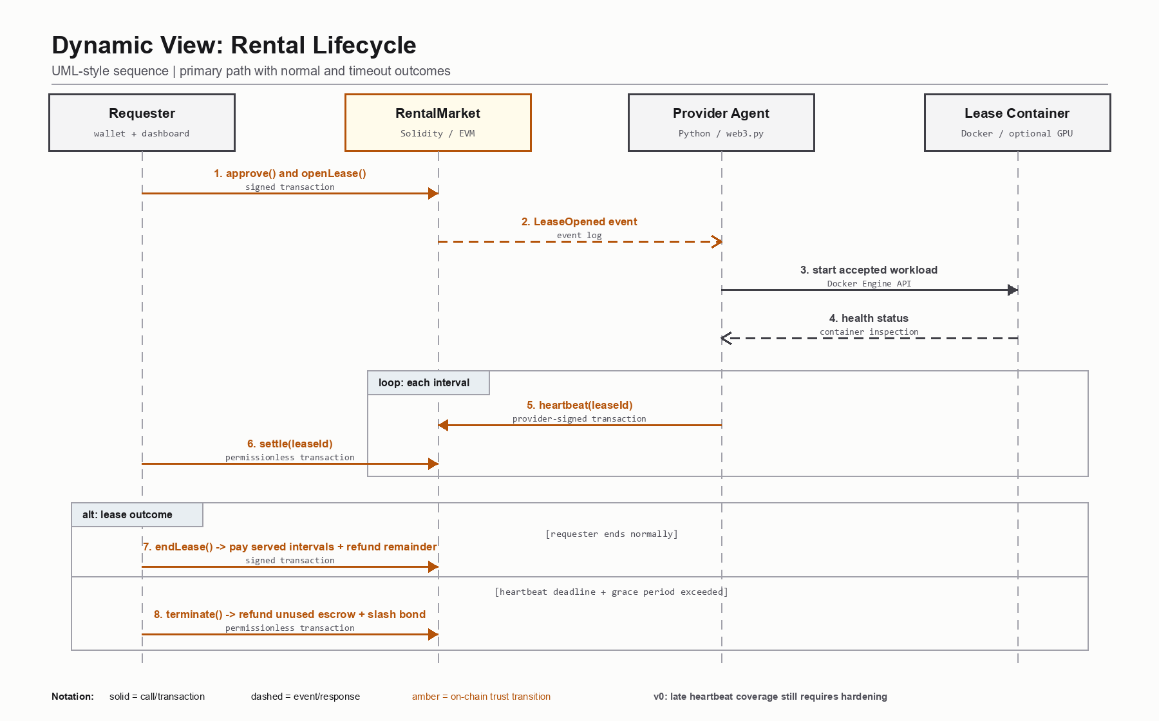
Figure 3. UML-style sequence diagram for the rental lifecycle

8.3 Workload Isolation Method
The current lease runtime creates one labeled Docker container per active lease. Production images must be pinned by SHA-256 digest. The runtime accepts only array-form commands and bounded environment variables. It supplies no renter-controlled host mounts, disables networking by default, uses a read-only root filesystem and non-root user, drops Linux capabilities, enables no-new-privileges, and limits CPU, memory, swap, temporary storage, and process count. NVIDIA device access is disabled unless explicitly enabled and restricted by provider configuration.
Figure 4 separates administrative control into requester, public-chain, routing-service, and provider zones. This view makes the critical invariant explicit: only contracts control escrow and slashing, while off-chain services remain non-custodial and untrusted.
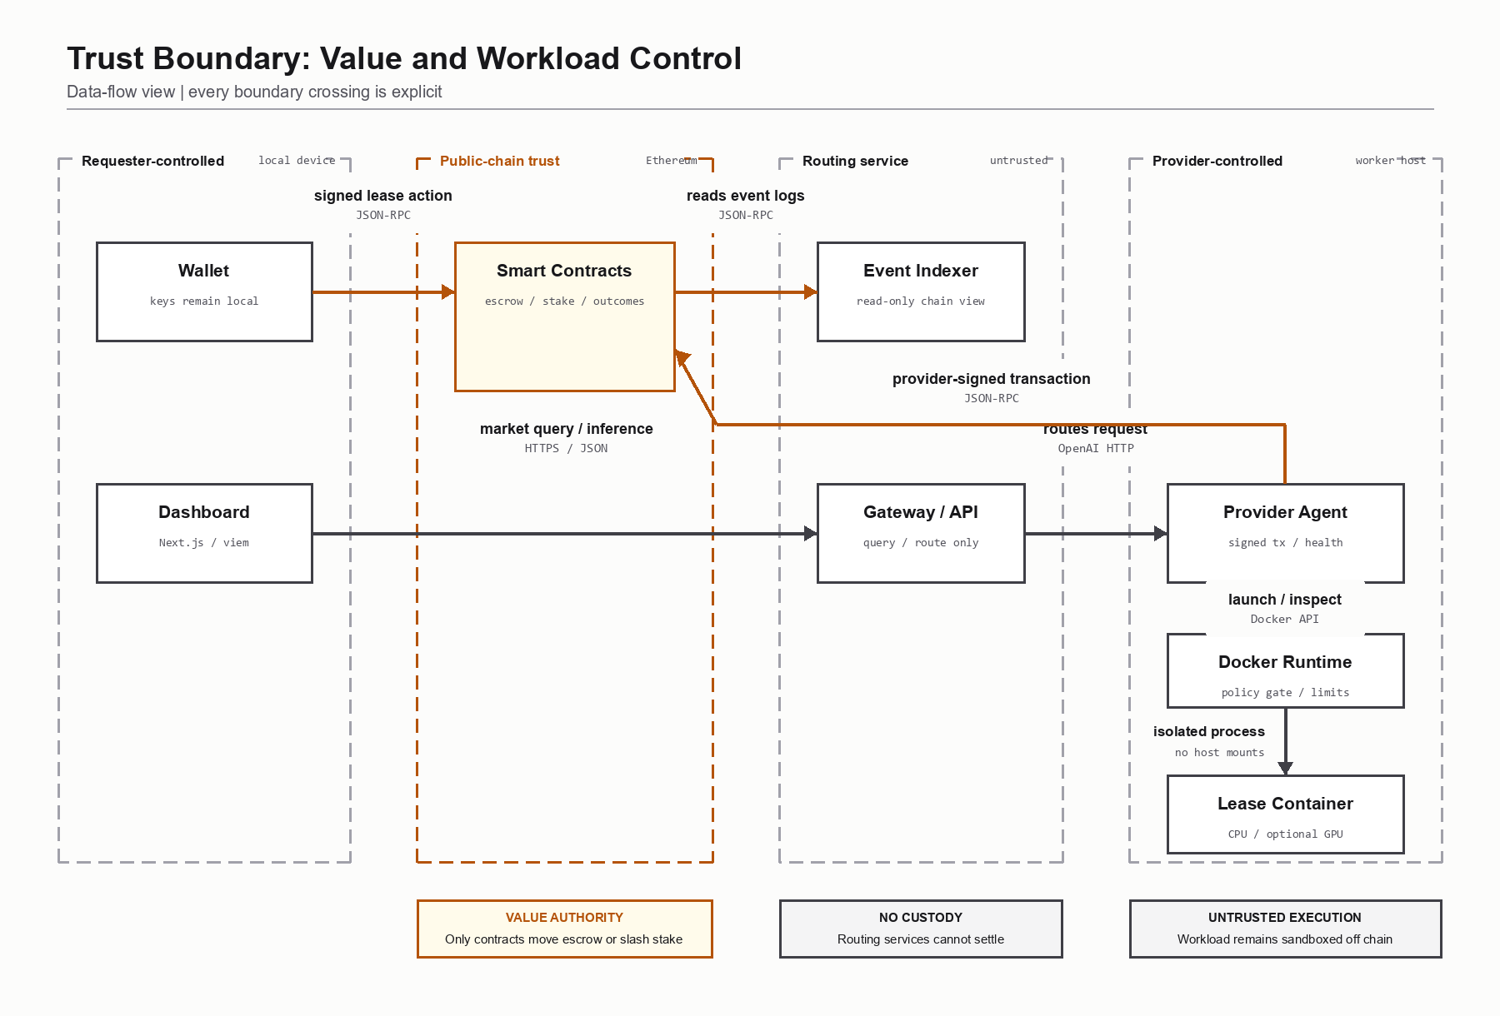
Figure 4. Data-flow and trust-boundary diagram

8.4 Verification Workflow
Deterministic jobs use a content-addressed manifest and output commitment. The current contract supports eligible-provider plaintext votes over exact result hashes. Random sampling and commit-reveal are target mechanisms, not current implementation. Exact deterministic outputs can use keccak256(output). Rendering output affected by hardware floating-point differences requires a pinned environment and a future tolerant comparison policy, such as perceptual hash or SSIM with an agreed threshold.

9. Technology Stack
Layer | Technology | Current use
Blockchain | Ethereum-compatible EVM; Hardhat locally; Sepolia planned | Contract execution and public settlement target
Smart contracts | Solidity 0.8.24, OpenZeppelin, Hardhat | Token, registry, rental, jobs, verification, tests, deployment
Provider | Python 3.11, web3.py, Docker SDK | Transactions, workloads, heartbeats, inference endpoint
Compute runtime | Docker Desktop/Engine; NVIDIA Container Toolkit where available | Isolated CPU workload now; optional GPU device requests implemented
Inference | OpenAI-compatible HTTP; echo and Ollama backends | Routing and metering prototype; real model backend next
Orchestrator | Node.js 20, TypeScript, ethers | Event indexing, APIs, inference routing, split and stitch
Web | Next.js, React, TypeScript, Tailwind, viem | Marketplace, wallet, leases, model catalog, playground
Storage | IPFS adapter and Kubo service | Content-addressed task inputs and outputs
Database | PostgreSQL provisioned; current event projection is in memory | Persistent indexing remains a planned hardening task
Infrastructure | Docker Compose, Git, npm, pytest | Reproducible development, service orchestration, tests

10. Initial Prototype and Current Status

10.1 Implemented Prototype
The repository contains a functioning local prototype rather than only interface mock-ups. One Docker Compose command starts a Hardhat chain, deploys contracts, runs IPFS and PostgreSQL, creates real on-chain demo listings and a lease, starts the provider daemon, launches a constrained lease container, starts the orchestrator, and serves the dashboard.
The dashboard currently provides Overview, Rent GPUs, My Leases, and Models screens. It displays three seeded providers and GPU listings, one funded lease, settled spending, attestation status, and model routes. Wallet actions submit actual contract approvals and lease calls. The model playground forwards an OpenAI-compatible request through the orchestrator to the provider.

10.2 Verification Status
Component | Verification result
Smart contracts | 7 passing Hardhat tests covering registration, rental settlement, refunds, downtime, and verification paths
Provider agent | 12 passing pytest tests covering rental flows, inference, constrained execution, GPU gating, recovery, and health-backed heartbeats
Orchestrator | 17 passing tests with a clean TypeScript typecheck
Web dashboard | Successful Next.js production build and browser verification
Full local stack | Three indexed listings, one 24-hour demo lease, one live lease container, and routed inference

The contract, agent, and orchestrator results are automated test runs. The web production build is automated; dashboard and full-stack observations are manual integration checks.

10.3 Prototype Boundary
The following behavior is real: local contract execution, signed transactions, token escrow, stake and bond accounting, event indexing, wallet calls, API routing, and Docker container lifecycle. The following behavior is seeded or incomplete: provider identities, GPU declarations, trusted operator attestation, the CPU placeholder lease workload, and deterministic echo model responses. The prototype therefore validates system integration and economic state transitions, not production-grade hardware verification or model quality.
Two contract-level limits are material. First, a late provider heartbeat can retrospectively extend payable coverage because v0 stores only the latest heartbeat. Second, verification uses voluntary plaintext votes from eligible providers, simple majority, and a default quorum of one; it does not yet select challengers randomly or use commit-reveal, monetary challenger rewards, or perceptual comparison. The current tests validate these v0 state transitions, not the security of the planned mechanisms.

11. Input Details and Evaluation Plan

11.1 Dataset Applicability
A conventional training dataset is not required because ShaderMesh is a marketplace and protocol, not a supervised machine-learning model. This rubric item is therefore not directly applicable. The project instead defines reproducible operational inputs:
- Rental inputs: duration, listing identifier, resource specification, and workload manifest.
- Inference inputs: model identifier, prompt messages, sampling parameters, and token usage.
- Deterministic task inputs: pinned container, manifest, input CID, and expected output policy.
- Current simulator inputs: reward, provider bond, spot-check rate, challenger count, cheating probability, trial count, and random seed for deterministic-task economics.
- Planned adversarial inputs: missed heartbeats, heterogeneous providers, false commitments, failed challenges, and collusion.

11.2 Evaluation Measures
- Functional correctness of contract state transitions and access control.
- Escrow conservation across payment, refund, extension, and slash paths.
- Provider earnings and renter refunds by served interval.
- Heartbeat and outage response time under configured intervals and grace periods.
- Gas consumed by registration, listing, lease, heartbeat, settlement, and termination.
- Sandbox enforcement for CPU, memory, processes, filesystem, mounts, network, and GPU access.
- Inference route correctness, latency, and reported token usage.
- Verification cost and cheating deterrence under different challenge probabilities.

12. Expected Outcomes
1. A tested smart-contract suite deployed locally and on Sepolia.
2. A two-to-three-laptop demonstration with unique provider and requester wallets.
3. Real NVIDIA hardware discovery, benchmark evidence, and provider listings.
4. A requester-funded lease that launches an accepted container and settles by interval.
5. A real Ollama or vLLM model reached through the OpenAI-compatible gateway.
6. A controlled outage demonstration showing missed availability, refund, and slashing.
7. A deterministic task demonstration showing commitment, challenge, and settlement.
8. A gas, security, and economic evaluation with documented limitations.

13. Project Timeline
Weeks | Work package | Deliverable | Status
1-2 | Problem definition, literature, requirements, architecture | Review 1 proposal and design | Complete
3-4 | Core contracts and economic state machines | Token, registry, rental, job, verification tests | Prototype complete
5-6 | Provider execution and inference | Python agent, Docker runtime, heartbeats, model API | Prototype complete
7 | Orchestrator and event projection | APIs, indexer, gateway, split and stitch | Prototype complete
8 | Requester dashboard | Marketplace, leases, models, wallet actions | First release complete
9 | Multi-laptop and Sepolia integration | Public deployment and physical provider nodes | Next milestone
10 | Hardware and model integration | NVIDIA benchmark, accepted workloads, Ollama/vLLM | Planned
11 | Adversarial and end-to-end testing | Outage, slashing, browser automation, CI | Planned
12 | Evaluation and delivery | Gas report, recorded demo, final report, presentation | Planned

14. Risks, Limitations, and Ethical Considerations
Risk or limitation | Effect | Planned mitigation
Provider sends heartbeats without useful service | False availability claim | Independent probes, requester evidence, challenge protocol, and bounded settlement
Late heartbeat covers earlier silence in v0 | Provider may receive payment without timely evidence | Enforce per-interval deadlines or separately signed observations before settlement
Advertised GPU is false | Renter receives weaker hardware | Signed benchmark challenge, attestation evidence, expiry, and reputation
Malicious renter workload | Provider host compromise | Digest-pinned allowlist, provider acceptance, strict sandbox, dedicated worker host or microVM
Docker socket compromise | Agent obtains host-level authority | Isolate the agent host, use least privilege, rootless runtime where practical, and avoid unrelated workloads
LLM output is subjective | Incorrect hard-slashing decision | Do not use result equality for rentals; use availability and reputation
Voluntary plaintext voting and quorum of one in v0 | Copying, collusion, or false challenge can produce an unsafe outcome | Random selection, commit-reveal, challenger bonds and rewards, stronger quorum
GPU output differs across devices | Honest task falsely disputed | Pin runtime and use workload-specific tolerant comparison
Sepolia RPC or gas failure | Missed heartbeats and unreliable demo | Fund wallets, use conservative intervals, monitor balances, and keep local fallback
Token price volatility | Unstable compute price | Prototype USD display peg; production stablecoin or oracle-based pricing
Sensitive renter data | Leakage to unknown provider | Clearly disclose trust boundary, encrypt inputs, and avoid sensitive workloads without a TEE
Centralized attester in prototype | Operator remains a trust point | Multi-attester policy, evidence hashes, and reproducible benchmark challenges

The project must not describe unverified provider hardware as cryptographically proven. It must also avoid presenting a test token as an investment. Provider operators must understand that executing third-party workloads creates security and legal responsibilities. Requesters must be informed that public-chain metadata is visible and that ordinary Docker isolation is not a secure environment for highly confidential workloads.

15. Conclusion
ShaderMesh proposes a decentralized coordination and settlement layer for renting compute from independent providers. Its primary rental mode combines escrow, interval settlement, stake, attestation, reputation, and SLA penalties. Its secondary verifiable-task design uses optimistic re-execution where objective output checking is possible. This separation is central to the design because interactive GPU and LLM workloads cannot be treated as deterministic proofs. The v0 contract implements basic eligible-provider voting; randomized verification remains planned.
The initial prototype demonstrates the complete local path from contract deployment and provider listing to a funded lease, constrained workload container, heartbeats, event indexing, dashboard, and inference routing. It also exposes the remaining trust assumptions. The next implementation stage will move to Sepolia and multiple NVIDIA laptops, add accepted workload manifests, replace seeded attestation with reproducible benchmarks, and use a real model backend. The project is therefore technically feasible, demonstrable, and suitable for continued implementation and evaluation.

16. References
[1] V. Buterin, "A Next-Generation Smart Contract and Decentralized Application Platform," Ethereum Whitepaper, 2014. Available: https://ethereum.org/en/whitepaper/
[2] Golem Factory GmbH, "Golem Overview," official documentation. Available: https://docs.golem.network/docs/golem/overview
[3] J. Teutsch and C. Reitwiessner, "A Scalable Verification Solution for Blockchains," arXiv:1908.04756, 2019. Available: https://arxiv.org/abs/1908.04756
[4] D. Petkanics and E. Tang, "Livepeer Whitepaper: Protocol and Economic Incentives for a Decentralized Live Video Streaming Network," 2017. Available: https://github.com/livepeer/wiki/blob/master/WHITEPAPER.md
[5] iExec, "Proof-of-Contribution," official protocol documentation. Available: https://docs.iex.ec/protocol/proof-of-contribution
[6] Akash Network, "Akash: Decentralized Serverless Network," official repository and documentation. Available: https://github.com/akash-network/node
[7] Render Foundation, "Render Network Whitepaper v4.0," 2023. Available: https://renderfoundation.com/whitepaper
[8] Protocol Labs, "Filecoin: A Decentralized Storage Network," 2017. Available: https://research.protocol.ai/publications/filecoin-a-decentralized-storage-network/
[9] W. Kwon et al., "Efficient Memory Management for Large Language Model Serving with PagedAttention," Proceedings of the 29th ACM Symposium on Operating Systems Principles,
2023. Available: https://arxiv.org/abs/2309.06180
[10] Vast.ai, official documentation. Available: https://docs.vast.ai/
[11] OpenZeppelin, "OpenZeppelin Contracts," official documentation. Available: https://docs.openzeppelin.com/contracts/
All online sources were accessed on 16 September 2026.

