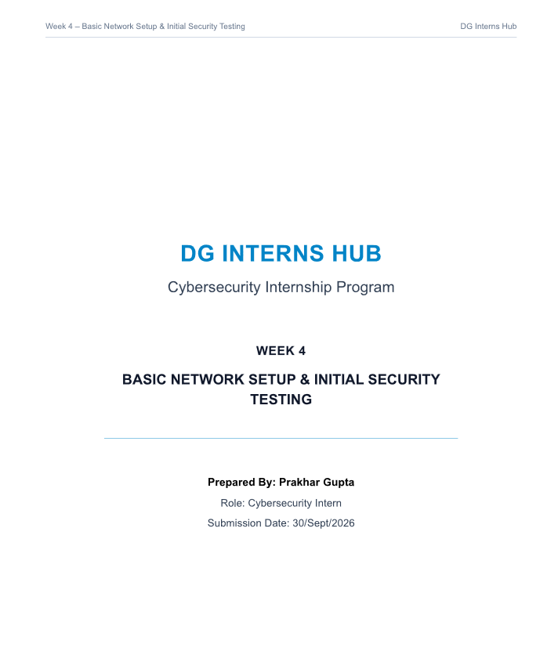

Table of Contents
- Introduction to Network Security
- Objective
- Why Network Security Matters
- Lab Setup Explanation5. Network Diagram
- Services Configuration
- Nmap Scan Analysis
- Wireshark Findings
- Mini Project Output
- Conclusion & Learning
- Task Breakdown Summary
- Challenges Faced
- Bonus Work Considered
14. Conclusion

1. Introduction to Network Security
Network security is the practice of protecting the confidentiality, integrity and availability of data as it moves across a network. A core skill for any cybersecurity professional is being able to set up a small lab network, run services on it, and then use standard tools to observe and test that network from an attacker's perspective — exactly the workflow covered in this Week 4 assignment.
This report documents the setup of a small authorized lab network, the configuration and verification of a running web service, an Nmap scan of that service, and a Wireshark capture analysing the resulting traffic.

2. Objective
To understand basic network setup and perform initial security testing in a lab environment, covering: building a small multi-machine lab, running a network service, scanning it with Nmap, and analysing its traffic with Wireshark.

3. Why Network Security Matters
Every device on a network exposes some combination of open ports and running services, and each of these represents a potential entry point for an attacker. Before a system can be defended, its owner must first understand exactly what is running and reachable on it — this is the core purpose of the reconnaissance and testing workflow demonstrated in this report.
- Confidentiality: ensuring data is only accessible to authorised parties (e.g., not sent over unencrypted protocols like Telnet or plain HTTP).
- Integrity: ensuring data is not modified in transit without detection.
- Availability: ensuring services remain accessible to legitimate users, and are not disrupted by attacks or misconfiguration.
Scanning tools such as Nmap and traffic analysers such as Wireshark are two of the most fundamental tools used by both attackers and defenders to understand these properties of a live network — which is exactly why this assignment focuses on using them together.

4. Lab Setup Explanation
Component | Details
Hypervisor | VMware Workstation Pro
Attacker Machine | Kali Linux — IP 192.168.94.137
Target Machine | Metasploitable 2 (Ubuntu Linux) — IP 192.168.94.135
Network Mode | VMware NAT network, subnet 192.168.94.0/24
Web Service | Apache HTTP Server 2.2.8, running on the target (port 80)
Both machines are connected on the same isolated NAT network, allowing the attacker (Kali) machine to directly reach and test services on the target (Metasploitable) machine, while remaining fully isolated from any external or public network.

5. Network Diagram
The lab topology is a simple two-node network sharing a single virtual switch:
[ Kali Linux : 192.168.94.137 ] ↔ VMware NAT Switch (192.168.94.0/24) ↔ [ Metasploitable 2 :
192.168.94.135 ]
Gateway: 192.168.94.2. Both machines communicate directly across the virtual switch; no traffic leaves the isolated lab network.

6. Services Configuration
The target machine's Apache web server was verified to be running and serving its default landing page.
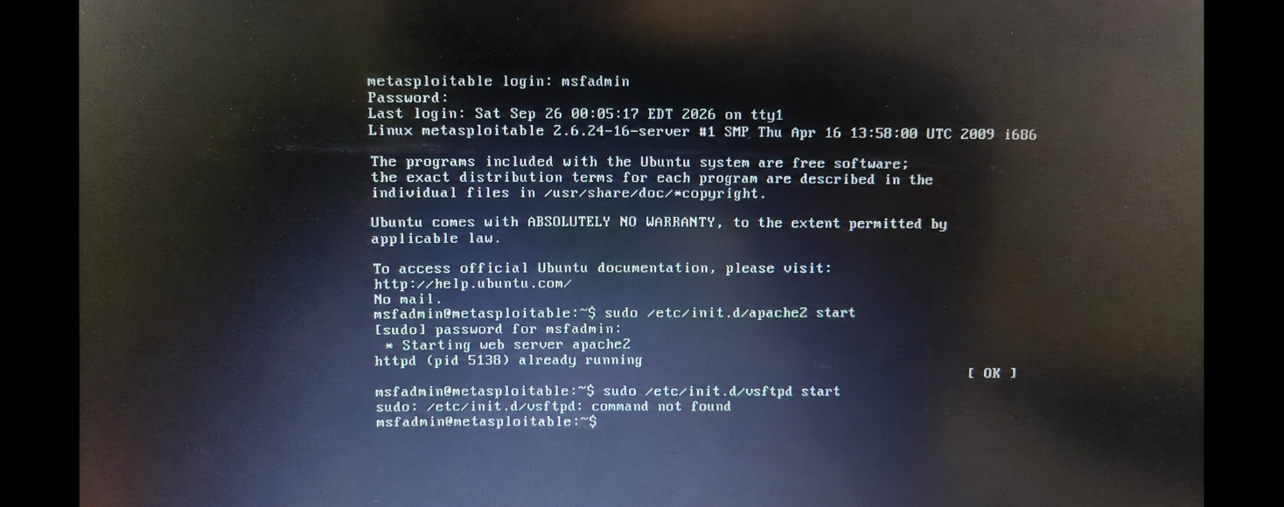
Metasploitable terminal: verifying the Apache web server (apache2) is running
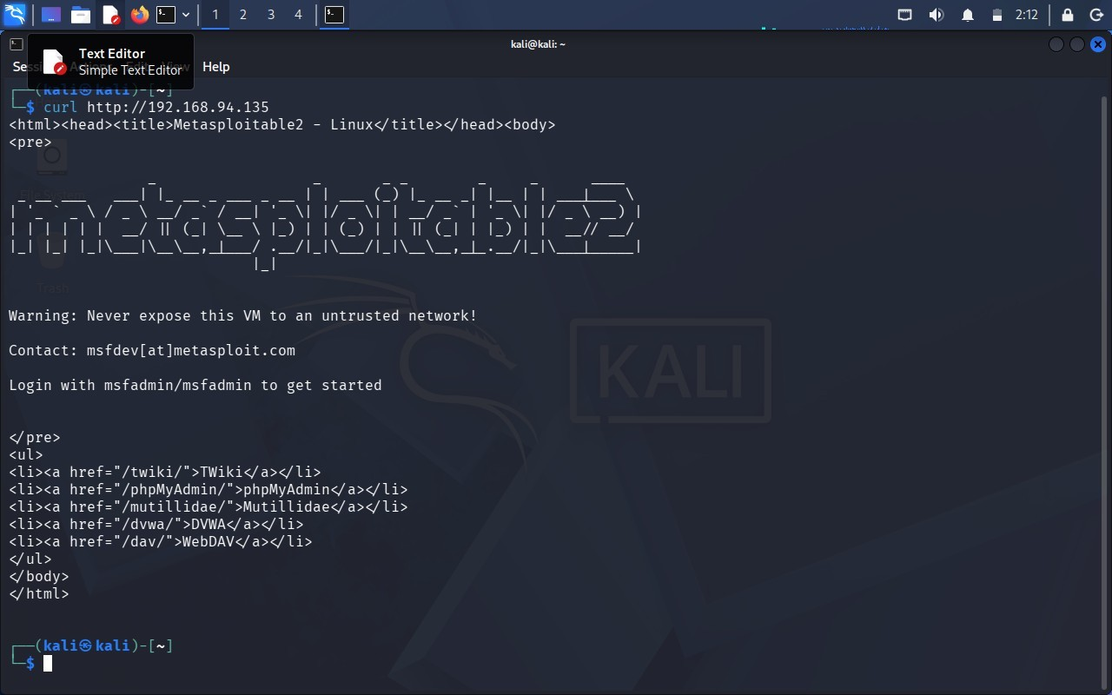
curl http://192.168.94.135 from Kali – confirms the web server responds with a valid HTML page
The response confirms the target's web server is reachable and serving content, including links to several bundled vulnerable web applications (TWiki, phpMyAdmin, Mutillidae, DVWA, WebDAV) that ship with Metasploitable 2 for security training purposes.

7. Nmap Scan Analysis
A service/version detection scan (nmap -sV) was run from Kali Linux against the target to identify all open ports and the exact software running on each.
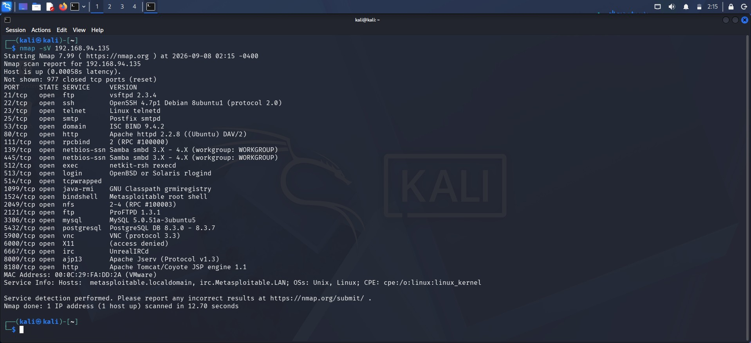
nmap -sV 192.168.94.135 – 24 open TCP ports with service versions identified
Port | Service | Version | Observation
21 | FTP | vsftpd 2.3.4 | Outdated FTP version; a known backdoored release
22 | SSH | OpenSSH 4.7p1 | Remote administration exposed, outdated version
23 | Telnet | Linux telnetd | Unencrypted remote login — high risk
80 | HTTP | Apache httpd 2.2.8 | The target web server verified above, outdated version
3306 | MySQL | MySQL 5.0.51a | Database service directly reachable on the network
The scan confirms the Apache web service on port 80 is running exactly as configured, and reveals that the target exposes an unusually large number of additional services, many running outdated software — useful context for prioritising which services would need hardening in a real assessment.

Full Port List
For completeness, all 24 open ports identified by the scan are recorded below.
Port | Service
21/tcp | ftp (vsftpd 2.3.4)
22/tcp | ssh (OpenSSH 4.7p1)
23/tcp | telnet
25/tcp | smtp (Postfix)
Port | Service
53/tcp | domain (ISC BIND 9.4.2)
80/tcp | http (Apache httpd 2.2.8)
111/tcp | rpcbind
139/tcp | netbios-ssn (Samba)
445/tcp | netbios-ssn (Samba)
512/tcp | exec (netkit-rsh)
513/tcp | login (rlogind)
514/tcp | tcpwrapped
1099/tcp | java-rmi
1524/tcp | bindshell
2049/tcp | nfs
2121/tcp | ftp (ProFTPD)
3306/tcp | mysql
5432/tcp | postgresql
5900/tcp | vnc
6000/tcp | X11
6667/tcp | irc (UnrealIRCd)
8009/tcp | ajp13 (Apache Jserv)
8180/tcp | http (Tomcat)
 | (24 ports total)

Analysis
Comparing this list against the single service that was intentionally configured (Apache on port 80) highlights an important lesson: a machine can be running far more than what its administrator explicitly set up. On
Metasploitable, this is by design for training purposes, but on a real system, an unexpectedly large list like this would immediately prompt an investigation into which services are actually needed and which should be disabled.

8. Wireshark Findings
A live packet capture was taken on Kali's network interface while browsing to the target's web server and pinging it, then filtered to isolate three core protocols.

HTTP Traffic
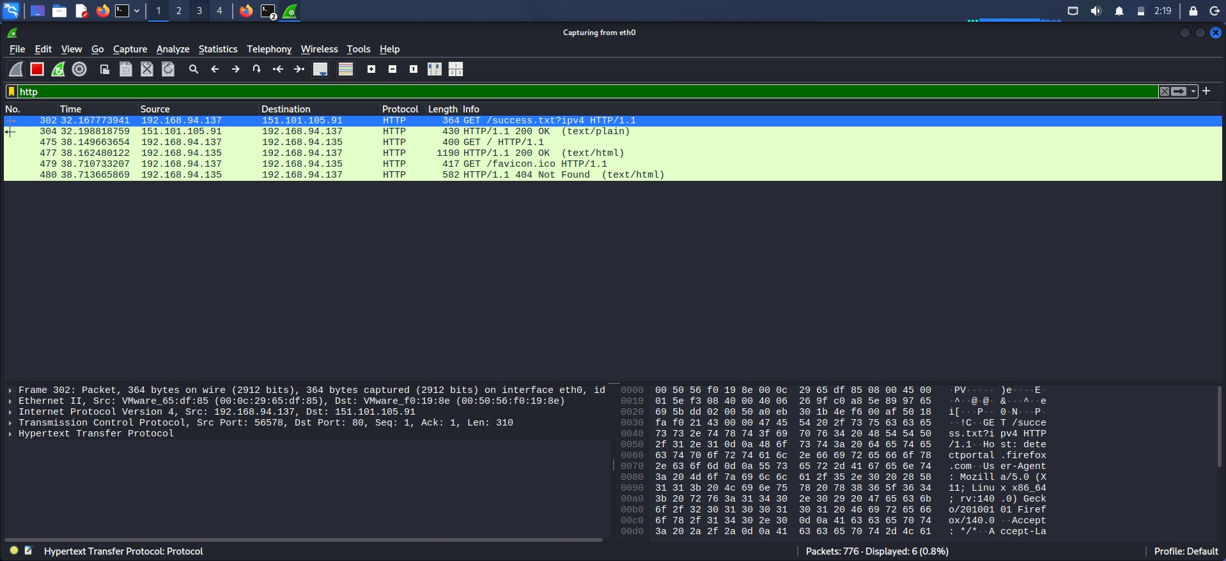
Wireshark filter: http – GET requests to the target web server and 200 OK responses
The capture shows a GET / request to 192.168.94.135 followed by an HTTP/1.1 200 OK response containing the web page's HTML — confirming the same web traffic that curl retrieved earlier, but now visible at the packet level.
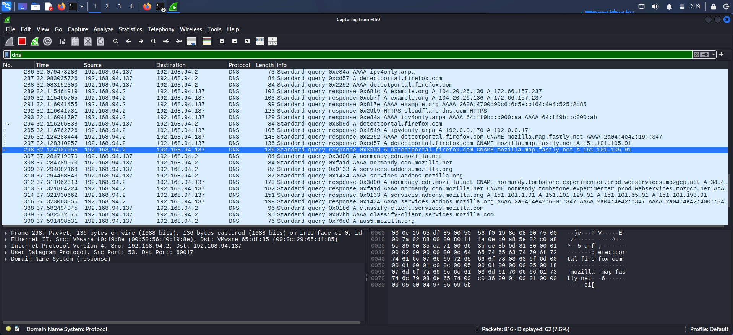
DNS Traffic
Wireshark filter: dns – domain name resolution queries and responses
Standard DNS queries and responses are visible for various domains resolved through the gateway (192.168.94.2), showing how a device looks up an IP address before establishing any connection.

ICMP Traffic
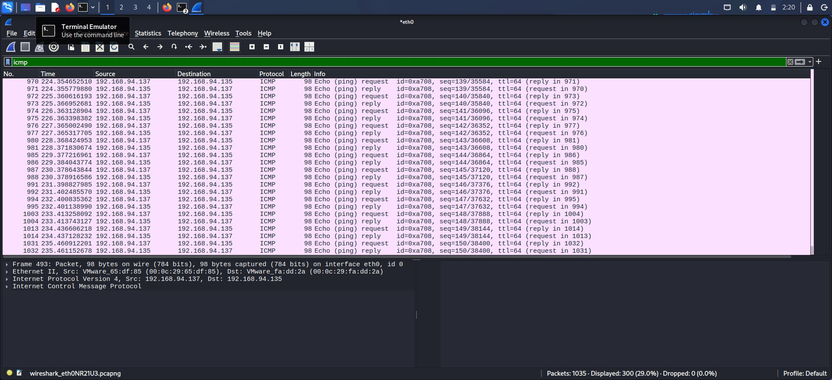
Wireshark filter: icmp – ping echo request/reply pairs between Kali and the target
Repeated ICMP echo request/reply pairs between 192.168.94.137 and 192.168.94.135 confirm basic reachability testing (ping) between the attacker and target machines on the lab network.

9. Mini Project Output – Full Workflow
Stage | Result
Network Setup | Kali Linux (192.168.94.137) and Metasploitable 2 (192.168.94.135) connected on an isolated VMware NAT lab network
Services Running | Apache HTTP Server confirmed active on the target, serving its default page and linked vulnerable web apps
Scan Results | Nmap identified 24 open TCP ports, including the target web service (Apache 2.2.8) and several other exposed services
Traffic Capture | Wireshark captured and confirmed HTTP, DNS and ICMP traffic between the two lab machines

10. Conclusion & Learning
This assignment built directly on previous weeks' networking and scanning fundamentals, this time focused specifically on validating that a running service (a web server) is both functional and visible to standard reconnaissance tools. Setting up the lab, confirming the service with curl, scanning it with Nmap, and then observing the same traffic in Wireshark reinforced how these tools complement each other: curl proves a service works, Nmap proves it is discoverable, and Wireshark proves exactly what is happening on the wire.
A key learning point was recognising that legacy training systems like Metasploitable intentionally run many outdated, exposed services — useful for practice, but a clear illustration of what NOT to expose on a production network. This reinforces the security principle, from earlier weeks, of minimising unnecessary open services and keeping software up to date.

11. Task Breakdown Summary
Task | Description | Status
Task 1 | Set up a basic lab network (Kali Linux attacker + Metasploitable target) on VMware, connected on the same subnet | Completed
Task 2 | Install & verify a web server (Apache) on the target machine, confirmed reachable and responding | Completed
Task 3 | Scan the target with Nmap to identify open ports and running services | Completed
Task 4 | Capture and filter network traffic with Wireshark (HTTP, DNS, ICMP) | Completed
Task 5 | Document the complete workflow as a mini project with report and presentation | Completed

12. Challenges Faced
- Ensuring the Apache service was actually running on the target before scanning — verified directly on the machine using the init script rather than assuming the service was active.
- Filtering Wireshark captures to isolate only the relevant HTTP, DNS and ICMP traffic from the large volume of background packets generated by normal browsing and lab activity.
- Correlating the exact same web request across three different views — the curl output, the Nmap service detection, and the Wireshark packet capture — to build a single, consistent picture of the same underlying event.

13. Bonus Work Considered
As optional bonus scope, this lab's design already supports adding further virtual machines to the same NAT network for a larger topology, and the Nmap scan performed (-sV, full port range) goes beyond a minimal default scan by including service version detection. Future extensions could include analysing additional protocols (e.g., FTP or SMTP handshakes) and adding a dedicated firewall/pfSense VM between the attacker and target to observe how filtering changes the scan and capture results.

14. Conclusion
This assignment successfully demonstrated the end-to-end workflow of initial network reconnaissance and security testing within an isolated lab environment. By integrating multiple tools—using curl to confirm service responsiveness, Nmap to map out discoverable entry points, and Wireshark to analyze underlying packet exchanges—the exercise highlighted how these utilities complement one another to provide a complete picture of network activity. A key takeaway from the lab is recognizing that default or legacy systems often expose a wide array of legacy services and outdated software, reinforcing the fundamental cybersecurity principle of minimizing unnecessary open ports, reducing the attack surface, and maintaining rigorous patch management in production environments.

