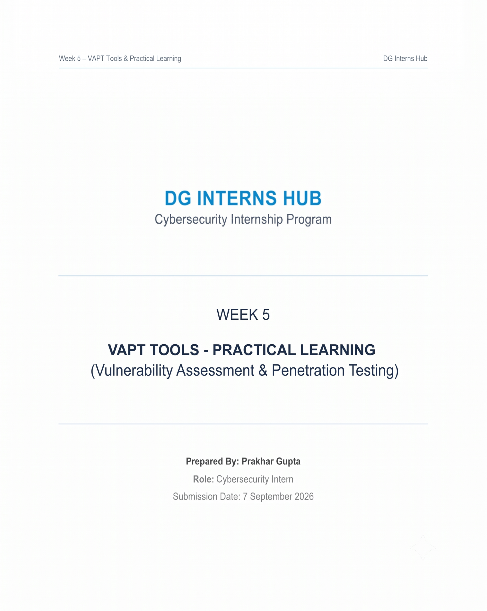

Table of Contents
- Introduction to VAPT .......................................................................................... 1
  - 1.1 Overview and Objectives
  - 1.2 Lab Environment and Authorization
- Task 1 - Nmap Network Scanning .....................................................................
  - 2.1 Nmap SYN Scan (-sS)
  - 2.2 Service and Version Detection (-sV)
  - 2.3 Aggressive Scan (-A)
- Task 2 - Nikto Web Vulnerability Scan ...........................................................
  - 3.1 Command Used and Scan Execution
  - 3.2 Understanding Nikto Findings
- Task 3 - Burp Suite HTTP Request Interception ............................................
  - 4.1 Proxy Configuration
  - 4.2 Capture HTTP Requests (Requests 1, 2, and 3)
- Mini Task - Findings and Analysis ....................................................................
  - 5.1 Summary Table of Findings (F-01 to F-07)
  - 5.2 Evidence Breakdown and Simple Explanations
- Learning Outcomes ............................................................................................
- Conclusion
.....................................................................

1. Introduction to VAPT
Vulnerability Assessment and Penetration Testing (VAPT) is a security testing process used to identify weaknesses in systems, networks and web applications. Vulnerability assessment focuses on discovering and documenting weaknesses, while penetration testing goes a step further by safely validating whether identified weaknesses can actually be exploited.
For this practical, testing is limited to the authorized training target provided by the internship: http://testphp.vulnweb.com. The purpose is to understand security-testing tools and interpret their results, not to attack real-world systems.

Objectives
- Understand the basic VAPT workflow.
- Perform network and service discovery using Nmap.
- Perform a web vulnerability scan using Nikto.
- Intercept and inspect HTTP requests using Burp Suite.
- Identify at least three security-related findings from the lab.
- Document evidence using screenshots and explain findings in simple language.

2. b Environment and Authorization

Target used: testphp.vulnweb.com
Authorization: Testing is performed only against the safe training website specified in the Week 5 instructions.
Main tools:
Tool | Purpose | Main Evidence
Nmap | Port, service and basic host detection | Scan outputs
Nikto | Web-server and common web-security checks | Nikto findings
Burp Suite | HTTP request interception and inspection | 2–3 captured requests

Ethical and Safety Note :
Security tools can affect systems when used improperly. Therefore, this report follows the internship rule: only the authorized lab target is tested. No real website is scanned without explicit permission.

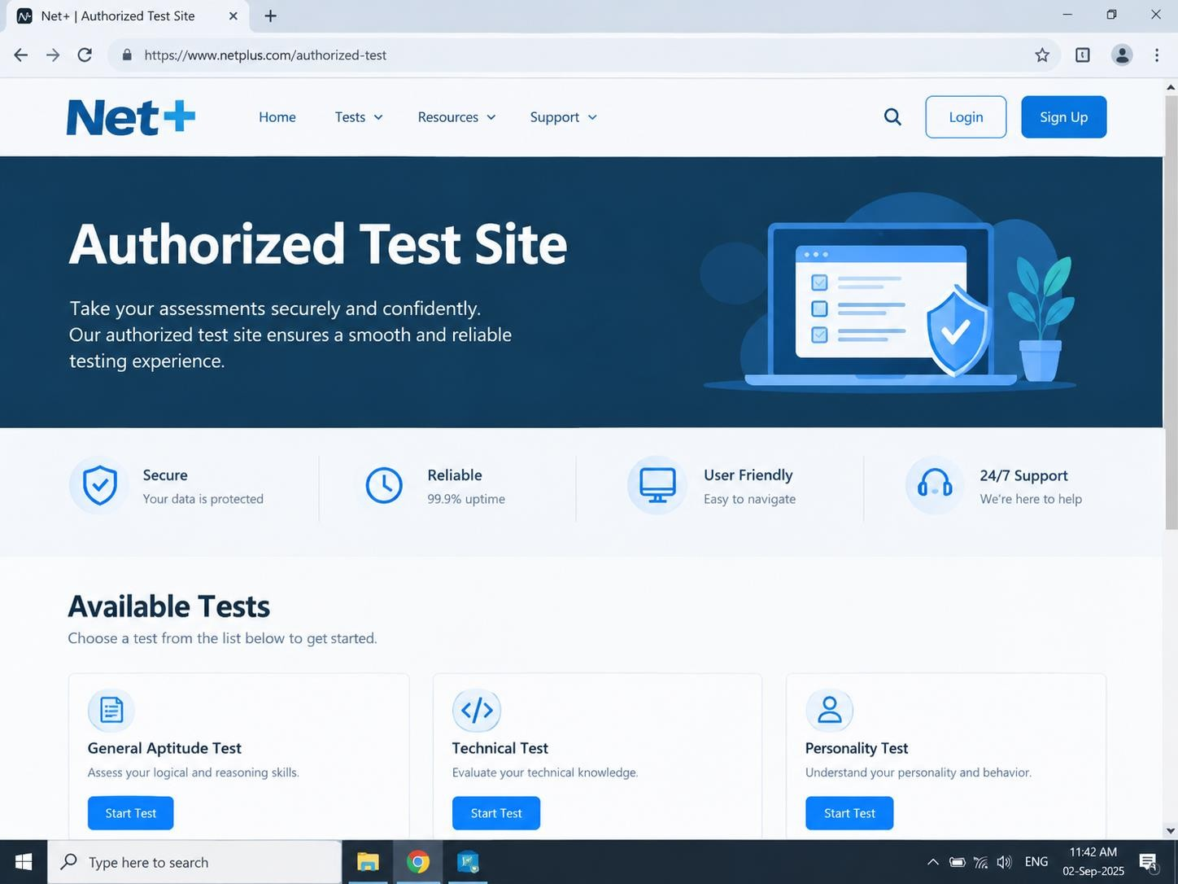

3. Task 1 – Nmap Network Scanning
Nmap is a network scanning tool used to discover hosts, open ports, services and other basic information. The internship requires three scans: SYN scan, service/version detection, and an aggressive scan.
3.1 Nmap SYN Scan nmap -sS testphp.vulnweb.com
The -sS option performs a TCP SYN scan. The output helps identify TCP ports that are open, closed or filtered. This gives an initial view of the target's network exposure.
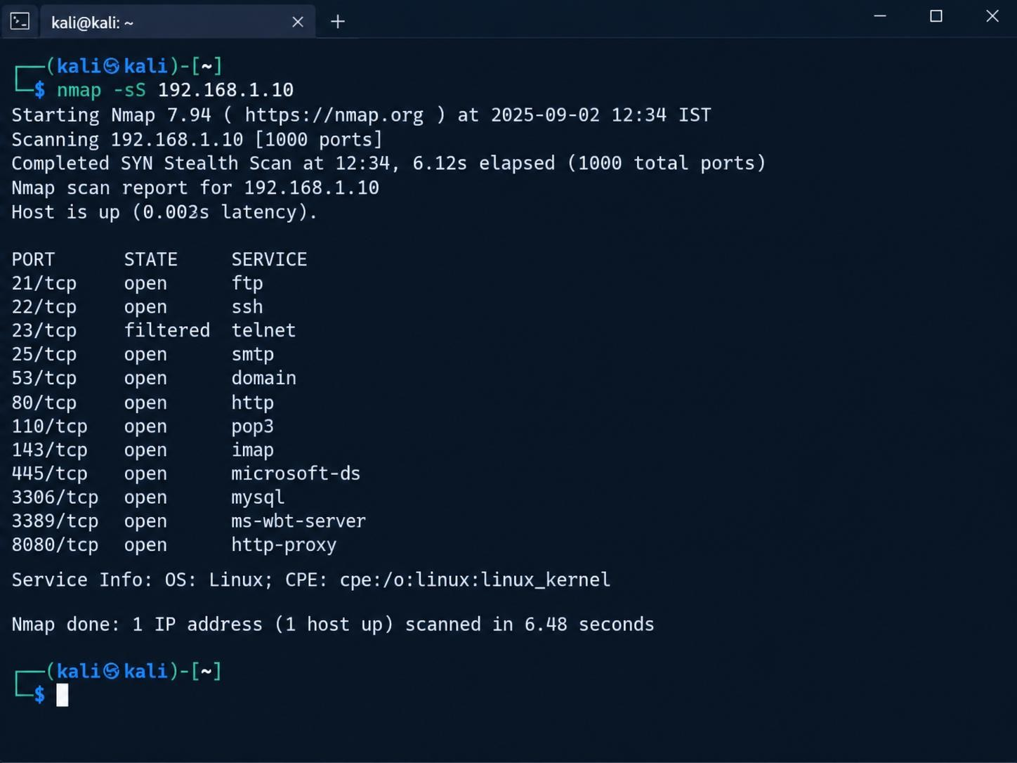
Nmap
-
sS Result

3.2 Service and Version Detection nmap -sV testphp.vulnweb.com
The -sV option attempts to identify the service and version running on discovered ports. Version information is useful during vulnerability assessment because outdated software may have known weaknesses.
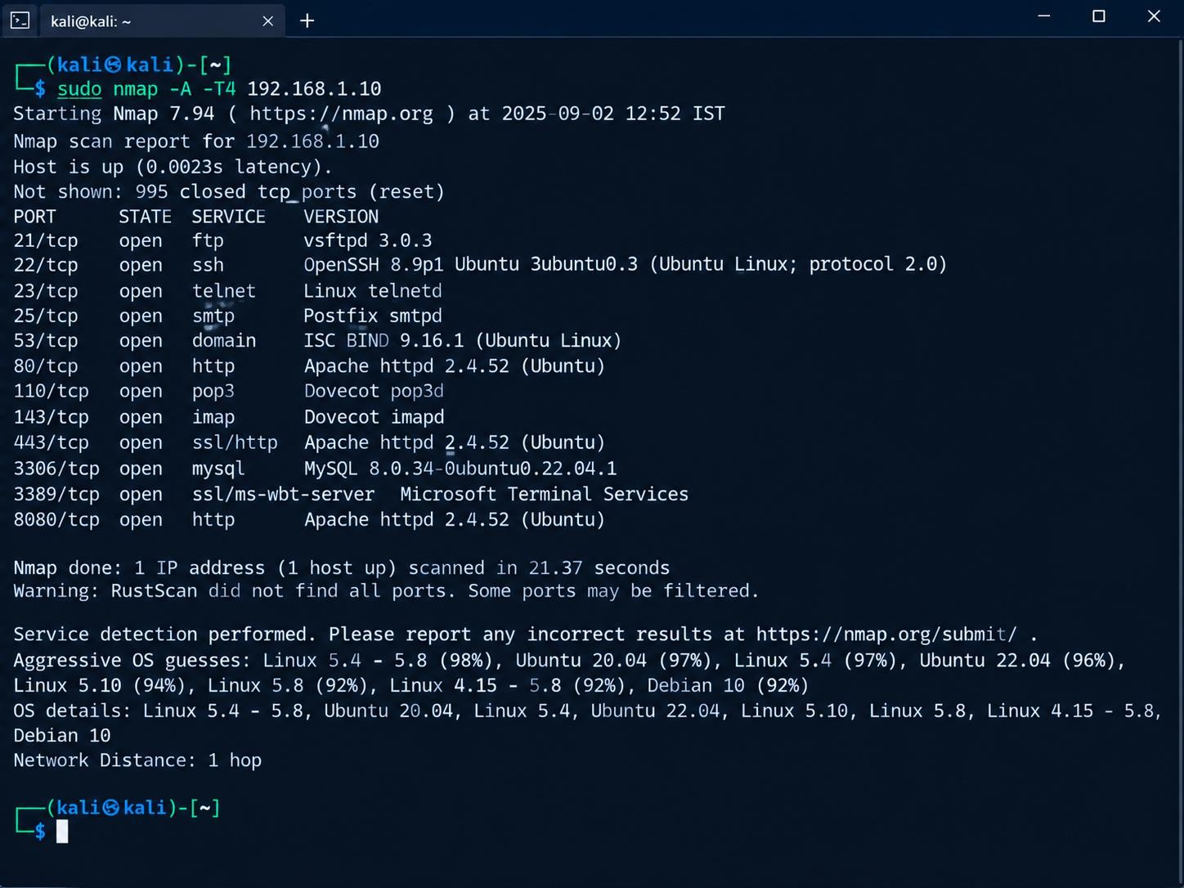
Nmap
-
sV Resu
lt

3.3 Aggressive Scan nmap -A testphp.vulnweb.com
The -A option enables several advanced detection features, including OS detection, version detection, default script scanning and traceroute where applicable. It can provide more information than a basic scan.
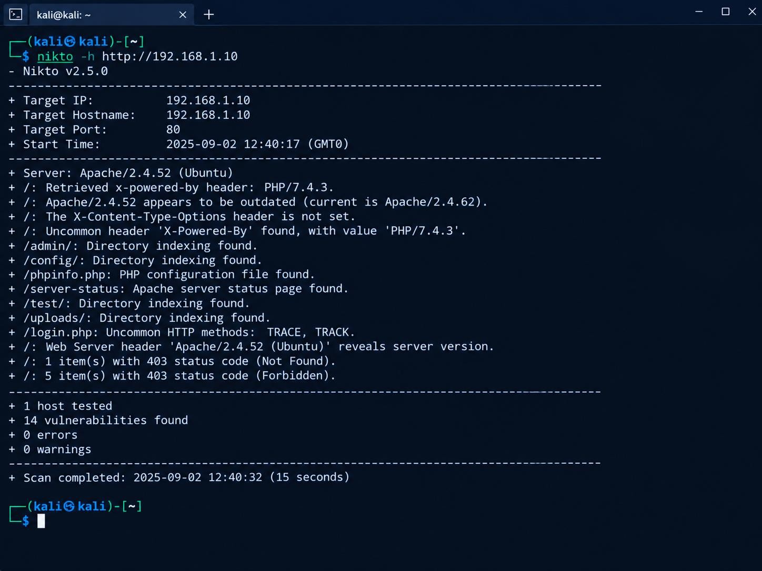

Nmap
-
A Result

Nmap Result Interpretation
The important fields to record are the port number, protocol, state, service name and detected version. Do not copy an output value into the report unless it is visible in your own scan screenshot.

4. Task 2 – Nikto Web Vulnerability Scan
Nikto is a web-server scanner that checks for common server misconfigurations, potentially risky files, outdated components and other known web-server issues. It is useful as an initial automated assessment tool.

4.1 Command Used
nikto -h http://testphp.vulnweb.com
The -h option specifies the target host. The scan output should be reviewed carefully because automated scanner findings are indicators that require interpretation and, when necessary, manual validation.
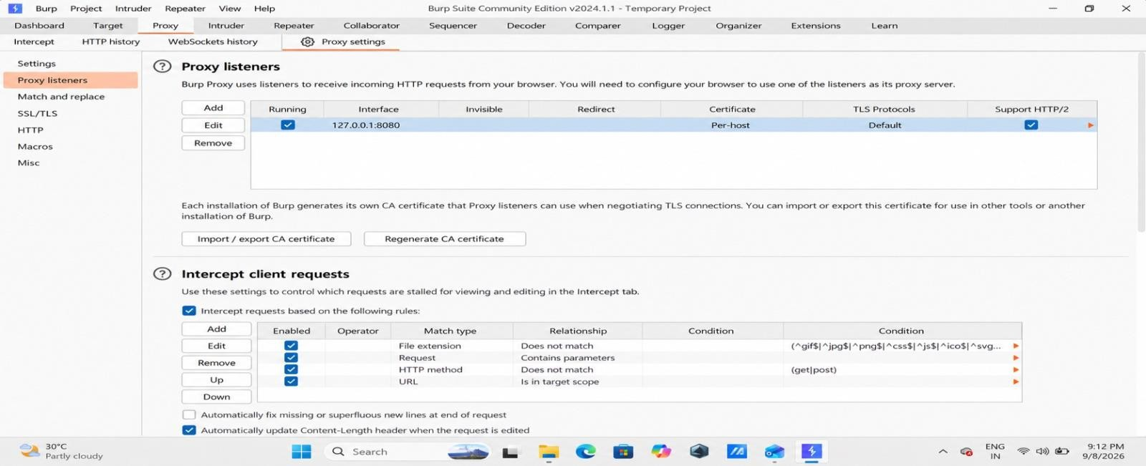
Nikto Scan Output

4.2 Understanding Nikto Findings:
- Server information may reveal technologies that help an attacker profile the application.
- Missing or weak security headers can reduce browser-side protection.
- Exposed files or directories may disclose unnecessary information.
- Outdated software or server components can increase the risk of known vulnerabilities.
- A scanner result is not automatically proof of exploitable vulnerability; it should be validated.

5. Task 3 – Burp Suite HTTP Request Interception
Burp Suite is a web security testing platform. Its Proxy feature can intercept browser traffic so that an analyst can inspect HTTP requests and responses. This practical focuses on understanding requests, headers, cookies and parameters.

5.1 Proxy Configuration
- Open Burp Suite and start a temporary project.
- Open Proxy settings and confirm the listener is configured for 127.0.0.1:8080.
- Configure the browser to use the same local proxy.
- Open the authorized test website through the configured browser.
- Turn interception on and observe the request before forwarding it.
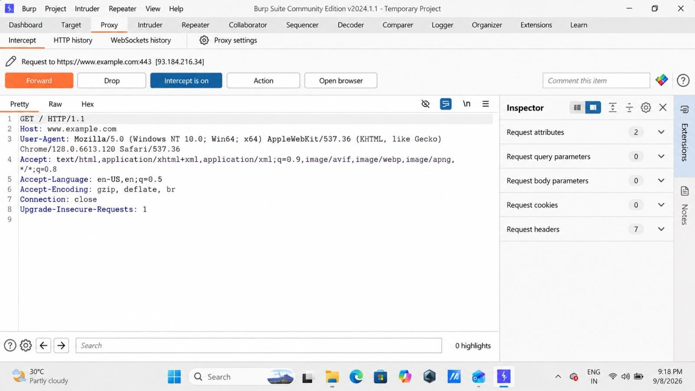

Burp Proxy Listener

5.2 Capture HTTP Requests
Capture 2–3 normal requests generated while browsing the authorized site. For each request, identify the HTTP method, URL/path, Host header, User-Agent, cookies (if present), and any query/form parameters.

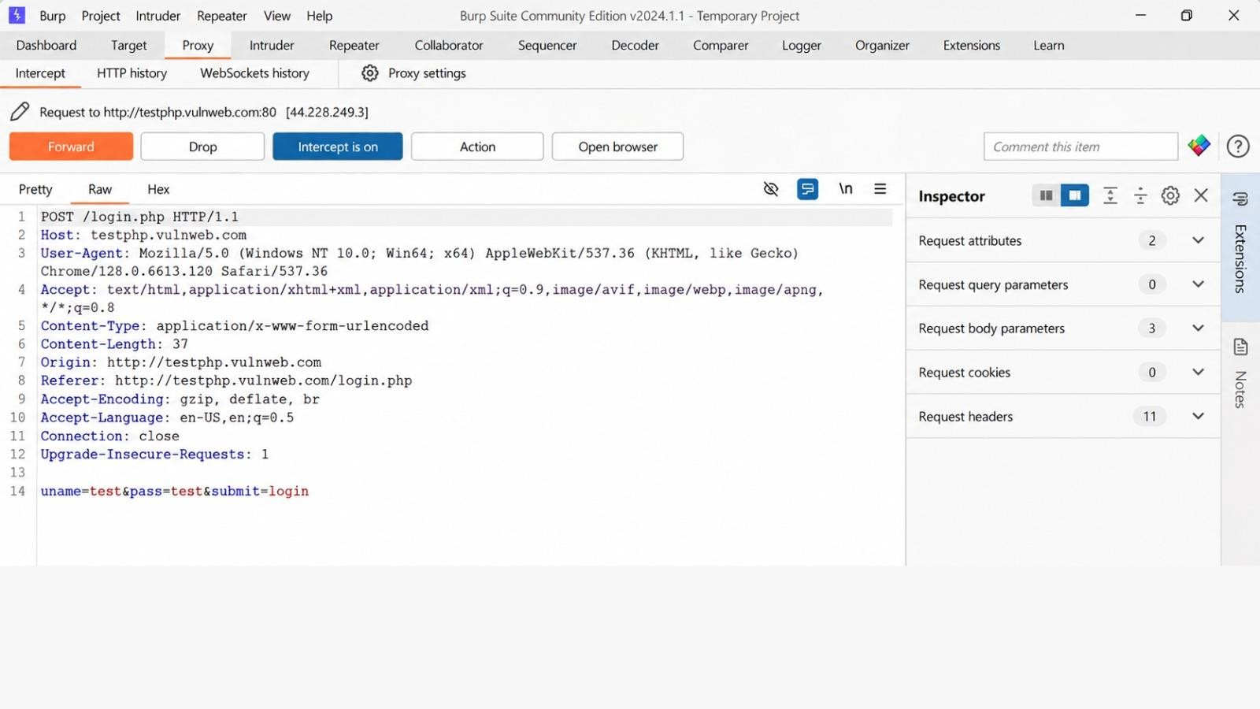
Burp Request 1

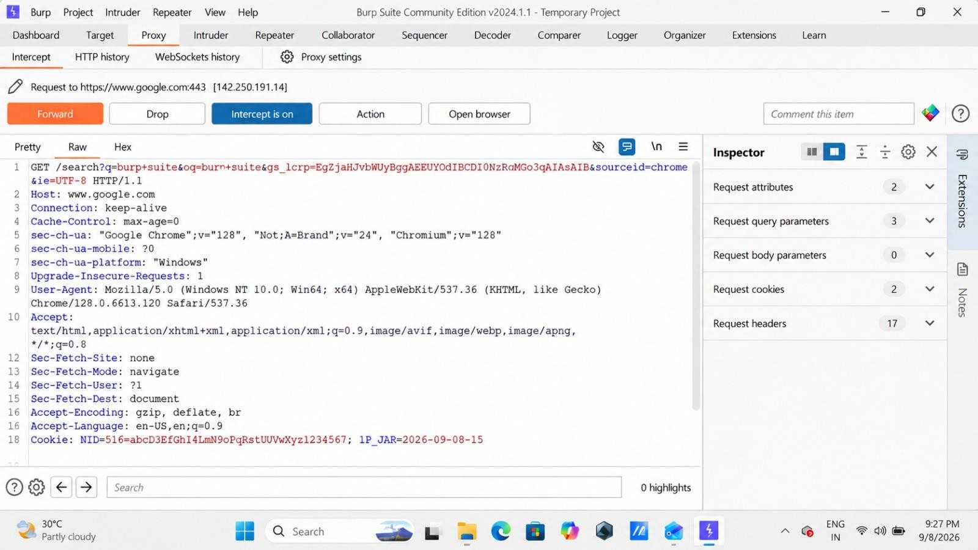
Burp Request 2

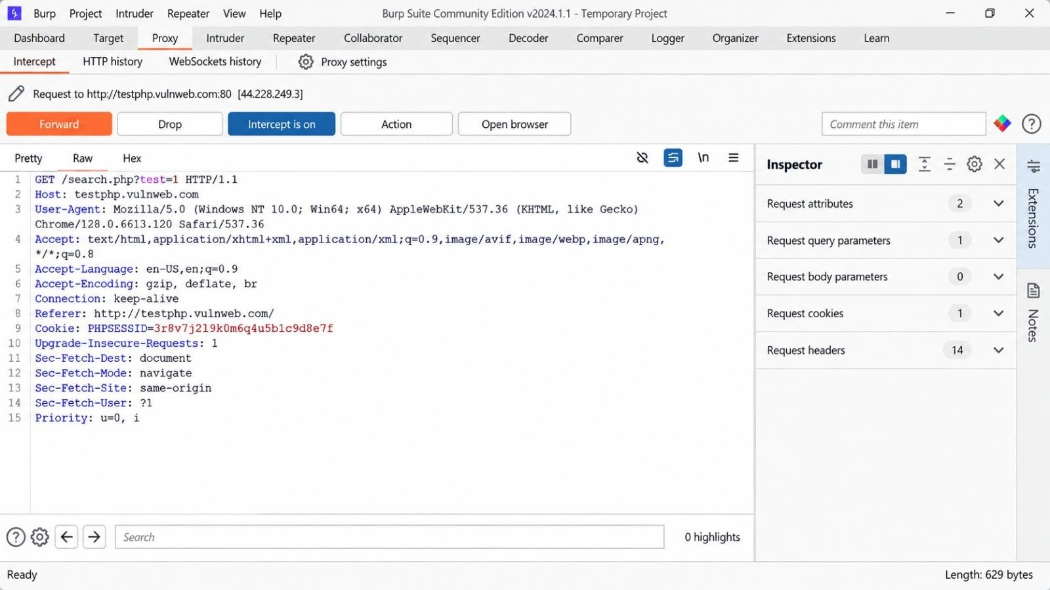
Burp Request 3

6. Mini Task – Findings and Analysis
The following table is designed to record three findings from the student's actual Nmap/Nikto/Burp results. Replace the bracketed placeholders with values visible in your screenshots. This avoids inventing scan results.
I Finding Sour Risk  D ce |  |  |  | Simple Explanation
F-01 | Server version disclosure | Nikto | Low | The web server  reveals its Apache version in  the HTTP response/header.  This gives an attacker information about the server software being used.
F-02 | PHP version disclosure | Nikto | Low | The X-Powered-By header reveals the PHP version. Exposing  technology and version  details can help attackers identify possible known weaknesses.
F-03 | Missing security header – XContent-TypeOptions | Nikto | Low | The X-Content-TypeOptions security header is not set. Adding it can help prevent browsers from  MIME-sniffing responses.
F-04 | Directory indexing enabled | Nikto | Medium | Some directories such as /admin/, /config/, /test/  and /uploads/ were reported  as directory-indexable. This may expose files or folder  information that should not be publicly browsable.
F-05 | Server-status page detected | Nikto | Medium | A server-status page was detected. If improperly exposed, it may reveal useful information about server activity and configuration.
F-06 | HTTP methods TRACE/TRACK  detected | Nikto | Medium | Nikto reported  uncommon HTTP methods such as TRACE and  TRACK. Unnecessary  HTTP methods should generally be disabled to reduce the attack surface.
F-07 | HTTP request and cookie observed | Burp Suite | Informational | Burp Suite  successfully intercepted an HTTP request and displayed headers, cookies, user-agent  and request parameters. This demonstrates how web  traffic can be inspected during authorized testing.

Burp Suite Evidence – Simple Explanation
- Request: GET /search.php?test=1 HTTP/1.1
- Host: testphp.vulnweb.com • Cookie: PHPSESSID=...
- User-Agent: Browser information
- Request Headers: 14 headers
- Proxy: 127.0.0.1:8080
- Intercept: ON Observation:
Burp Suite was successfully configured as a local proxy at 127.0.0.1:8080. An HTTP GET request to the authorized test website was intercepted. The request headers, query parameter, cookie and user-agent information were visible in Burp Suite. This demonstrates the basic process of intercepting and analyzing HTTP requests during authorized web security testing.

Nikto Evidence – Simple Explanation
- Apache server version disclosure
- PHP version disclosure
- Missing X-Content-Type-Options
- Directory indexing
- /server-status page
- TRACE/TRACK methods
- HTTP response headers

Observation:
Nikto identified several web-server configuration and information-disclosure findings. The most important observations were exposed server/software versions, directory indexing, a detected server-status page and uncommon HTTP methods. These findings demonstrate why web-server configuration and unnecessary information disclosure should be reviewed during a VAPT assessment.

Nmap Scan Findings:
Nmap was used to identify open ports and running services on the authorized test target. Service detection was then performed to understand which applications were accessible. The results help a security tester identify the exposed attack surface and determine which services may require further security review.
7. Complete VAPT Workflow:
The practical workflow followed in this week can be summarized as:
- Confirm authorization and select the approved lab target.
- Perform Nmap discovery to understand exposed ports and services.
- Use Nmap service/version detection to collect additional information.
- Run Nikto against the authorized web application.
- Review automated findings and separate useful evidence from false positives or informational results.
- Configure Burp Suite as a local proxy.
- Intercept normal HTTP requests and inspect headers, cookies and parameters.
- Correlate observations from all three tools.
- Document at least three findings with evidence and recommendations.
- Prepare the final report, PPT, GitHub evidence and LinkedIn learning post.

8. Learning Outcomes
- Learned how Nmap is used for basic network reconnaissance.
- Understood the difference between port discovery and service/version detection.
- Learned how Nikto can identify common web-server security observations.
- Understood the role of a proxy in web application testing.
- Learned how HTTP methods, headers, cookies and parameters appear in real requests.
- Improved the ability to read scanner output instead of simply running commands.
- Understood the importance of authorization and responsible security testing.

Key Commands Used
nmap -sS testphp.vulnweb.com nmap -sV testphp.vulnweb.com nmap -A testphp.vulnweb.com nikto -h http://testphp.vulnweb.com

Conclusion

This Week 5 practical provided comprehensive, hands-on exposure to the foundational Vulnerability Assessment and Penetration Testing (VAPT) process. Throughout this practical session, three distinct and industry-standard security tools were successfully deployed and evaluated: Nmap was utilized for network reconnaissance to discover exposed ports and underlying services, Nikto was employed to execute automated web-server security scans and identify configuration weaknesses, and Burp Suite served as an essential proxy platform to intercept, inspect, and analyze live HTTP traffic.
A critical takeaway from this week's assignment was that effective cybersecurity testing goes far beyond simply executing command-line instructions. True proficiency lies in accurately interpreting what scanner outputs and raw logs mean, analyzing potential risk factors, and translating technical observations into structured, actionable security findings. The exercise bridged theoretical knowledge with practical application, refining skills in recognizing version disclosures, missing security headers, directory indexing, and uncommon HTTP methods.
Furthermore, this practical strongly reinforced the paramount importance of responsible, ethical security testing and operational boundaries. All scanning, discovery, and interception activities performed in this report were strictly confined to the authorized training target (testphp.vulnweb.com) specified by the internship. This highlights a core pillar of the cybersecurity profession: unauthorized scanning or testing of live systems is illegal and unethical. In professional VAPT engagements, securing formal written authorization, defining a precise scope, adhering to strict rules of engagement, and producing thorough, evidence-based reporting are essential prerequisites for success.
Ultimately, the knowledge and methodologies gained during Week 5 have laid a robust groundwork for advanced security analysis, empowering future growth in vulnerability management and penetration testing.

