***Simple CRUD with Codeigniter and MySQL***

***Name:*** Shawn Michael A. Sudaria ***BSIT-3B***

**EVSU Research Archive**

**What is CRUD?**

**CRUD stands for:**

* **C - Create (Add new data)**
* **R - Read (Display or view data)**
* **U - Update (Edit or modify data)**
* **D - Delete (Remove data)**

In this tutorial, we will build a simple student list web app that allows you to Create, Read, and Delete student information using CodeIgniter 4.

**What is CodeIgniter?**

CodeIgniter is a lightweight PHP framework used to build web applications quickly and easily. It’s beginner-friendly and works well for simple systems like inventory, student records, etc.

**Recap of Activity 5**

Before continuing with this tutorial (Activity 6), let's quickly review what was done in **Activity 5**:

* **Step 1**: Searched and explored the official **CodeIgniter Documentation**
* **Step 2**: Installed **Composer** as a PHP dependency manager
* **Step 3**: Created a new **CodeIgniter Project** using Composer
* **Step 4**: Built a simple **User Interface (UI)** layout for the CRUD system
* **Step 5**: Set up a **Controller** to manage logic and flow
* **Step 6**: Configured the **Routes** to connect URLs to controller actions
* **Step 7**: Creating User Dashboard

You should now have a basic CodeIgniter setup with UI, controller, and routing. If not, review Activity 5 before starting this tutorial.

Let's begin with **Activity 6**: Creating CRUD Operations

**Step 1: Install Requirements**

You'll need:

* A computer or laptop
* **Laragon** (includes Apache + MySQL)
* **CodeIgniter 4**
* A browser (like Chrome)

**Step 2: Open Laragon and Start Services**

* Open **Laragon Control Panel**
* Start both **Apache** and **MySQL**
* Open vscode

**Step 3: Connect CodeIgniter to the Database**

1. Inside your CodeIgniter project folder, look for a file named env

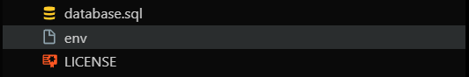

1. **Copy** it, **paste** it in the same folder, and rename it to .env

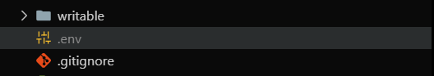

1. Go to the app/Config/Database.php and make sure it follows this structure

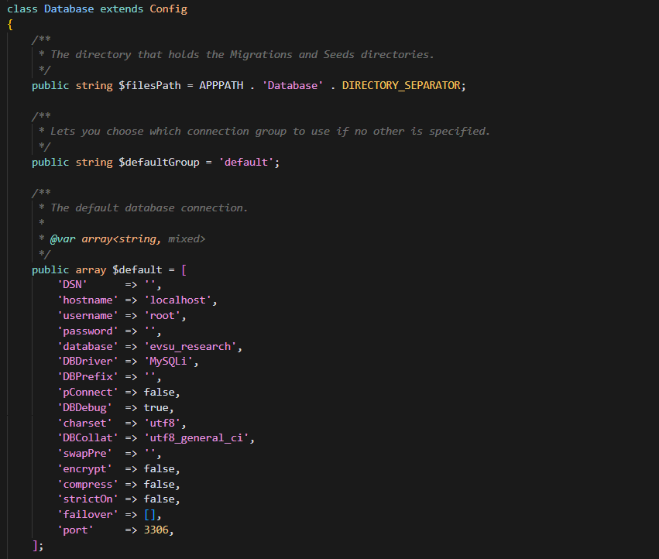

**Step 5: Create the Database and Table**

Since this tutorial is the continuation of tutorial 5, let’s assume that you already have the database named “evsu_research”.

1. We will be creating table where we will be saving the classes of the instructors. Open the MySQL laragon database and copy the following sql commands.
   1. First, we will use the evsu_research databse so use the command: *use evsu_research;*
   2. Create the table publication using the code below:

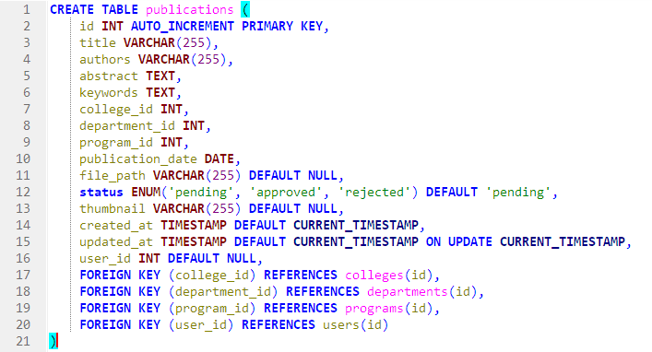

Now that the **table** are set up, you can move on to **creating models**, **controllers**, ***routes*** and **views** for the CRUD operations.\

***Step 5 : Create a Model in CodeIgniter***

**What is a Model?**

A **Model** in CodeIgniter is a file that connects your application to the **database**.

* It is responsible for **retrieving**, **inserting**, **updating**, and **deleting** data.
* Think of it as the **bridge** between your database and your website.
* Models help keep your code organized by separating the database logic from the rest of your application (like the user interface and page structure).

Open your terminal in the project root

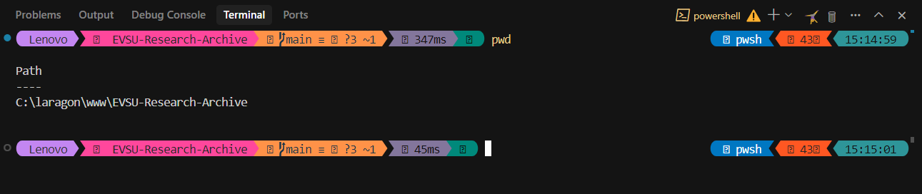

Use this command to generate a model:



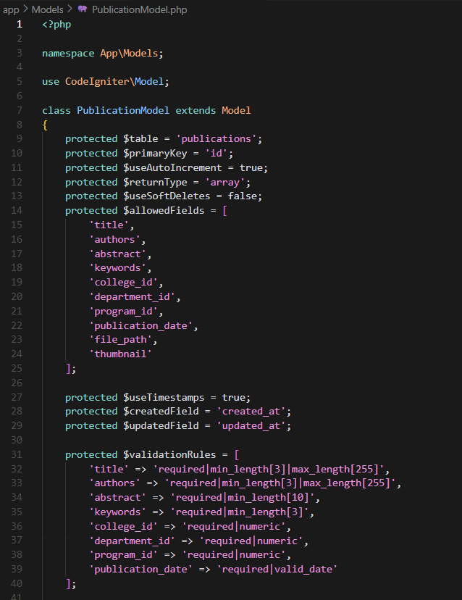

**Step 6: Creating a Controller (Part of Activity 5)**

**What is a Controller?**

A **Controller** is the part of CodeIgniter that **handles user requests** and **controls what to do with them**.

* It acts like a traffic manager: when the user clicks a button or visits a page, the controller decides **which data to get**, **which page to show**, and **what action to perform** (like add, edit, or delete).
* It **talks to the Model** for data and **shows it using the View**.

**How to Create a Controller**

Use the terminal in your project directory and run:

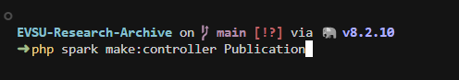

**Edit the Controller**

Open the Publication.php file and start with this basic setup:

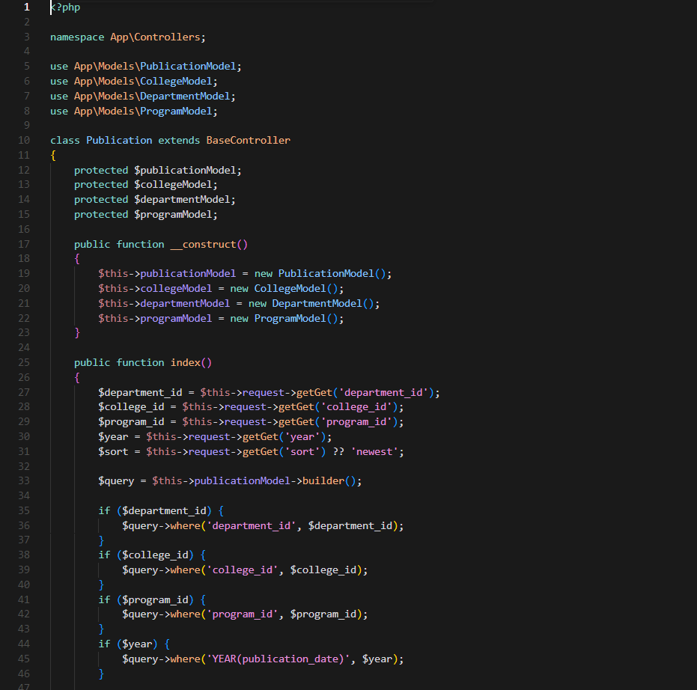

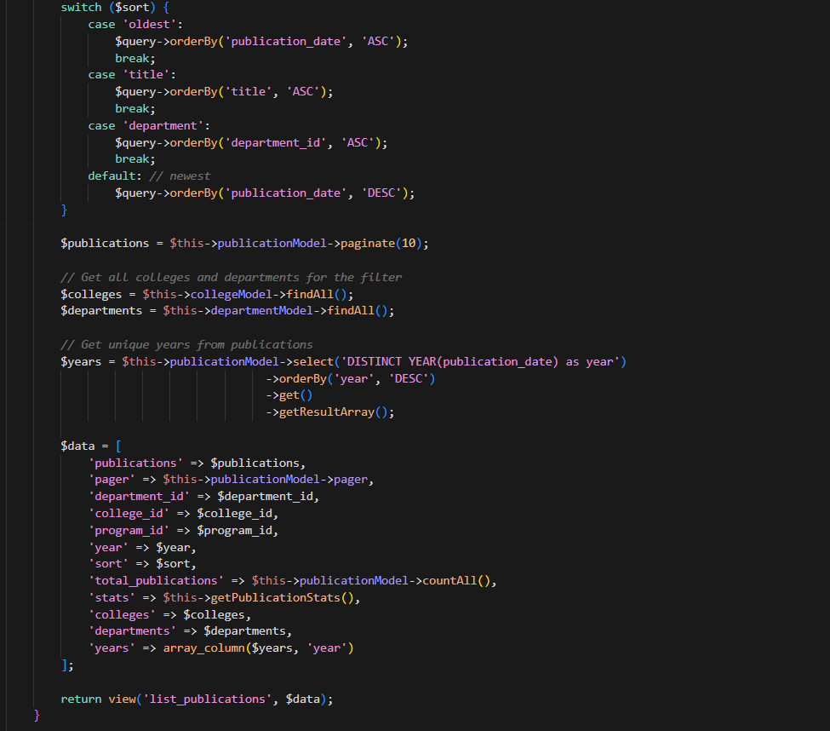

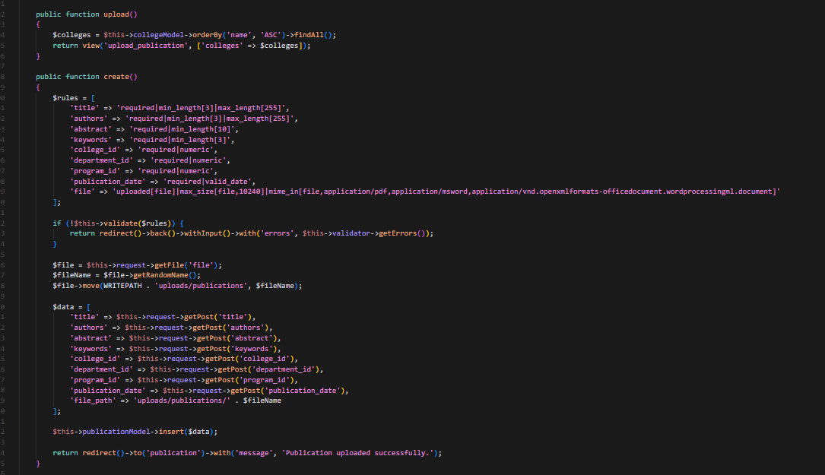

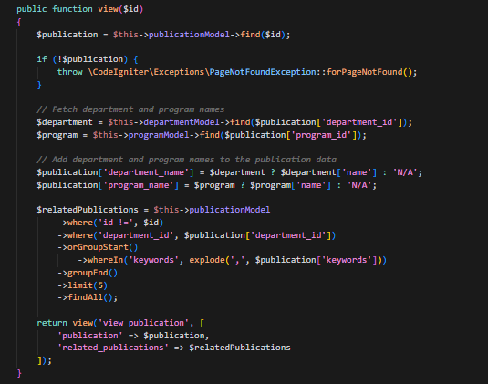

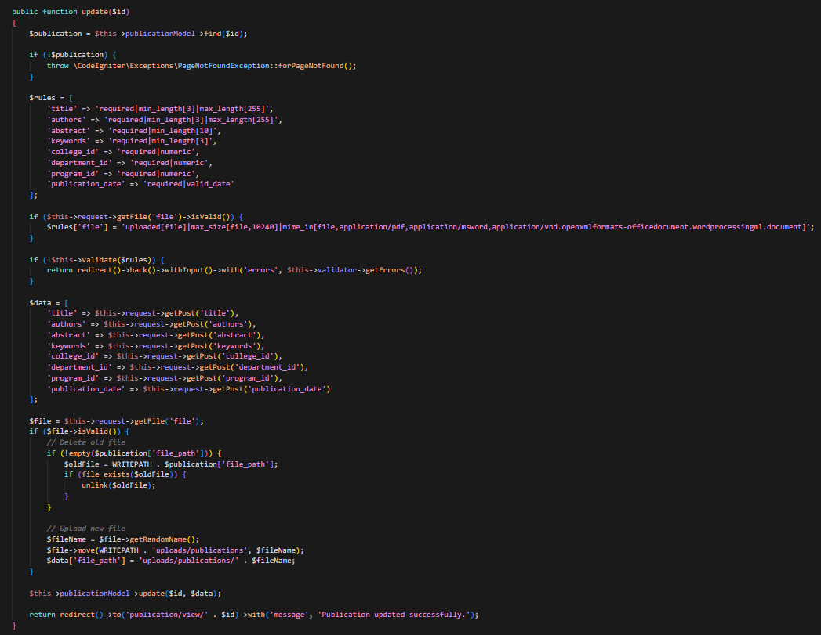

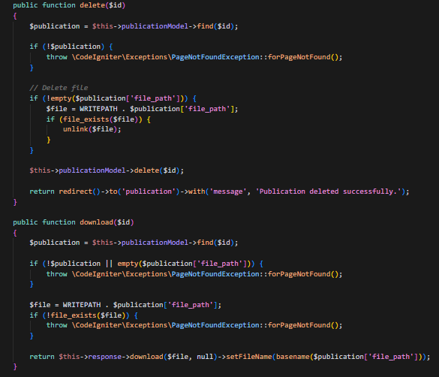

**What this Controller does:**

* upload() – for uploading the document
* create() – creating an entry in the table for the metadata of the file
* view() – viewing the publication
* update() – updating the metadata of the publication
* update() – update publication info
* delete() – delete a publication
* download() – for the ability to download the publication for authorized users

**Step 7: Setting Up Routes (Part of Activity 5)**

*note: Setting up routes was already introduced in* ***Activity 5****, but here we’ll apply it in our actual CRUD system.*

**What is a Route?**

A **Route** tells CodeIgniter which **controller function** to run when a user visits a certain URL.

Think of it as a **map** that connects website links (like /resident/create) to functions inside your controller.

**How to Add Routes**

Open this file in your project:



Scroll down to the part where you can define your own routes, and add this:

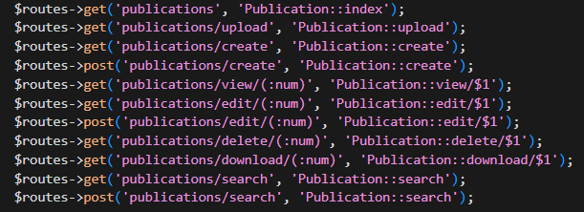

**What These Routes Do:**

* */publications (GET)* - Displays a list of all publications.
* */publications/upload (GET)* - Shows the form to upload a new publication.
* */publications/create (GET)* - Displays the form to create a new publication record.
* */publications/create (POST)* - Processes data submitted from the new publication form.
* */publications/view/(:num) (GET)* - Views a specific publication by its ID.
* */publications/edit/(:num) (GET)* - Displays the form to edit a specific publication by its ID.
* */publications/edit/(:num) (POST)* - Processes data from the edit publication form for a specific ID.
* /publications/delete/(:num) (GET) - Deletes a specific publication by its ID. (Using GET for deletion is not recommended).
* /publications/download/(:num) (GET) - Downloads a file for a specific publication by its ID.
* /publications/search (GET) - Displays the search form or initial results.
* /publications/search (POST) - Processes search form submissions.

The routes might appear to have duplicates (like /publication vs /publications if the singular route exists) because each unique URI pattern defined creates a distinct access point, even if multiple URIs point to the same controller action. This can be done for flexibility, allowing users to reach the same content through slightly different URLs.

Your routes are now connected!

Step 8: Creating Views (Part of Activity 5)

note: Creating the UI (views) was already part of **Activity 5**. If you already designed the interface there, we would now connect it to make it functional.

**What is a View?**

A **View** in CodeIgniter is a file that contains **HTML code**. It’s what the user **sees** on the browser.

* Views are used to display forms, tables, and other visual elements.
* They **receive data from the controller** and show it in a human-friendly way.

**Where to Place the Views**

Save your view files in this folder:

*apps/views/*

1. Create a php file called list_publications.php and add the following code to it.

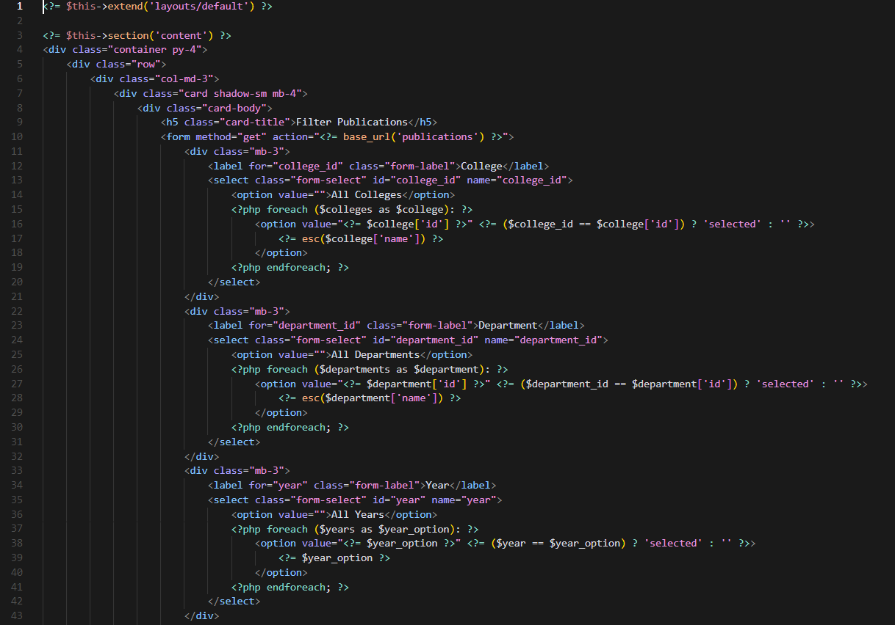

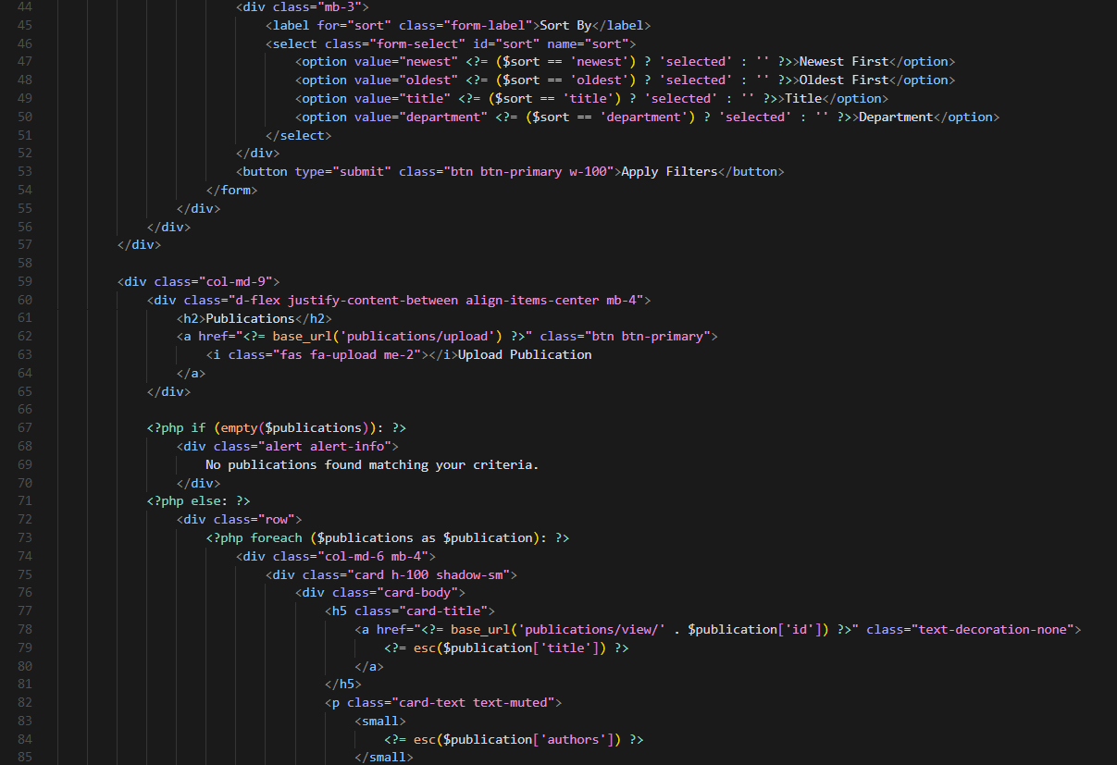

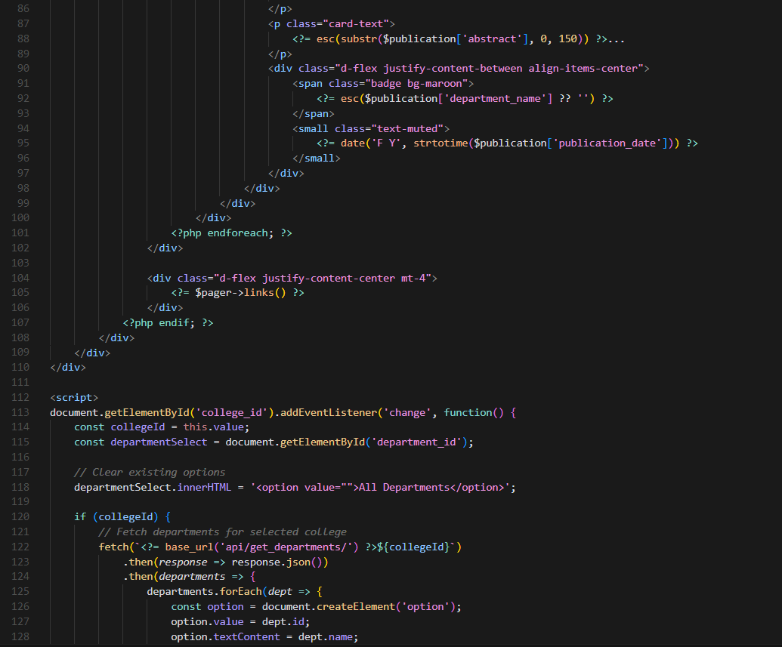

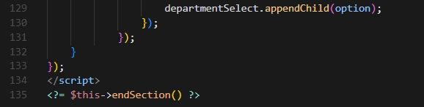

2. Now we will create the upload page to upload the publication. Create a file named “upload_publication.php” and add the code below.

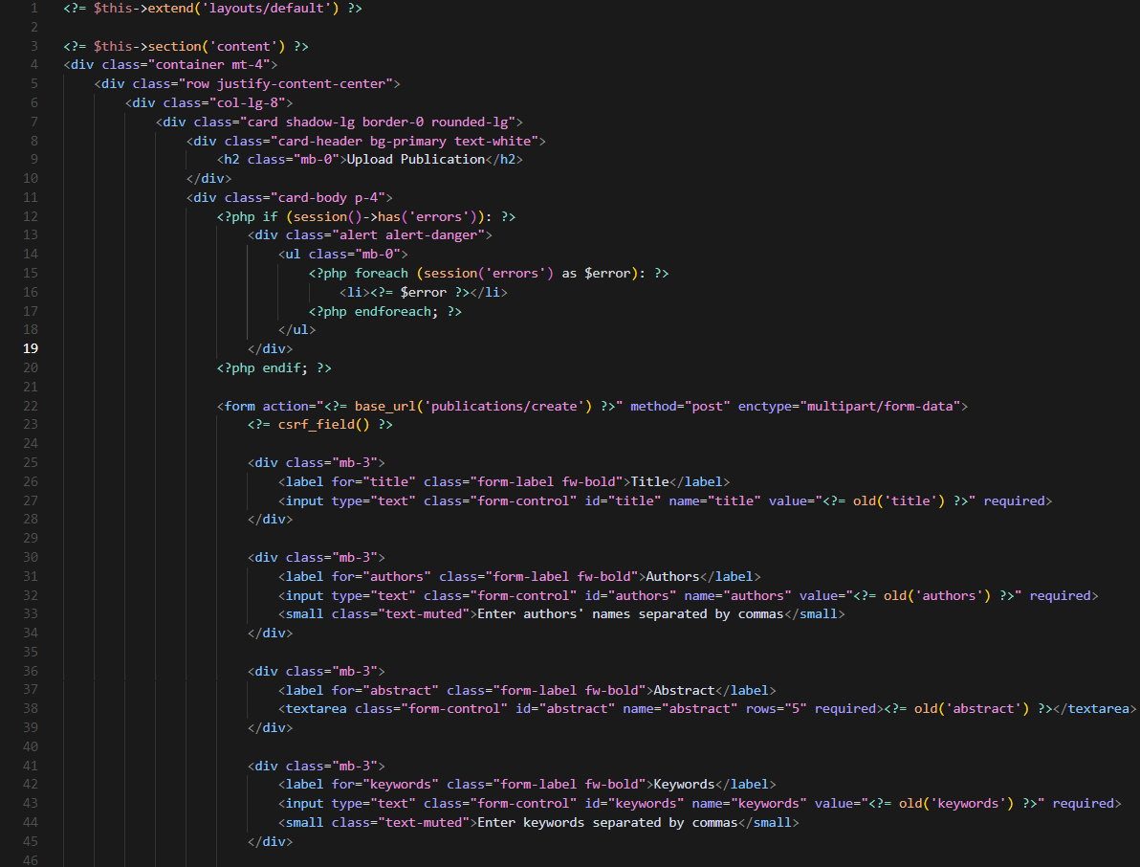

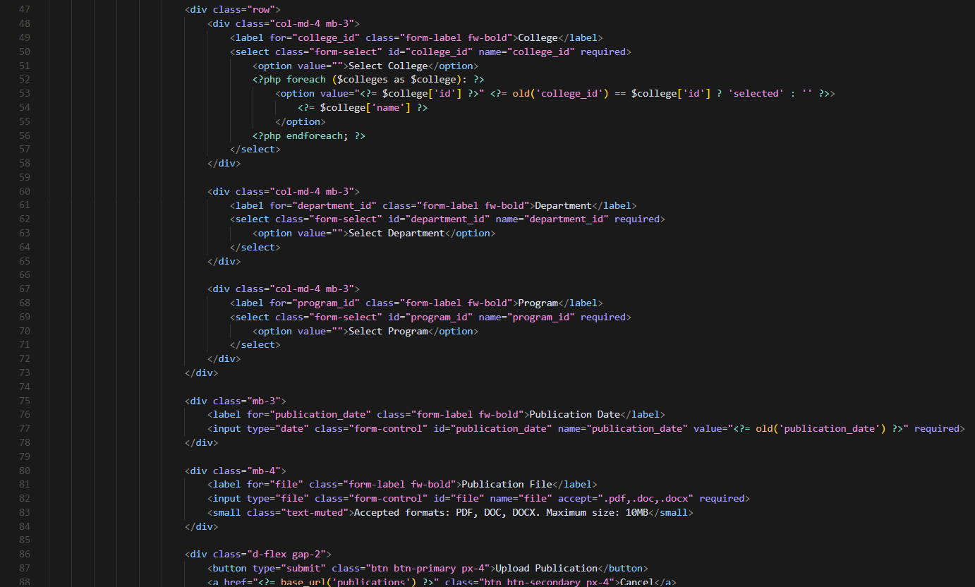

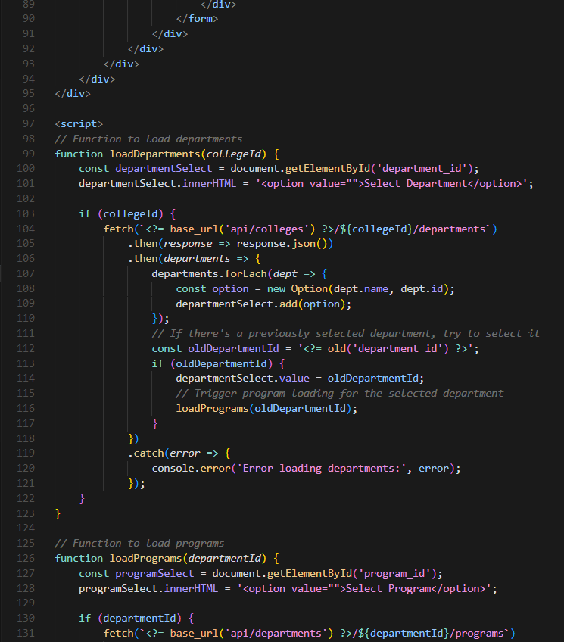

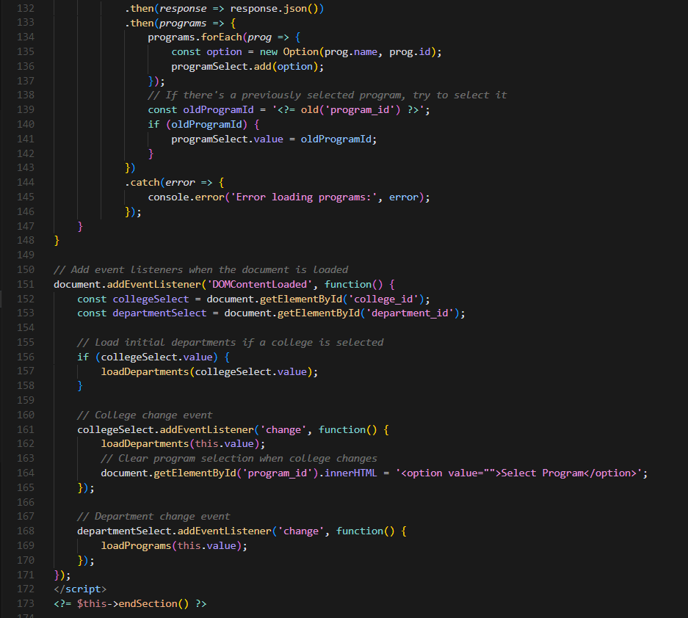

3. Now let’s create a file called update_publication.php and copy the code below.

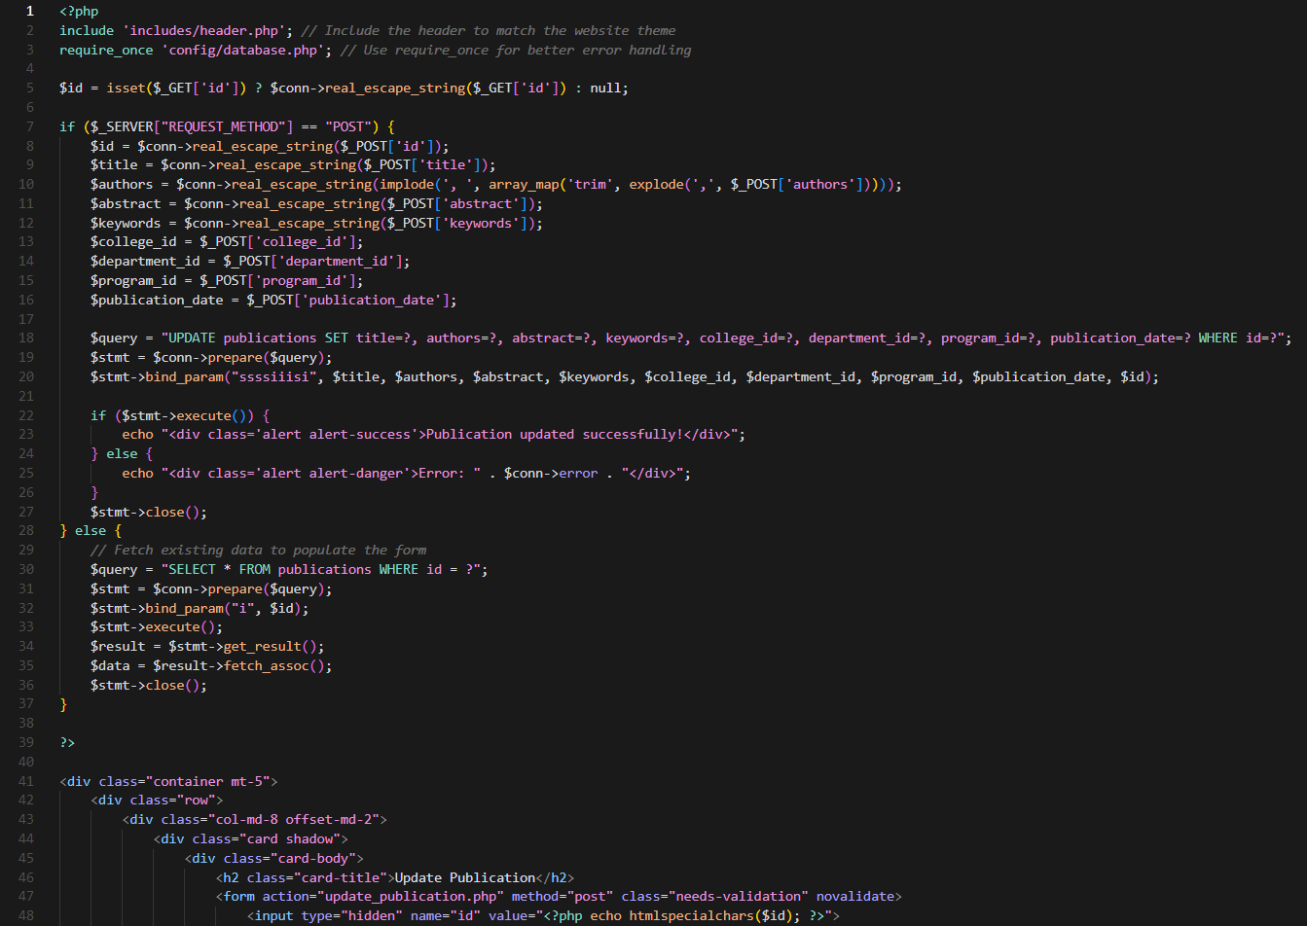

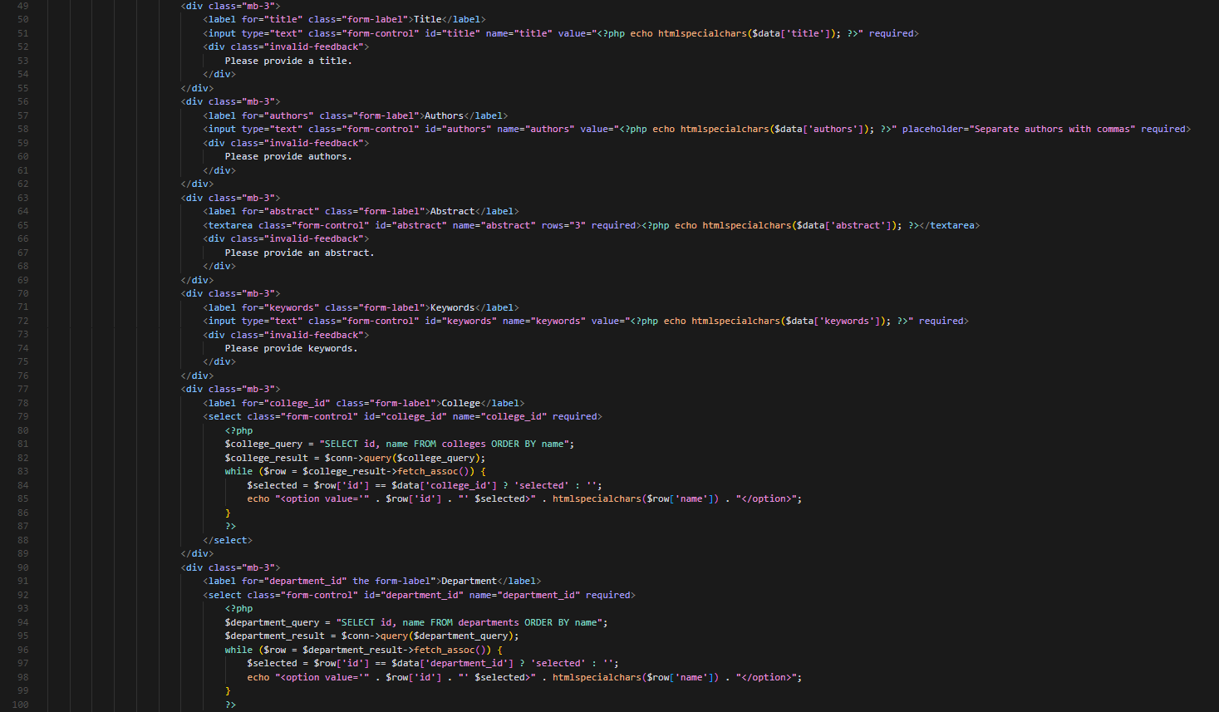

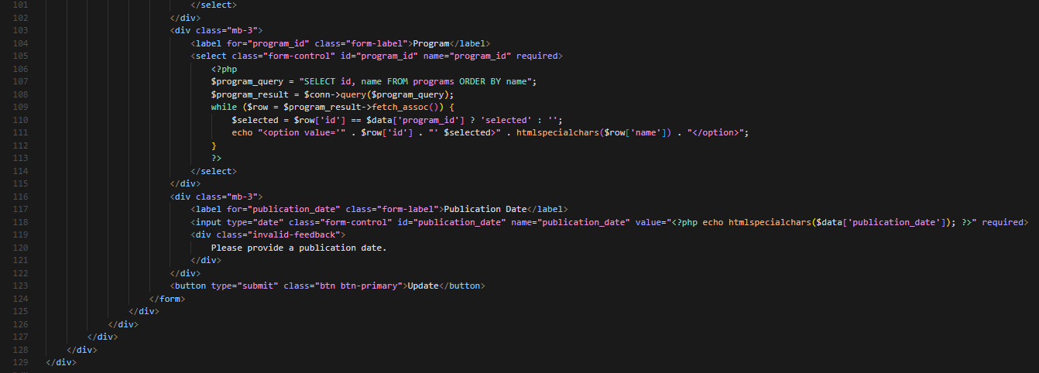

***Save the file, restart the server (php spark serve), and visit:***

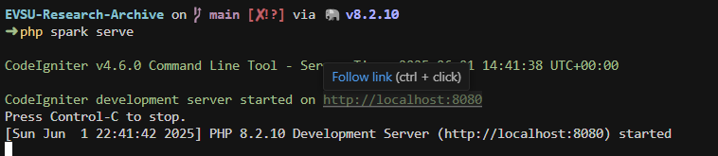

***Open your browser and go to*** [***http://localhost:8080***](http://localhost:8080)***. You should see the view you’ve created in the previous activity.***

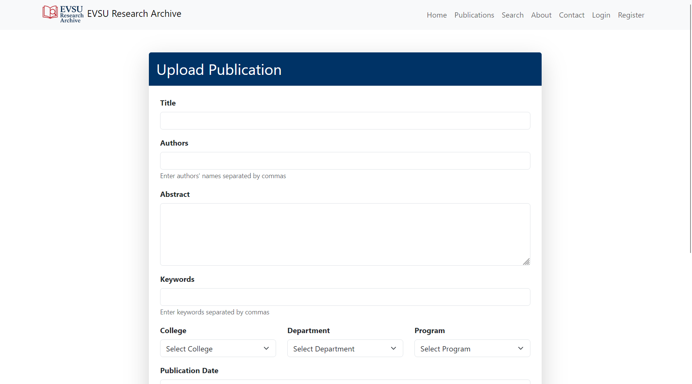

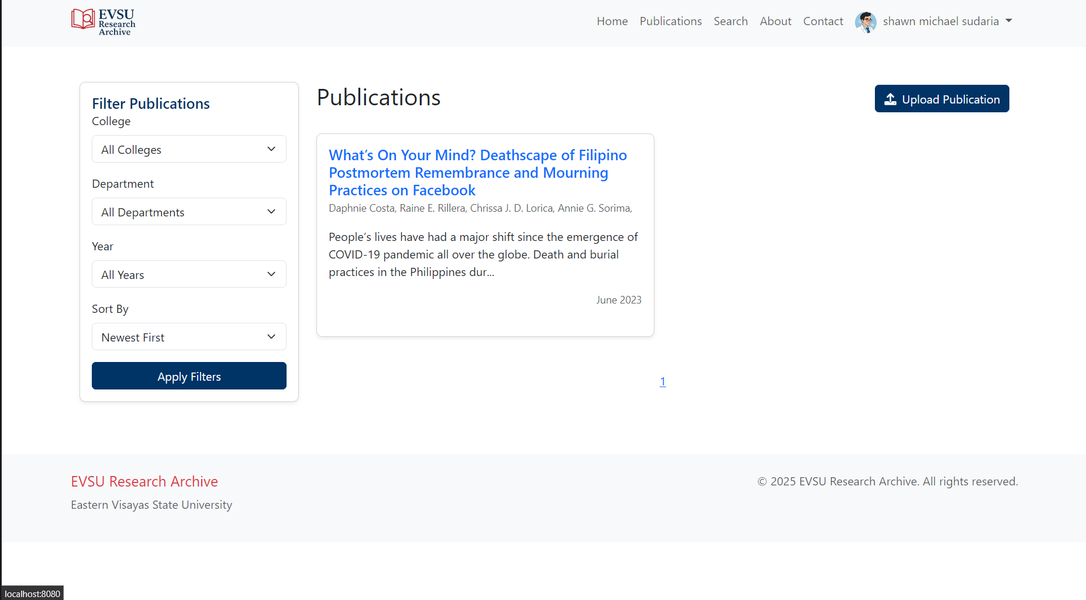

***The upload publication feature should be working now. Let’s try and upload a publication.***

* + 1. We can use the information below to submit a sample publication

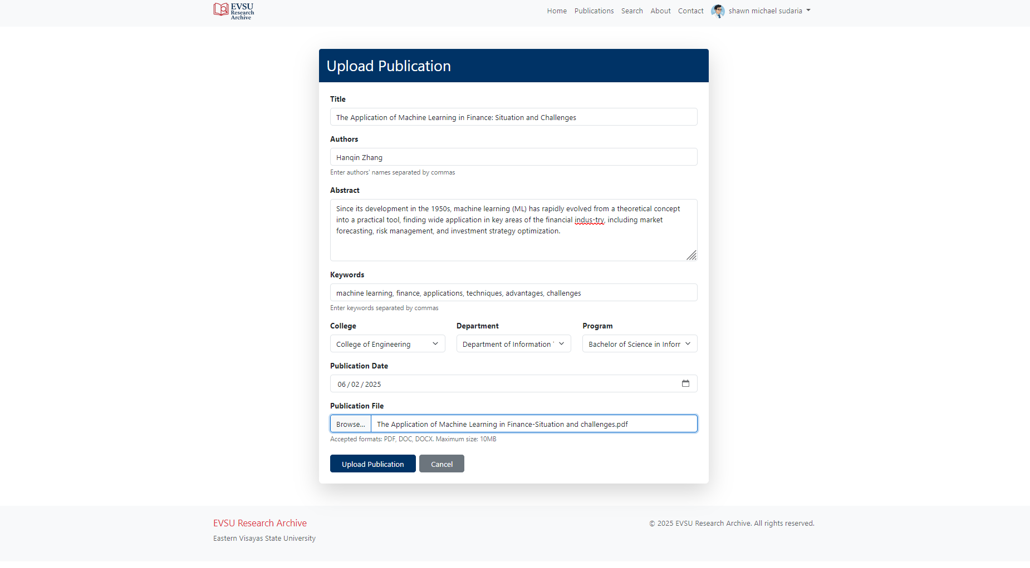

* + 1. Click the upload publication and you should see the alert that the publication was uploaded successfully.

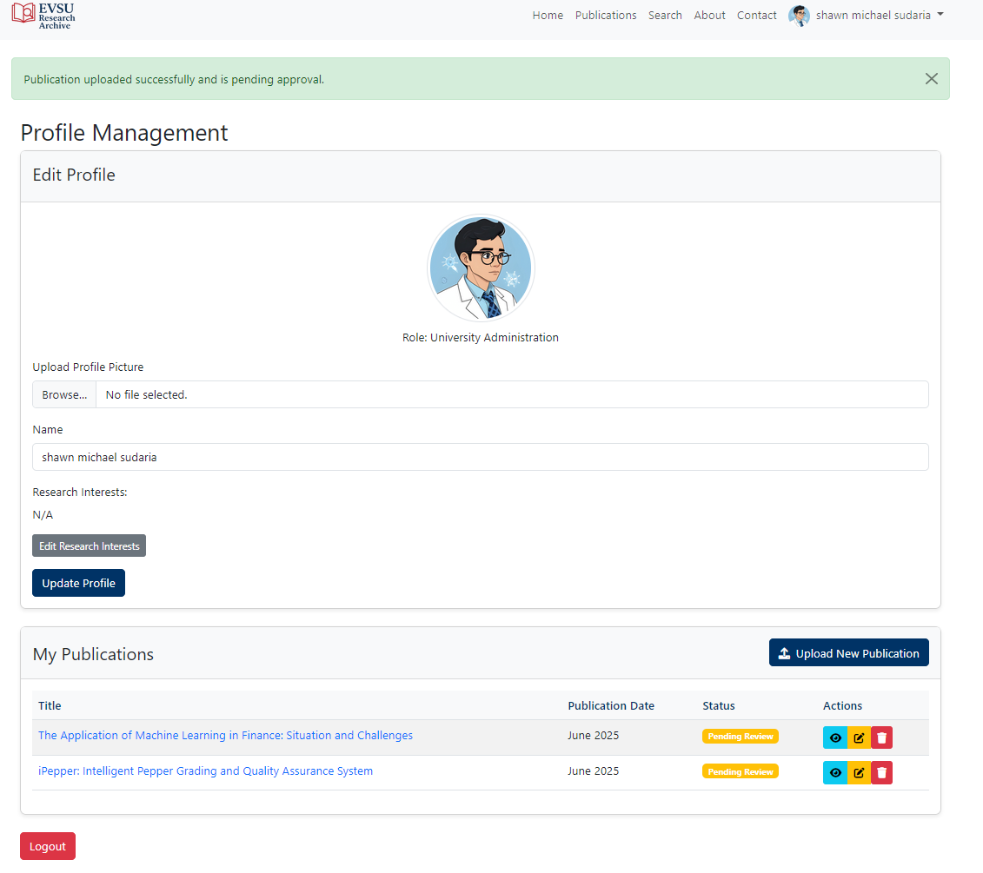

***Let’s now try to delete the publication.***

1. In the profile page. You can see the list of publication you have uploaded. You can notice the trash icon on each row of the ‘My Publications’ page. By clicking on that button, you are going to delete that publication as see using the code below.   
   NOTE: You are able to delete the publication once it’s still pending review. If you want to delete it once it has been approved you will need to contact the admin.

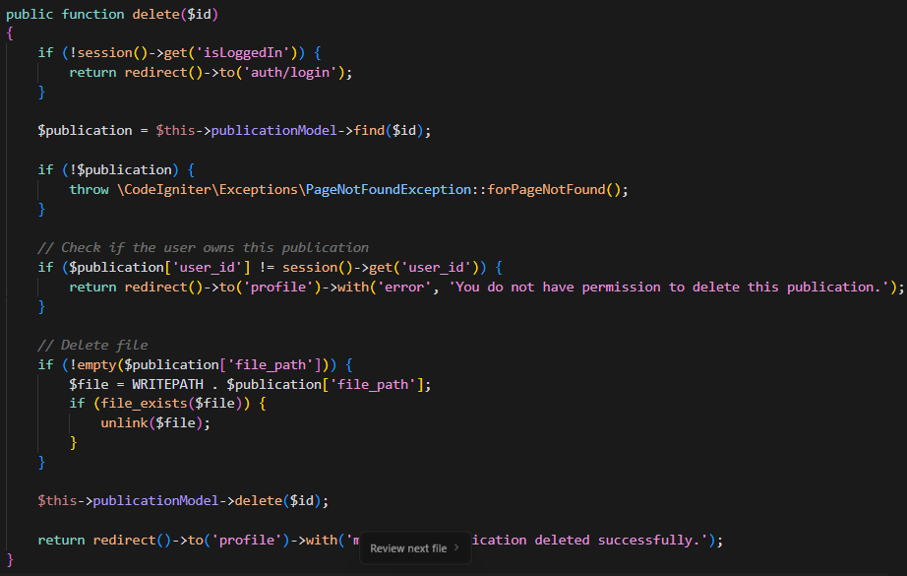

When you try to delete a publication, you are greeted with this pop up box confirming you deletion.

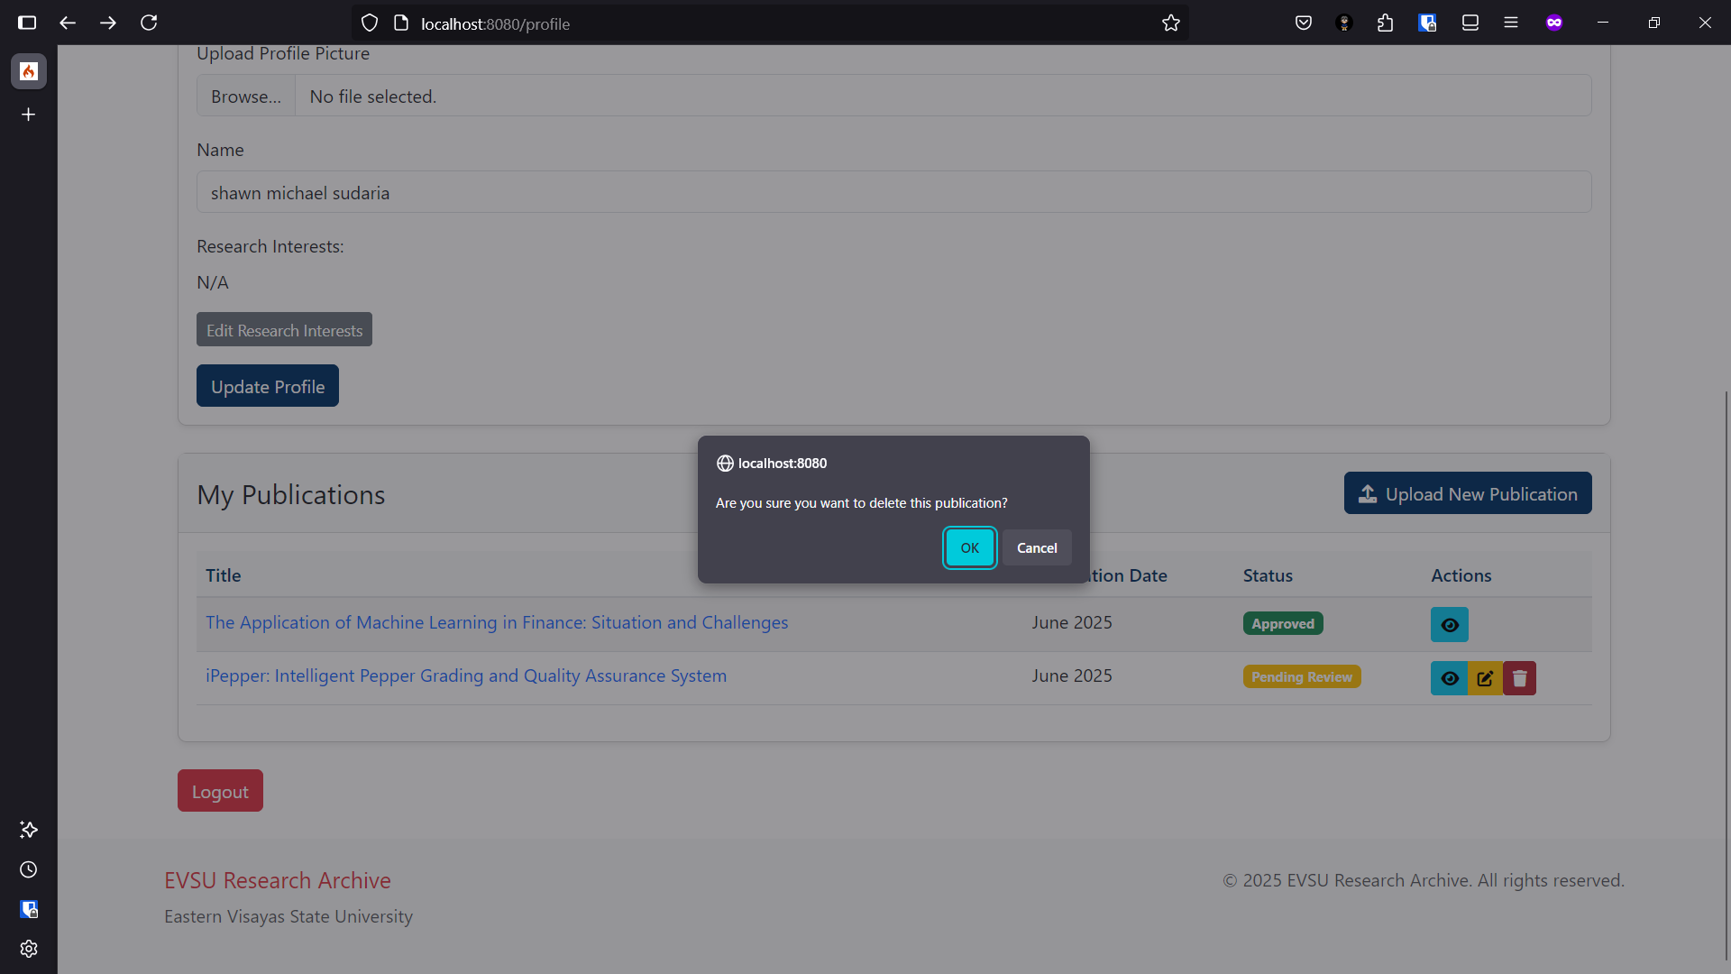

Once deleted, that publication will not be shown in the “My Publications” table.

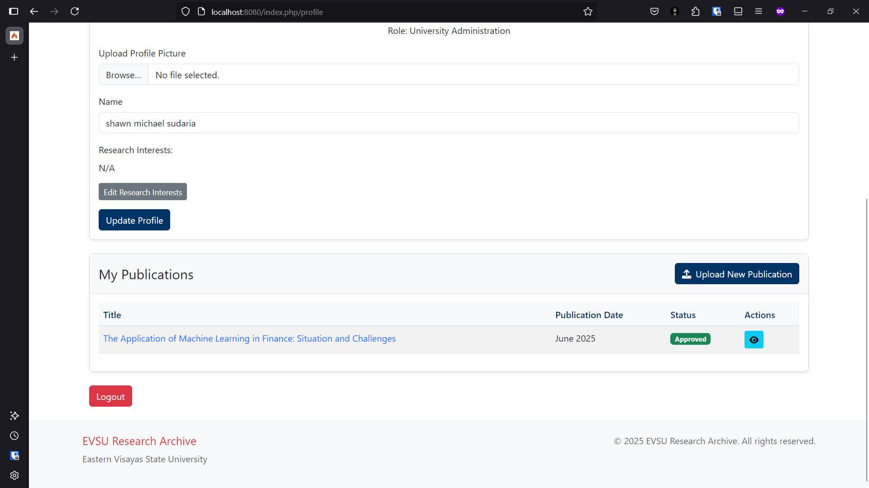

***Let’s now try to update a publication.***

You go the profile page as seen in the image above and on the “My Publications” page, when you click the edit button a modal appears. 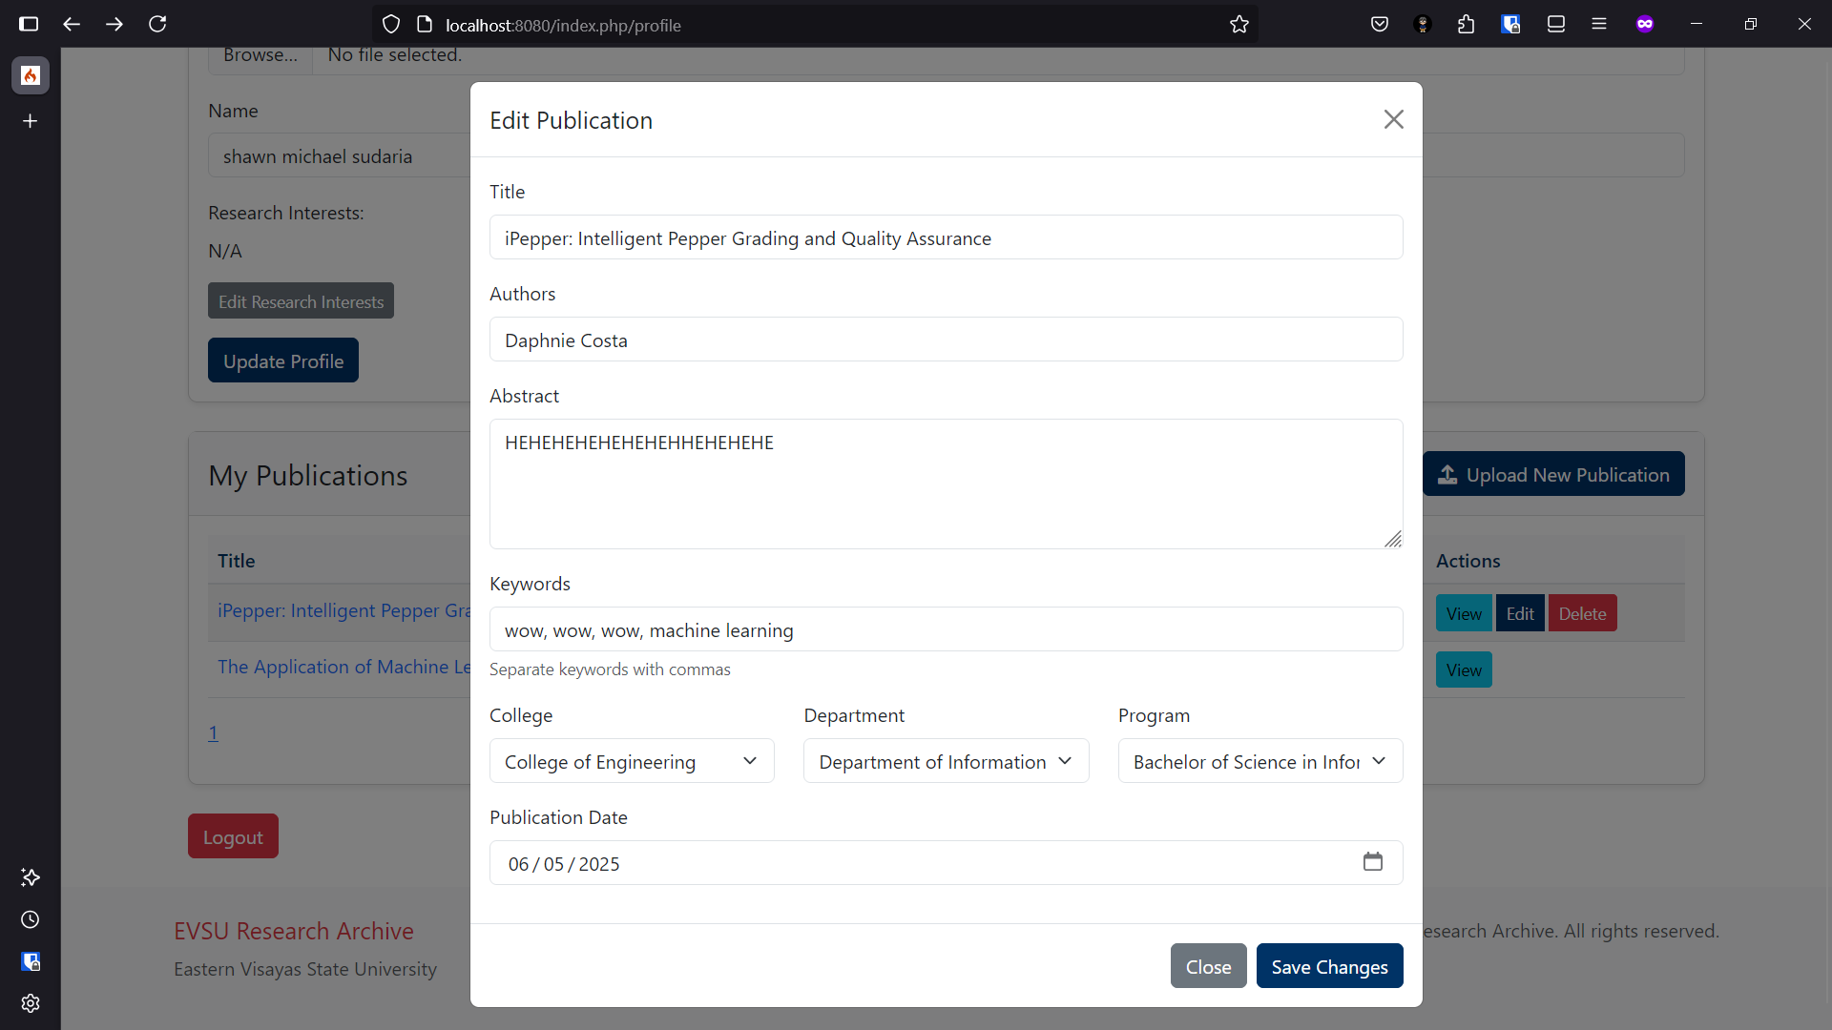

When the Save Changes button is clicked it will update the row in the publication table.



**Conclusion**

*After following the steps for applying the CRUD operation. You can now perform retrieve, insert, update, and delete function for the classes in our project.*

*You perform the following:*

* *Setting up the project*
* *Installing Codeigniter*
* *Environment Configuration*
* *Creating Database*
* *Creating Models*
* *Creating Controller*
* *Routes Configuration*
* *Creating Views*
* *Performs CRUD Operation*