Chapter 3: Methodology

3.1 Introduction
This chapter explains how StudentSense was designed, built, and evaluated. It describes the research design, the way the system was developed, the people who use it, how the software is organized, how data moves through it, how the check-in questionnaire is scored, and how the support-level models were trained and measured. It also states the ethical safeguards and the limits of the work.
StudentSense is a web application that students, teachers, and school counselors open in a phone or computer browser. Students complete a short weekly check-in. The system turns the answers into a support level (Low, Moderate, or High), gives self-care tips, and alerts a counselor when a check-in needs prompt attention.
Note for the researchers. Items in this chapter that describe the study process (research design label, development approach, and evaluation data) follow what is actually present in the project's code and history. If your institution requires a particular design label, participant count, or ethics approval number, add it in Sections 3.2 and 3.12. No such details were available in the project files, so none have been invented here.

3.2 Research design
The study uses a developmental (design-and-build) research design with a quantitative evaluation. The work has two parts:
- Building the system. A working application was designed, programmed, and tested against a list of required features.
- Evaluating the support-level model. The model was trained and then measured with standard classification measures (Section 3.10).
The model evaluation and the demonstration records used in this study are generated (synthetic) data. They are used to show that the software and the training process work from start to finish. They are not responses collected from real students, and they are not evidence about any real person's wellbeing.

3.3 Development approach
The system was built in small, repeated cycles (iterative prototyping). Each cycle added or refined a feature, tested it, and corrected problems before the next one began. The main cycles were:
Cycle | Main result
1 | Accounts and roles (student, teacher, counselor)
2 | The 20-question check-in, survey scoring, and result page
3 | Recommendations, history, and personal analytics
4 | Counselor support dashboard, messaging, teacher referrals, notes, and appointments
5 | First support-level model and a research prototype for the next check-in
6 | Mobile-first design, notifications, and installable web app behavior
7 | Visual refinement, clearer answer labels, and testing

3.4 System requirements

3.4.1 Users and their roles
Role | What the person can do
Student | Create an account, complete check-ins, view results, history and personal analytics, message the counselor, ask for urgent help, and book appointments
Teacher | Refer a student to the counselor. Teacher accounts stay disabled until a counselor approves them
Counselor | Review urgent requests, teacher referrals, and students who need attention. View each student's analytics, send messages, add private notes, set availability, and manage appointments

3.4.2 Main features
- Account sign-up and sign-in, with role-based access
- A 20-question check-in with a 1-to-5 answer scale, plus a few daily-habit questions
- Automatic draft saving, so a student can return to an unfinished check-in
- A result page with the support level, scores for four areas, and tips
- Check-in history and personal analytics
- An experimental "possible next support level" view (research only)
- Counselor dashboard, student list, and analytics for each student
- Two-way messaging, urgent-help requests, and teacher referrals
- Appointment availability and booking
- In-app notifications, and browser push notifications when configured
- Use on small phone screens and installation as a home-screen app

3.4.3 Quality requirements
- Privacy: only the student and counselors can see a student's results.
- Safety: a High result opens an urgent follow-up. The system never claims to diagnose.
- Usability: short screens, clear labels, and a layout that works on phones.
- Reliability: automated tests cover the main flows, so changes can be checked quickly.

3.5 System architecture
StudentSense is a Django (Python) application. Django is split into "apps", and each StudentSense app has one clear job.
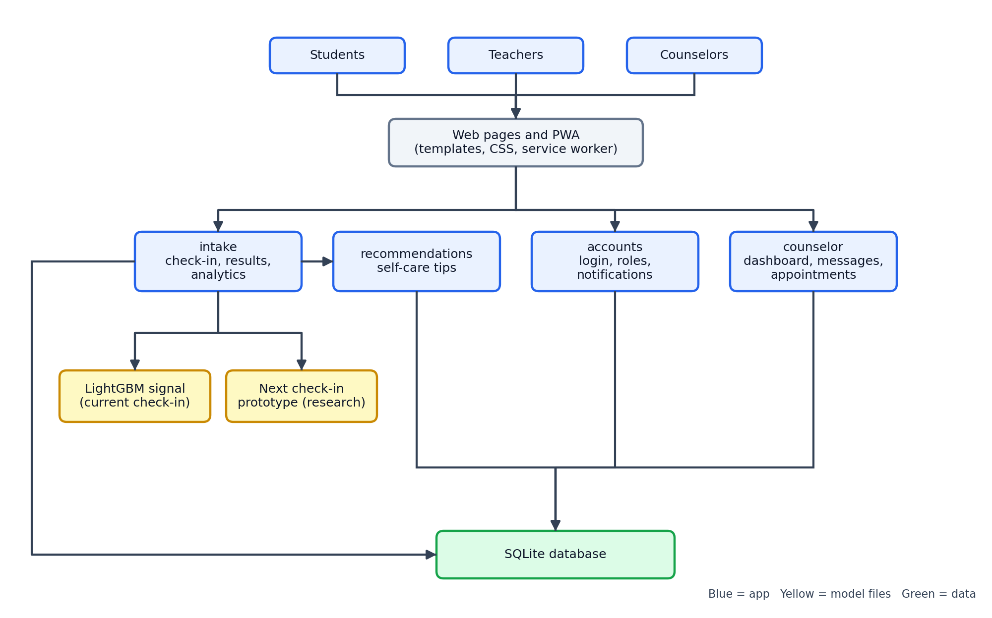
Figure 1 explanation. Students, teachers, and counselors all use the system through a web browser. The page templates and style sheet display the screens, and a small background script (a service worker) lets the app work like an installed phone app. Behind the screens, four application areas do the work:
App area | Purpose
accounts | Sign-up, sign-in, user roles, and notifications
intake | The check-in, scoring, results, history, and analytics
recommendations | The self-care tips attached to each result
counselor | The support dashboard, messages, referrals, notes, and appointments
The intake area reads two saved model files (Section 3.9). All areas store their information in one SQLite database file.

3.6 System flow
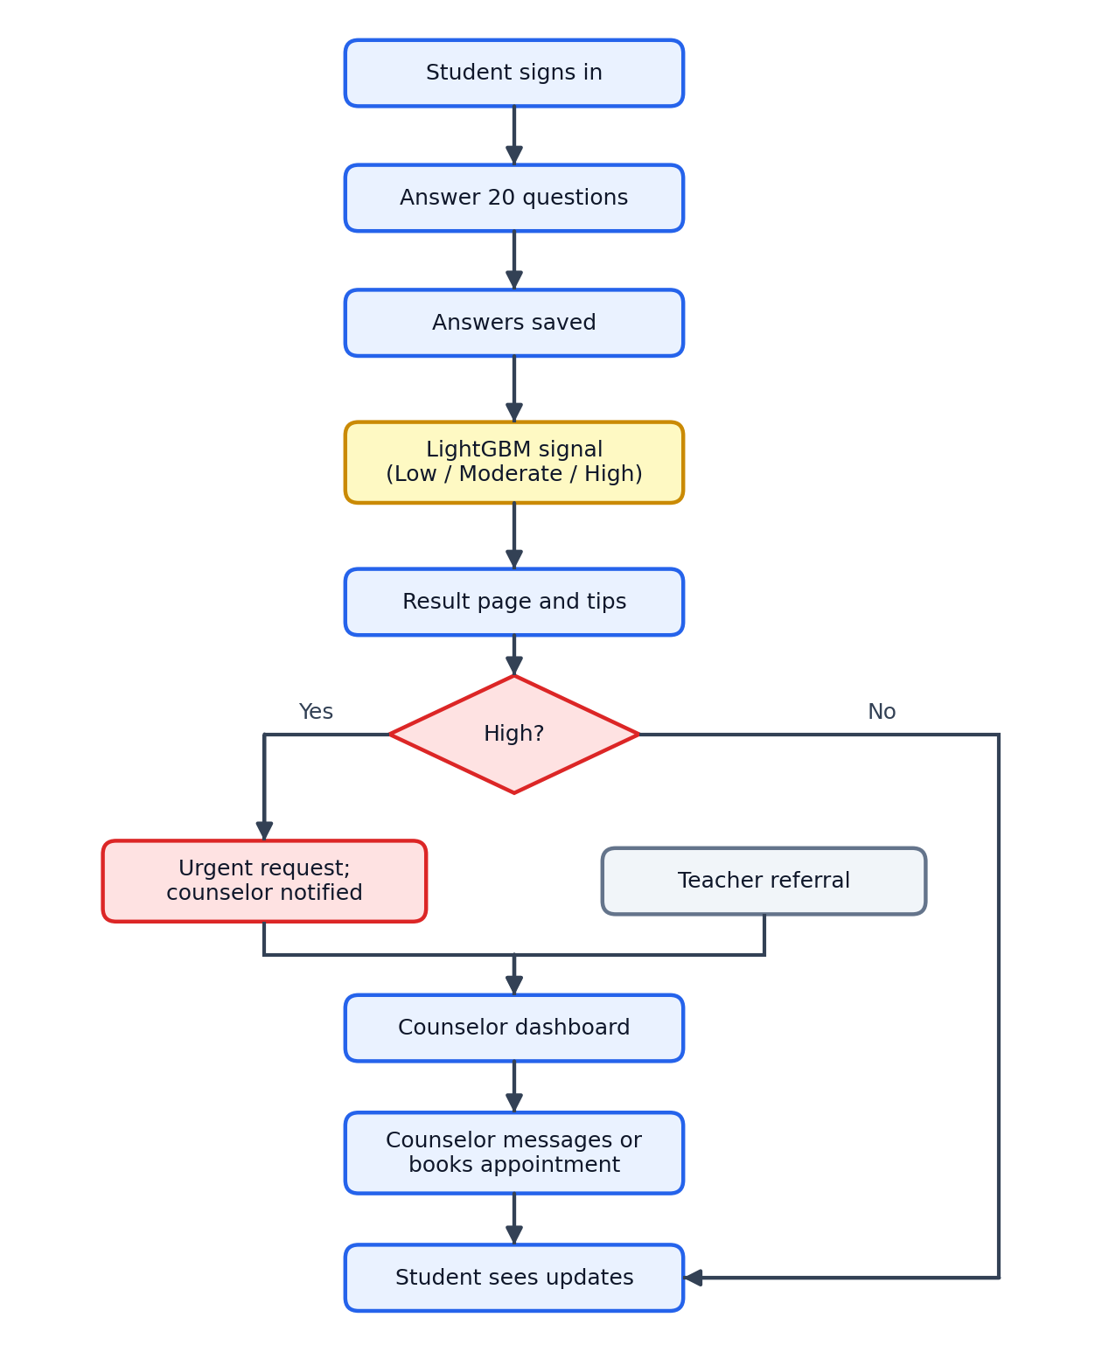
Figure 2 explanation. The flow starts when a student signs in and finishes the 20-question check-in. The answers are saved and passed to the LightGBM model, which gives the Low, Moderate, or High support signal. The result page shows the level, the area scores, and tips. If the level is High, the system automatically opens an urgent help request and notifies the student and the counselor. Teacher referrals reach the same counselor dashboard. The counselor can then review analytics, send a message, or book an appointment, and the student sees these updates in their own pages.

3.7 Database design
The database stores each fact once and links records together, as shown below.
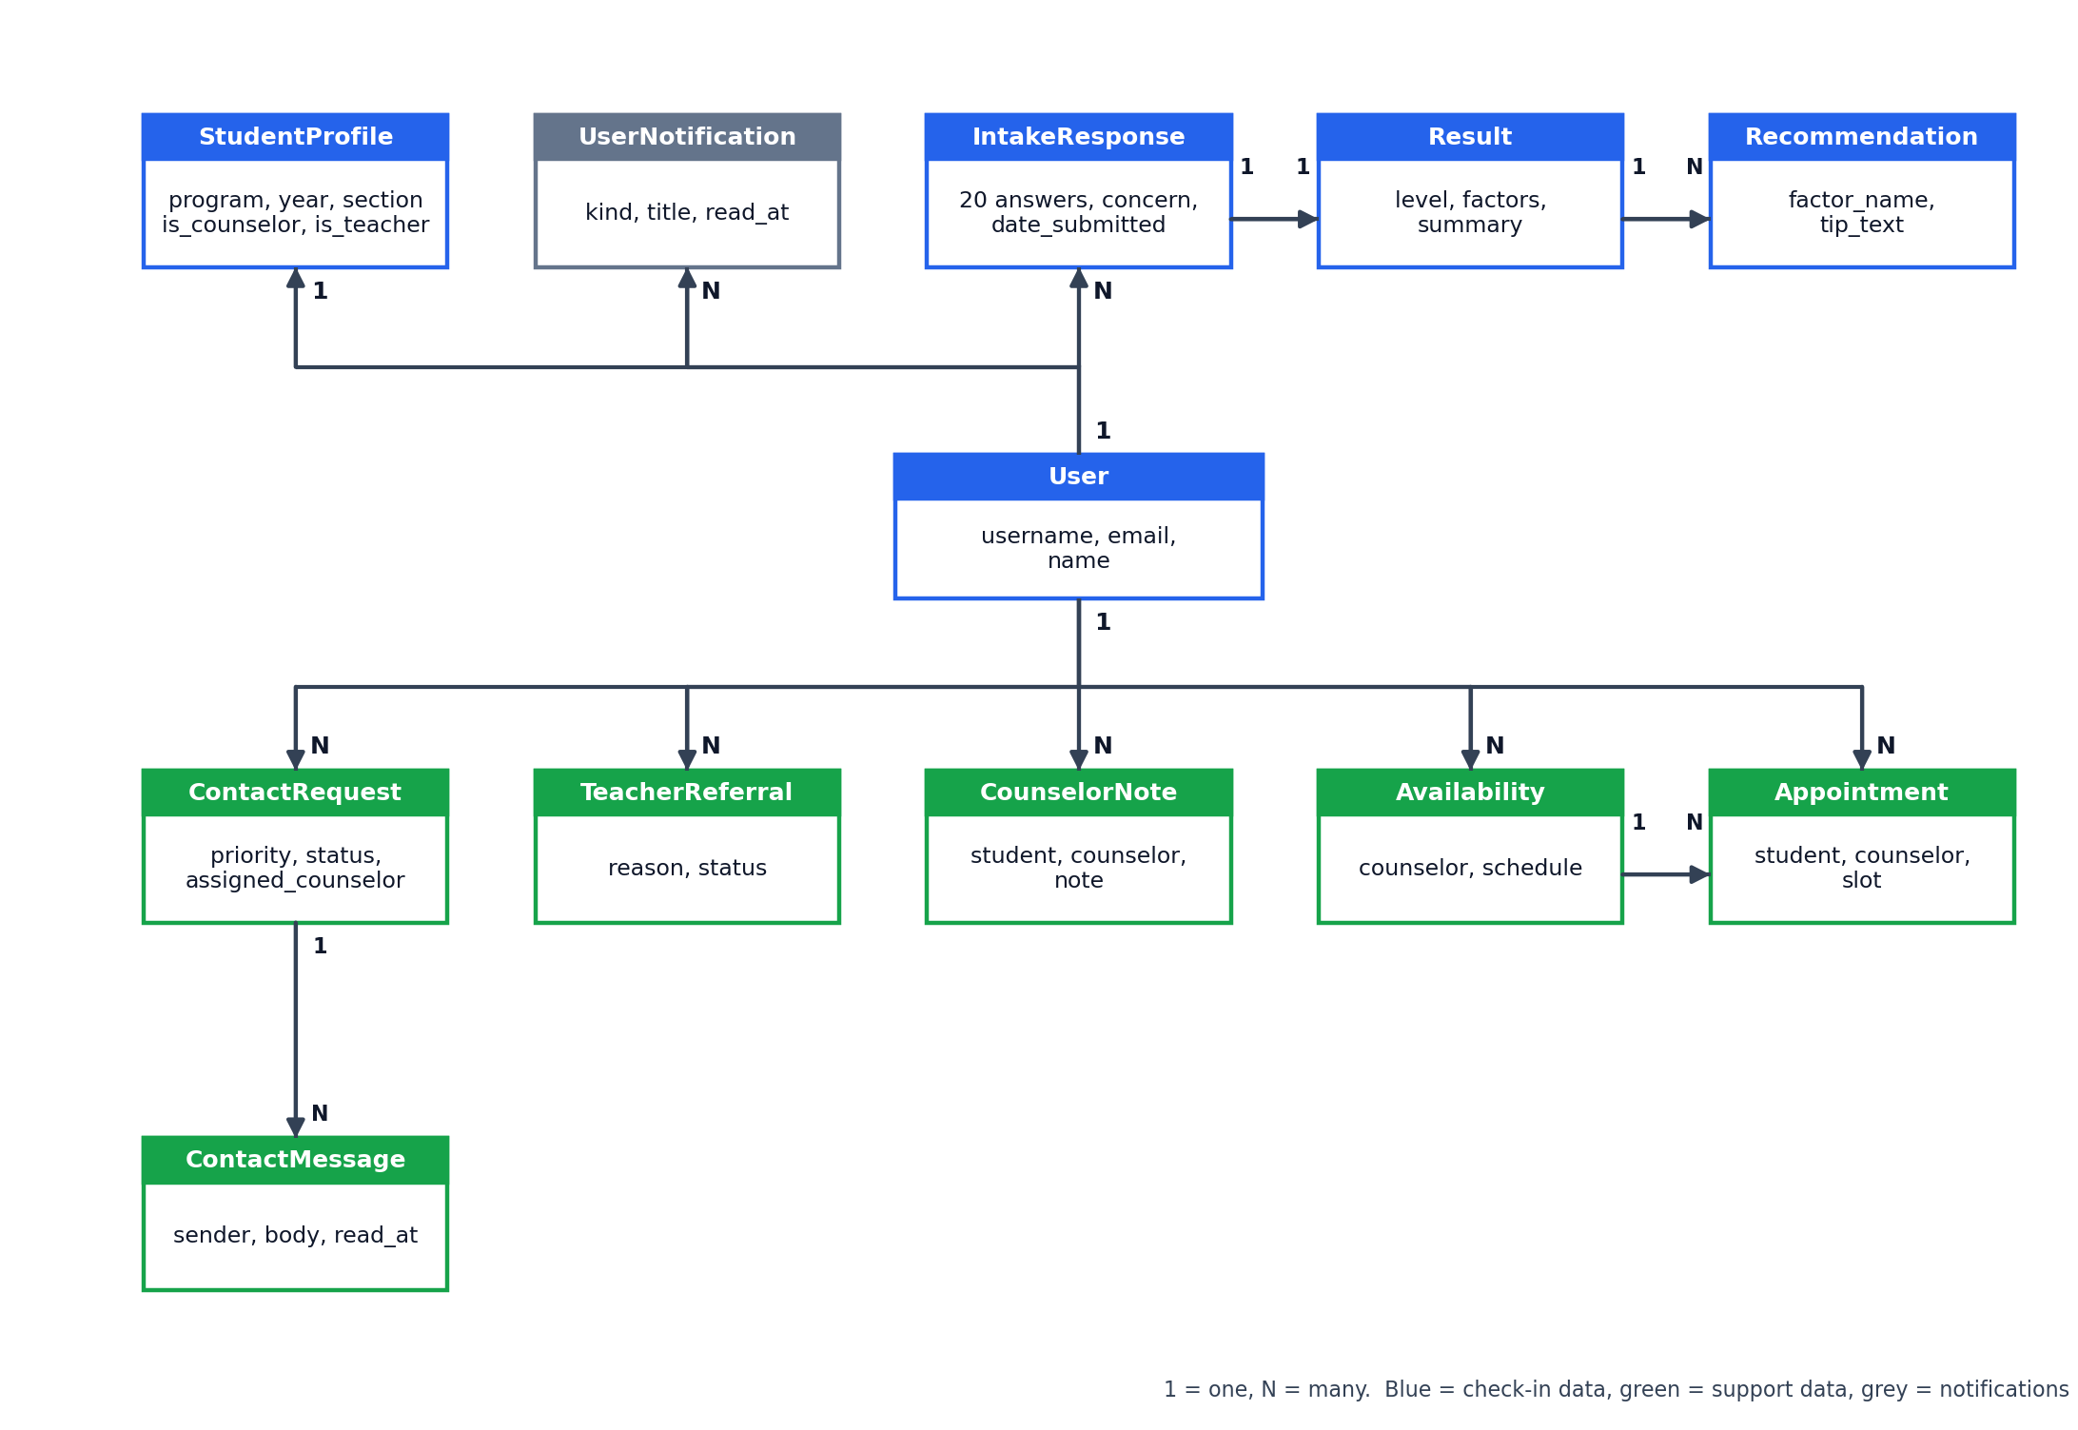
Figure 3 explanation. Everything is linked to the user account. In blue: a user has one profile, and can have many check-ins (IntakeResponse). Each check-in has exactly one Result, and a result can have several Recommendation tips. In green, the counselor tables record support requests and their messages, teacher referrals, counselor notes, availability, and appointment bookings. In grey, UserNotification stores messages shown in the notification page. Results can be archived instead of deleted, so history is not lost by accident.

3.8 Data collection instrument and scoring

3.8.1 The check-in
Each check-in has 20 questions, each answered on a five-point scale: 1 – Never, 2 – Rarely, 3 – Sometimes, 4 – Often, 5 – Very often. The questions are grouped into four areas that are adapted from published student wellbeing scales.
Area | Questions | Number of items | Possible score
Academic burnout | 1–5 | 5 | 5–25
Academic stress and workload | 6–10 | 5 | 5–25
Social media usage | 11–16 | 6 | 6–30
Sleep patterns and habits | 17–20 | 4 | 4–20
The check-in also asks about everyday habits (study hours, sleep hours, social media hours, deadline pressure, class load, mood and energy, exercise, and sleep consistency) and offers an optional note and an optional supporting file. The file must be a PDF, DOC, DOCX, TXT, JPG, or PNG of 50 MB or less.

3.8.2 How the support level is decided
The scoring rules are simple and visible, so counselors can understand them.
- Score each area. Add up the answers in the area.
- Give each area a band. The possible score range is split into three equal parts: the lowest third is Low, the middle third is Moderate, and the highest third is High.
Area | Low | Moderate | High
Academic burnout | 5 to 11.7 | above 11.7 to 18.3 | above 18.3
Academic stress and workload | 5 to 11.7 | above 11.7 to 18.3 | above 18.3
Social media usage | 6 to 14 | above 14 to 22 | above 22
Sleep patterns and habits | 4 to 9.3 | above 9.3 to 14.7 | above 14.7
- Combine the four bands into the overall level.
- High if two or more areas are High, or if burnout is High and stress and workload is Moderate or High.
- Moderate if one area is High, or two or more areas are Moderate.
- Low otherwise.
These bands are provisional survey bands, not clinical cut-offs. They show where a student may want support. They do not diagnose anything.

3.9 Support-level models
StudentSense has two separate models. Neither one replaces the scoring rules in Section 3.8.2.

3.9.1 Model in the app: the current-check-in support signal
Item | Description
Purpose | Show a second, experimental support signal beside the survey result
Method | LightGBM, a tree-based machine-learning method, used for three-way classification
Input | The 20 answers from the current check-in
Output | Low, Moderate, or High, with probabilities
Training data | 12,000 generated sets of 20 random answers (1 to 5), made with a fixed random seed so that the run can be repeated
Labels | Each generated set was labeled using the scoring rules in Section 3.8.2
Settings | 180 boosting rounds, learning rate 0.05, 31 leaves per tree, at least 20 records per leaf, 90% of features and 90% of records sampled each round
Saved as | A model file and a metadata file inside the intake folder
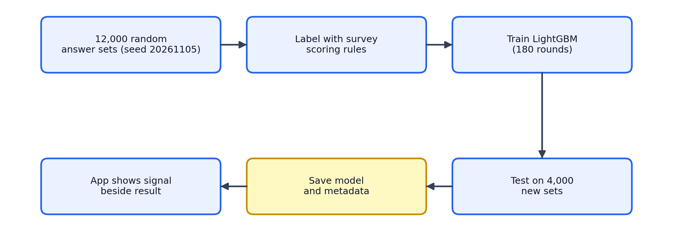
Figure 4 explanation. The pipeline generates answers, labels them with the scoring rules, trains the model, tests it on 4,000 new generated sets, saves it, and lets the app load it. Because the labels come from the scoring rules, the model learns to copy those rules. It was not trained on real students or on a validated mental-health outcome. For that reason it is described as experimental, and it never changes the official result.

3.9.2 Research prototype: possible next support level
Item | Description
Purpose | Explore whether earlier check-ins can hint at the level of the next check-in
Method | Multinomial logistic regression (scikit-learn) with standardized inputs and balanced class weights
Input | The most recent check-in (scores, habits, and its level) plus how many check-ins the student has made and the days since the previous one
Training rows | One row for every pair of back-to-back check-ins by the same student
Splitting | By student, so the same student is never in both training and testing
Safeguards | At least 30 pairs are required, and Low, Moderate, and High must appear in both the training and testing groups
Use in the app | Shown on the analytics page after two check-ins, labeled experimental, and it never triggers alerts
The prototype needs a saved model file. The file is created by running the training script and is not stored in the code repository.

3.10 Evaluation procedure
The models are measured on test data that the model has not seen during training. The following measures are used.
Measure | Plain-English meaning
Accuracy | The share of all test records that were labeled correctly
Balanced accuracy | The average correct share per level, so a rare level counts as much as a common one
Precision | When the model says a level, how often it is right
Recall | Of the records that truly belong to a level, how many the model finds
Macro F1 | One combined score of precision and recall, averaged equally across Low, Moderate, and High
Confusion matrix | A table of true levels against predicted levels that shows the kinds of mistakes
Recall for the High level is the most important in practice, because a missed High result is the costliest mistake. Results are reported in Chapter 4.

3.11 Software testing and tools

3.11.1 Testing
Test type | What it checks
Automated tests for public pages | The home, about, and sign-in pages load
Form and model tests | Check-in answers, labels, and database rules
Account tests | Sign-up, sign-in, roles, and teacher approval
Check-in tests | Scoring, results, history, analytics, and drafts
Counselor tests | Dashboard, messages, referrals, notes, and appointments
Browser tests | Page layout and behavior on a phone-sized screen
Performance checks | Pages stay fast with many records
Manual testing | A person tries the main pages in a real browser

3.11.2 Tools and environment
Tool | Use
Python and Django 5.2 | Application framework
SQLite | Database
LightGBM 4.7 | Model used inside the app
scikit-learn 1.9 and joblib | Next-check-in research prototype
pywebpush | Browser push notifications
HTML, CSS, JavaScript, and a service worker | Screens and installable behavior
PythonAnywhere | Online hosting
Git and GitHub | Version control

3.12 Ethical considerations and data protection
- Not a diagnosis. Every results page and analytics page states that the output is not a medical diagnosis. Counselor judgment always comes first.
- Careful handling of High results. A High result opens an urgent help request, so a counselor can follow up quickly, but the wording avoids alarming the student.
- Role-based access. Counselor pages reject anyone who is not a counselor. Students can only open their own results and files.
- Teacher approval. A new teacher account cannot sign in until a counselor approves it.
- Safe file uploads. Only listed file types up to 50 MB are accepted, and the file type must match its extension.
- Synthetic data. The demonstration accounts and records are generated, are clearly labeled as demonstration data, and use fake e-mail addresses. They must not be presented as real participants.
- Before real use. Using StudentSense with real students requires the school's and the institution's ethics approval, informed consent (and parent or guardian consent where students are minors), a data-privacy review, and counselor-reviewed validation of the questions and scoring.

3.13 Limitations of the method
- The scoring bands are provisional and have not been validated against a clinical measure.
- The in-app model was trained on generated answers labeled by the scoring rules, so its accuracy shows how well it copies those rules, not how well it recognizes real distress.
- The next-check-in prototype depends on how many students and check-ins are available, and its results should be read as exploratory.
- Demonstration data cannot show real usage, real changes in students, or real counselor workload.
- The answers are self-reported and can be affected by mood, honesty, and understanding of the questions.

