Chapter 4: Results and Discussion

4.1 Introduction
This chapter presents two different kinds of results: an evaluation of the StudentSense support-level model and a demonstration of the application's main pages. The model evaluation uses generated questionnaire responses. The local application screenshots use generated demonstration accounts and records.
These are synthetic results, not findings from real students or teachers. The generated records do not show that an actual four-month study took place. They must not be reported as real participant data or as evidence that the model can identify a student's mental-health needs. The model is not a diagnostic tool.

4.2 Model training results

Training data and method
The model used by the check-in result page is a LightGBM classifier. The training script generated 12,000 rows, with 20 questionnaire answers in each row. Each answer was an integer from 1 to 5. The script assigned the labels Low, Moderate, or High using the application's survey scoring rules. The model therefore learned to approximate those rules; it was not trained on responses collected from people.
The saved application model was trained using 180 boosting rounds. To measure how it performed on new generated examples, it was evaluated on a separate set of 4,000 generated rows. This test set used a different random seed, but the same response generator and labeling rules. The test is useful for checking the model implementation, but it is not an independent clinical or real-world validation.
The training set contained 157 Low labels (1.3%), 9,703 Moderate labels (80.9%), and 2,140 High labels (17.8%).
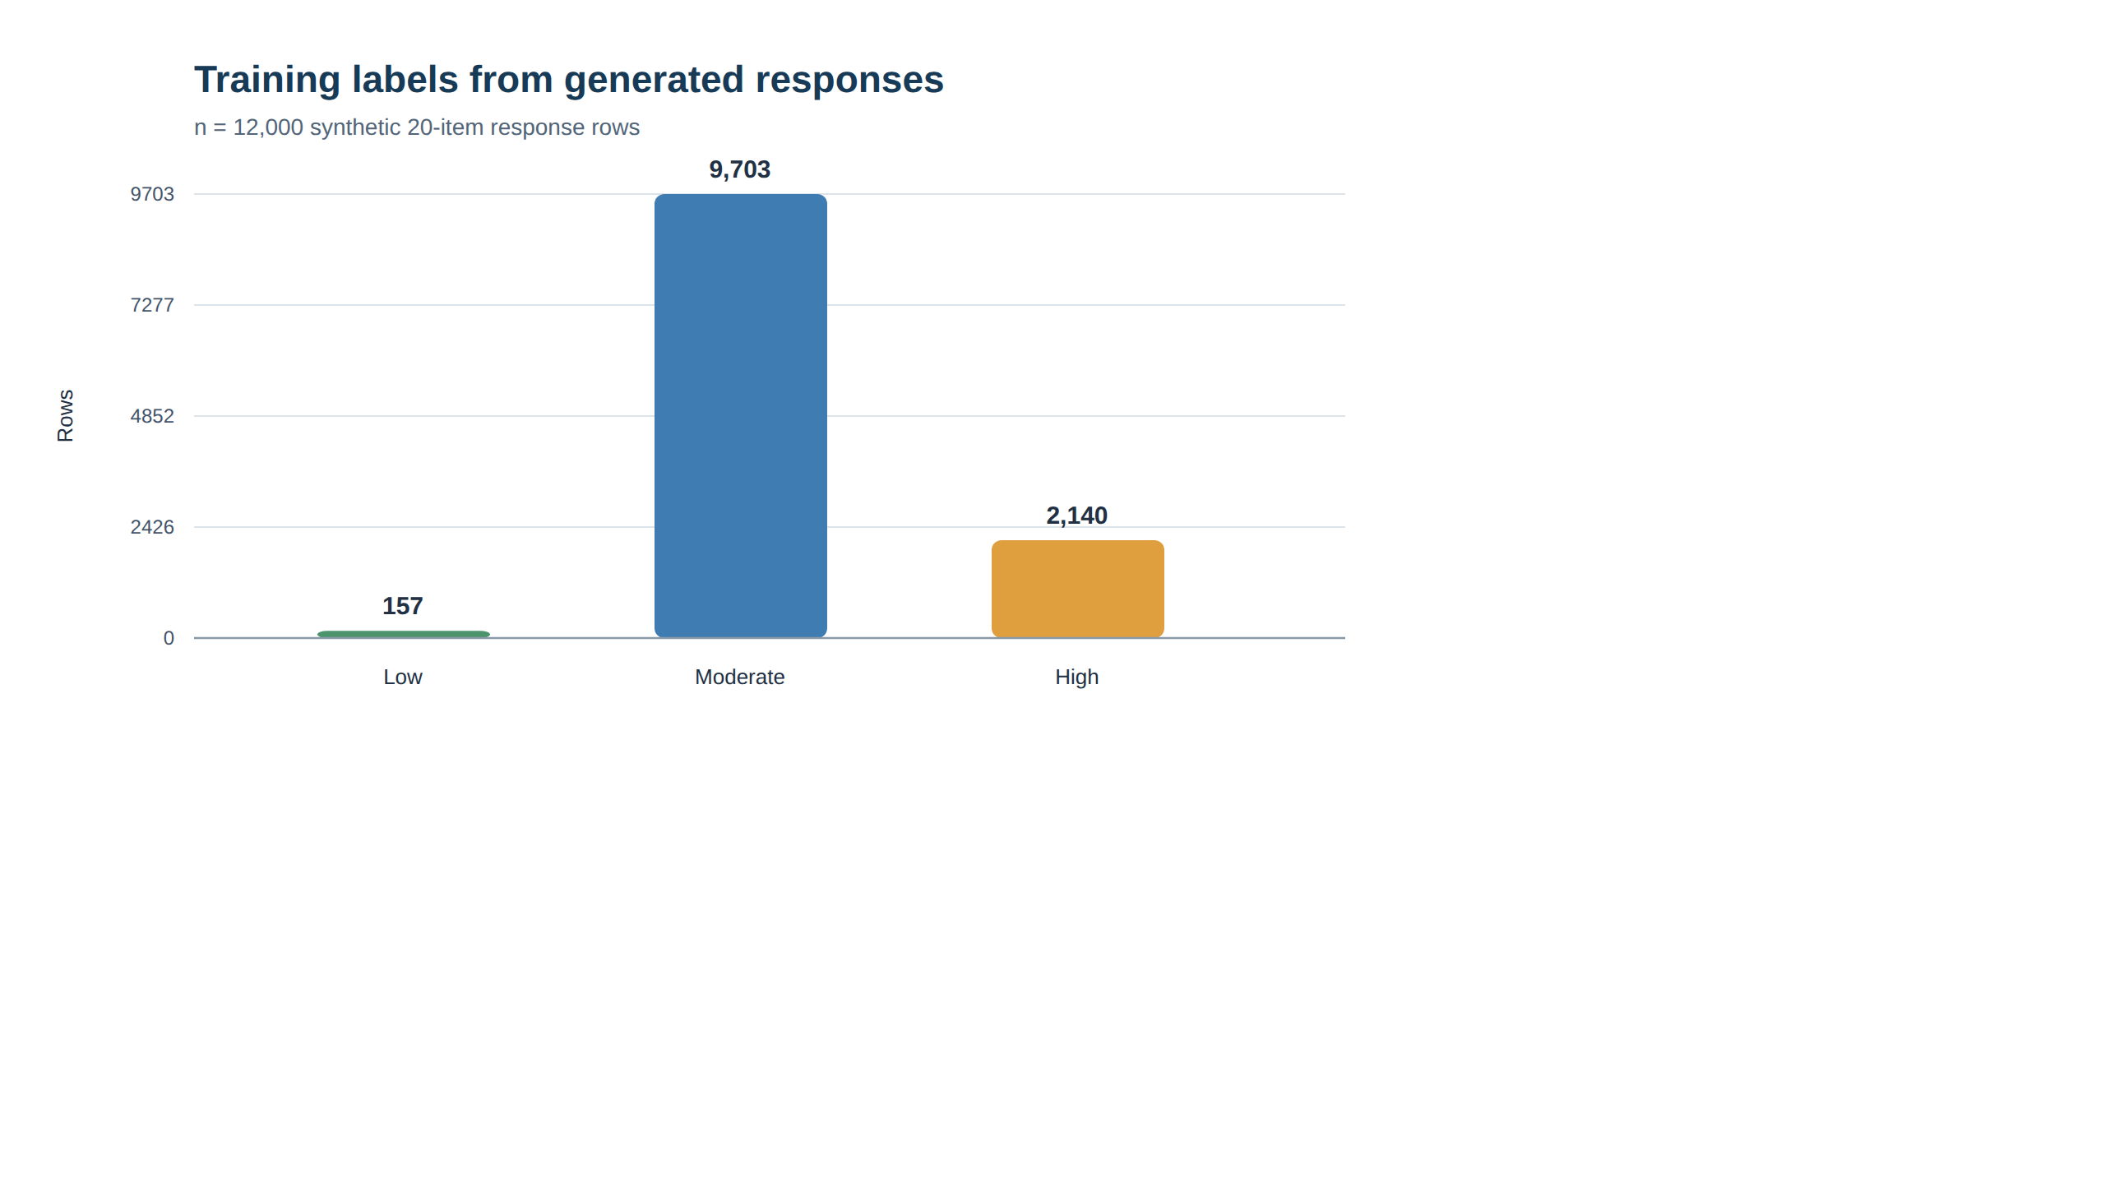
Figure 1. Distribution of generated labels in the model training set.
Figure 1 discussion. Most generated rows were labeled Moderate, while very few were labeled Low. This imbalance matters when interpreting the model's accuracy: a model can perform well on the largest group while missing much of a smaller group. The distribution is a result of the response generator and the scoring rules, not a measured distribution of student wellbeing.

Final application model evaluation
Table 1 summarizes the saved application model's results on the 4,000-row synthetic test set.
Measure | Result
Overall accuracy | 91.7%
Balanced accuracy | 58.0%
Macro F1 score | 0.623
Test rows | 4,000
The confusion matrix below shows the actual rule-based label in each row and the model's predicted label in each column.
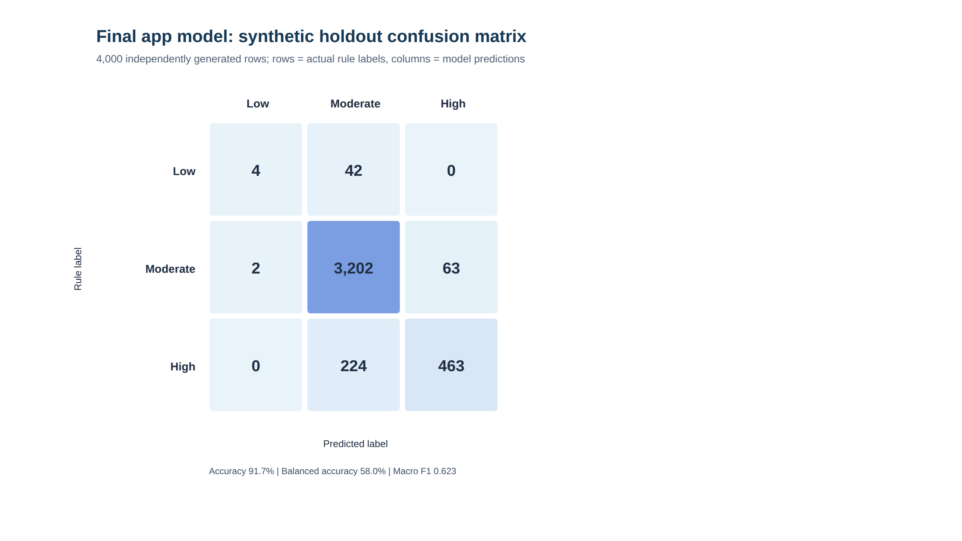
Figure 2. Confusion matrix for the final application model on generated test rows.
Figure 2 discussion. The model correctly classified 3,202 of 3,267 Moderate rows and 463 of 687 High rows. It correctly classified only 4 of 46 Low rows; the other 42 were predicted as Moderate. This explains why the overall accuracy is 91.7% while balanced accuracy is much lower at 58.0%. Accuracy alone would hide the weak result for the Low group. The model's performance on these generated examples should not be treated as evidence of performance with real students.

How the model appears in the application
The saved model reads the 20 check-in answers and returns a predicted support label, class probabilities, and the highest questionnaire-area scores. The result page also shows the application's survey-rule result. These are separate outputs: the survey rules produce the displayed check-in result, and the LightGBM model provides an additional support signal. The area scores are questionnaire totals; they do not prove that an area caused a result.
Although the response generator creates many randomized examples for testing, it does not represent a student's real check-in history. The deployed LightGBM model uses the 20 answers from the current check-in; it does not learn from a student's earlier submissions. Repeated check-ins can help the app display changes in a student's history, but they do not by themselves improve the model's accuracy or prove that it recognizes that student's patterns better. Demonstrating such improvement would require a separately designed longitudinal model, appropriate real-world data, and evaluation on students who were not included in training.
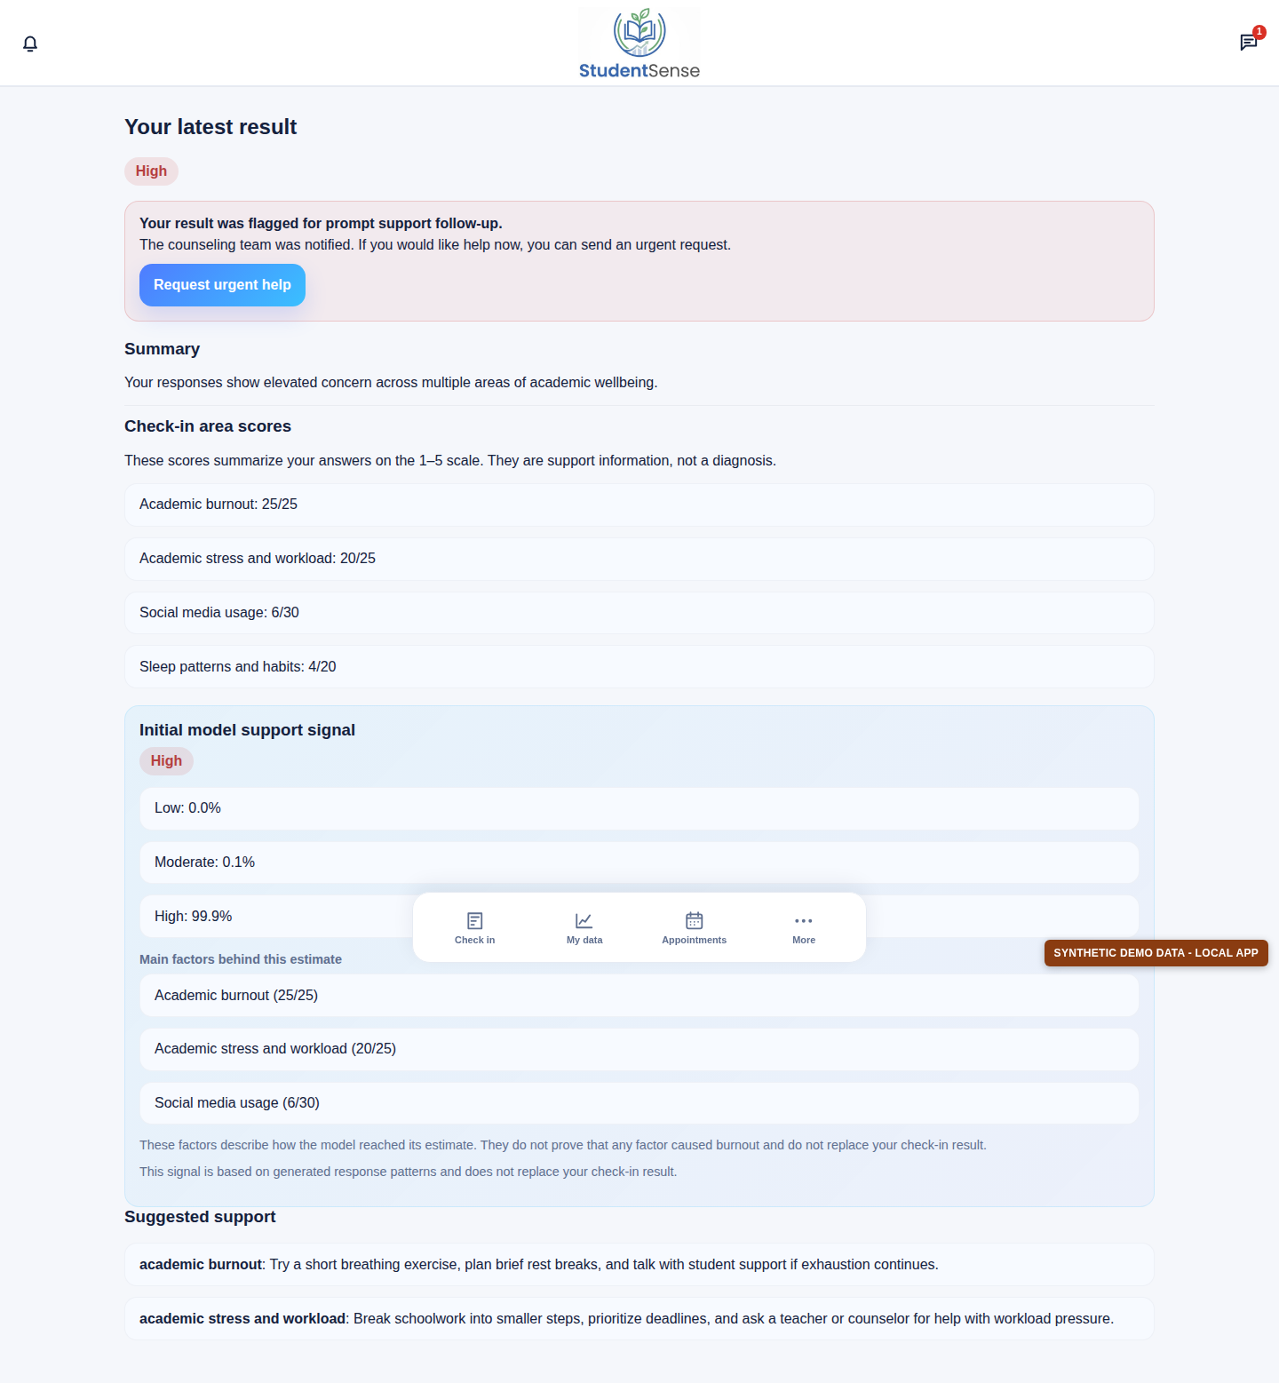
Figure 3. Student result page showing the survey result and the separate model support signal. This screenshot contains synthetic demo data.
Figure 3 discussion. The result page presents the check-in result, area scores, model probabilities, and suggested support information. The page also states that the model signal is based on generated response patterns and is not a diagnosis. The displayed probability is an output from this model for this synthetic example; it is not a measure of a real student's risk.
The separate scripts in model_prototype/ are exploratory research prototypes. They are not the saved model evaluated above and are not used to produce the application's check-in result.

4.3 Local application demonstration

Demonstration data
For screenshots and page testing, the repository's local SQLite database was populated with:
- 10 synthetic student accounts;
- 3 synthetic, approved teacher accounts;
- 1 synthetic counselor account;
- 360 generated check-ins, dated July 6 to November 5, 2026;
- 36 check-ins per student, scheduled twice per week across 18 weeks; and
- sample messages, support requests, teacher referrals, and appointment
availability.
The dates and answers were generated for this demonstration. They do not represent real attendance, conversations, referrals, appointments, or student responses. The records remain in the local database so the pages can be reviewed again. The safe, repeatable command is:
.venv/bin/python manage.py seed_chapter4_demo_data
The command is restricted to the repository's local SQLite database with development mode enabled. It adds missing demonstration records and does not delete existing records.
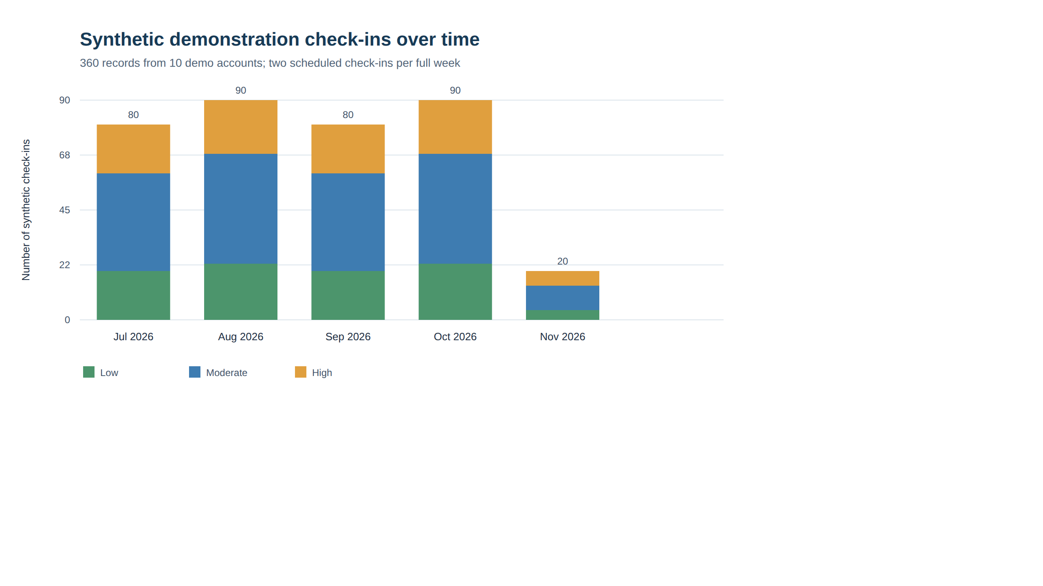
Figure 4. Monthly counts for the generated local check-in records.
Figure 4 discussion. The chart shows how the generated records are spread over the demonstration period. The partial months contain fewer check-ins because the schedule starts and ends partway through those months. The Low, Moderate, and High counts were deliberately created for page testing. They are not observed changes in student wellbeing and should not be used as study findings.

Main application pages
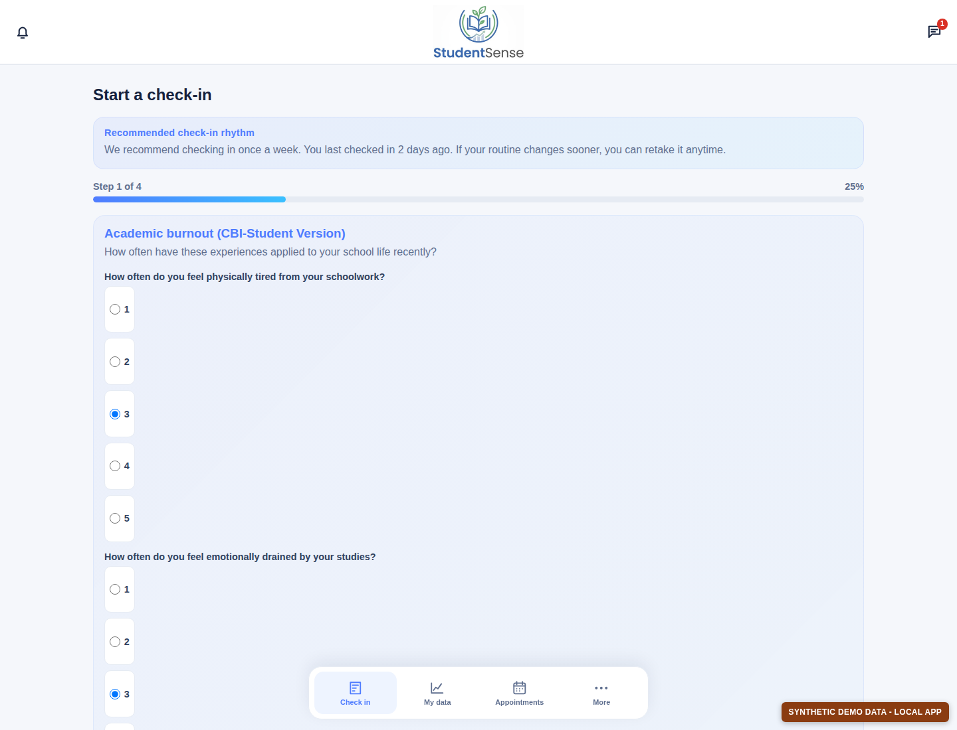
Figure 5. Student check-in form showing the first step of the questionnaire. Synthetic demo data is used.
Figure 5 discussion. The check-in page groups questionnaire items into steps and uses a 1-to-5 response scale. The page displays a suggested weekly check-in rhythm. This screenshot shows the form interface; no check-in was submitted as part of taking the screenshot.
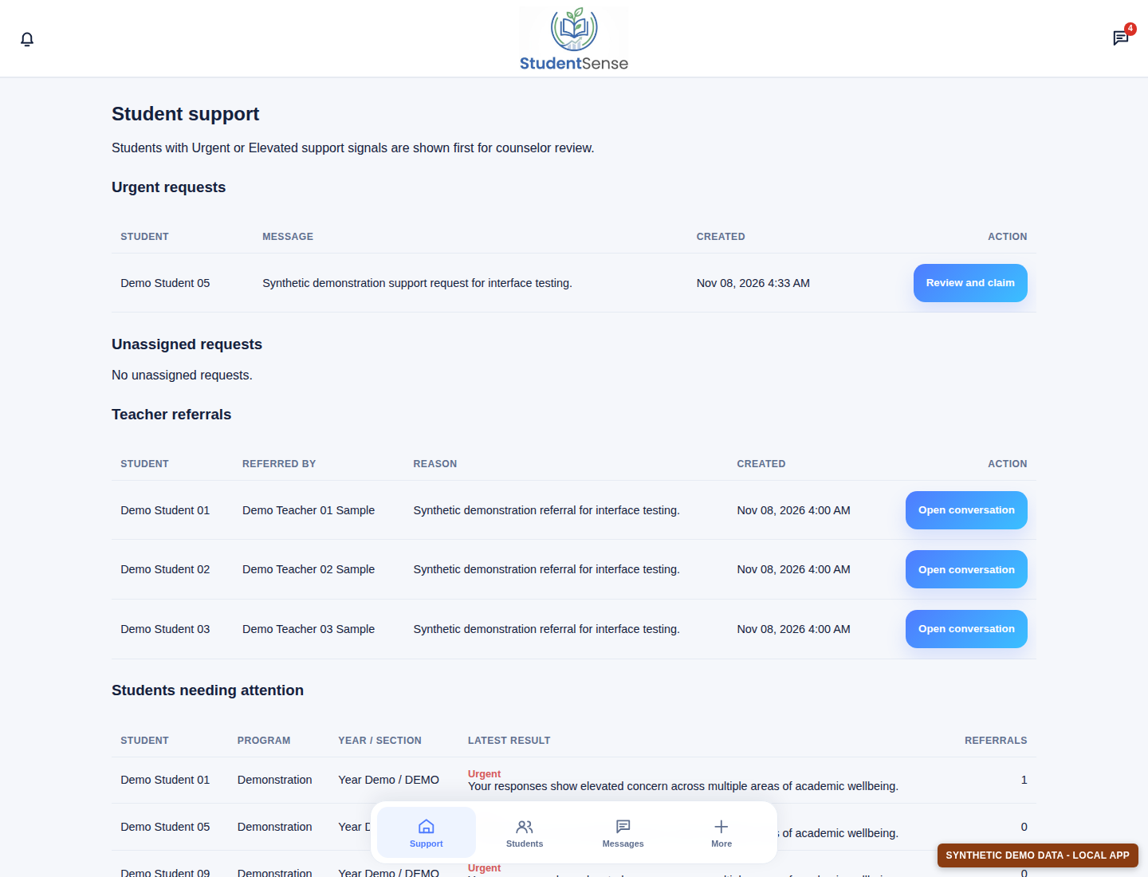
Figure 6. Counselor student-support dashboard with synthetic support requests, referrals, and check-in results.
Figure 6 discussion. The counselor dashboard brings together support requests, teacher referrals, and students whose latest results need attention. The rows and messages shown here were generated for the local demonstration. They illustrate how a counselor can review information in one place; they do not represent real cases or actual follow-up.
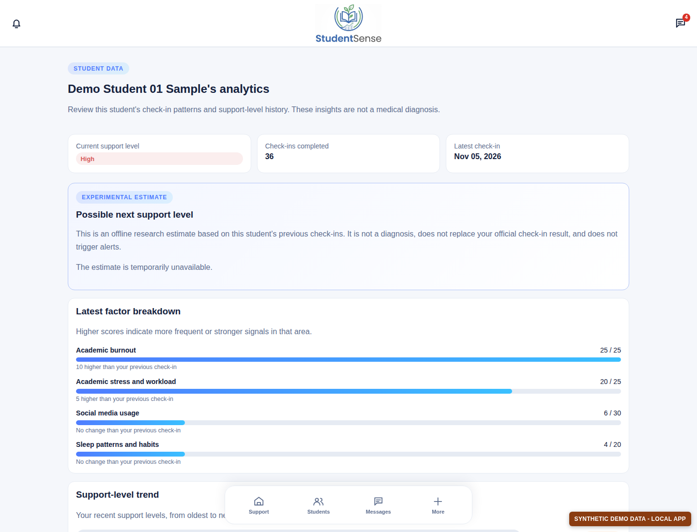
Figure 7. Counselor analytics page for a synthetic student account.
Figure 7 discussion. The analytics page summarizes a student's check-in count, latest result, area scores, and recent support-level history. The screenshot shows 36 generated check-ins. Its separate next-check-in estimate is an offline experimental feature and may be unavailable when its optional research artifact has not been trained. It is not the final application model described in Section 4.2.
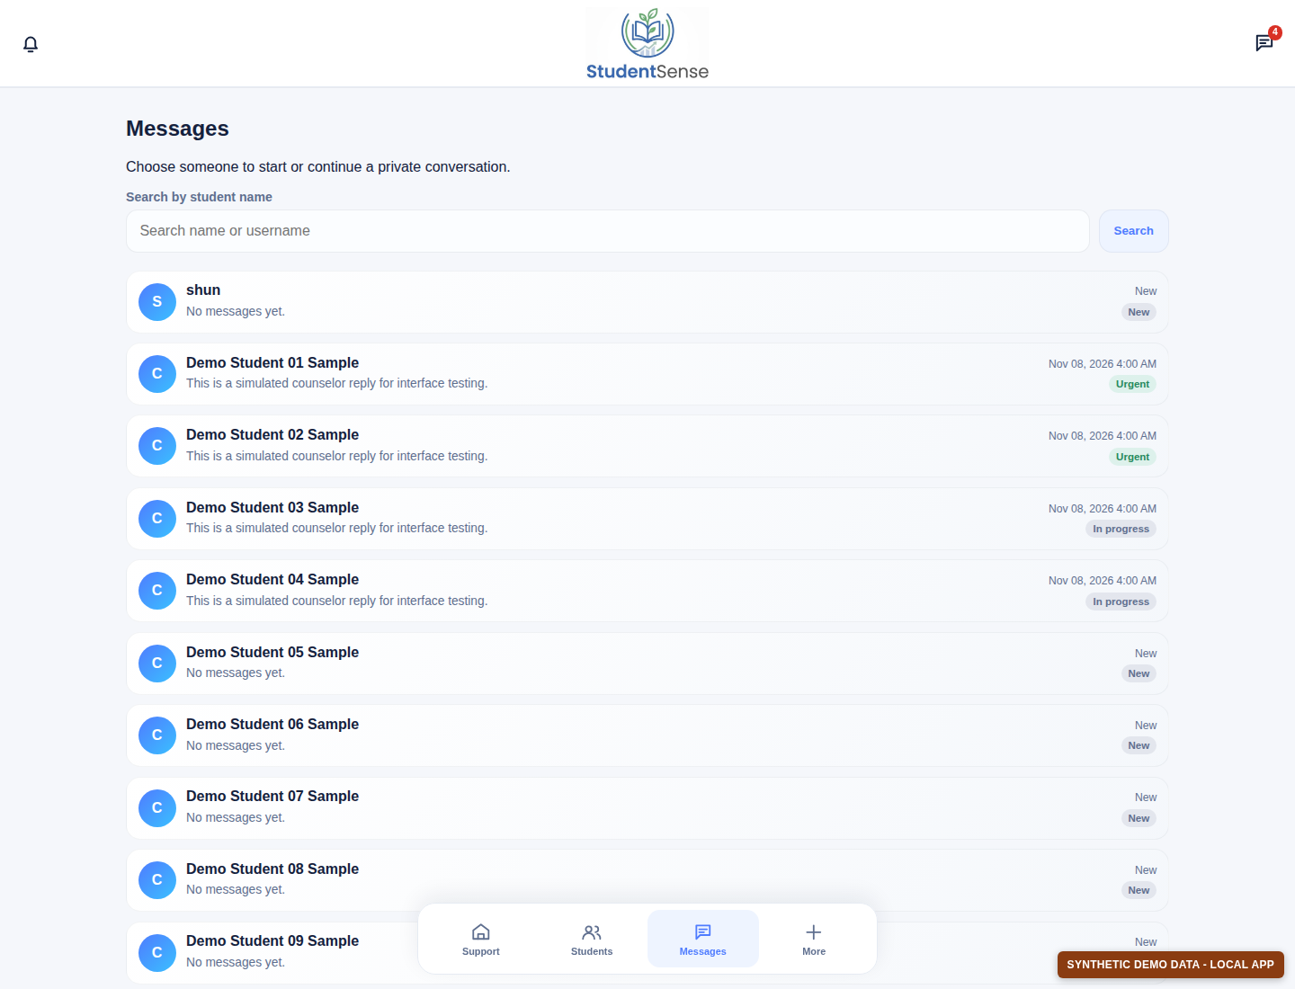
Figure 8. Counselor message list with synthetic demonstration conversations.
Figure 8 discussion. The message list groups conversations by student and shows each thread's latest message and status. The sample conversations were created solely to make the local interface usable for screenshots. No real student or counselor communication is shown.
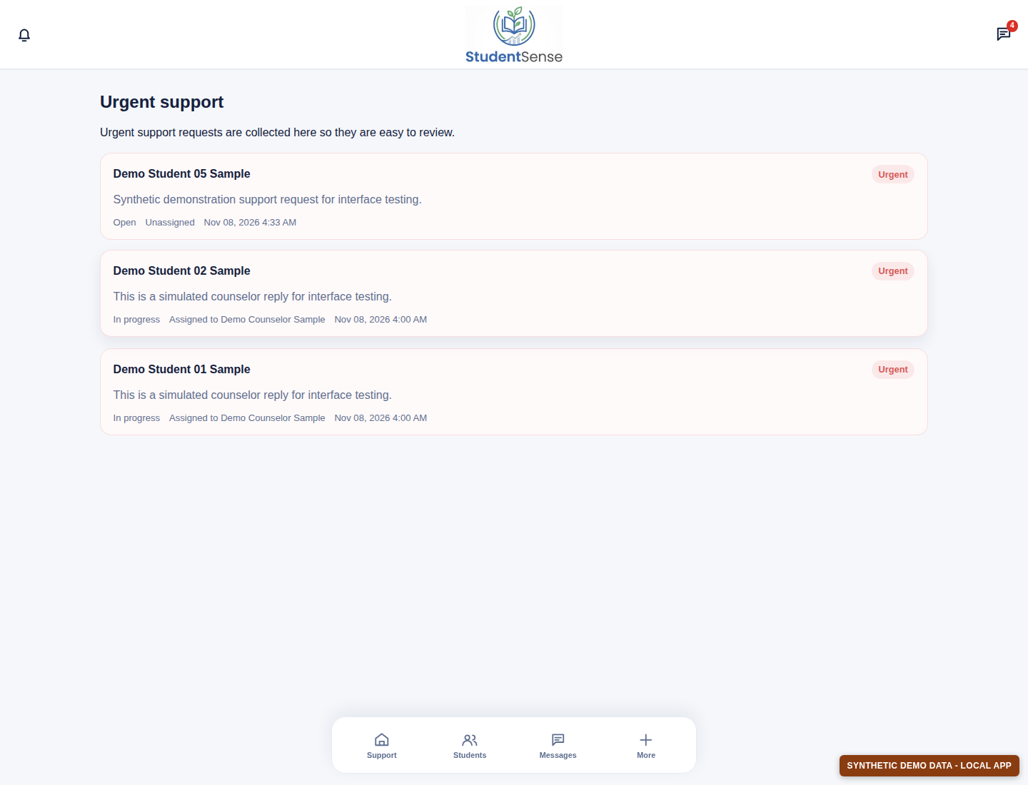
Figure 9. Urgent-support page with generated local demonstration requests.
Figure 9 discussion. The urgent-support page collects requests for counselor review and indicates whether each request is assigned. The names and messages in this screenshot belong to synthetic accounts and are not real support cases.
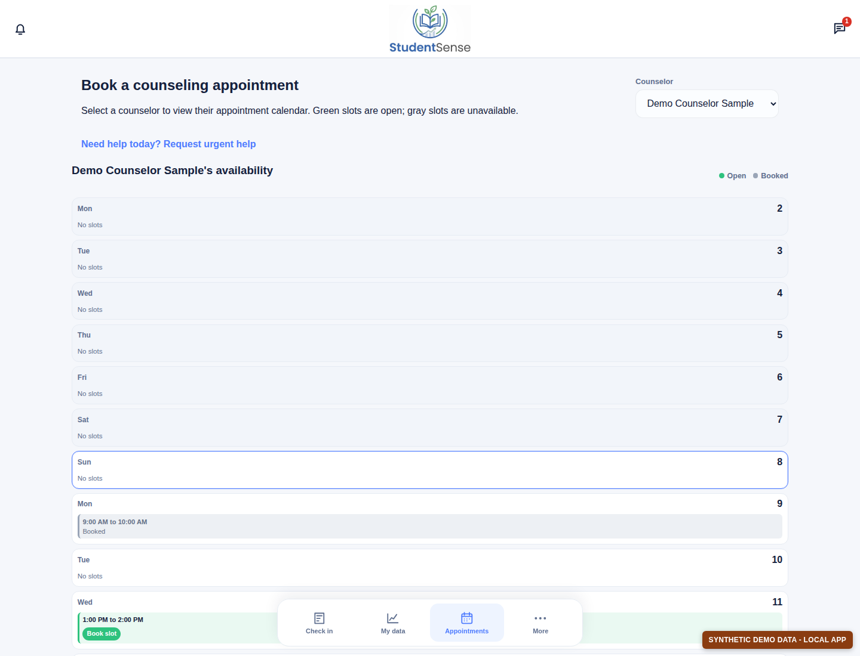
Figure 10. Student appointment calendar showing synthetic availability and a demonstration booking.
Figure 10 discussion. The appointment page lets a student review a counselor's available times and shows booked times as unavailable. The open and booked slots in this screenshot were created for interface testing; they do not document actual appointments.

4.4 Summary and limitations
The saved application model can reproduce some of the rule-based labels on generated questionnaire rows, but its results are uneven across classes. In particular, its recall for the Low class was 8.7% on the synthetic test set. The strong overall accuracy is influenced by the large number of Moderate examples. These results are a software-development check, not a validated assessment of students.
The local database and screenshots demonstrate the application's check-in, analytics, counselor support, messaging, and appointment workflows. All accounts, records, messages, referrals, and appointments created for these screenshots are synthetic. A study with real participants would require appropriate approvals, consent and privacy protections, a defined evaluation method, and independent review of the model before its results could support research claims or student-support decisions.

