Contents
1. Scope of Work 2
1.1 Timeline 2
1.2 Targets 2
1.3 Limitations 2
2. Finding Overview 3
3. Risk Overview 4
4. Potential Business Impact 5
5. Technical Vulnerabilities Details 6
5.1 Application Wide SQL Injection Error! Bookmark not defined.
5.2 Information Disclosure Error! Bookmark not defined.

Scope of Work
This section outlines the specific scope of the penetration testing, referred to throughout the document as the targeted application.

Timeline
Name | Start Date | End Date | Man-days
OWASP Juice Shop | Nov 21st, 2025 | Nov 27th, 2025 | 6

Targets
The below scope was DIVA
ID | Asset Identifier (URL/IP)
1 | https://demo.owasp-juice.shop/#/

Limitations
The findings in this report reflect the state of the application during a specific time frame. Changes to the architecture, code, or configurations could lead to different results if the test is repeated. This penetration test specifically does not include:
- Distributed Denial of Service Attacks.
- Social Engineering

Finding Overview
The table below presents a high-level summary of the security vulnerabilities that have been successfully found and verified by the Vector.
ID | Vulnerability Name | Severity
Vuln 01 | Broken Access Control | High
Vuln 02 | Unvalidated Redirects | Medium
Vuln 03 | Improper Input Validation | Medium
Vuln 04 | Improper Input Validation | Low

Risk Overview
The Below chart shows the Number of vulnerabilities, and their risks, categorized as Critical, High, Medium, Low, and Informative.

Potential Business Impact
The highlights of business impact possible due to the Pentest are listed below:
- Weak access controls or exposed debugging interfaces could allow unauthorized parties to interact with backend components or internal services, increasing the likelihood of deeper system compromise.
- Improperly protected endpoints may enable attackers to extract sensitive data such as configuration details, customer information, operational logic, or system credentials.
- Gaining unintended access to backend logic or databases might allow malicious actors to alter records, modify application behavior, or falsify business-critical information.
- Manipulation of inputs or parameters (e.g., via improper validation) could distort system functionality, create inconsistencies in business data, or undermine processes that rely on accurate user input.
- Redirection weaknesses could be leveraged to funnel users toward deceptive or harmful websites, creating pathways for fraudulent collection of user data or credentials.
- Redirects users to malicious websites, facilitating phishing attacks.
- Any successful exploitation—whether through redirects, data leakage, or visible malfunctions—can damage users’ confidence in the platform, ultimately affecting brand reputation and user retention.
- Information disclosure and predictable application behavior provide attackers with reconnaissance data, which can serve as building blocks for more advanced attacks including privilege escalation, session compromise, or lateral movement.
- Input inconsistencies (e.g., invalid ratings or duplicated accounts) could skew reporting dashboards, distort usage insights, or mislead decision-makers reliant on accurate metrics.
- Data breaches or mishandling of sensitive information may result in non-compliance with privacy regulations, leading to legal penalties or mandatory disclosure obligations.
- May disclose version information, source code, or other critical data.
- Provides reconnaissance information to attackers for further exploitation.
- Reveals the server’s directory structure, potentially assisting in crafting targeted exploits.
- Can disclose sensitive paths that lead to unauthorized access or data leakage.
- Often a steppingstone for more severe vulnerabilities like file inclusion attacks.
- Executes malicious scripts in a user's browser, leading to theft of session tokens, credentials, or sensitive data.
- Can facilitate phishing attacks, defacement, or distribution of malware.
- Damages user trust and the application’s reputation.

Technical Vulnerabilities Details
Below are the finding details with their respective exploitation scenarios in severity ordered from Critical to Informative.

Exposed Web3 sandbox
Severity | High
CVSS | CVSS 8.2
Affected Assets | - web3-sandbox
Reference | A01 Broken Access Control - OWASP Top 10:2025 RC1

Description
The application exposes a publicly accessible Web3 Sandbox that allows users to execute arbitrary Web3 and JavaScript commands in the browser. This debugging interface is not protected by authentication and permits direct interaction with the application's simulated smart-contract functions.
IMPACT
- Unauthenticated users can issue direct Web3 method calls, manipulate blockchain-related data, and trigger internal logic that is not intended to be user-accessible. In real-world scenarios, similar exposure could lead to unauthorized contract execution or application state manipulation.
RECOMMENDATIONS
- Restrict access to debugging interfaces, remove sandbox components from production builds, and apply proper authentication and authorization to all Web3-related operations.

Steps to Reproduce
- In the main.js file search for web3, scroll through the search results and look for the path: “web3-sandbox”
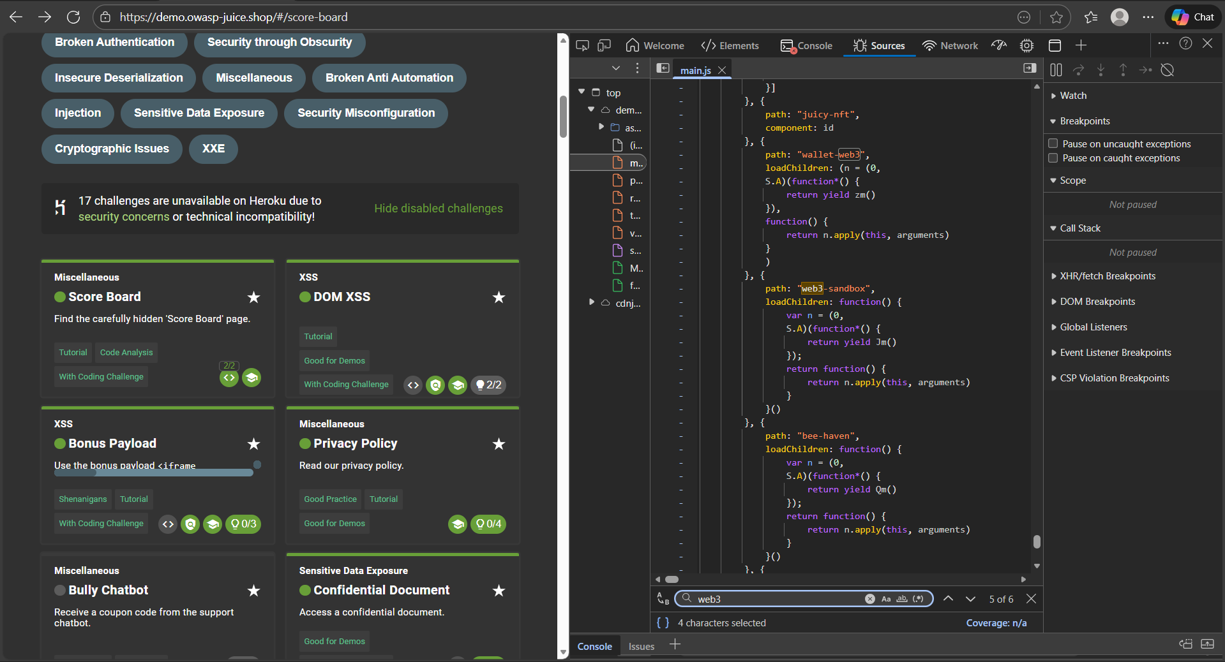
- Copy the path from the Dev Tools and paste in the URL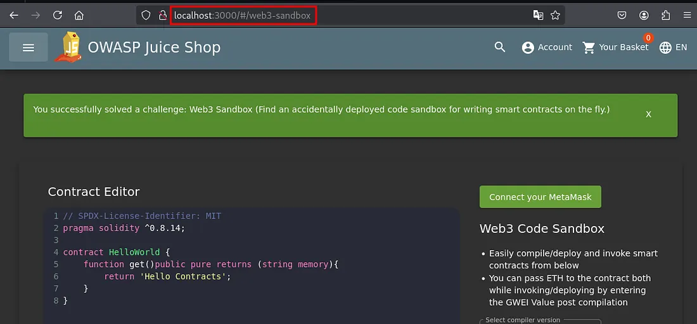

Repetitve Registration
Severity | Medium
CVSS | CVSS 5.3
Affected Assets | - register
Reference | Input Validation - OWASP Cheat Sheet Series

Description
The registration workflow does not correctly validate the “password” and “repeatPassword” fields on the server side. In particular, submitting a registration request with mismatched or manipulated password fields may still succeed under certain conditions. This allows the creation of a new user account with an already existing email address. i.e., the same email can be registered again.
IMPACT
- Multiple accounts can be registered with the same email identity. This undermines uniqueness and identity integrity, potentially enabling account duplication, confusion over user identity, misuse of application features under duplicate accounts, or skewing of user‑based metrics, especially relevant in real-world systems relying on unique user accounts for authorization, logging, or rate-limiting.
RECOMMENDATIONS
- Enforce server‑side validation for both password and confirm‑password fields. Ensure that the two values must match and meet minimum password strength requirements (e.g. length, complexity).
- Prevent registration when the provided email already exists in the database (unique constraint on email).
- Avoid relying solely on client-side validation.
- Log and monitor registration attempts with failed or suspicious inputs.

Steps to Reproduce
- Entered password as “12345” and repeat password as “123456” it says “Passwords do not match”
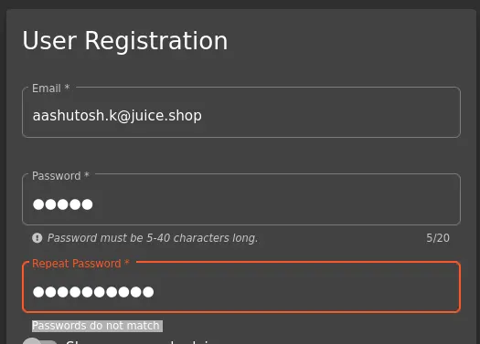
- Then entered “1234512345” in password field and it didn’t shown any kind of error.

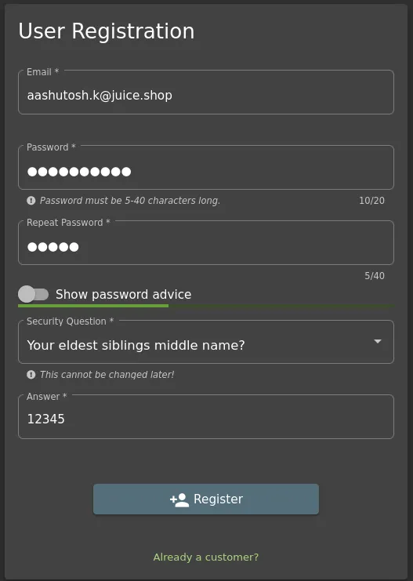

UNVALIDATED REDIrects
Severity | Medium
CVSS | CVSS 6.5
Affected Assets | - /redirect?to=https://blockchain.info/address/1AbKfgvw9psQ41NbLi8kufDQTezwG8DRZm
Reference | Unvalidated Redirects and Forwards - OWASP Cheat Sheet Series

Description
The application accepts a user‑controlled URL parameter and performs a redirect without validating or restricting the destination. Because the redirect target is not checked against an allowlist, any external URL can be supplied, enabling forced navigation to arbitrary sites.
IMPACT
- Users may be redirected to malicious or misleading external pages, facilitating phishing, credential harvesting, or malware delivery. In real deployments, unvalidated redirects commonly serve as a stepping stone in social‑engineering attacks.
RECOMMENDATIONS
- Implement strict validation of redirect targets using an allowlist of permitted internal paths. Reject all external URLs and sanitize user‑supplied input before performing navigation.

Steps to Reproduce
- In the Developer Tools > Memory > main.js
search for the term “redirect”

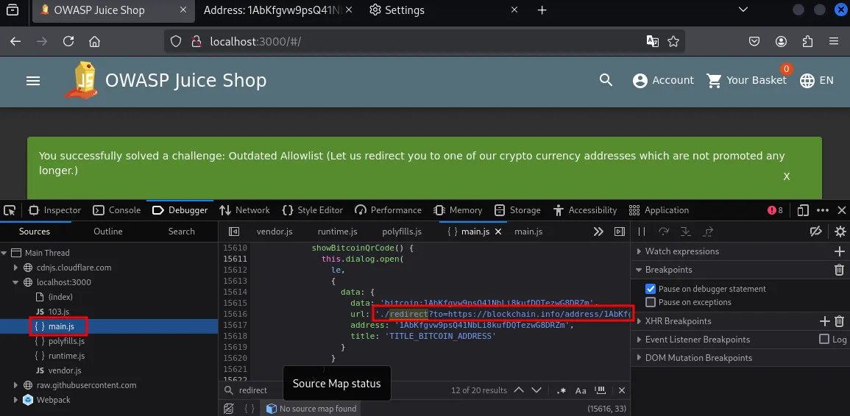
- Copy the URL containing the redirect and paste in the URL path
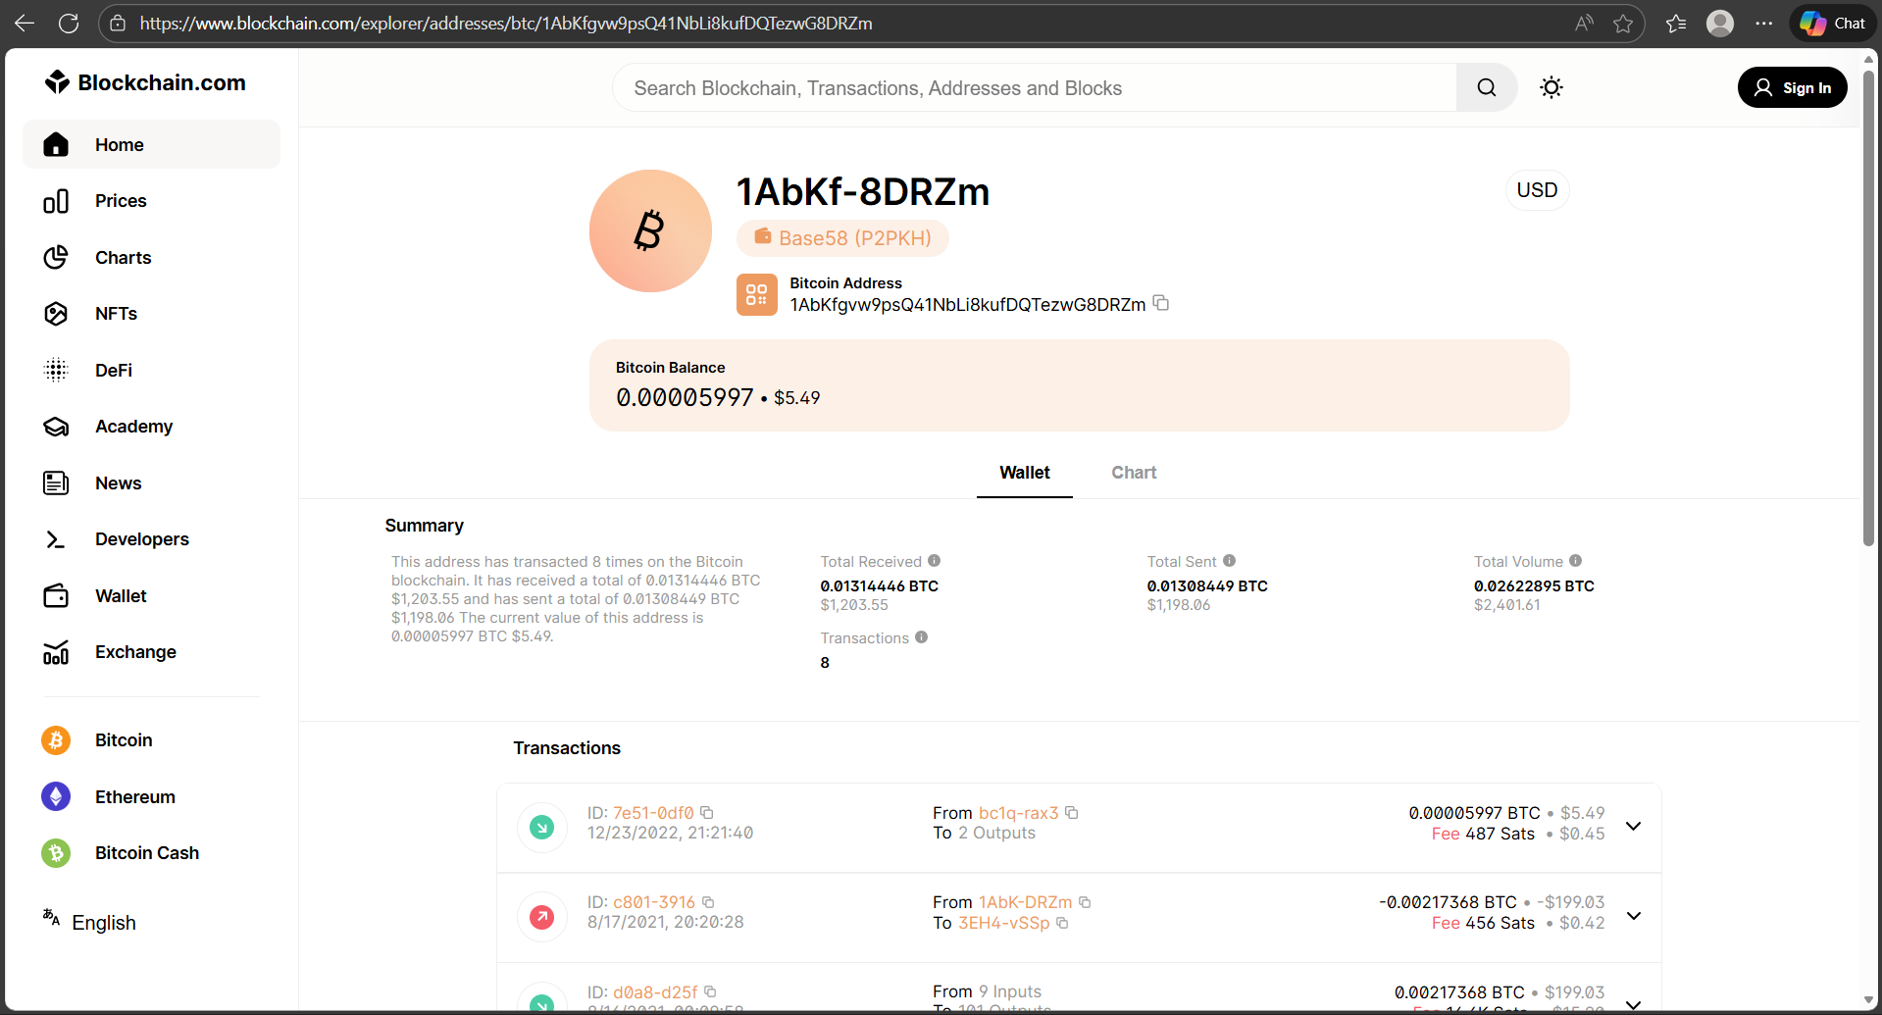

Exposed Web3 sandbox
Severity | Low
CVSS | CVSS 3.7
Affected Assets | - /contact
Reference | Input Validation - OWASP Cheat Sheet Series

Description
The product review feature does not properly validate rating input values. By manipulating the request client‑side, it is possible to submit a review with a rating of zero stars, even though the UI restricts scores to 1–5. The server accepts the out‑of‑range value due to missing server‑side validation.
IMPACT
- Submitting invalid or unexpected rating values can undermine data integrity in product reviews. In real systems, improper validation of rating or scoring fields can distort analytics, damage product reputation, or enable automated manipulation of scoring systems.
RECOMMENDATIONS
- Enforce server‑side validation for review ratings, ensuring that only values within the expected range are accepted. Reject or normalize any out‑of‑range inputs.

Steps to Reproduce
- Go to the menu bar and open customer feedback, in the feedback, the least you can do is 1 star.
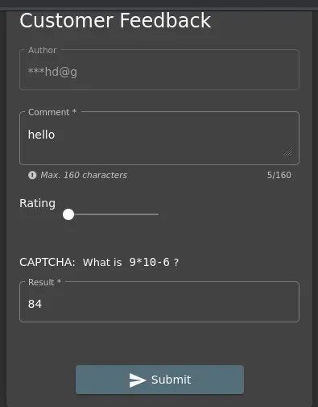
- Intercept the request with burp and change the rating number as you wish.L