Contents
1. Scope of Work 2
1.1 Timeline 2
1.2 Targets 2
2. Finding Overview 3
3. Risk Overview 4
4. Potential Business Impact [after all vulnerabilities] 5
5. Technical Vulnerabilities Details 6
5.1 SQL Injection 6
5.2 Broken Authentication 9
5.3 Broken Access control 13
5.4 Sensitive Data exposure 16
5.5 Insecure Direct Object Reference 19

Scope of Work
This section outlines the specific scope of the penetration testing, referred to throughout the document as the targeted application.

Timeline
Name | Start Date | End Date | Man-days
OWASP Juice Shop | Nov 21st, 2025 | Nov 27th, 2025 | 6

Targets
The below scope was OWASP Juice Shop
ID | Asset Identifier (URL/IP)
1 | http://localhost:3000/

Finding Overview
The table below presents a high-level summary of the security vulnerabilities that have been successfully found and verified by Malak Yasser.
ID | Vulnerability Name | Severity
Vuln 01 | SQL Injection | Critical
Vuln 02 | Broken Authentication | High
Vuln 03 | Broken access control | Medium
Vuln 04 | Sensitive Data Exposure | Medium
Vuln 06 | Insecure Direct Object Reference | Medium

Risk Overview
The Below chart shows the Number of vulnerabilities, and their risks, categorized as Critical, High, Medium, Low, and Informative.

Potential Business Impact [after all vulnerabilities]
The highlights of business impact possible due to the Pentest are listed below:
- Allows attackers to bypass authentication and access administrative accounts, potentially gaining control over sensitive functionality.
- Unauthorized access to user accounts, including the administrator, can lead to viewing, modifying, or deleting user data.
- Exposure of user emails and basket contents undermines user privacy and may violate data protection regulations.
- Hardcoded credentials in client-side code could be exploited to gain unauthorized access, leading to misuse of testing accounts.
- Direct access to hidden administrative routes increases the risk of manipulation of internal systems without proper authorization.
- SQL injection vulnerabilities could allow attackers to manipulate backend databases, delete data, or escalate privileges.
- Attackers can alter or delete basket items, affecting order integrity and potentially disrupting business operations.
- Sensitive internal information, such as client-side JavaScript structure and hidden paths, can be used for further targeted attacks.
- Erodes the customer trust and confidence in the website.
- Exploitation could harm the company’s reputation and may result in financial or legal repercussions if user data is compromised.
- Weaknesses in access control, authentication, and input validation provide attackers with reconnaissance opportunities to map the application’s structure and security posture.
- Failure to enforce proper authorization and protect sensitive information exposes the organization to regulatory compliance risks.

Technical Vulnerabilities Details
Below are the finding details with their respective exploitation scenarios in severity ordered from Critical to Informative.

SQL Injection
Severity | Critical
CVSS | CVSS 9.1
Affected Assets | - http://localhost:3000/#/login
Reference | SQL Injection

Description
The Juice Shop web application does not properly sanitize user input in the login form and directly embeds the supplied email value into its SQL authentication query. Because the input is not validated or parameterized, an attacker can inject SQL code into the field and alter the logic of the query. By doing so, the attacker can bypass authentication and gain access to protected accounts, including the administrator account. This allows unauthorized access to sensitive information and administrative functionality, posing a significant security risk.
IMPACT
- Administrator account can be compromised, allowing unauthorized access to sensitive functionality and profile information.
- User comments can be deleted, and email addresses of other users can be viewed, resulting in data exposure and loss of integrity.
RECOMMENDATIONS
- Use parameterized queries or prepared statements to prevent SQL injection.
- Validate and sanitize all user input on the server side.
- Restrict database account privileges to minimize the impact of successful injection.
- Disable detailed error messages that reveal internal database or system information.
- Implement monitoring for unusual login activity to detect potential abuse.

Steps to Reproduce
- Navigate to http://localhost:3000/#/login
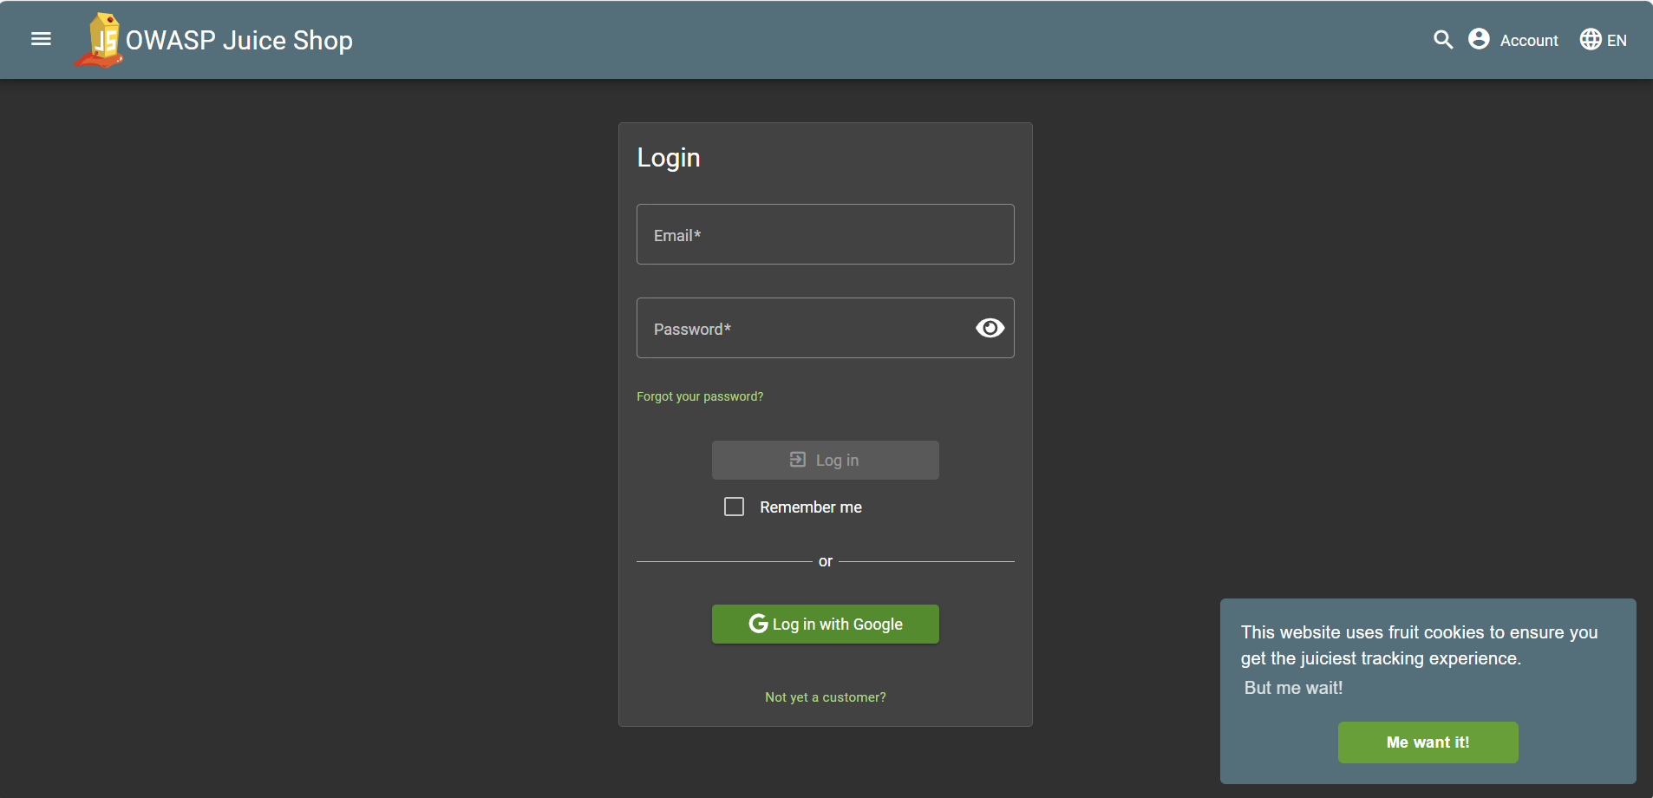
Figure 1 The login page
- In Email field use ' OR 1=1 – payload and write any password in password section
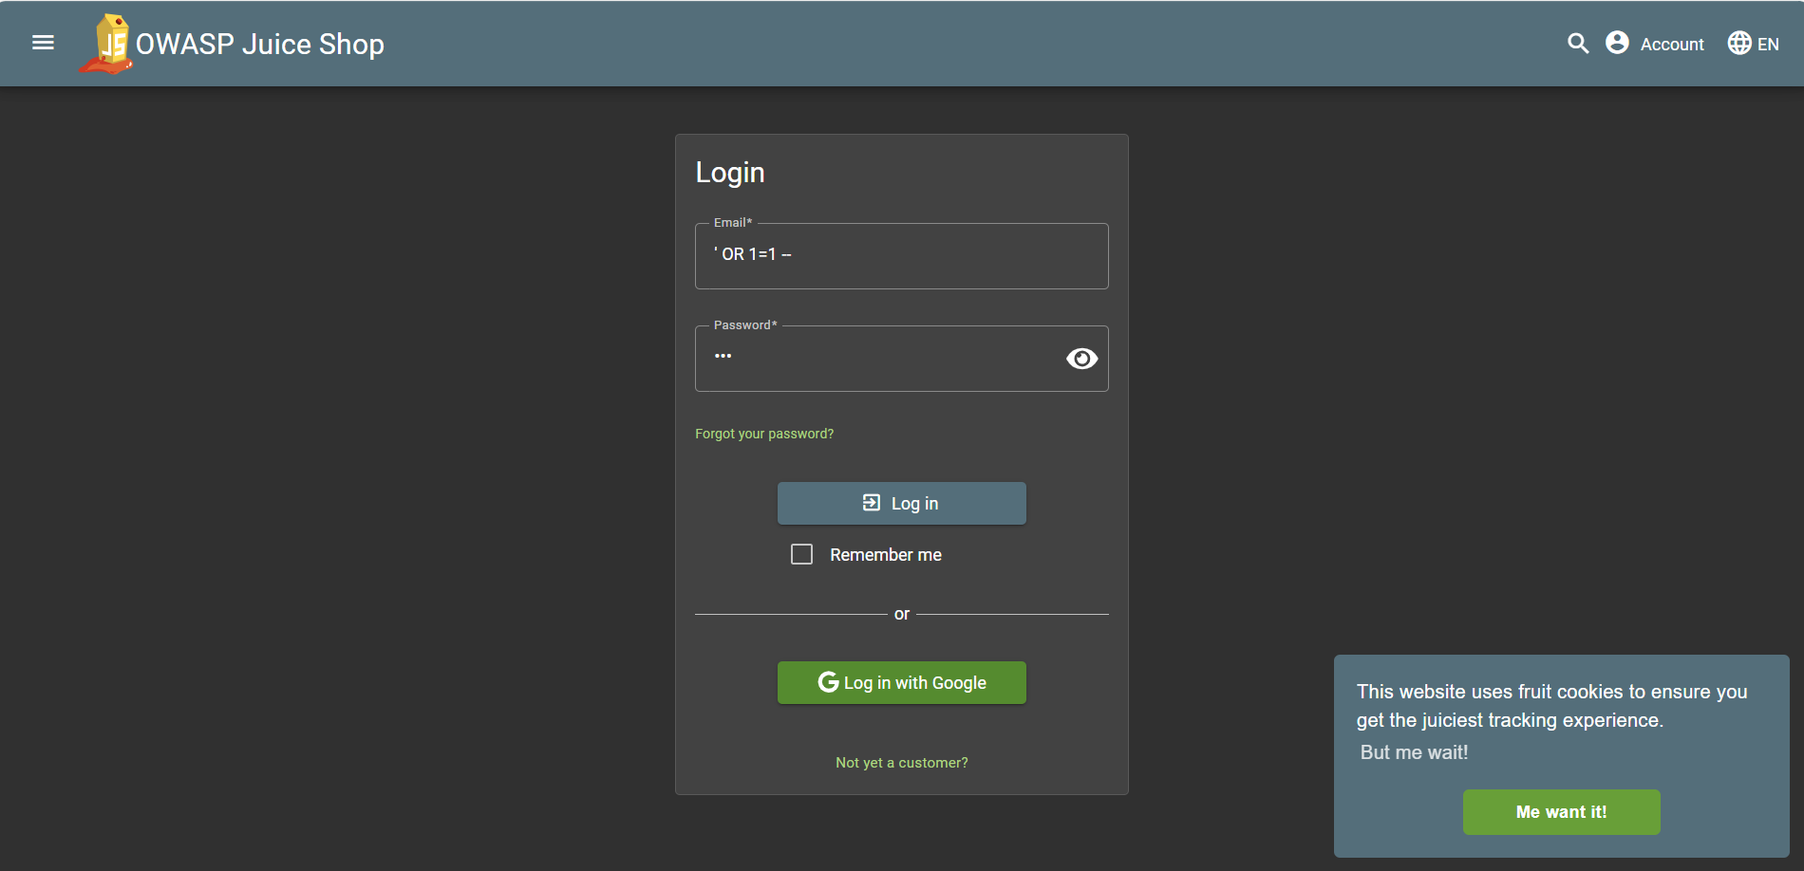
Figure 2 Writing the payload in the email field

- Logs in as the administrator
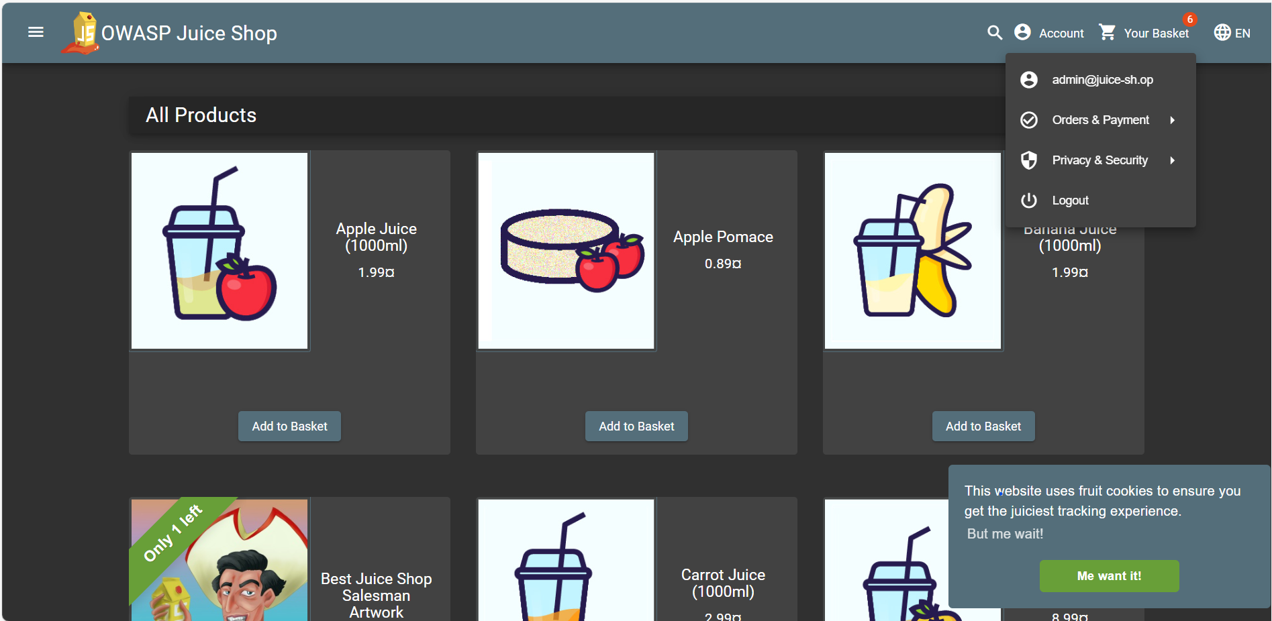
Figure 3 Logged in the admin's page

Broken Authentication
Severity | High
CVSS | CVSS 8.2
Affected Assets | - http://localhost:3000/#/login
Reference | Broken authentication

Description
The Juice Shop application does not implement sufficient protections against password brute-force or credential stuffing attacks. After obtaining a valid user email address, such as the administrator’s address, an attacker can automate repeated login attempts using common or guessable passwords. The login endpoint imposes no rate limiting, account lockout, CAPTCHA, or delays between attempts. Because authentication requests can be made without restriction, an attacker can systematically try multiple passwords until the correct one is identified, leading to unauthorized access.
IMPACT
- Unauthorized access to user or administrative accounts can be gained.
- Sensitive information and administrative functionality become exposed.
- Compromise of an administrator account may lead to some control over the application, such as viewing users’ emails, details and deleting comments.

RECOMMENDATIONS
- Implement account lockout policies after several failed login attempts.
- Use rate limiting and throttling to prevent automated login attempts.
- Add mandatory multi-factor authentication (MFA) to protect high-privilege accounts.
- Monitor login attempts for unusual patterns and alerts on suspicious activity.
- Educate users to avoid common or weak passwords.

Steps to Reproduce
- Navigate to http://localhost:3000/#/login
- Enter the admin’s email address admin@juice-sh.op and any random password such as 0000
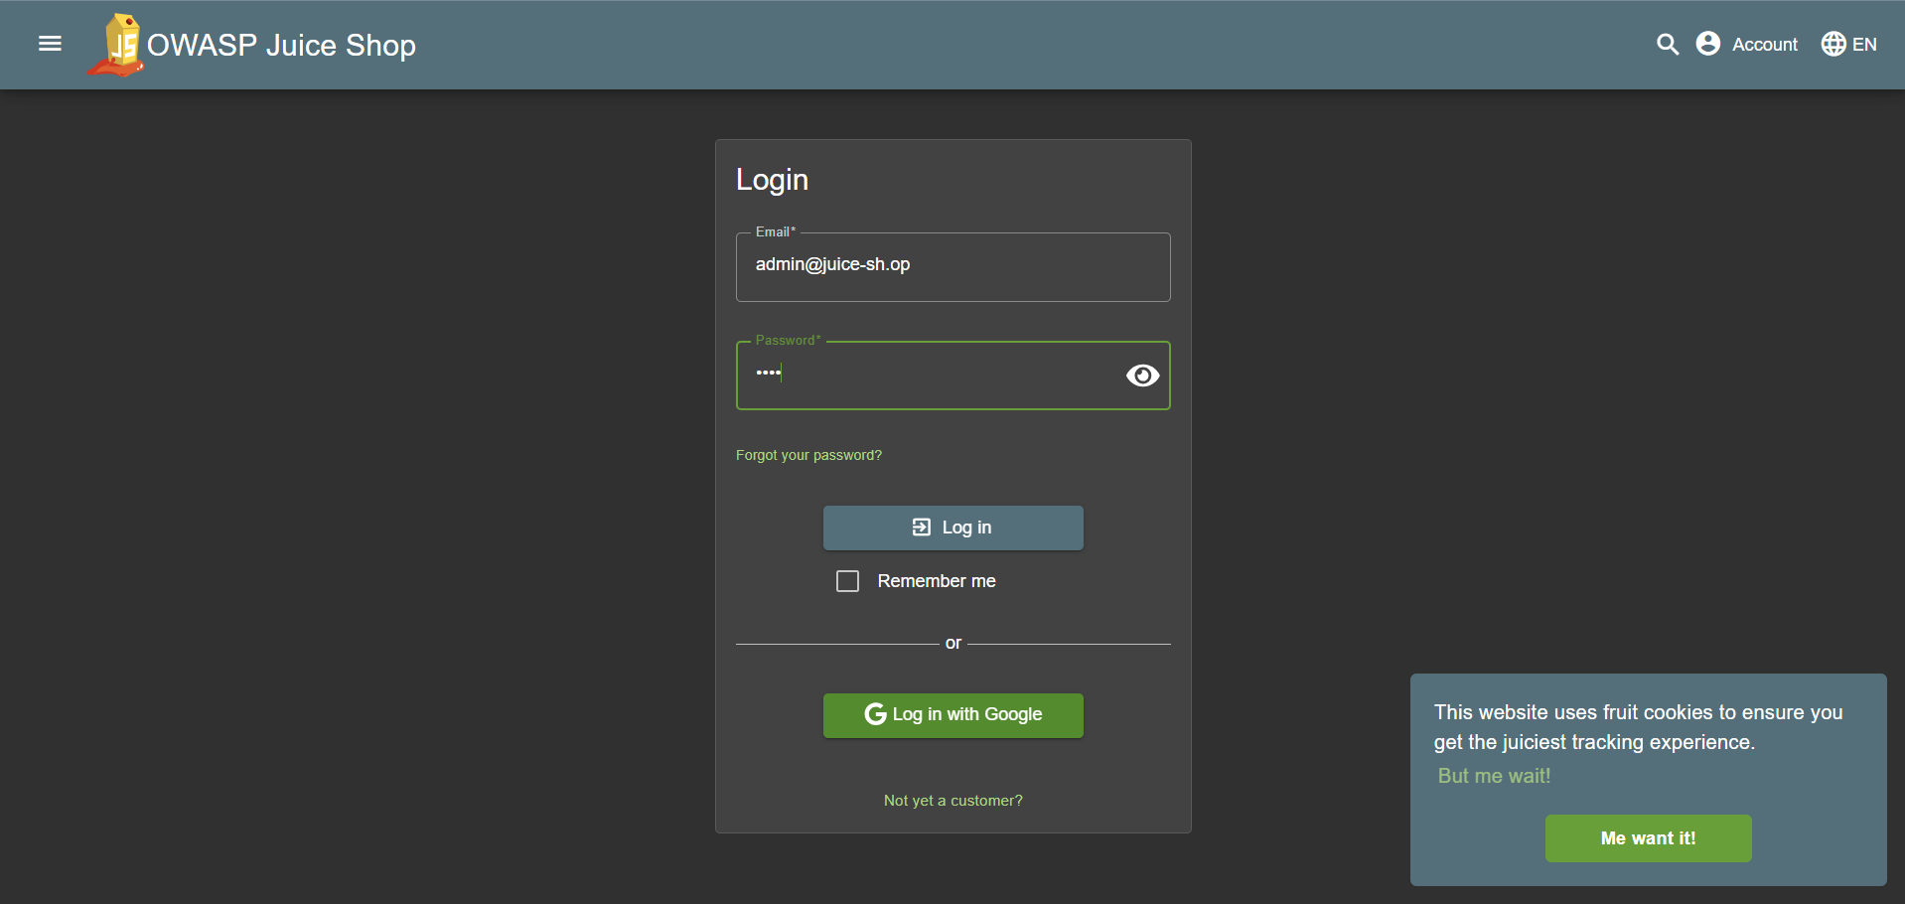
Figure 4 Entering admin's username and a random password
- Turn the interception on in the burp suite and click on login to capture the HTTP request
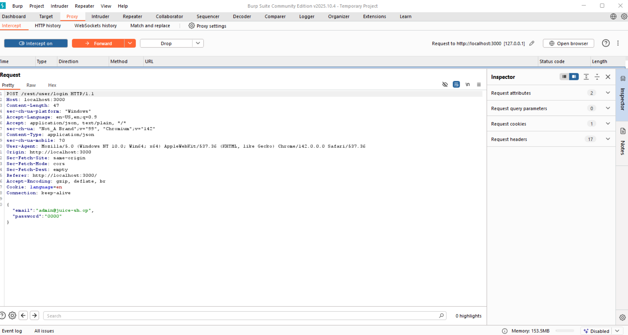
Figure 5 capturing HTTP request

- Send the captured post request to the intruder
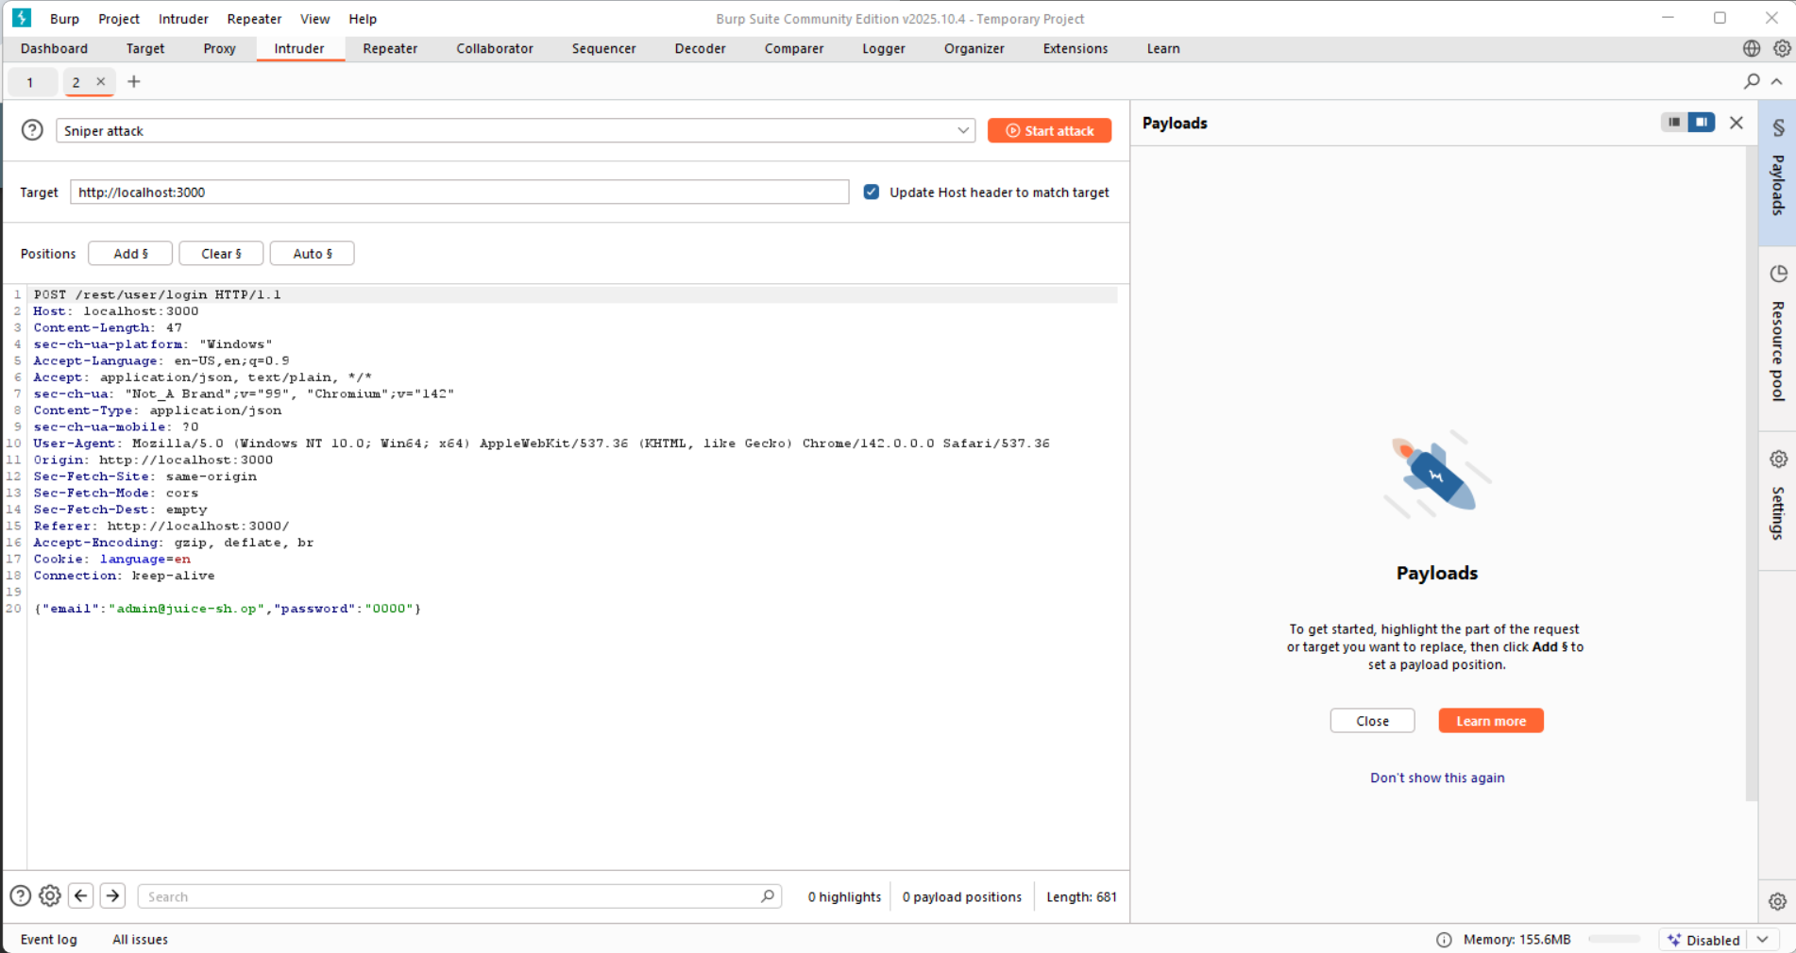
Figure 6 The request in the intruder
- Add position to the password then use a list of commonly used password such as from https://nordpass.com/most-common-passwords-list/ and copy them into the payload
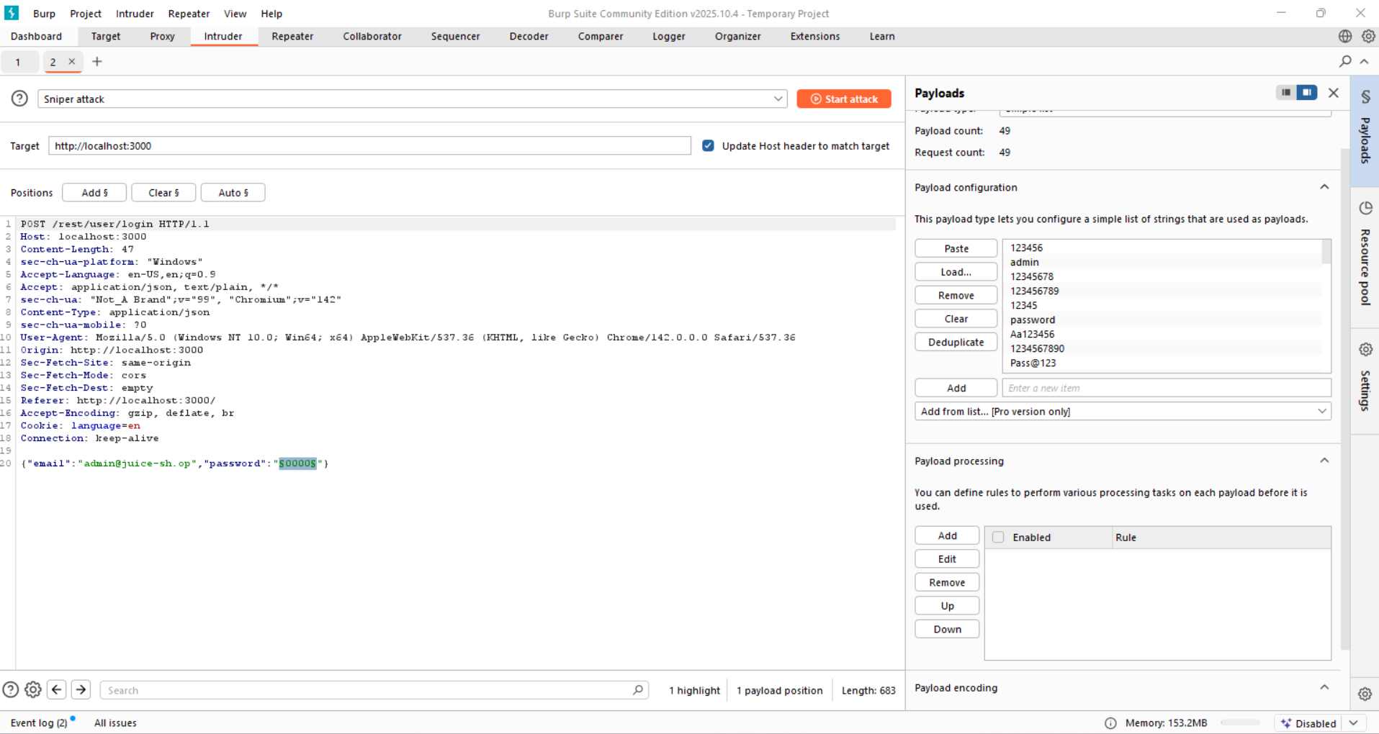
Figure 7 Adding position and payload
- Start the attack and look for the password with the status code 200
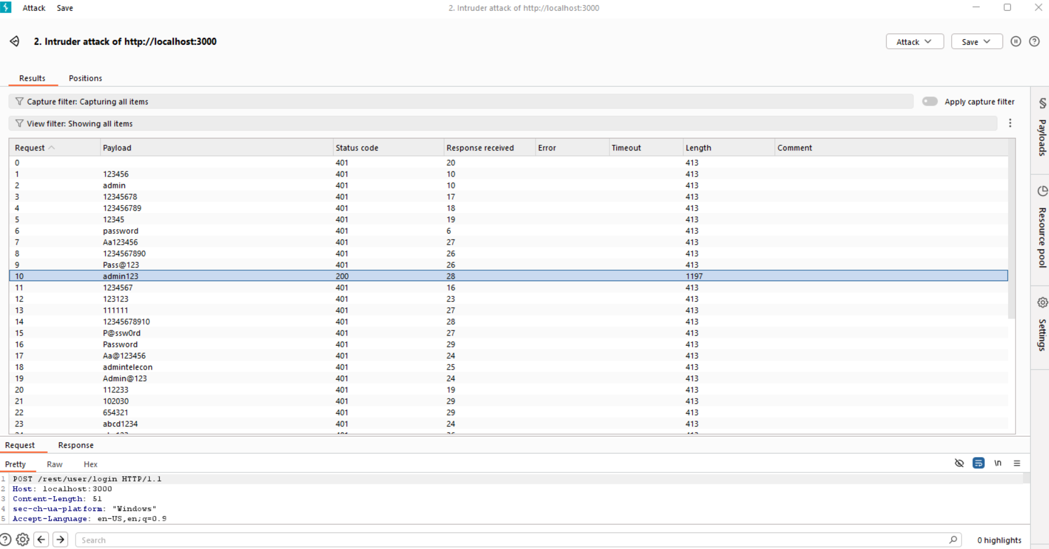
Figure 8 Finding the admin’s password
- Navigate back to http://localhost:3000/#/login and enter the admin’s email admin@juice-sh.op with the password admin123 then login successfully
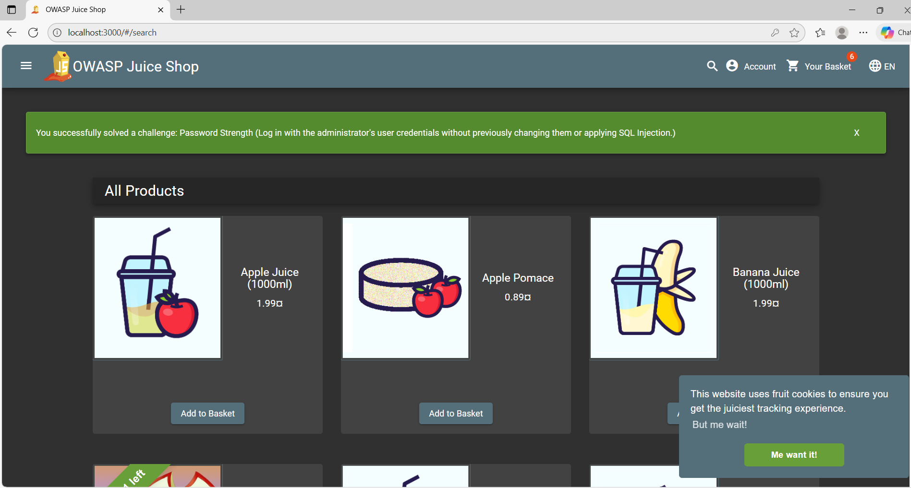
Figure 9 logged in the admin's account

Broken Access control
Severity | Medium
CVSS | CVSS 5.5
Affected Assets | - http://localhost:3000/#/administration
Reference | A03:2021 – Broken access control

Description
The application is vulnerable to broken access control, allowing users to directly access a hidden administration page by manually browsing to the /administration route. This endpoint is defined in the client-side JavaScript but not linked in the interface, yet it remains fully accessible once an admin session is active. As a result, sensitive information such as all user email addresses becomes visible, and administrative functions like deleting user comments can be performed without proper server-side authorization checks. This exposes internal data and functionality that should be securely restricted.
IMPACT
An attacker can exploit this vulnerability to:
- Exposure of all user email addresses to anyone with unauthorized access to an admin session.
- Ability to delete user comments, leading to loss of data integrity.
- Increased overall risk if administrator accounts are compromised, as hidden administrative functionality becomes directly accessible.
RECOMMENDATIONS
- Implement server-side role-based access control to restrict access to administrative routes.
- Validate authorization on each administrative action rather than relying on client-side route protection.
- Avoid exposing sensitive or administrative paths within client-side code.
- Log and monitor all administrative actions for auditing and detection of misuse.

Steps to Reproduce
- Log in to the website as an admin
- Open the developer tools and navigate to sources
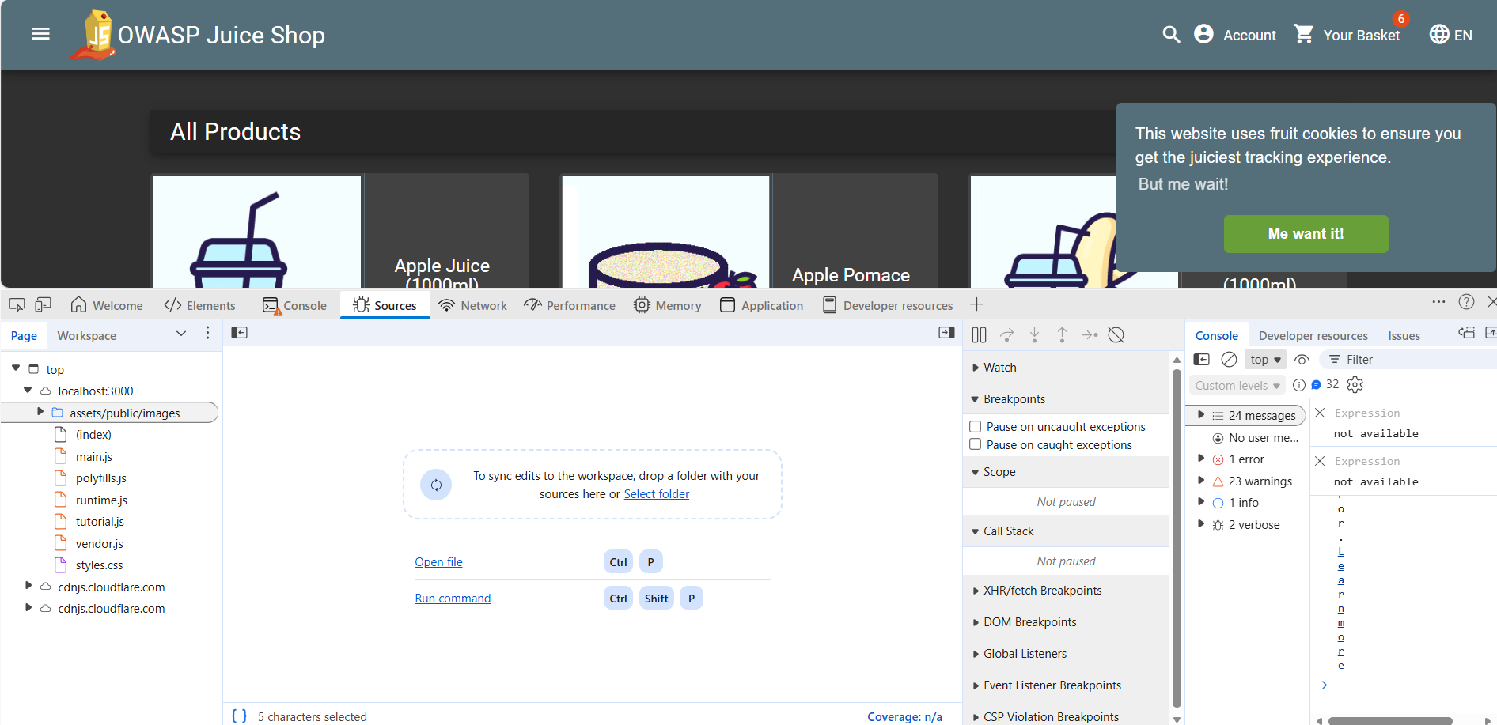
Figure 10 opening sources in the developer tools
- Open main.js and search for the word administration to find the hidden route
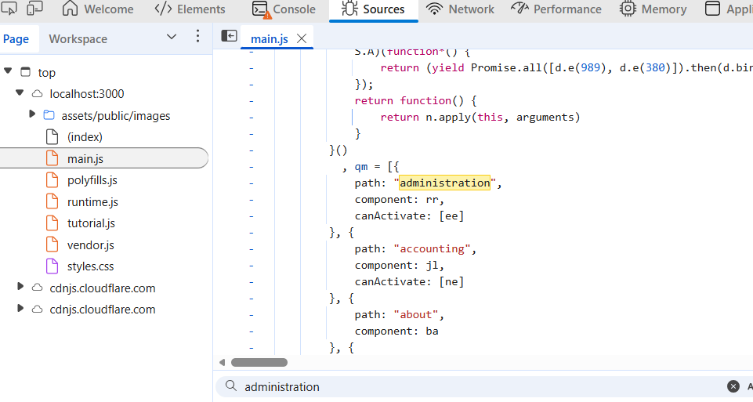
Figure 11 Finding path to the administration
- In the URL enter http://localhost:3000/#/administration to open the administration page
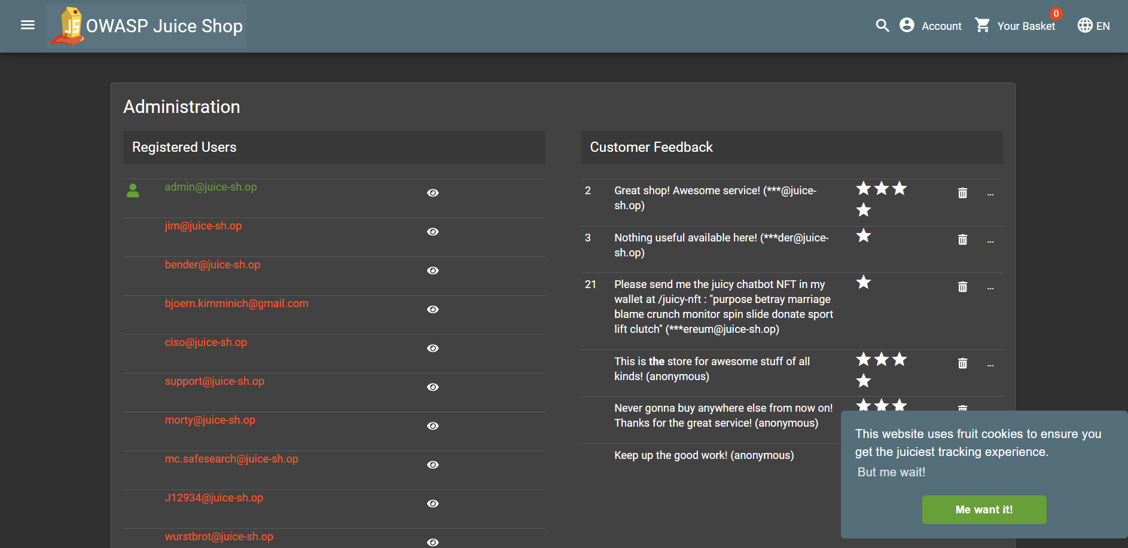
Figure 12 The administration page

Sensitive Data exposure
Severity | Medium
CVSS | CVSS 6.5
Affected Assets | - main.js
Reference | Sensitive Data Exposure

Description
The Juice Shop application contains hardcoded credentials for a testing account within its client-side JavaScript (main.js). These credentials are embedded directly in the source code and remain valid for authentication. Because client-side JavaScript is fully accessible to end users through browser developer tools, an attacker can easily extract these credentials and log in without authorization. This issue exposes a functional user account and represents a significant security risk caused by improper handling of sensitive information.
IMPACT
- Unauthorized users can log in using the exposed testing account credentials.
- Attackers may view or modify data associated with the compromised account.
- Exposure of internal testing data increases the risk of further exploitation and misuse.
RECOMMENDATIONS
- Remove all hardcoded credentials from client-side code.
- Disable or delete unused testing accounts in production environments.
- Store sensitive information securely on the server side and never within JavaScript assets.
- Implement regular code reviews to ensure credentials and secrets are not exposed in source files.

Steps to Reproduce
- Navigate to http://localhost:3000/#/login
- Open developer tools then click on main.js
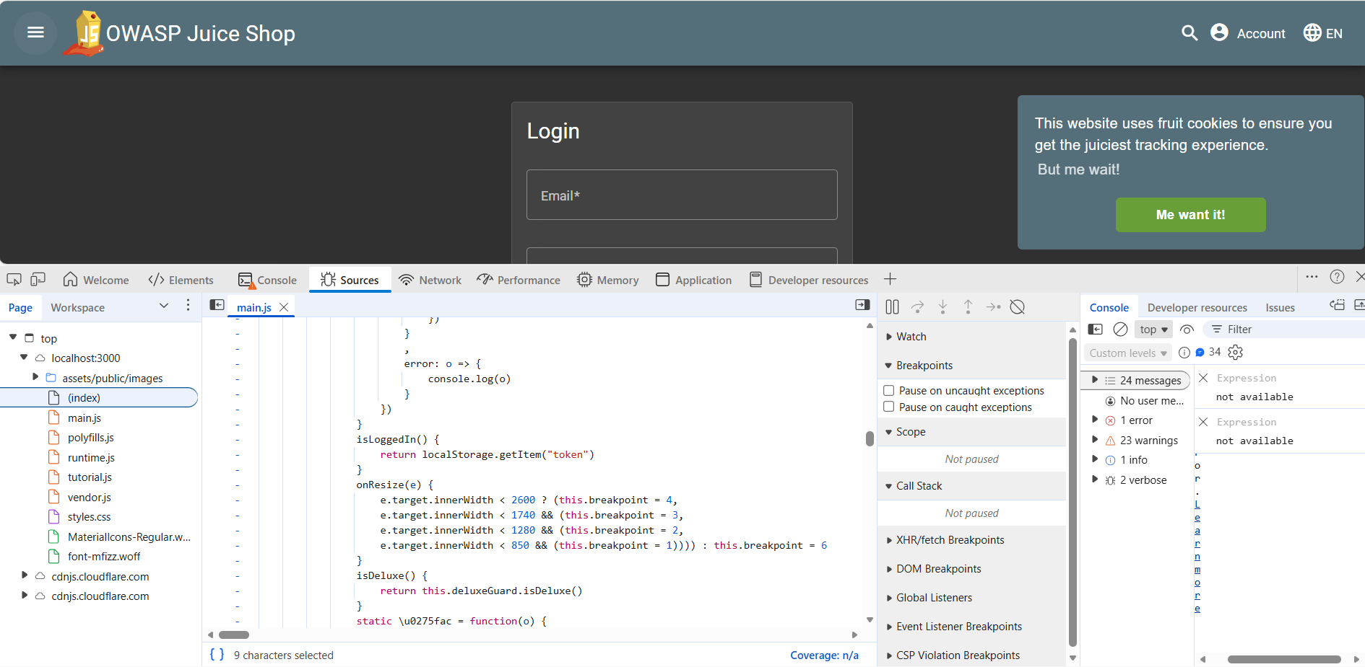
Figure 13 main.js in the developer tools
- Search for keyword “password” and look for the testing credentials
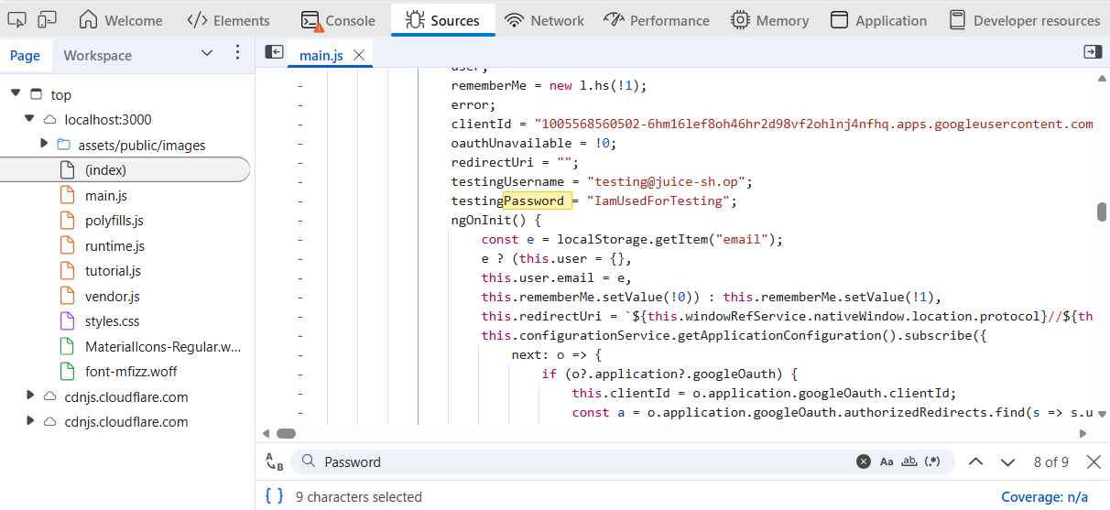
Figure 14 Finding the email and password

- Enter the found credentials of email “testing@juice-sh.op” and password “IamUsedForTesting” in the login
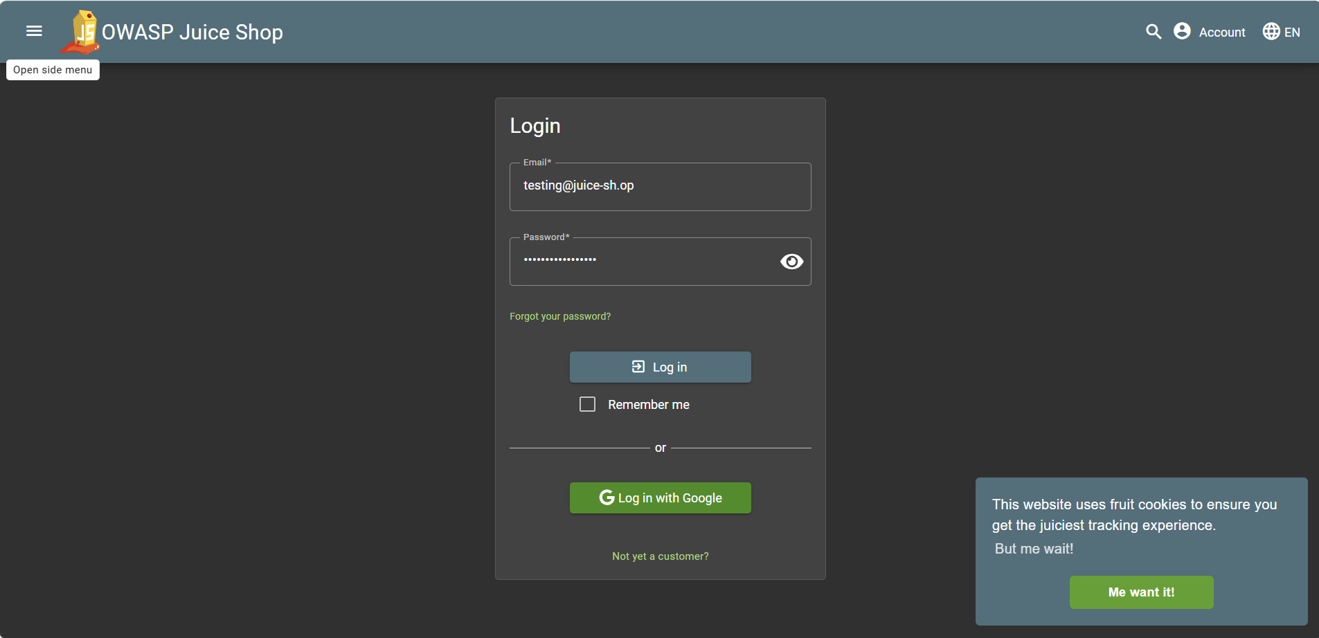
Figure 15 putting the found credentials in the login form
- Click on the login button to login with the testing account
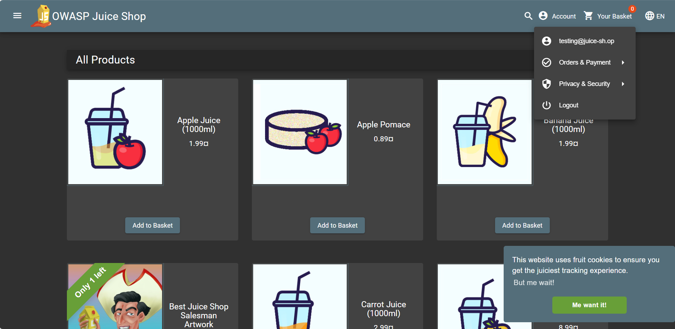
Figure 16 Logged in with the testing account

Insecure Direct Object Reference
Severity | Medium
CVSS | CVSS 5.4
Affected Assets | - http://localhost:3000/#/basket
Reference | Insecure Direct Object Reference

Description
The Juice Shop application does not properly enforce authorization checks on user basket identifiers. The basket ID (bid) is stored in the browser’s session storage and is fully client-controlled. When a user modifies this value, the application does not verify whether the basket belongs to them. As a result, an attacker can change their own bid to another valid basket ID, allowing them to view and modify the contents of that basket. While the email displayed remains the attacker’s own, this issue allows unauthorized access and modification of other users’ basket contents, demonstrating a failure to enforce proper access control on server-side resources.
IMPACT
- Attackers can view and modify the basket contents of other users.
- Attackers can modify or delete items in another user’s basket, affecting the integrity of that resource.

RECOMMENDATIONS
- Do not trust client-side identifiers such as basket ids.
- Implement server-side authorization checks to ensure each request belongs to the authenticated user.
- Avoid storing sensitive or critical data like basket ids in session storage.
- Use securely generated, non-enumerable identifiers tied to user sessions.
- Perform regular access control tests on all endpoints handling user data.

Steps to Reproduce
- Login using your account then navigate to the basket page http://localhost:3000/#/basket
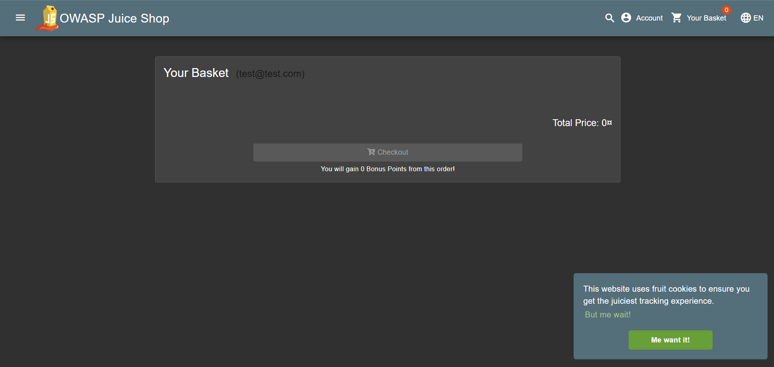
Figure 17 The My basket
- Open the developer tools and go to session storage located in application section
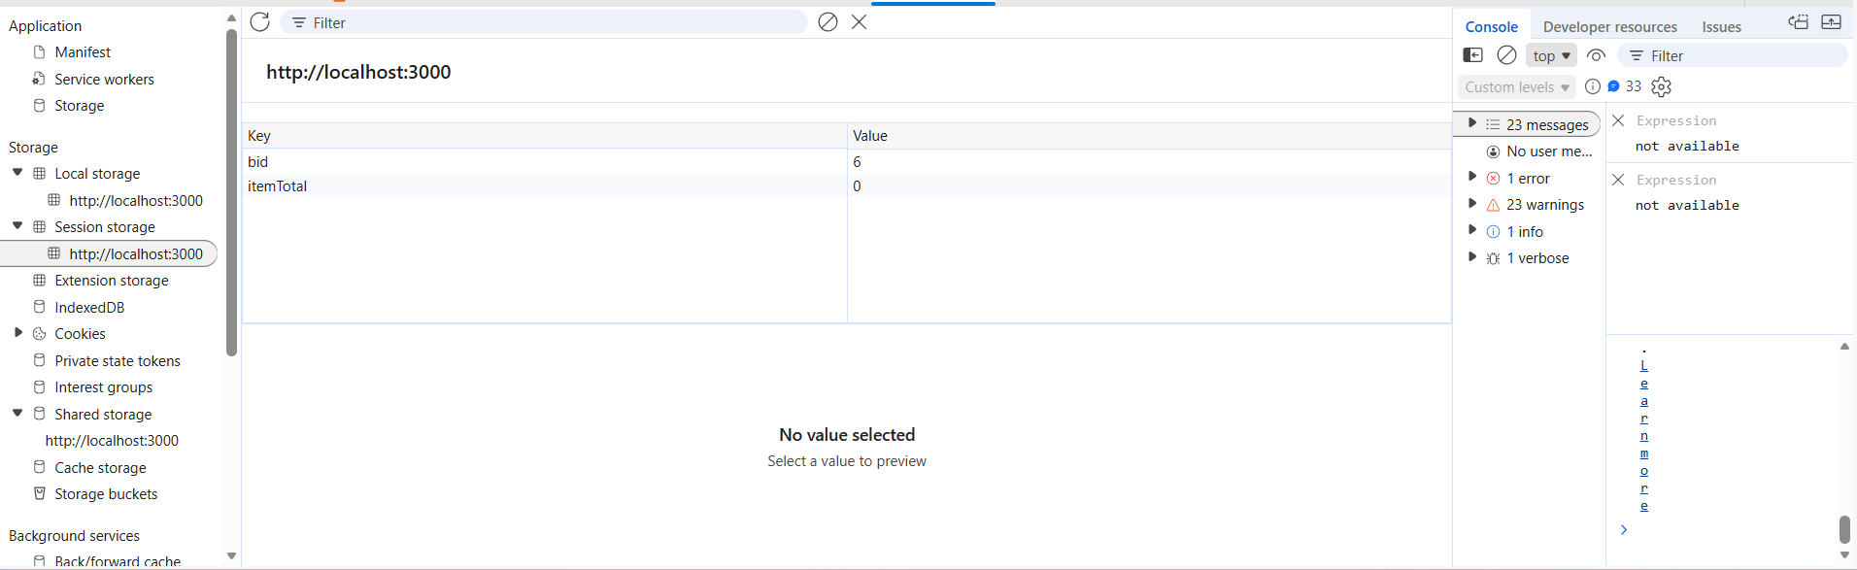
Figure 18 My basket id in storage session

- Change the bid value to 1
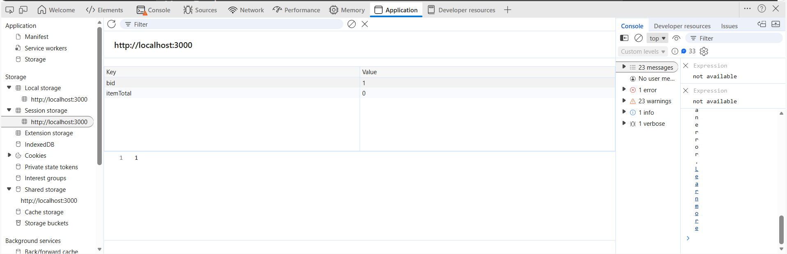
Figure 19 Changing the basket id to another value
- Refresh the page
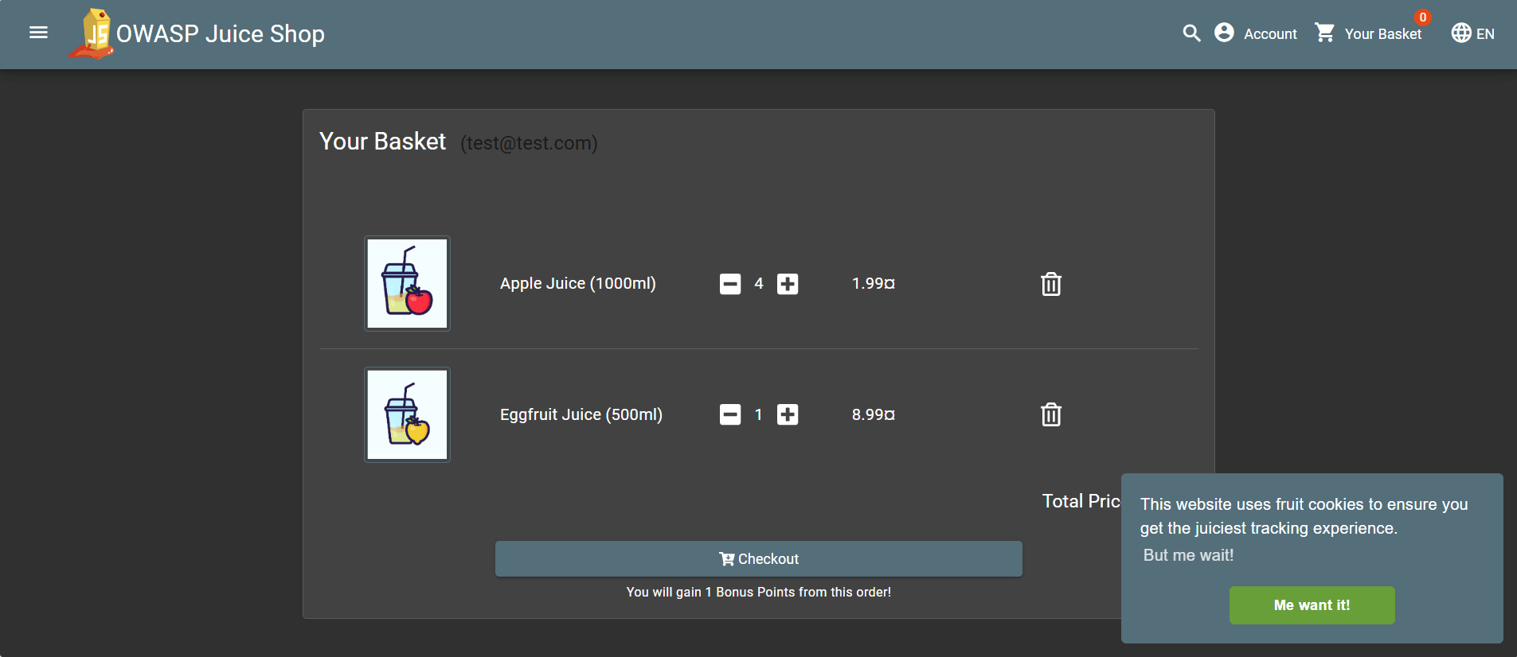
Figure 20 content of a basket of another user is displayed

