Contents
1. Scope of Work 2
1.1 Timeline 2
1.2 Targets 2
2. Finding Overview 3
3. Risk Overview 4
4. Potential Business Impact [after all vulnerabilities] 5
5. Technical Vulnerabilities Details 6
5.1 SQL Injection 6
5.2 Broken Authentication 9
5.3 Broken Access control 13
5.4 Sensitive Data exposure 16
5.5 Insecure Direct Object Reference 19

Scope of Work
This section outlines the specific scope of the penetration testing, referred to throughout the document as the targeted application.

Timeline
Name | Start Date | End Date | Man-days
OWASP Juice Shop | Nov 27, 2025 | Nov 30th, 2025 | 3

Targets
The below scope was OWASP Juice Shop
ID | Asset Identifier (URL/IP)
1 | http://localhost:3000/

Finding Overview
The table below presents a high-level summary of the security vulnerabilities that have been successfully found and verified by Malak Yasser.
ID | Vulnerability Name | Severity
01 | SQL Injection | 🔴 Critical
02 | Broken Authentication | 🟠 High
03 | Stored XSS | 🟠 High
04 | Broken Access Control | 🟡 Medium
05 | Insecure Direct Object Reference (IDOR) | 🟡 Medium
06 | DOM XSS | 🟡 Medium
07 | Sensitive Data Exposure | 🟡 Medium

Risk Overview
The Below chart shows the Number of vulnerabilities, and their risks, categorized as Critical, High, Medium, Low, and Informative.

Potential Business Impact [after all vulnerabilities]
The following impacts could occur if the discovered vulnerabilities were exploited in a real-world scenario:
- Attackers can completely bypass authentication and access administrative interfaces.
- Unauthorized viewing, modification, and deletion of customer data.
- Exposure of sensitive user information such as emails and shopping basket contents, violating privacy requirements.
- Hardcoded credentials in JavaScript files may allow attackers to log in using test accounts.
- Direct access to hidden admin routes could lead to unauthorized manipulation of internal features.
- SQL Injection allows attackers to run arbitrary database queries, modify data, or escalate privileges.
- Attackers can manipulate basket IDs to access other users’ shopping carts (Broken Object Level Authorization).
- XSS vulnerabilities can allow account takeover, credential theft, and session hijacking.
- Weak access control and poor input validation may expose internal system structure and logic to attackers.
- Legal, financial, and reputational damage due to data breaches and non-compliance with GDPR or similar regulations.
- Loss of customer trust and confidence in the security of the application.

Technical Vulnerabilities Details
Below are the finding details with their respective exploitation scenarios in severity ordered from Critical to Informative.

SQL Injection
Severity | Critical
CVSS | CVSS 9.1
Affected Assets | - http://localhost:3000/#/login
Reference | SQL Injection

Description
The application does not properly sanitize or validate input submitted through the login form. The user-controlled email field is directly inserted into an SQL authentication query without parameterization, allowing an attacker to inject malicious SQL code.
By injecting the payload:
' OR 1=1 --
the attacker alters the SQL query logic to always evaluate to TRUE, successfully bypassing authentication. This allows full compromise of user accounts, including the administrator account.

IMPACT
• Full administrator authentication bypass, granting unrestricted access to admin features.
• Exposure of sensitive user information (email addresses, comments, and profile details).
• Ability to delete user comments and manipulate system data.
• Potential for full database compromise if the vulnerability is exploited further (e.g., UNION-based injection).
RECOMMENDATIONS
• Implement parameterized queries or prepared statements across all database interactions.
• Sanitize and validate all user-supplied input on the server side.
• Apply least privilege to database accounts to minimize potential impact.
• Disable verbose SQL error messages.
• Implement login attempt rate-limiting and monitoring to detect suspicious activity.

Steps to Reproduce
- Navigate to http://localhost:3000/#/login
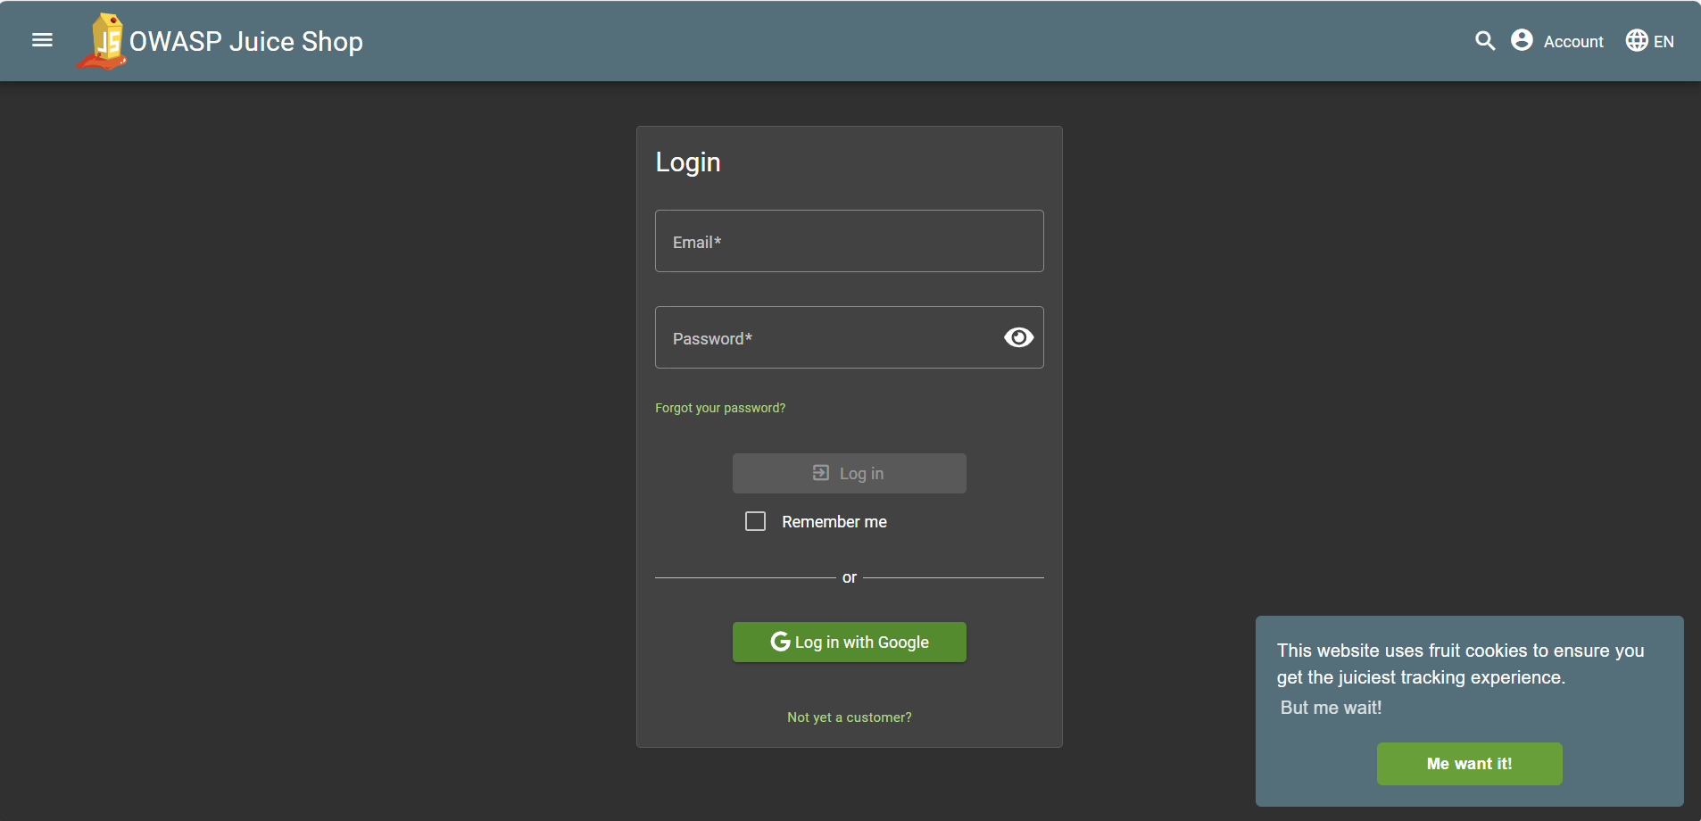
Figure 1 The login page
I could check first if any of the input bar has some kind of strange behaviour when inputted with single (‘) or double quotes (“). If the results received expected strange behaviour, then there’s a probability that SQLi vulnerabilities exists.
In this test, the expected strange behaviour exists. We could confirm the input bar could be vulnerable to SQLi.
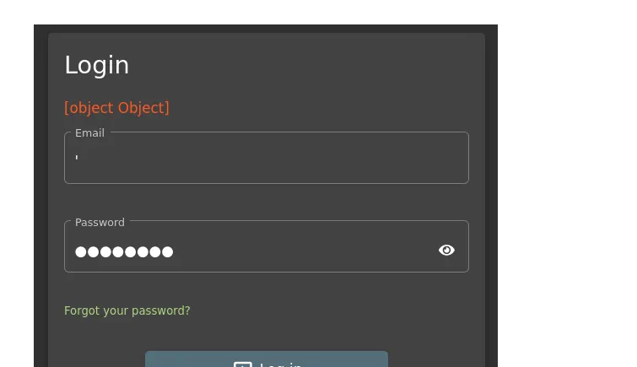
- I found sql injection in email
write something' OR 1=1 -- and any pass , it get me to admin panel
- Logs in as the administrator
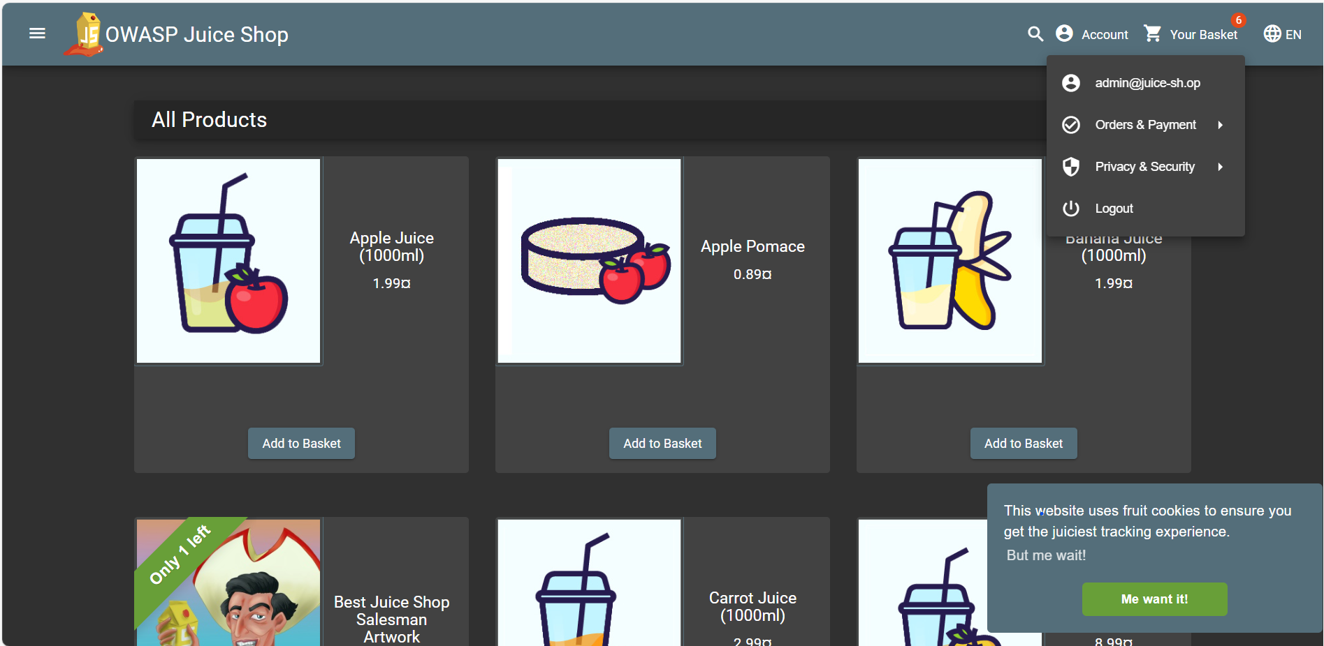
Figure 3 Logged in the admin's page
The very reason why this injection works explained correctly on the platform. The statement produce a True value and any restrictions will be commented. To be exact, the entire SQL query should be like this :
- SELECT user_id FROM users_table WHERE email_address = '' OR 1=1--' AND password = 'thepassword';

5.2 BROKEN AUTHENTICATION
Severity: High
CVSS: 8.2
Affected Asset: http://localhost:3000/#/login
Reference: OWASP A07 – Identification & Authentication Failures

- DESCRIPTION
The application allows authentication bypass through SQL Injection and also exposes sensitive account identifiers (emails) publicly in product reviews.
Additionally, weak password security is present:
- The admin password ("admin123") was found using brute force with a publicly available password list.
- No account lockout or rate limiting exists.
- Email addresses are directly visible in product reviews, making targeted attacks easier.
This combination leads to predictable credential exploitation and full account compromise.

- IMPACT
- Attackers can brute-force login credentials without restriction.
- Administrator account compromise leads to full system control.
- User accounts (e.g., bender@juice-sh.op) can be accessed using authentication bypass payloads:
- bender@juice-sh.op'--
- Leakage of user emails increases phishing and credential-stuffing risks.

- RECOMMENDATIONS
- Implement rate limiting, CAPTCHA, or IP throttling for login attempts.
- Enforce strong password policies (NIST / OWASP recommended).
- Hash passwords using a secure algorithm (bcrypt, argon2).
- Avoid showing user emails publicly; use anonymization.
- Implement MFA for administrative accounts.

- STEPS TO REPRODUCE
- Extract admin email from public product reviews.
- Use Burp Suite Intruder + SecLists wordlist:
100k-most-used-passwords-NCSC.txt
- Send brute-force requests with the discovered email.
- Authentication succeeds with password admin123, confirming weak credential protection.

5.3 BROKEN ACCESS CONTROL
Severity: Medium
CVSS: 6.5
Affected Asset: http://localhost:3000/rest/basket/<id>
Reference: OWASP A01 – Broken Access Control

- DESCRIPTION
The “My Basket” feature does not validate whether the requested basket ID belongs to the authenticated user. By modifying the basket ID in an intercepted request, an attacker can view and access the shopping basket of any other user.
This is known as Broken Object Level Authorization (BOLA) — part of OWASP API Top 10.

- IMPACT
- Unauthorized access to other users’ basket contents.
- Potential manipulation of items in another user's cart.
- Leakage of product preferences, personal usage behaviors, and internal IDs.
- Can be extended for privilege escalation in more complex systems.

- RECOMMENDATIONS
- Enforce server-side authorization checks on all object identifiers.
- Implement ownership validation before serving objects.
- Avoid exposing predictable sequential IDs.
- Use UUIDs or secure references.

- STEPS TO REPRODUCE
- Add an item to your basket.
- Intercept the API request using Burp Suite.
- Modify the URL from:
- /rest/basket/1
to:
/rest/basket/2
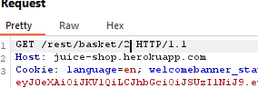
- The application returns another user’s basket data without performing authorization validation.

5.4 INSECURE DIRECT OBJECT REFERENCE (IDOR)
Severity: Medium
CVSS: 6.2
Affected Asset: http://localhost:3000/rest/basket/<id>
(IDOR and BOLA align, but listed separately for reporting clarity.)

- DESCRIPTION
The application accepts direct object identifiers (basket IDs) without validating ownership, allowing horizontal privilege escalation.

- IMPACT
- Attackers can view or modify resources belonging to other users.
- Personal user data exposure (shopping history, emails indirectly).

- RECOMMENDATIONS
- Replace numeric identifiers with opaque randomized tokens (UUIDs).
- Validate object ownership before returning data.

- STEPS TO REPRODUCE
Same as Broken Access Control (Section 5.3).

5.5 DOM-BASED XSS
Severity: Medium
CVSS: 6.4
Affected Asset: Search bar (#/search)
Reference: OWASP A03 – Injection

- DESCRIPTION
The search input is processed entirely in the browser (client-side JavaScript) without any sanitization. As a result, DOM-based Cross-Site Scripting (DOM XSS) is possible.
Using the payload:
<iframe src="javascript:alert(`xss`)">
the script executes in the victim’s browser.
This affects all users including authenticated ones.

- IMPACT
- Session hijacking
- Token theft via JavaScript
- Redirection to malicious pages
- Phishing attacks
- Ability to perform actions on behalf of the victim

- RECOMMENDATIONS
- Sanitize and encode all user-controlled DOM input.
- Implement client-side HTML escaping (DOMPurify recommended).
- Use Content Security Policy (CSP) to block inline JavaScript.

- STEPS TO REPRODUCE
- Navigate to the search bar.
- Enter:
- <iframe src="javascript:alert(`xss`)">
- Press Enter.
- The JavaScript alert executes, confirming DOM XSS.
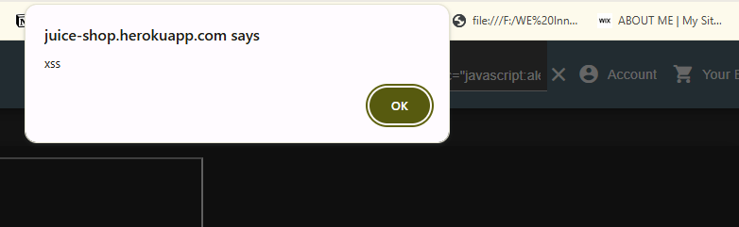

5.6 STORED XSS (FILTER BYPASS)
Severity: High
CVSS: 7.4
Affected Asset: #/register → “Contact Us” or stored fields
Reference: Stored XSS

- DESCRIPTION
The client-side JavaScript filters <script> tags.
However, these filters can be bypassed by:
- Intercepting the registration request using Burp Suite
- Injecting a payload after client-side validation
- Escaping double quotes to maintain JSON integrity
Payload used:
"user@domain.com<script>alert(\"XSS2\")</script>"
The script is stored in the database and later executed when the user section is loaded, classifying it as Persistent XSS.

- IMPACT
- Persistent execution of malicious JavaScript for any user viewing affected pages
- Session token theft
- Account takeover
- Full control over victim browsers
- Defacement or forced redirection

- RECOMMENDATIONS
- Sanitize all input on the server side, not only client side
- Escape special characters before storage
- Use server-side HTML encoding
- Implement Content Security Policy (CSP)

- STEPS TO REPRODUCE
- Start user registration normally.
- Intercept the request with Burp Suite.
- Modify the email parameter:
- "email":"user@domain.com<script>alert(\"XSS2\")</script>"
- Forward the request.
- Visit the user page or admin section → XSS triggers.

5.7 SENSITIVE DATA EXPOSURE
Severity: Medium
CVSS: 5.9
Affected Asset: Client-side JavaScript (main.js), Reviews, API responses
Reference: OWASP A02 – Cryptographic Failures

- DESCRIPTION
Multiple forms of sensitive data exposure were observed:
- Hardcoded credentials found in main.js during code inspection.
- Administrative routes leaked in client-side JavaScript (e.g., /score-board, /administration).
- Email addresses exposed publicly in product reviews.
- Session data not protected with secure flags or HttpOnly cookies.
These exposures help attackers perform enumeration, reconnaissance, and targeted exploitation.

- IMPACT
- Attackers can identify admin accounts
- Easier brute-forcing or credential attacks
- Disclosure of internal functions and hidden routes
- Loss of privacy for users
- Increased risk of phishing attacks

- RECOMMENDATIONS
- Remove all hardcoded credentials from client-side code
- Avoid exposing internal endpoints in JavaScript
- Mask or hash user identifiers shown publicly
- Use secure cookie attributes:
  - HttpOnly
  - Secure
  - SameSite=Strict
- Implement API rate limiting

- STEPS TO REPRODUCE
- Open browser DevTools → Sources → main.js.
- Prettify script and search keywords like "path:", "admin", "email".
- Observe hardcoded credentials and admin routes.
- Confirm that user emails appear in product reviews without masking.

