Contents
1. Scope of Work 2
1.1 Timeline 2
1.2 Targets 2
1.3 Limitations 2
2. Finding Overview 3
3. Risk Overview 4
4. Potential Business Impact 5
5. Technical Vulnerabilities Details 6
5.1 Unauthorized Admin Registration (Broken Access Control) 6
5.2 login mc safesearch(Sensitive Data Exposure) 9
5.3 Empty user registration (Improper Input Validation) 11
5.4 Deprecated Interface 15

Scope of Work
This section outlines the specific scope of the penetration testing, referred to throughout the document as the targeted Web.

Timeline
Name | Start Date | End Date | Man-days
OWASP Juice shop | Nov 20th, 2025 | Nov 30th, 2025 | 10

Targets
The below scope was OWASP Juice shop
ID | Asset Identifier (URL/IP)
1 | https://juice-shop.herokuapp.com  http://127.0.0.1:3000/

Limitations
The findings in this report reflect the state of the application during a specific time frame. Changes to the architecture, code, or configurations could lead to different results if the test is repeated. This penetration test specifically does not include:
- Distributed Denial of Service Attacks.
- Social Engineering (except where explicitly part of a challenge logic).
- Physical security attacks.

Finding Overview
The table below presents a high-level summary of the security vulnerabilities that have been successfully found and verified by Saif.
ID | Vulnerability Name | Severity
Vuln 01 | UNAUTHORIZED ADMIN REGISTRATION | Critical
Vuln 02 | Login MC SafeSearch | High
Vuln 03 | Empty User Registration | Medium
Vuln 04 | Deprecated Interface | Medium

Risk Overview
The Below chart shows the Number of vulnerabilities, and their risks, categorized as Critical, High, Medium, Low, and Informative.

Potential Business Impact
The highlights of business impact possible due to the Pentest are listed below:
- Full Administrative Takeover:
Unauthorized creation of admin accounts enables attackers to assume complete control over the platform. This includes modifying configurations, managing or deleting any user account, altering system behavior, and creating persistent backdoor administrators. Such total privilege escalation can lead to a full compromise of the application’s integrity and governance.
- Account Compromise & Unauthorized Access:
Weak or easily guessable credentials (e.g., MC SafeSearch) allow malicious actors to log in as privileged or specific users without resistance. This can expose private user information, enable impersonation, and facilitate unauthorized transactions or actions across the platform. A compromised account may also serve as a pivot point for broader exploitation.
- Severe Data Integrity Loss:
Exploiting feedback manipulation vulnerabilities allows attackers to submit forged reviews, impersonate legitimate users, or delete genuine feedback. Such actions directly undermine the credibility of the ratings system, distort customer perception, and can significantly harm the business’s reputation. Manipulated feedback may also lead to unreliable analytics and poor decision-making.
- Legacy Code Path Abuse:
The presence of deprecated interfaces, such as the hidden XML upload logic, exposes outdated code that may not align with modern security standards. Attackers can interact with these forgotten functionalities to extract sensitive data, trigger unintended processing, or bypass existing controls. Legacy interfaces frequently contain vulnerabilities like lax validation, insecure parsing, or outdated authentication flows.
- Ghost Account Creation & Database Pollution:
Allowing user registration with empty fields opens the door to mass creation of anonymous “ghost” accounts. These malformed entries can clutter the user database, degrade system performance, and complicate account auditing and monitoring. Large-scale abuse may enable spam, automated attacks, or the disguising of malicious activity behind disposable identities.
- System Trust & Operational Reliability Impact:
Collectively, these vulnerabilities threaten the platform’s credibility, user trust, and operational accuracy. Attackers can distort system data, impersonate users, manipulate business workflows, and exploit forgotten interfaces. If left unmitigated, these issues may result in financial loss, reputational harm, regulatory exposure, and long-term damage to platform stability.

Technical Vulnerabilities Details
Below are the finding details with their respective exploitation scenarios in severity ordered from Critical to Informative.

Unauthorized Admin Registration (Broken Access Control)
Severity | Critical
CVSS | CVSS 9.1
Affected Assets | /register
Reference | OWASP A01:2021 – Broken Access Control

Description
The application exposes an Admin Registration endpoint that is publicly accessible without any authentication or authorization checks. Any external user can directly access the admin registration page and create a fully privileged administrative account.
This vulnerability results from missing role-based access control (RBAC) and lack of server-side validation restricting who can create administrative accounts. The flaw allows attackers to elevate privileges from unauthenticated to full administrative access without exploiting any weakness—only by sending a legitimate registration request.
This is classified as Broken Access Control, one of the highest-risk categories in OWASP’s Top 10.
IMPACT
The impact of this vulnerability is critical, as it allows a complete compromise of the application:
- Full administrative takeover of the system.
- Ability to view, edit, or delete any user data.
- Ability to manipulate business-critical settings and configurations.
- Complete loss of data integrity and confidentiality.
- Potential pivoting into backend systems depending on admin capabilities.
- Total loss of trust in the authentication model.
This grants attackers the highest level of privileges, making this one of the most severe access control vulnerabilities possible.
RECOMMENDATIONS
• Restrict access to the admin registration endpoint to authorized internal roles only.
• Enforce server-side RBAC with strict privilege checks.
• Disable public admin self-registration entirely unless explicitly required.
• If admin creation is needed, restrict it to:
- Internal admin dashboard only
- Authorized IP ranges
- MFA-protected admin accounts
• Log all admin creation events including IP, user agent, and timestamp.
• Conduct a full audit for any unauthorized admin accounts created before patching
Steps to Reproduce
- Navigate to the User Registration page (/#/register).and, Fill in the form with valid data for a new user.
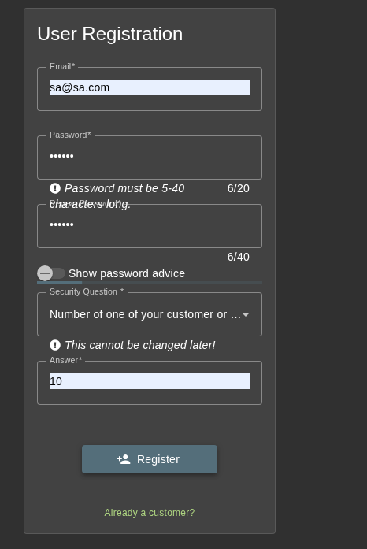
- Intercept the request using a proxy tool (e.g., Burp Suite).
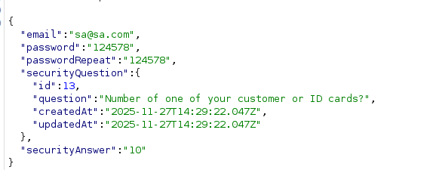

- Modify the JSON body to include the admin role:
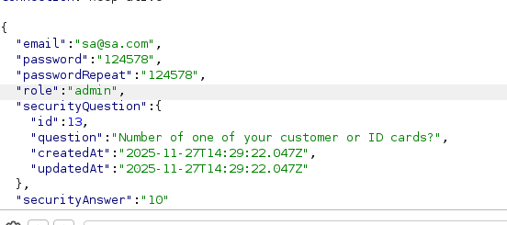
- Forward the request.
- Log in with the new credentials and verify administrative access (e.g., access to the Administration page).

login mc safesearch(Sensitive Data Exposure)
Severity | High
CVSS | CVSS 8.2
Affected Assets | /login
Reference | CWE-522: Insufficiently Protected Credential

Description
The user account for mc.safesearch@juice-sh.op is protected by a weak password that can be guessed based on the user's public persona/username. The password Mr.N00dle is easily guessable via Open Source Intelligence (OSINT) related to the "Protect Ya Neck" video context.
IMPACT
An attacker can exploit this vulnerability to:
- Full account takeover.
- Exposure of sensitive user information.
- Ability to perform privileged actions tied to the account.
- Possible lateral movement across related systems.

RECOMMENDATIONS
• Remove all hardcoded or legacy service credentials.
• Hash all passwords using PBKDF2, bcrypt, or Argon2.
• Enforce MFA and password rotation policies.
• Audit authentication logs for suspicious activity.
Steps to Reproduce
1.Open the Login PageNavigate to (/#/login)
2. Identify the Target User (MC SafeSearch)
Use one of the following passive discovery methods:
- Browse public pages for user references
- Inspect page content, comments, or review sections
- Check the REST API responses available to all users (e.g., product reviews)
- Observe consistent naming patterns of user accounts
3. Enumerate or Discover the User’s Email Address

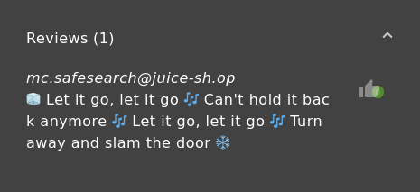
4.Determine the Weak / Guessable Credential

- Visible clues in reviews, comments, or profile-related content
- Patterns consistent with other low-security accounts in Juice Shop
- Common weak-password patterns used intentionally for training
5. Log in Using the Discovered Credentials
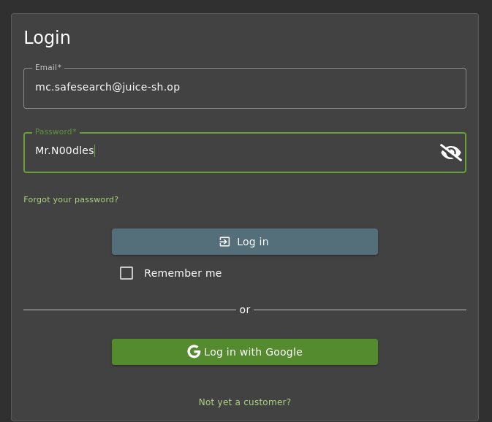

Empty user registration (Improper Input Validation)
Severity | Medium
CVSS | CVSS 6.5
Affected Assets | / register
Reference | CWE-20: Improper Input Validation

Description
The application fails to properly validate input during the user registration process. It is possible to register a new user account with an empty email address and an empty password by manipulating the API request. This allows the creation of "ghost" accounts that violate database integrity constraints and standard authentication requirements.
IMPACT
• Attackers can create unlimited anonymous “ghost” accounts.
•Creation of malformed user records pollutes the database.
• Potentially allows login with empty credentials if the login logic does not handle null/empty strings correctly..
• Attackers could flood the database with invalid accounts.

RECOMMENDATIONS
• Enforce strict server-side validation for all fields.
• Require minimum password complexity.
• Reject null, empty, or malformed data.
• Implement rate limiting and CAPTCHA on registration

Steps to Reproduce
- Navigate to the User Registration page (/#/register).and Fill in the form with dummy data.
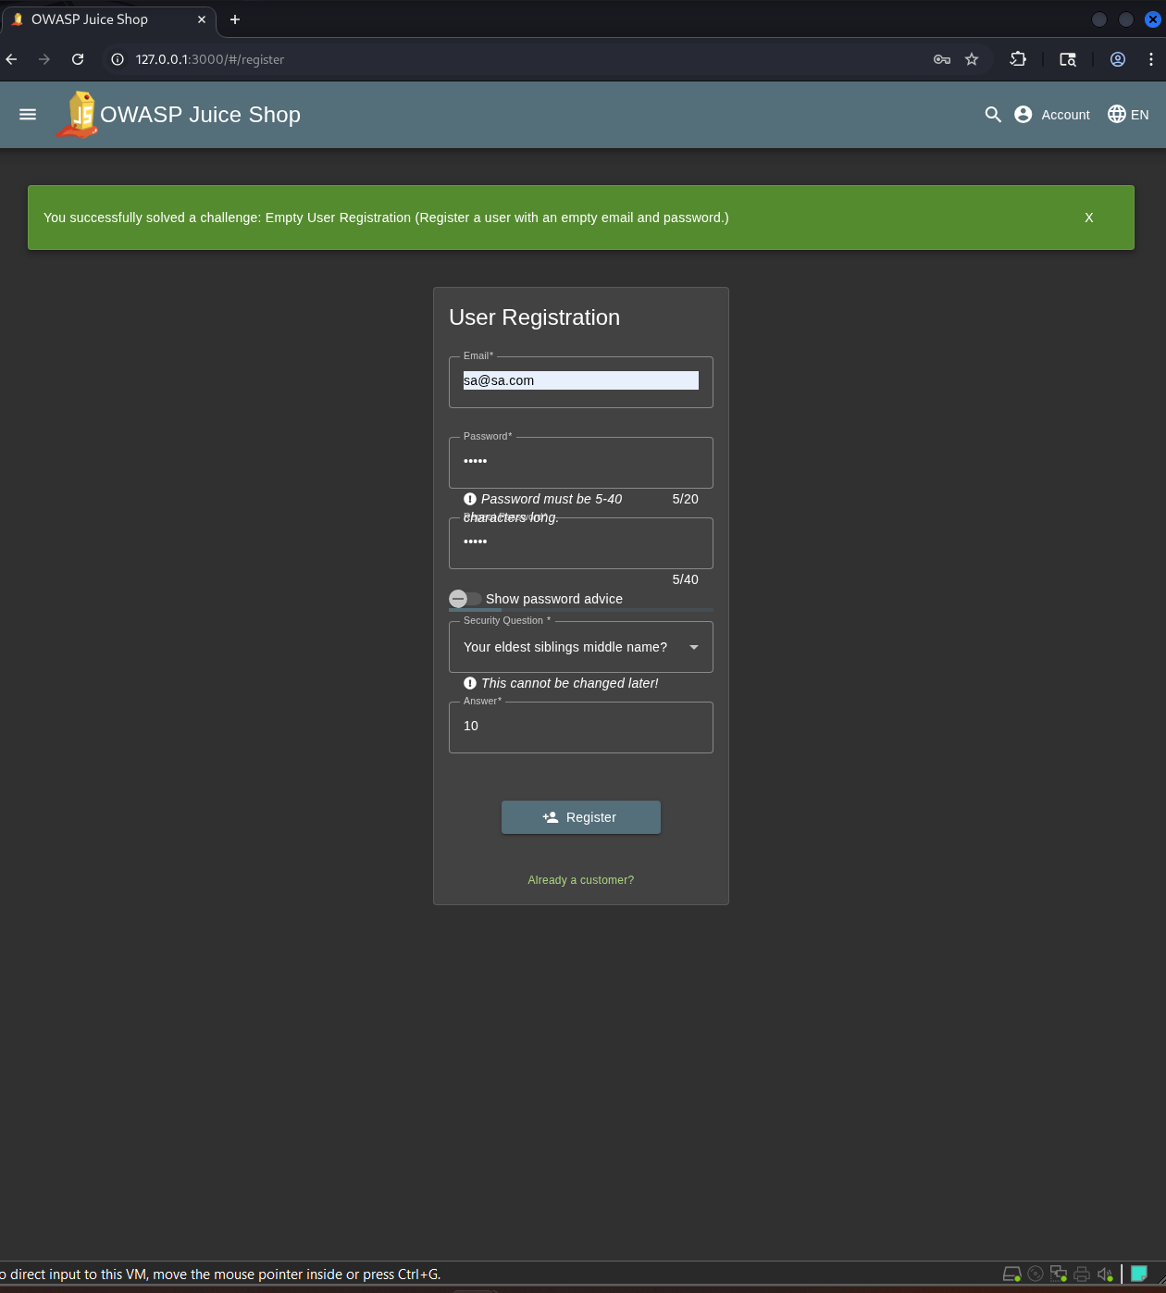
- Intercept the registration request using a proxy tool (e.g., Burp Suite), Modify the JSON body to set "email" and "password" to empty strings:
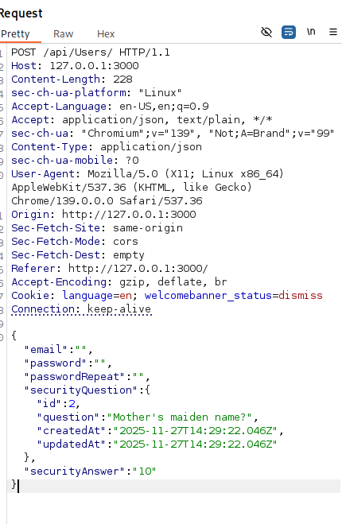
- Forward the request ,and observe the server responds with 201 Created (Success).
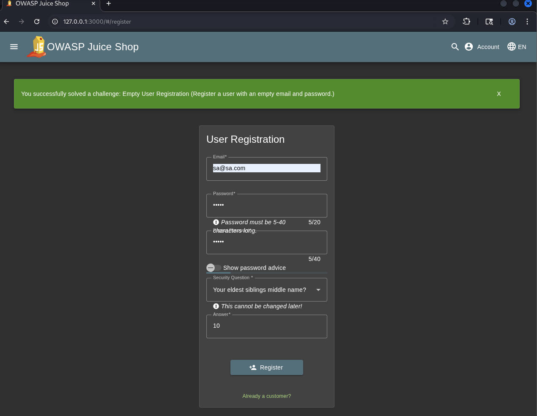

Deprecated Interface
Severity | Medium
CVSS | CVSS 5.3
Affected Assets | /complain
Reference | A05:2021 – Security Misconfiguration

Description
The system continues to support an undocumented and deprecated XML-based B2B interface. XML uploads submitted via the complaint form activate legacy backend logic, demonstrating that the interface was never fully retired. This increases the application’s attack surface and may expose outdated business processes or data.IMPACT
• Increased attack surface.
• Possible leakage of legacy business logic or data.
• Risk of exploitation through outdated code paths.
RECOMMENDATIONS
• Fully remove or disable the deprecated endpoint.
• Block old routes at server/router level.
• Maintain API versioning and lifecycle policy.
• Whitelist only necessary file types (e.g., PDF, ZIP) and strictly reject XML.

Steps to Reproduce
            - Navigate to the complaint submission page: #/complain.
            - Attempt to upload a file that is not listed as allowed (e.g., .exe, .jpg).
The interface will reject the file as expected, showing that client-side validation is active. 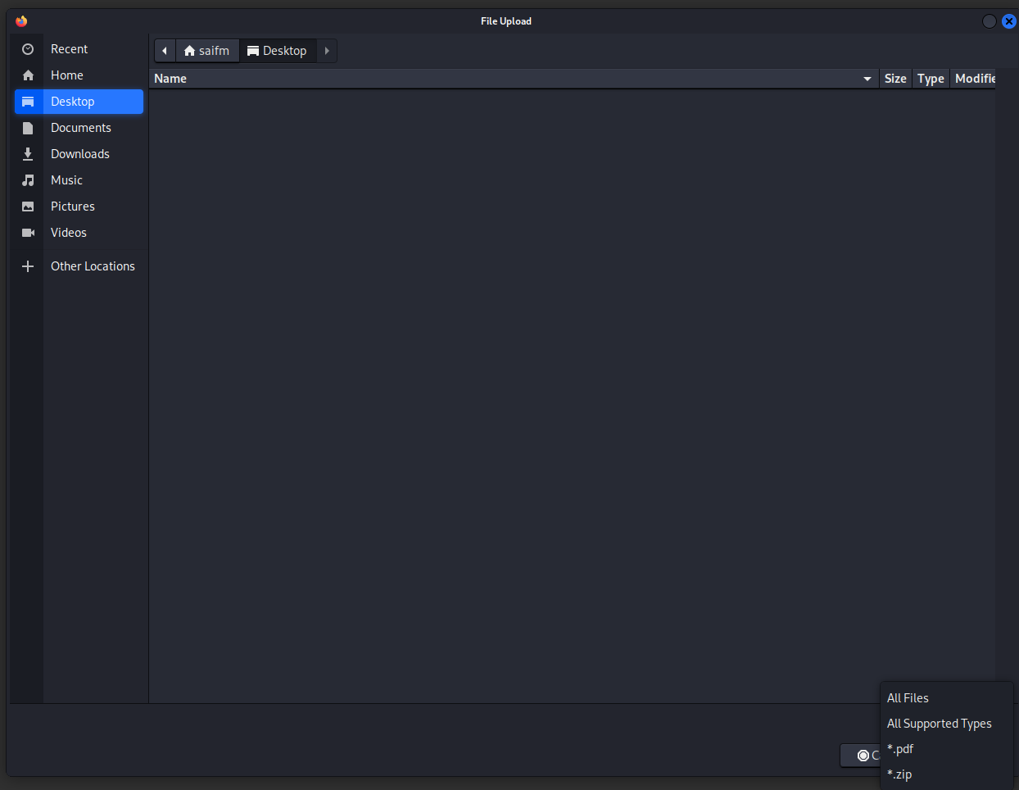
            - Open Developer Tools (F12) → navigate to the Sources tab.
Locate the JavaScript file that performs client-side file-type validation and observe that the allowedtype array includes an additional, unlisted type, specifically: xml.
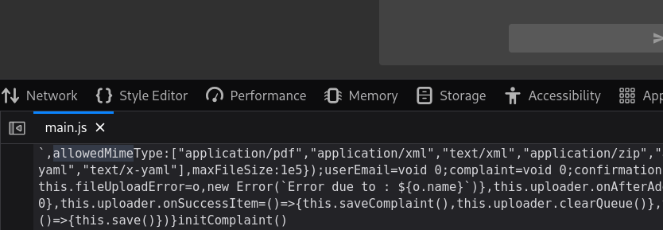
            - Upload the XML file through the same interface.
Despite the UI indicating only “zip, pdf” as allowed, the system accepts the .xml file and processes it successfully. 