Software Requirements Specification
for
FLEX — FAST NUCES Academic Portal (Clone)
Version 1.0 approved

Prepared by
Name | Roll Number
Suleman Ahmed | 24L-3072
Shahzaib Saeed | 24L-3081
Mustafa Salman | 24L-3051
Hammad Mushtaq | 24L-3034

FAST NUCES, Lahore Campus — BS Software Engineering, Section BSE-4A
Software Requirements Engineering — Spring 2026
Instructor: Mr. Zeeshan Ali Rana

April 2026

Table of Contents
Revision History
1. Introduction
1.1 Purpose
1.2 Document Conventions
1.3 Intended Audience and Reading Suggestions
1.4 Product Scope
1.5 References
2. Overall Description
2.1 Product Perspective
2.2 Product Functions
2.3 User Classes and Characteristics
2.4 Operating Environment
2.5 Design and Implementation Constraints
2.6 User Documentation
2.7 Assumptions and Dependencies
3. External Interface Requirements
3.1 User Interfaces
3.2 Hardware Interfaces
3.3 Software Interfaces
3.4 Communications Interfaces
4. System Features
4.1 Authentication and Session Management
4.2 Layout and Navigation
4.3 Student — Course Registration
4.4 Student — Attendance Viewing
4.5 Student — Marks Viewing
4.6 Student — Transcript & Grade Reports
4.7 Student — Fee Management
4.8 Student — Course Withdrawal
4.9 Student — Retake / Grade Change / Feedback
4.10 Faculty — Course Roster
4.11 Faculty — Attendance Marking (Manual + BLE)
4.12 Faculty — Marks Entry
4.13 Faculty — Grading & Submit-to-HOD
4.14 Faculty — Withdrawal Recommendations
4.15 Faculty — Reports & Course Review
4.16 HOD Module
4.17 Academic Officer Module
4.18 Asst Academic Officer / Asst Manager Modules
4.19 Manager (Academics) Module
4.20 Exam Office Module
4.21 Finance Module
4.22 IT Administrator Module
4.23 Registrar Module
4.24 Admissions Officer Module
4.25 Central Academic Office (CAO) Module
4.26 BLE Attendance — Technical Layer
4.27 System Notifications
5. Other Nonfunctional Requirements
5.1 Performance Requirements
5.2 Safety Requirements
5.3 Security Requirements
5.4 Software Quality Attributes
5.5 Business Rules
6. Other Requirements
Appendix A: Glossary
Appendix B: Analysis Models
Appendix C: To-Be-Determined List

Revision History
Name | Date | Reason for Changes | Version
Team 5 | 23-Apr-2026 | Project kickoff; initial SRS skeleton from IEEE-830 template. | 0.1
Team 5 | 24-Apr-2026 | §1 Introduction + §2 Overall Description drafted. | 0.2
Team 5 | 25-Apr-2026 | User classes + §3 External Interfaces fleshed out. | 0.4
Team 5 | 26-Apr-2026 | Functional requirements drafted for Student + Faculty modules. | 0.6
Team 5 | 27-Apr-2026 | HOD, AO, Exam Office, Finance, IT modules added. | 0.7
Team 5 | 28-Apr-2026 | NFRs + Appendix B analysis models + glossary + TBD list. | 0.9
Team 5 | 29-Apr-2026 | IEEE-830 final pass; v1.0 submission. | 1.0

1. Introduction

1.1 Purpose
This Software Requirements Specification defines version 1.0 of FLEX — a clone of FAST NUCES's institutional Academic Portal (flex.nu.edu.pk). The product covers the complete academic lifecycle for one university campus: admissions, enrolment, attendance, evaluation, grading, examinations, finance, and reporting. Two parallel front-end portals are in scope:
- Portal A — Student Portal (flexstudent.nu.edu.pk), used exclusively by students.
- Portal B — Academic Suite (flex.nu.edu.pk), shared by all staff roles via role-based access.
Both portals are backed by a single REST API and a single relational database.

1.2 Document Conventions
- Requirements use hierarchical numbering that mirrors the section structure (e.g. requirement 4.1.3.5 is the fifth requirement under Sec. 4.1.3 Functional Requirements of feature 4.1).
- Requirements are written in IEEE standard form: [identifier] The [noun phrase] shall (not) [verb phrase] [constraint phrase].
- Priorities are stated at the feature level. Where unspecified, all atomic requirements inherit the priority of their parent feature.

1.3 Intended Audience and Reading Suggestions
Audience | Recommended path
Course instructor / evaluators | Sec. 1 → Sec. 2 → Sec. 4 → Sec. 5 → Appendix B
Development team (4 members, BSE-4A) | Sec. 3 → Sec. 4 → Sec. 5 → Appendix B; consult Sec. 2.5 before stack changes
Stakeholders — Faculty, HOD, Academic Officer, Registrar, Exam Office, Finance | Sec. 2.3 → Sec. 4 (the feature most relevant to your role)
Testers / QA | Sec. 4 (Stim/Response sequences) → Sec. 5 → Appendix C
IT Administrators and maintainers | Sec. 2.4 → Sec. 2.5 → Sec. 3 → Sec. 5.3 → Sec. 6
FAST IT Department / future maintainers (re-use of components) | Sec. 2.1 → Sec. 2.5 → Sec. 3.3 → Sec. 6

1.4 Product Scope
FLEX digitises the full academic operations of a FAST NUCES campus. It removes paper attendance registers (replaced with Bluetooth Low-Energy auto-marking per the BLE attendance requirements in Sec. 4.11), enforces the multi-stage approval workflows that exist informally in the live system (withdrawal, late registration, retake, grade change), and surfaces outcome-based-education (CLO/PLO) reporting at every level.
Business goals:
- Reduce attendance-marking time per lecture from ~5 minutes to under 30 seconds.
- Eliminate proxy attendance (BLE binds attendance to the student's registered device).
- Close audit gaps around marks edits and grade changes (every change is logged).
- Give the Academic Officer a single dashboard for the operations they currently track in Excel.

1.5 References
Document | Source
IEEE Std 830-1998 SRS Template (Wiegers) | base template for this document
list_of_requirements (1).docx | Phase-2 functional + non-functional requirements
list_of_stakeholders (1).docx | Phase-1 stakeholder analysis (9 stakeholders)
elicitation_elaboration_techniques.docx | Phase-2 technique justification (10 elicitation + 12 elaboration)
AO Stakeholder Interview (audio: New Recording 923 (2).txt) | Real Academic Officer at FAST NUCES Lahore — drove the late-registration flow, sub-roles, dept-scope, attendance-correction routing
FAST NUCES MCA Document | grading scheme rules (Absolute / Relative)
HEC OBE Manual | CLO / PLO mapping conventions
Web Bluetooth API spec (W3C, CR 2024) | BLE attendance feature
Implementation repo | ~/Projects/studentportal/ (React + Spring Boot + MySQL)

2. Overall Description

2.1 Product Perspective
FLEX is a net-new system that replaces the existing institutional FLEX clone described to us by the Academic Officer during stakeholder elicitation. It is composed of five major components:
- Student Portal — React 18 + Vite, served on :5173, talks to the API over HTTPS / JWT.
- Academic Suite — React 18 + Vite, served on :5175, same API contract but role-routed.
- Spring Boot 3 REST API — :8080, JWT-secured, JDBC to MySQL.
- MySQL 8 — single relational database, daily backed up to a separate vault.
- Faculty / Student devices — perform the BLE handshake via the Web Bluetooth API.
The component diagram is depicted at Appendix B-1. The persistent data model is in Appendix B-2.

2.2 Product Functions
High-level function summary (each expanded in Sec. 4):
- Authenticate students (roll-number) and staff (username) with role-aware JWTs and CAPTCHA.
- Manage course registration windows, drop windows, withdrawal windows, retake windows, feedback windows.
- Take attendance via BLE auto-mark (faculty broadcasts; student self-marks within ~5 s) or via Manual marking (default Present, only override absences/leave).
- Capture marks against a 3-level evaluation hierarchy (category → instrument → component) with editable max + weight.
- Compute grades (Absolute or Relative scheme) with optional instrument drops and an 'Adjust' period for students who missed the final.
- Route multi-stage approval workflows: Withdrawal · Grade Change · Late Registration · Retake · Fee Exemption.
- Generate reports: attendance sheet, day-wise attendance, mark sheet, eval report, grade contribution, OBE / CLO attainment, low-CLO watchlist.
- Manage admissions, fee challans, payment integration, financial holds, and portal access suspension.
- Provide IT administration: user accounts, role assignment, password resets, audit logs.

2.3 User Classes and Characteristics
The system has 13 user classes:
# | Class | Frequency | Tech expertise | Privileges
1 | Student | daily | low | view own data, submit requests
2 | Faculty / Teacher | daily during semester | medium | manage assigned sections, take attendance, enter marks
3 | HOD | weekly | medium | approve grades, oversee dept
4 | Academic Officer | hourly during ops | high (power user — uses ⌘K) | windows, enrolments, late registration
5 | Asst Academic Officer | daily | medium | mailing lists, view-only records
6 | Manager (Academics) | weekly | high | wide AO-equivalent access
7 | Asst Manager (Academics) | daily | medium | Asst AO-equivalent
8 | Exam Office | semester-wise | medium | exam schedule, grade publish
9 | Finance Officer | monthly | medium | fee challans, holds
10 | IT Admin | as needed | high | user / role / log management
11 | Registrar | weekly | medium | final approver of late registration / grade changes
12 | Admissions Officer | seasonal | medium | new student profile creation
13 | CAO (Central Academic Office) | monthly | medium | profile distribution, DC cases
Disciplinary Committee, Director, Dean, Rector and Retake Committee participate in workflows but do not have their own portal login — they appear as approval steps consumed by the roles above.

2.4 Operating Environment
- Browser (client): Chrome 110+, Firefox 110+, Edge 110+ on Windows / macOS.
- Mobile (BLE): Android 8.0+ (Chrome with Web Bluetooth flag) or iOS 13.0+ (limited Web Bluetooth support; faculty advertise from a dedicated beacon when student devices cannot connect).
- Server: Spring Boot 3.2.5 on JDK 17 (JRE in production, eclipse-temurin base image), runnable via Docker.
- Database: MySQL 8.4.
- Network: HTTPS / TLS 1.2+ end-to-end; CORS limited to known portal hostnames.

2.5 Design and Implementation Constraints
- Stack: React 18 + Vite + TailwindCSS for both portals; Spring Boot 3 + Spring Security + JPA for backend; MySQL 8 for persistence. Hibernate as ORM.
- Auth: stateless JWT (HMAC-SHA512) carrying subject + role claim; 24-hour expiration.
- BLE: must use Web Bluetooth API; no native mobile app required for v1.
- Containerisation: the entire backend stack ships in a docker compose file — MySQL volume + multi-stage Maven→JRE backend image. Required for team reproducibility.
- Compliance: academic records retained ≥ 10 years (HEC); passwords hashed with bcrypt cost ≥ 10; no plaintext storage.
- Look-and-feel: retro-functional 'NUKED' theme with strict colour palette and pixel-shadow components. Both portals share the same Tailwind config and CSS.

2.6 User Documentation
Delivered with v1:
- In-portal walkthroughs (first-login tour per role).
- README.md at repo root — quickstart for developers (docker compose up && npm run dev × 2).
- DEMO_LOGINS.md — list of seeded users per role for testing.
- Faculty Quick Reference (PDF) — 1-page guide on BLE attendance + manual fallback.
- Student Quick Reference (PDF) — registration windows + Mark Attendance button.

2.7 Assumptions and Dependencies
- The university provides authoritative student / course / faculty rosters at the start of each semester (seeded into MySQL via DataInitializer for v1).
- Payment Gateway (QuickPay or partner-bank API) exposes a callback endpoint (assumption, not yet integrated; modelled as a stub).
- BLE hardware: the faculty's laptop or a desk beacon broadcasts; we do not require a dedicated Bluetooth dongle.
- Email provider (assumed SMTP) for password resets and notifications; for v1 these are mocked but instrumented.
- The project depends on the Web Bluetooth API; if a browser disables it, the BLE attendance feature falls back to manual entry.

3. External Interface Requirements

3.1 User Interfaces
- Layout convention. All staff pages share one StaffLayout: 240-px cocoa-themed sidebar grouped by function, top breadcrumb bar with command-palette search (⌘K), notifications bell with unread badge, sign-out button. Every page renders its content inside chunky-card blocks with the pixel-shadow style.
- ⌘K global search. Fuzzy-matches sidebar items; pressing Enter navigates. Adopted from observed AO power-user behaviour.
- Status / mode badges. Each module tells the user what state they are in: IDLE, VIEW, MANUAL, BLE, SUBMITTED, LIVE DB, etc.
- Forms. All inputs use the pixel-bordered input style; primary actions use bg-cocoa text-bone, destructive bg-bad text-bone, neutral bg-bone text-ink.
- Errors. Inline, ≤ 1 second, in plain language without exposing stack traces (NFR Sec. 5.3).
- Responsive. Renders correctly at 1280×720 and above.

3.2 Hardware Interfaces
- Bluetooth Low Energy. Faculty device advertises a non-connectable BLE service whose UUID encodes the active session token. Enrolled student devices scan via the Web Bluetooth API and POST the matched token to the server, which validates the device-binding before recording attendance.
- Standard input devices. Keyboard / mouse for staff. Touch on student mobile.

3.3 Software Interfaces
Counterpart | Direction | Purpose
MySQL 8 | server ↔ DB | persistence; Hibernate dialect = org.hibernate.dialect.MySQLDialect
Web Bluetooth API | client → device | BLE scanning / advertising
QuickPay / Bank API (stub) | server ↔ external | challan payment confirmations
SMTP provider (mocked) | server → external | password reset + notifications
lucide-react | client | icon set
Spring Security | server | auth + RBAC + CORS

3.4 Communications Interfaces
- HTTPS / TLS 1.2+ for all browser ↔ server traffic.
- JSON over HTTP for all REST endpoints; bodies validated with Jakarta Bean Validation (@Valid).
- CORS: server allows only hostnames matching http://localhost:* in development; production allows the two portal hostnames.
- Authorization header: Bearer <jwt>.
- WebSocket / SSE: not used in v1 (BLE roster polled at 2 s interval; sufficient for ≤ 60-student sections per NFR Sec. 5.1).

4. System Features
This section organises the system by feature. Each feature carries a priority and a numbered set of requirements.

4.1 Authentication and Session Management (Priority: HIGH · benefit 9 · risk 7)

4.1.1 Description and Priority
Foundation for every other feature. Both portals share this. Without it, every other requirement is meaningless.

4.1.2 Stimulus / Response Sequences
- User opens portal → sees role-appropriate login form.
- Enters credentials, holds the CAPTCHA fingerprint to verify.
- System validates, returns JWT, redirects to role-specific home.
- Inactivity > 30 min → server invalidates token; client redirects to login.

4.1.3 Functional Requirements
4.1.3.1 The system shall allow a student to log in with a valid Roll Number and password.
4.1.3.2 The system shall allow staff to log in with a valid username, password, and selected role.
4.1.3.3 The system shall display a hold-to-verify CAPTCHA on every login form and shall not submit until verified.
4.1.3.4 The system shall reject an invalid login within 3 s without revealing which field is incorrect.
4.1.3.5 The system shall lock a student account for 15 min after 5 consecutive failed attempts; staff for 30 min.
4.1.3.6 The system shall send a password reset link via email within 2 min of the request.
4.1.3.7 The system shall issue a JWT carrying subject + role claim, valid for 24 h.
4.1.3.8 The system shall enforce role-based access on every /api/* endpoint (Student / Faculty / HOD / AO / Asst-AO / Manager / Asst-Manager / Exam-Office / Finance / IT-Admin / Registrar / Admissions / CAO).
4.1.3.9 The system shall log out a session that is idle for > 30 min and redirect to login.
4.1.3.10 The system shall not permit two concurrent active sessions for the same account (single-session enforcement).

4.2 Layout and Navigation (Priority: HIGH · benefit 8 · risk 2)

4.2.1 Description
Both portals must feel coherent and let power users (especially AOs) move at the speed they currently do in Excel.

4.2.2 Stimulus / Response
User presses ⌘K (or Ctrl+K) → search bar focuses → typing fuzzy-matches sidebar items → Enter navigates.

4.2.3 Functional Requirements
4.2.3.1 The system shall display a fixed-width sidebar with role-specific module links; the active item shall be highlighted.
4.2.3.2 The system shall display a top bar with breadcrumb, command-palette search, notifications, and sign-out.
4.2.3.3 The system shall provide a global keyboard-shortcut search (⌘K / Ctrl+K) that fuzzy-matches every sidebar item visible to the role.
4.2.3.4 The system shall render a pixel-shadow card grid as the primary layout primitive.
4.2.3.5 The system shall display a footer with © 2026 NUKED · {role} · {employee/student id}.
4.2.3.6 The system shall render correctly on Chrome, Firefox, Edge (≥ 110) on desktop and on mobile widths down to 1280×720.

4.3 Student — Course Registration (Priority: HIGH · benefit 9)

4.3.1 Description
Students self-register during the open registration window.

4.3.2 Functional Requirements
4.3.2.1 The system shall permit course registration only during an active registration window controlled by the Academic Officer.
4.3.2.2 The system shall display the course catalogue split into Core and Elective with Code, Title, Credit Hours.
4.3.2.3 The system shall display an inline warning when an unsatisfied prerequisite, exceeded credit-hour cap, time clash, or batch restriction would block submission.
4.3.2.4 The system shall enforce linked course + lab dependencies for add and drop.
4.3.2.5 The system shall block registration when the student has an outstanding fee balance.
4.3.2.6 The system shall confirm registration and reflect available seats within 5 s.
4.3.2.7 The system shall not allow drop after the drop deadline.

4.4 Student — Attendance Viewing (Priority: HIGH · benefit 8)

4.4.1 Functional Requirements
4.4.1.1 The system shall let a student view attendance per enrolled course per semester.
4.4.1.2 The system shall display Lecture #, Date, Duration, Presence (P/A/L), and Method (Bluetooth / Manual / Auto) per session.
4.4.1.3 The system shall calculate overall attendance % per course with colour coding (≥ 80 % green, 75–79 yellow, < 75 red).
4.4.1.4 The system shall display an alert banner on the student dashboard when any course attendance falls below 75 %.
4.4.1.5 The system shall not allow a student to modify their own attendance record.
4.4.1.6 The system shall display a Live BLE Session widget on the student attendance page when their faculty has opened a window, showing time-left and a Mark Attendance button.
4.4.1.7 The system shall accept a student self-mark only when the student is logged in, enrolled in the section, the session is OPEN, and the window has not expired.

4.5 Student — Marks Viewing (Priority: HIGH · benefit 8)
4.5.1 The system shall let a student view marks per evaluation instrument per course per semester.
4.5.2 The system shall display Weight %, Obtained, Total, Class Average, σ, Min, Max for each instrument.
4.5.3 The system shall hide final-exam marks and the final letter grade until the HOD has approved and the Exam Office has published.

4.6 Student — Transcript & Grade Reports (Priority: MEDIUM)
4.6.1 The system shall display a transcript with ARN, Roll, Name, Batch.
4.6.2 The system shall list semesters chronologically with Credits Attempted/Earned, SGPA, CGPA.
4.6.3 The system shall let students download the transcript as PDF.
4.6.4 The system shall display only HOD-approved, Exam-Office-published grades on the transcript.

4.7 Student — Fee Management (Priority: HIGH)
4.7.1 The system shall let a student select a semester + fee type and generate a downloadable PDF challan within 10 s.
4.7.2 The system shall display fee history (Semester, Challan #, Amount, Date, Status).
4.7.3 The system shall integrate with QuickPay (or partner bank) and update fee status to Paid within 10 min of callback.

4.8 Student — Course Withdrawal (Priority: HIGH)

4.8.1 Stimulus / Response
Student → Faculty (recommend) → HOD (final).
4.8.1.1 The system shall let a student submit a withdrawal request during the active withdrawal window only.
4.8.1.2 The system shall route the request to the assigned Faculty for recommendation, then to the HOD for final decision.
4.8.1.3 The system shall let a student upload a signed withdrawal form (image ≤ 650 KB).
4.8.1.4 The system shall notify the student in-portal when the request status changes.

4.9 Student — Retake Exam Request, Grade Change, Feedback (Priority: MEDIUM)
4.9.1 The system shall let a student submit a retake request during the active retake window only.
4.9.2 The system shall route retake requests Student → AO → Retake Committee → HOD → Director → Exam Office.
4.9.3 The system shall let a student submit a grade-change request within 2 weeks of grade publication.
4.9.4 The system shall route grade-change requests Student → Faculty → AO → HOD.
4.9.5 The system shall let a student submit course feedback during the active feedback window only and only once per course.
4.9.6 The system shall not reveal individual feedback responses to the Faculty during the active feedback window (anonymity).

4.10 Faculty — Course Roster (Priority: HIGH)
4.10.1 The system shall display all assigned sections for the current semester with Code, Title, Section, Enrolled count, Room, Day, Time.
4.10.2 The system shall let Faculty view the complete roster per section (Roll, Name, Program).
4.10.3 The system shall let Faculty download the roster as Excel CSV.
4.10.4 The system shall let Faculty download the roster as PDF.

4.11 Faculty — Attendance Marking (Manual + BLE) (Priority: CRITICAL · benefit 9 · risk 8)

4.11.1 Description
Faculty picks a section, then selects one of three modes: View (read-only past records), Manual (everyone defaults to Present, faculty marks deviations), BLE (window opens, students self-mark from their portal).

4.11.2 Stimulus / Response — BLE flow
- Faculty picks section + types topic + sets duration (5–30 min, default 15) → presses Open.
- Server creates an attendance_sessions row (status OPEN) and returns a session token.
- Browser issues navigator.bluetooth.requestDevice(...) to engage BLE; advertises the token.
- Each enrolled student sees a LIVE card on their student-portal Attendance page; they press Mark Attendance; their device handshake POSTs the token; server validates and writes an attendance row with method = Bluetooth, idempotent.
- Faculty UI polls server every 2 s for live marks; faculty can also override per-row.
- Faculty presses Close & Save (or window expires) → still-Pending students become Absent with method = Auto; closed-state persisted.

4.11.3 Stimulus / Response — Manual flow
- Faculty picks section, types topic (required) → server doesn't open a session yet.
- Roster loads with everyone Present by default.
- Faculty clicks A or L on rows that are absent / on leave; clicking the same status again toggles back to Pending (visually unmarked dashed box).
- Save Attendance → server opens session and immediately closes it with the marks payload (Pending counted as Present).

4.11.4 Functional Requirements
4.11.4.1 The system shall allow attendance only for sessions on or before the current date.
4.11.4.2 The system shall let Faculty set the BLE window duration between 5 and 30 minutes (default 15).
4.11.4.3 The system shall display a live countdown of the open BLE window.
4.11.4.4 The system shall auto-mark a student Present (method Bluetooth) when their device handshake is received and validated within the window.
4.11.4.5 The system shall auto-mark all still-Pending students Absent (method Auto) at window close.
4.11.4.6 The system shall let Faculty override any student's status to P / A / L before saving.
4.11.4.7 The system shall record method ∈ {Bluetooth, Manual, Auto} per attendance row.
4.11.4.8 The system shall require a non-empty topic in both Manual and BLE modes.
4.11.4.9 The system shall, in Manual mode, default every student to Present; clicking the active status toggles to Pending (unmarked, no fill).
4.11.4.10 The system shall, in BLE mode, render the roster read-only with no override controls; corrections are made via Manual mode after closing.
4.11.4.11 The system shall not allow editing past-date attendance; faculty must Delete the existing record then take attendance fresh.
4.11.4.12 The system shall save the complete record within 3 s of close and display a confirmation.
4.11.4.13 The system shall flag students with attendance < 75 % in a dedicated faculty view, refreshed within 1 min of any change.

4.12 Faculty — Marks Entry (Priority: HIGH · benefit 8)

4.12.1 Description
Three-level evaluation hierarchy: Category → Instrument → Component.
- Categories are fixed by university policy: Quizzes, Assignments, Sessionals, Final Exam.
- Instruments are added by faculty inside each category: Quiz 1, Quiz 2, Sessional 1, Final…
- Components are added inside an instrument as table columns (e.g. Sessional 1's Q1, Q2, Q3), each with its own max marks and weight %.

4.12.2 Functional Requirements
4.12.2.1 The system shall display the four fixed categories at the top of the Marks page.
4.12.2.2 The system shall let Faculty add and remove instruments inside each category.
4.12.2.3 The system shall let Faculty add and remove components (per-question parts) inside each instrument.
4.12.2.4 The system shall let Faculty edit the max marks and weight % of every component inline as the bottom rows of the marking table (no scroll-up).
4.12.2.5 The system shall let Faculty enter marks per-student per-component; reject values outside [0, max] with a 2 s error.
4.12.2.6 The system shall display per-instrument completion (marked / total students) and a green check when full.
4.12.2.7 The system shall show a global total-weight badge; green when 100 %, red otherwise.
4.12.2.8 The Marks module shall not offer Excel import/export, automatic component generation, or Submit-to-HOD — those belong to Reports and Grading respectively.

4.13 Faculty — Grading & Submit-to-HOD (Priority: CRITICAL)

4.13.1 Description
Distinct from Marks. Faculty selects scheme, optionally drops instruments, generates grades, reviews preview, submits.

4.13.2 Functional Requirements
4.13.2.1 The system shall let Faculty pick Absolute or Relative grading scheme per the MCA.
4.13.2.2 The system shall let Faculty drop selected instruments before grading; effective weights shall be re-distributed proportionally to live total 100 %.
4.13.2.3 The system shall provide an Adjust Period (Missing Finals) panel where faculty flag students who missed the final and enter their late marks; re-generation incorporates them.
4.13.2.4 The system shall block grade generation until every student has marks for every undropped component.
4.13.2.5 The system shall display a grade preview: per-student final % + letter grade; bar-chart distribution count per grade (A+ … F); mean.
4.13.2.6 The system shall let Faculty submit the grade list to the HOD for approval.
4.13.2.7 The system shall lock the grade sheet for editing once submitted; if returned by the HOD, the system shall unlock it and notify Faculty within 5 min.
4.13.2.8 The system shall not finalise or publish grades until HOD approval is granted.

4.14 Faculty — Withdrawal Recommendations (Priority: HIGH)
4.14.1 The system shall display all pending withdrawal requests for the faculty's courses.
4.14.2 The system shall let Faculty record a recommendation (Approve / Reject) and forward to the HOD.
4.14.3 The system shall send an in-portal notification to Faculty when a new withdrawal request is submitted for their course.

4.15 Faculty — Reports & Course Review (Priority: MEDIUM)

4.15.1 Functional Requirements
4.15.1.1 The system shall provide the following reports per assigned section:
- Mark Sheet — single-student view of all components, printable.
- Day-Wise Attendance — present / absent counts per lecture session.
- Attendance Sheet — printable blank-cell roster for offline use.
- Eval Report — mean / min / max / σ per instrument with auto drop-suggestion (mean < 50 % AND σ > 20 % of max).
- Grade Contribution — per-component contribution to each student's final %.
- OBE / CLO Attainment — bar graph vs CLO target with met/missed status.
- Low-CLO Watchlist — outcome-based navigation: students < 40 % on any CLO.
4.15.1.2 The system shall let Faculty record Course Review notes — desired changes for the next offering — saved per course.
4.15.1.3 The system shall not display CGPA, transcript or full profile of any student to a Faculty member outside their assigned sections.

4.16 HOD Module (Priority: CRITICAL)

4.16.1 Functional Requirements
4.16.1.1 The system shall notify the HOD when a Faculty submits a grade list for a course pending approval.
4.16.1.2 The system shall display the full grade sheet to the HOD: scheme, course type (core/elective), grade-distribution summary, mean.
4.16.1.3 The system shall let the HOD approve or reject the submitted grade list.
4.16.1.4 The system shall publish approved grades to students and generate a final grade report only after HOD approval.
4.16.1.5 The system shall let the HOD view marks of any student in any departmental course by entering the roll number, including marks per evaluation instrument.
4.16.1.6 The system shall let the HOD view total lecture sessions conducted and cumulative attendance for any course in the department.
4.16.1.7 The system shall provide section-wise, student-wise, and course-wise attendance and academic reports.
4.16.1.8 The system shall provide CLO/PLO mapping reports and a CQI report listing students with low CLO performance.
4.16.1.9 The system shall let the HOD generate lists of graduating students and warning-status students.
4.16.1.10 The system shall let the HOD view all departmental sections with enrolment count, available seats, and assigned faculty.
4.16.1.11 The system shall let the HOD submit a request to open a new section (Faculty + room + day + time) subject to AO approval.
4.16.1.12 The system shall notify the HOD within 24 h of an AO decision on a section request.
4.16.1.13 The system shall route Faculty-recommended withdrawal requests to the HOD for the final decision.
4.16.1.14 The system shall let the HOD approve or reject grade-change decisions.
4.16.1.15 The system shall forward HOD-approved fee-exemption requests to the Director.
4.16.1.16 The system shall let the HOD review Retake Committee recommendations (agree / disagree / request review) before forwarding to the Director.
4.16.1.17 The system shall not permit the HOD to mark or directly edit any student's attendance; the HOD's view is read-only.

4.17 Academic Officer Module (Priority: CRITICAL)

4.17.1 Description
Per AO interview the AO is a tiered role — Academic Officer / Asst Academic Officer / Manager / Asst Manager — with department-scoped access.

4.17.2 Functional Requirements
4.17.2.1 The system shall let the AO create a new semester defining: Name, Start/End, Registration Open/Close, Drop Deadline, Withdrawal Deadline, Feedback Window.
4.17.2.2 The system shall prevent student enrolment outside the active registration window.
4.17.2.3 The system shall let the AO manually extend a registration deadline for a specific student, logging username + timestamp.
4.17.2.4 The system shall let the AO open / close registration for all students, a specific program, or a specific batch.
4.17.2.5 The system shall let the AO activate / deactivate time-bound modules (retake window, feedback window).
4.17.2.6 The system shall let the AO view all enrolment requests filterable by Pending / Approved / Rejected.
4.17.2.7 The system shall not allow the AO to register a regular student manually; manual registration is permitted only for Warning-Count-2 students.
4.17.2.8 The system shall let the AO drop a student manually (with reason logged).
4.17.2.9 The system shall provide an Late Registration multi-stage flow: AO opens a draft, enters detailed remarks, submits → HOD review → Registrar review → Flex Support performs the actual enrolment.
4.17.2.10 The system shall provide a Course Section Clashes tab listing every enrolled student whose schedule overlaps another section.
4.17.2.11 The system shall provide a Pending Faculty Inputs watchlist showing Faculty members behind on attendance / marks entry, with one-click Remind and Escalate to HOD.
4.17.2.12 The system shall let the AO search any student by Roll / Name / CNIC.
4.17.2.13 The system shall let the AO update a student's program, batch, or status (Active / On Leave / Graduated / Expelled).
4.17.2.14 The system shall let the AO place or remove an academic hold blocking enrolment.
4.17.2.15 The system shall not allow the AO to directly edit attendance; corrections route Student → Faculty (remarks) → HOD (written approval) → record updated.
4.17.2.16 The system shall provide AO sub-tier views with progressive permissions (Asst AO ⊂ AO ⊂ Manager); department scope shall be enforced (e.g. FoC AO cannot access Mgmt Sciences students).

4.18 Asst Academic Officer / Asst Manager Modules (Priority: MEDIUM)
4.18.1 The system shall provide the Asst AO with mailing-list composer scoped to their department, plus read-only access to student records.
4.18.2 The mailing-list export shall include both Roll No and Email columns (today's pain point: only roll exports automatically).
4.18.3 The Asst Manager shall have the same read-only access plus tasks queued by the Manager.

4.19 Manager (Academics) Module (Priority: HIGH)
4.19.1 The system shall provide the Manager with cross-departmental enrolment + section-clash + late-registration + student-records views, with the same write privileges as the AO at faculty scope.

4.20 Exam Office Module (Priority: HIGH)
4.20.1 The system shall let the Exam Office create mid-term and final exam schedules (date / time / room per section).
4.20.2 The system shall flag scheduling conflicts within 5 s.
4.20.3 The system shall publish the schedule to all students and faculty simultaneously.
4.20.4 The system shall let the Exam Office assign seating plans (room + seat per student).
4.20.5 The system shall notify all affected students within 10 min of any post-publication schedule change.
4.20.6 The system shall let the Exam Office review HOD-approved grade sheets and either return them to Faculty (with comments, notify in 5 min) or publish them.
4.20.7 The system shall, on publish, permanently disable Faculty editing for that grade sheet.
4.20.8 The system shall compute and store SGPA / CGPA after grade finalisation.
4.20.9 The system shall generate official transcript PDFs on request.
4.20.10 The system shall route missed-final-exam applications Student → AO → Retake Committee → HOD → Director → Exam Office.

4.21 Finance Module (Priority: HIGH)
4.21.1 The system shall let Finance generate semester-wise fee challans for an entire batch / program / individual student.
4.21.2 The system shall integrate with QuickPay (or partner bank) and update fee status to Paid automatically on callback.
4.21.3 The system shall let Finance record manual fee payments and generate downloadable receipts.
4.21.4 The system shall let Finance apply late-payment fines and place / remove financial holds.
4.21.5 The system shall update fee-clearance status within 2 min and remove enrolment blocks accordingly.
4.21.6 The system shall let Finance trigger portal-access suspension for students in fee default.
4.21.7 The system shall maintain a transaction log of every fee payment.

4.22 IT Administrator Module (Priority: HIGH)
4.22.1 The system shall let the IT Admin create user accounts for all roles.
4.22.2 The system shall let the IT Admin deactivate / reactivate accounts.
4.22.3 The system shall let the IT Admin assign or modify roles.
4.22.4 The system shall let the IT Admin reset passwords (email delivery within 2 min).
4.22.5 The system shall log every login attempt and let the IT Admin view + filter the log.
4.22.6 The system shall log all critical events with (userId, timestamp) and let the IT Admin export them as CSV.
4.22.7 The system shall let the IT Admin configure the academic year / semester without source-code edits.

4.23 Registrar Module (Priority: MEDIUM)
4.23.1 The system shall let the Registrar approve / reject HOD-cleared late registration cases; allowed cases route to Flex Support for the actual enrolment.
4.23.2 The system shall let the Registrar process HOD-cleared grade-change appeals.
4.23.3 The system shall let the Registrar approve the per-semester course-offering plan.

4.24 Admissions Officer Module (Priority: MEDIUM)
4.24.1 The system shall let the Admissions Officer create new student profiles at admission time, including all required personal + academic fields.
4.24.2 The system shall send the new student an automatic welcome email with login credentials.

4.25 Central Academic Office (CAO) Module (Priority: MEDIUM)
4.25.1 The system shall let the CAO distribute initial student profiles to local Academic Offices per campus.
4.25.2 The system shall let the CAO handle Disciplinary Committee cases:
- assignment / midterm DC: notify Faculty to enter zero;
- course DC: apply F directly with DC remark on transcript.
4.25.3 The system shall retain DC case logs for ≥ 10 years per Compliance NFR Sec. 5.4 (Software Quality Attributes).

4.26 BLE Attendance — Technical Layer (Priority: CRITICAL · spans Faculty + Student)
4.26.1 The system shall not initiate Bluetooth scanning until the student presses Mark Attendance.
4.26.2 The system shall use the Web Bluetooth API to detect the Faculty's BLE advertising device.
4.26.3 The system shall send the session token + timestamp to the backend; the backend shall validate session-status, expiry, enrolment, and uniqueness.
4.26.4 The system shall not store invalid attendance records.
4.26.5 The system shall reject duplicate self-marks (idempotent).
4.26.6 The system shall restrict the feature to supported browsers (Chrome 110+, Firefox 110+, Edge 110+).
4.26.7 The system shall enforce HTTPS for every BLE-related endpoint.
4.26.8 The system shall expose GET /api/faculty/attendance/sessions/{id}/marks for the Faculty UI to poll live student self-marks at 2 s interval.
4.26.9 The system shall, on faculty close, preserve already-self-marked rows (no overwrite).

4.27 System Notifications (Priority: HIGH)
4.27.1 The system shall send in-portal notifications for: new fee challan, attendance below threshold, grade status changes, withdrawal status updates, academic warnings, retake decisions, late-registration stage changes.
4.27.2 The system shall send Faculty an in-portal notification when a withdrawal request is submitted for their course.
4.27.3 The system shall send the HOD an in-portal notification when a Faculty submits grades.

5. Other Nonfunctional Requirements

5.1 Performance Requirements
5.1.1 Any portal page shall load within 3 s for 1 000 concurrent users.
5.1.2 Course registration / drop shall confirm within 5 s.
5.1.3 Bulk student import (≤ 500 records) shall report within 60 s.
5.1.4 Any report shall generate within 8 s for ≤ 1 000 students.
5.1.5 Any PDF (transcript, challan, timetable, roster) shall generate within 10 s.
5.1.6 Payment-gateway callback shall reflect within 10 min.
5.1.7 A structurally invalid imported file shall be rejected within 5 s with the specific structural mismatch displayed.

5.2 Safety Requirements
5.2.1 No safety-critical concerns; the system handles academic data only. No physical actuators, no medical / industrial control. Standard data-loss safeguards (backups, transactions) apply per Sec. 5.4.

5.3 Security Requirements
5.3.1 All client ↔ server traffic over HTTPS / TLS 1.2+.
5.3.2 Passwords stored using bcrypt (cost ≥ 10); never plaintext.
5.3.3 Minimum password: 8 chars, ≥ 1 uppercase, ≥ 1 digit, ≥ 1 special.
5.3.4 Role-based access control on every endpoint.
5.3.5 A student's CNIC, DOB, mobile shall be visible only to the student, AO, and IT Admin.
5.3.6 Unauthorised access attempts shall be logged and alerted to IT Admin within 5 min.

5.4 Software Quality Attributes
- Availability: ≥ 99.5 % monthly uptime; recovery within 30 min of server failure.
- Reliability: no committed transaction shall be lost on unplanned failure; automated daily database backups with ≥ 30 days retention.
- Maintainability: modular Spring services per role; React component library shared across portals; new role onboarding is a config map (roleConfig.js) plus 1–N stub pages.
- Usability: ≤ 3 clicks from any role's dashboard to its primary function. ⌘K search reaches every module by name.
- Portability: runs in any Docker-capable host; no platform-specific dependencies.
- Compliance: academic records ≥ 10 years; manual attendance overrides logged with username + timestamp + before / after; HEC-compatible reports on demand.
- Scalability: horizontal-scaling-friendly stateless API; designed to handle 200 % growth without rearchitecture; tested for 100 concurrent users without exceeding the 3 s page-load limit.

5.5 Business Rules
5.5.1 Marks distribution is fixed by faculty for a section; the system shall not auto-alter weights once saved.
5.5.2 HOD approval is required for Grades, not for Marks.
5.5.3 Faculty cannot edit attendance for past dates; correction = delete + re-enter.
5.5.4 Topic is mandatory in both Manual and BLE attendance; once entered, it is shown at the top of the active session.
5.5.5 Student attendance binds to the registered device; one student cannot mark on behalf of another.
5.5.6 Late registration must complete the full chain AO → HOD → Registrar → Flex Support; bypassing any stage is prohibited.
5.5.7 Disciplinary cases are routed to CAO, not handled by the AO.
5.5.8 AOs cannot directly edit attendance — corrections route through Faculty + HOD.

6. Other Requirements
- Database: MySQL 8.4 with persistent volume. Migrations via Hibernate ddl-auto: update for v1; switch to Flyway in v2.
- Internationalisation: v1 ships English only; UI strings centralised to enable Urdu / Punjabi locales in v2.
- Reuse: the React component library (PageShell, StaffLayout, roleConfig) and Spring service patterns are designed for reuse in adjacent FAST internal portals.
- Legal: all academic data covered by the FAST NUCES Privacy Policy; PII access governed by the security requirements in Sec. 5.3.

Appendix A: Glossary
Term | Meaning
AO | Academic Officer
CAO | Central Academic Office
HOD | Head of Department
MCA | Manual of Course Administration (FAST NUCES grading rules document)
CLO / PLO | Course Learning Outcome / Program Learning Outcome (HEC OBE)
CQI | Continuous Quality Improvement
DC | Disciplinary Committee case
FA | F due to attendance shortage
BLE | Bluetooth Low Energy
JWT | JSON Web Token
NUKED | Project codename / theme of FLEX clone UI
Flex Support | the operational team that performs system-level enrolments after Registrar approval

Appendix B: Analysis Models
This appendix collects every analysis model referenced throughout the SRS. Each diagram is followed by a short description of what it depicts and how it relates to the requirements in Sec. 4 and Sec. 5.

B.1 Use Case Diagram
The use-case diagram captures every interaction between the system and its external actors. Nine actors sit outside the system boundary — the eight portal-login roles (Student, Faculty, HOD, AO, Registrar, Exam Office, Finance, IT Admin) plus an All Users actor representing the shared authentication surface. Inside the boundary, thirty-one use cases cover the full feature set: authentication and CAPTCHA, the ten student-facing services (registration, BLE attendance, marks, transcript, fee, withdrawal, retake, grade-change, feedback), the six faculty operations, the three HOD operations, the AO semester-management trio, the two Exam Office actions, the two Finance actions, and the two IT Admin actions.
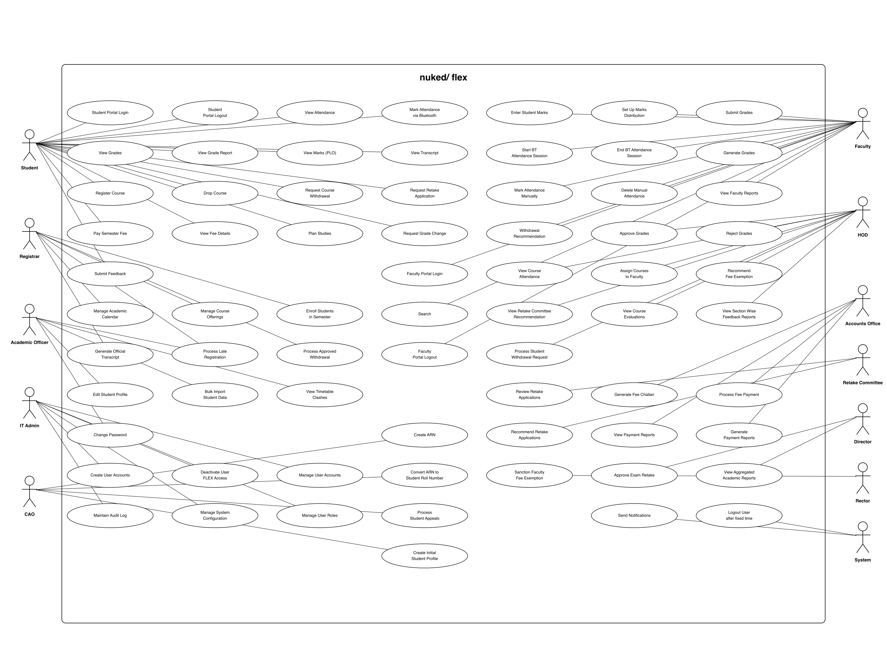
Figure B.1 — Use cases for all 13 user classes.

B.2 Entity-Relationship Diagram
The ERD shows the persistent data model in Peter Chen notation. Eight core entities are connected through seven relationships (Offers, Teaches, Enrols, Opens, Records, Produces, Pays). Section is the central hub: each Section is offered by one Course, taught by one Faculty, scheduled in one Semester, and connects to many Students through the M-to-M Enrols relationship. Attendance carries a method attribute taking one of {Bluetooth, Manual, Auto}, and AttendanceSession carries the BLE token + open-state used at run time. Underlined attributes denote the primary key for each entity.
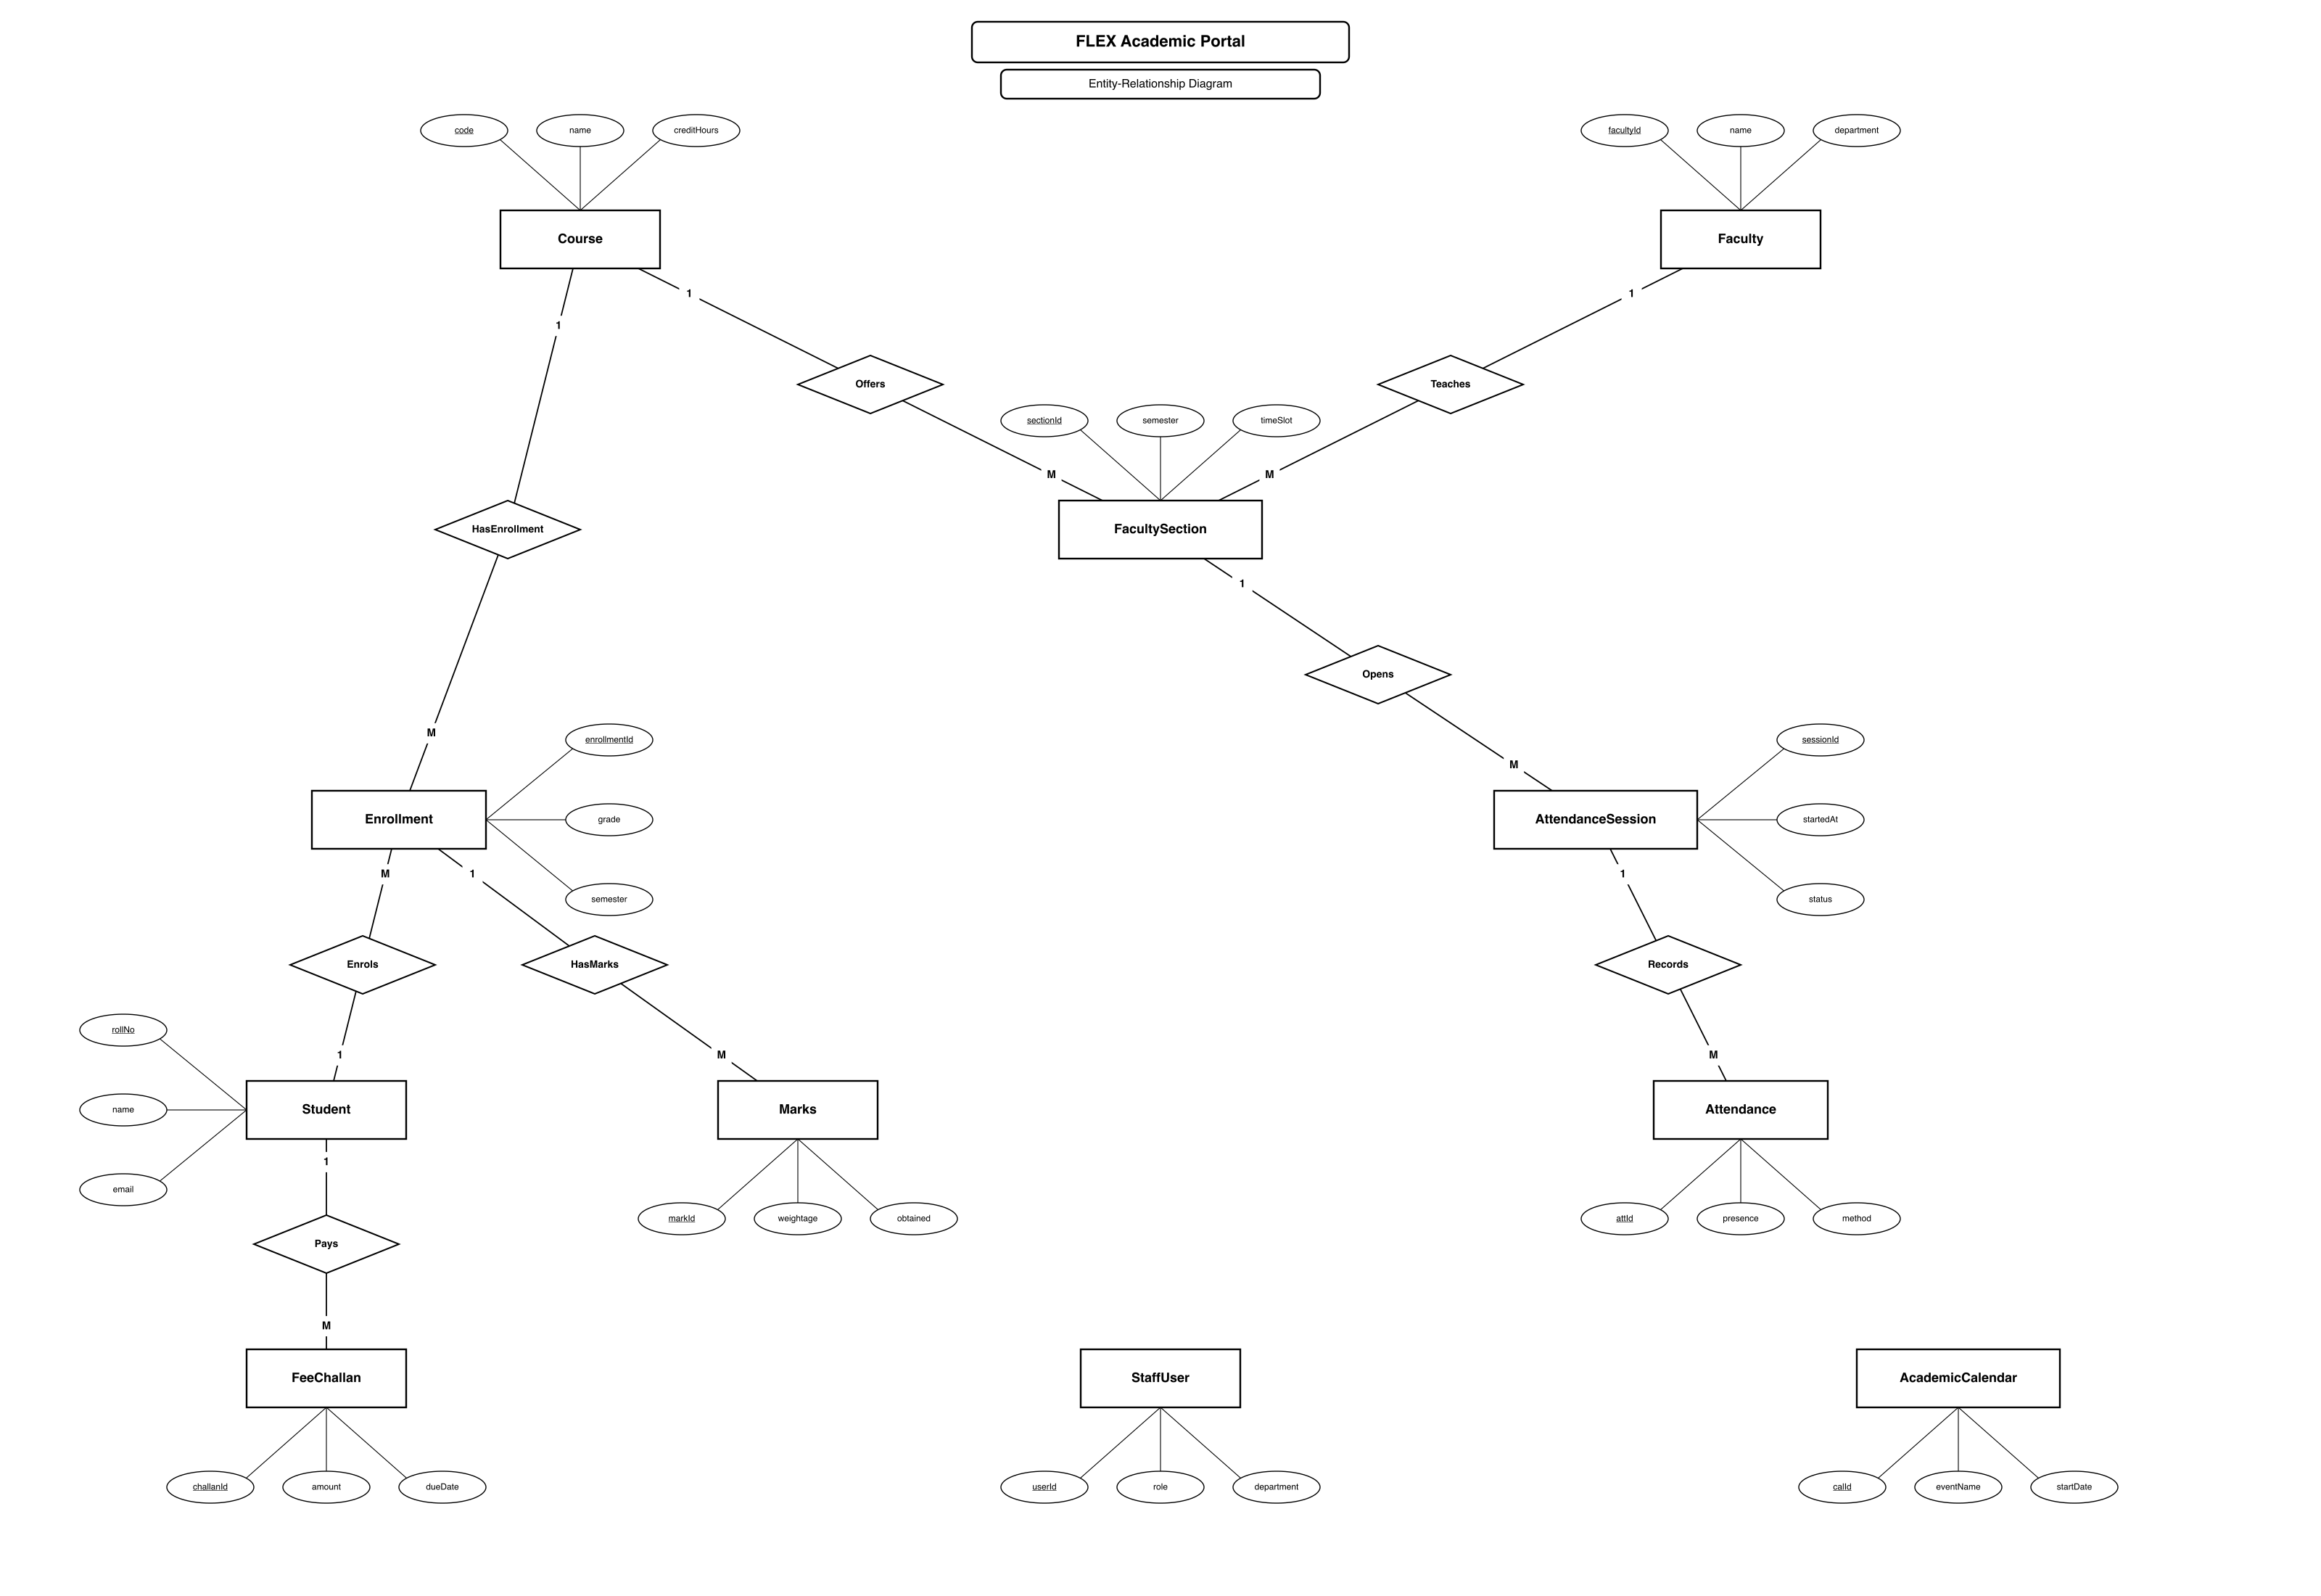
Figure B.2 — Persistent data model.

B.3 Activity Diagram — BLE Attendance Flow
This activity diagram traces a single BLE attendance session from beginning to end. The top serial chain is the faculty-side preparation (pick section, set window, press Open). Once the session is OPEN, control forks into two parallel branches: the student branch (open Attendance page → press Mark → BLE handshake → POST → server validates → row written), and the faculty branch (UI polls /marks every 2 s, displays the live roster). The two branches join at the Close decision: when the window expires or the faculty clicks Close, all still-Pending students are auto-marked Absent.
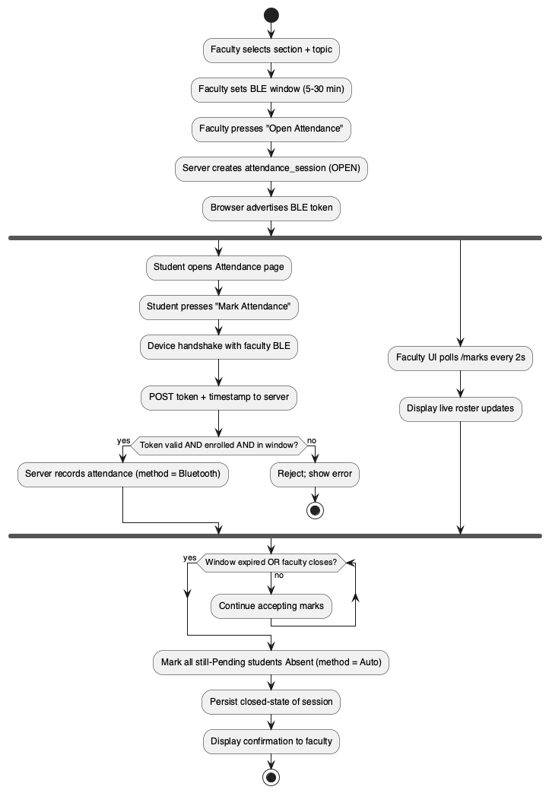
Figure B.3 — End-to-end BLE attendance lifecycle.

B.4 Activity Diagram — Late Registration Flow
The late-registration approval workflow is a sequential decision tree across four roles. The student submits a request that enters the Academic Officer's queue. The AO either rejects it or attaches remarks and forwards it to the HOD. The HOD's approval forwards the case to the Registrar; the Registrar's approval forwards to Flex Support, who performs the actual system enrolment. Any rejection along the chain ends the workflow and notifies the student.
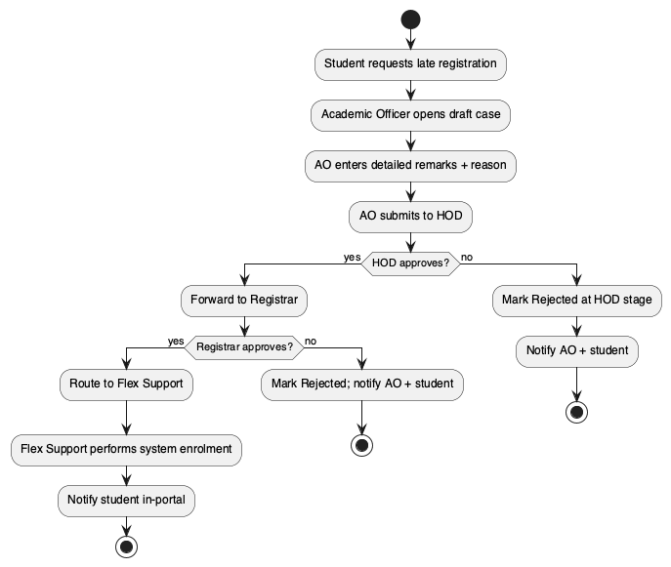
Figure B.4 — Late-registration approval flow.

B.5 Sequence Diagram — Grade Submission to HOD
The sequence diagram traces the full grade-publication round-trip across three actors and three system participants. The faculty's Submit Grades action POSTs to the API, which writes status SUBMITTED in MySQL and notifies the HOD. The HOD's approval transitions status to HOD_APPROVED and notifies the Exam Office. The Exam Office publishes, locking faculty edits permanently and triggering SGPA/CGPA computation. Finally the student fetches their transcript and sees the published letter grade.
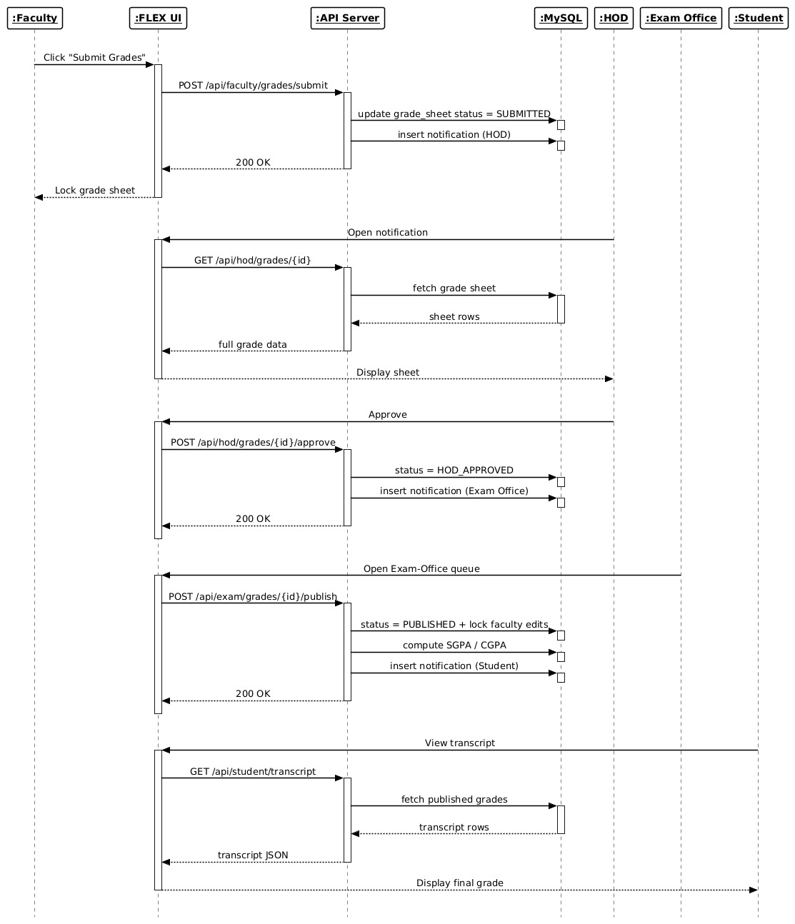
Figure B.5 — Faculty → HOD → Exam Office grade-publication round-trip.

B.6 State Diagram — Attendance Session
The attendance session has a small state machine. From the initial node a session becomes Draft when the faculty selects a section, transitions to Open when the BLE window is broadcast, and ends in Closed either by an explicit faculty close or by automatic window-timer expiry. Every student handshake while in Open generates a self-loop that inserts an attendance row.
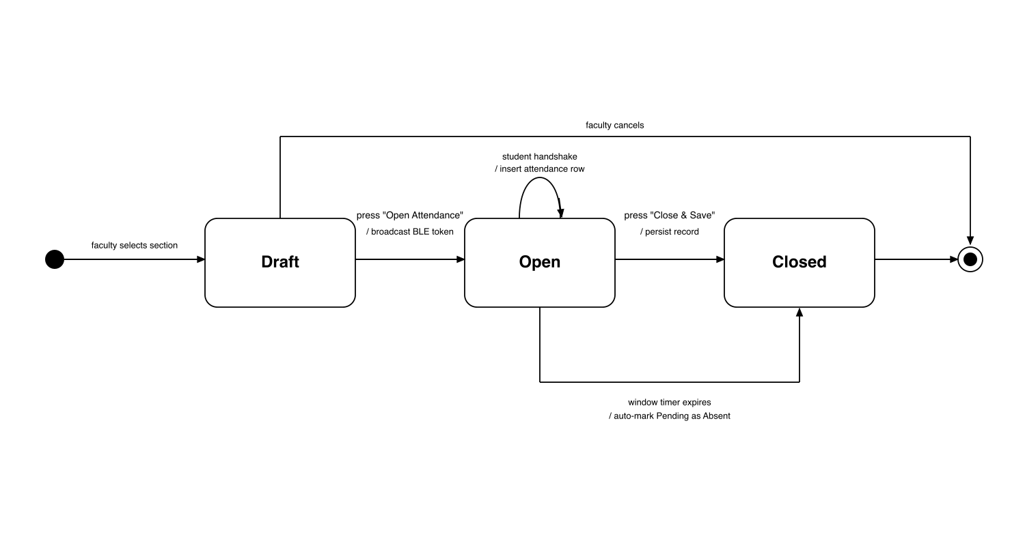
Figure B.6 — attendance_sessions.status lifecycle.

B.7 State Diagram — Grade Sheet
The grade sheet has its own state machine that mirrors the multi-stage approval chain. A faculty's freshly created sheet is in Draft, becomes Submitted on submit (faculty edits locked), advances to HOD_Approved when the HOD signs off, and finally reaches Published when the Exam Office clicks publish. Both the HOD and the Exam Office can return the sheet to Draft, unlocking faculty edits with comments.
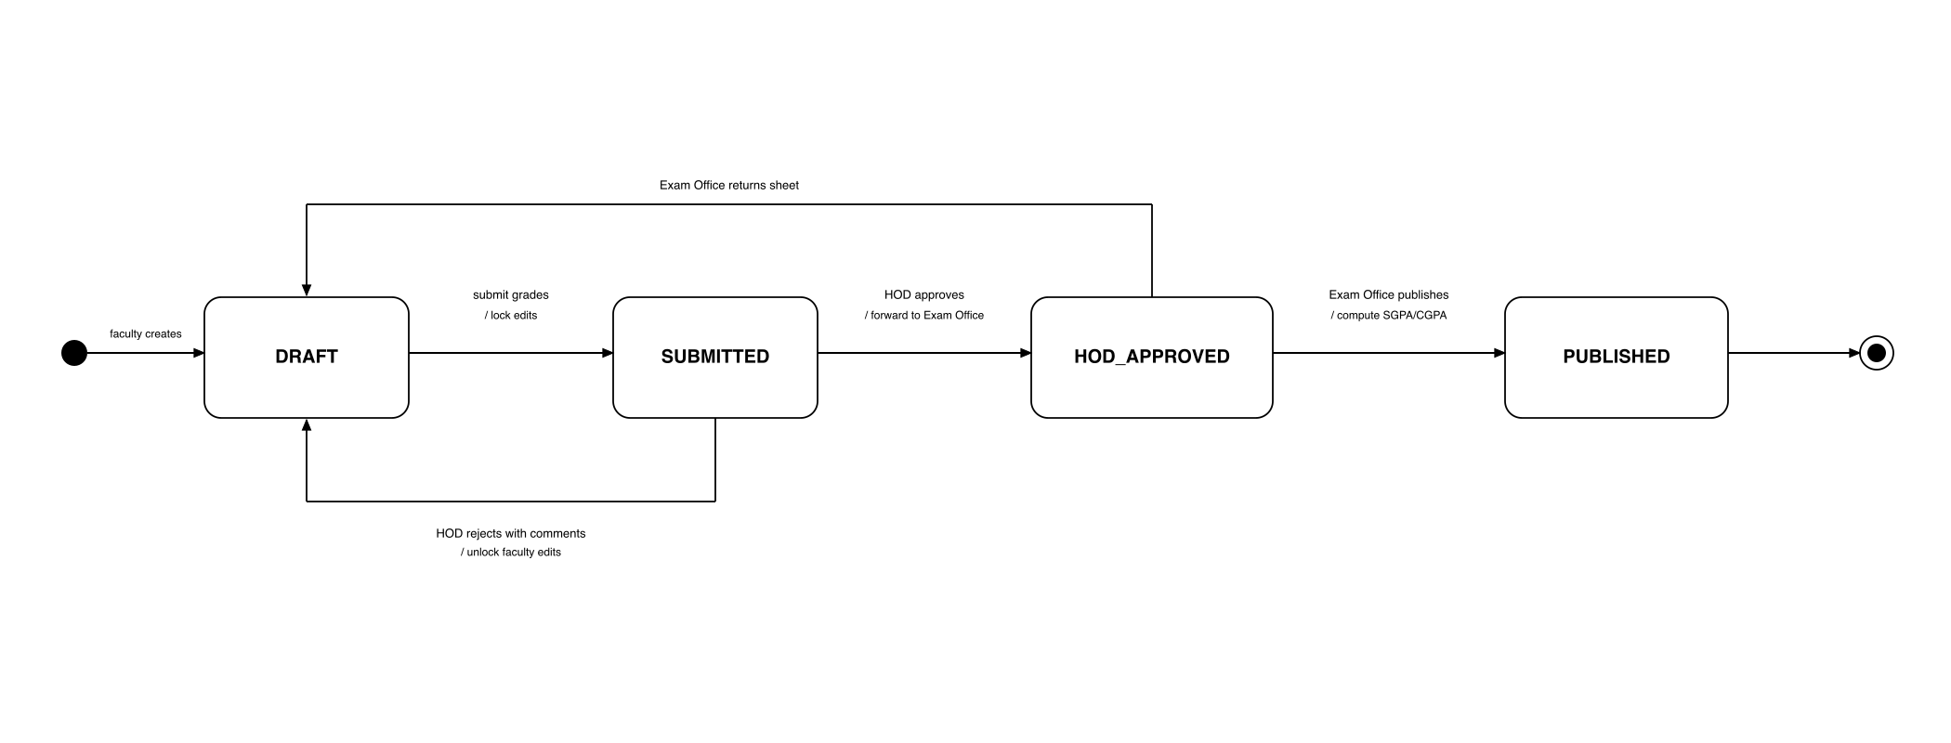
Figure B.7 — Grade-sheet lifecycle from Draft through Published.

B.8 State Diagram — Late Registration Case
Each late-registration case carries one of seven states tracking which approver currently owns it. A case starts in AT_AO, advances through AT_HOD, AT_REGISTRAR and AT_FLEX_SUPPORT on positive approvals, and reaches Enrolled when Flex Support completes the system enrolment. A rejection at any of the AO, HOD or Registrar stages terminates the case in the Rejected state.
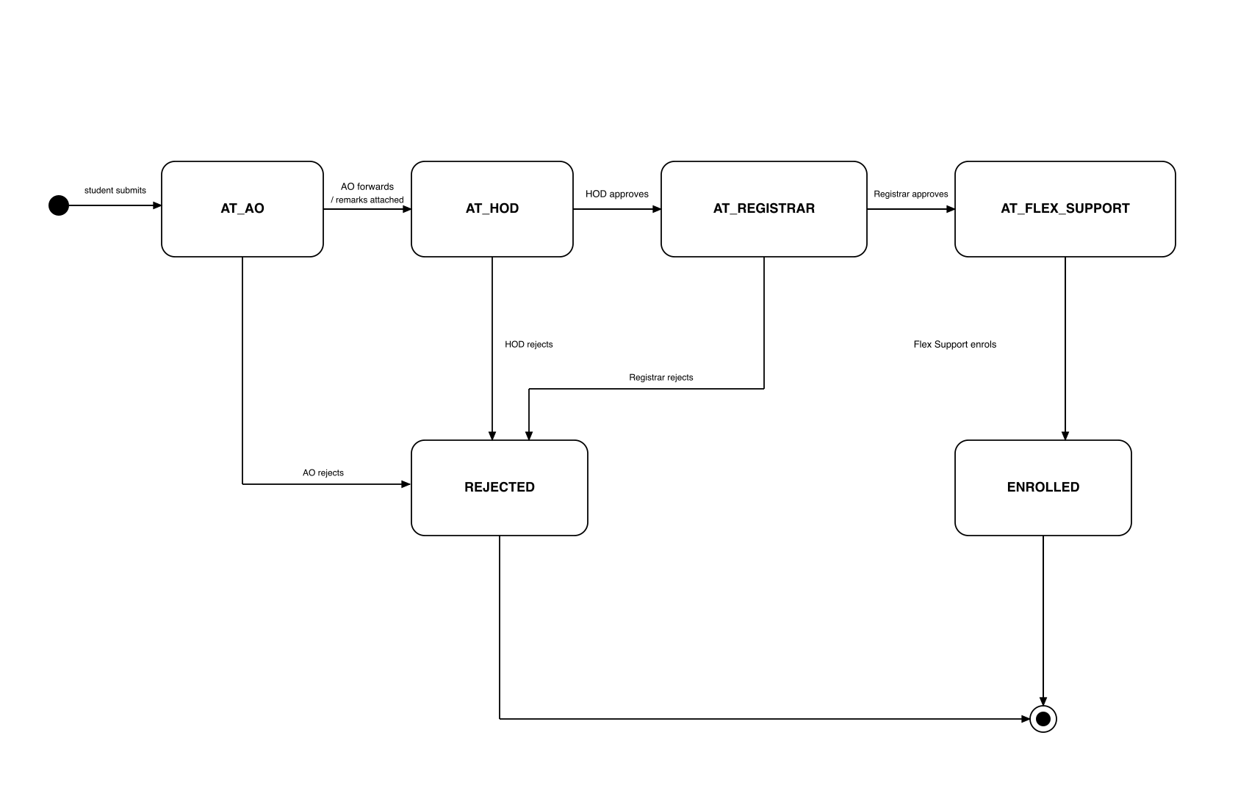
Figure B.8 — Late-registration case states across AO → HOD → Registrar → Flex Support.

B.9 Swimlane Diagram — Late Registration
The same late-registration flow drawn as a swimlane to make the role hand-offs explicit. Each vertical lane represents one role; each rounded rectangle represents an action that role performs; arrows crossing lane boundaries are the hand-offs between roles. Reading top-to-bottom gives the case timeline; reading left-to-right gives the participants' workload.
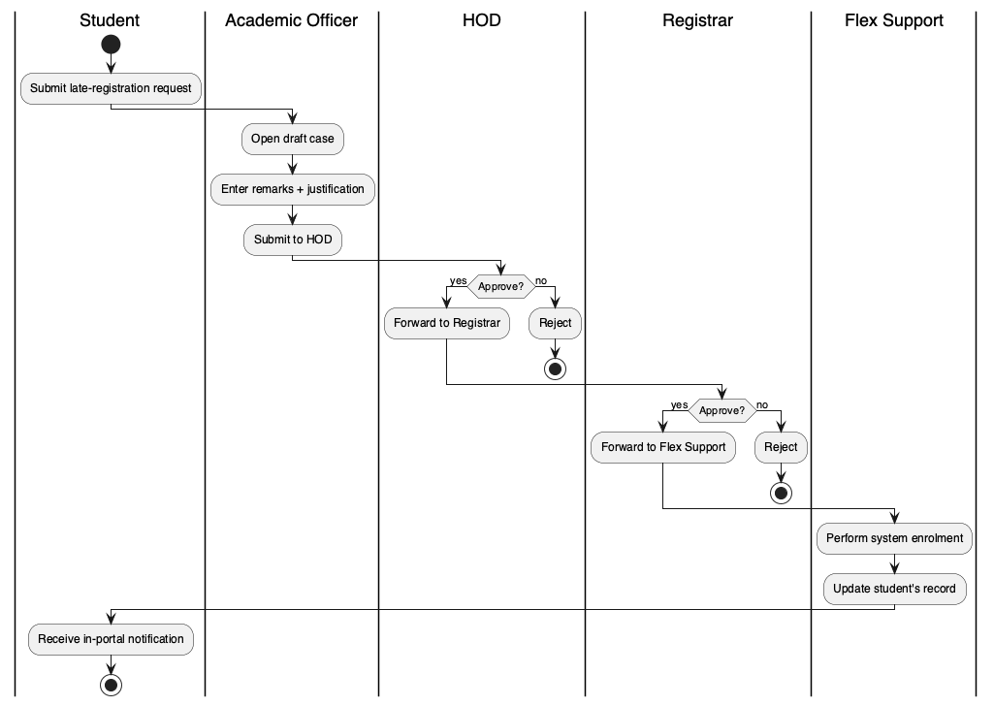
Figure B.9 — Late-registration flow with role lanes.

B.10 Decision Table — Course Registration Eligibility
The course-registration decision table lists the six guard conditions checked by the system on every registration submission. Each column captures one combination of condition outcomes and the resulting action; '-' marks a condition whose value is irrelevant once a higher-priority condition has already failed. The table is the tabular projection of the decision tree below.
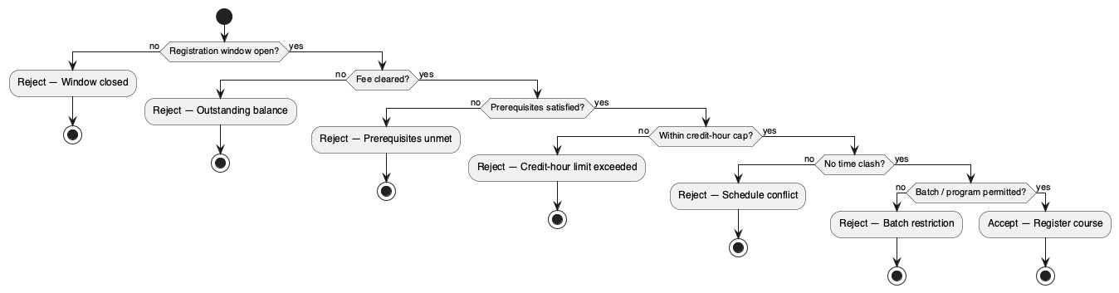
Figure B.10 — Decision tree for course-registration eligibility.
Condition / Action
Registration window open? | F | T | T | T | T | T | T
Fee cleared? | - | F | T | T | T | T | T
Pre-requisites satisfied? | - | - | F | T | T | T | T
Within credit-hour cap? | - | - | - | F | T | T | T
No time clash? | - | - | - | - | F | T | T
Batch / program permitted? | - | - | - | - | - | F | T
Reject — Window closed | X
Reject — Outstanding balance |  | X
Reject — Prerequisites unmet |  |  | X
Reject — Credit-hour limit exceeded |  |  |  | X
Reject — Schedule conflict |  |  |  |  | X
Reject — Batch restriction |  |  |  |  |  | X
Accept — Register course |  |  |  |  |  |  | X

B.11 Decision Table — Attendance Marking Outcome
This decision table covers the per-student outcome of an attendance attempt. The five conditions on top — student enrolment, session status, BLE handshake validity, faculty manual flag and window expiry — are evaluated for every mark request. The outcome row shows what the system records (Present-BLE, Present-Manual, Absent-Auto, or a rejection).
Condition / Action
Student enrolled in section? | F | T | T | T | T
Session status = OPEN? | - | F | T | T | T
Valid BLE handshake within window? | - | - | T | F | F
Faculty manually marked Present? | - | - | - | T | F
Window timer expired with no mark? | - | - | - | - | T
Reject — student not enrolled | X
Reject — session not open |  | X
Record Present (method = Bluetooth) |  |  | X
Record Present (method = Manual) |  |  |  | X
Record Absent (method = Auto) |  |  |  |  | X

Appendix C: To-Be-Determined List
# | Item | Resolution path
TBD-1 | QuickPay vs partner-bank API selection | depends on Finance Office decision
TBD-2 | Email provider for password reset / notifications | Postmark, SES, or institutional SMTP
TBD-3 | Whether Asst AO mailing scope is dept-only or program-only | confirm with AO interviewee
TBD-4 | Low-CLO threshold (currently 40 %) | confirm with HEC OBE coordinator
TBD-5 | Disciplinary Committee scope across campuses (single-campus only or cross-campus) | confirm with CAO
TBD-6 | Identity of the 'Flex Support' team in the late-registration final step | confirm with Registrar's office
TBD-7 | Maximum number of late-registration cases permitted per student per semester | policy clarification needed from AO
TBD-8 | Retake-exam fee policy and amount | Finance + Exam Office decision

