SE2004 BSE-4A FAST-NUCES Dr. Ali Afzal Malik

Phase 3
Team 1
Member Name | Member Roll # | Primary Responsibility
Saad Mehmood | 24L-3050 | SAD Review
Natiq Ali | 23L-0882 | Rationale
Abdul Muiz | 23L-3097 | ArCD
Suleman Ahmed | 24L-3072 | SAD Integration, Formatting
Ammar Arif | 24L-3067 | B & A Architecture
M. Waleed | 24L-3035 | Description Table

Table of Contents
Table of Contents ................................................................................. ii
1. ArCD ............................................................................................ 1
2. B & A Architecture .............................................................................. 2
3. Rationale ....................................................................................... 3
4. Description Table ............................................................................... 4

1. ArCD
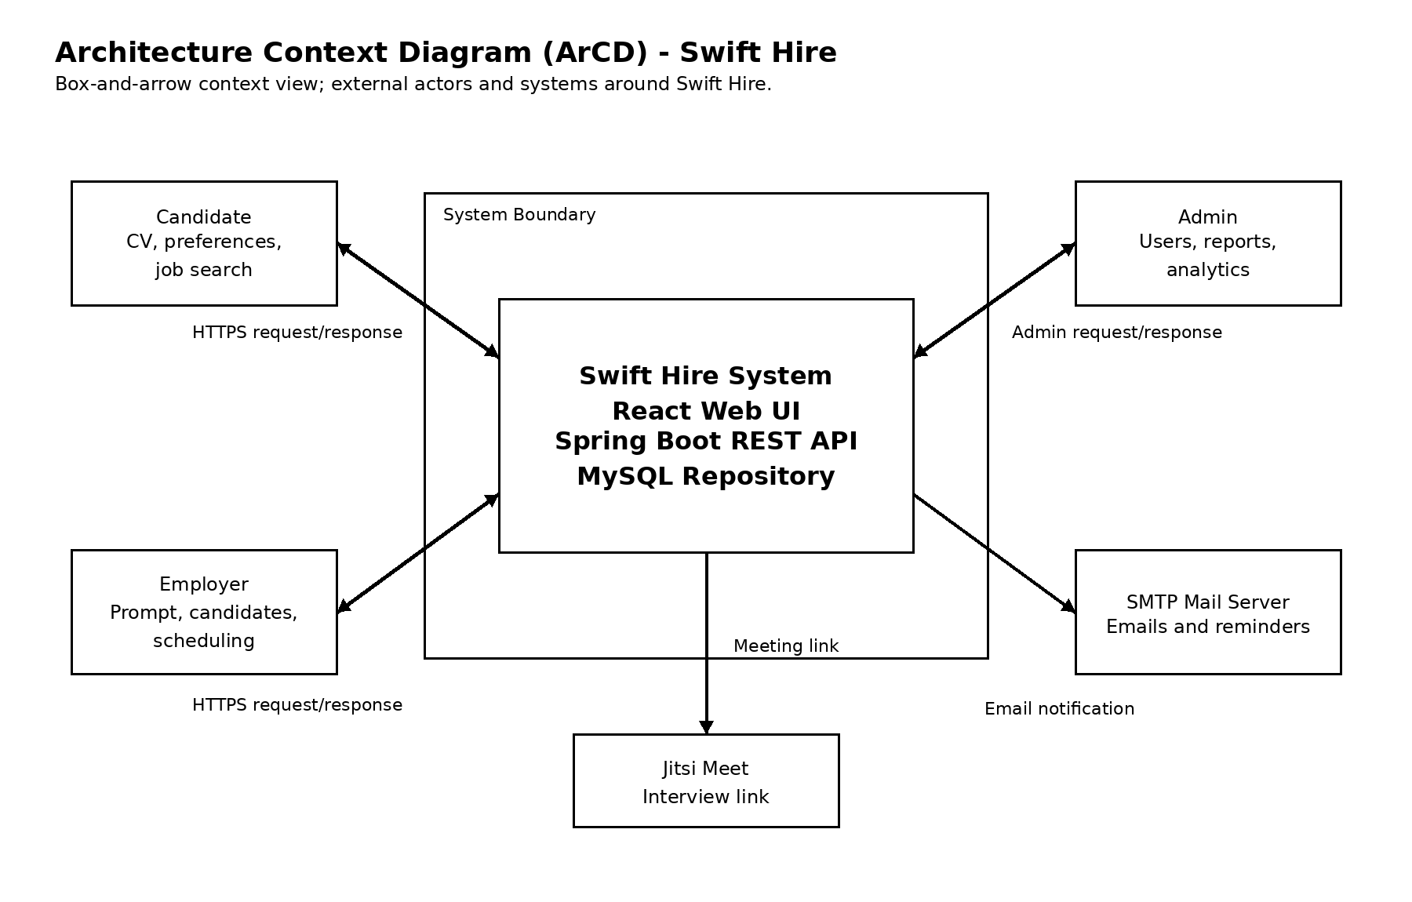
Fig.1 ArCD: Swift Hire

2. B & A Architecture
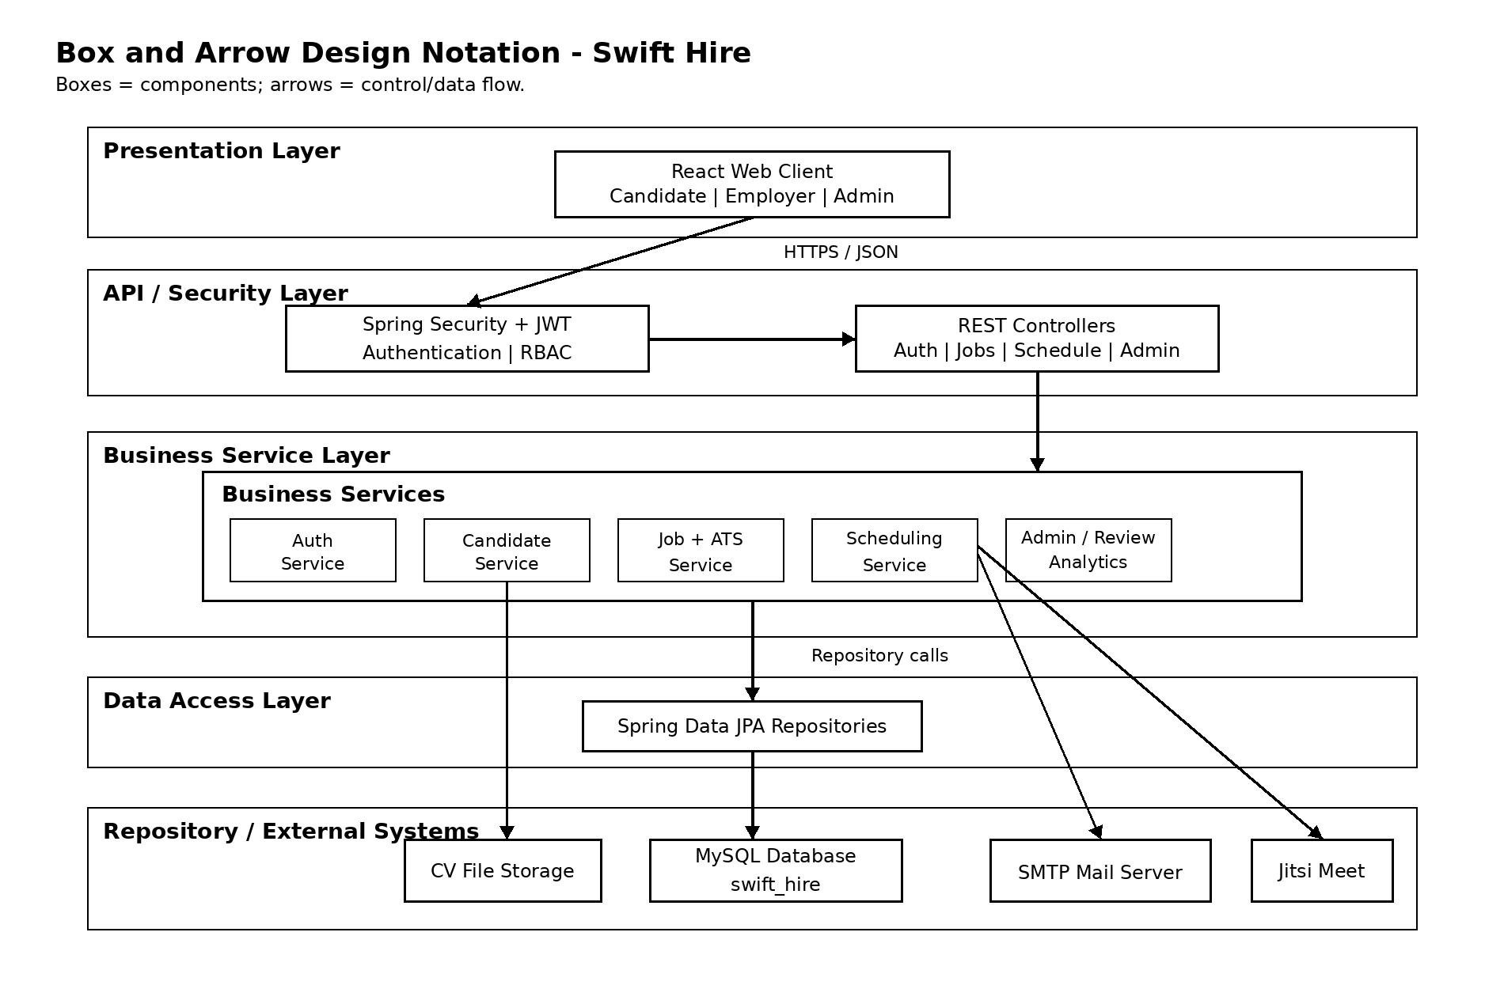
Fig.2 B & A Architecture: Swift Hire

3. Rationale
Swift Hire uses a combined client-server, layered, and data-centered repository architecture because the system has three clear user roles, separate web and backend responsibilities, and persistent recruitment data shared by all major use cases. The React client acts as the presentation layer and sends HTTPS/JSON requests to the Spring Boot REST API, while Spring Security, controllers, services, repositories, and MySQL are kept in separate layers. This keeps UI concerns separate from business rules such as prompt parsing, ATS scoring, CV parsing, auto-scheduling, reminders, reviews, reports, and account administration. The repository-centered MySQL design is suitable because users, candidates, employers, job postings, match scores, interview slots, reviews, reports, audit logs, notification logs, and dictionary entries must remain consistent across UC-01 to UC-17. This architecture also supports the required NFRs: performance is improved by placing matching and parsing inside focused services, scalability is supported by separating the React frontend, Spring Boot backend, database, and email integration, security is enforced through JWT and RBAC in the security layer, and notifications remain non-blocking through the email and reminder components.

4. Description Table
S# | C Name | C Desc | Req. Ref
1 | React Web Client | Presentation component for Candidate, Employer, and Admin dashboards.  It collects input, displays responses, and communicates with backend  REST APIs. | UC-01 to UC-17; NFR 3.3.1 to 3.3.4
2 | REST Controllers | Boundary component that receives HTTPS/JSON requests, maps them to  use-case endpoints, validates request structure, and returns API  responses. | UC-01 to UC-17; NFR 3.4.2
3 | Spring Security + JWT | Security component that authenticates users, verifies tokens, enforces  RBAC, limits login abuse, and protects role-specific operations. | UC-01, UC-06, UC-07; NFR 3.6.1 to  3.6.6; NFR 3.8.2 to 3.8.4
4 | Auth Service | Business component for signup, login, logout, email verification,  password reset, account lock, and credential handling. | UC-01, UC-06, UC-07; NFR 3.4.4; NFR  3.8.2 to 3.8.4
5 | Candidate Service | Business component for candidate profile management, CV upload, CV  parsing, preferences, and ranked job visibility. | UC-08, UC-09, UC-10, UC-11; NFR  3.1.2; NFR 3.4.1; NFR 3.5.3 to  3.5.4
6 | Employer + Job Service | Business component for employer profile, prompt processing,  KnownSkillsDictionary matching, job posting creation, ATS score  calculation, and ranked candidates. | UC-02, UC-03, UC-17; NFR 3.1.1; NFR  3.1.4; NFR 3.5.1 to 3.5.2; NFR  3.9.1 to 3.9.5
7 | Scheduling Service | Business component that creates interview windows, generates 45-minute  slots, assigns top candidates, and manages interview slot status. | UC-04, UC-15; NFR 3.7.4 to 3.7.5;  NFR 3.10.2
8 | Email + Reminder Scheduler | Automation component that sends verification, reset, invitation, and  reminder emails asynchronously and records notification events. | UC-15; NFR 3.2.3; NFR 3.7.1 to  3.7.5; NFR 3.10.1; NFR 3.10.4
9 | Review Service | Business component for candidate and employer ratings after  interviews, including rating validation and average rating updates. | UC-05, UC-12
10 | Admin + Analytics | Business component for user management, account status changes, audit  logs, graphical reports, CSV exports, and hiring analytics. | UC-13, UC-14, UC-16; NFR 3.8.5
11 | Spring Data JPA Repositories | Data access component that isolates persistence operations for users,  jobs, schedules, reviews, reports, dictionary data, and notification  logs. | UC-01 to UC-17; NFR 3.2.2; NFR  3.9.4
12 | MySQL Database | Repository component that stores authoritative system data including  users, candidates, employers, jobs, prompts, match scores, slots,  reviews, reports, logs, and skill dictionary entries. | UC-01 to UC-17; NFR 3.7.3; NFR  3.8.5; NFR 3.9.5
13 | CV File Storage | Storage component for uploaded PDF files; file paths are linked with  candidate records and parsed skills are saved for matching. | UC-09, UC-11; NFR 3.1.2; NFR 3.4.1;  NFR 3.6.4
14 | SMTP Mail Server | External integration that sends transactional emails, interview  invitations, verification messages, reset links, and reminders. | UC-15; NFR 3.7.1 to 3.7.5; NFR  3.10.1; NFR 3.10.3
15 | Jitsi Meet | External integration used to provide meeting links for auto-scheduled  interview slots. | UC-04, UC-15; NFR 3.10.2 to 3.10.5

