**# What is Kivy?**

Kivy is an opensource multi-platform GUI development library for Python and can run on iOS, Android, Windows, OS X, and GNU/Linux. It helps develop applications that make use of innovative, multi-touch UI. The fundamental idea behind Kivy is to enable the developer to build an app once and use it across all devices, making the code reusable and deployable, allowing for quick and easy interaction design and rapid prototyping.

# Advantages

Advantages of Kivy is given below –

* + Kivy helps us to design innovative user interfaces with multi-touch functionalities.
  + It can smoothly work with various platforms such as Windows, Android, Linux, iOs, macOS, and Raspberry Pi.
  + It helps us to run code on all supported platforms.
  + It provides well-documented APIs.
  + It offers a better representation of programs, including classes, widget configuration, and inherited classes.
  + It performs better than HTML 5.

Disadvantages

* + Non-native looking User Interface.
  + Bigger package size (because Python interpreter needs to be included).
  + Lack of community support (Kivy Community isn’t particularly large).
  + Lack of good examples and documentation.
  + Better and more community rich alternates available if only focusing on Mobile Cross-platform devices i.e React Native.

## # **Kivy Installation on Windows**

Considering you have already installed Python on your machine and IDE, if you haven’t just follow the instructions in another file regarding the same in the repository.

we’ll directly head over to installing kivy.

You will have to install Anaconda, Now, follow the below steps to download the Anaconda –

**Step 1:** Click on the below link to install Anaconda [https://www.anaconda.com/products/individual](https://www.anaconda.com/products/individual" \t "_blank)

**Step 2:** The following page appears on the screen. Scroll down the window and click on **64-bit Graphical Installer (446 MB)** at the bottom of the screen.

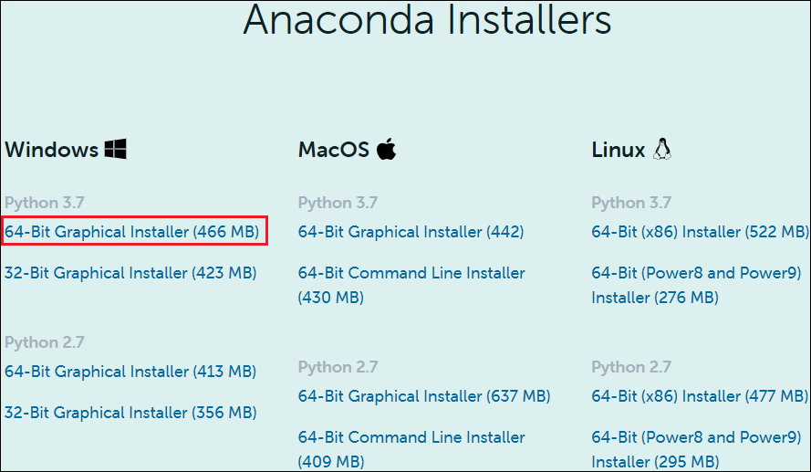

**Step 3:** You can see that Anaconda Graphical Installer is to started download. Once the file is downloaded, double click on that executable file. The following window appears on the screen in which click on the **Next**.

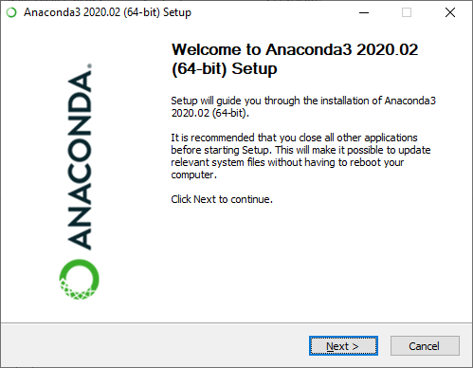

**Step 4:** A License Agreement window appears on the screen, in which click on the **I Agree.**

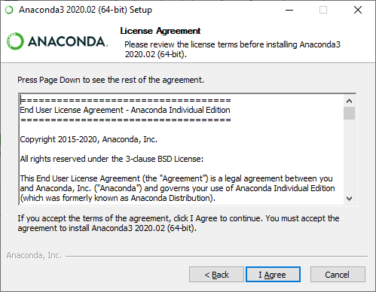

**Step 5:** In Installer type, select Install for **Just Me (recommended)**.

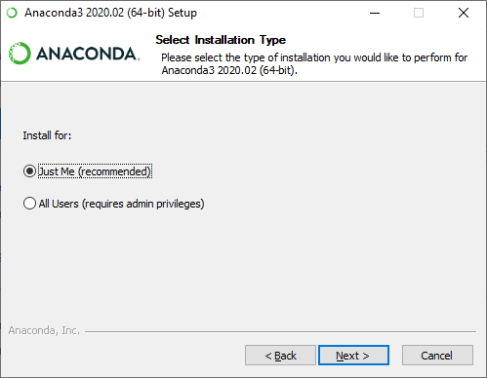

**Step 6: Browse the location** where you want to install Anaconda and click on the **Next**.

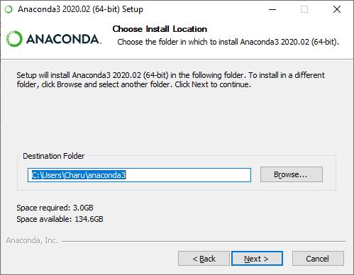

**Step 7: An Advanced Installation Options** window appears on the screen, tick on **Register Anaconda3 as my default Python 3.7**. And click on the **Install**.

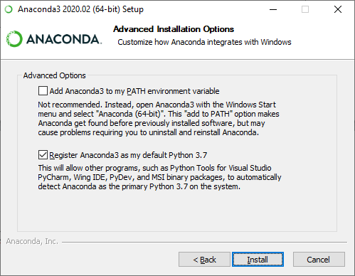

**Step 8:** The below screenshot shows that Anaconda Installation is in progress.

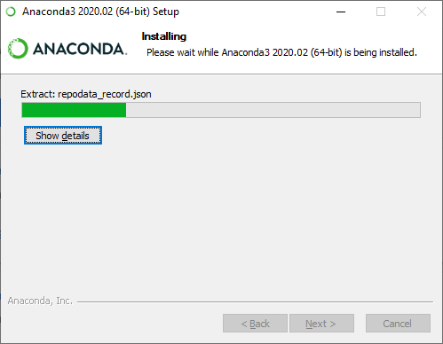

**Step 9:** Once the Installation process is completed, click on the **Next** button.

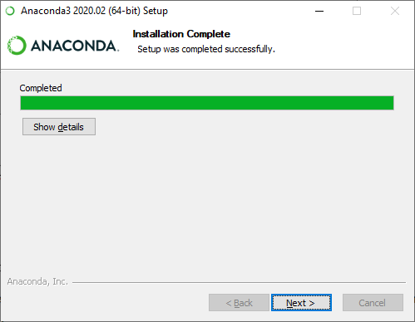

**Step 10:** The following window appears on the screen in which click on the **Next**.

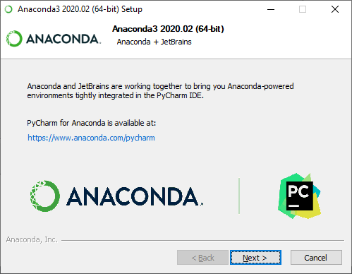

**Step 11:** A completing Anaconda set up window appears on the screen, simply click on the **Finish** on that window.

### # Install Kivy

There are the following steps to install kivy -

**Step 1:** Go to the Anaconda Prompt.

**Step 2:** Before installing kivy, first update the pip by using the following command.

‘’’python

python -m pip install - -upgrade pip wheel setuptools

**‘’’**

**Step 3: Install the Dependencies**

There are the following 3 dependencies that we need to install while installing the Kivy.

‘’’python

Python -m pip install docutils pygments pypiwin32 kivy.deps.sdl2 kivy.deps.glew

python -m pip install kivy.deps.gstreamer

python -m pip install kivy.deps.angle

**‘’’**

**Step 4: Install Kivy**

Use the following command to install Kivy.

‘’’python

python -m pip install kivy

### ‘’’

### # Creating your first GUI application using Kivy

## **Create a Hello World program in Kivy**

There are the following steps to create a Hello World program in Kivy -

**Step 1:** Open any text editor (Notepad or Notepad++)

**Step 2:** Write the following code on the Editor.

‘’’python

**import** kivy  # **import** kivy module

from kivy.app **import** App # **import** Kivy App module to create a Kivy **interface**

from kivy.uix.label **import** Label # **import** Label Module

kivy.require('1.11.1')  # version required to run Kivy Application

**class** MyKivyApp(App): # Create a **class** MyKivyApp

    def build(self):

**return** Label(text ="Hello World !") #**return** a Label with text Hello World ! as a root widget

MyKivyApp().run()  # Class MyKivyApp is initialized and run () method is called to run the App.

  ‘’’

**Step 3:** Save the file with **.py** extension for example Javatpoint.py

**Step 4:** Open the Anaconda Prompt and provide the valid path where your kivy program is saved.

**Step 5:** To run program, use the flowing command and press Enter.

‘’’python

python file\_name.py (Ex: python javatpoint.py)

‘’’

When you run the command following output appears on the screen.

### Kivy Tutorial

# Additional Resources

If you dont wanna stop here learn more on how to create amazing apps using kivy you can the resources below:

* + <https://youtube.com/playlist?list=PLCC34OHNcOtpz7PJQ7Tv7hqFBP_xDDjqg>
  + <https://youtu.be/l8Imtec4ReQ>
  + [Kivy Tutorial - GeeksforGeeks](https://www.geeksforgeeks.org/kivy-tutorial/)
  + <https://www.javatpoint.com/kivy>