<http://tfs.xpandsoftware.com:8181/tfs/Products/Upgrade%20Services%20Landing%20for%20Customers/_backlogs/iteration/June%202018>

**Business explanation**:

In 70% of cases, customers either will not be able or will not want to provide objects from their NAV database due to privacy reasons. For this cases, we would like to offer to customers to provide statistics about the customized and new objects in their database. In return, we would calculate a very rough and average cost of the upgrade.

**Technical explanation**:

Step 1: Customer selects Option 2 to calculate the cost of the upgrade. The following pop-up should appear (make the list of fields static. A user should not be able to modify it via the backend):

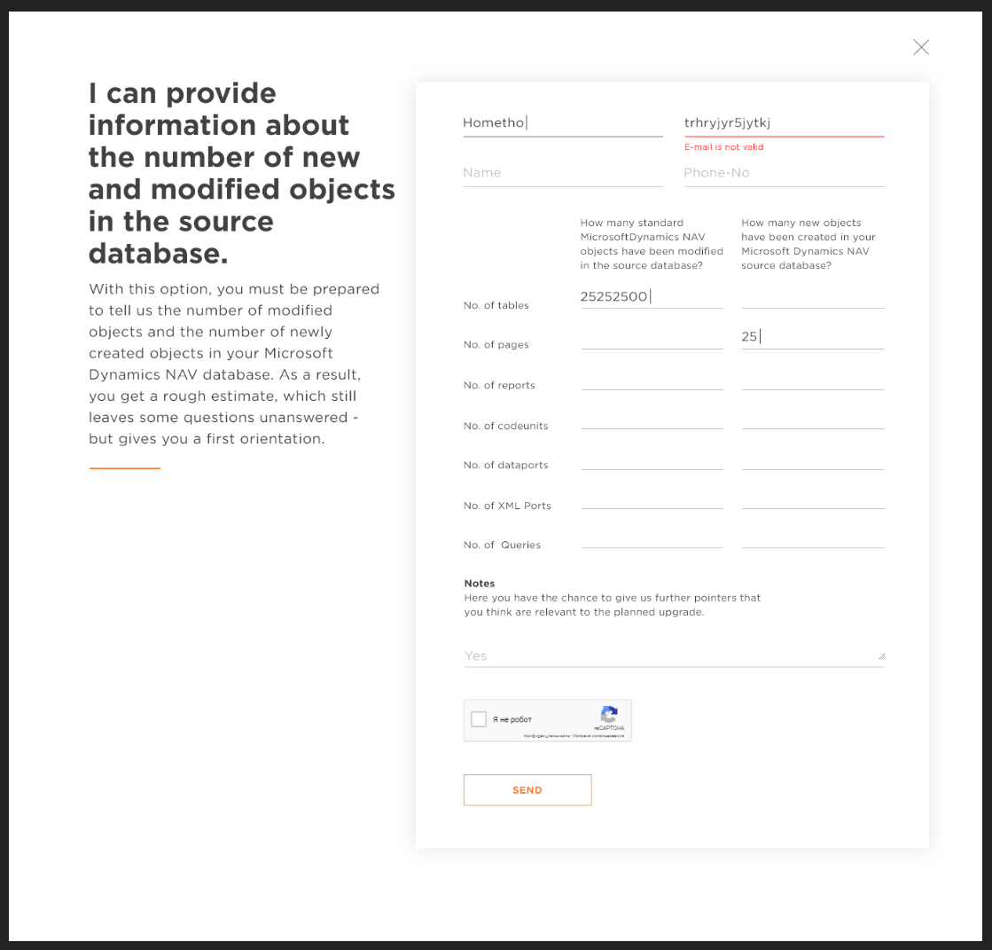

Step 2. The Customer fills in a) very basic information about himself: company name, email, name, phone number, b) a statistic about the number of changed and new objects in his database, c) Notes if needed and goes through the Captcha validation.

Step 3. The system sends this data to a common web service at the Xpand side (the idea is that there could be multiple sites like this belonging to different partners and I would prefer to have one place that would perform calculations) where the calculation happens. The system should send periodic status updates to the user interface and show the progress:

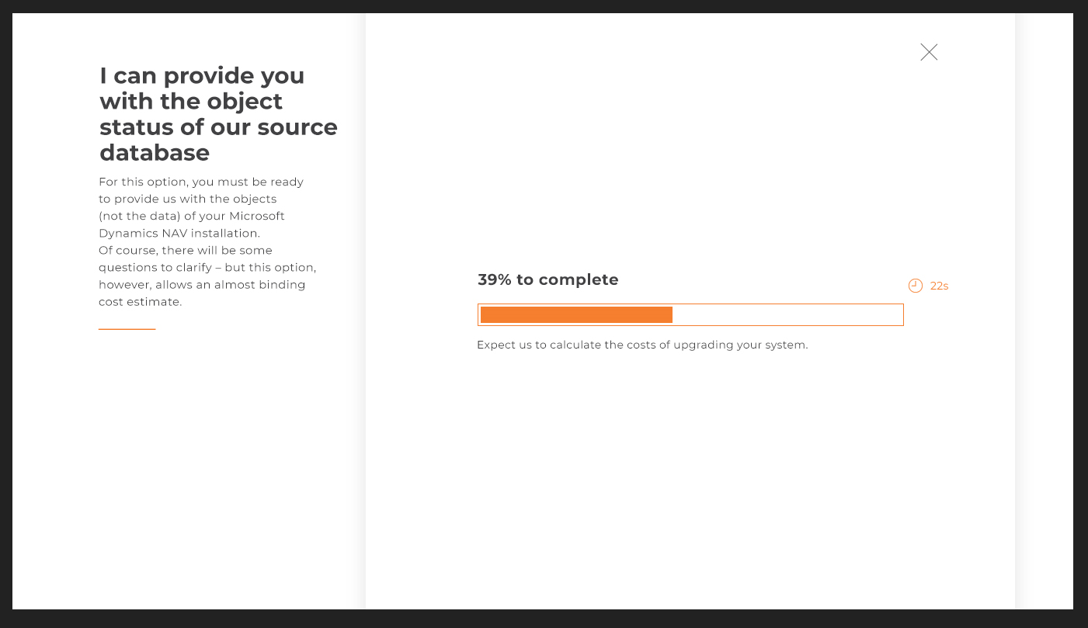

Step 4. After the calculation is performed a) the response is sent back to the user and a pdf file with the results of calculation is shown to the user and b) the same pdf is sent to the user via email.

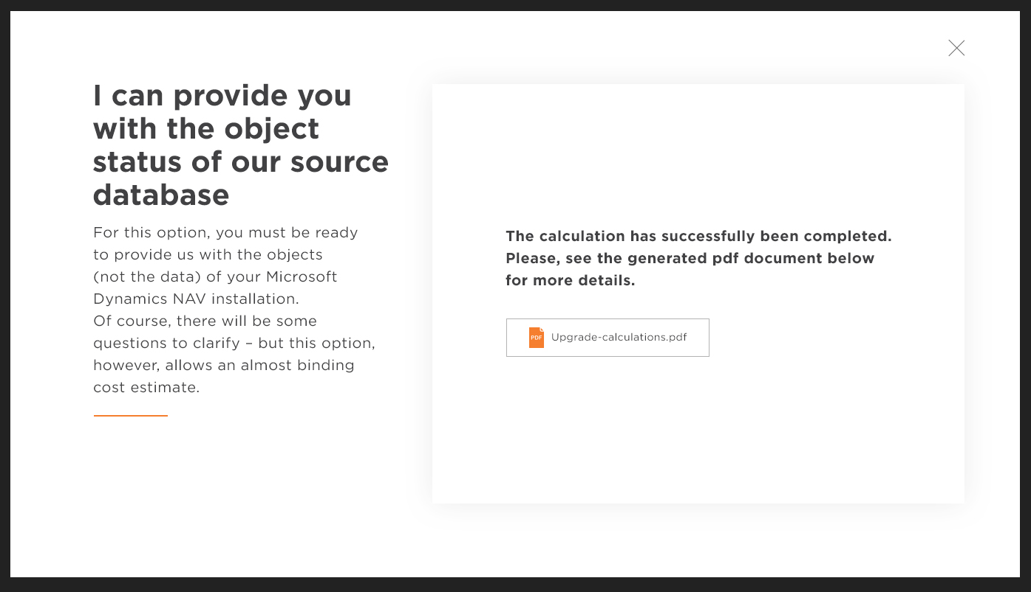

<https://www.youtube.com/channel/UCfelJa0QlJWwPEZ6XNbNRyA/playlists>

<https://github.com/Microsoft/CNTK>