0xVM Layer 2 Bitcoin

Decentralized Bitcoin ZK Rollup Layer2 that is compatible with the EVM ecosystem and uses native BTC as gas.

0xVM introduces the EVM ecosystem to BTC, granting the Bitcoin ecosystem the capability to issue assets and build applications.

Simplicity –

Designing with maximum simplicity is one of the primary objectives of 0xVM. 0xVM is a versatile ZK Rollup that employs EVM for off-chain computations. This implies that users can interact with 0xVM in a manner similar to interacting with Ethereum, and developers can build on top of 0xVM just as they would on Ethereum. This simplicity provides 0xVM with several notable advantages compared to more complex Layer 2 implementations.

Sustanaibility –

0xVM is intended for long-term, sustainable operation. Application developers need to ensure that the platform they build remains viable and competitive over an extended period. The design process of 0xVM is centered around the idea of long-term sustainability rather than taking shortcuts in scalability. Ultimately, a scalable system is meaningless if it doesn't sustain its ecosystem.

Fraud Proof –

0xVM utilizes ZK Rollup technology to bundle multiple transactions into a single batch and validate them on the Bitcoin main network as a single transaction. 0xVM employs native BTC as gas for the EVM. Even though 0xVM is an experiment the aim is to add value to the native BTC network.

PoW Based –

While 0xVM may appear as a standalone blockchain, it is ultimately designed as an extension of Bitcoin. This fact is kept in mind every time we create new features or attempt to simplify existing ones. 0xVM can achieve the same level of security as Bitcoin while maintaining simplicity without altering the consensus rules of the Bitcoin network.

As depicted in the diagram, the 0xVM chain comprises three layers.

SETTLEMENT LAYER (BITCOIN): The settlement layer delivers the capacity for on-chain validation of the validity of 0xVM transactions, and the resultant verification outcomes are observable by all participants. Throughout the verification process, the digest of off-chain data is documented and preserved within this layer. It encompasses two dynamically generated taproot transactions, including Bit Commitments Taproot and Verification Taproot, tasked with accepting execution traces and conducting on-chain verification.

SEQUENCING LAYER: Situated in this layer are the foundational nodes, which bear the responsibility of upholding the functionality of 0xVM. Temporarily, this layer can store all pertinent transactions and states, a validity that can be substantiated through on-chain data.

PROVING LAYER (CIRCUITS): This layer is responsible for generating proofs and plays a key role in verifying 0xVM transactions and states on Bitcoin. It generates transactions according to Bitcoin Taproot specifications, allowing the verification of 0xVM blocks on Bitcoin. Provers and nodes work together to transform data into specific taproot transactions and create execution traces where a node is capable of validating the entire process.

0xVM

Abstract

0xVM is a decentralized Bitcoin ZK Rollup Layer 2 solution compatible with the Ethereum Virtual Machine (EVM) ecosystem, using native BTC as gas. Empowered with the ability to connect both Bitcoin and EVM ecosystems, it seamlessly merges the value anchoring of BTC with the programmability of EVM, bringing infinite possibilities to the evolution of the new ecosystem.

Innovation-driven

0xVM closely monitors the development of emerging technologies within the industry, committed to integrating the advantages of these technologies with its own characteristics. We continuously explore new possibilities to enhance 0xVM capabilities. Recognizing the crucial role of rapid technological evolution in project development, we actively seek and adopt new technologies that can elevate 0xVM, ensuring that we remain at the forefront of the industry and provide users with an outstanding experience.

Abstract

0xVM is a decentralized Bitcoin ZK Rollup Layer 2 solution compatible with the Ethereum Virtual Machine (EVM) ecosystem, using native BTC as gas. Empowered with the ability to connect both Bitcoin and EVM ecosystems, it seamlessly merges the value anchoring of BTC with the programmability of EVM, bringing infinite possibilities to the evolution of the new ecosystem.

Innovation-driven

0xVM closely monitors the development of emerging technologies within the industry, committed to integrating the advantages of these technologies with its own characteristics. We continuously explore new possibilities to enhance 0xVM capabilities. Recognizing the crucial role of rapid technological evolution in project development, we actively seek and adopt new technologies that can elevate 0xVM, ensuring that we remain at the forefront of the industry and provide users with an outstanding experience.

0xVM is a Bitcoin Layer2 solution that incorporates the ZK Stark algorithm and Taproot script. Given that Bitcoin itself does not support overly complex programs, 0xVM executes complex smart contracts off-chain and utilizes the technical features of Taproot Script to verify the results of certain off-chain computations on the BTC blockchain. Similar to the concept behind bitVM, 0xVM compiles high-level language programs into a series of low-level opcodes off-chain. Following the principles of electronic computing, these opcodes can be represented in the form of digital circuits (logic gates). Ultimately, by expressing the logic gate circuits in the form of Bitcoin Script, it is possible to simulate the operation of part of the logic gate circuit on the Bitcoin blockchain when necessary and observe its results.

The 0xVM Yellow Paper highlights that, with the aforementioned approach, arbitrary computations can be executed off the BTC blockchain, and only when necessary, certain minor steps of the off-chain computation process are verified through on-chain validation. This achieves an effect similar to Ethereum Rollups like Arbitrum. Furthermore, 0xVM employs zkEVM as the execution environment to generate ZK Proofs, which are submitted to off-chain validators for verification, thereby reducing the computational pressure and bandwidth consumption of nodes. To address censorship resistance issues, 0xVM also proposes the 0VMZK scheme to achieve censorship resistance for the sequencer.

Community-driven

0xVM is a community-driven project, and we look forward to achieving long-term stability and development of the protocol through the collaborative efforts of the community and the project. We firmly believe that community engagement and cooperation are key to the project's success.

0xVM places a strong emphasis on early users and collaboration with ecosystem partners. We encourage their active contribution to the project. In 0xVM Tokenomics and future decision-making, we will always prioritize the interests of all community participants. We are committed to establishing an open and transparent community to ensure fairness in the decision-making process, while fully respecting the community's voice, aiming for mutual long-term success.

**Token Utility**

0xVM is a community-driven project where $0xVM, its native token, plays a crucial role in advancing community development. $0xVM motivates community participants and fosters collaboration. In the Tokenomics section, a significant portion of $0xVM is allocated to the Ecosystem, emphasizing its role in incentivizing community engagement and project co-creation.

Common utilities

Governance and Voting

$0xVM holders influence the future direction of 0xVM. Actively participating in governance proposals and voting empowers $0xVM holders to shape important decisions, ensuring alignment with the community's aspirations.

Staking Rewards

Staking $0xVM tokens provides an additional way for holders to earn rewards within the 0xVM ecosystem. By participating in the staking program, users contribute to ecosystem stability while enjoying attractive rewards.

Premium utilities

Early Participant Incentives

In appreciation of contributors during the Testnet and Super-Mega-Alpha Mainnet stages, $0xVM serves as a token of gratitude, offering phased incentive programs to encourage ongoing community involvement.

Ecosystem Priority

$0xVM serves as a mechanism to reward and incentivize active participation and contributions within the 0xVM community. As part of our commitment to community growth, we would collaborate with programs prioritizing $0xVM holders, ensuring they receive rewards for actively engaging in community-driven initiatives.

Liquidity Provider Rewards

As 0xVM operates as a Bitcoin Layer 2 with native BTC as gas, $0xVM incentivizes BTC liquidity providers. Recognizing their contributions to 0xVM value and usability aligns their interests with the ecosystem's continual growth.

Security Model Rewards

Participants in the Prover and Verifier modules, guardians of security, play a vital role in maintaining 0xVM safety. Their commitment to overall integrity is rewarded with $0xVM.

**0xVM Token Information**

Basic information

The fundamental information of $0xVM is as follows:

Token Name: 0xVM

Token Symbol: 0xVM

Token Decimals: 9

Total supply: 21,000,000

**Token Distribution**

Overview

The Distribution of 0xVM is a follow :

Pancakeswap Liquidity: 70%

Ecosystem : 10%

Staking : 10%

Farming Pool : 5%

CEX : 5%

Tax Distributions

10/10%

Marketing : 5%

Liquidity : 2%

Ecosystem : 3%

0xVM

ARCHITECTURE

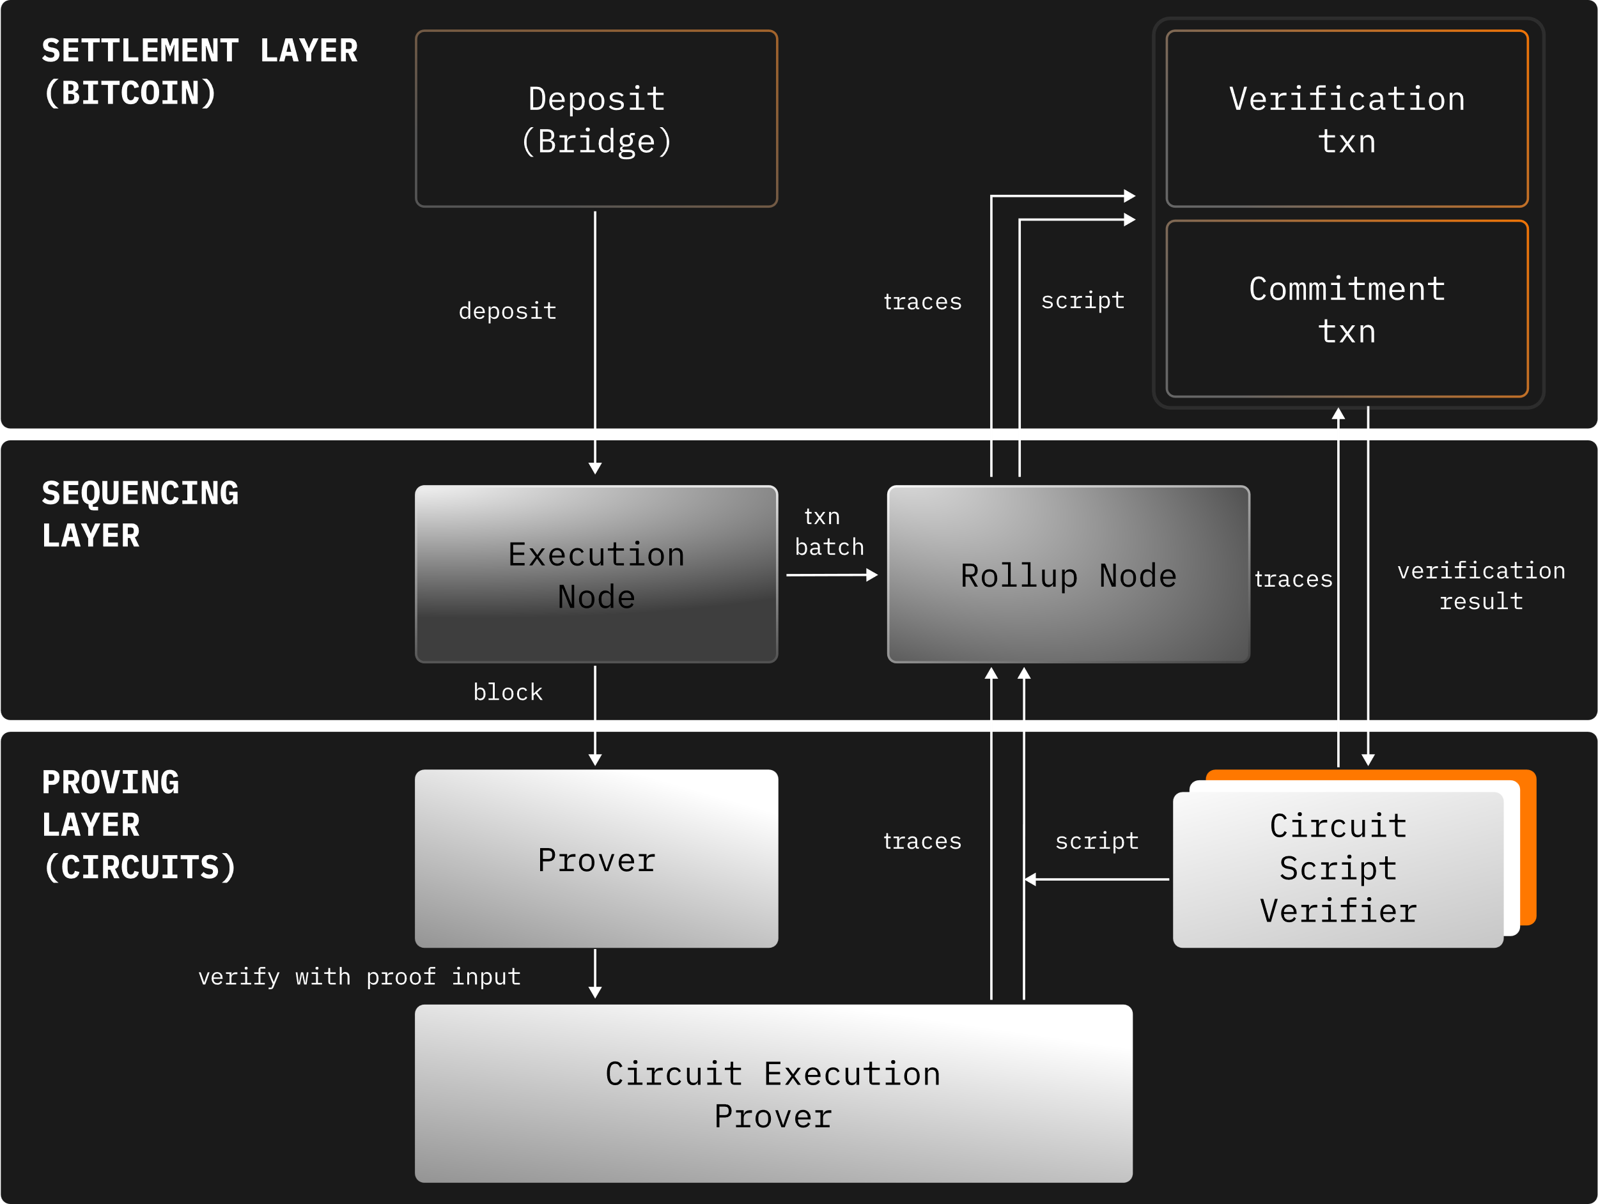

As depicted in the diagram, the 0xVM chain comprises three layers.

SETTLEMENT LAYER (BITCOIN): The settlement layer delivers the capacity for on-chain validation of the validity of 0xVM transactions, and the resultant verification outcomes are observable by all participants. Throughout the verification process, the digest of off-chain data is documented and preserved within this layer. It encompasses two dynamically generated taproot transactions, including Bit Commitments Taproot and Verification Taproot, tasked with accepting execution traces and conducting on-chain verification.

SEQUENCING LAYER: Situated in this layer are the foundational nodes, which bear the responsibility of upholding the functionality of 0xVM. Temporarily, this layer can store all pertinent transactions and states, a validity that can be substantiated through on-chain data.

PROVING LAYER (CIRCUITS): This layer is responsible for generating proofs and plays a key role in verifying 0xVM transactions and states on Bitcoin. It generates transactions according to Bitcoin Taproot specifications, allowing the verification of 0xVM blocks on Bitcoin. Provers and nodes work together to transform data into specific taproot transactions and create execution traces where a node is capable of validating the entire process.

