**TITLE** **OF** **PROJECT**

**A** **Project** **Work** **Report**

*Submitted* *in* *the* *partial* *fulfilment* *for* *the* *award* *of* *the* *degree* *of*

**BACHELOR** **OF** E**NGINEERING**

**IN**

**INFORMATION SECURITY**

**Submitted** **by:**

**RISHANK MEHROTRA**

**TANMAY RASTOGI**

**YASH KAPOOR**

**19BCS3573**

**19BCS3534**

**19BCS3561**

**Under** **the** **Supervision** **of:**

**JYOTI MEHRA**

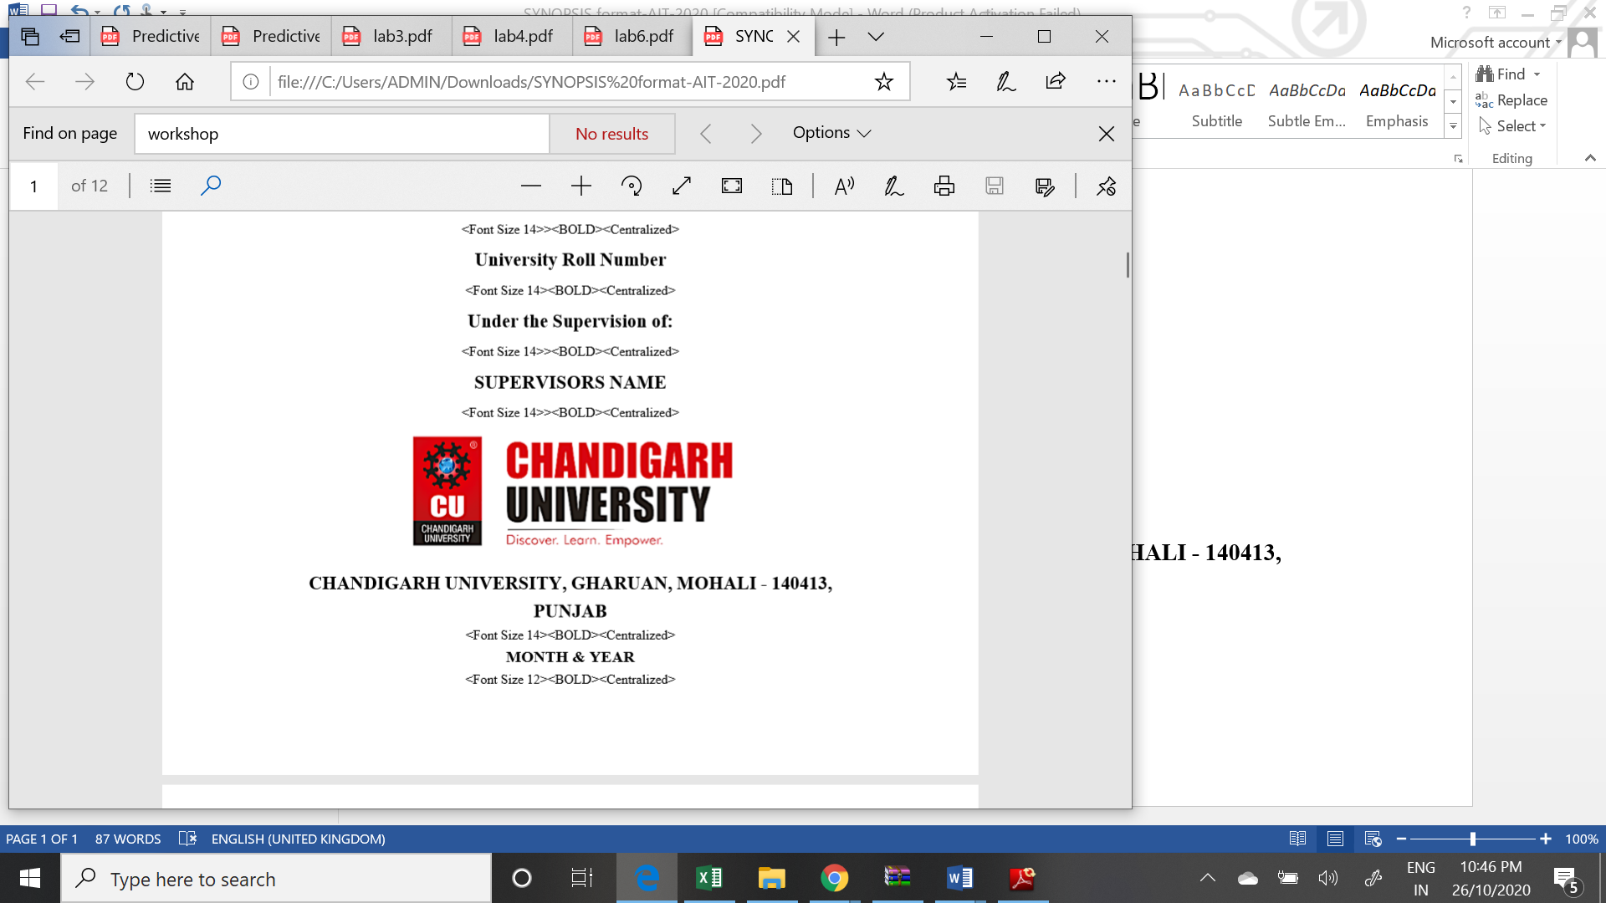

**CHANDIGARH** **UNIVERSITY,** **GHARUAN,** **MOHALI** **-** **140413,** **PUNJAB**

**December, 2020**

Name and signature of student(s)

Name and signature of Supervisor

# 

# PROJECT COMPLETION CERTIFICATE

## Project Title

This is to certify that RISHANK MEHROTRA has successfully completed the project work titled “ CTF PRACTICE GUIDE ” *Submitted* *in* *the* *partial* *fulfilment* *for* *the* *award* *of* *the* *degree of* **BACHELOR** **OF** E**NGINEERING** **IN INFORMATION SECURITY**

This project is the record of authentic work carried out during the academic year

**_____________________**

Project Guide

**Date:**

# DECLARATION

I the undersigned solemnly declare that the project report is based on my own work carried out during the course of our study under the supervision of JYOTI MEHRA. I assert the statements made and conclusions drawn are an outcome of my work. I further certify that the work contained in the report is original and has been done by me under the general supervision of my supervisor.

II. The work has not been submitted to any other Institution for any other degree/diploma/certificate in this university or any other University of India or abroad.

III. We have followed the guidelines provided by the university in writing the report.

IV. Whenever we have used materials (data, theoretical analysis, and text) from other sources, we have given due credit to them in the text of the report and giving their details in the references.

Rishank Mehrotra

19BCS3573

# ACKNOWLEDGEMENT

I have taken efforts in this project. However, it would not have been possible without the kind support and help of many individuals and organizations. I would like to extend my sincere thanks to all of them.

I am highly indebted to Ms Jyoti Mehra for their guidance and constant supervision as well as for providing necessary information regarding the project & also for their support in completing the project.

I would like to express my gratitude towards my parents and my department for their kind co-operation and encouragement which help me in completion of this project.

THANKS AGAIN TO ALL WHO HELPED

**TABLE OF CONTENTS**

Chapter 1: Introduction to project

Chapter 2: Project Requirements (Software/Hardware requirements)

Chapter 3: Implementation Details (Algorithm, code )

Chapter 4: Output Analysis (screenshots)

**INTRODUCTION**

Before giving the brief introduction about the project lets first discuss the motive behind the development of the application. So, what is CTF? To answer the question lets first know the full form of CTF. So **CTF** stands for **Capture The Flag.**

The very first cyber security CTF developed and hosted was in 1996 at DEFCON in Las Vegas, Nevada. DEFCON is the largest cyber security conference in the United States and it was officially started in 1993 by Jeff Moss. DEFCON had become a platform for a skills competition and as the Internet grew, both DEFCON and the CTF competitions did as well. CTF competitions have become global as they did not have any borders and can be done via the Internet. International teams were competing for different types of prizes and bragging rights. There are two formats of the cyber security CTF: attack-defend and Jeopardy-style.

The attack-defend CTF is where each team attacks the other team’s system, as well as defend their own system. Usually, there are two rounds of game play in which one team is the attacking team and the other team is the defending team in the first round and then they switch for the second round. There are flags (text files, folders, images, etc.) in the defending machines that the attacking team attempts to find as they compromise the machines. The attacking team is able to use different hacking tools in order to compromise the defending machines but there are rules in place to ensure that the teams are not at an advantage over the other. The defending team can do anything within the rules to defend their machines against the attacking team. They are not allowed to disable any network connections or turn off the machines. If there is any rule violation, the team will incur a penalty or be disqualified.

So now as you are aware of CTFs its time to know the project. As the need for cyber security experts is increasing day in and day out we have designed an android based application for learning and practising the concepts of Cyber Security by the means of resources and questions available in the application. Anyone who wants to be aware of different aspects of Cyber Security can install the app and learn through it. We have covered “Five“ major topics. They are as follows

* Cryptography
* Forensics
* Miscellaneous
* Web
* Reverse Engineering

For each topic we have provided learning materials by which one can learn the concepts and topic wise questions are also provided to test the knowledge.

**PROJECT REQUIREMENTS**

**Hardware:**

* Pentium IV or above
* 700 MB Hard Disk Drive Space.
* 256 MB RAM.

**Software:**

* Operating System: Windows 7 or later.
* Android Studio

**IMPLEMENTATION DETAILS**

package com.yk.ctfguide;

import androidx.annotation.NonNull;

import androidx.appcompat.app.AppCompatActivity;

import androidx.appcompat.widget.Toolbar;

import androidx.appcompat.widget.ToolbarWidgetWrapper;

import androidx.drawerlayout.widget.DrawerLayout;

import android.content.Intent;

import android.os.Bundle;

import android.view.Gravity;

import android.view.Menu;

import android.view.MenuInflater;

import android.view.MenuItem;

import android.view.View;

import android.widget.Button;

import android.widget.ImageButton;

import android.widget.ListView;

import android.widget.TextView;

public class Homepage extends AppCompatActivity {

    DrawerLayout dLayout;

    ImageButton btguide,btpractice;

    @Override

    public boolean onCreateOptionsMenu(Menu menu) {

        MenuInflater inflater = getMenuInflater();

        inflater.inflate(R.menu.menu, menu);

        return true;

    }

    @Override

    public boolean onOptionsItemSelected(MenuItem item) {

        switch (item.getItemId()){

            case R.id.profile:

                Intent intent = new Intent(Homepage.this,Scoreboard.class);

                startActivity(intent);

                break;

            case R.id.logout:

                Intent intent1 = new Intent(Homepage.this,MainActivity.class);

                startActivity(intent1);

                finish();

                break;

            case R.id.about:

                Intent intent2 = new Intent(Homepage.this, About.class);

                startActivity(intent2);

                break;

        }

        return super.onOptionsItemSelected(item);

    }

    @Override

    protected void onCreate(Bundle savedInstanceState) {

        super.onCreate(savedInstanceState);

        setContentView(R.layout.activity_homepage);

        final Toolbar toolbar = (Toolbar) findViewById(R.id.tbmenu);

        setSupportActionBar(toolbar);

        btguide = (ImageButton) findViewById(R.id.btguide);

        btpractice = (ImageButton) findViewById(R.id.btpractice);

        btguide.setOnClickListener(new View.OnClickListener() {

            @Override

            public void onClick(View view) {

                Intent intent = new Intent(Homepage.this,guide.class);

                startActivity(intent);

            }

        });

        btpractice.setOnClickListener(new View.OnClickListener() {

            @Override

            public void onClick(View view) {

                Intent intent = new Intent(Homepage.this,practice_challs.class);

                startActivity(intent);

            }

        });

    }

}

package com.yk.ctfguide;

import androidx.appcompat.app.AppCompatActivity;

import androidx.appcompat.widget.Toolbar;

import android.content.Intent;

import android.os.Bundle;

import android.view.View;

import android.widget.Button;

public class pr_crypto extends AppCompatActivity {

    private Button q1,q2,q3,q4,q5;

    @Override

    protected void onCreate(Bundle savedInstanceState) {

        super.onCreate(savedInstanceState);

        final androidx.appcompat.widget.Toolbar toolbar = (Toolbar) findViewById(R.id.tbcrypto);

        setSupportActionBar(toolbar);

        setContentView(R.layout.activity_pr_crypto);

        q1 = (Button) findViewById(R.id.base64);

        q2 = (Button) findViewById(R.id.vig);

        q3 = (Button) findViewById(R.id.morse);

        q4 = (Button) findViewById(R.id.subs);

        q5 = (Button) findViewById(R.id.rsa);

        q1.setOnClickListener(new View.OnClickListener() {

            @Override

            public void onClick(View view) {

                Intent intent = new Intent(pr_crypto.this,crypto_q1.class);

                startActivity(intent);

            }

        });

        q2.setOnClickListener(new View.OnClickListener() {

            @Override

            public void onClick(View view) {

                Intent intent = new Intent(pr_crypto.this,crypto_q2.class);

                startActivity(intent);

            }

        });

        q3.setOnClickListener(new View.OnClickListener() {

            @Override

            public void onClick(View view) {

                Intent intent = new Intent(pr_crypto.this,crypto_q3.class);

                startActivity(intent);

            }

        });

        q4.setOnClickListener(new View.OnClickListener() {

            @Override

            public void onClick(View view) {

                Intent intent = new Intent(pr_crypto.this,crypto_q4.class);

                startActivity(intent);

            }

        });

        q5.setOnClickListener(new View.OnClickListener() {

            @Override

            public void onClick(View view) {

                Intent intent = new Intent(pr_crypto.this,crypto_q5.class);

                startActivity(intent);

            }

        });

    }

}

package com.yk.ctfguide;

        import androidx.appcompat.app.AppCompatActivity;

        import android.os.Bundle;

        import android.text.method.ScrollingMovementMethod;

        import android.widget.TextView;

public class Forensic_guide extends AppCompatActivity {

    @Override

    protected void onCreate(Bundle savedInstanceState) {

        super.onCreate(savedInstanceState);

        setContentView(R.layout.activity_forensic_guide);

        TextView textView = (TextView) findViewById(R.id.textView);

        String para = "What is Forensics? \n" +

                " Forensics is the art of recovering the digital trail left on a computer. There are plently of methods to find data which is seemingly deleted, not stored, or worse, covertly recorded. \n" +

                " An important part of Forensics is having the right tools, as well as being familair with the following topics: \n" +

                "      File Formats \n" +

                "      EXIF data \n" +

                "      Wireshark & PCAPs \n" +

                "      Stegonagraphy \n" +

                "      Imaging\n" +

                "      Working of an Operating System. \n" +

                " \n" +

                " Also I recommend using a good binary viewer/editor: \n" +

                "      eg.HxD: https://mh-nexus.de/en/hxd/ \n" +

                " For file and disk carving use linux terminal itself. \n" +

                " \n" +

                " Courses: \n" +

                " Computer Forensics Fundamentals: https://www.udemy.com/course/computer-forensics-fundamentals/ \n" +

                " \n" +

                " Tools and Resources: \n" +

                "      Binwalk\n" +

                "      Volatility\n" +

                "      Binary Viewer/Editor \n" +

                "      Process Explorers\n" +

                "      Disk imagers \n" +

                " \n" +

                " Practice on: \n" +

                "      1. Hackthebox- https://www.hackthebox.eu/home/challenges/forensics \n" +

                " 2. w3challs Forensics Challenges- https://w3challs.com/challenges/list/forensics \n" +

                " 3. CTFlearn Forensics- https://ctflearn.com/challenge/1/browse";

        textView.setText(para);

        textView.setMovementMethod(new ScrollingMovementMethod());

    }}

**OUTPUT ANALYSIS**

***LOGIN PAGE***

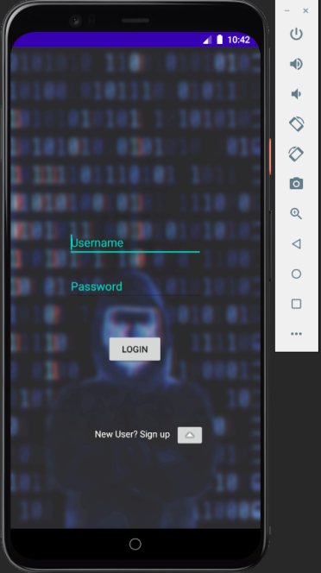

***HOME PAGE***

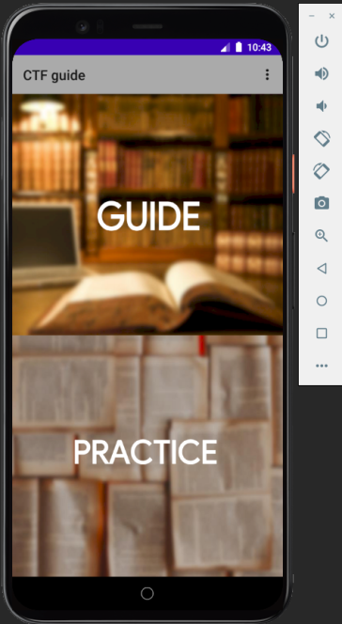

***QUESTION PAGE***

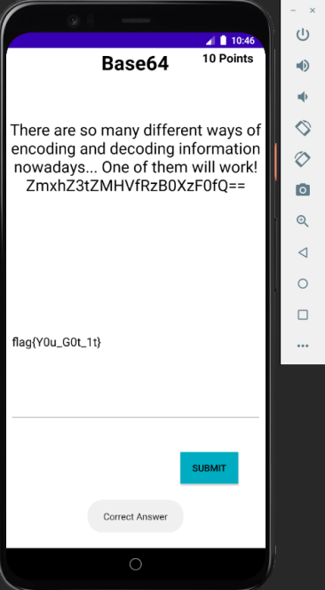

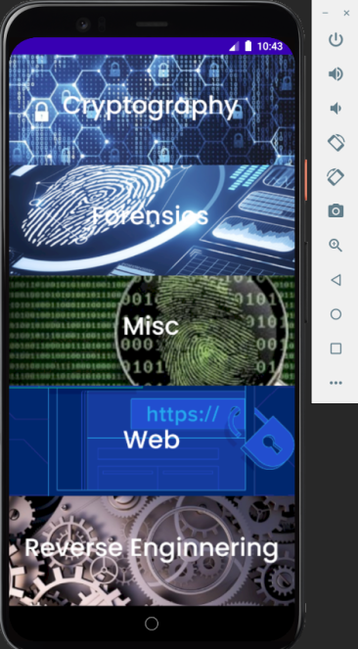***OPTIONS PAGE***

***SCOREBOARD***

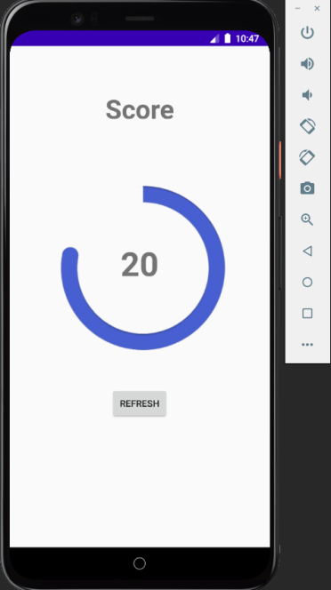

***FORENSICS GUIDE***

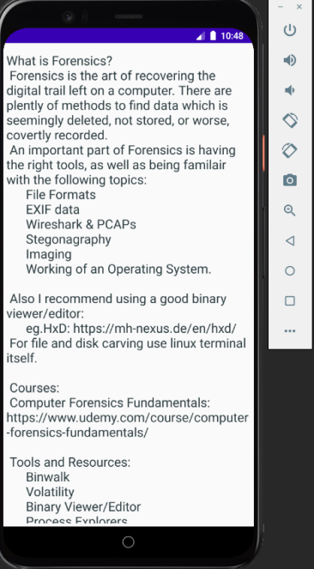

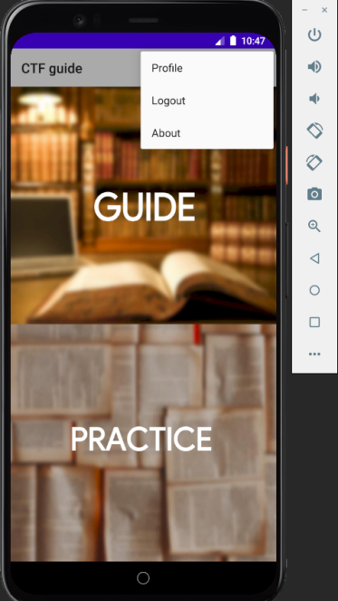***LOGOUT TOGGLE***

***CRYPTOGRAPHY QUESTIONS PAGE***

