**A Formal Report of**

Networks and Networking

for

UCDF2007-AICT003-NWN Assignment

**Lecturer: Ms. Zaireeda Mohd Fauzee**

**Prepared By:**

Choong Wei Jun TP061867

**Prepared On:**

January, 17 2022

### Table of Contents

Table of Contents 2

Introduction 1

Network Topology 2

Justifications of the network topology used 2

LAN Topology 2

WAN Topology 3

IP Addressing Plan 4

Justification of The IP Addressing and Subnetting Scheme Used 4

IP Addressing Table 4

Conclusion 8

Critical Evaluation 8

References 9

# Introduction

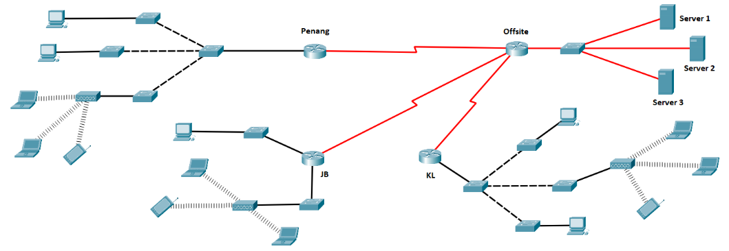

**Figure 1: Topology Design for DigitalSea Inc. Network**

This report is to design and implement an IP Addressing Scheme for the physical network design above given by the DigitalSea Inc. Network. The network give above are connected using both the tree topology and hub topology, it also can be described as hybrid topology since it contains more than one type of topology. By using the VLSM subnetting technique, we should get a network that IP Address collision event rarely or never happen. The IP Addressing Scheme planned in this report met the requirements and scenario of the expected network.

# Network Topology

## Justifications of the network topology used

### LAN Topology

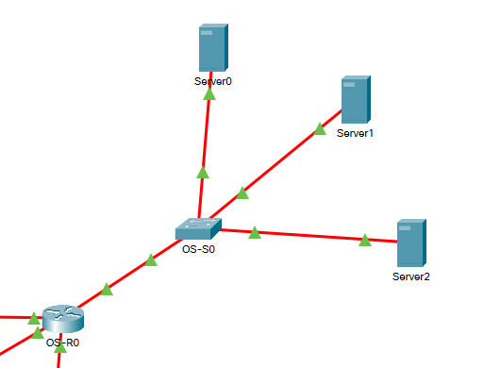

**Figure 2: Lan Topology of The Network**

The LAN of the network is designed with the tree network topology. Tree network topology connections are connected in layers of node and sub-node pattern or one to many pattern. This topology can be understood easily and not getting confused compared to other network topology design. Tree network topology has a high scalability characteristic since it can be scaled horizontally by staking the Tree Network. Unlike the other network topology like hub topology and ring topology, tree topology is more reliable compared to these topology design where if any of the host of the network or the hub of the network are not functioning properly the connection will break down. The hosts in this topology can be maintained without affecting the entire network which bring a lots unexpected trouble. This network topology is relied on the characteristic of how the IPv4 internet protocol designed, hence all most of the hardware should able to works with the network topology design, this can lower the cost of the hardware and get the best combinations of hardware while using the right amount of money. (pulkitagarwal03pulkit, 2020)

### WAN Topology

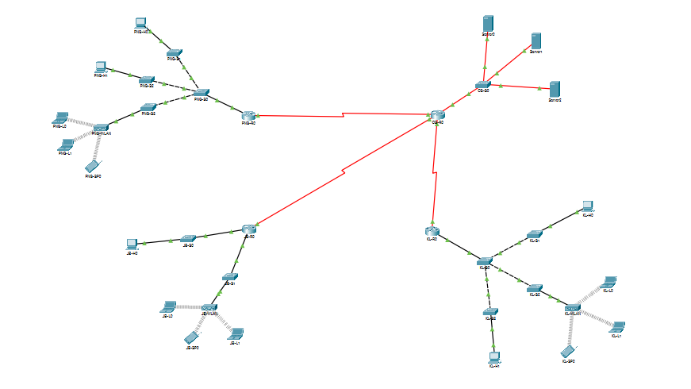

**Figure 3: Wan Topology of The Network**

The WAN of the network is designed with the star network topology or hub network topology. Star network topology are connected in a single master node and the rest of it connect to it or one to many patterns. Overview, star network topology is quite similar to the tree network topology as the LAN. Star network Topology are more likely to be a tree network topology without a higher-level node connected to. The main different of the hub network topology in this network to the tree network topology is that the devices are not stacked together, where they are directly connected to the core node which manage the whole network. Other than that, star network topology is very easy to add additional devices to the network when there are sufficient number of internet interface port or it can be extended with unmanaged switch. The hierarchy of this network topology might get congested if there are large data being transmitted through the network and the hub are not having a sufficient amount of computation power to handle the traffics, but since it’s a WAN most of the data exchanges could be done within the LAN before it gets to the WAN. (pulkitagarwal03pulkit, 2020)

# IP Addressing Plan

## Justification of The IP Addressing and Subnetting Scheme Used

The IP Addressing and Subnetting Scheme technique used is VLSM. The word VLSM stands for the word Variable Length Subnet Mask. VLSM is a technique invented for dividing a group of IP addresses by using more than one subnet mask to subnetting. VLSM subnet mask works in 4 groups of 8bits group, thus cause the characteristics of the subnet mask sub-netted network addresses only come in numbers that are the product of power to the 2. For example, it starts from the smallest size of the network address can be divided into by using VLSM is /32 which require the NAT technique to make the network works since it is only has a single IP Address, and the following are 2, 4, 8, 16, 32, 64, 128 and etc. Subnetting the IP Addresses allow the networking hardware get the internet data packet to the right place faster and more efficient with the help of subnetting. By using subnetting, networking hardware like routers can determine the right and fastest path to the right address faster by checking the subnet mask which save a lot of them than checking the ip from every router on the network before sending the data packet. (pulkitagarwal03pulkit, 2020)

## IP Addressing Table

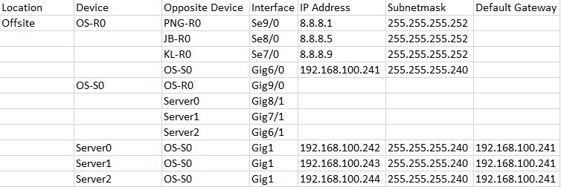

**Figure 4: Table of Offsite IP Addressing and Subnetting Scheme**

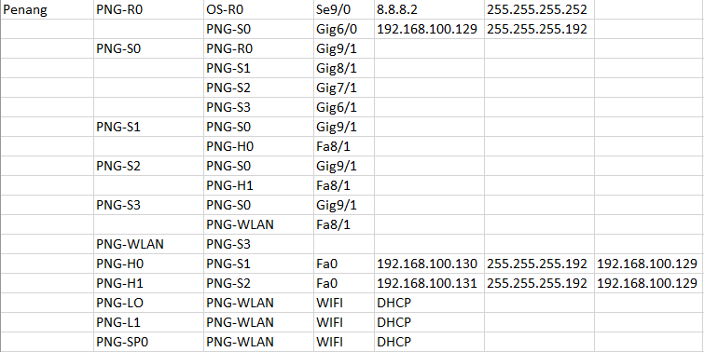

**Figure 5: Table of Penang IP Addressing and Subnetting Scheme**

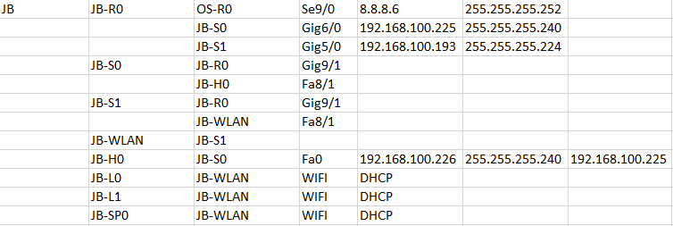

**Figure 6: Table of JB IP Addressing and Subnetting Scheme**

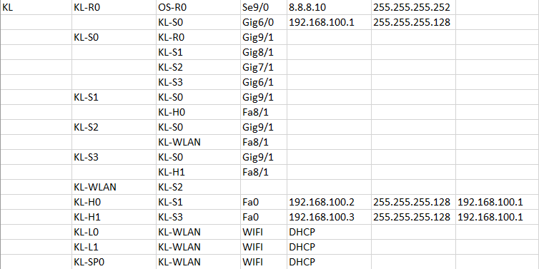

**Figure 7: Table of KL IP Addressing and Subnetting Scheme**

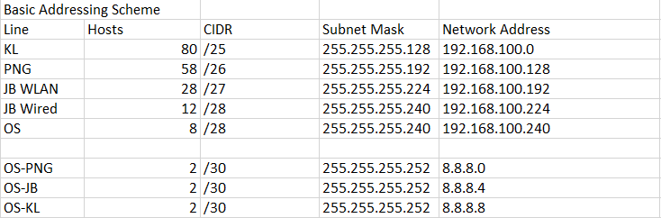

**Figure 8: Table of Subnetting**

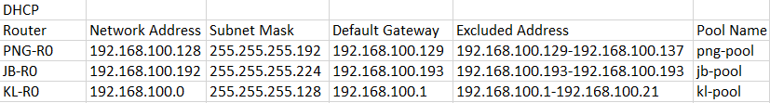

**Figure 9: Table of IP Addressing DHCP Pools**

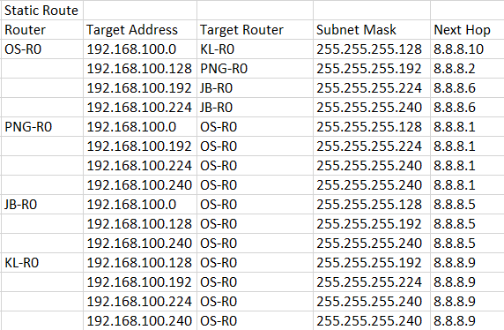

**Figure 10: Table of IP Addressing Static Routes**

# Conclusion

## Critical Evaluation

Since spring up of technology, we human’s everyday life are tightly bonded with the internet technology. Without the technology of internet connection, the human society might get in very serious condition where even our human basic requirement can’t be fulfilled. IP Addressing and Subnetting Technique is a very important technique which structure the foundation of the internet connection today. Without it, the internet will loss it’s ability to determine the route of network addresses accurately.

# References

pulkitagarwal03pulkit, 2020. *GeeksforGeeks.* [Online]   
Available at: https://www.geeksforgeeks.org/advantages-and-disadvantages-of-tree-topology/, https://www.geeksforgeeks.org/advantages-and-disadvantages-of-star-topology/, https://www.geeksforgeeks.org/introduction-of-variable-length-subnet-mask-vlsm/  
[Accessed 17 Jan 2022].