
Lebanese University
Faculty of Science II
Computer science and statistics department

I3333 Project Report
Spring 2025-2026

Night City

Prepared by: Majd Zeid-61050
Yara Rachah-61159

Presented For: Ibtissam Constantin

Problem Description
The core objective of this project was to develop a visually immersive 3D urban environment using a linear isometric projection system. The motivation was to move away from standard perspective cameras and create a "living" metropolis that maintains consistent geometric proportions.
This simulation addresses the challenge of managing a high volume of dynamic entities, such as autonomous vehicles and pedestrians, within a fixed-perspective diorama. A key focus was placed on "Life Simulation": ensuring that the city does not just look 3D, but feels inhabited through randomized lighting, moving traffic, and pedestrians that interact with their environment.

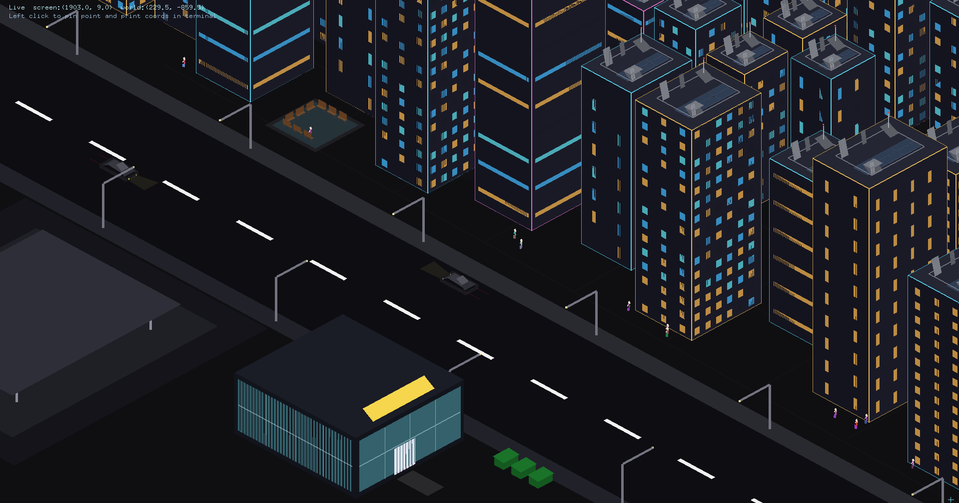Figure 1: Full picture of the city

Methodology
The project is built on the following technical models:
- Linear Isometric Projection Model: The core transformation is handled by a custom project() function that converts 3D world coordinates (x, y, z) into 2D screen coordinates (sx, sy).
  - sx = (x - z) \times 0.866 + (\text{ScreenWidth} \times 0.5)
  - sy = (x + z) \times 0.500 + y + (\text{ScreenHeight} \times 0.3)
- Occlusion and Depth Model: Rather than a simple Painter's Algorithm, the system utilizes a hardware-accelerated Z-buffer (GL\_DEPTH\_TEST).
- A custom depth value sz = -(x + z) \times 0.01 is calculated to ensure that objects further from the camera along both the X and Z axes are correctly occluded by foreground elements.
- Procedural Building System: Buildings are generated as 3D primitives (quads) with structured geometric properties (x, y, z, w, h, d). The system includes a collision detection algorithm (canPlaceBuildingAt) that enforces a minimum spatial separation of 10 units between structures to prevent overlapping geometries.
- Autonomous Traffic System: Vehicles are modeled with a velocity-based state machine, utilizing std::vector<Car> for state management. They spawn in specific lane centers (-105, -45, 45, 105) and move along the Z-axis at randomized speeds.
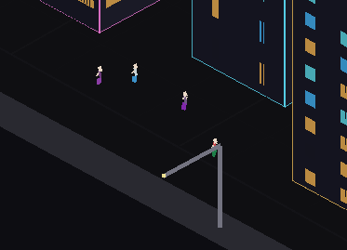Figure 2: Pedestrians walking with path determination and object avoidance

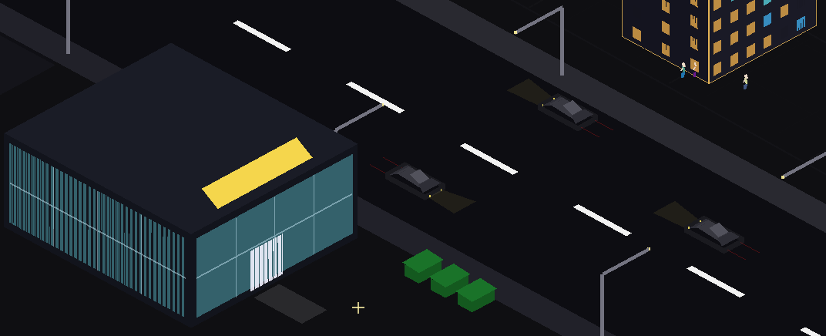Figure 3: cars driving on the road

Experimentations and Results
The following algorithms were implemented to achieve the final simulation:
- Procedural Window Generation: To simulate a "living" city, buildings use three distinct window types. Type 3 buildings employ a color-variation algorithm based on a hash of their coordinates: (row * 73.0 + x * 3.0 + z * 5.0) % 10. This ensures that no two skyscrapers have identical lighting patterns.
- Temporal Animation Logic: A glutTimerFunc is used to maintain a consistent 60 FPS (approx. 16ms intervals). This timer drives the traffic movement.
- Interactive Placement: A Coordinate-Mapping algorithm (screenToWorldGround) was developed to allow for mouse interaction. It reverses the isometric projection to find the 3D world coordinates of a 2D screen click, allowing buildings to be "pinned" accurately to the city grid.

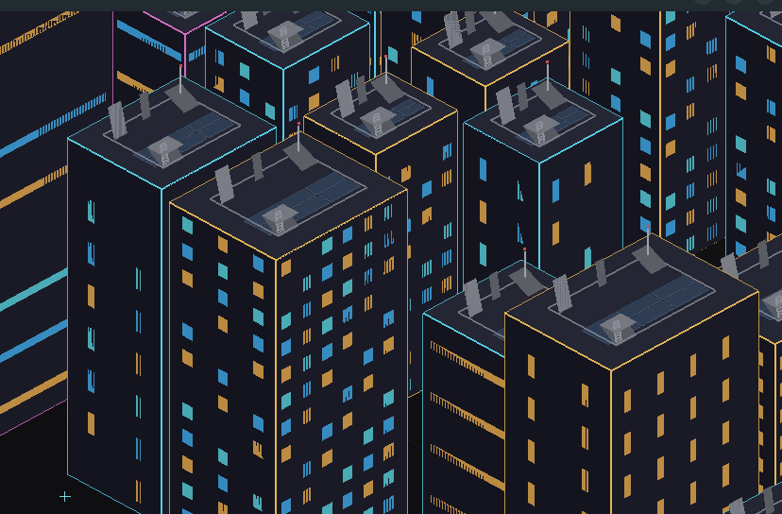Figure 4: Buildings spawning with collision avoidance algorithm and window generation

AI Acknowledgment:
The use of AI (Gemini) was utilized for troubleshooting OpenGL depth buffer artifacts, refactoring the linear isometric projection math, and assisting in the technical structuring of this project report. Final code implementation and scene design were performed by the student.

