# SE3ProjectA User Guide

This program facilitates the booking of seats within a movie theatre. Users are able to specify how many seats they want, what type of seats they want, and where they want those seats to be.

## Choosing a Movie Session

Upon opening the program, you will be presented with a dialog showing which movies and times you can book seats for.

When you select a movies and session time, the seating plan (showing all bookings) for that theatre session will be displayed on the left side of the window and a list of theatres showing that movie at that time will appear below.

When you are happy with your choice of theatre session, press “Select Tickets” to move to the next stage.

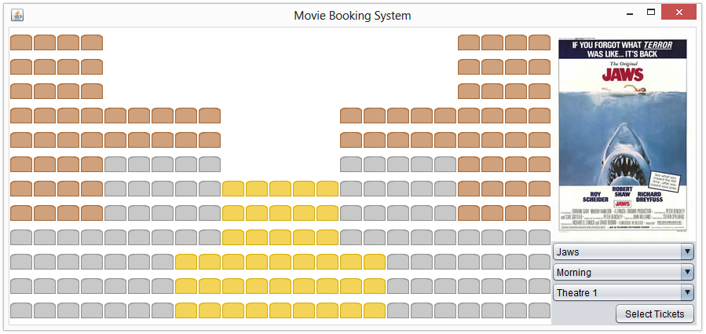

## Selecting Tickets

Once you have chosen your movie, click the "Select Tickets" button, which will take you to another screen showing which types of tickets you can book. For example, you might want to choose tickets in "Gold" seats for children.

You may choose seats from multiple sections and for multiple people; e.g. by pressing the "+" button, another row will appear for further data entry.

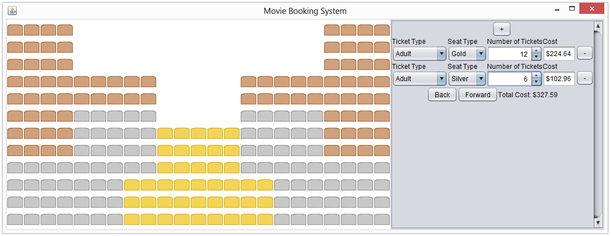

Once you have chosen how many seats you want and of what type, click the "Forward" button. If you have chosen more seats of a certain type than there are available (e.g. chosen 20 gold seats when there are only 10 empty gold seats in the theatre), you will be asked to change your chosen number of seats.

## Placing Seats

The next page allows you to choose where your seats are.

One way to place seats is to click the empty seats you want left of the window. A person will appear in them, indicating that you have chosen them. If you wish to unselect this seat, click the seat again and it will show an empty seat again.

The counters on the right will reflect how many more seats you have to place. In the below image, the user must place six more silver seats before they can continue.

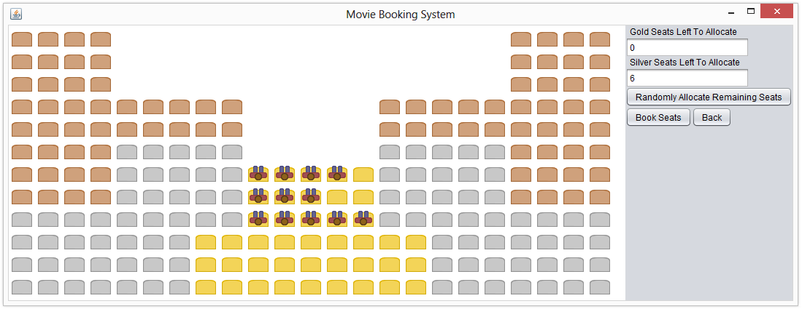

There is also a button shown on the right, labelled "Randomly Allocate Remaining Seats". Pressing this button will randomly choose a location for every seat you haven’t placed manually.

When you use the random allocation tool, the program will try to keep your seats together, however, they will be placed separately if they're of different types (e.g. gold and silver seats may not be together) or do not fit together.

The following seats were placed entirely using the random allocation tool. Note that the gold seats were broken up, as there was no row in which they could all fit.

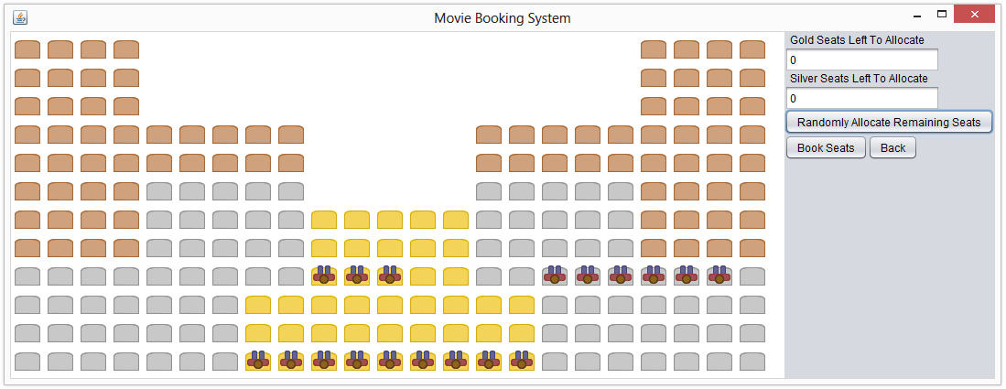

If you wish to change the number of seats you ordered, press the back button. Be aware that this will cause the placement of your seats to be lost, and you will have to place them again.

## Finalizing

Once all seats have been placed, you may click the "Book Seats" button to finalize your booking. The seats will be greyed out, and you will not be able to modify them any further. You can now create other bookings.

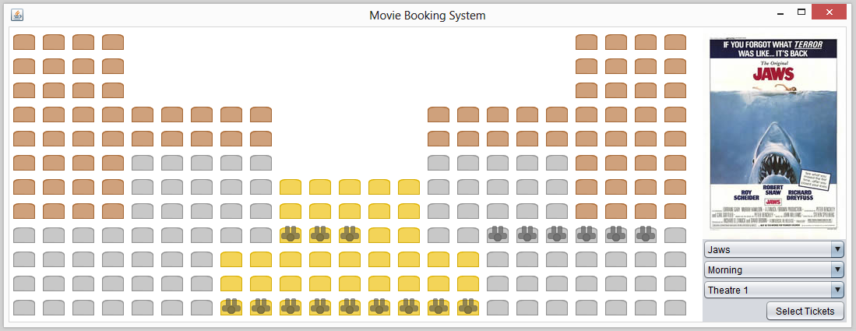

Bookings will be saved when you exit the application.