Guide Name |  | Panel Head
 | Mr. M. Arul Prakash | Ms. J. Jaya Pradha
 | Faculty Advisor(s) | Project Domain
 | Mr. M. Arul Prakash | Mobile Crowd Sensing
 | Student(s) Details: Name | Passport size photo(s)
 | - M. Sri Roshitha  - Ankita Pal |   

Registration Number(s)
- RA1711003010276
- RA1711003010611

Email ID(s)&Mobile Number(s)
mm8724@srmist.edu.in | aa1238@srmist.edu.in
+91 7901237436 | +91 7490054195

Abstract Architecture Diagram
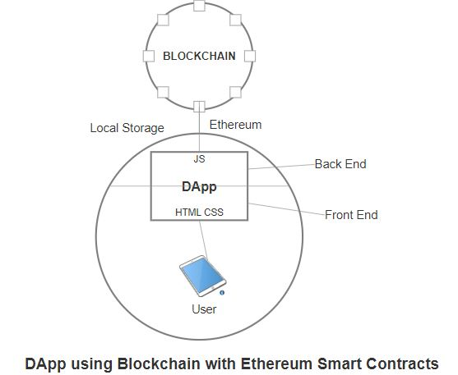
The smart factory is a representative element reshaping conventional computer-aided industry to data-driven smart industry. Data-driven industrial systems rely on sensory data collected from sensors. Advances in sensing and computing have paved the way for the emerging paradigm of Mobile Crowd Sensing. However, the existing mobile crowdsensing models are mostly based on a centralized platform, which is not fully trusted in reality and results in the existence of fraud and other security problems. The goal is to implement a mobile crowdsensing (MCS) systems which address security threats such as jamming, spoofing and faked sensing attacks during both sensing and information exchange processes in large-scale dynamic and heterogeneous networks.

Significance of the Project Conclusion
The main objective of this report is to develop a decentralized crowdsensing system that replaces the conventional triangular architecture. We aim at leveraging the Ethereum smart contracts by which security attacks like DDos, false reporting and single point of failure attacks can be efficiently prevented.

In conclusion, we proposed an architecture for a decentralised application of the Mobile Participatory Crowdsensing paradigm based road sensing system. We realized that the conventional crowdsensing architecture suffers from single point of failure threat. We leveraged Ethereum Smart Contract deployed on Blockchain technology. The proposed architecture exercises smart contracts that enable crowdsensing providers to proffer their requests and run an action to ascertain the most fitting mobile users engaged in administering the crowdsensing tasks.

Conference/Journal Publication Details (If Any)
Paper Title: Secure Mobile Crowd Sensing using Blockchain
Journal Name: Springer Journal, E-ISSN-
Paper ID:

