­

Team: Velocity-X

By:

PLACE YOUR TEXT HERE

01

03

02

Resilient, transparent, and trusted supply chain:

LedgerLink

Hackfest-Advaita

Tradability

Transparency

Traceability

Supply Chain Management

System

Blockchain Based

Problem Statement:

The problem with traditional supply chain management systems is that they lack transparency, efficiency, and are vulnerable to fraud. This occurs due to the reliance on a centralized database, which can be easily compromised, and multiple intermediaries that can obscure the flow of goods and services.

It can be difficult to trace the origins and movements of goods, making it hard to ensure that goods are coming from reputable sources and are being handled properly. Supply chain data can be vulnerable to tampering or unauthorized access, which can lead to errors or fraud also it has limited visibility into each other's operations, making it hard to coordinate and optimize the supply chain as a whole. It can be difficult to gain real-time visibility into the end-to-end supply chain which can make it difficult to identify and resolve issues in a timely manner.

* According to a study by Accenture, supply chain disruptions can cost companies an average of $1.75 billion annually.
* Another study by Gartner found that supply chain disruptions can result in a loss of revenue of up to 20% for affected companies.
* According to a survey by the World Economic Forum, nearly 60% of companies reported experiencing a supply chain disruption in the past year.
* A report by the World Customs Organization estimates that counterfeit goods account for up to 5% of global trade, with a value of nearly $500 billion per year.
* According to a study by DHL, the average number of intermediaries in global supply chains is now around 15, which increases the complexity and inefficiency of supply chain management.
* A survey by Deloitte found that 69% of supply chain professionals believe that their organizations are only moderately prepared to handle supply chain disruptions.
* A report by the World Bank, states that about 30% of trade finance applications are declined due to lack of proper documentation and traceability.

These statistics demonstrate that current supply chain management systems are facing significant challenges, including inefficiency, disruptions, fraud and lack of traceability, which are having a significant impact on business operations and bottom line.

What is the supply chain?

Practically every product that reaches an end-user represents the cumulative effort of many organizations and stakeholders. These are referred to collectively as the supply chain.

Organizations within a supply chain are linked through physical and information flows:

* **Physical flows** involve the transformation, movement, and storage of goods and materials
* **Information flows** involve the coordination between partners to control the day-to-day flow of goods and materials up and down the supply chain; it also involves long-term planning.

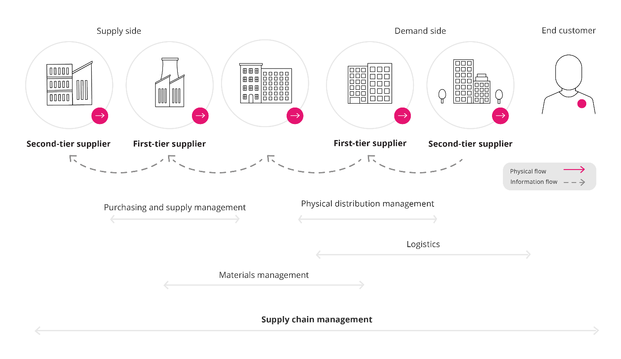

The management of the product development, sourcing, procurement, production, and logistics of raw materials, products, and finished goods from one point to another is called supply chain management (SCM). Effective supply chain management can lower costs, speed up production cycles, and mitigate risk.

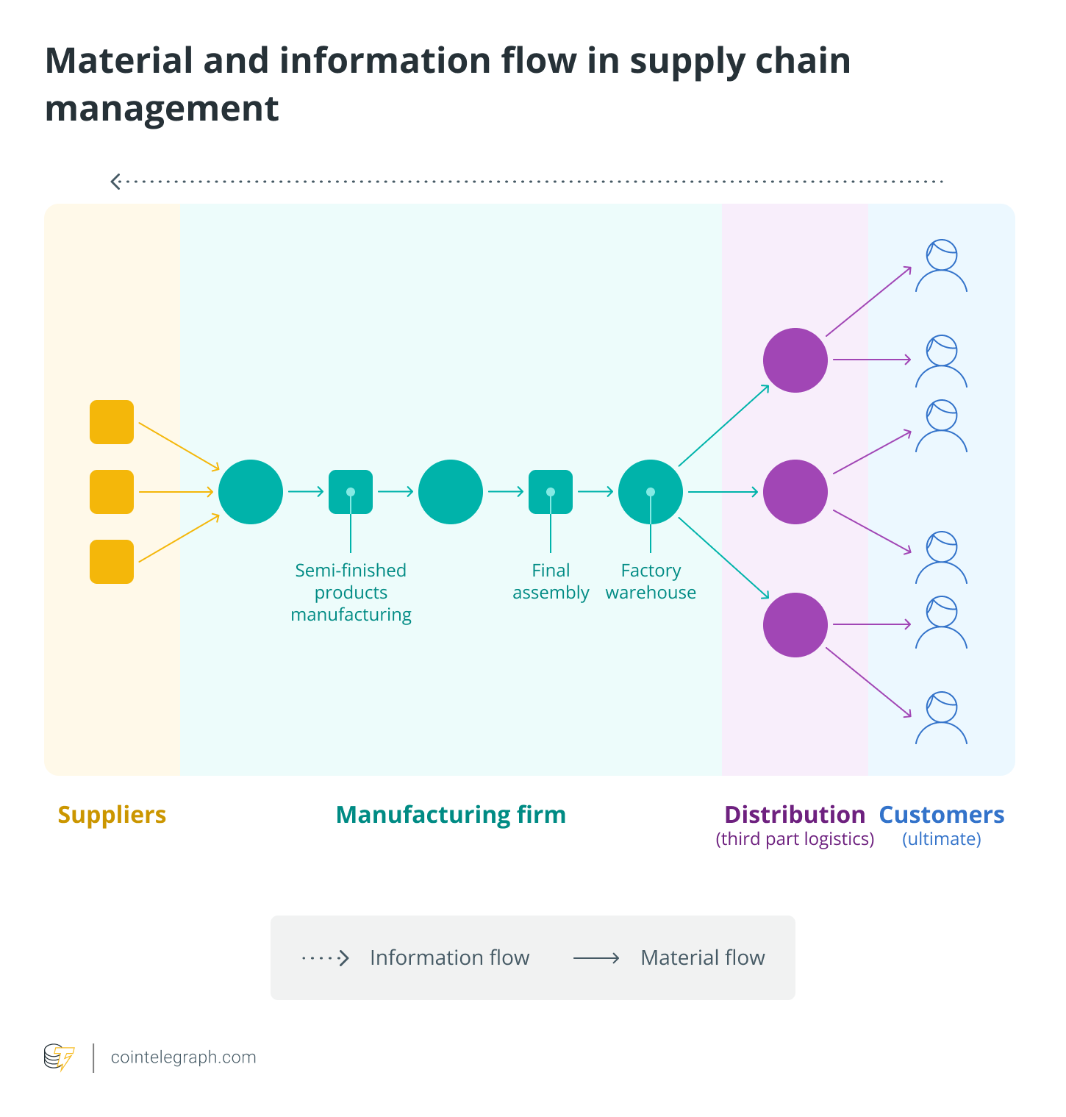

On the contrary, modern SCM systems are managed using software from the creation of goods and services, warehousing, inventory management, order fulfillment, information tracking and product/service delivery to after-sales services. For instance, numerous robotic and automated technologies are used by Amazon to stack and store goods, as well as to pick and pack orders.

How does blockchain work?

Blockchain is a form of distributed ledger technology that holds records of digital data or ‘exchanges’ in a way that makes them tamper-resistant. When a transaction is requested on the system, it’s broadcast to a peer-to-peer network comprising several interconnected computers called nodes. Each of these solves equations to check and validate the transaction for consistency across the network. Once validated, the transaction is grouped with other transactions to create a block of data for the ledger.

Businesses can use blockchain technology to track any transaction, making it possible to share documents, personal information, and cryptocurrencies. Because the ledger is fully distributed across the network, it’s very difficult to corrupt. To make a change in the ledger, you’d have to log the change on every node across the entire network simultaneously. If this isn’t done, the network recognizes that one record doesn’t match the rest and flags the transaction as corrupt.

Think of the technology as resembling a Google document, where many people can view and edit the same document simultaneously, instead of a Word document that’s locked and owned by one person. Every node on the network can access and make changes to the system simultaneously, with ‘Track Changes’ always on.

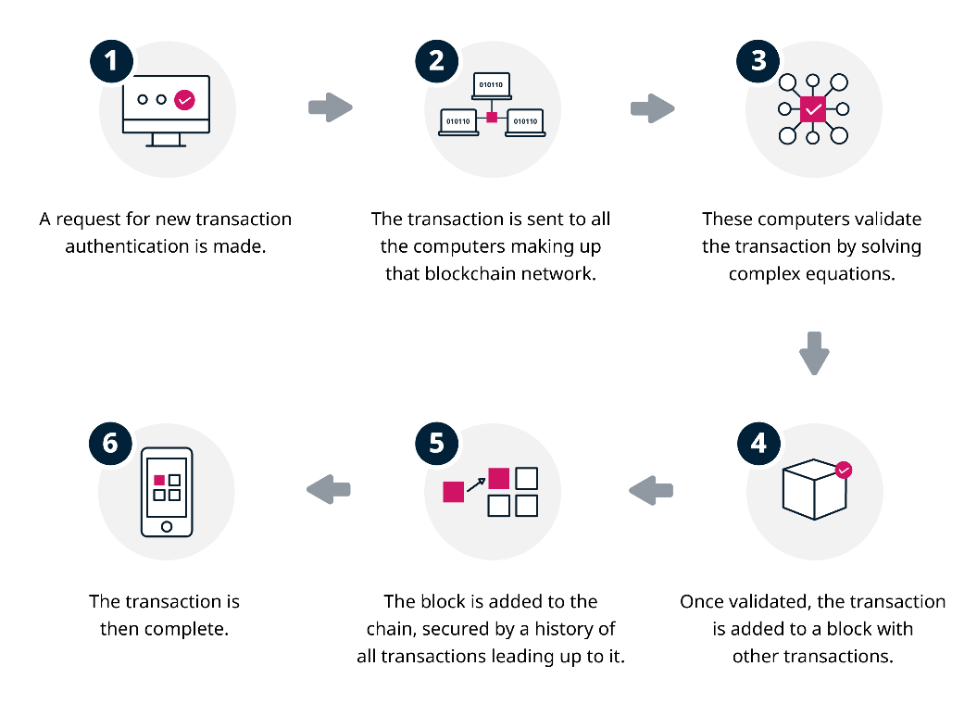

How does blockchain technology improve supply chain management?

Unlike traditional supply chains, blockchain-based supply chains will automatically update the data transaction records when a change is made, enhancing traceability along the overall supply chain network.

Blockchain-based supply chain networks might need a closed, private and permissioned blockchain with limited actors, in contrast to Bitcoin and other financial blockchain applications, which may be public. However, the possibility of a more open set of partnerships may still exist.

In blockchain-based supply networks, four key actors play roles, including registrars, standard organizations, certifiers, and actors:

* Registrars: They provide network actors with distinct identities.
* Standard organizations: These organizations develop blockchain rules and technical specifications or standards schemes, such as Fairtrade, for environmentally friendly supply chains.
* Certifiers: They certify individuals for involvement in supply chain networks.
* Actors: A registered auditor or certifier must certify participants or actors, such as producers, sellers and buyers, to retain the system’s credibility.

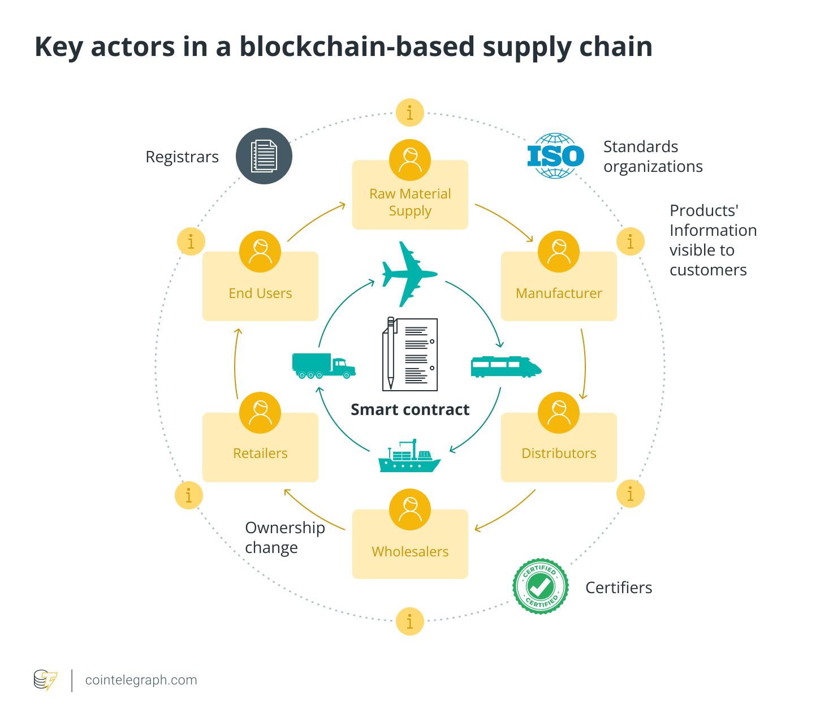

How a product is “owned” or transferred by a specific actor is an intriguing feature of structure and flow management and among the benefits of blockchain in supply chain management. But does blockchain make supply chain management more transparent?

As the concerned parties are required to fulfill a smart contract condition before a product is transferred (or sold) to another actor to validate the exchange of goods or services, and the blockchain ledger is updated with transaction information after all participants have complied with their duties and processes, overall transparency across the value chain is improved.

Additionally, the nature, quantity, quality, location and ownership product dimensions are transparently specified by blockchain technology. As a result, customers can view the continuous chain of custody and transactions from the raw materials to the final sale, eliminating the requirement for a reliable central organization to administer and maintain digital supply chains.

Solution: Blockchain Based Supply Chain Management System

Blockchain-based Supply Chain Management System (SCMS) is a decentralized system that uses blockchain technology to track and manage the flow of goods and services. It enables the creation of a tamper-proof, transparent and immutable record of all transactions throughout the supply chain, from the point of origin to the end consumer.

It allows for real-time tracking of products, reducing the need for intermediaries, and increasing efficiency. Smart contracts can also be used to automate certain processes and reduce the need for manual intervention, further increasing efficiency. In addition, a Blockchain-based SCMS can also enhance security by providing a tamper-proof record of all transactions, and ensures authenticity by providing traceability of products from the point of origin to the end consumer.

* According to a report by Accenture, blockchain technology has the potential to add $1.76 trillion to the global economy by 2030 by improving supply chain efficiencies.
* According to a study by IBM, blockchain technology can reduce supply chain finance costs by up to 30%.
* Another study by PwC found that blockchain technology can improve supply chain traceability by up to 90%, reducing the risk of fraud and counterfeit goods.

These statistics indicate that the implementation of blockchain-based supply chain management systems could bring significant benefits in terms of cost savings, improved efficiency, increased traceability, and reduced fraud.

What is Track and Trace?

In the supply chain industry, track and trace refers to the ability to identify the past and present locations of all product inventory, as well as a history of product custody. Track and trace require following products through a complex journey from raw material, through multiple geographic regions for processing and manufacturing, through regulatory control, and finally, to retailers and consumers. Tracking provenance throughout this journey is crucial to ensuring product authenticity.

Track and trace are often a challenge for today’s supply chains due to outdated paper processes and disjointed data systems that slow down communication. The lack of data compatibility exposes supply chains to problems like visibility gaps, inaccurate supply and demand predictions, manual errors, counterfeiting, and compliance violations.

Track and Trace with Blockchain

Blockchain technology can be used to build applications on which multiple parties can transact directly via a peer-to-peer network, without the need for a central authority to verify transactions. Each network participant has access to a shared ledger that immutably and cryptographically records all transactions, and there is no single network owner.

With blockchain, supply chain companies can document production updates to a single shared ledger, which provides complete data visibility and a single source of truth. Because transactions are always time-stamped and up to date, companies can query a product’s status and location at any point in time. This helps to combat issues like counterfeit goods, compliance violations, delays, and waste. In addition, immediate action can be taken during emergencies (e.g., in the case of product recalls), and regulatory compliance is ensured by the ledger audit trail. Moreover, by combining blockchain with smart technology like Internet of Things, supply chains can automate tracking the conditions of production, transportation, and quality control. Companies can also choose to share track and trace data with their customers as a way to verify product authenticity and ethical supply chain practices.

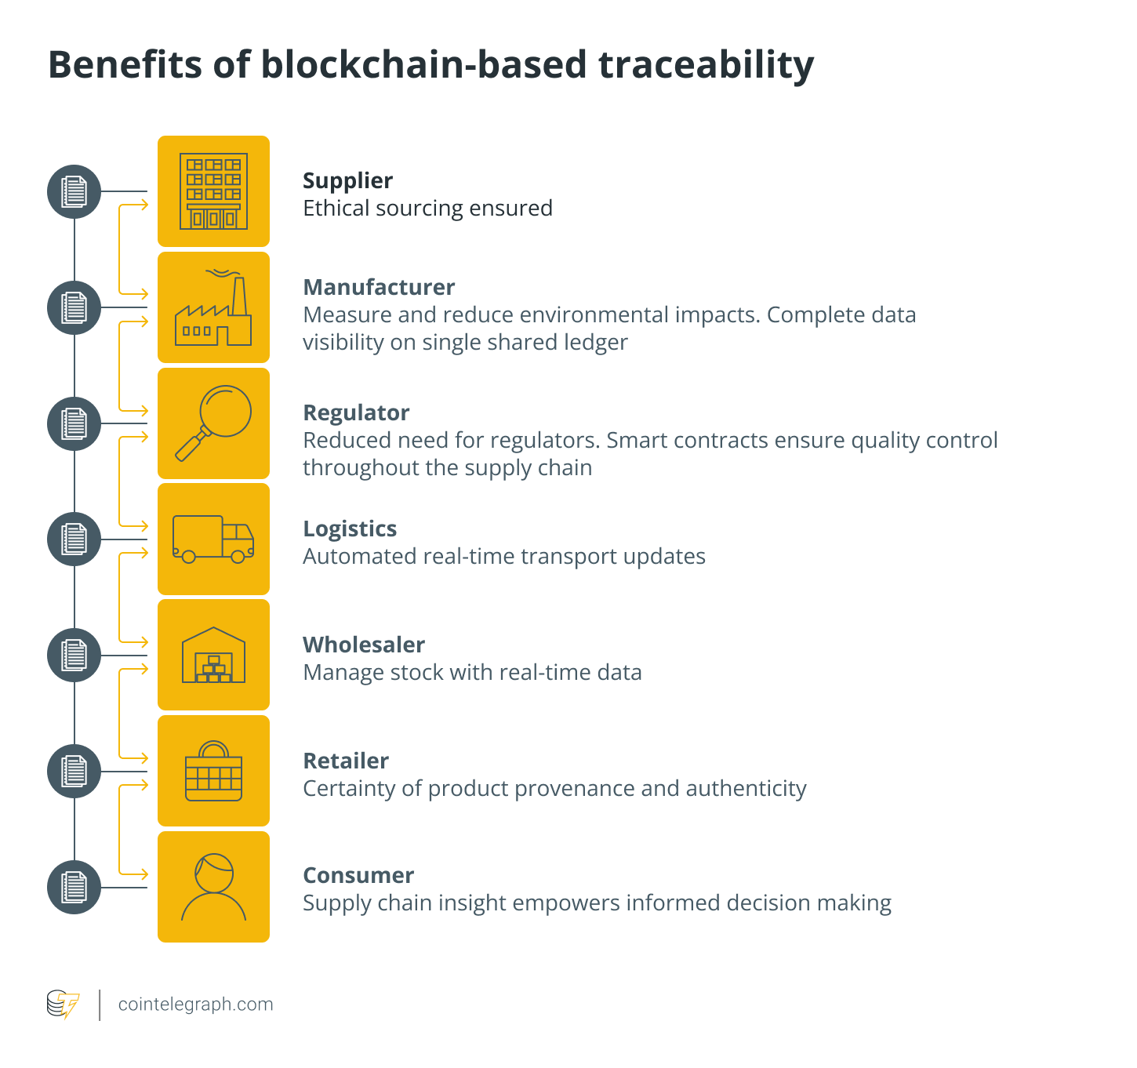

Supply Chain Challenges

### No universal database

Despite the fact that our world has become interconnected, various organizations are still keeping their database confined to themselves. All the teams are making their individual records and sharing with each other only on request. A result of this is that there are various communication gaps between any two parties, which benefits the exploiters.

### Inadequate assets traceability

Another challenge found in supply chain management is the inability to trace assets. They have introduced the finest of equipment and processes for keeping an eye on inhouse activities, but no such method to trace the state of products once out for delivery. This is making it easier for exploiters to replace the original product with ‘lookalike’ counterfeit ones.

### Undue costs

Since every team creates and maintains an individual database of data, they often invest their efforts and capital into gathering the same information again and again. This brings a drastic rise in the associated cost.

### Lengthy quality analysis process

Because of discontinuity in the current SCM process, it is an extensive and expensive task to determine at which point the quality has been compromised, or the product has been replaced. Additionally, because of a centralized structure, company’s processes are generally exposed to multiple risks like code of conduct violations and frauds – highlighting the dire fact that there is a lack of effective risk management process in supply chain systems.

Inefficient supply chain risk management

The company’s processes are usually exposed to different types of risks, such as fraud and code of conduct violations. Effective risk management programs are essential to effective supply chain management. Blockchain allows accurate product tracking, which helps predict many risks in the chain and lets all participants act appropriately.

Lack of end-to-end visibility

The lack of transparency can cause cost and customer relationship issues, which can negatively influence a brand name. Blockchain technology offers a solution that the product provides provenance tracking. The system participants, including suppliers, manufacturers, couriers, and end-customers, are permitted to access this information, which helps to establish trust between them.

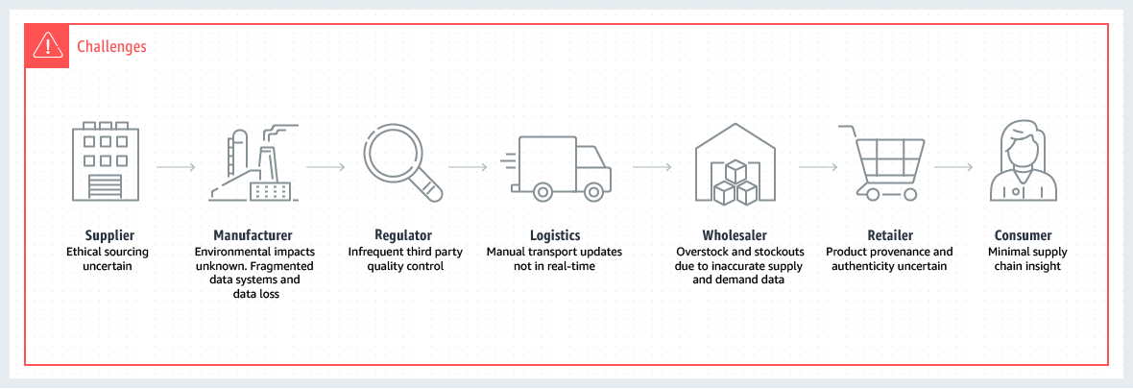

Blockchain Appliances in Supply Chain Management

### Effective tradability

Blockchain in supply chain enables efficient licensing and ownership. By the help of smart contracts, blockchain can be applied to accurately license services, software, and products. Additionally, blockchain offers consensus – that means there is no dispute in chains related to the transactions by designs. All the entities present on the blockchain have the same ledger version added with the potential to track the ownership records.

### Healthy customer relationships

With the help of Blockchain, consumers are able to know everything about the product they are using. Blockchain for order management plays a huge role in elevating customer experience by making the process of order tracking transparent. Additionally, customers are able to check the genuinity of their products. This is shaping a sense of trust among the consumers and the respective brands.

### Faster processing

Even though supply chains can handle complex and large data sets a number of the processes, specifically ones belonging to lower supply tiers are slow and heavily dependent on paper – something that is very common in the shipping industry. What worsens the process further is the presence of intermediaries. By replacing third-party intermediaries and elimination of the dependency on pen and paper with Smart Contracts, Blockchain also cuts down the operation time.

### Real-time tracking

A Blockchain-powered supply chain management process operates within the characteristics of transparency and decentralization. This makes it easier for one to be familiar with every activity going around at any point in time. The benefit of this is not just evident in the manufacturing sector, but also in how blockchain makes the fashion industry transparent.

### Strengthening traceability

Growing demand and regulations around provenance information is driving considerable change in the supply chain domain. Better traceability through inclusion of blockchain technology in supply chain leads to an added value created by mitigation of high cost of quality-related issues like reputational damage, recalls, and revenue loss because of gray or black-market products.

### Consensus and permission

Blockchain is often explained as “one version of the truth” for each product. It is a system of records that is aimed to capture proof of money transactions like bills of lading and money transactions. It covers all stages of the supply chain – from serialization, and shipping to receiving and installation – each is tracked automatically. This system is absolutely built on principles of trust, transparency, and audibility. All participants have access to the same information. In case, if one of the participants endeavors to perpetrate fraud, then he/she is automatically out of sync with a system and identified as a threat. It works as an effective deterrent to malware behavior.

### Transparent transactions

Now all transactions can be maximally transparent anywhere in the world – no need to use traditional banking. Money transfers can be easily made between a payer and payee within a few minutes. You need no longer wait for days since with a Blockchain-based system, and everything happens much faster and safer.

### Monitoring of product conditions

Some kinds of products, like food or medicines, are susceptible and have specific needs. The product storage conditions, such as temperature, humidity, or vibration, can be recorded by sensors and stored on a Blockchain. If one of the parameters deviates from a norm, then it will be immediately tracked by the Blockchain participants. In this case, a smart contract can automatically solve a problem by triggering needed actions.

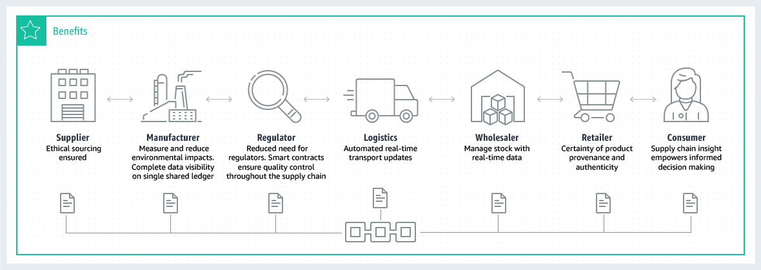

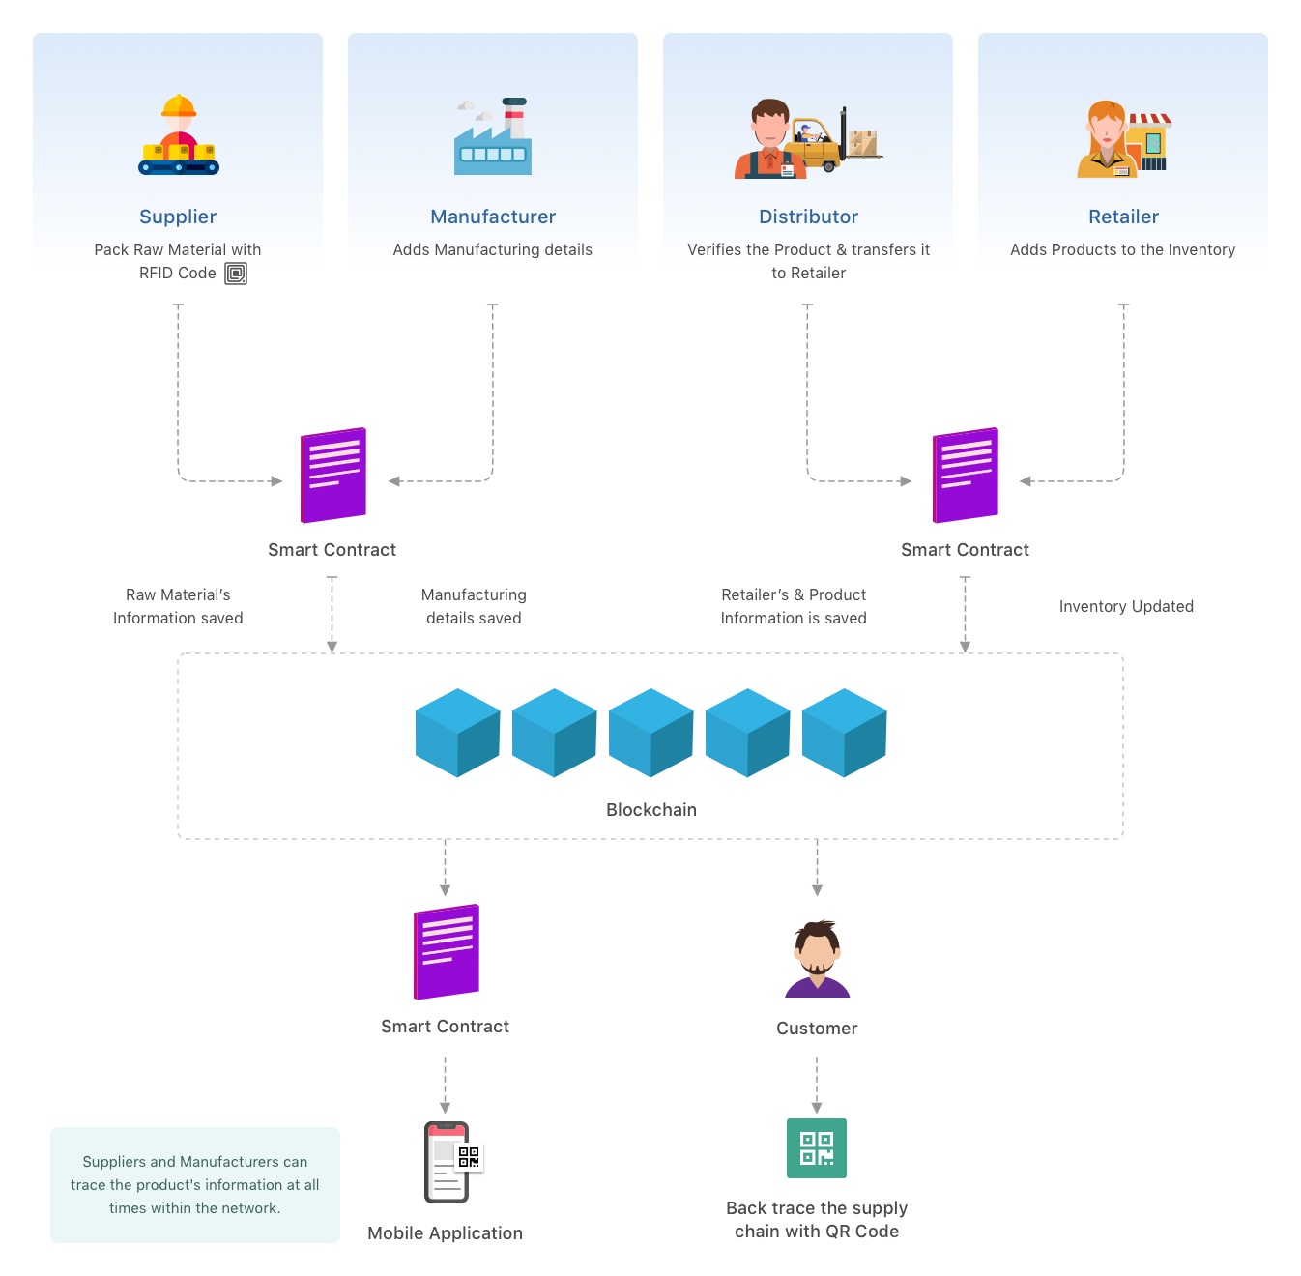Prototype/Demo

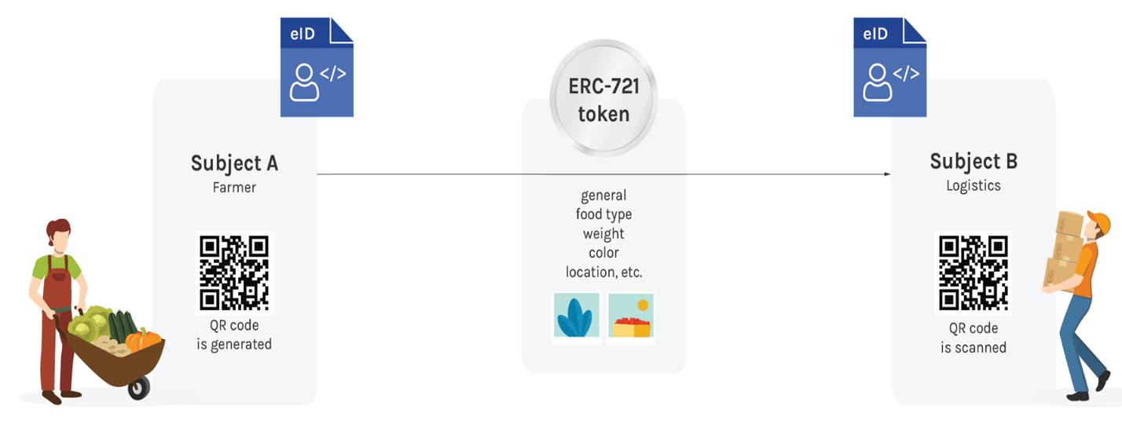

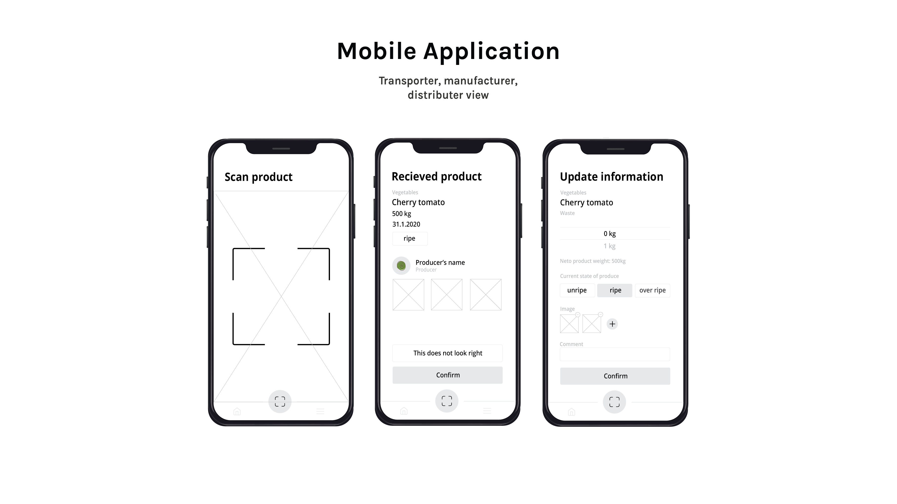

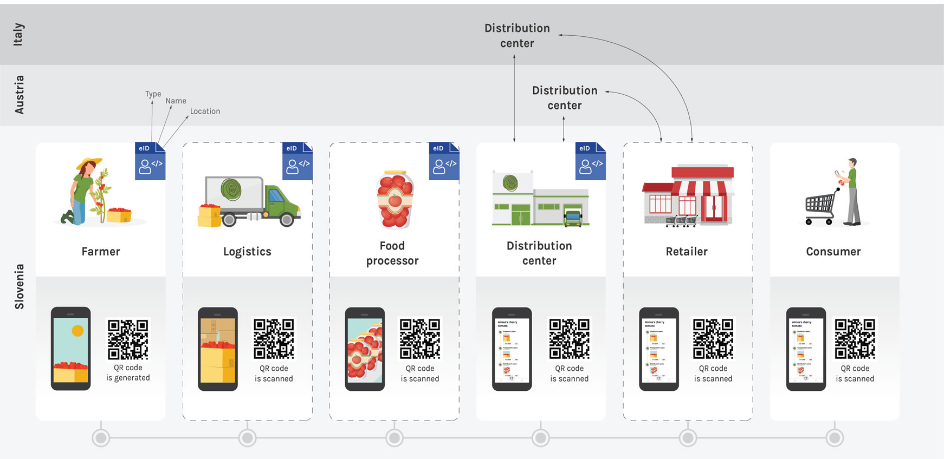

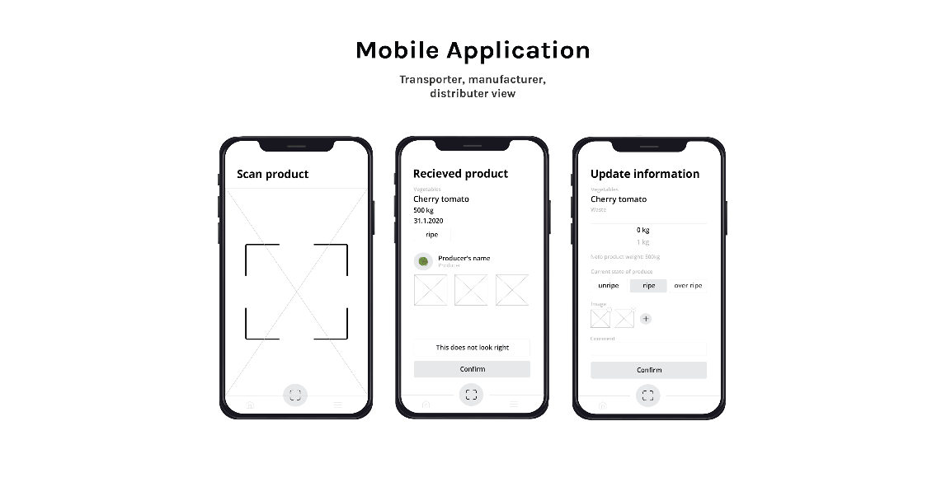

Architecture

The smart contract is being written with Solidity which is then compiled, migrated and deployed using Truffle.js on the local blockchain network created using Ganache-cli. The frontend uses Web3.js to communicate with the smart contract and local blockchain network and is written using React.js framework for better component and state lifecycle management. The requests from user are forwarded to frontend through Nginx (load balancer) and Express.js for dynamic routing.

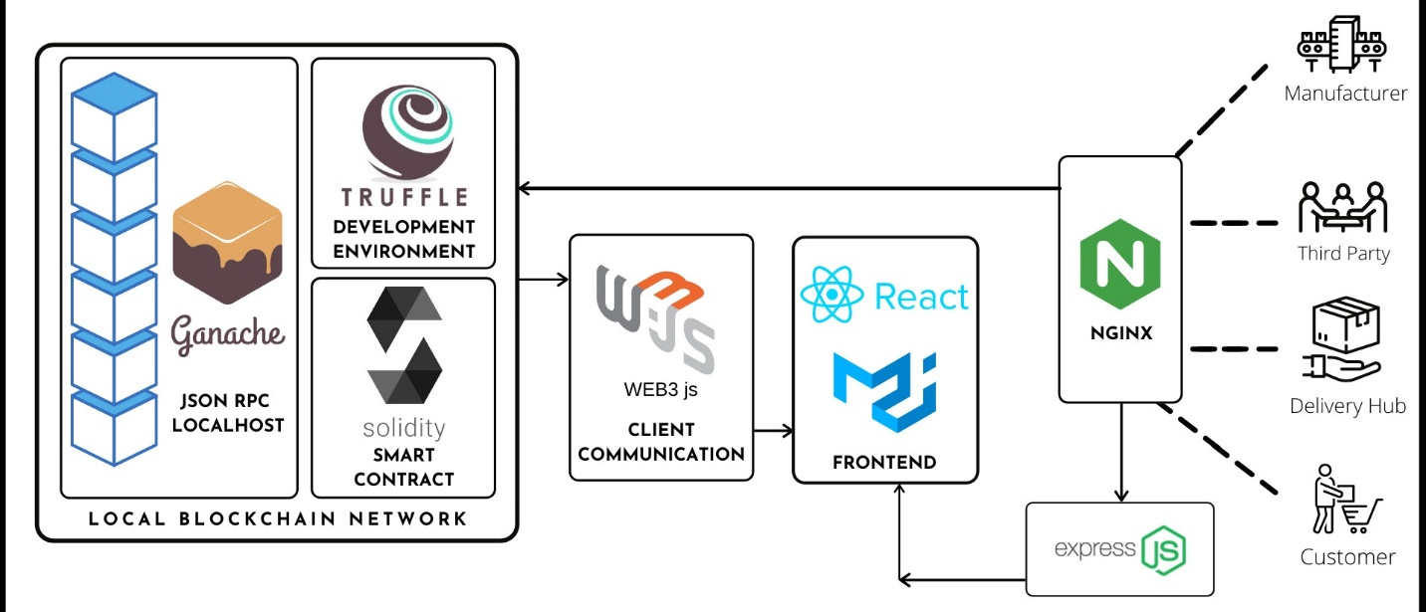

Methodology

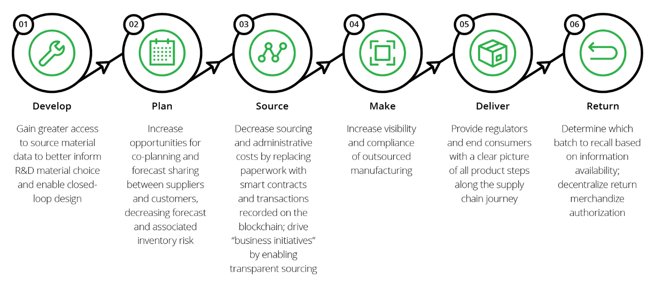The proposed methodology utilizes blockchain technology through the functionality of dedicated type of smart contract that was developed based on a special-purpose structure. The latter provides encryption, and hence, secured transmission of data. All transactions recorded and verified on the blockchain cannot be reversed, hacked or deleted. The main purpose of the proposed dApp is to allow users to securely send and track items on the blockchain and then share them with others. For the design of the dApp, we first used the Solidity language for the implementation and deployment of the smart contract on the Ethereum ledger, and then we utilized the Web3.js library, which is a collection of modules that contain unique functionalities for the Ethereum framework, to develop a user-friendly interface that allow users to easily interact with the smart contract.

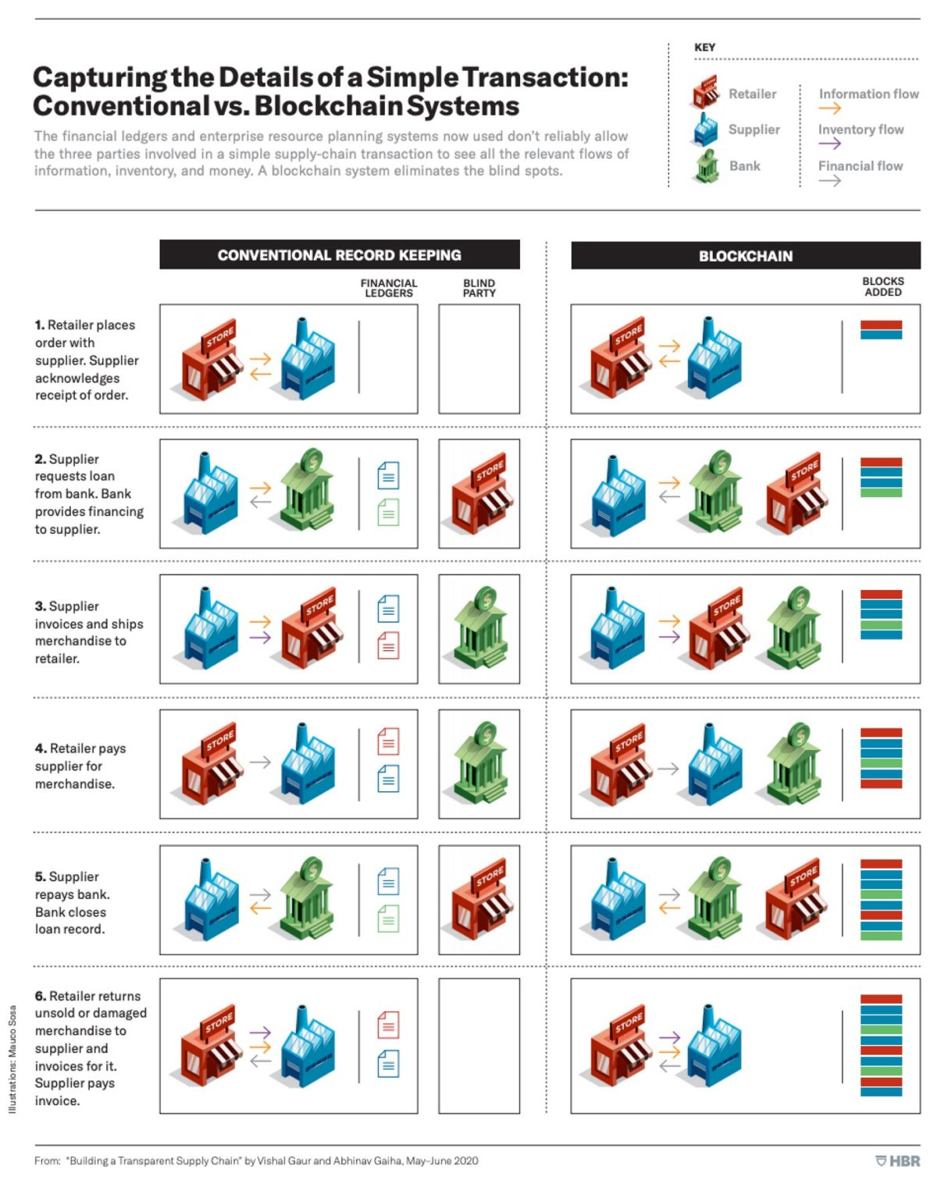Flow

Data Flow Diagram

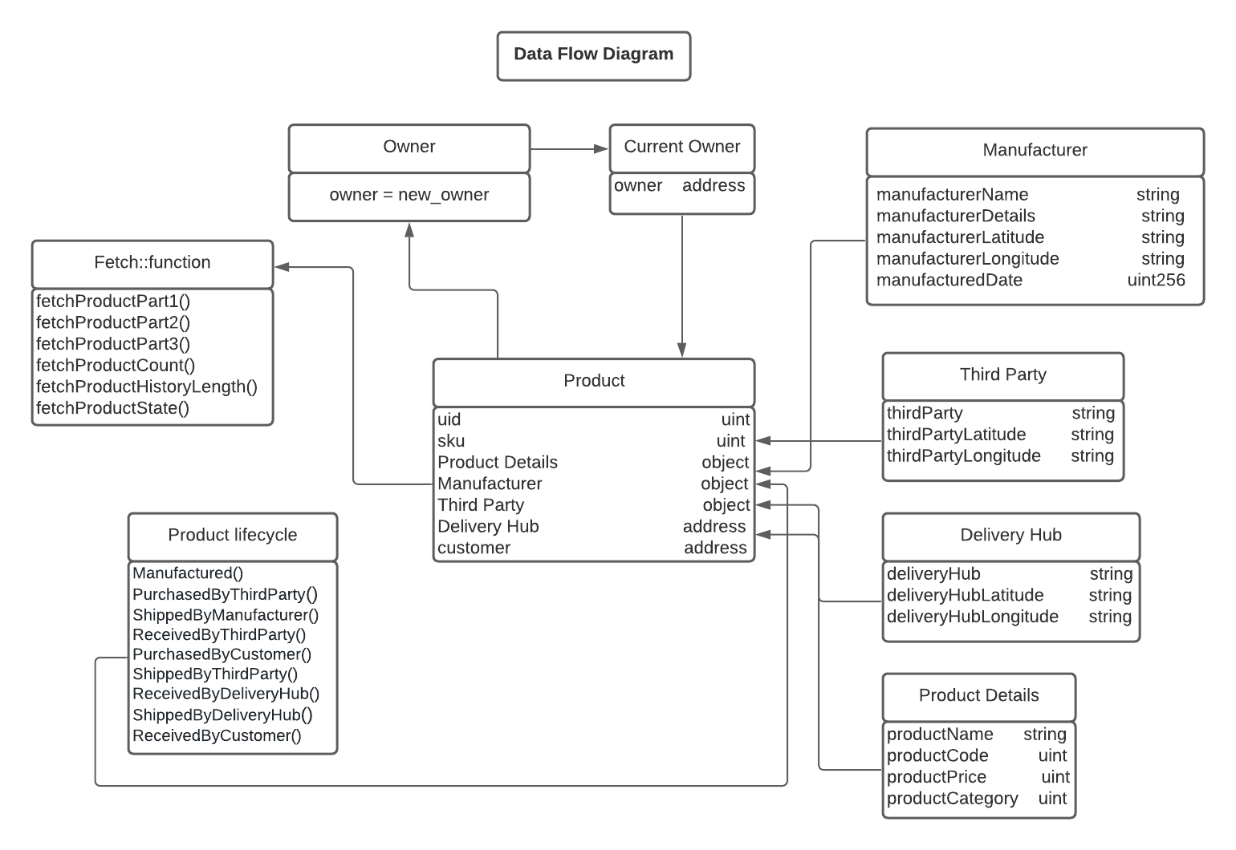

Activity

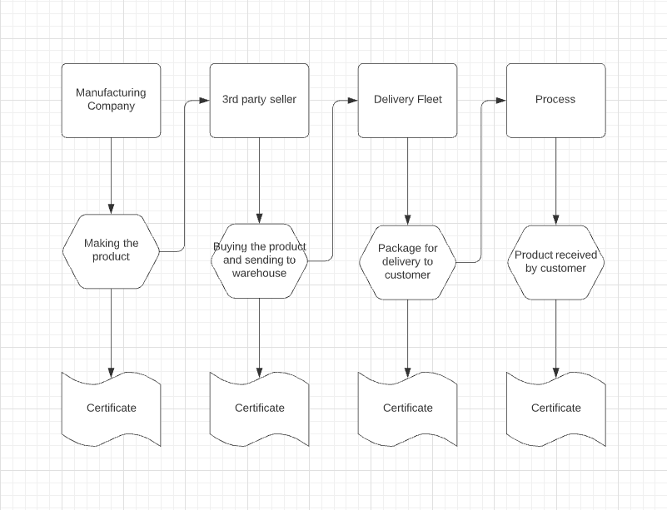

Sequence

Sequence

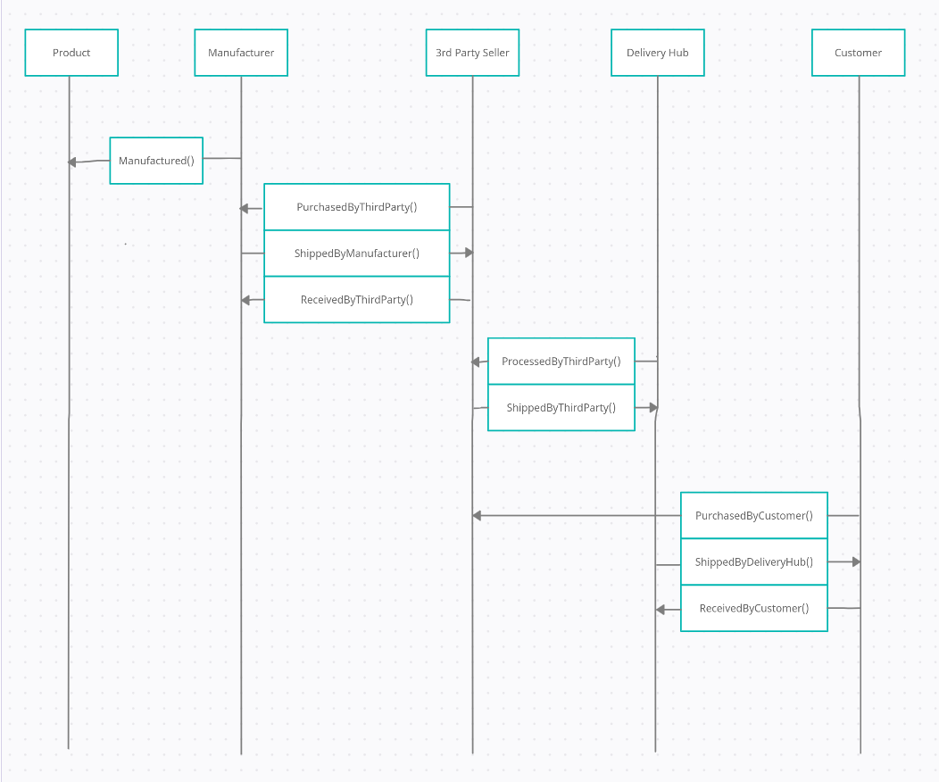

Swot Analysis

Strengths:

* Transparency: Blockchain technology allows for a tamper-proof record of all transactions, increasing visibility and trust among all stakeholders.
* Traceability: Blockchain-based systems can be used to track the movement of goods throughout the entire supply chain, providing real-time data on their location and status.
* Security: Blockchain technology is inherently secure, making it difficult for hackers to tamper with records or steal sensitive information.
* Automation: Smart contracts can be used to automate processes, reducing the need for intermediaries and increasing efficiency.

Weaknesses:

* Lack of standardization: Blockchain technology is still in its early stages, and there is currently a lack of standardization across different platforms and systems.
* Complexity: Implementing blockchain technology can be complex, requiring significant resources and expertise.
* Limited adoption: For the full potential of a blockchain-based supply chain management system to be realized, it must be adopted by all stakeholders in the supply chain.
* Legal and regulatory challenges: Blockchain technology is still not fully understood by the regulators and legal structure, which may cause difficulties in its implementation.

Opportunities:

* Cost reduction: Blockchain-based supply chain management systems can reduce costs by eliminating intermediaries and automating processes.
* Increased efficiency: Blockchain technology can improve the efficiency of supply chain processes by providing real-time data and automating processes.
* Competitive advantage: Businesses that adopt blockchain technology can gain a competitive advantage by increasing transparency and traceability.
* New business models: Blockchain technology can enable new business models, such as decentralized marketplaces and peer-to-peer networks.

Threats:

* Cybersecurity threats: Blockchain-based systems are vulnerable to hacking and other cyber threats, which can compromise the integrity of the data.
* Lack of understanding: Many businesses and individuals may not understand how to use blockchain technology, which could slow its adoption.
* Technical challenges: Blockchain technology is still in its early stages, and there may be technical challenges in scaling and integrating it with existing systems.
* Regulatory environment: Current regulatory environment may not be favorable for the blockchain technology and its adoption.

Industrial Use Cases

* Food and Agriculture

Track products throughout the supply chain to respond quickly in the event of food safety emergencies. Differentiate your brand from the rest of the market and empower customers by providing detailed food supply chain insights. Compensate small farmers quickly and equitably.

* Pharmaceuticals

Reduce counterfeit medicines. Minimize patient risk by reacting quickly to medication recalls, and reduce overall pharmaceutical costs.

* Manufacturing

Inform consumers about the provenance of their clothes and shoes to demonstrate authenticity and ethical practices. Track spare auto parts and streamline auto safety recall processes to save money and reduce the number of affected customers.

* Mining

Ensure ethical sourcing and authenticity of raw materials. Accurately track environmental impacts of production, revealing new opportunities for sustainability.

Conclusion

A blockchain-based supply chain management system can bring significant benefits to the supply chain industry. It can increase transparency, traceability, and security, while reducing costs and improving efficiency. Blockchain technology can be used to create a tamper-proof record of all transactions, allowing for greater visibility and trust among all stakeholders. Additionally, smart contracts can be used to automate processes, reducing the need for intermediaries and increasing efficiency. However, the full potential of a blockchain-based supply chain management system will only be realized if the technology is adopted by all stakeholders in the supply chain. It is important for businesses to carefully evaluate their current supply chain processes and assess how blockchain technology can be integrated to bring the most value.