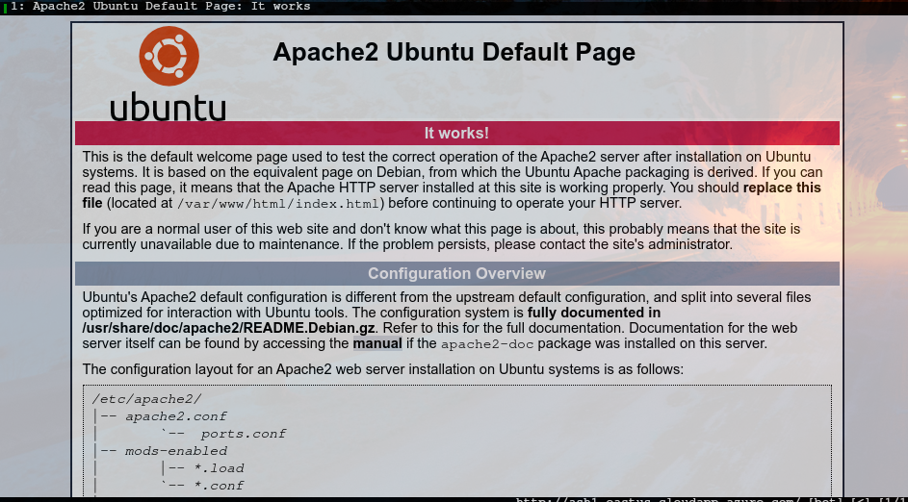
Apache httpd

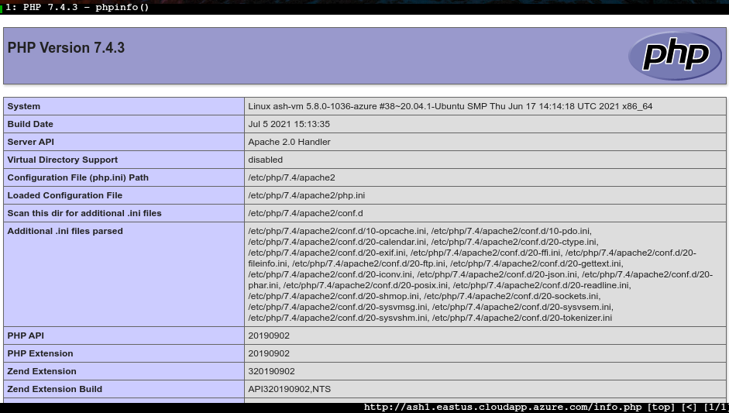
Php

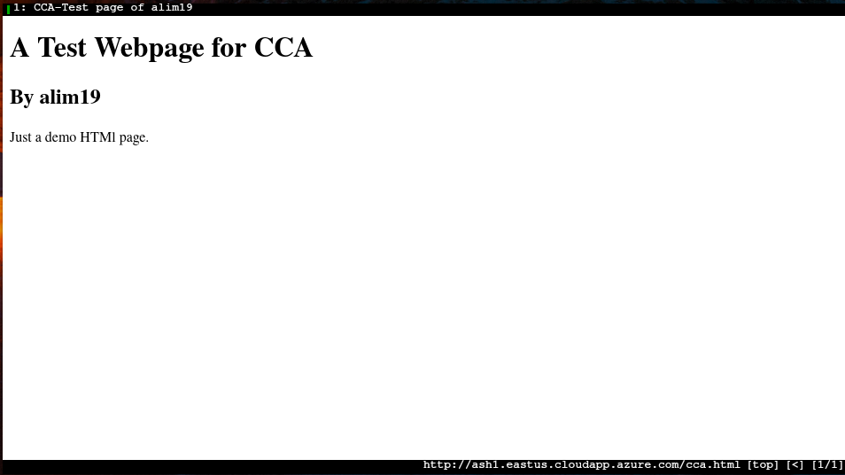
CCA.html

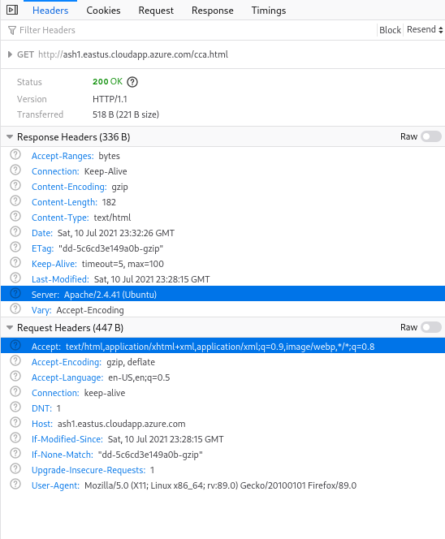
Headers

1. IP: 137.135.119.163 Port 80 (http)
1. Assuming User-agent: Mozilla/5.0 (X11; Linux x86_64; rv:89.0) Gecko/20100101 Firefox/89.0
Version: HTTP/1.1
1. Status Code: 200 Ok
1. Response size: 336 Bytes
1. Software: Apache Version: 2.4.41
1. Full response Content:

Accept-Ranges | bytes

Connection | Keep-Alive
Content-Encoding | gzip
Content-Length | 182
Content-Type | text/html
Date | Sat, 10 Jul 2021 23:33:37 GMT
ETag | "dd-5c6cd3e149a0b-gzip"
Keep-Alive | timeout=5, max=100
Last-Modified | Sat, 10 Jul 2021 23:28:15 GMT
Server | Apache/2.4.41 (Ubuntu)
Vary | Accept-Encoding

A Test Webpage for CCA

By alim19
Just a demo HTMl page.

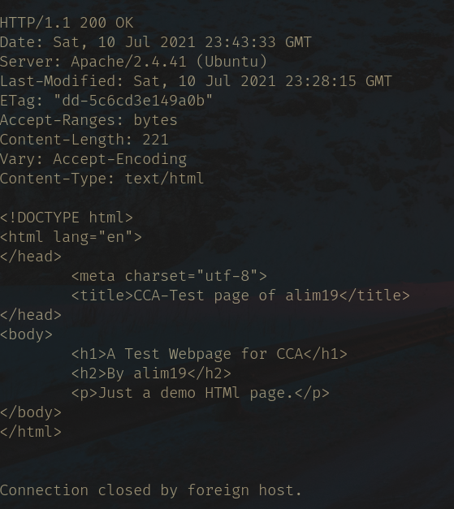
Telnet Response

1. The header found in the website using dev tools contains more request information compared to the telnet one. The content length on telnet is the “transferred” in the dev tools sc. “Keep alive”is not found in the telnet one. Telnet shows the connection being closed by foreign host. In Telnet we get the raw html of the webpage, on devtools we can find the same information on another option.

2. My understanding is that the client (me) and the server (apache httpd here) are communicating via a request and response. I request the page, and the response is given (in an insecure way since http). Both the request and the response have ‘headers’ showing general information about me and the server alike. Information for example, the content-type, which is txt here, content-length (for security reasons) and more.

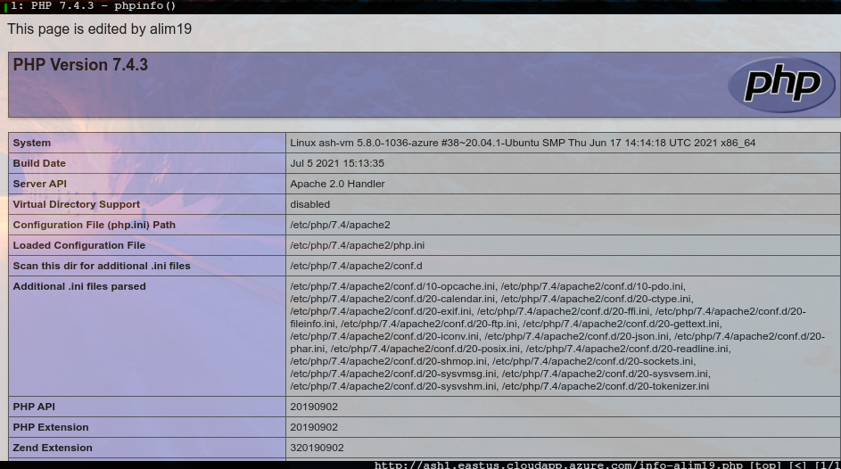
Info-alim19.php

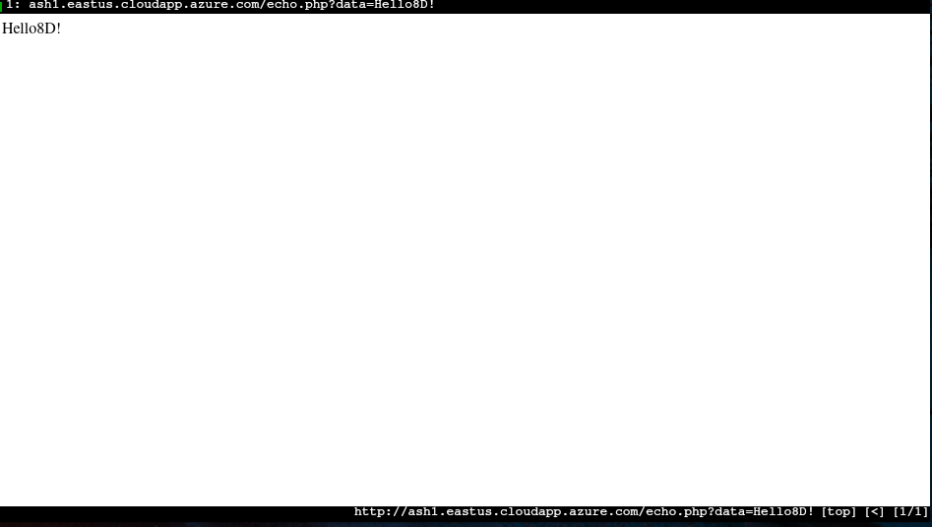
echo.php

I will start using burpsuite from now on (if allowed, obviously) due to header information using firefox is absolutely horrendous + chrome is spyware.

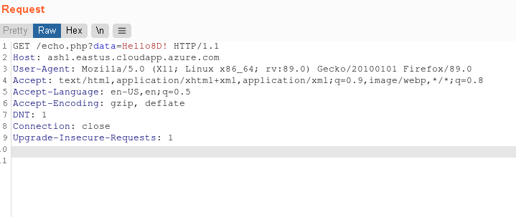
Echo.php Header

User data is attached in line 1:

GET echo.php?data=Hello8D! HTTP1.1

This is the client request; parameter data; user input is *Hello8D!*


cca-form.html output

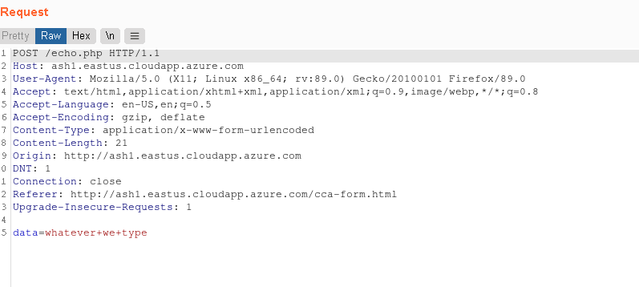
Header information on cca-form.html

User data is attached all the way at the bottom for a post form in line 15.

In the get request we can see in the url the information being requested, e.g:

echo.php?data=”input”

but in the post form the url does not include the user input. e.g:

echo.php

In the header for get we can see In the first like /echo.php?data=”input” but in post its in the last set to variable data. It’s like in post we are sending data to the server to be handled or used, while in the get request we’re directly requesting something from the server. The end output to the user is still the same, the user input is given as output in echo.php form as we coded.

