

© 2017 SPH Engineering

[www.ugcs.com](http://www.ugcs.com)

UGCS DDC

Using RTK Base to broadcast corrections over telemetry link

# Introduction

If a vehicle is equipped with RTK GPS module, the same telemetry link that is used to send and receive information to vehicle might be used to send RTK corrections to vehicles. This kind of set-up does not require additional data link for the RTK GPS only and therefore can simplify the whole fleet. For the configuration described in this document to work it is required to use WiFi modules – ESP8266 based or XBee WiFi.

# Requirements

A specific RTK Base unit or usually the same Rover module as on the vehicle can be used for this configuration. The unit must send the corrections in RTCM 3.0 protocol format.

Example base configurations:

* + North SmaRTK base unit
  + North RTKite unit configured as base
  + Ublox Neo-M8P configured as base
  + Here+ RTK GPS ground unit

To broadcast the corrections to several vehicles at once, a custom installation of Mission Planner is required. The installation can be downloaded from here: <https://github.com/ugcs/MissionPlanner/releases>.

To receive the RTK corrections on the vehicle, ESP-07 modules (or similar) based on ESP8266 chip using custom firmware available from here: <https://github.com/ugcs/mavesp8266/releases> are required. Please refer to document “ESP WiFi Module configuration and connection for UDP Protocol” for detailed information. Also XBee WiFi modules can be used.

# Configuration

Before using the custom Mission Planner for broadcast, first connect the base unit to PC and only then open up Mission Planner. Then go to section “INITIAL SETUP” on upper menu and choose “Optional hardware” from left menu then click on “RTK/GPS Inject”.

See Image 1 where the important settings are highlighted. First it is necessary to select correct COM port, if unsure which port is assigned to the Base unit, it can be viewed in Windows DeviceManager. Depending on the base unit, it needs to be configured to transmit the RTK corrections to the PC. For Ublox units, Mission Planner offers automated configuration, see “M8P autoconfig” checkbox on Image 1.

As for network settings, the PC running Mission Planner must be in the same network as all the vehicles. It is necessary to define the correct IP address mask and UDP port. This depends on the network settings configured on the router and WiFi modules. The IP address (or broadcast address) should be structured depending on subnet. Typically it should be 192.168.0.255 or 192.168.1.255 or other. The same applies to port, but the incoming port for the WiFi modules should be the same for all modules. Refer to document “ESP WiFi Module configuration and connection for UDP Protocol” for more information.

The RTK/GPS Inject section prior to connecting a base unit

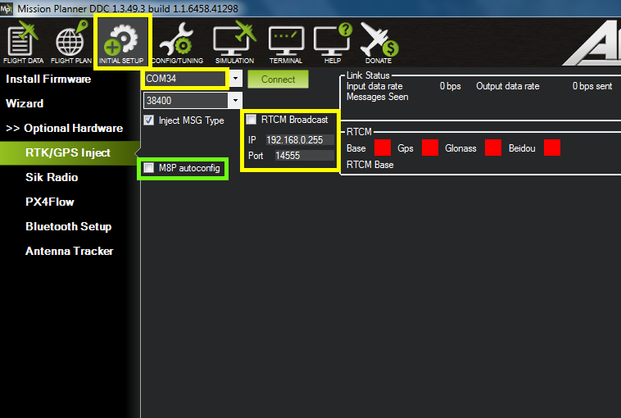  
Image 1

After successful configuration and connection to the base (click “Connect” next to COM port setting) he Mission Planner should start displaying which satellites are available to the base and display them like shown on Image 2. To start UDP broadcast enable RTCM Broadcast checkbox.

Displaying available satellite status for the base.

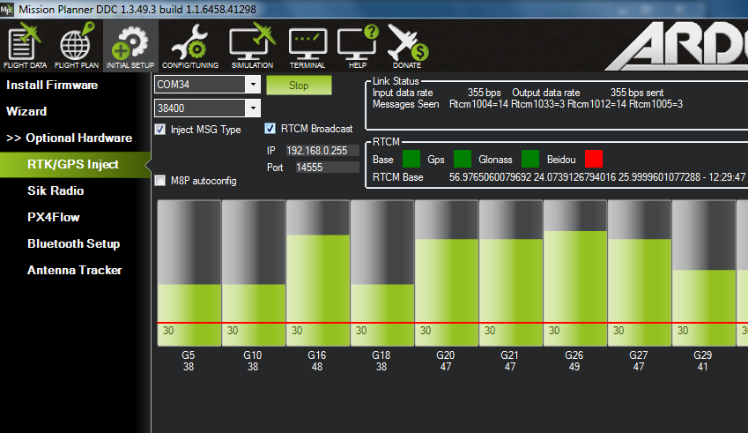  
Image 2

Now check if the vehicles change status to RTK Float or RTK Fix.