 

# ESP WiFi Module configuration and connection for UDP Protocol

### This manual explains how to flash ESP-07 modules with firmware for use with UDP protocol and how to configure connection settings in UgCS.

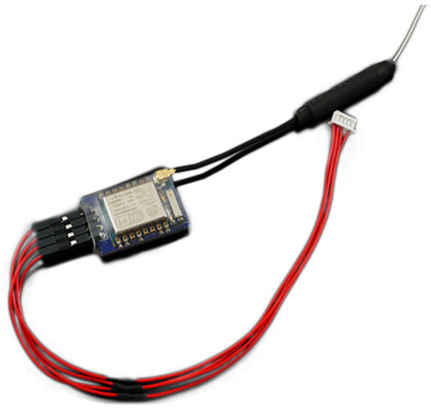

**Preparing for firmware update**

* Download custom firmware from our server: <http://www.sph.engineering/download/firmware_UDP.zip>
* Download firmware flashing utility ESP8266Flasher:

<https://github.com/nodemcu/nodemcu-flasher/raw/master/Win32/Release/ESP8266Flasher.exe>

Connect ESP-07 to PC via any appropriate USB-UART adapter like **TTL-232R-3V3**

Manual: <http://www.ftdichip.com/Support/Documents/DataSheets/Cables/DS_TTL-232R_CABLES.pdf>

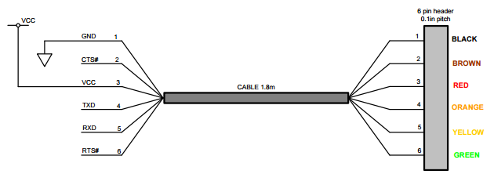

Connection diagram:

|  |  |
| --- | --- |
| **TTL-232R-3V3** | **ESP-07** |
| 5V | 5V/3V |
| GND | GND |
| TXD | RXD |
| RXD | TXD |

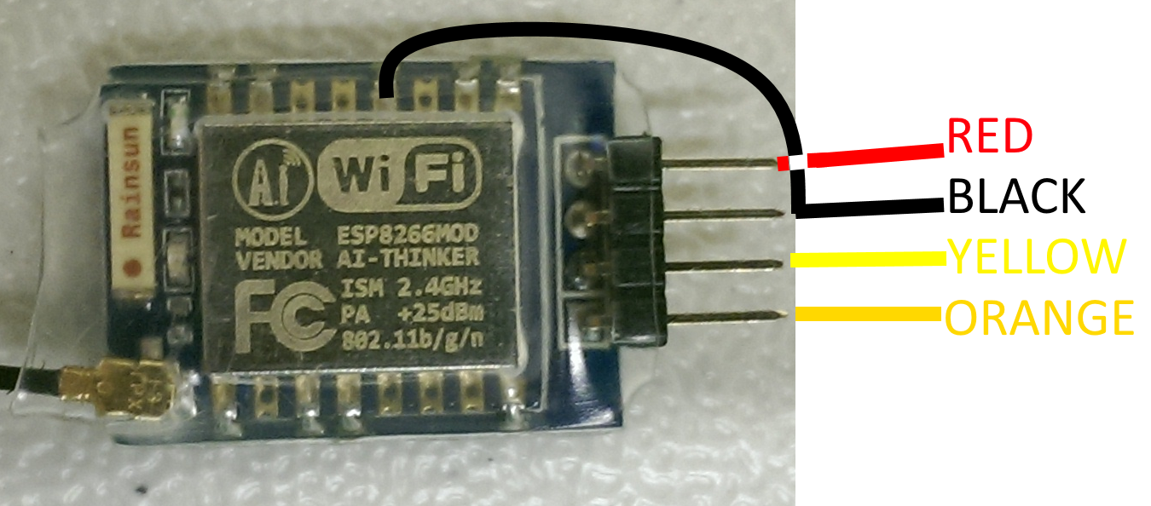

Image displaying the colored wire connection from UART to ESP module during flashing.

**Note:** to initialize flash mode for the ESP-07 module, it is necessary to ground pin GPIO0 (shown on picture above) during powering on the module and recommended to leave grounded throughout the flashing.

**Flashing the firmware**

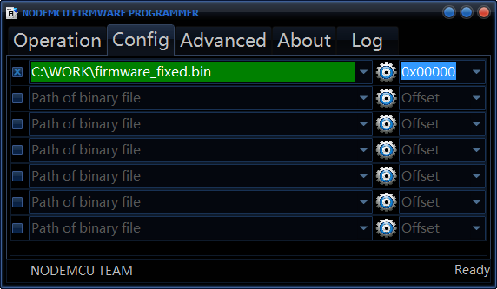Run ESP8266Flasher as administrator and use following settings (**Config** and **Advanced** tabs):

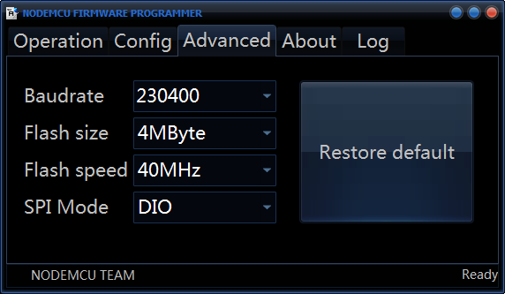**Configuring the modules**

After successfully flashing and power cycling a module, a new wireless network should appear – PixRacer.

Connect to the network and enter “pixracer” as password.

**SSID: PixRacer**

**Key: pixracer**

Now to configure each module, a network address must be followed while connected to the PixRacer network.

For example this: <http://192.168.4.1/setparameters?hport=14560&mode=1&ssidsta=DRONE-DANCE&pwdsta=1234567890&gatewaysta=192.168.0.1&subnetsta=255.255.255.0&ipsta=192.168.0.10&baud=57600>

In this link there are the following important parameters:

* hport=14560 this sets the UDP port of the module, each module must have an unique port, it is recommended to use increasing port numbers starting from 14560, t.i. 14561, 14562…
* ipsta=192.168.0.10 sets the IP address of module, each module must have an unique address according to subnet mask

*The following parameters will remain the same for all modules:*

* + ssidsta=DRONE-DANCE sets the SSID or network name
  + pwdsta=1234567890 sets the network key (password)
  + gatewaysta=192.168.0.1 sets the default gateway
  + subnetsta=255.255.255.0 sets the subnet mask
  + baud=57600 sets the connection baud rate

As an example, the first module of the swarm would have the configuration mentioned above, but second would have the following: <http://192.168.4.1/setparameters?hport=14561&mode=1&ssidsta=DRONE-DANCE&pwdsta=1234567890&gatewaysta=192.168.0.1&subnetsta=255.255.255.0&ipsta=192.168.0.20&baud=57600>

Notice that only hport and ipsta parameters change.

After setting the parameters (following link), it is recommended to restart the module and check if the parameters were correctly set, by following this link:

<http://192.168.4.1/setparameters?reboot=1>

Now a list of parameters should appear on screen, two can be checked to confirm successful settings change:

|  |  |
| --- | --- |
| WIFI_UDP_HPORT | 14560 |
| UART_BAUDRATE | 57600 |

**Configuring Ardupilot VSM to connect to modules**

After successfully configuring modules, it is necessary to configure vsm-ardupilot.conf file accordingly. The following example shows how the settings for one module must look:

connection.udp_in.1.local_port = 14561

To add additional modules, just add the same line and edit like this, for example:

connection.udp_in.2.local_port = 14562

connection.udp_in.3.local_port = 14563

Notice how only the port number and number after udp_in. changes.