Technical Documentation for End-Users

How End-Users Support the Cyber-Risk Assessment Process
Cyber risk assessment helps identify, evaluate, and mitigate risks associated with digital assets. It involves identifying what can go wrong, how likely it is to happen, and its potential impact.

Process of Cyber Risk Assessment
1. Identify systems and assets
2. Identify threats and vulnerabilities
3. Assess the likelihood and impact
4. Implement security measures
5. Regularly monitor and review

Role of End-Users
- Report suspicious activities
- Use strong passwords
- Regularly update software
- Follow cybersecurity guidelines

Business Implications of Cybersecurity Breaches
Breaches can lead to financial losses, legal issues, damage to reputation, and loss of customer trust.

Implications for Users
Ignoring security protocols can expose sensitive data, increase vulnerability to attacks, and potentially lead to disciplinary actions.

Operating Systems (Windows) Security
Windows OS can be vulnerable to unpatched software, malware, phishing, and misconfigured settings.

Methods to Improve Windows Security
1. Enable Windows Defender Firewall.
2. Regularly update Windows.

Virtualisation Operation and Structure
Virtualisation creates isolated virtual machines (VMs) on your computer for safe testing and system usage without risk to your main system.

Accessing Virtualisation
Use tools such as VirtualBox or VMware Workstation to manage virtual machines.

Virtualisation Structure
- Host: Your physical computer.
- Hypervisor: Software managing VMs (e.g., VirtualBox).
- Guest VM: Virtualised computer.

Creating and Configuring Virtualised Images
Open VirtualBox -> New VM -> Name it -> Select OS -> Allocate RAM -> Create Virtual Disk -> Install OS.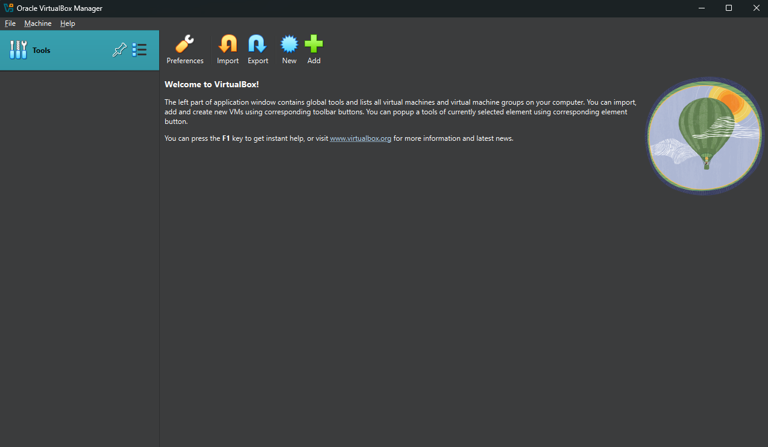
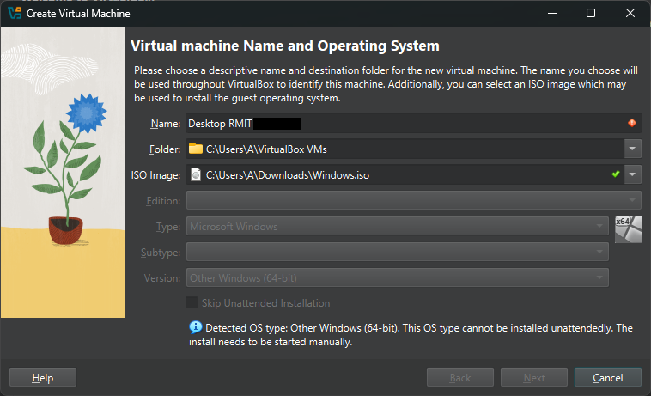
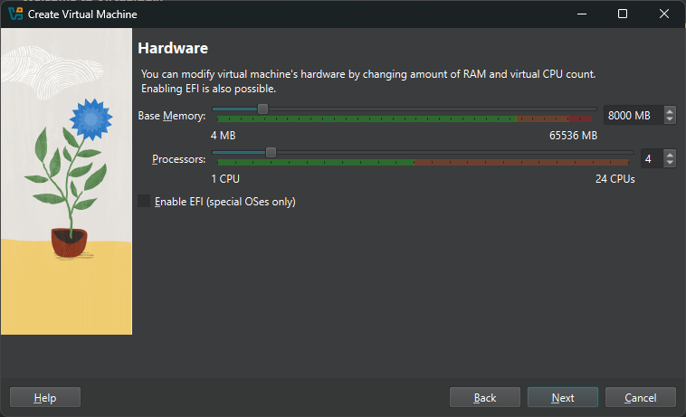
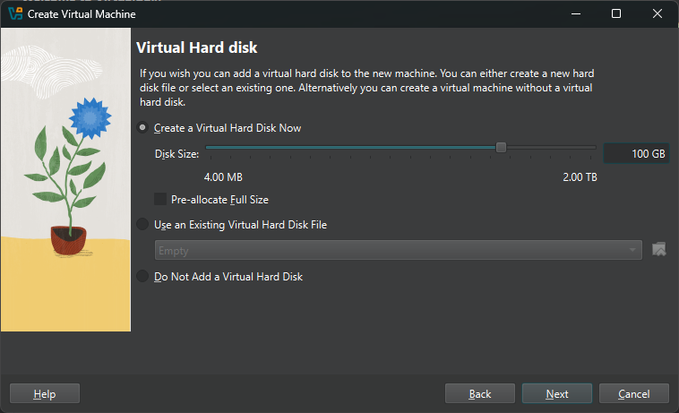
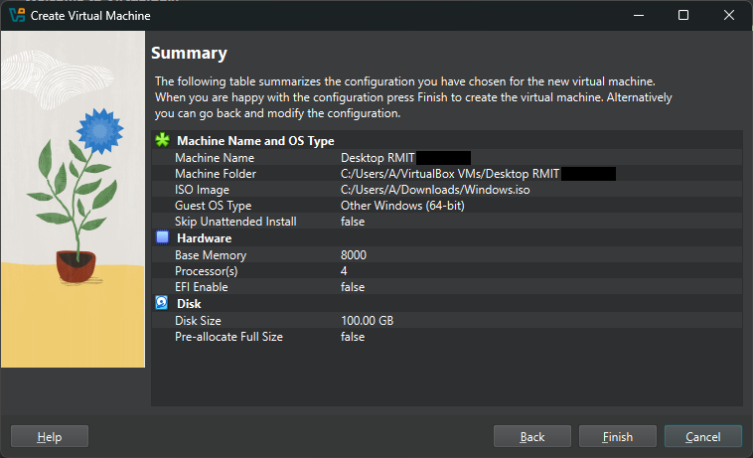
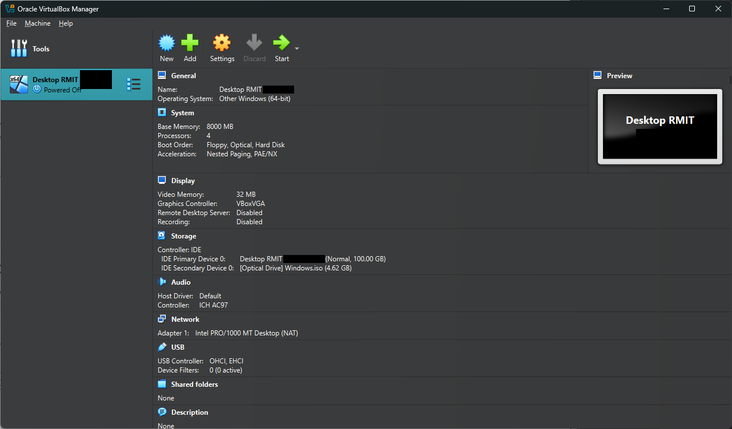Interconnecting Virtual Images
Set VM network settings to 'Internal Network' -> Assign static IPs -> Test connectivity using ping.
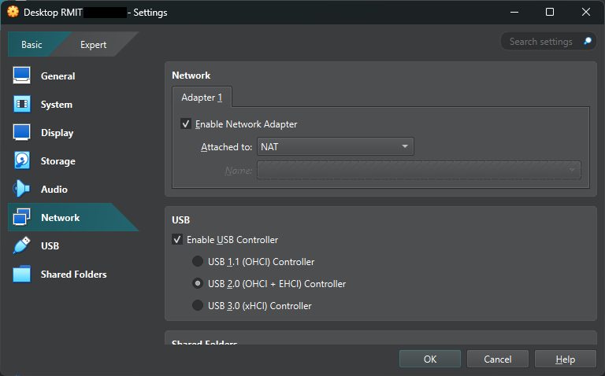
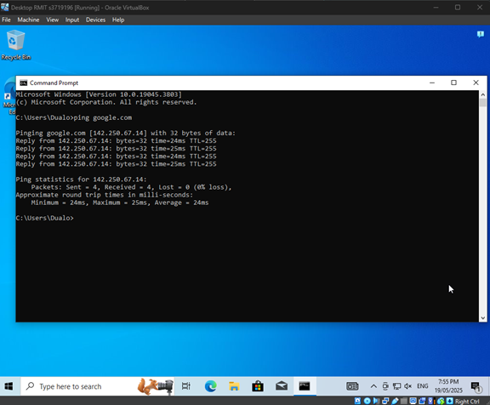

Creating a Windows Server
Go to https://portal.azure.com/ and click onto Virtual machines, then create one 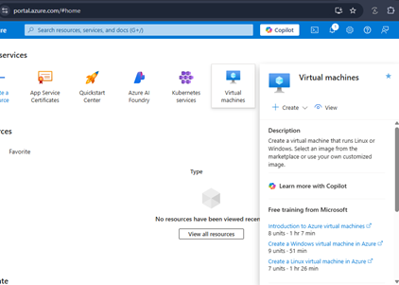
Or you can click onto the left side menu and select Create a resource
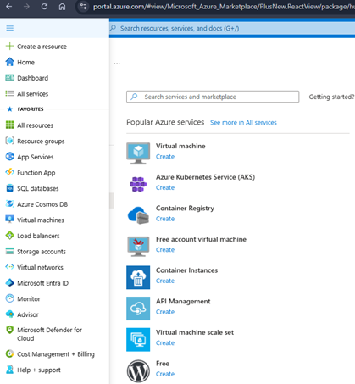
Select Compute then select Virtual Machine
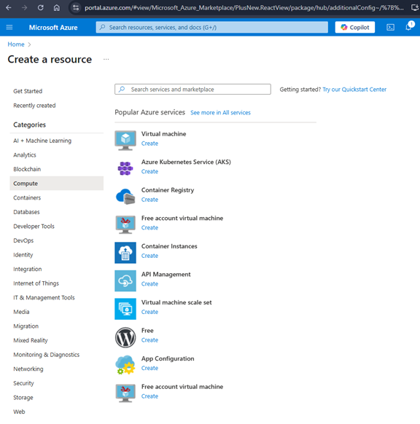
Configuration settings -
Basic:
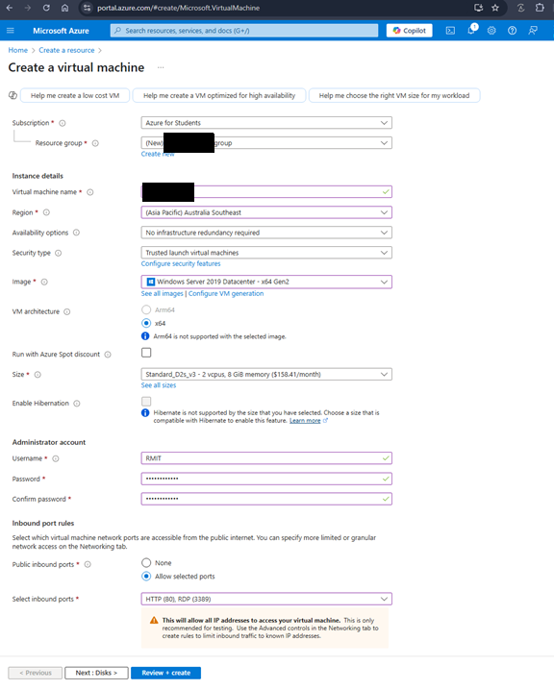
Disks:
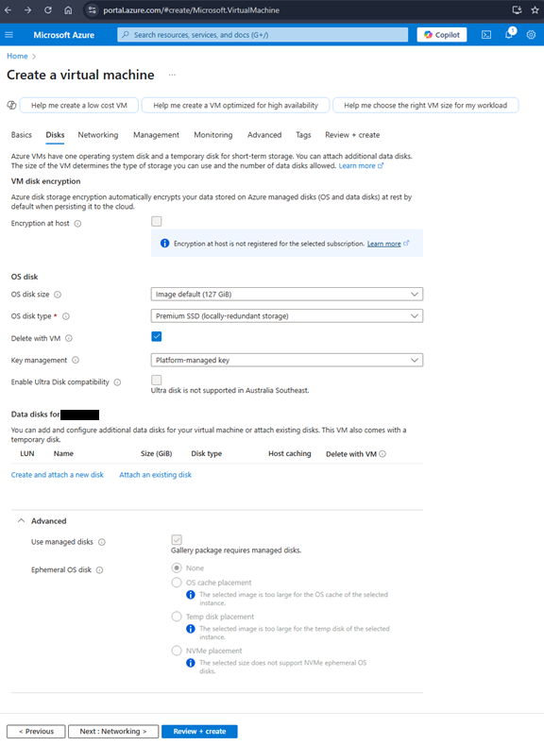
Networking: After this, select Review + Create
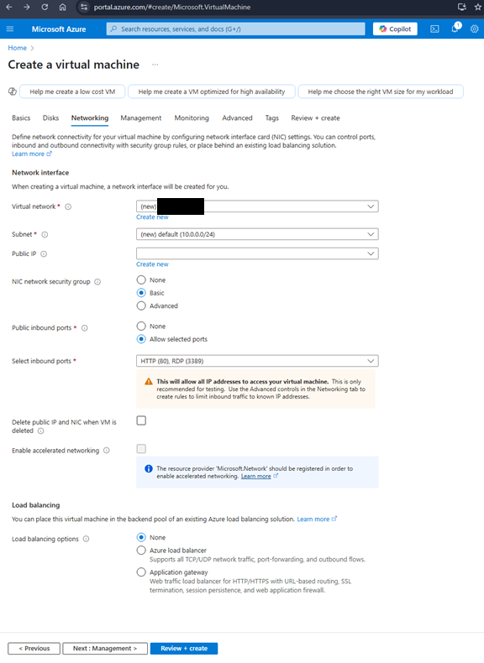
Validating:
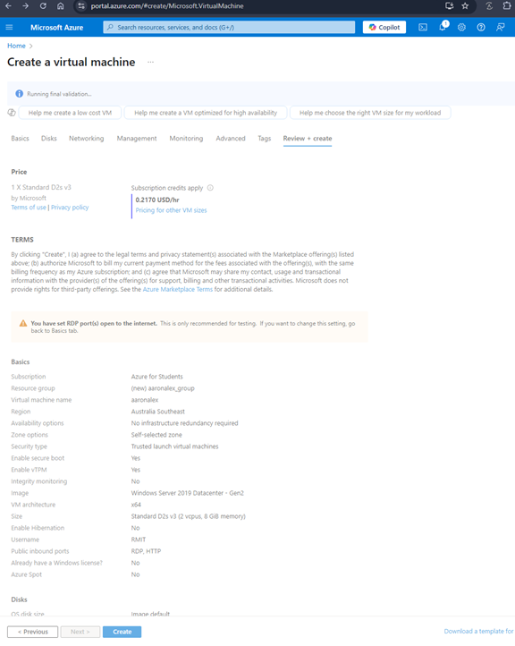
Validation passed and now select Create and it will show you your Deployment is in progress to being complete:
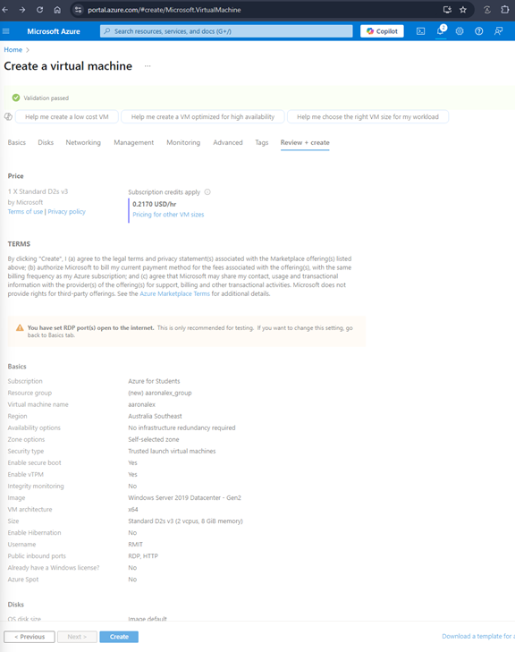
Go to resource:
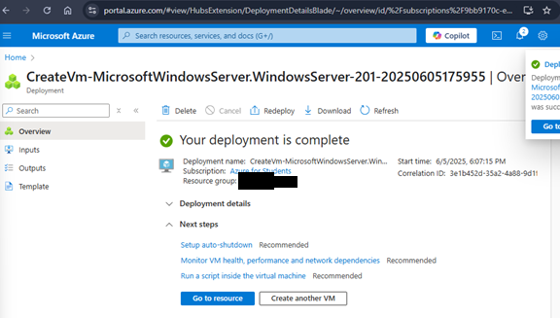
Click on Connect to connect to the VM:
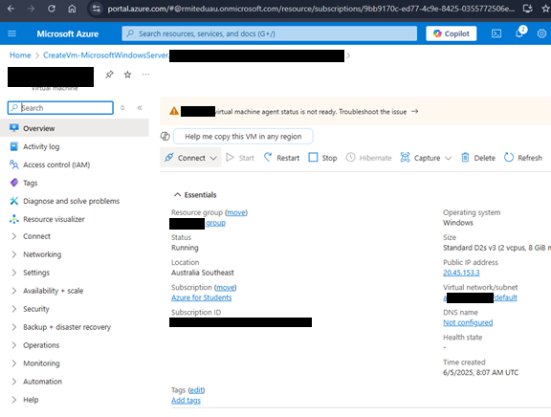
Download the RDP file:
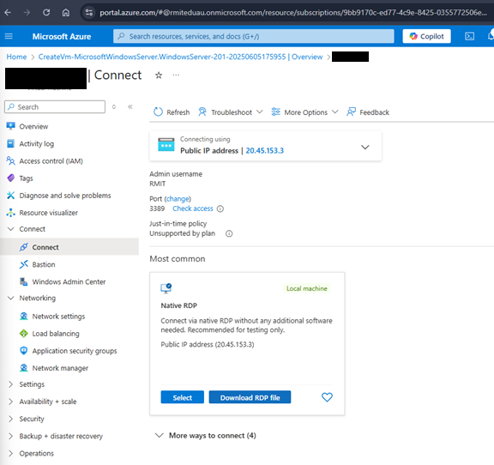

Creating a domain in Azure Directory
Login to the RDP
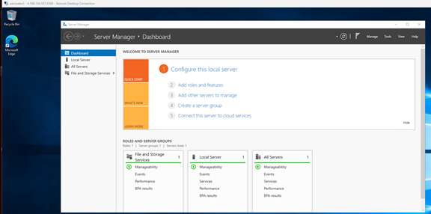
Select Add roles and features and a wizard page will pop up, select Role-based or feature-based installation
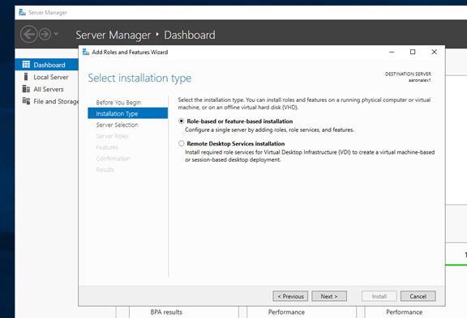
Leave server selection as default
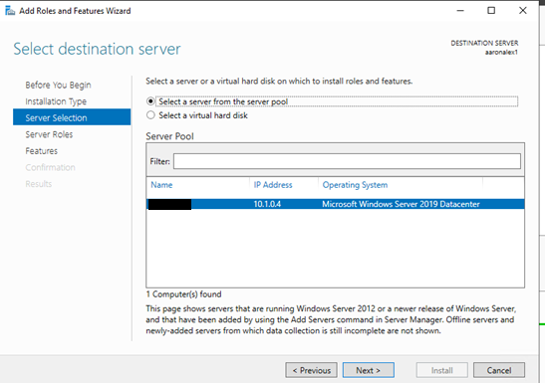
Select Active Directory Domain Services
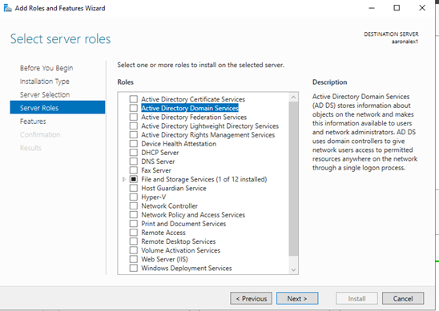
Add Features
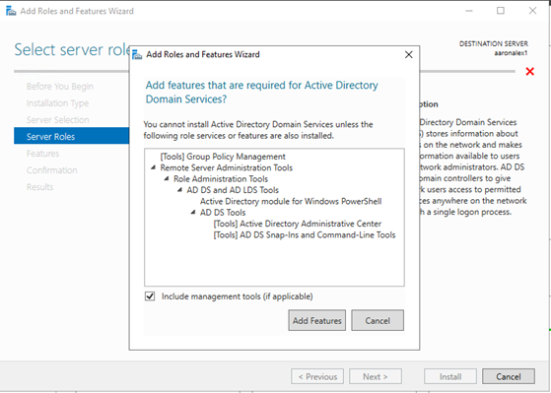
Click Next through to Confirmation then install
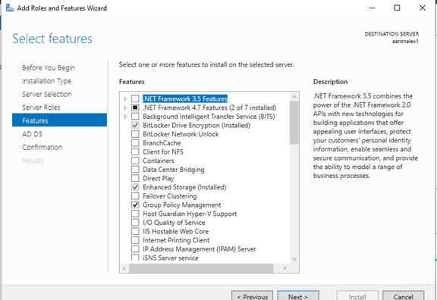
Click Install
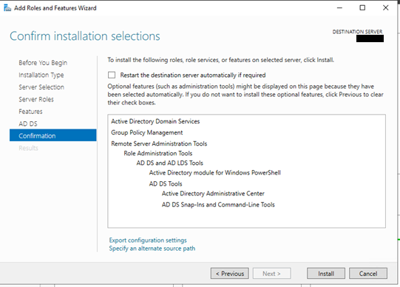
Close
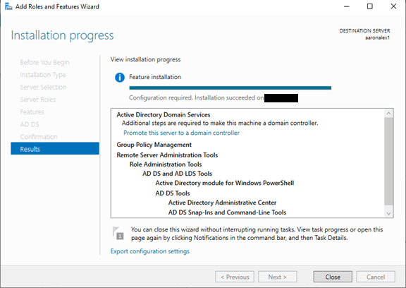

Click onto the flag notification and select Promote this server to a domain controller
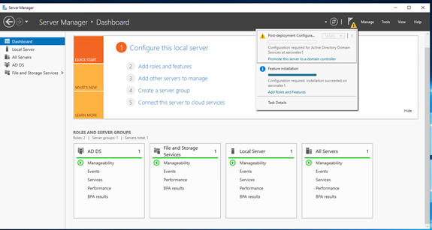
Add a new forest and add a name for the root domain
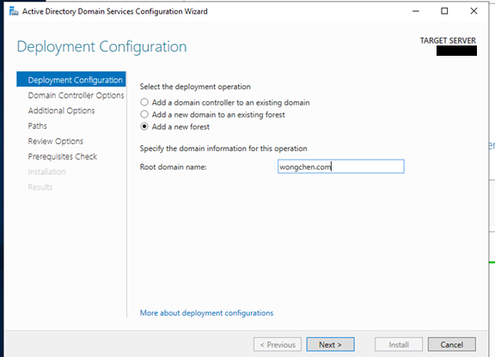

Add a password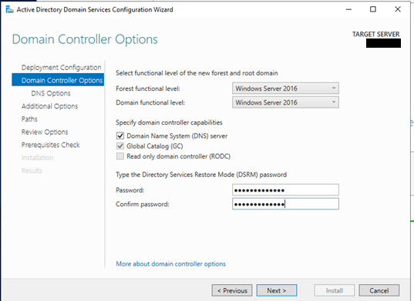
Click Next
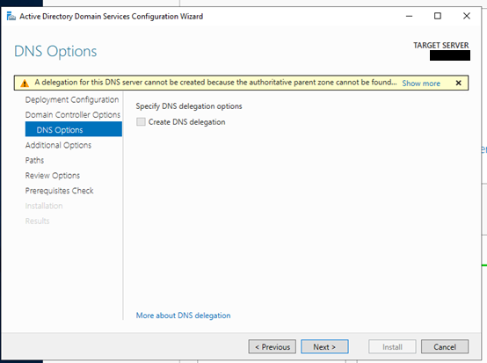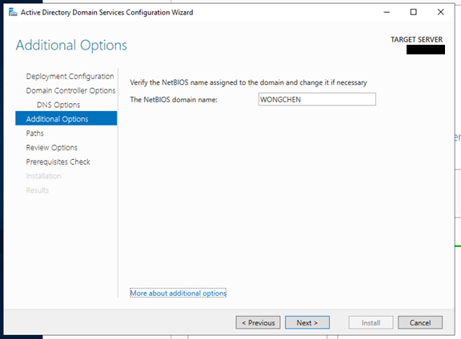
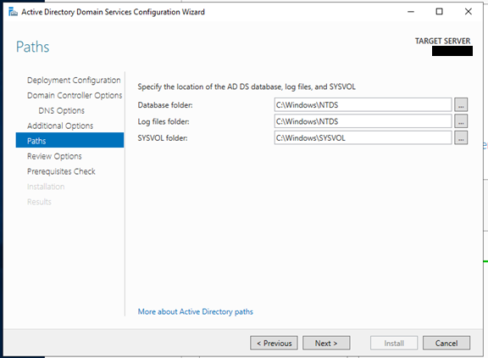
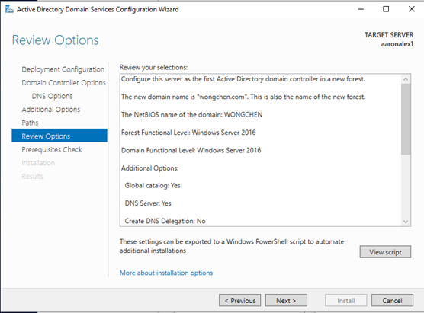
Click Install
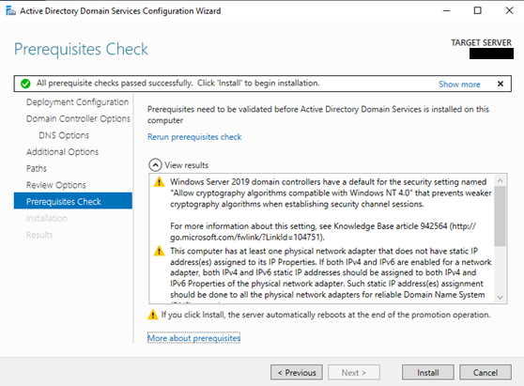
After installation, the server will reboot and become a domain controller
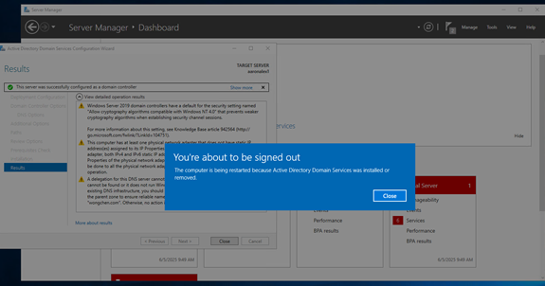
After reboot, open Server Manager and click Tools -> Active Directory Users and Computers
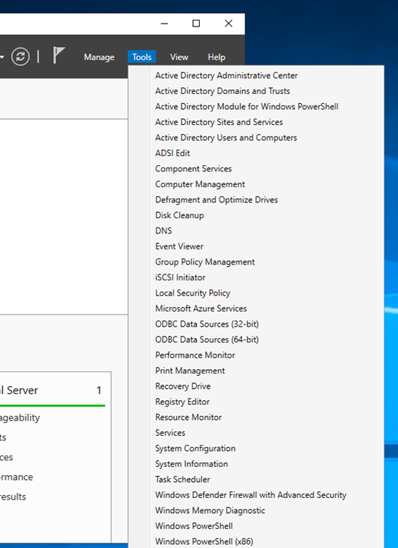
You will see your domain wongchen.com
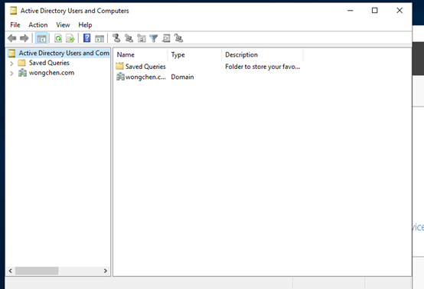
Create new users
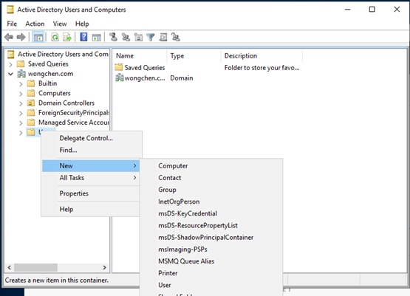
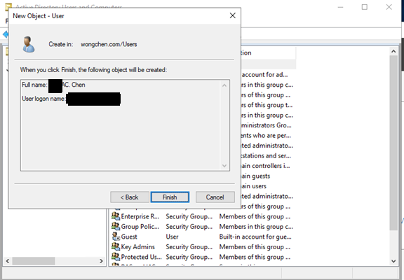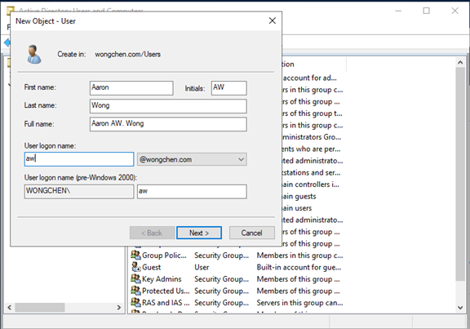
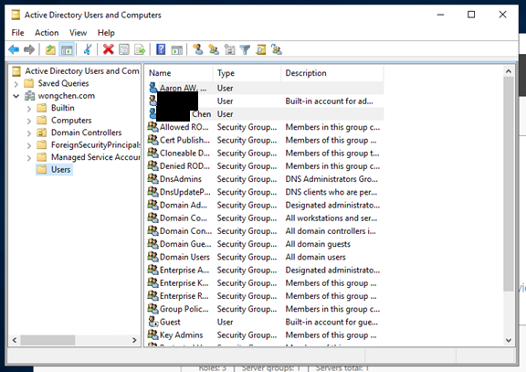
Right click the user to add to a group, reset password, etc
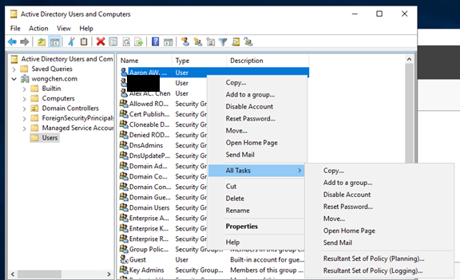
To join the domain on a Windows PC:
Open Settings and navigate to Access work or school
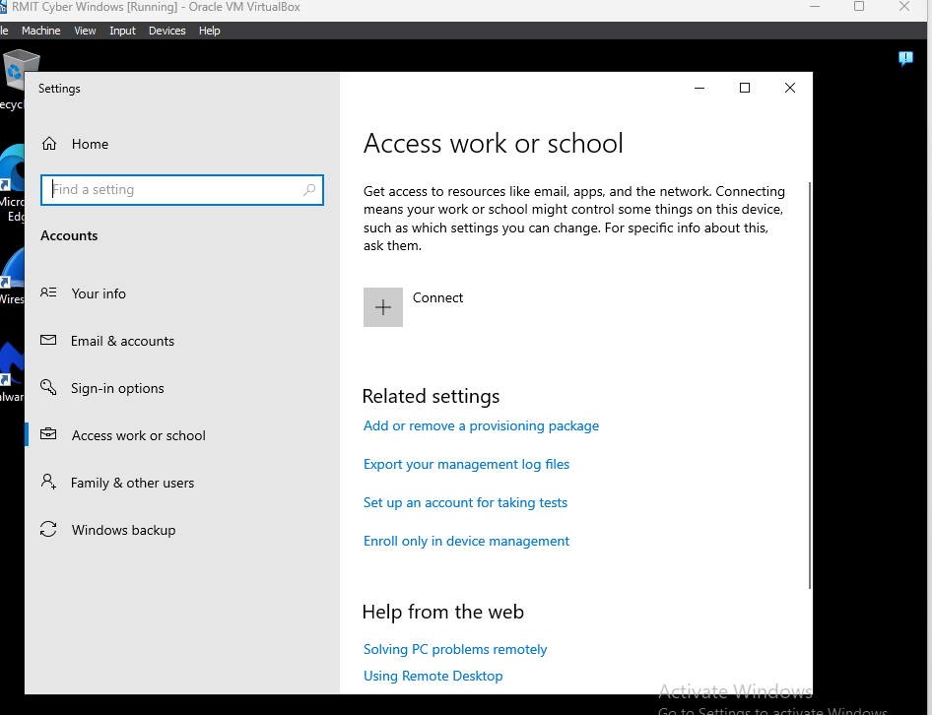
Press Connect and Join the domain (in this case it is wongchen.com)
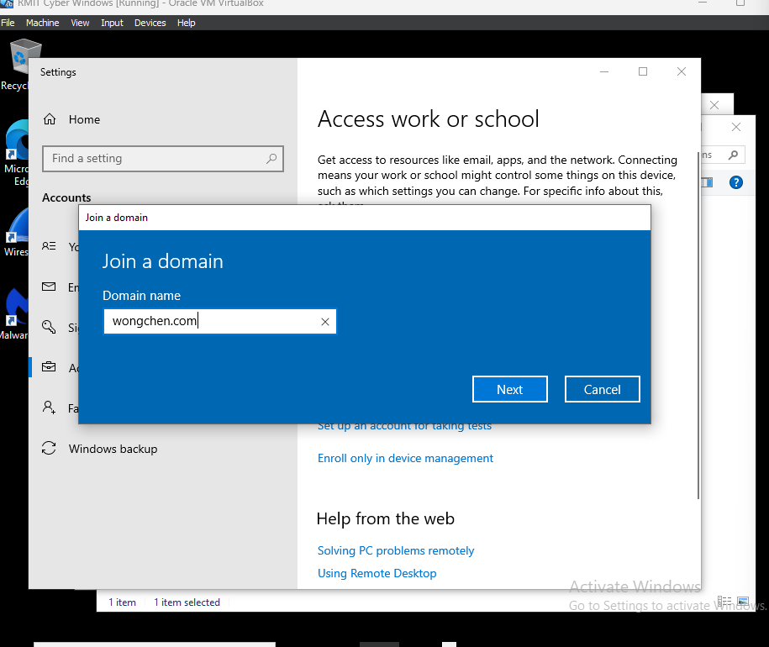
Point the Client’s DNS to the Domain Controller (if domain is not connecting)
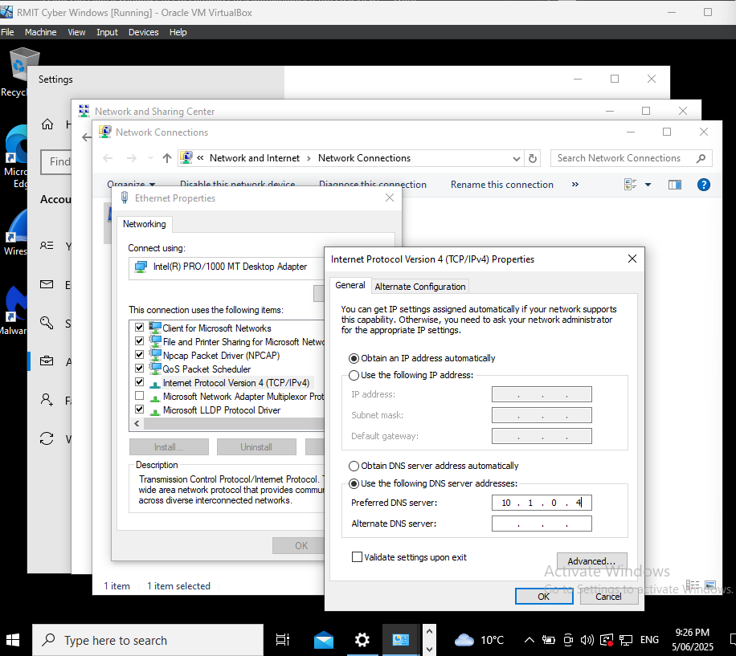

Using Networking Devices

What Networking Devices the End-User May Need to Interact With
End-users or IT staff may interact with the following networking devices:
- Router: connects the business network to the internet and manages traffic
- Switch: links multiple devices together on the local network
- Firewall: protects the network by filtering traffic
- Access Points: provide Wi-Fi connectivity
- Domain Controller or Server: manages user authentication and access

Instructions for Using Networking Devices Post-Implementation
1. Gaining Access:
Use a secure admin login to access each device. Enter the device’s IP in a web browser (e.g., 192.168.1.1), then use a username and password. Only trained personnel should access device settings.
2. Maintaining Access:
Set up roles for different users (e.g., admin, read-only). Regularly update firmware and save backup configurations.
3. Controlling Access:
Enable MAC address filtering and use access logs to track new devices. Use scheduling for guest or staff access.
4. Securing Devices:
Change default passwords, enable two-factor authentication where possible, turn off remote access if unnecessary, and use WPA2/WPA3 encryption for Wi-Fi.

Configuring Firewalls

How Firewalls Are to Be Used in the Client Workplace
Firewalls like pfSense are used to protect the business network by:
- Blocking unwanted or harmful traffic
- Managing access to network ports and services
- Filtering internet use
- Monitoring logs for unusual activity
Windows Firewall on devices is also used to reduce visibility to scans and block unauthorized access.

Instructions for Configuring or Maintaining the Firewall
For pfSense:
- Login via browser (e.g., 192.168.50.1)
- Go to Firewall -> Rules
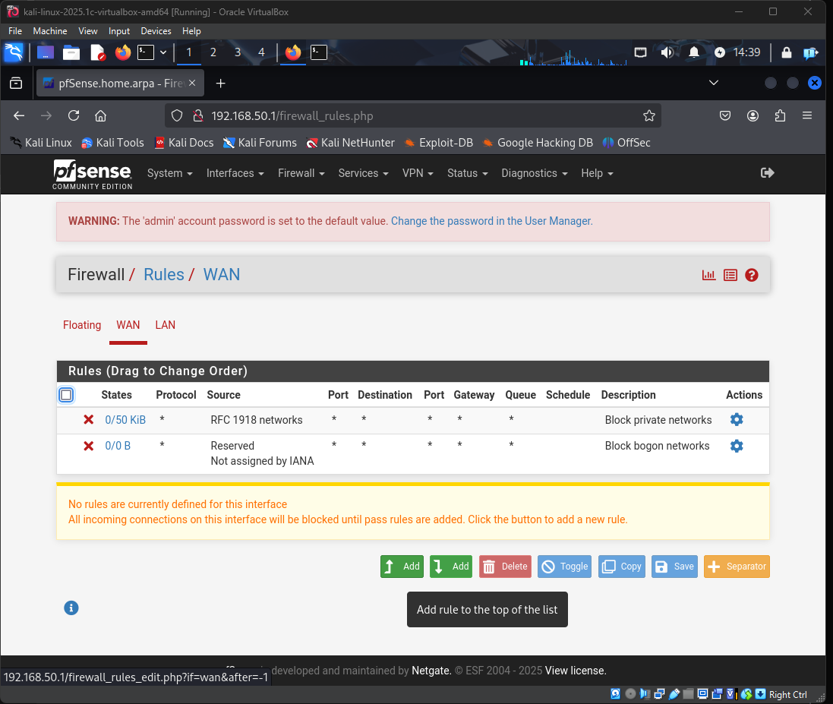
- Create rules to block all inbound traffic and allow only essential services
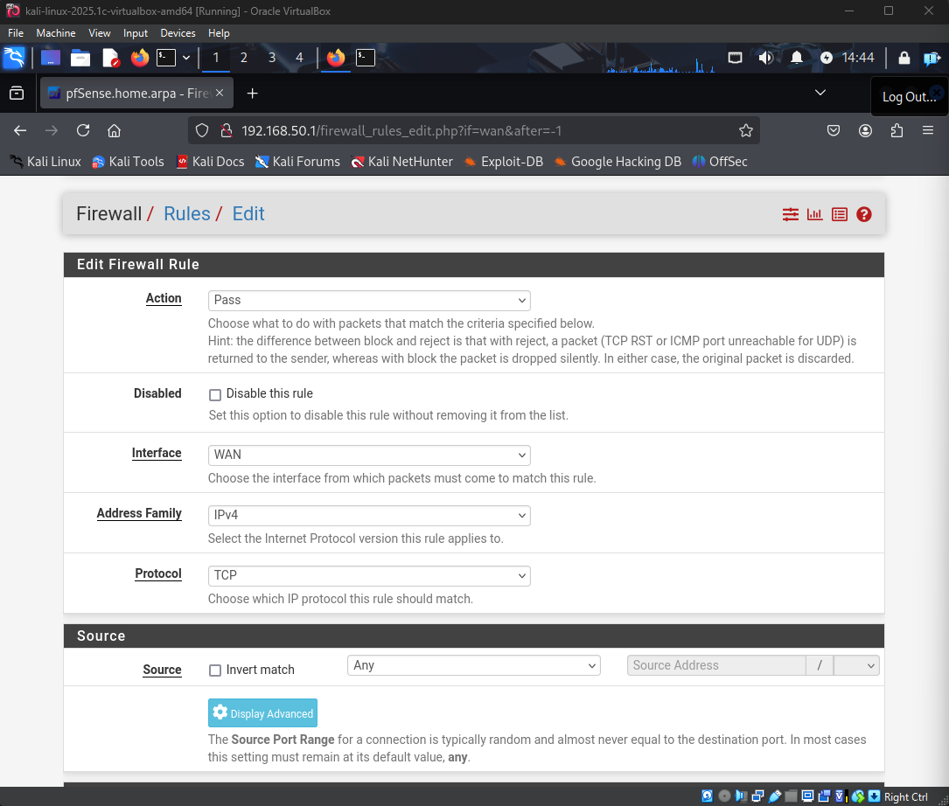
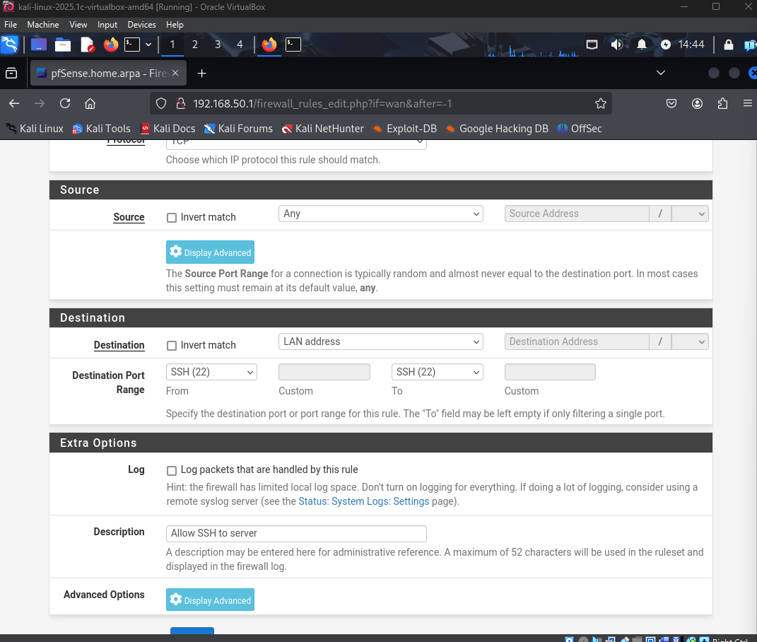
- Use Traffic Shaper to limit large traffic bursts
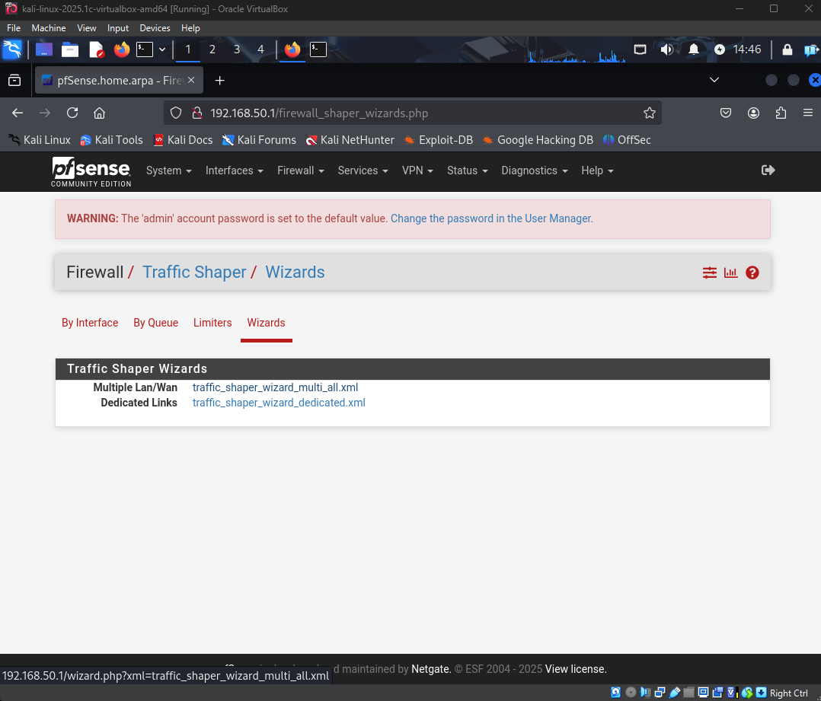
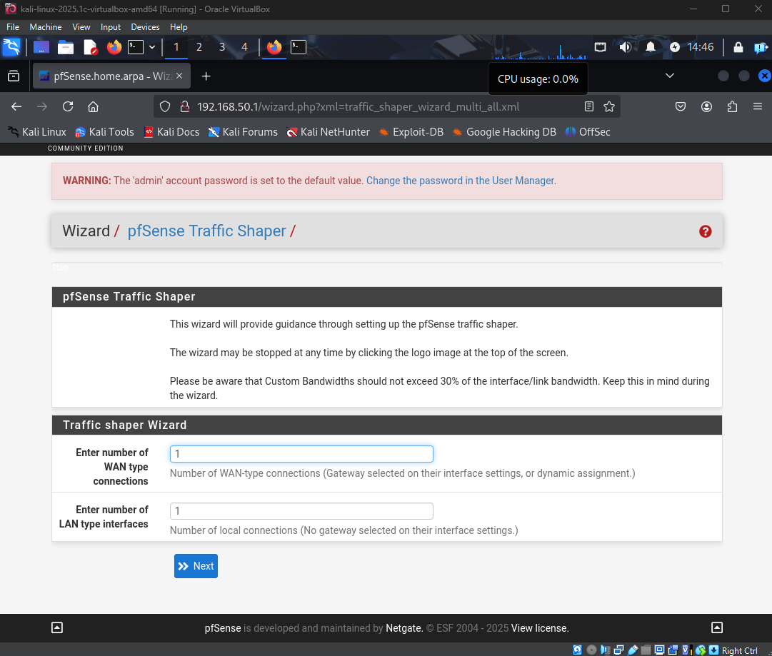
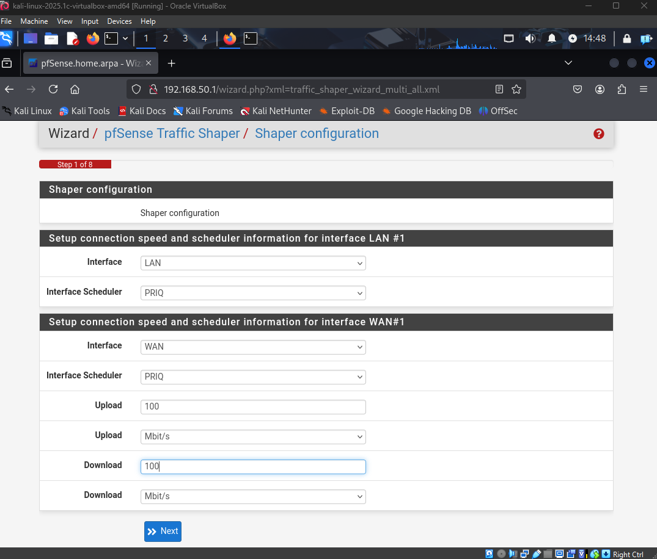
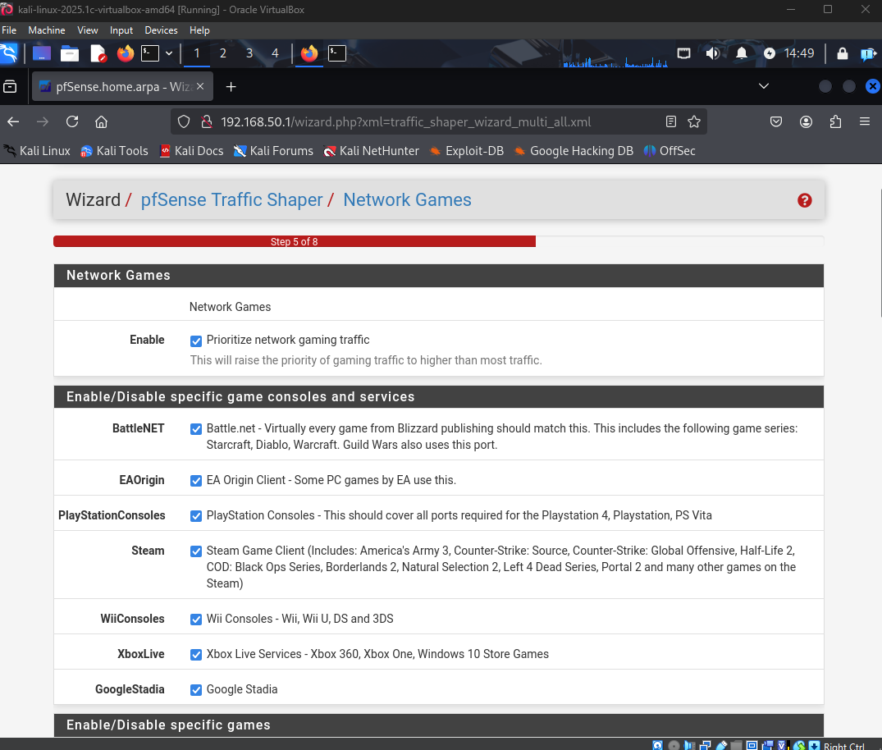
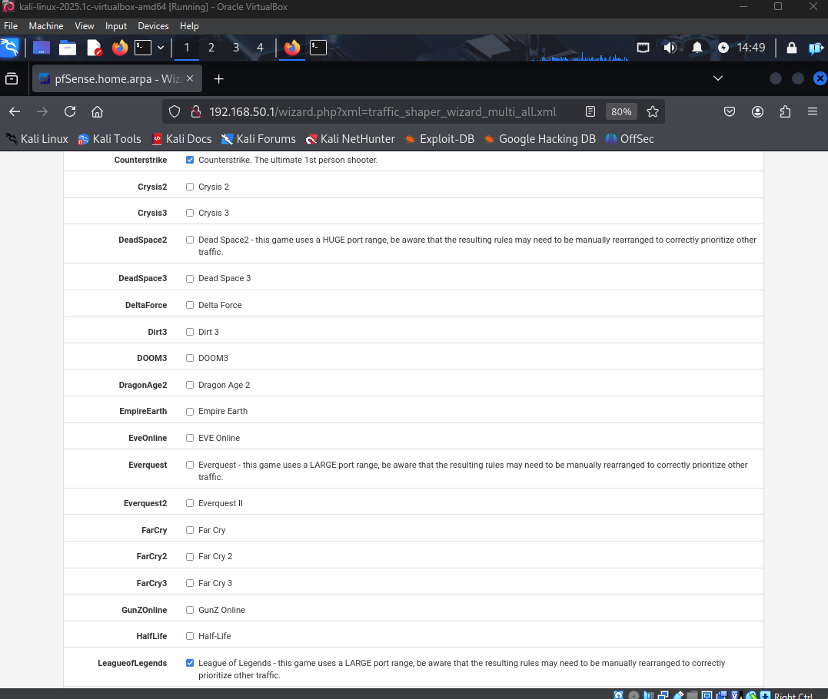
- Check logs regularly
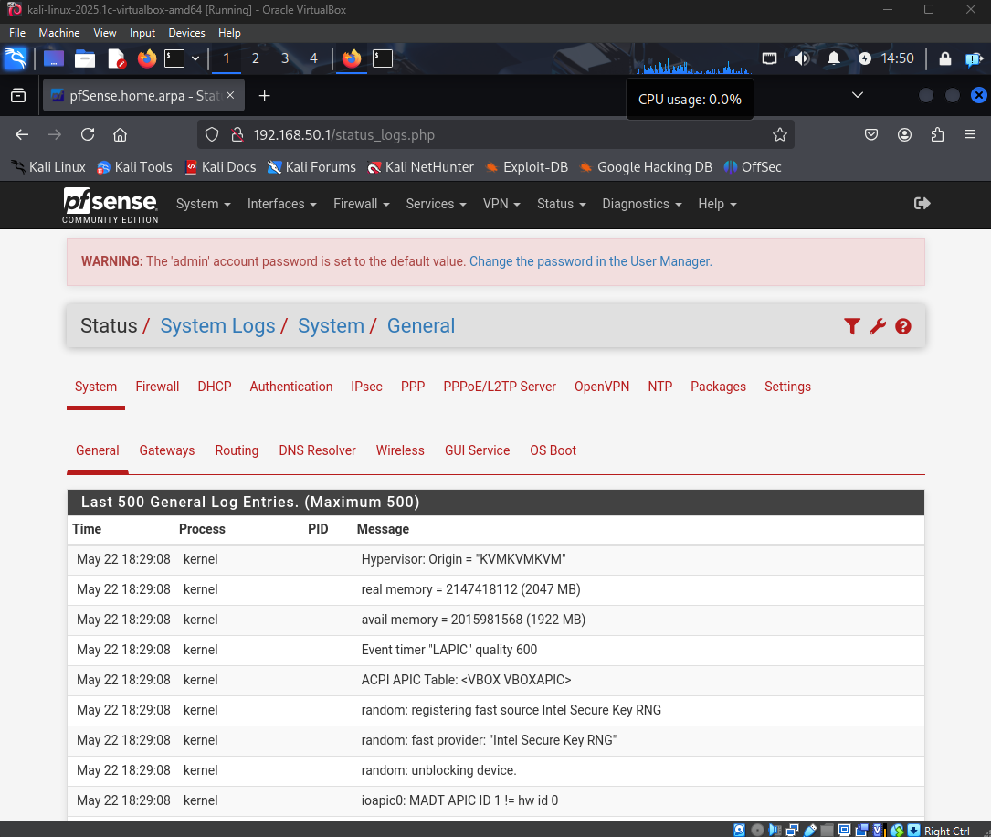

For Windows Firewall:
- Go to Control Panel -> Windows Defender Firewall
- Open Advanced Settings
- Disable unused ports in Inbound Rules
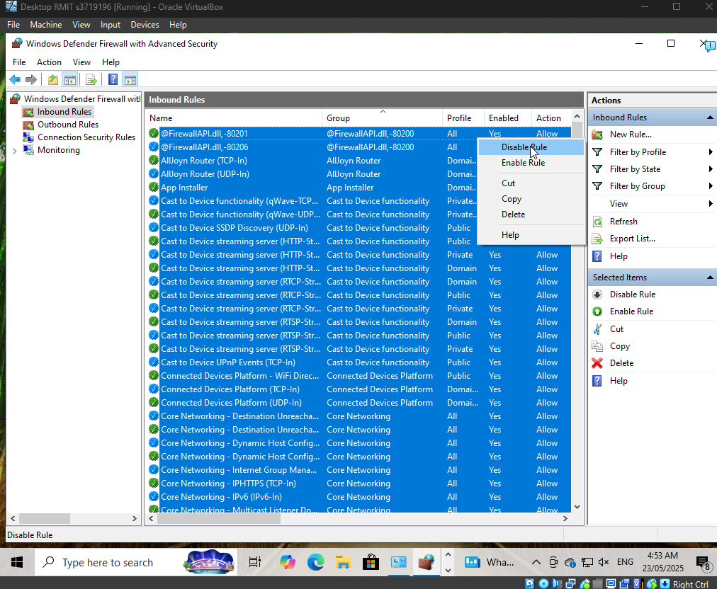
- Allow only approved apps in Outbound Rules
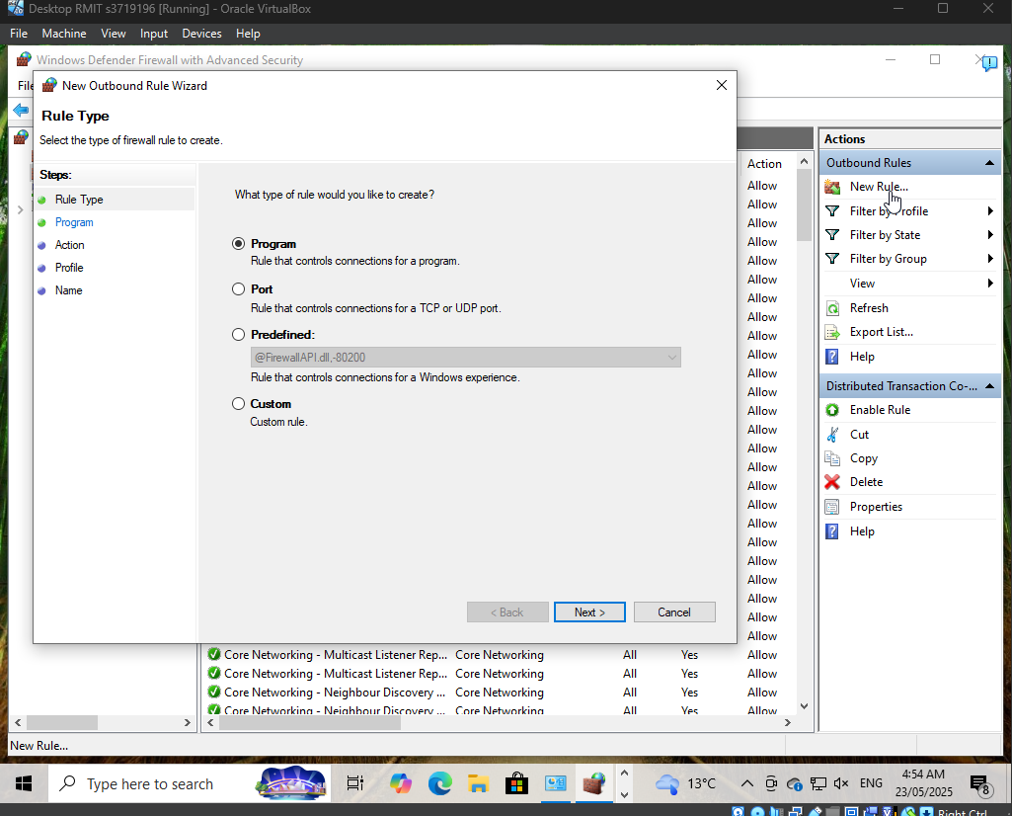
- Enable notifications for unknown access attempts
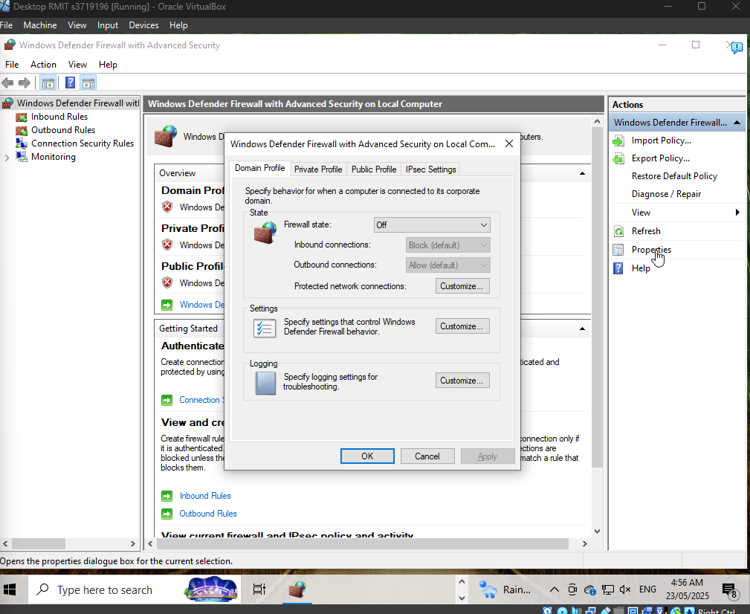
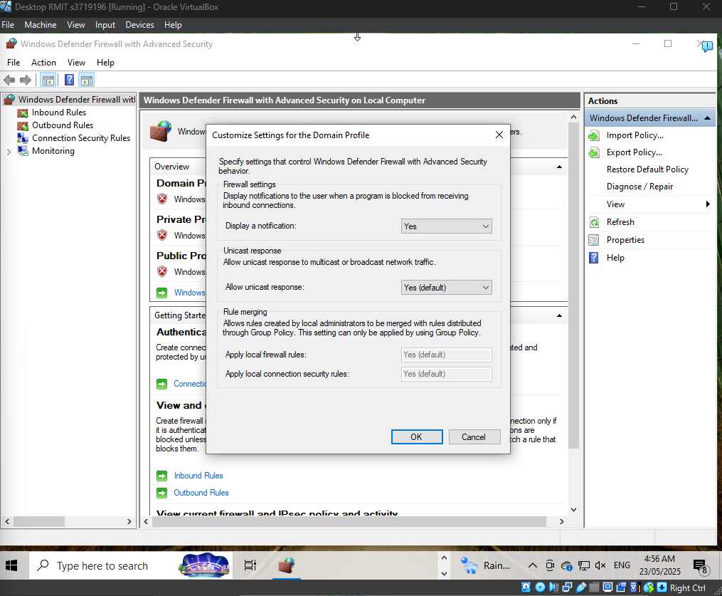

Implementing Intrusion Detection Systems (IDS)

Purpose of the IDS Implemented
We used Snort as the Intrusion Detection System (IDS). It helps monitor network traffic and detect unusual or suspicious behavior like port scans, phishing, or malware activity.
Snort works by checking traffic against known attack patterns (called signatures). If it sees something bad, it logs it and sends alerts.
Key features:
• Real-time traffic inspection
• Detects known attack signatures
• Sends alerts when a threat is detected
• Logs activity for later review

How End-Users Can Use the IDS
End-users, especially IT staff, can use Snort to check for threats. They can:
• Open Snort logs to find strange activity
• Use simple rules to watch for dangerous behavior
• Get alerts if Snort sees something suspicious
• Look at reports and use them to update firewall settings or train staff
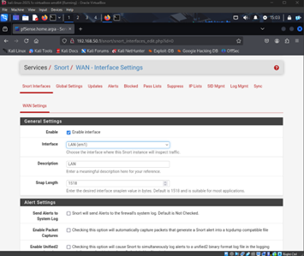
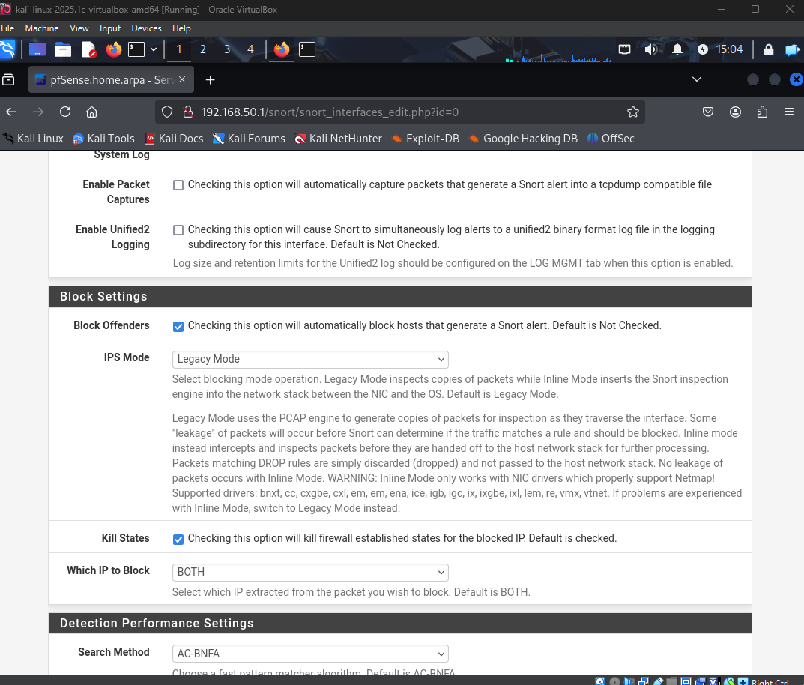
Create a rule, in this case we will be creating a ping rule
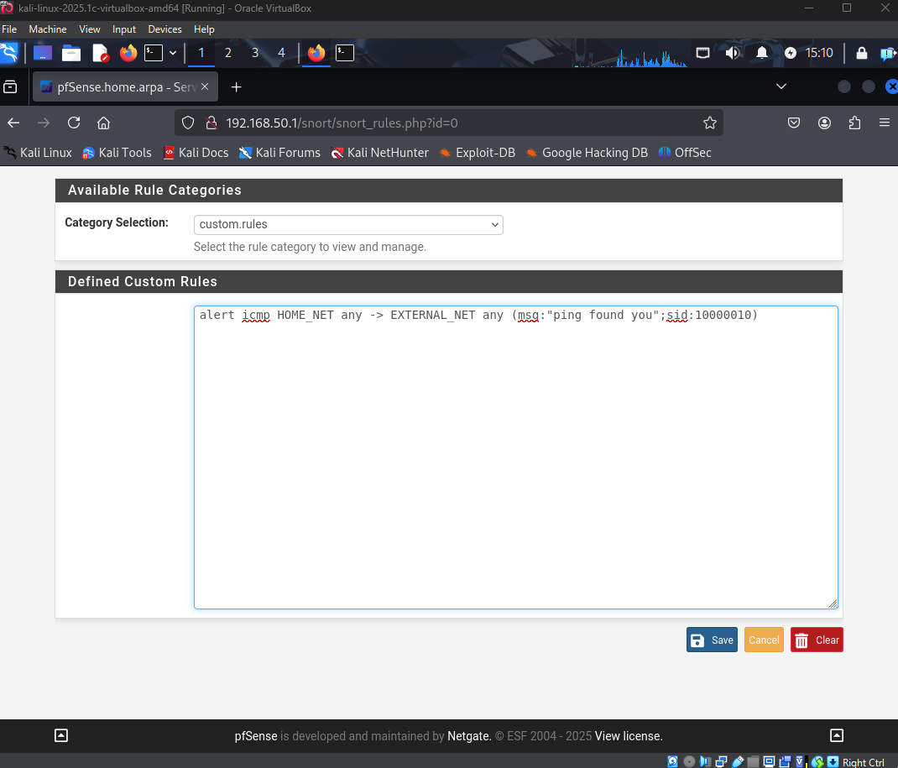
Here we are starting Snort after defining the rules
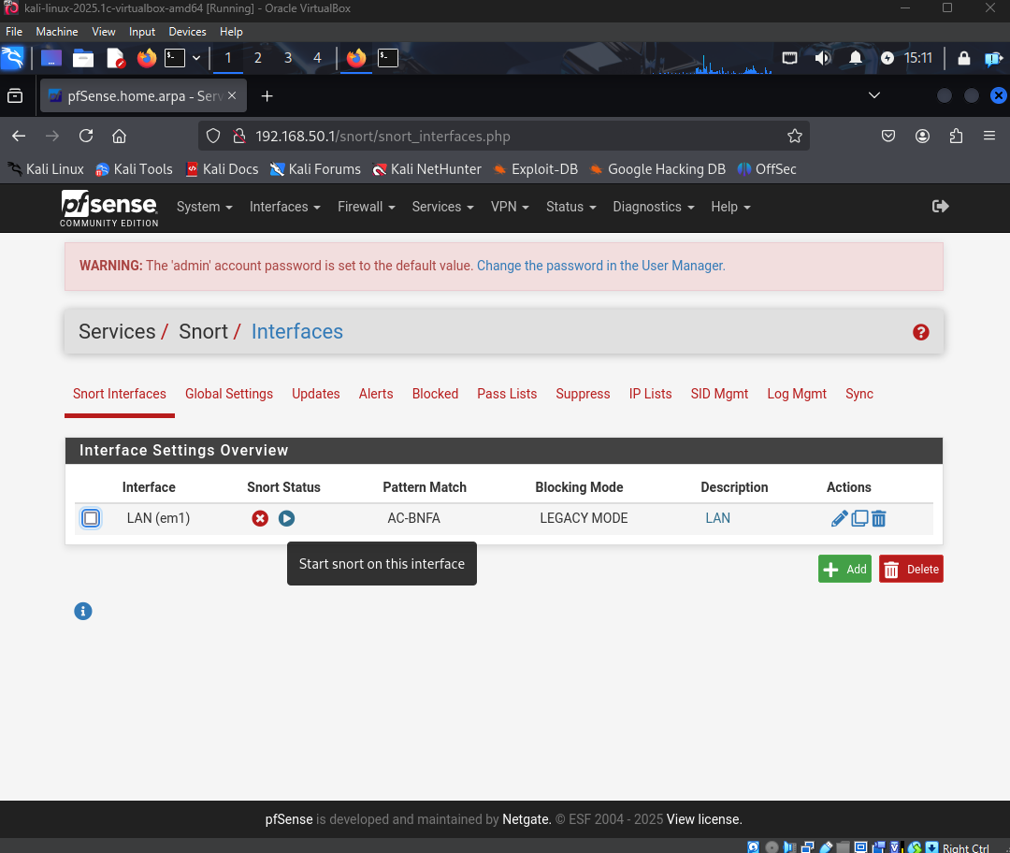
We pinging 8.8.8.8 but nothing comes back because of the rules, and you can see alerts
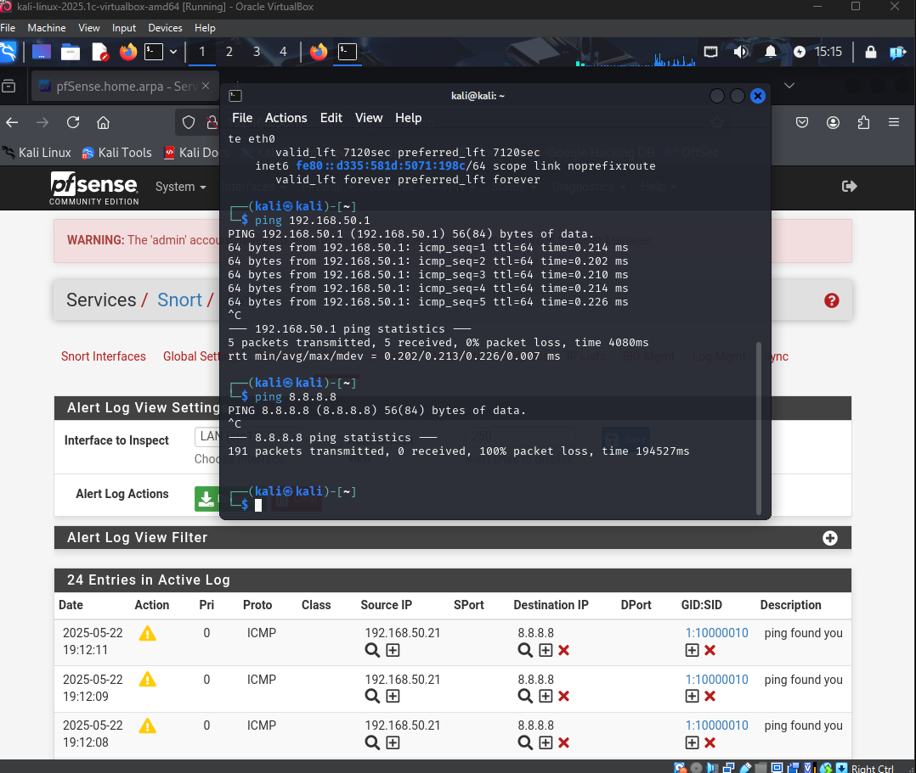

Implementing Intrusion Prevention Systems (IPS)

Purpose of the IPS Implemented
We used pfSense as an Intrusion Prevention System (IPS). It helps block bad traffic and prevent attacks like DoS, port scans, and malware.
During testing, we also used Ettercap to simulate attacks, and pfSense successfully blocked or slowed them down.
Key features:
- Blocks known threats automatically
- Uses firewall rules to control network access
- Rate-limits connections to stop DoS attacks
- Filters traffic based on IP, port, or protocol

How End-Users Can Use the IPS
End-users or IT staff can:
- Use the pfSense dashboard to watch for blocked traffic
- Edit firewall rules to allow or block services
- Look at traffic logs to find patterns
- Adjust settings if an attack is detected
This helps stop attacks before they cause problems.

IDS/IPS Integration with SIEM (Splunk)
All logs generated by Snort and pfSense are forwarded to Splunk, a centralized Security Information and Event Management (SIEM) platform. Splunk enhances this IDS/IPS setup by:
- Correlating alerts from Snort and pfSense with system and authentication logs
- Detecting patterns and anomalies across multiple sources
- Generating real-time alerts and visual dashboards for incident monitoring
- Supporting forensic investigations and compliance reporting
This integration significantly improves visibility into the network and accelerates incident response, making it a core component of the organization’s perimeter defense and logging strategy.

System Hardening:

Antivirus Tools
Antivirus tools are special programs that help protect your computer from harmful software, like viruses and ransomware. They check your files and watch for anything suspicious. If they find a problem, they stop it and let you know. This helps keep your computer and your information safe.
Windows Defender is usually sufficient enough as an antivirus solution, however, if a third party solution is required then Avast antivirus is an available option. It keeps an eye on your computer, scans for malware, and makes sure your Wi-Fi is safe.
Below is a demonstration for the Avast antivirus tool:
Visit https://www.avast.com/en-au/free-antivirus-download#pc and download
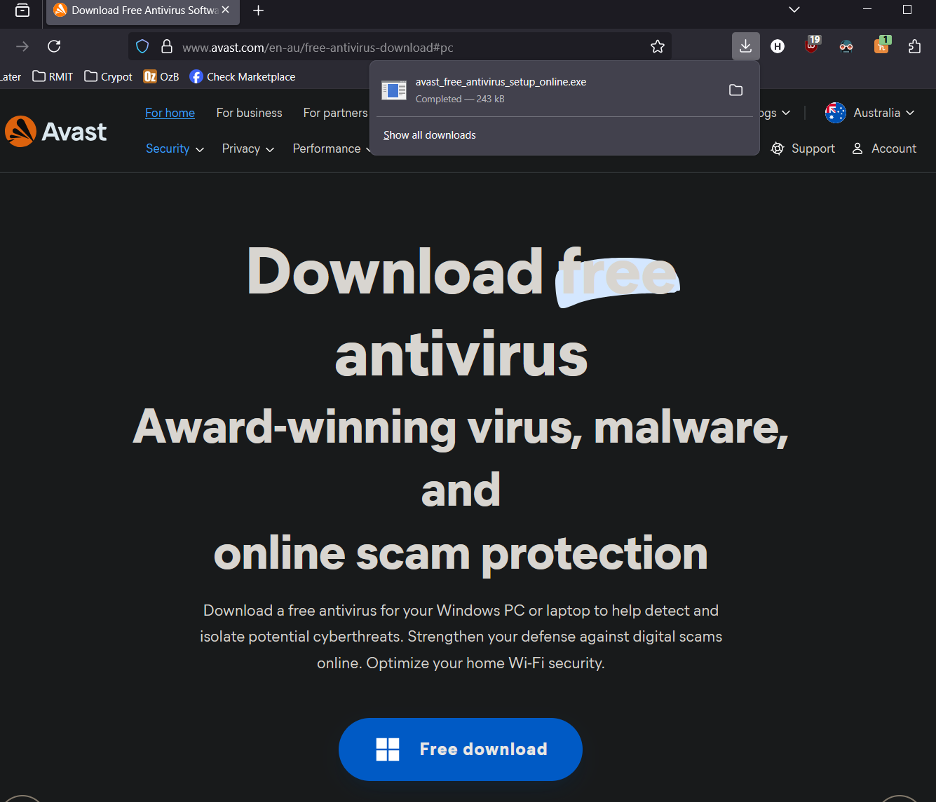
Install the exe
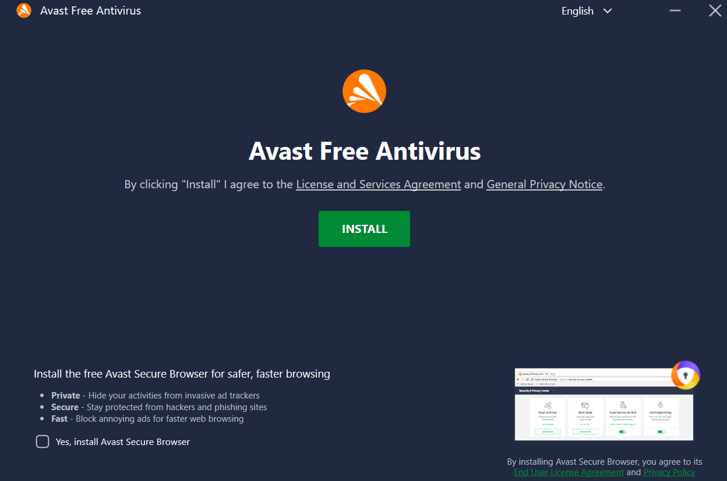
Run a scan
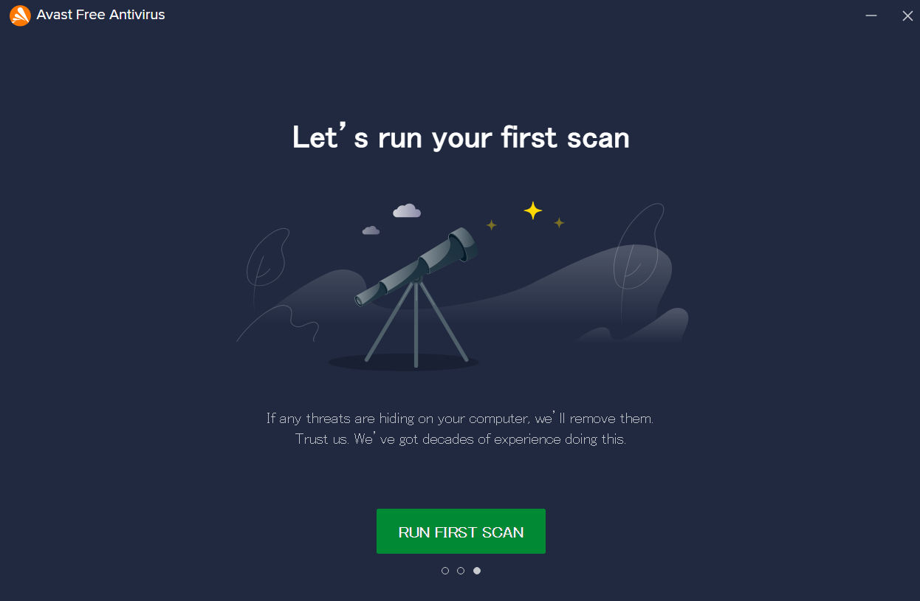
Review results and address any issues
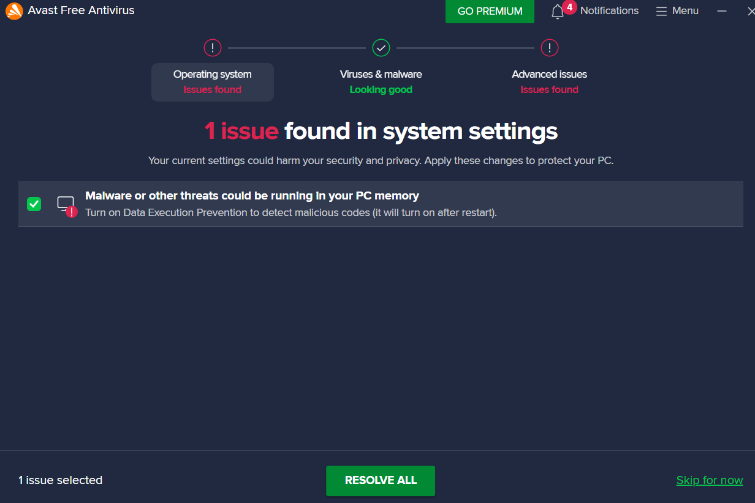
Here is the advanced issues tab, these are not viruses but suggestions to improve general cyber security for the user
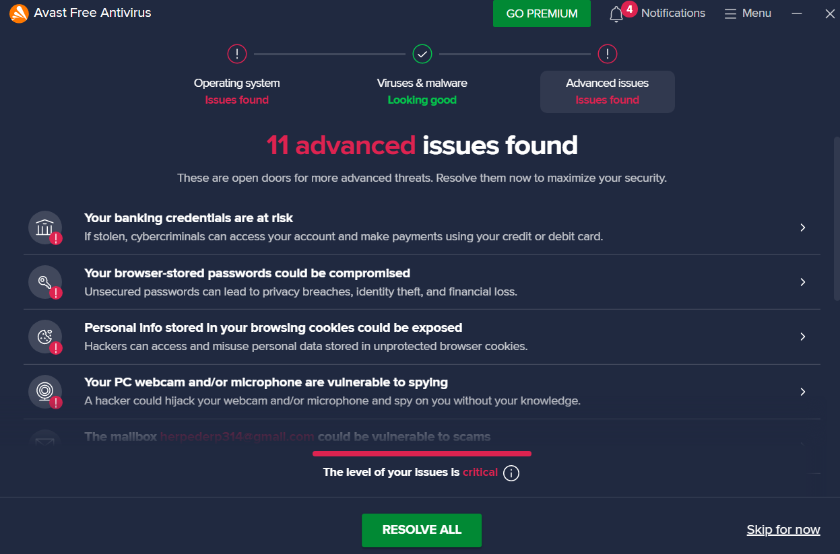
When Avast runs a scan, it often shows a lot of warnings and issues. While some of these are real security concerns, many are actually ads or suggestions to use Avast’s own products such as their browser, email service, or paid antivirus options. This can make it seem like your computer has more problems than it really does, but in most cases only a few issues are important for your security.

Mail security with SPF, DKIM and DMARC

SPF (Sender Policy Framework)
SPF tells email receivers which servers are allowed to send mail on behalf of your domain
Open Server Manager -> Tools -> DNS
Forward Lookup Zones -> examplelab.com
Create mail and www and enter the IP (in this case it is a local IP as this is being configured locally)
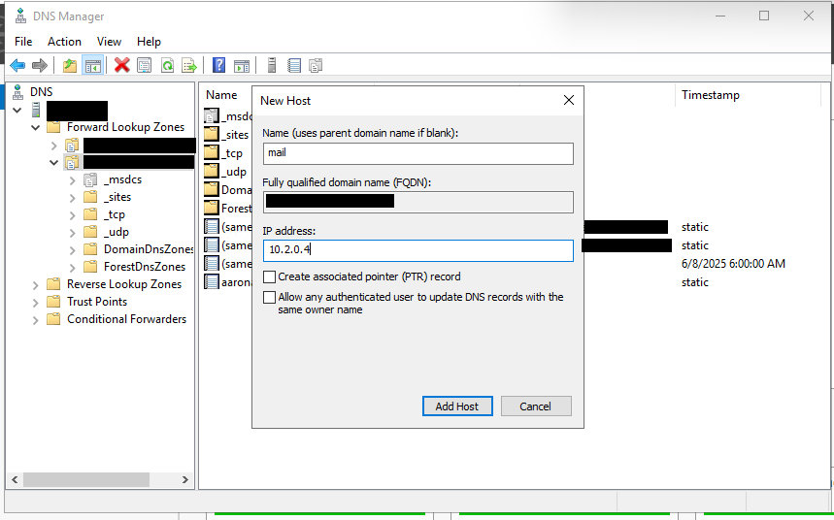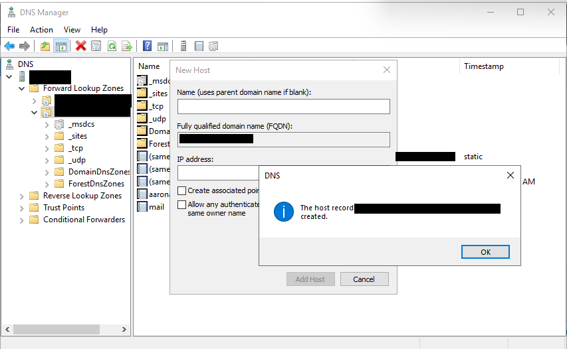
Open CMD and use the commands
nslookup mail.examplelab.com
Ping mail.examplelab.com
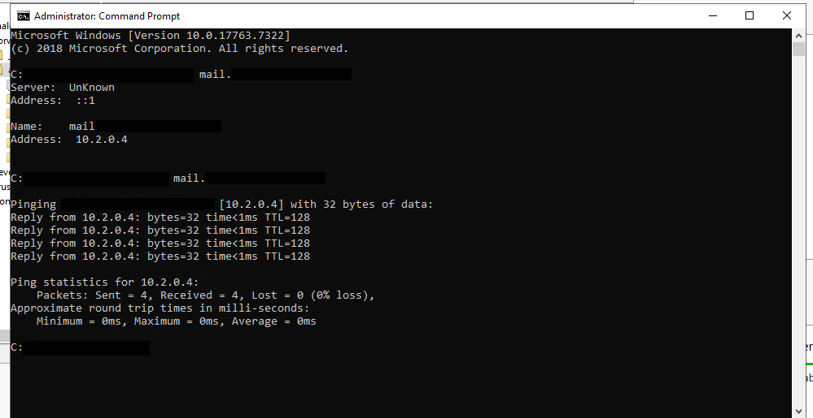

Select Other New Records…
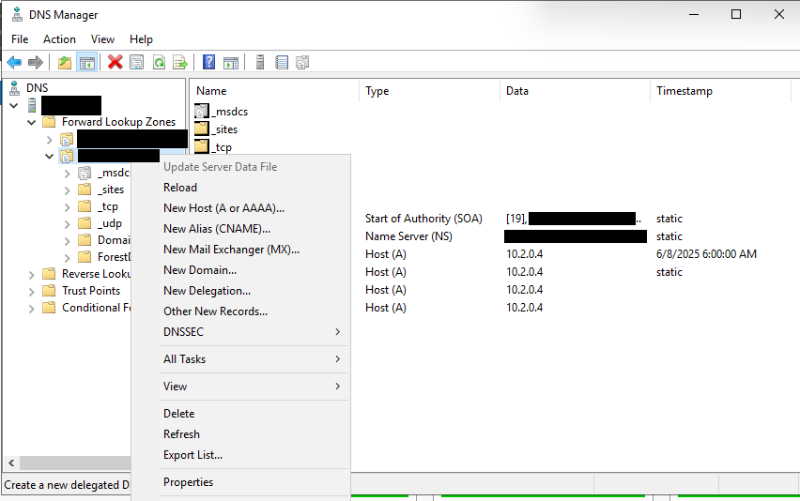

Select Text (TXT) and Create Record…
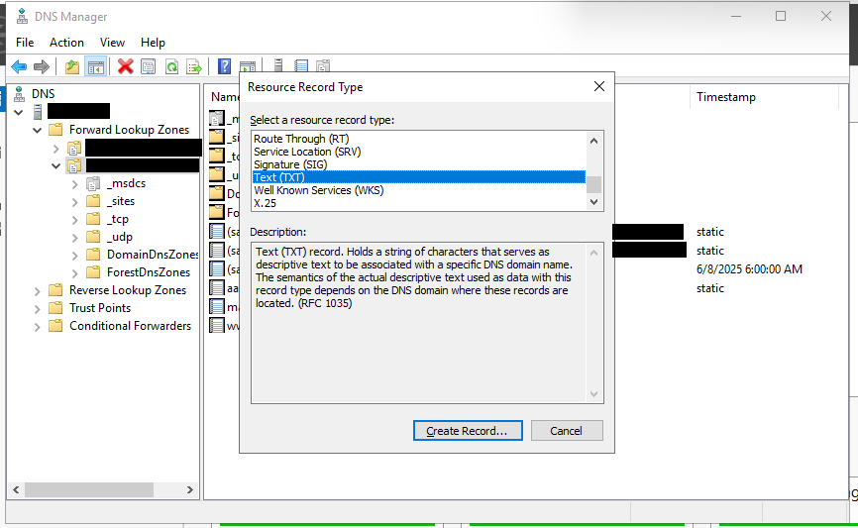
In the Record name box, leave it empty as it will use the parent domain if left blank
In the Text box, type v=spf a -all
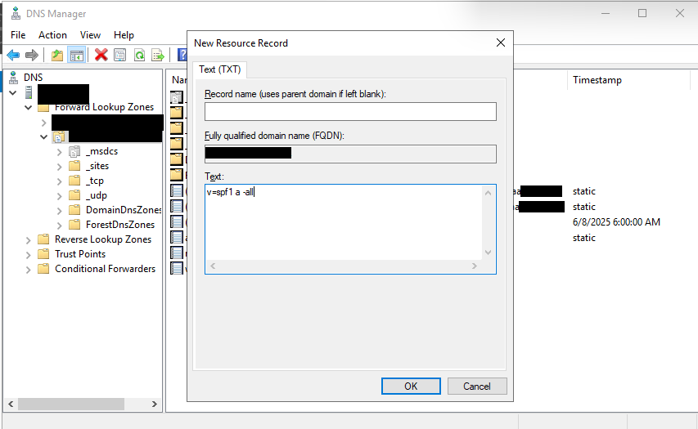
This means only allow hosts with A record (your own mail server) to send mail

DKIM (DomainKeys Identified Mail)
DKIM is a method to validate that an email came from your domain and was not tampered with
Select Other New Records
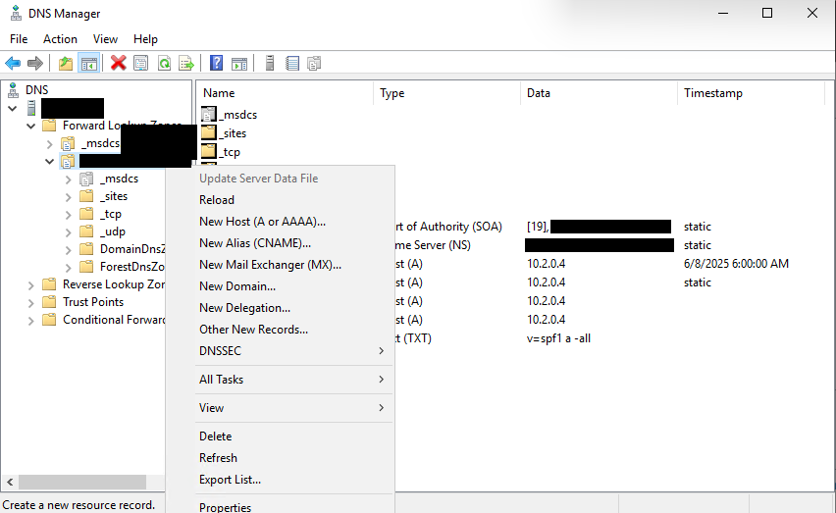
Select Text (TXT) and Create Record…
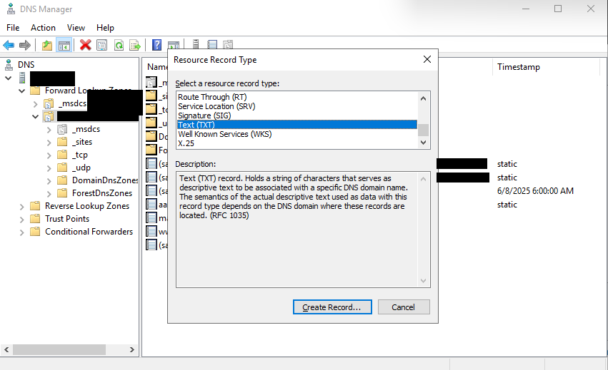
In the Record name box, type selector1._domainkey
In the Text box, type v=DKIM1; k=rsa; p=FakeDKIMPublicKey123ForTestOnly
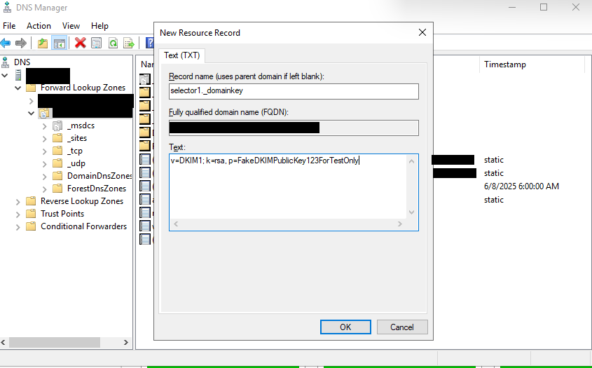
This creates a placeholder DKIM key under selector1._domainkey.examplelab.com

DMARC (Domain-based Message Authentication, Reporting, and Conformance)
DMARC tells receiving mail servers what to do when SPF or DKIM fails
Select Other New Records…
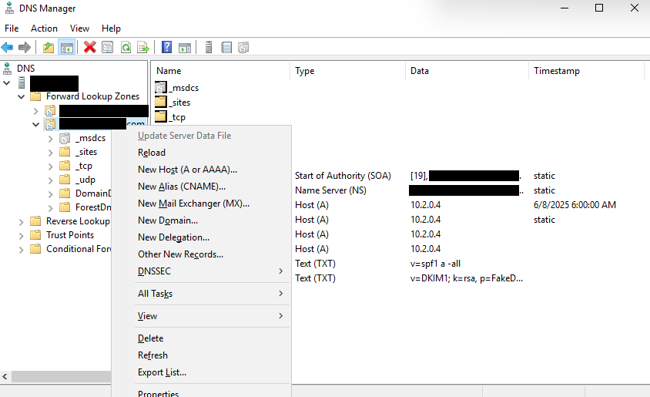
Select Text (TXT) and Create Record…
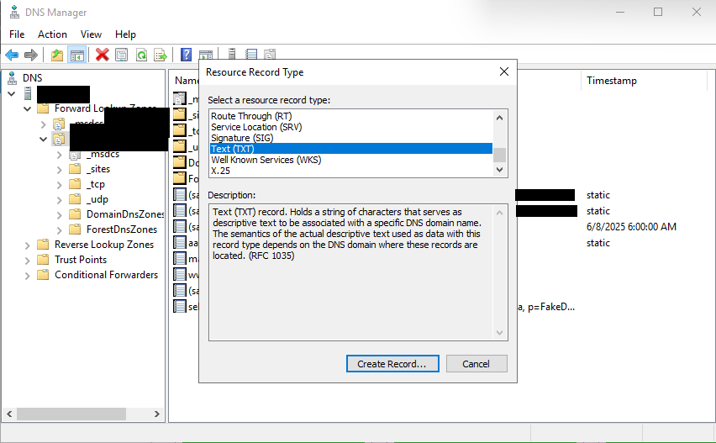
In the Record name box, type _dmarc
In the Text box, type one of the following:
v=DMARC1; p=none; pct=100
v=DMARC1; p=quarantine; pct=100
v=DMARC1; p=reject; pct=100
v=DMARC1; p=none; rua=mailto:dmarc@examplelab.com (say that this email is for reviewing emails)
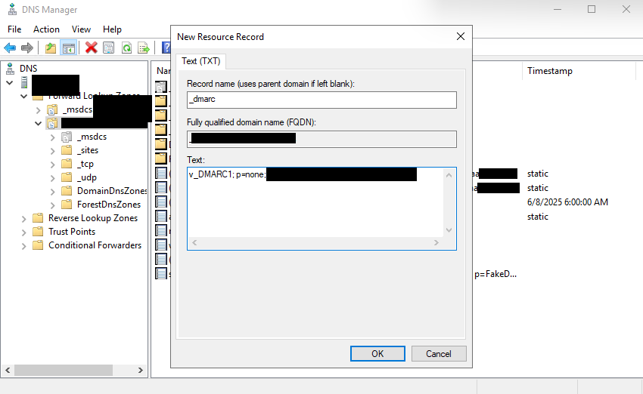
p=none means just monitor, no emails are blocked
p=quarantine means an email without SPF or DKIM to quarantine
p=reject means any email that fails DMARC authentication will be rejected, it will not even be delivered to the recipient’s inbox or spam folder
pct=100 means % of email, e.g. for 100% of the emails you either do nothing, quarantine, or reject
rua= would send reports to the email address, rua exists for email domain owners to gain insights into the authentication status of their outgoing emails

Overall, DMARC records will reveal whether emails are passing or failing DMARC, SPF and DKIM authentication, and the actions taken by the receiving server based on the DMARC policy (e.g. p=none, p=quarantine, p=reject).

Verifying SPF, DKIM, and DMARC
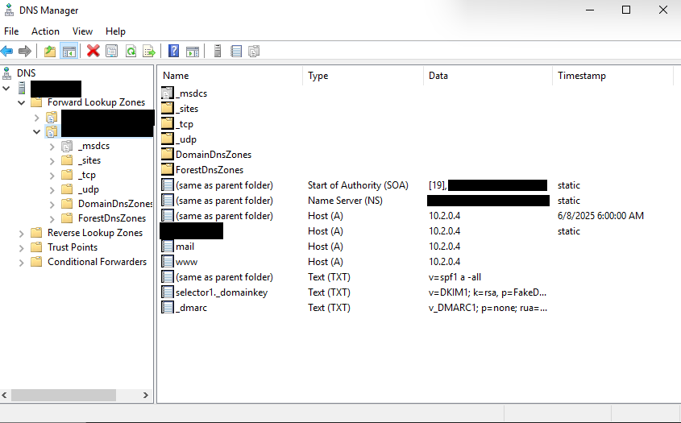
Open CMD and use the commands to verify records
nslookup -type=TXT examplelab.com
nslookup -type=TXT selector1._domainkey.examplelab.com
nslookup -type=TXT _dmarc.examplelab.com
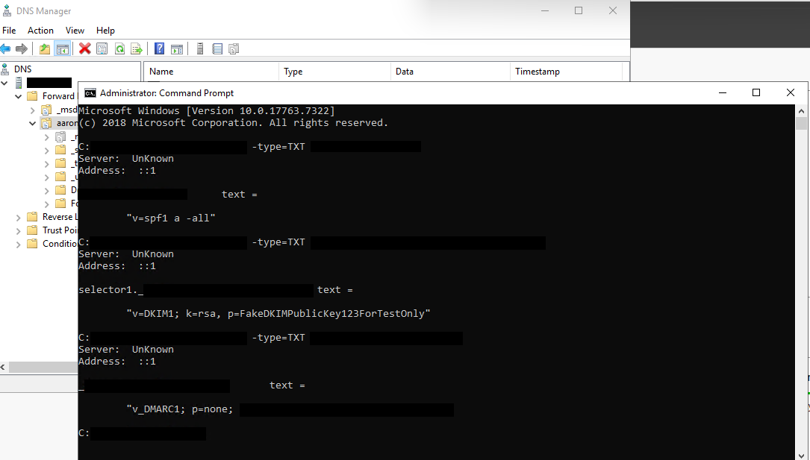
SPF v=spf1 a -all authenticates the server
DKIM selector1._domainkey signs messages with public key
DMARC _dmarc defines policy if SPF/DKIM fails

