THE BUSINESS IDE
BIDE — "Windsurf for Business"
Product Reference
One orchestrating intelligence across every business function —
vision, architecture, data foundation, workflows, build plan, and go-to-market, in one place.
About this document
The Business IDE (BIDE) is a single, reusable AI engine that loads the full context of a company — its transactions, inventory, sales, and the tacit knowledge in the owner's head — and lets the owner run the business by asking questions and receiving grounded, calibrated answers, and increasingly by delegating safe actions.
This is the complete product reference: the vision and core principles, the layered architecture, the data foundation, memory and knowledge, the tools-and-agent core, the dashboard, every business workflow, the marketing engine, the engineering build plan, and the go-to-market plan. Source-agnostic by design; TranzAct is the first data adapter, with more to follow.
Internal & Confidential

Contents
(In Microsoft Word, right-click the field below and choose "Update Field" to generate live, clickable page numbers.)
Part 0 — Product Vision & Core Concepts
what BIDE is · the three promises · the Windsurf parallel · the universal loop · the confidence gate · calibrated confidence · "are we a wrapper?" · first principles
Part 1 — The Architecture
the twelve-layer stack · four concentric layers · the Business IDE four-layer view · the two storage planes · the case catalog (Families A–H)
Part 2 — The Base Layer (Data Foundation)
four stages · the ten TranzAct reports · raw layer · canonical layer, envelope & adapter · LLM map / deterministic load · ingest_issues · synchronisation · calculations
Part 3 — Memory & Knowledge
business profile · memory_fact · capture & decay · entity_summary · the knowledge plane (RAG + KG) · the learn-and-evolve loop
Part 4 — Tools, Agent & Reasoning
the tool interface & contract · the three-family catalog · the tools-only AI (retrieve→reason→validate) · gates & model tiering · the reasoning base · the agent core · the action spine
Part 5 — The Dashboard
the money story · page-by-page panel catalog & formulas · the business dictionary
Part 6 — Workflows: The 13 Business Fields
all 13 fields and every workflow · the synapse bus · the seven flagship synapses
Part 7 — The Marketing Engine
the four revenue engines · the hold-back proof method · rollout
Part 8 — The Build Plan (Engineering)
current baseline · phases 0–7 · build order · learning curriculum · risk register · infrastructure & scaling · cost model · long-term tech decisions
Part 9 — Go-to-Market: The Stagewise Business Plan
the wedge · stages 0–4 · pricing · rules never broken · the weekly numbers
Part 10 — Stage 0 → Stage 1: A Productized MSME Growth System
the problem & opportunity · stage definitions · four phases, eleven steps · lead lifecycle · the automation tool suite · commercials
Appendix A — Consolidated Glossary
Appendix B — Diagram & Source Index
Live table of contents (updates in Word):

Part 0 — Product Vision & Core Concepts

0.1 What BIDE is
The Business IDE (BIDE) is one intelligence that runs a business, not another toolbox that records it. Today most companies run on software that only logs what already happened — an ERP logs transactions, a CRM logs contacts, a helpdesk logs tickets — and a human is the connecting intelligence stitching the drawers together by hand. BIDE inverts that: a single intelligence perceives across every function, reasons about what to do, and acts, keeping a human in the loop exactly where judgement and money are at stake. The tools become sources BIDE reads from and writes to, not islands a person ferries between. Throughout this document, "the brain" is used as a shorthand for this single orchestrating intelligence.
One principle governs the whole product: BIDE is source-agnostic by design. The first release serves TranzAct data, but nothing in the architecture is TranzAct-specific. Every layer above the data adapter speaks a source-independent canonical language, so adding Tally, Busy, Zoho, email or any API later is a new adapter and zero changes to the brain.
In plain terms
Imagine a busy shop that keeps its information in separate drawers — one for money, one for customers, one for complaints, one for stock — and the drawers do not talk to each other, so a person has to run around opening each and joining the dots in their head. BIDE replaces that running-around person with one intelligence that can read every drawer at once, understand what it sees, and take helpful actions — while always asking a person before anything that could lose money.
If you remember only one sentence: BIDE is one system that can see everything the business knows, think about it, and do helpful things, while always asking a human before anything risky.

0.2 The three promises every feature must serve
Every capability BIDE ships must serve one of three promises, each with its own kind of confidence:
Promise | Meaning | Confidence type
Know | What is actually happening right now | Computed facts, no guesswork
Understand | Why it is happening | Inference from patterns, assumptions flagged
Decide | What to do about it | Recommendations with explicit confidence
Target users: the SMB owner (trading / manufacturing) drowning in Tally / Busy / Excel; the finance manager whose monthly close takes 10 days; the sales head with no churn visibility; the operations lead whose inventory aging lives in an untrusted spreadsheet.

0.3 The Windsurf / Cursor parallel — and where it breaks
Just as Cursor / Windsurf reads every file in a codebase and lets a developer ask "what's broken here?", BIDE reads every domain of a company and lets the owner ask "what's broken in my business?" — and answers with data-backed confidence, not guesswork.
Where the analogy breaks — and why it matters
Code parsers are pre-built by the open-source community; you must build business parsers yourself, one per source per industry. A codebase is closed and machine-readable; a business is open, incomplete, and partly inside people's heads. Code compiles or fails in seconds; business advice plays out over months. A wrong code suggestion is a red squiggle; wrong business advice is a real-money decision. The analogy is the source of both the idea's strength and its biggest trap.

0.4 The universal loop — the one idea everything is built from
Every workflow in BIDE — chasing an overdue invoice, reordering stock, drafting a support reply, flagging a risky contract — is the same loop pointed at different data. Internalising this one shape (the universal loop) makes the entire system easy to reason about.
- Trigger — an event (a payment lands), a schedule (a 3 a.m. sync), or a person asking a question.
- Gather — the brain reads the data it needs, through tools, turning raw data into tagged evidence.
- Reason — it builds claims, deciding what the data means.
- Gate — it checks how sure it is. This is the heart of the design (see 0.5).
- Act — it does the thing (or answers), within what the gate allows.
- Remember — it writes the outcome back to memory so the next pass is better informed.
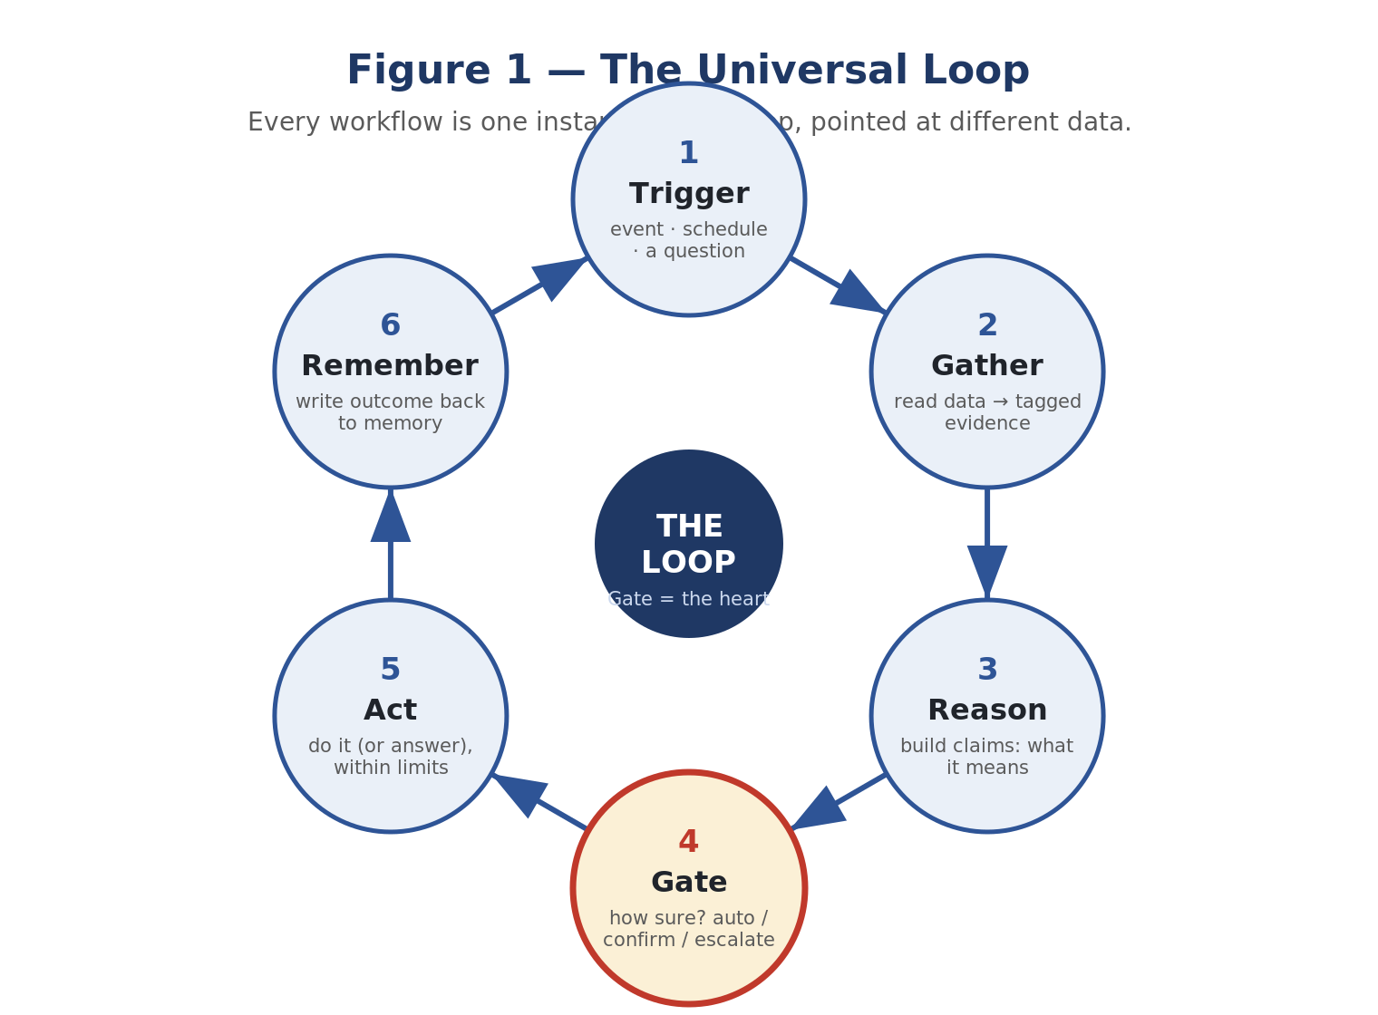
Figure 1 — The universal loop. Every workflow is one instance of it, pointed at different data.

0.5 The confidence gate — what makes autonomy safe
Business decisions move real money, so a confidently wrong answer is worse than no answer. Every workflow therefore passes through a three-way gate before it acts — think of it as a traffic light:
- CERTAIN / Green: actions run automatically — the brain just does it.
- PROBABLE / Yellow: the work is done but waits for a human to press "yes" before it takes effect.
- UNCERTAIN / Red: the brain stops and hands the job to a person.
The one unbreakable rule
Anything that moves money or files with a regulator ALWAYS needs a human — no matter how sure the brain is. The brain does the work; a person makes the final call.
The design principle that makes the AI trustworthy
The model proposes; deterministic code disposes. The AI may decide what to do, but whether it is safe to actually do it is decided by a rules engine we own — never by the model grading itself. Confidence is computed from real signals (is the data fresh? did the match resolve unambiguously? is this a money action?), not from the model saying "I'm 90% sure". This is the line between a controlled brain and a reckless agent.
Why you can trust the numbers: the brain is built so it cannot make up a number. It is only ever allowed to repeat numbers it actually looked up, and it never grades its own confidence — the gate is decided by fixed rules we wrote.
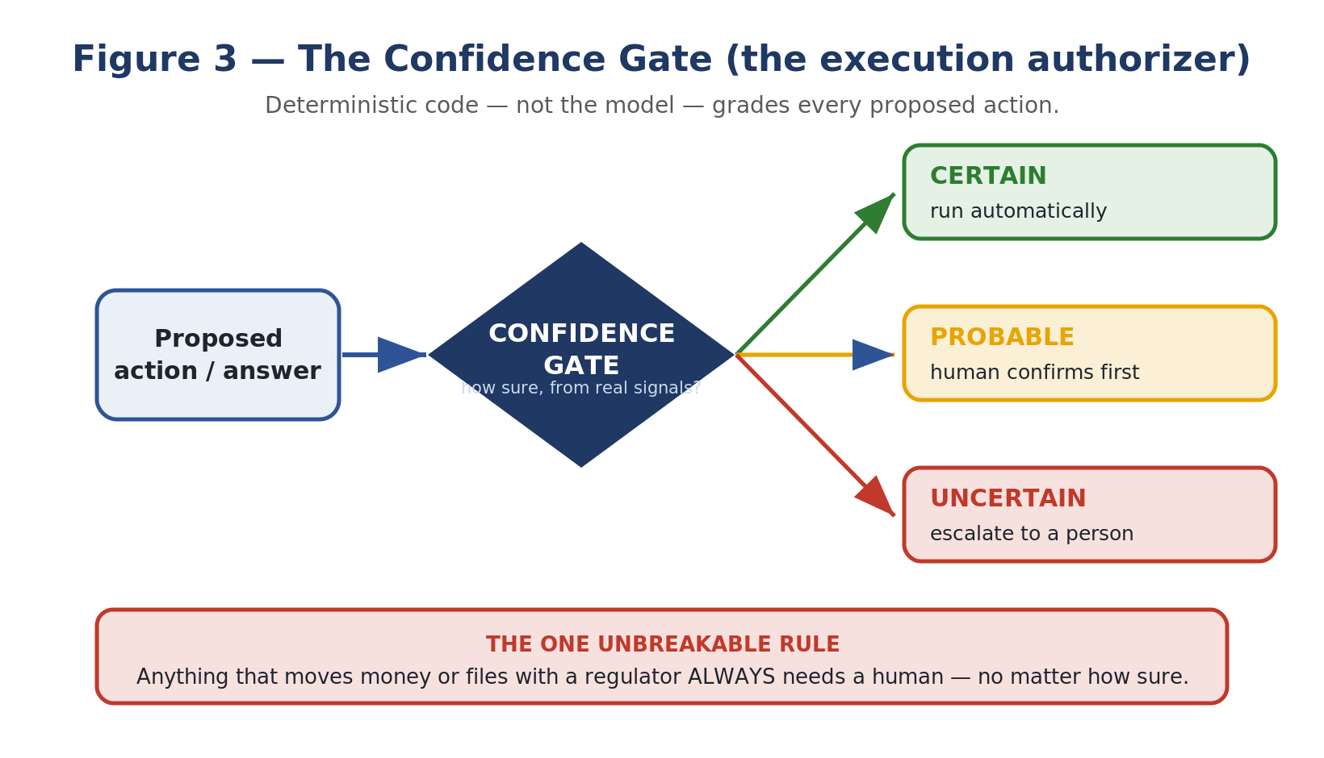
Figure 3 — The confidence gate as the execution authorizer.

0.6 Calibrated confidence — the non-negotiable principle
Every AI response carries exactly one label. This is what earns multi-year trust.
Level | When | Example
CERTAIN | Data complete, rule defined, deterministic | "Your March revenue was Rs 24.3L, down 8.2% from Feb. Driven by 3 large orders delayed to April."
PROBABLE | Pattern exists, variables missing | "Based on last 6 months, Q3 looks weak — but I don't have your forward order book to confirm."
UNCERTAIN | Insufficient data or too many unknowns | "I cannot advise reliably. Here's the data I'd need: [list]. Please provide it."

0.7 "Are we a wrapper?" — the governing test
One question sits underneath the whole product: "If a business owner simply handed all his data to a chatbot, wouldn't he get the same answers BIDE gives? So what is BIDE actually for?" BIDE treats this as the governing test of the whole architecture rather than a worry to be reassured away — every layer exists because there is a case where raw-dump fails and BIDE does not.

The honest two-part answer
- For a small, clean, low-volume business asking a one-off question — raw-dump often is enough. We admit this freely; pretending otherwise is how teams build moats nobody needs.
- The moment the business is real and ongoing, raw-dump breaks in predictable ways — cost, trust, freshness, memory, consistency, messy data. Our product lives entirely in that gap. The architecture is the disciplined capture of that gap, case by case.
The raw-dump test (our permanent yardstick)
For every capability we consider building, we ask: does it beat "dump the data into Claude and ask" on a specific, named case? If it does, it earns its place in the architecture. If it does not, it is decoration. Raw-dump Claude is not the enemy — it is the baseline we measure ourselves against, forever.
The one-line differentiator
A one-time analysis is a wrapper. A living, always-fresh, owner-corrected, auditable system of record is a product. Our moat is in time and trust, not in any single answer.

0.8 First principles (the non-negotiables)
These commitments the rest of the architecture must obey. If a future decision violates one, the decision is wrong — not the principle.
- Substrate first, chat last. The chat is the most visible layer and the least defensible one. We sell and defend the substrate; the chat is the demo that proves it works.
- The dashboard is the hook; the parser and memory are the moat. The dashboard wins the meeting but does not keep the customer or keep out a competitor. Clean normalised data across messy ERPs, plus accumulated owner-specific memory, does.
- Honesty is structural, not prompted. Numbers come from deterministic queries; a separate check blocks any invented figure; every answer carries a confidence label and its sources. "I don't know" is a designed behaviour, not a hope.
- Earned complexity. No layer or feature is built because it is clever or because a competitor has it — only when a named case demands it and it beats the baseline. Complexity must pay rent.
- Memory compounds; data refreshes. Live data is rented from the source system. Owner-confirmed knowledge — terms, trust, seasonality, what a SKU really is — is ours and grows over time. The compounding asset is the memory, not the dashboard.
- Reason once at ingest, consult at query. Expensive understanding (mapping, summarising, reconciling) happens once when data arrives and is stored; questions consult pre-built understanding rather than re-deriving it every time.
- A scoreboard or it didn't happen. We hold a fixed set of real owner questions with hand-verified answers and measure ourselves against the raw-dump baseline. If we can't measure a gain, we didn't make one.

Part 1 — The Architecture
BIDE can be viewed through two complementary architectural lenses. The first is a twelve-layer stack (Layers 0–11) built ground-up, where each layer has one responsibility. The second is four concentric layers ordered by defensibility — surface, reasoning, memory, and substrate. Both describe the same system; this part presents both, plus the two-plane storage model that underpins them.

1.1 The layered architecture (the twelve-layer stack)
The brain is a stack of layers. Each has one responsibility and one strict rule about what it is allowed to know. This separation is the entire reason a new data source or a new workflow can be added without disturbing the rest. The lower layers (the substrate) are the hard, defensible part — adapters into messy local systems, a canonical model, memory, and a confidence-gated reasoning core. The upper layers (tools, agent, actions, workflows) are the apps that run on that substrate.
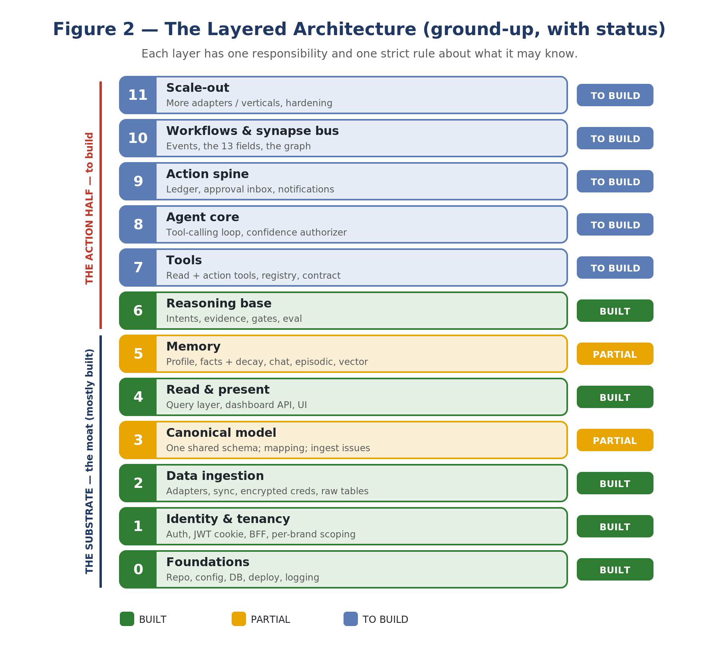
Figure 2 — The layered architecture, ground-up, with current status.
Layer | What it is | Status
0 · Foundations | Repo, config, DB, deploy, logging | BUILT
1 · Identity & tenancy | Auth, JWT cookie, BFF, per-brand scoping | BUILT
2 · Data ingestion | Adapters, sync, encrypted creds, raw tables | BUILT
3 · Canonical model | One shared schema; mapping; ingest issues | PARTIAL
4 · Read & present | Query layer, dashboard API, UI | BUILT
5 · Memory | Profile, facts + decay, chat, episodic, vector | PARTIAL
6 · Reasoning base | Intents, evidence, gates, eval | BUILT
7 · Tools | Read + action tools, registry, contract | TO BUILD
8 · Agent core | Tool-calling loop, confidence authorizer | TO BUILD
9 · Action spine | Ledger, approval inbox, notifications | TO BUILD
10 · Workflows & synapse bus | Events, the 13 fields, the graph | TO BUILD
11 · Scale-out | More adapters / verticals, hardening | TO BUILD
Where we are, in one line: the entire substrate (Layers 0–3) and the safe reasoning core (Layer 6) are built; the read layer (4) and memory (5) are partly built. The work ahead is the action half — Layers 7–10: tools, the tool-calling agent, the action / approval spine, and the synapse bus. That is the build that turns today's grounded analytics product into the self-running Business IDE.

1.2 The four concentric layers (by defensibility)
Strip away the technology and the product is four concentric things, each wrapping the one below. Value and defensibility increase as you go inward; visibility increases as you go outward. The outer layers are where most effort has been spent so far (dashboard + chat); the inner layers — memory and especially the substrate — are where the defensibility lives and where we are thinnest. The strategic correction: stop polishing the hook and build the moat.
Layer | In plain words | The case it exists for | Defensibility
Surface | The dashboard the owner opens each morning, and the chat they ask questions in. | "Show me how the business is doing" and "let me just ask." | Low. Anyone can build a screen.
Reasoning & honesty | The analyst that turns data into answers it can stand behind, or honestly refuses. | "Give me an answer I can act on without being misled." | Medium. We are already strong here.
Memory & context | What we know about this specific business that is not in the raw data. | "Remember how my business actually works." | High. Compounds; cannot be copied.
Substrate (source of truth) | Clean, normalised, traceable business data, independent of which ERP it came from. | "Make my messy data trustworthy and queryable." | Highest. The real moat.

1.3 The Business IDE four-layer view
The same architecture can also be framed as four build-and-validate-in-order layers — the sequence in which BIDE is built and hardened:
Layer | What it does | Why it is hard / valuable
0 — Ingestion & Parser | Convert raw, chaotic source data (Tally XML, Tranzact reports, Busy exports, messy Excel) into a clean canonical schema. | The moat. Competitors cannot clone it quickly; it is earned integration by integration.
1 — Storage & Aggregation | Store canonical data in Postgres; pre-compute aggregates so the AI gets small, calibrated payloads, not raw tables. | Keeps the LLM cheap, fast, and accurate (small payloads beat raw rows).
2 — Context & Memory | (a) A static business profile seeded at onboarding; (b) a growing memory layer capturing human knowledge the moment it is revealed. | The deeper moat. The dashboard is the hook; the memory is what compounds.
3 — Reasoning & Interface | The cockpit: KPI canvas, charts, AI chat. Routes questions, fetches calibrated payloads, scores confidence, generates grounded responses. | Where trust is won or lost in a single session.

1.4 The two storage planes
Memory is split in two, and the two halves are deliberately walled off — they meet only at the tool interface. This boundary is a hard rule.
Plane | What lives here | How it is queried
Structured plane | Numeric business truth: invoices, customers, items, payments, receivables — normalised into the canonical model with provenance. | Deterministic SQL query functions. No embeddings, ever. A money number always comes from here.
Knowledge plane (NEW) | Unstructured meaning: owner documents, business studies / playbooks, domain notes, learned context — chunked, embedded, and linked into a lightweight knowledge graph. | Semantic search (RAG) + graph traversal tools. Answers "how / why / what does this mean", never the source of a figure.
The hard boundary
A money figure or a countable fact is ALWAYS sourced from the structured plane. The knowledge plane answers "how / why / what does this mean / what's the playbook" — it never originates a number. The AI orchestrator enforces this: numeric claims may only cite structured-plane tools.

1.5 The case catalog — situations the architecture must handle
The architecture is derived from the situations BIDE must handle, not from technology. These are enumerated as eight families of cases; every architectural choice points back to a case here.

Family A — Differentiation cases (where we beat raw-dump)
# | Situation | What raw-dump does | What we do (and the layer)
A1 | Owner asks the same kind of question every week for a year | Re-reads the entire dataset every time; pays full cost, risks a different answer each time | Parses once at ingest; answers are cheap and consistent (Substrate + Reasoning)
A2 | An answer must be defended to a banker, partner or auditor | Produces a confident paragraph with no verifiable trail | Every number traces to a source row and freshness timestamp (Substrate provenance)
A3 | Data is messy, inconsistent, spread across reports | Chokes, mixes things up, or quietly guesses | Normalises into one clean model; flags what it can't map (Substrate)
A4 | Right answer depends on something only the owner knows | Has no way to know; invents or omits | Recalls owner-confirmed facts and uses them (Memory)
A5 | Numbers change through the day (cash, orders, stock) | Only knows the snapshot it was given | Stays fresh on a schedule; can alert proactively (Substrate sync + Surface)
A6 | A money figure must be exactly right | Will happily produce a plausible wrong number | Cannot state a money figure it did not compute (Reasoning honesty guard)
A7 | Owner adds a second system later (e.g. Tally) | Starts over; nothing carries | New source plugs into the same model; questions keep working (Substrate contract)

Family B — Question cases (what owners actually ask)
Type | Owner intent | Examples | What "good" means
Know | A fact retrieval | "What did I sell last month?" "Who owes me money?" | Exact, sourced, fast
Understand | An interpretation / pattern | "Am I too dependent on one customer?" "Is my stock moving?" | A judgement, clearly labelled as such, with the assumption stated
Decide | A recommendation / judgement call | "Is this customer safe to extend credit to?" "What should I reorder?" | Lay out the evidence; never pretend the decision is ours to make alone

Family C — Response-mode cases (how the system is allowed to answer)
Every question resolves into exactly one of four response modes. "Refuse" and "Ask" are features, not failures — raw-dump has essentially one mode: it always answers, confidently, right or wrong.
Mode | When it fires | What the owner sees
Answer | Data present, fresh, question maps to something we can compute | A direct answer with the figure, its source, and how recent it is
Flag | We can answer, but only by making an assumption | The answer plus the assumption, labelled as inference, not fact
Refuse | Data needed is missing, stale, or the question is outside what we can know | An honest "I can't answer this, and here's exactly what's missing"
Ask | We could answer if the owner taught us one fact | A specific question back, whose answer we then remember (feeds Memory)

Family D — Data-condition cases
Governing rule: stale is better than empty; flagged is better than wrong; quarantined is better than guessed.
Condition | What can go wrong | Required behaviour
Clean & complete | Complacency | Answer normally, with provenance
Messy / inconsistent | Wrong totals, mismatched names | Normalise; reconcile to the source's own stated totals
Partially unmappable | Silent guessing fills the gap | Map what is confident; quarantine the rest to an issues log; never invent
Missing entirely | Fabricated answer | Refuse, and say what data would be needed
Stale (sync failed) | Confident but out-of-date answer | Keep old data but mark it stale; warn before answering on it
Contradictory across sources | Two systems disagree | Surface the conflict rather than picking silently
Data contradicts a remembered fact | Acting on an outdated belief | Mark the fact stale and re-ask the owner

Families E, F, G, H
- Family E — Memory cases: how knowledge enters, is used, ages, and is corrected. An owner teaches a fact; corrects an answer; a fact ages and decays; a fact contradicts fresh data and is re-asked; facts are brand-specific and never leak between businesses.
- Family F — Trust & evaluation cases: the largest current blind spot. The baseline (how good raw-dump really is), the gold set (frozen real questions with hand-verified answers), the fabrication attempt (blocked), the correct refusal, regression on every change, and cost-per-question tracked and compared.
- Family G — Onboarding & lifecycle cases: a new business onboards fast (capped in days); first sync backfills safely and shows something real on day one; a second source plugs into the same model; cost/speed stay flat as volume grows; the product visibly gets smarter over time.
- Family H — Failure cases we design against: confident-wrong destroying trust; "consulting firm in SaaS costume"; building the universal version too early; cost surprise; silent drift; building blindly. Each has an architectural guard.

1.6 The layers, built one by one
Each layer below follows the same template: what it is, what exists today, what remains to improve or build, the modules and code (with the reason for each), how it connects to the layers around it, and the workflows it powers.

Layer 0 — Project Foundations · Status: BUILT
What it is. The skeleton everything runs on: how the code is organised, how configuration and secrets are loaded, how we reach the database, how we deploy, and how we see what is happening (logging).
What we have. A monorepo with two deployable services — a Python FastAPI backend (the brain) and a Next.js frontend (the face) — plus a shared TypeScript types package. Configuration is centralised in config.py, read from environment variables via python-dotenv (no secret is ever hard-coded). Database access goes through a single connection helper to PostgreSQL. Deployment is a Docker container running uvicorn; the frontend runs on Vercel.
Why this shape. Two services, not one, because the brain (Python, data + AI) and the face (TypeScript, UI) have different runtimes and scaling needs. A monorepo keeps them versioned together and lets them share types.
What to improve / build. A proper CI pipeline that runs the eval suite + tests on every push (PARTIAL); structured, queryable logging and request tracing — today logs are plain text (PARTIAL).
How it connects. Every other layer depends on this one for config, the DB connection, and deployment. Nothing here knows about the business — it is pure plumbing.

Layer 1 — Identity & Tenancy · Status: BUILT
What it is. Who the user is (authentication), what they are allowed to touch (authorisation), and how one account can run several brands without their data ever mixing (multi-tenancy). It is built first because every row and every request in the whole system is scoped by user and brand.
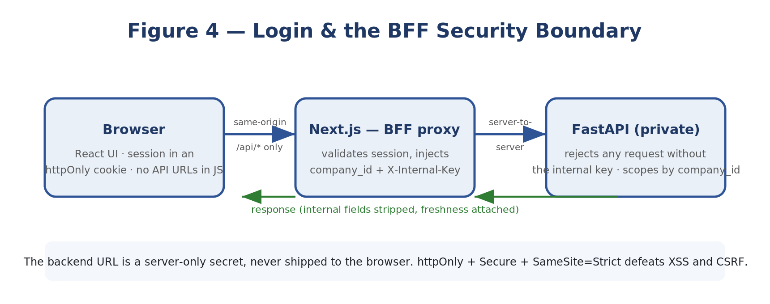
Figure 4 — Login and the BFF security boundary.
Authentication. A user logs in with email + password. The password is checked against a bcrypt hash in the users table (bcrypt is a deliberately slow, salted hash, so stolen hashes can't be brute-forced). On success the backend issues a JWT — a signed token carrying the user's email and brand — and sets it as an httpOnly, Secure, SameSite=Strict cookie.
# api/routes/auth.py (the essence)
def login(req, response):
row = db("SELECT password_hash, company_id FROM users WHERE email=%s", req.email)
if not row or not bcrypt.verify(req.password, row.password_hash):
raise HTTPException(401, "Invalid email or password")
token = jwt.encode({"sub": req.email, "company_id": row.company_id,
"exp": now()+8h}, JWT_SECRET, "HS256")
response.set_cookie("vb_access_token", token,
httponly=True, secure=True, samesite="strict") # invisible to JS
Why a JWT in an httpOnly cookie (not localStorage): an httpOnly cookie cannot be read by JavaScript, so a cross-site-scripting bug cannot steal the session; Secure means HTTPS-only; SameSite=Strict blocks CSRF. A token in localStorage has none of these protections. The JWT is ours, issued by our backend — we do not use the database host's auth system at all.
The BFF (Backend-for-Frontend) boundary. The browser never calls the backend directly. It calls Next.js API routes on the same origin, which forward the request server-to-server, adding an X-Internal-Key (so the backend rejects anyone who bypasses the proxy) and the X-Workspace-Id header. The backend URL is a server-only secret, never shipped to the browser.
Multi-tenancy. A ‘workspace’ is one brand = one source account = one data scope. Every data table carries a company_id column, and a require_workspace dependency resolves and authorises the brand before any query runs.
# api/routes/workspaces.py (the gatekeeper every endpoint depends on)
def require_workspace(request, user=Depends(get_current_user)) -> str:
ws = request.headers["X-Workspace-Id"] or user.company_id
if not db("SELECT 1 FROM companies WHERE id=%s AND (owner_id IS NULL OR owner_id=%s)",
ws, user.sub):
raise HTTPException(403, f"No access to workspace {ws}")
return ws # every query is then scoped: ... WHERE company_id = ws
What to improve / build. Roles (owner / admin / member / viewer) and — crucially for the brain — who is allowed to approve money actions (TO BUILD); team invites, password reset, email verification (TO BUILD); profile & preferences (PARTIAL); optional Google sign-in / 2-factor for larger customers (TO BUILD).
How it connects. Sits under everything: the BFF wraps the frontend (Layer 4), company_id scopes ingestion (Layer 2), the cache (Layer 3), queries (Layer 4), memory (Layer 5) and every workflow (Layer 10). Roles will gate the approval inbox (Layer 9).
Workflows it powers. Indirectly, all of them — every workflow runs inside a brand and is gated by who the user is. Directly, the People-Management workflows (onboarding / access) and any action requiring an approver depend on the roles added here.

Layer 2 — Data Ingestion (Adapters & Sync) · Status: BUILT
What it is. The plugs that pull data out of the messy real-world systems (TranzAct today; Tally, Busy, Zoho, email, APIs later) and land it in our database. This is the part nobody enjoys building — which is exactly why it is part of the moat.
The adapter contract. Every source implements the same interface — log in, fetch, hand back rows — so the layers above never care which source the data came from. The TranzAct adapter is in two modules: auth.py (logs in, caches the bearer token in memory keyed per account, reads the token's real expiry from the JWT so it refreshes at exactly the right time, and tries a cheap refresh before a full re-login) and client.py (the single fetch_report() that walks pages until the report is exhausted, throttles to stay under the rate limit, backs off on errors, and supports resumable chunks so a long sync survives a restart). A second adapter (Zoho) is in progress against the same contract.
Credential storage. Source credentials are encrypted with Fernet (authenticated AES) before being written to the DB and decrypted only in memory at sync time — never returned by any API.
The pipeline + scheduler. A BasePipeline gives every report the same safe contract:
# pipelines/base.py (the contract every report inherits)
def run_chunk(self, company_id, creds, ...):
run_id = log_start(tz_sync_runs, "running")
raw = fetch_report(self.REPORT_ID, creds=creds, ...) # adapter
rows = self._dedupe(self._validate(raw)) # Pydantic; bad rows skipped
self._upsert(conn, rows, company_id) # ON CONFLICT DO UPDATE
log_finish(run_id, "success", fetched=len(raw), upserted=len(rows))
# on any exception -> log "failed" and LEAVE OLD DATA IN PLACE
Why UPSERT, and why never truncate-and-reload
The source has no usable server-side date filter, so syncs re-fetch overlapping rows. Keying the write on a stable content hash means a re-fetched row overwrites in place instead of duplicating. And updating in place rather than wiping-and-reloading means a sync that dies halfway never empties the table — the dashboard keeps serving the last good data. ‘Stale is better than empty’ is enforced right here at the database.
Orchestration. APScheduler runs all reports hourly, staggered by minute so they never burst against the rate limit, once per connected brand. A heavier full historical sync walks every page with a resumable cursor.
What to improve / build. More adapters — Tally, Busy, email/IMAP, generic CSV/API (TO BUILD; Zoho in progress); real-time webhook ingestion so events push in instantly instead of waiting for the hourly pull — the trigger source for the event-driven brain (TO BUILD); a connector test + health surface per source (PARTIAL).
How it connects. Writes raw rows into the cache (Layer 3's source tables). Triggered by the scheduler (and later the event bus, Layer 10). Uses encrypted credentials stored via Layer 1. Knows nothing above it.
Workflows it powers. Every workflow that reads business data — nearly all of them. The Technology field's ‘data-freshness watchdog’ reads this layer's sync logs directly.

Layer 3 — The Canonical Model · Status: PARTIAL
What it is. The one normalised language every part of the brain speaks. The source tables are shaped like the ERP; the canonical tables are shaped like a business — Customer, Invoice, SKU, Payment, GL — regardless of which system the data came from. (Full treatment, with the data-flow diagram, in Part 2.)
What we have. A SourceAdapter contract (extract → map → load, where map returns either a clean canonical row or an Unmapped record); the first mapper (TranzAct → canonical) building Customers, Sales Invoices + lines, Inventory Items and AR/Payments, re-run after every sync; idempotent upserts keyed on (company_id, source, source_ref).
Two rules that make this layer trustworthy
Always keep the raw row — so we can re-map later without re-fetching. And log, don't guess — anything that can't be confidently mapped goes to an ingest_issues table, never a plausible fake value and never a silent drop. The brain is only as honest as its data, so bad data is surfaced, not invented.
What to improve / build. Extend the canonical schema to the full set the workflows need — GL accounts, Purchase docs, Orders, Production, Tickets, Contracts, Employees (PARTIAL); entity resolution — the same customer arriving from two sources (or spelled two ways) must resolve to one canonical entity (TO BUILD); a second adapter to prove the model is genuinely source-independent (Zoho in progress).
How it connects. Fed by Layer 2 (raw tables). Read by everything above: the query layer (Layer 4), the tools (Layer 7) and the agent (Layer 8) all read canonical, never source tables.
Workflows it powers. All cross-functional workflows (the synapses) only work because every field reads the same canonical Customer and Invoice. A churn score fusing support + payments + engagement is impossible unless all three resolve to one canonical customer.

Layer 4 — Read & Present (Query Layer + UI) · Status: BUILT
What it is. The layer that turns canonical data into answers a human can see — the pre-aggregated query functions, the API that serves them, and the dashboard UI. It delivers value on its own and doubles as the foundation the AI reuses: the same query functions become the AI's read-tools in Layer 7. (Full page/panel catalog in Part 5.)
What we have. ~45 query functions (queries.py) that run SQL aggregation and return typed dictionaries, never raw rows, with built-in Top-N caps (top 15 customers, 20 SKUs, etc.); ~35 dashboard endpoints, each returning a consistent envelope with a freshness flag; a Next.js dashboard fetched with SWR, every panel showing how fresh its data is.
{ "data": { ... }, # the answer
"meta": { "last_synced_at": "...Z", # always show data age
"report_id": 29, "stale": false } } # stale if last sync > 25h
Why pre-aggregate into typed dicts (the anti-hallucination foundation)
An LLM handed thousands of raw rows hallucinates. So the AI is never given raw rows — it is given the output of these functions: a small, named, capped summary. The function does the heavy lifting; the model only reasons. Building this for the dashboard also builds the safe data surface the brain will read. One investment, two payoffs.
What to improve / build. Finish the onboarding flow — connect source → set business profile → choose how much history to sync (PARTIAL); new UI surfaces the brain needs — the approval inbox, a notifications/activity feed, and the brain graph view (TO BUILD).
How it connects. Reads Layer 3 (canonical). Served through Layer 1 (BFF + scoping). Its query functions are promoted into tools in Layer 7. The UI gains the action surfaces from Layer 9.
Workflows it powers. Directly powers the read-only workflows that exist today — most importantly Finance's ‘natural-language financial querying’, the single workflow the current product already ships. Every other field's dashboards live here too.

Layer 5 — Memory · Status: PARTIAL
What it is. Everything the brain remembers between one moment and the next. There are four distinct kinds, and conflating them causes bugs, so we keep them separate (full detail in Part 3): the business profile (BUILT), durable facts that supersede + decay (BUILT), conversation memory (PARTIAL), the episodic / event log (TO BUILD), and semantic / vector memory (TO BUILD).
What we have. Durable facts that supersede and decay: when the owner confirms something it is saved as a structured fact; a new value retires the old one so there is always exactly one current truth; and facts go stale on two signals — a time expiry, or a contradiction with live data. A stale fact is flagged, not deleted, so the brain re-asks. Conversation storage: each Ask turn (question + full structured answer) is saved into a thread, scoped to the (user, brand) pair, and threads auto-name from the first question.
The honest gap: chat history is stored but not yet fed back
Today each new question is answered fresh — the past conversation is displayed but not fed back into the model as context. So a follow-up like ‘and which of those are overdue?’ doesn't yet know what ‘those’ means. For an agentic brain that takes multi-step actions, feeding recent turns back into the model is essential, and it is the first memory item to build.
What to improve / build. Feed recent conversation turns into the agent's context — multi-turn (TO BUILD); episodic log — persist every brain loop for learning + audit (TO BUILD); vector store — embed documents / tickets / contracts so retrieval workflows can search by meaning (TO BUILD).
How it connects. Read by the reasoning core (Layer 6) and the agent (Layer 8) as context before answering; written back to after each loop (the ‘Remember’ beat). The vector store is read by retrieval tools (Layer 7).
Workflows it powers. Vector memory powers Support tier-1 deflection, Legal document Q&A and R&D customer-need mining. Durable facts power Finance's payment-stretch and credit reasoning. The episodic log powers every workflow's ‘learns over time’ property and the audit trail.

Layer 6 — The Reasoning Base · Status: BUILT
What it is. The safe, deterministic core that answers a question with calibrated confidence — and the place where ‘say no’ is made structural rather than a polite request to the model. (Full treatment in Part 4.)
The three-stage pipeline. retrieve (deterministic) → reason → validate (deterministic). Retrieve calls the query functions; each number becomes a tagged piece of Evidence with a stable id. Reason builds Claims, each tagged computed / inference / unknown (a computed claim MUST cite an evidence id). Validate checks every computed claim traces to real evidence; if it can't, it is downgraded so it can never masquerade as a proven fact.
Confidence gates. Three checks set the label — Data (is there evidence?), Rule (did we recognise the question?), Confidence (is the conclusion a computation or a judgement?). An unanswerable question deliberately refuses and returns UNCERTAIN.
The Claude layer, tightly boxed. When enabled, the model does only two things: route an unrecognised question to one known intent, and rephrase the validated claims into consultant-quality prose. It is handed the claims, never the database. A numeric guard then scans the prose and rejects any rupee figure that wasn't computed, with one self-correcting retry before falling back to the safe template.
The eval harness. Because an LLM feature has no compiler, the eval suite is the compiler: golden cases across answerable / must-refuse / memory / must-not-say, scored on metrics that ship-block the build if the engine ever states an unsupported number or utters a banned phrase.
How it connects & what changes. Reads Layers 4/5 (queries + memory). Today it is the engine behind the Ask endpoint. In Layer 8 its hard-coded keyword router is replaced by tool-calling and its answer-confidence gate is generalised into an action authorizer — but the evidence → validate → gate spine is reused intact.

Layer 7 — Tools (the first all-new layer) · Status: TO BUILD
What it is. A tool is just a function the AI is allowed to call, described in a way the model understands. You give the model a menu of tools, each with a name, description, and typed inputs; the model reads the menu and replies ‘call get_ar_summary with company_id=…’; your code runs the real function and hands back the result. (Full detail and the diagram in Part 4.)
The tool contract (the key new abstraction). Every tool — read or action — declares the same metadata, so the agent and the gate can reason about it uniformly:
@tool(
name="create_reorder",
description="Raise a draft purchase order for a SKU below its reorder point.",
inputs={"sku_code": str, "quantity": int, "vendor_code": str},
side_effect="writes", # one of: read | writes | moves_money | files_regulator
gate="action", # 'read' tools never need approval; 'action' tools do
)
def create_reorder(ctx, sku_code, quantity, vendor_code) -> ToolResult:
...
return ToolResult(
data={"po_id": "...", "value": 84000},
evidence=[Evidence("po_value", "PO value", 84000, "Rs 84,000")],
quality={"vendor_known": True, "data_fresh": True}) # signals the GATE reads
What to build. A tool registry (a catalogue the agent is handed, filtered by permissions and the workflow); read tools wrapping the existing query functions (PARTIAL); action tools — draft_collection_email, create_reorder, post_journal_entry (money-gated), draft_reply, create_ticket, generate_nda, …; an execution runtime that runs the tool, captures evidence + quality + a dry-run preview, and records it to the action ledger (Layer 9).

Layer 8 — The Agent Core · Status: TO BUILD
What it is. The part that lets the model drive — choosing which tools to call, in what order, to satisfy a trigger — while staying inside the safety rails. This is the leap from ‘smart dashboard with a grounded Q&A box’ to ‘brain’. Full mechanics, the loop code, and the diagram are in Part 4 (§4.4). The same agent core serves all 13 fields; what differs per workflow is only the tools it is given and the trigger that starts it.

Layer 9 — The Action Spine & Human-in-the-Loop · Status: TO BUILD
What it is. The machinery that makes taking real-world actions safe and reversible: a log of everything the brain did, an inbox where ‘confirm-first’ actions wait for a person, and the channels that notify people. Full detail in Part 4 (§4.5). Every ‘confirm-first’ and ‘human-led’ workflow lives here — AP payment release, payroll disbursement, tax filing, large quotes and POs, hiring decisions, legal sign-off, security actions.

Layer 10 — Workflows & the Synapse Bus (the actual brain) · Status: TO BUILD
What it is. The layer that turns isolated workflows into one connected, self-running system. A workflow is a named bundle (its trigger, the tools it gathers with, the action it takes, its gate policy). The synapse bus lets one event in one field ripple into workflows in other fields. Full detail, the worked event example, and the synapse map are in Part 6 (§6.14). Workflow definitions are declarative — new workflows become data, not new code — and the first synapse to prove is Accounts → Sales.

Layer 11 — Scale-out & Hardening · Status: TO BUILD
What it is. Only after one vertical demonstrably works: more adapters (Tally / Busy) and more workflows; cost/performance hardening (model tiering, caching, token budgets); adopting an orchestration framework only if the workflow count and multi-agent handoffs justify it; and deeper observability + eval extended to actions, not just answers. (See the build sequencing rule in Part 8.)

Part 2 — The Base Layer (Data Foundation)
The base layer is everything the owner does not see directly: how data gets in, how it is made trustworthy, and how it is reshaped into clean business numbers. It is built as a series of stages, each with a single clear job, and favours correctness and resilience throughout: nothing is double-counted, an interrupted sync resumes where it left off, and figures separate the value of goods from the tax collected on top.
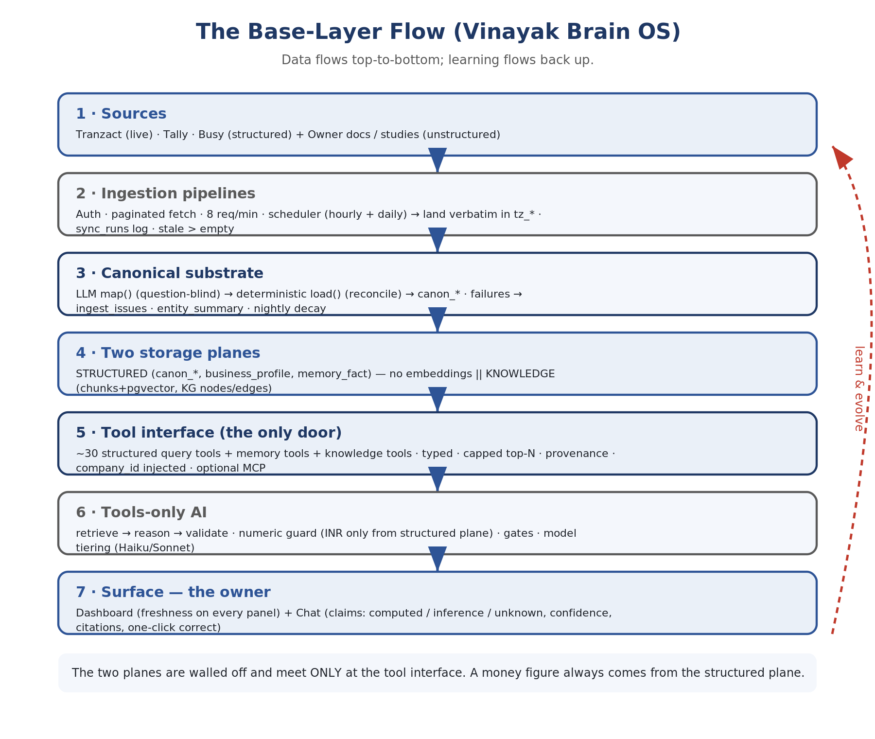
Figure 8 — The BIDE base-layer flow: Sources → ingestion → canonical & memory + knowledge → tool interface → tools-only AI → owner. Data flows top-to-bottom; learning flows back up.

2.1 The system at a glance — four stages
- Source — TranzAct. The brand's ERP. We read 10 standard business reports from its reporting service.
- Raw layer. Every row fetched is stored verbatim in a set of "raw" (tz_*) tables, one per report — an exact, auditable copy of what TranzAct returned, with built-in duplicate protection.
- Canonical layer. Raw rows are reshaped into a clean, source-independent business model — customers, invoices and lines, inventory, receivables. Business rules (such as separating tax from goods value) are applied here. The dashboard reads only from here.
- Dashboard. Panels read canonical figures and present them as charts, KPIs, and tables across themed sections.
Why two storage layers: keeping an untouched raw copy means we can always re-derive the clean numbers without re-fetching from TranzAct, and we can prove exactly what the source provided. The canonical layer is then free to apply business logic without ever risking the original data.

2.2 The source: the ten TranzAct reports
All data originates from TranzAct's reporting service. After a secure login, the system requests one report at a time; each has a fixed identifier and feeds a specific part of the dashboard.
Report | ID | Cadence | What each row is / what it feeds
Sales Invoices | 29 | daily | One invoice line — revenue (goods & invoiced), trend, top customers, top SKUs, invoice lines
AR Aging | 102 | hourly | One unpaid invoice — outstanding receivables and overdue buckets
Sales Orders | 2 | hourly | Open sales order book and status breakdown (dispatched %)
Purchase Invoices | 77 | daily | One purchase-invoice line — spend (goods & invoiced), vendor activity
Purchase Orders | 3 | hourly | Open POs and overdue exposure
GRN / Quality | 34 | daily | Goods received + inspection — receipts, pending QIR, rejection rate
Sales Quotations | 8 | daily | Quote pipeline — open, won, conversion rate
Inventory Valuation | 9 | hourly | One SKU snapshot — stock value, SKU count, category breakdown
Process Routing | 86 | daily | One routing step — BOM / routing coverage of manufactured items
Process Details | 25 | hourly | One work-order row — WIP, completed jobs, output, rejects

How data is requested — pagination and pacing
- About 50 rows per page: the service serves a fixed page size regardless of what is requested.
- Newest-first ordering: page 1 holds the most recent records, which is what makes a lightweight "newest only" refresh possible.
- The page number is the bookmark: the service remembers nothing between requests, so a sync can resume after an interruption.
- No server-side date filter: extensive testing confirmed the service ignores date-range requests; the system reads history by walking pages, not by asking for a date window.
- Rate limiting: at most 8 requests per minute (one page roughly every 7.5 seconds), staying under TranzAct's ~10 req/min limit. Effective throughput ≈ 400 rows/minute; sync time ≈ (total rows ÷ 400) minutes. This pacing, not data volume, determines how long a sync takes.

2.3 The raw layer
- Duplicate protection: each row gets a stable identity derived from its own contents (invoice number, item, quantity, price, line value). A re-fetched row overwrites in place rather than duplicating — revenue and counts never inflate from re-syncing.
- Restoration on re-sync: if rows are ever removed, a full re-sync re-fetches every page and missing rows are re-inserted.
- Audit trail: every sync run is logged (which report, when, rows fetched/stored, any error) so pipeline health is always visible on the Sync Health page.
The historical "huge numbers" bug
TranzAct's APIs have no reliable "give me only new rows since date X" filter, so every sync re-fetches overlapping pages. The early "huge numbers" bug was exactly this: the same row inserted 7–32 times before deduplication was added. The content-hash upsert key fixed it permanently.

2.4 The canonical layer
The canonical layer rebuilds a clean, business-ready model from the raw rows. It is fully derived from raw data and can be rebuilt at any time without contacting the source, so business rules live in exactly one place. This is the moment BIDE stops being "a TranzAct tool" and becomes "an engine that currently has one adapter".
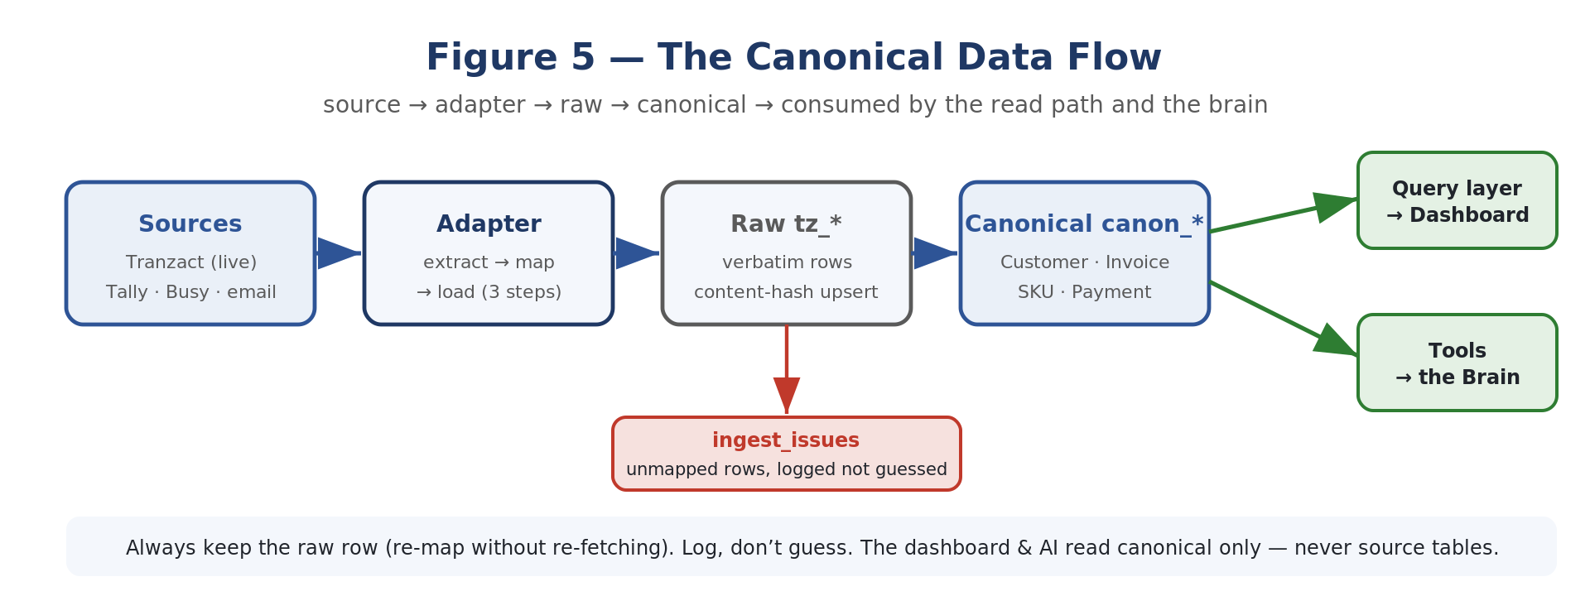
Figure 5 — The canonical data flow: source → adapter → raw → canonical → consumed by the read path and the brain.

What it builds (Slice-1 objects)
- Customers — a de-duplicated customer master, enriched with outstanding receivables.
- Sales invoices and their line items — one clean header per invoice plus its lines, so totals compute without double counting.
- Inventory items — current stock positions with value and category.
- Receivables (payments / AR) — outstanding amounts and aging.

The universal envelope (every canonical row)
Every canon_* row carries the same envelope so provenance and idempotency are uniform across objects and sources:
id uuid -- surrogate key
company_id text -- tenant isolation (always filtered)
source text -- 'tranzact' | 'tally' | 'busy'
source_ref text -- stable content key; UNIQUE(company_id, source, source_ref)
ingested_at timestamptz
confidence real -- per-row mapping confidence (0..1)
raw jsonb -- the original row, kept forever (re-map without re-fetch)
Canonical object | Holds | Flat view
canon_customer | name, code, credit_limit, payment_terms_days, outstanding, risk_score | —
canon_sales_invoice (+ _line) | header: number, dates, customer_ref, gross/tax/net, status; lines: sku, qty, unit_price, line_total, category | canon_sales_invoice_flat
canon_inventory_item | sku, category, warehouse, quantity, unit_cost, total_value, is_raw_material, is_negative_stock | canon_inventory_flat
canon_payment (AR) | customer_ref, invoice_number, amounts, days_overdue, aging_bucket | canon_ar_flat
Flat views mirror exactly the column names the query layer expects, so query functions repoint from tz_* to canonical by a table-name swap and reconcile by construction.

The SourceAdapter contract
Every source implements the same three-step protocol — extract, map, load. The LLM proposes mappings; deterministic code disposes.
class SourceAdapter(Protocol):
source_name: str
def rebuild(self, conn, company_id) -> LoadStats: ... # orchestrates the 3 steps
# 1. extract — raw rows for the company (already landed by the pipelines)
# 2. map(raw) -> CanonResult # CanonRow | Unmapped
# 3. load(rows) -> upsert canon_* on (company_id, source, source_ref)
@dataclass
class CanonRow: table; object_type; source_ref; fields: dict; confidence=1.0; raw=None
@dataclass
class Unmapped: object_type; field; reason; raw_value=None; source_ref=None

LLM-assisted map(), deterministic load()
map() runs the LLM in batch, at ingest only, and is question-blind — it never sees what will be asked, so it cannot bend toward pleasing a query. Input: a batch of raw rows + the canonical field definitions + 2–3 few-shot examples per report type. Output: strict JSON canonical rows each with a per-row confidence, plus an unmapped[] list with reasons.
load() is the deterministic trust layer, validating before anything touches the DB: a schema check (JSON parses, types correct, required fields present); reconciliation (line totals sum to invoice net ±rounding; dates parse and fall in window; customer_ref resolves; period totals match the report's own printed totals); and disposition (passing rows upsert into canon_*; failing rows go to ingest_issues with a reason).
Two rules that make this layer trustworthy
Always keep the raw row — so we can re-map later without re-fetching. And log, don't guess — anything that can't be confidently mapped goes to an ingest_issues table, never a plausible fake value and never a silent drop. Never coerce a bad date to today; never map a missing customer to "Unknown".

ingest_issues — the parser backlog
Everything unmappable lands here with object_type, field, reason, raw_value. This table is both a data-quality signal (surfaced before the AI is allowed to answer) and the prioritised work queue for hardening. Target: ≥ 95% of rows reconcile; the remainder must be in ingest_issues with reasons, never silently coerced.
The hardening rule (how the adapter library gets earned)
When ingest_issues shows the same failure pattern ≥ N times for a report type, write a deterministic mapper for it and take the LLM out of that path. Hand-written parsers are built from evidence, not up front.

2.5 Synchronisation
Because the source has no date filter, the system reads history by walking pages and remembers its position. There are two modes.

Full migration (resumable page-walk)
- Used when a brand is onboarded, or for a full re-check. Walks every page of a report from the beginning, a chunk at a time, saving its position (a cursor) after each chunk — so it can pause, resume, or survive a restart.
- Runs in the background: the user clicks once and keeps using the dashboard as data fills in progressively.
- Chunked: roughly 10 pages per chunk (~75 seconds). After each chunk, canonical figures rebuild so the dashboard updates as the migration proceeds.
- Self-checking: walking from the top and overwriting by content identity re-verifies every row and restores anything missing, with no duplicates.

Incremental refresh (newest only)
For routine freshness. Because pages are newest-first, the refresh pulls just the top few pages of each report and updates them. It is fast and does not disturb an in-progress migration.
Trigger | What runs | Why
"Sync all" button (Settings) | Full migration / re-check of every report | Onboarding a brand, or re-verifying all data
Per-report "Run / Resume" | Migration of a single report | Pull or continue one report on its own
On login (once per session) | Incremental newest-only refresh | Show fresh data the moment a user signs in
Hourly (automatic, background) | Incremental newest-only refresh of all reports | Keep data current even when no one is logged in
Real figures: a single large report (~2 yr sales invoices, ~2,400 rows) ≈ 6 minutes; all ten reports (2 yr history, ~13,500 rows) ≈ 30–45 minutes; a routine incremental refresh (~200 newest rows) ≈ 30 seconds. A measured example: one brand's sales-invoice report held 367 rows across 8 pages and fully pulled in about a minute. The full historical migration is never triggered automatically by the hourly schedule — that stays a deliberate "Sync all" action.
The reliability contract (every pipeline obeys)
Idempotent upsert (re-running never duplicates); atomic per run (fully commits or rolls back); stale > empty (on failure, previously-synced data stays in place — we never blank a table because a fetch failed); recorded (every run writes to sync_runs); rate-safe (throttles respected, staggered hourly jobs, exponential backoff on 429/5xx, one forced re-auth + retry on 401); bounded freshness (each pipeline declares a max-age; exceeding it raises a staleness alert surfaced to the tool layer so the AI can refuse on stale data); backfill-able.

2.6 Calculations & business rules

Revenue: two bases
Revenue is shown on two clearly labelled bases so the figure is never ambiguous. TranzAct's line value is tax-inclusive, so the canonical layer separates them explicitly:
- Revenue · goods value (ex-tax): sum of line values excluding tax — the true taxable / assessable business value of goods sold.
- Revenue · invoice total (incl. tax): sum of each invoice's printed grand total, including tax and freight — the billed amount the customer actually pays.
These are computed per invoice and then summed, avoiding a common trap: adding a line-level total across every line would multiply each invoice by its number of lines. The system always counts each invoice's header total once.
Worked example (one real invoice)
Goods value ≈ ₹11.3 lakh, tax (GST at 18%) ≈ ₹2.0 lakh, giving an invoice total ≈ ₹13.3 lakh. The goods figure and the invoice figure differ by exactly the tax.

Other key figures
Figure | How it is calculated
Average per invoice | Invoice total (incl. tax) ÷ number of printed invoices
Monthly average (12 mo) | Trailing twelve months of available data, anchored to the latest invoice date (not the calendar date)
Year-to-date | Totals for the year of the latest available data, on both goods and invoiced bases
Quote conversion rate | Won quotes ÷ total quotes in the window
AR overdue % | Overdue receivables ÷ total outstanding receivables
Rejection rate (GRN) | Rejected quantity ÷ received quantity
BOM coverage | Manufactured items with a defined routing ÷ all manufactured items
Inventory value | Sum of stock value across all SKUs (current snapshot)
The data window: by default every panel shows the brand's entire available history — there is no hidden "last 30/90 days" window. A single date picker in the top-right narrows the view consistently across a page. Panels representing a live snapshot (current stock, open orders, current receivables) are point-in-time and unaffected by the date picker. (Where a rolling default is used instead, a panel shows the last 30 days counted back from the latest data date — never from today — so panels are never empty just because the last sync landed on a Friday.)

Part 3 — Memory & Knowledge (the compounding moat)
Memory is what we know about this specific business that is not in the raw data. It is what makes us un-cloneable: every week of use makes the product harder to leave and impossible to clone, because the knowledge lives nowhere else. There are two kinds — structured memory (exact, high-stakes facts) and the knowledge plane (unstructured meaning) — deliberately walled off from each other.
BIDE distinguishes five kinds of memory, and conflating them causes bugs, so they are kept separate:
Kind of memory | What it holds | Status
Business profile | Static facts set at onboarding: industry, fiscal year, healthy-margin benchmark, seasonality | BUILT
Durable facts | Things the owner teaches ("Customer X pays in 7 days"); supersede + decay | BUILT
Conversation memory | Chat threads + turns, so a tab can be reopened | PARTIAL
Episodic / event log | A record of what the brain did each loop, so it learns and is auditable | TO BUILD
Semantic (vector) memory | Searchable docs, tickets, contracts, KB — for retrieval workflows | TO BUILD

3.1 Business profile — seeded at onboarding
A ~10-minute flow seeds the static context the AI always loads (one business_profile row per company, JSONB for flexible fields):
- Industry type and sub-vertical (trading, manufacturing, retail, services).
- Fiscal year start, GST registration status, base currency.
- Healthy margin benchmark for this industry.
- Known seasonality (Diwali spike, Q4 push).
- Key customer relationships and special payment terms.
- Which KPIs the owner actually cares about.

3.2 memory_fact — durable, decaying facts
When the owner confirms something it is saved as a structured fact; a new value retires the old one so there is always exactly one current truth. The DB is the source of truth; optional per-entity markdown renders are a view of active facts, never the write target.
memory_fact (
id, company_id,
entity_type, -- 'customer' | 'item' | 'company'
entity_ref, -- 'customer:dev-colour' (links to a canonical entity)
claim_key, -- 'payment_terms_days'
claim_value jsonb, -- 60
origin, -- 'user_confirmed' | 'ai_inferred' | 'imported'
confidence real,
valid_until, -- when to re-check (null = no expiry)
last_validated_at,
status, -- 'active' | 'stale' | 'superseded'
superseded_by, stale_reason, source_msg_id ) -- provenance to the chat turn

3.3 The capture & decay loop
Event | Required behaviour
Owner confirms / corrects in chat | write_fact with origin=user_confirmed, confidence=1.0, linked to the source message; it changes the very next answer.
Time passes | valid_until reached → fact marked for re-validation; before relying on it, the answer flags it as needing reconfirmation.
Data contradicts a fact | Nightly sweep compares active facts to fresh aggregates (e.g. terms=60d vs last 5 invoices cleared in 95d) → mark stale, queue a re-ask.
Multiple businesses | Every read filters by company_id; one tenant's memory can never surface in another's answer.
The safety net (ship decay with capture)
Treating memory as write-once truth is the trap. Without decay, your own memory becomes the confident-wrong failure you fear most. Before the AI relies on a stale/soon-to-expire fact, it asks instead of silently using it: "Last you told me DEV COLOUR is on 60-day terms; recent invoices clear in ~95. Still 60, or changed?"
Why memory is NOT RAG
Memory facts are few, structured, and high-stakes (terms, trust, margins). They are looked up by exact key on an entity, not by semantic similarity. Embedding them would add fuzziness where we need precision. RAG enters only for genuinely unstructured knowledge.

3.4 entity_summary — reason once at ingest
After each successful sync, a per-entity summary is refreshed for entities whose data changed — the structured-plane equivalent of a wiki page. A question about a customer then loads one pre-built summary instead of re-deriving from rows, and the dashboard's entity pages come free from the rendered markdown.
entity_summary (
company_id, entity_type, entity_ref, -- 'customer:dev-colour'
summary jsonb, -- outstanding, aging, trend, last activity,
-- active memory facts, open contradictions
rendered_md text, -- human-readable (also loadable into AI context / dashboard page)
refreshed_at timestamptz )

3.5 The knowledge plane — KG + RAG (right-sized)
The knowledge plane handles unstructured knowledge — owner-uploaded documents, business studies / playbooks, and learned notes — and makes it retrievable by meaning and by relationship. It is deliberately walled off from the structured plane, and this is where "learn and evolve" lives.
Belongs in the knowledge plane | Never in the knowledge plane
Owner documents (SOPs, contracts, supplier terms PDFs) | Invoice / payment / stock figures (→ canonical SQL)
Business studies / domain playbooks | Exact owner facts like payment_terms_days (→ memory_fact)
Learned domain notes, definitions, "how this industry works" | Anything that is the source of a money number
Narrative context the owner explains over time | Anything needing exact, not fuzzy, lookup

RAG storage (semantic retrieval)
Retrieval is hybrid: dense (embedding similarity) + sparse (keyword) fused, with the source title/section returned for citation. Chunking respects document structure. pgvector enters the system only for this plane.
knowledge_source (id, company_id, kind, -- 'owner_doc'|'business_study'|'learned_note'|'chat_extract'
title, uri, content_hash, ingested_at, status) -- hash dedupes re-uploads
knowledge_chunk (id, company_id, source_id, ordinal, text, token_count,
embedding vector, -- pgvector; introduced HERE, not in the structured plane
metadata jsonb) -- section, page, doc title (for citations)

Knowledge graph (relationships, lightweight)
Not a graph engine — two tables in the same Postgres. Nodes are concepts / domain entities / rules; edges are typed relationships. Crucially, a node may link to a real canonical entity (canon_ref), so domain knowledge attaches to actual data.
knowledge_node (id, company_id, node_type, -- 'concept'|'entity'|'rule'|'metric_definition'
label, summary, canon_ref, -- nullable: 'customer:dev-colour' (bridge to data)
confidence, created_at)
knowledge_edge (id, company_id, src_node, dst_node,
relation, -- 'depends_on'|'defined_as'|'applies_to'|'contradicts'
weight, confidence, evidence_chunk_id) -- the chunk that justifies this edge

The learn-and-evolve loop
Mechanism | Behaviour
Accumulate | New owner docs, studies, and chat-extracted notes add sources/chunks/nodes; coverage grows.
Promote | When unstructured knowledge becomes a precise, repeatable fact (e.g. a confirmed payment term), it is promoted into memory_fact — moving from fuzzy to exact.
Reconcile | "contradicts" edges and contradictions against canonical data are surfaced, not silently resolved; the owner adjudicates.
Decay | Knowledge inherits the same staleness discipline as memory: stale knowledge is flagged before it is relied upon.

Part 4 — Tools, Agent & Reasoning
This part covers the seam between the AI and the data (the tool interface), how the AI is allowed to use it (the tools-only orchestrator and its gates), the safe reasoning core that already ships, and the action machinery still to build.

4.1 The tool interface — the only door the AI uses
A tool is just a function the AI is allowed to call, described in a way the model understands: a name, a description, and a typed list of inputs. The model reads the menu and replies "call get_ar_summary with company_id=kbrushes"; your code runs the real function and hands back the result. That is the entire idea behind tool calling and behind MCP. The AI never touches the database or raw rows — it sees only a catalog of typed tools, and every tool returns pre-aggregated data plus provenance.
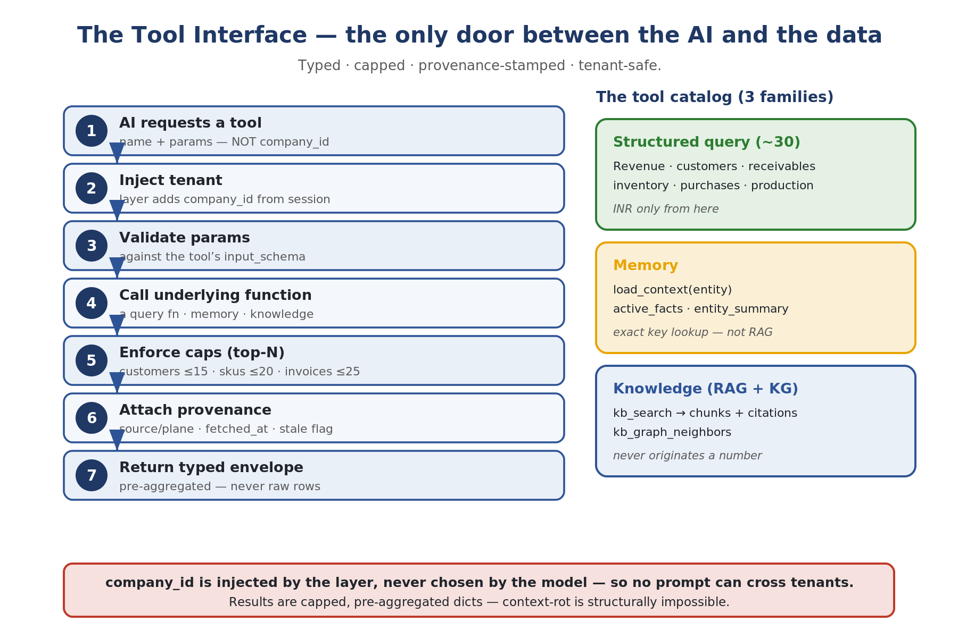
Figure 9 — The tool interface: the only door between the AI and the data — typed, capped, provenance-stamped, tenant-safe.

The tool contract
ToolSpec {
name str # 'get_ar_summary'
description str # what it answers, for the model's selection
input_schema json # typed params (company_id injected by the layer, not the model)
returns dict # pre-aggregated, capped (top-N), typed — NEVER raw rows
citations [..] # always: {plane, source, fetched_at, freshness}
caps {...} # e.g. customers<=15, skus<=20, invoices<=25
}
Tools follow a domain.verb_noun naming convention (e.g. finance.get_ar_summary, notify.draft_email) and one of five kinds: read (never gated), action (proposes; the ledger + approval inbox execute), memory, meta, and external. For action tools the contract additionally declares a side_effect class (read | writes | moves_money | files_regulator). The side_effect class is what the gate uses to force money/regulator actions to a human; evidence keeps the grounding guarantee; quality signals let the gate compute confidence from facts, not the model's opinion. One rule never bends: no tool both reads and writes, and moves_money / files_regulator actions always terminate at a human regardless of confidence.
Two invariants of the tool layer
(1) company_id is injected by the tool layer, never chosen by the model — a tenant cannot be crossed by a prompt. (2) Results are pre-aggregated and capped, so context-rot is structurally impossible: the model reasons over a ~15-key dict, not a thousand rows.

The tool catalog (three families)
Family | Plane | Tools (examples)
Structured query (~30, EXISTS) | Structured (SQL) — INR only from here | get_revenue_summary/_trend, get_top/bottom_skus_revenue, get_customer_concentration, get_ar_summary, get_dso, get_collections_priority, get_dead_stock, get_inventory_summary, get_purchases_summary, get_top_vendors_spend, order_book, production …
Memory (NEW) | Memory | load_context(entity)→{profile,facts}, active_facts(entity), get_entity_summary(ref) — exact lookup by key, not RAG
Knowledge (NEW) | Knowledge (RAG+KG) | kb_search(query,k,filters)→chunks+citations, kb_graph_neighbors(node,relation?,depth), kb_entity_brief(canon_ref)

MCP vs in-process tools
MCP (Model Context Protocol) is a standard way to expose tools as a separate service that any AI client can connect to; it shines when tools must be shared across apps or run in another process. In-process tools are just functions registered in the same backend, passed to the model via the Anthropic SDK's native tool-use. Recommendation: start with in-process tools using the Anthropic SDK; adopt MCP later if third-party clients must reuse the same tools. The tool contract is designed so either path works without rewriting the tools. An MCP server can expose the whole catalog so any agent can call the business as a tool — with company identity injected by the layer, never chosen by the model.

4.2 The tools-only AI — retrieve → reason → validate
The honest analyst works in three steps. Numbers are deterministic; the model only chooses tools and phrases the result.
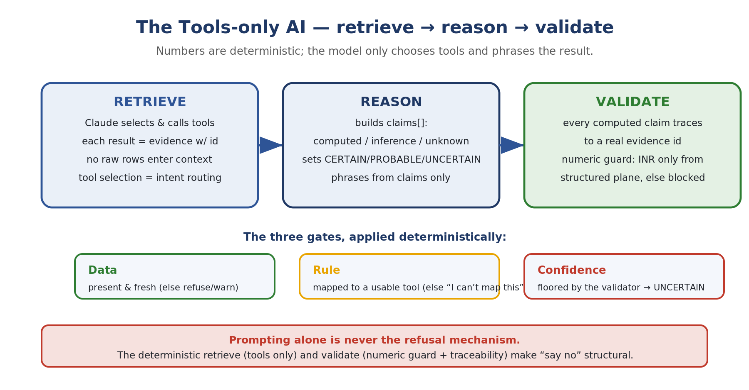
Figure 10 — The tools-only AI: retrieve → reason → validate, with the numeric guard and the three gates.
Stage | Contract
RETRIEVE | Claude is given the tool catalog + business_profile + relevant memory facts/entity summaries, and selects which tools to call. Each tool returns evidence with a stable id. No raw rows enter context. Tool selection IS intent routing — no separate router until evals prove one is needed.
REASON | Claude returns structured output: an answer plus claims[], each tagged computed (must cite an evidence id) / inference (must state its assumption) / unknown (becomes a question routed to memory capture), and a confidence_level (CERTAIN / PROBABLE / UNCERTAIN).
VALIDATE | Deterministic post-check before display: every computed claim must trace to a real evidence id; every money figure in the prose must appear in the retrieved evidence (numeric guard) or the claim is blocked / downgraded. Numeric claims may cite ONLY structured-plane tools.

The three gates
Gate | Passes when
Data | Required evidence is present and within its freshness bound (stale data → refuse or warn).
Rule | The question mapped to at least one usable tool; otherwise an honest "I can't map this."
Confidence | Set by the reasoning, floored by the validator: any unknown-without-computed, or any untraceable number, forces UNCERTAIN.

Structured output schema
{
"answer": "string, owner-facing",
"confidence_level": "CERTAIN | PROBABLE | UNCERTAIN",
"claims": [
{ "text": "...", "type": "computed", "source_id": "q_revenue_mar" },
{ "text": "...", "type": "inference", "assumption": "arm's-length sales" },
{ "text": "...", "type": "unknown" } ],
"assumptions": ["..."],
"data_used": ["q_revenue_mar", "mem:customer:dev-colour:terms"],
"what_i_dont_know": ["forward order book"]
}
The non-negotiable
Prompting alone is never the refusal mechanism. The deterministic retrieve (tools only) and validate (numeric guard + traceability) are what make "say no" and "don't invent a number" structural. The model's words can change; the numbers and the gates cannot.

Model tiering (cost discipline)
A fast model (Haiku) handles clean factual lookups; a stronger model (Sonnet) is used only when the answer needs judgement — concentration, payment-stretch, forecasts, anything carrying inference or an off-router question. Per-call cost is logged so cost-per-question stays a tracked, compared number. Prompt caching on the stable prefix (system prompt + business profile) cuts repeat cost ~80%.

4.3 The reasoning base (what ships today)
The safe, deterministic core that answers a question with calibrated confidence — the place where "say no" is structural. Its three-stage pipeline is retrieve (deterministic) → reason → validate (deterministic). Retrieve calls the query functions; each number becomes tagged Evidence with a stable id. Reason builds Claims tagged computed / inference / unknown (a computed claim must cite an evidence id). Validate checks every computed claim traces to real evidence, downgrading any that can't.
The Claude layer, tightly boxed: when enabled, the model does only two things — route an unrecognised question to one known intent, and rephrase validated claims into consultant-quality prose. It is handed the claims, never the database. A numeric guard then scans the prose and rejects any rupee figure that wasn't computed, with one self-correcting retry before falling back to the safe template.
The eval harness: because an LLM feature has no compiler, the eval suite is the compiler — golden cases across answerable / must-refuse / memory / must-not-say, scored on metrics that ship-block the build if the engine ever states an unsupported number or utters a banned phrase.

4.4 The agent core (to build)
The agent core lets the model drive — choosing which tools to call, in what order, to satisfy a trigger — while staying inside the safety rails. This is the leap from "smart dashboard with a grounded Q&A box" to "brain".
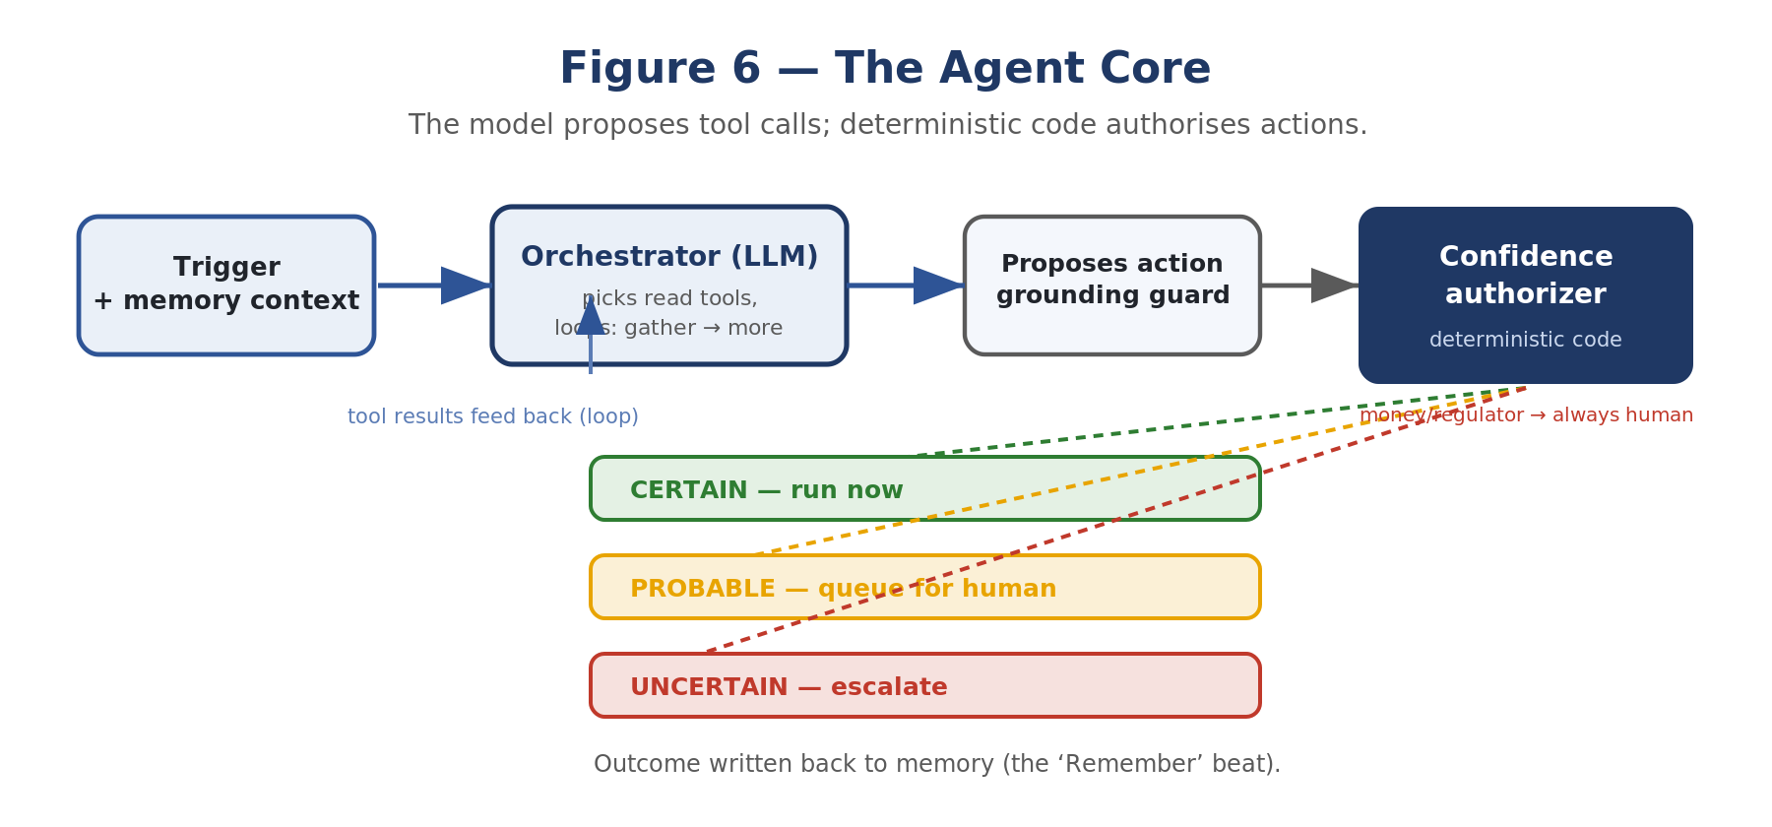
Figure 6 — The agent core: the model proposes tool calls; deterministic code authorises actions.
- A trigger (question or event) plus memory context enters the orchestrator (the LLM).
- The model picks read tools to gather what it needs; each returns evidence. It may loop — gather, see results, gather more.
- It proposes an action (or an answer). The grounding guard rejects any stated value not returned by a tool.
- The confidence authorizer — deterministic code — grades the proposed action from the tool quality signals + side-effect class, and routes it: CERTAIN run now, PROBABLE queue for human confirm, UNCERTAIN escalate. Money/regulator always human.
- The action runs (or waits), and the outcome is written back to memory.
def run_agent(trigger, ctx):
messages = build_context(trigger, ctx) # + recent memory (Layer 5)
while True:
resp = claude.messages.create(model=tier(trigger),
tools=registry.for(ctx.user, trigger), messages=messages)
if resp.stop_reason != "tool_use":
return finalize(resp) # grounding guard runs here
for call in resp.tool_calls:
tool = registry[call.name]
if tool.side_effect != "read":
decision = authorizer.grade(tool, call.args, ctx) # the GATE
if decision != "CERTAIN":
queue_for_human(tool, call.args, decision); continue
result = runtime.execute(tool, call.args, ctx) # + ledger
messages.append(tool_result(call, result))
Why raw SDK tool-use first (not ADK / Agent Framework / LangGraph)
Those frameworks take ownership of the control loop — which is exactly where your safety lives. The Anthropic SDK already does native tool-calling, so you can build this loop directly and keep the authorizer as your own code. Adopt a heavier framework later, only when many sub-agents hand off to each other (the synapses) and need orchestration + observability — and even then, the gate stays yours.

4.5 The action spine & human-in-the-loop (to build)
The machinery that makes taking real-world actions safe and reversible. The instant the brain can write to the world, this layer must exist.
- Action ledger — every action (proposed, approved, executed, failed) recorded with inputs, gate decision, and result. Idempotent (never send the same chase twice) and dry-run-able. The existing sync-run log is its seed.
- Approval inbox — the UI where PROBABLE actions queue with a preview and confirm/reject buttons, gated by role.
- Notifications — email / WhatsApp / in-app, so people are told what needs them and what the brain did.
- Escalation routing — UNCERTAIN items go to the right human.
The one rule, enforced here
Anything that moves money or files with a regulator is always routed to a human, regardless of confidence. The ledger + inbox are how that rule becomes real software rather than a promise.

Part 5 — The Dashboard
The dashboard turns canonical data into answers a human can see. It delivers value on its own and doubles as the foundation the AI reuses: the same query functions become the AI's read-tools. It comprises ~45 query functions (typed dicts with Top-N caps), ~35 dashboard endpoints (each returning a consistent envelope with a freshness flag), and a Next.js UI where every panel shows how fresh its data is.
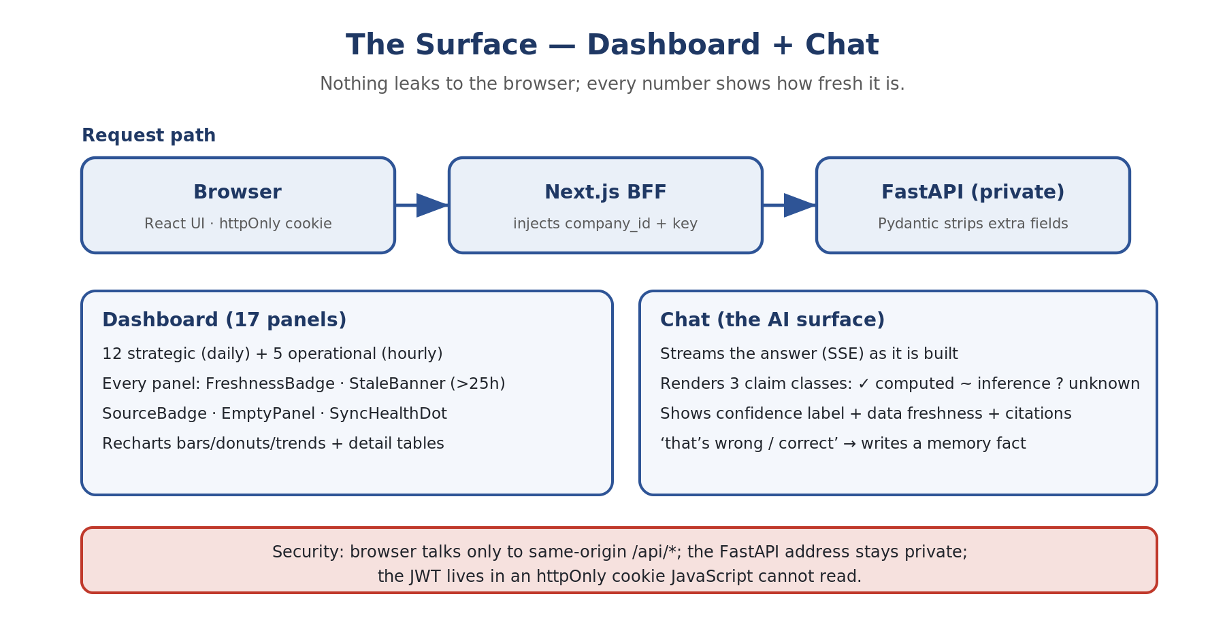
Figure 11 — The surface: dashboard + chat. Nothing leaks to the browser; every number shows how fresh it is.

5.1 The money story (read this first)
A manufacturing business is two loops of paperwork: one for selling, one for buying. Every screen is a window onto one step of these loops.

The selling loop (money coming in)
- Quotation → a customer asks "what will it cost?" and we send a formal price offer. Not a sale yet.
- Sales Order (SO) → the customer says yes. The order is "open" until everything ships ("dispatched").
- Production → the factory makes the goods. A Work Order is the instruction to make X units; while being made it is WIP; units that fail quality checks are "rejected".
- Sales Invoice → goods ship, and we send the bill. THIS is the moment we count revenue — with line items, tax on top, and a due date.
- Payment → the customer actually sends money, usually weeks later. Between invoice and payment, that money is Accounts Receivable — our money, sitting in their pocket.

The buying loop (money going out) — the mirror image
Purchase Order (PO) → we order raw material from a vendor. GRN (Goods Received Note) → the truck arrives; we record and inspect (the inspection is the QIR). Purchase Invoice → the vendor's bill; now we owe them (Accounts Payable). In the middle sit the two piles of stuff: Inventory (stock, each unit a SKU — frozen money) and the BOM (Bill of Materials — the recipe for a manufactured product, with a routing being the sequence of factory steps).

5.2 The dashboard, page by page
Every panel reads from the canonical layer, states its basis, and shows freshness (a "stale" warning if the last sync is more than 25 hours old). The sidebar groups pages into business themes: Revenue, Receivables, Procurement, Operations, Intelligence, System.
Page (feed) | Panels & formulas (in brief)
Overview / Revenue (Sales Invoices #29) | Revenue goods (Σ line_totals, ex-tax) · Revenue invoice total (Σ printed grand totals) · Invoices (distinct invoice numbers) · Customers (distinct codes) · Avg/Invoice · Monthly Avg (12mo) · YTD · Revenue Trend (monthly, 6mo) · Daily Revenue (90d) · Customer Concentration (top-5 share + Others)
Customers (#29) | Top Customers (revenue, invoice count, % of total — top 15) · Growing/shrinking (this period vs previous equal period) · New/lapsed
AR — Accounts Receivable (#102) | Total Outstanding (Σ outstanding) · Overdue (days_overdue>0) · Aging buckets 0-30/31-60/61-90/90+ · Top Exposures (top 15 chase list) · Collections priority (AI: biggest overdue weighted by lateness)
Inventory (#9, live snapshot) | Total Stock Value (Σ qty×unit value) · SKUs Tracked · Zero/Negative Stock (flags data-entry errors) · By Category / Top Holdings · Dead stock (AI: zero sales in 90 days)
Purchases (#77) | Spend (goods / invoice total) · Active Vendors · Top Vendors (top 10)
Orders (#2) | Open Orders / Open Value · Dispatched % · Overdue Orders
POs (#3) | Open POs / value · Overdue POs / value at risk
Quotes (#8) | Won / Won value · Open / Open value · Conversion Rate (won ÷ total)
Production (#25) | FG Produced / Rejected · Reject Rate (rejected ÷ produced+rejected) · WIP Jobs · Completed
GRN (#34) | GRNs Received · Rejection Rate (Σ rejected ÷ Σ received) · Pending QIR
BOM (#86) | Coverage (manufactured SKUs with a routing ÷ all manufactured SKUs)
Sync (internal) | One row per pipeline run: timing, success/failure, rows fetched/saved — the "is the data fresh?" control room
Ask (all feeds) | Reads the SAME query functions as the panels (never raw tables); classifies the question to an intent, calls the matching queries, answers only from retrieved numbers, states confidence, refuses when data can't answer (e.g. margin needs cost data we don't have)
The one mental model to keep
Feeds land raw rows into tz_* tables → the canonical layer reshapes them into business objects → ~45 query functions compute small, capped summaries → the dashboard panels AND the AI both read only those summaries. So if a number ever looks wrong on screen, the question is always: which query function, over which table, from which report.

5.3 Business dictionary (A–Z of what is on screen)
Key terms, so a developer with zero finance background can read every panel:
Term | What it actually means
Revenue / Sales | Money earned from selling, counted when the invoice is raised (not when cash arrives).
Goods value | Sum of line items only (price × quantity), EXCLUDING tax and freight — the "real" trading value.
Invoice total | The grand total printed on the invoice, INCLUDING tax and freight.
AR (Accounts Receivable) | All money customers owe right now — invoices raised but not yet paid ("receivables", "debtors").
Outstanding / Overdue | Outstanding = all unpaid; overdue = the late subset (past due date and still unpaid).
AR Aging | Sorting unpaid invoices into "how late?" buckets (0-30/31-60/61-90/90+). 90+ is the scary one.
Exposure | How much we'd lose if one customer never paid — their total outstanding.
DSO (Days Sales Outstanding) | On average, how many days between invoicing and getting paid. Lower is better.
Customer concentration | What share of revenue comes from the top few customers — the dependence risk.
AP (Accounts Payable) | The mirror of AR: money WE owe vendors.
PO / GRN / QIR | Purchase Order; Goods Received Note (record at the gate); Quality Inspection Report (passed/rejected).
Inventory valuation | Stock value: for each SKU, quantity on hand × unit value; summed = total stock value.
Dead stock / non-moving | Items not sold in a long time (90 days) — capital frozen on a shelf.
Stock turns / Days of cover | Turnover: how many times a year the warehouse empties & refills. Days of cover: days before an item runs out.
SKU | Stock Keeping Unit — one distinct product code.
Work Order / WIP / FG | The instruction to manufacture; Work In Progress (half-made); Finished Goods (ready to sell).
Reject rate | Of everything produced (or received), what % failed quality.
BOM / Routing | Bill of Materials (the recipe); Routing (the ordered factory operations).
Order book | All open sales orders — "future revenue already agreed".
Margin / COGS | Selling price minus cost. We do NOT have cost data from TranzAct yet, which is why the AI refuses margin questions.
YTD / MoM | Year To Date; Month over Month (usually a % change).
Stale (freshness) | Flag that the last sync is older than 25 hours — the panel still shows data but warns it may be behind.

Part 6 — Workflows: The 13 Business Fields
Every workflow is one instance of the universal loop. The Flow column uses the five beats: Trigger → Gather → Reason → GATE → Act (or escalate). The Tier column places it on the automation ladder: A = runs fully automatically, C = runs after a human confirms, H = human-led (AI assists). Nearly every workflow uses the same stack (ingestion → canonical → tools → agent → gate); the Layers/notes column flags only the distinctive needs.

6.1 Finance & Accounts
Owns: the books, the cash, and compliance.
Workflow | Flow | Tier | Layers / notes
Invoice & bill capture | doc arrives → OCR → match PO & vendor → GATE clean? → post · else review | C | OCR adapter, action tool
Transaction categorisation | txn → history & rules → propose code + conf → GATE high? → auto-code · else confirm | A | read+write tools
Reconciliation | import → auto-match → clear → GATE unmatched? → exception → human | A | read-heavy
Journal entries | event/schedule → compute → draft JE → GATE rule-based? → post · else approve | C | action tool
Period close | close date → checklist & chase → flag variances → GATE clear? → compile → HUMAN sign-off | C | human gate
Statements & consolidation | close done → assemble → consolidate → GATE balanced? → draft → review → publish | C | action tool
AR aging & collections | past due → aging+history → draft escalation → GATE high-value? → send · else human | A | BUILT base; action tool (email)
Cash application | payment in → match invoices → GATE unambiguous? → apply · else review | A | entity resolution
Credit & concentration risk | activity → behaviour & exposure → score → GATE threshold? → update · alert human | A | read; durable facts
Accounts payable (3-way match) | bill → match PO↔GRN↔bill → route → GATE release money → HUMAN releases | C | MONEY-gated
Duplicate-payment / fraud | payment stream → vs patterns → score → GATE suspicious? → hold → human | A | anomaly; human hold
Cashflow forecasting | daily → AR+AP+orders → model → GATE squeeze? → alert · publish | A | read; event
GST returns & ITC recon | period → assemble → reconcile 2A/2B → GATE file → HUMAN files | C | REGULATOR-gated
e-Invoicing & e-way bills | dispatch → build IRN/e-way → GATE valid? → generate · else fix | A | action; source write-back
Payroll computation | cycle → gross→deductions→net → payslips → GATE disburse → HUMAN approves | C | MONEY-gated
Continuous audit & policy | txn/claim → vs policy → GATE breach? → flag · pass | A | monitor
NL financial querying | question → query canonical → GATE confident? → answer · else uncertain | A | BUILT TODAY (L6)
Into the brain: Feeds Sales (credit/AR gates upsell) and Strategy (cashflow, working capital). Fed by Order Tracking (dispatch triggers an invoice), Inventory (valuation), and every field that spends.

6.2 Sales
Owns: turning interest into revenue.
Workflow | Flow | Tier | Layers / notes
Lead generation & enrichment | inbound → find & enrich → score fit → GATE real? → pipeline · else discard | A | external tools
ICP-fit scoring | lead → vs ICP → score → GATE above? → prioritise · else nurture | A | read
Outreach sequencing | qualified → draft sequence → schedule → GATE high-value? → send · else review | C | action (email)
Pipeline hygiene | scan → stale/incomplete → GATE safe? → auto-update · nudge owner | A | write tool
Deal forecasting | pipeline change → score prob → aggregate → publish → Finance | A | synapse → Finance
Quote & proposal generation | request → product/price/stock/credit → draft → GATE large? → send · else human | C | reads Inventory+Accounts
Follow-up nudges | no activity N days → draft from history → GATE sensitive? → send · else review | A | action
Win/loss analysis | deal closed → extract reasons → log & route → R&D / Marketing | A | synapse → R&D/Marketing
Into the brain: Feeds Order Tracking, Production, Inventory (demand), Finance (revenue forecast), Marketing (what converts). Fed by R&D (battlecards), Marketing (leads), Accounts (credit), Inventory (stock), Production (lead times).

6.3 Marketing
Owns: creating demand.
Workflow | Flow | Tier | Layers / notes
Content generation & repurposing | brief → draft + variants → GATE brand-sensitive? → publish · else review | C | vector (brand voice)
SEO briefs | topic/gap → research keywords & SERP → draft brief → hand to content | A | external tools
Ad copy & A/B variants | live → variants → A/B → GATE budget change? → scale · spend → human | C | MONEY (budget)
Campaign performance | data → attribute & analyse → report + insight → Sales | A | synapse → Sales
Audience segmentation | refresh → cluster → update segments | A | read
Social scheduling | calendar → draft & queue → GATE risky? → auto-post · else review | A | action
Brand & sentiment monitoring | mentions → classify sentiment → GATE spike? → alert human · log signal | A | event; synapse → R&D
Into the brain: Feeds Sales (qualified leads) and R&D (demand signal). Fed by R&D (positioning), Support (common questions → content), Sales (which segments convert).

6.4 Support
Owns: keeping the customers you already won.
Workflow | Flow | Tier | Layers / notes
Tier-1 deflection | ticket → retrieve docs + 360 → draft → GATE confident & simple? → auto-resolve · else agent | A | VECTOR memory (L5)
Ticket routing | ticket → classify topic & priority → GATE clear? → route · else triage | A | read
Sentiment-based escalation | ticket → score sentiment → GATE high risk? → escalate now → human | A | event
Draft replies | agent opens → draft from context → agent edits & sends | H | assist only
KB auto-generation | resolved → extract Q&A → GATE novel? → draft article → review | C | writes vector store
SLA monitoring | clock → track vs SLA → GATE near breach? → alert/escalate | A | event
Ticket-theme analysis | batch → cluster themes → report top issues → R&D / QA | A | synapse → R&D/QA
Into the brain: Feeds R&D, Production & QA, Sales (churn/upsell), CRM. Fed by Order Tracking, CRM, Accounts.

6.5 CRM
Owns: the customer relationship — really the customer axis of the brain.
Workflow | Flow | Tier | Layers / notes
Unified customer-360 | any interaction → attach to record → update 360 view | A | entity resolution (L3)
Interaction logging | comms event → match to account → GATE clear? → log · else confirm | A | event
Health & churn scoring | refresh → fuse 3 signals → score → GATE at risk? → flag + next-best-action | A | SYNAPSE 6 (fuses 3 fields)
Segmentation | data change → recompute segments → update | A | read
Next-best-action | account state → evaluate → suggest to owner | A | read
Data hygiene & de-dup | scan → detect dupes → GATE safe merge? → auto-merge · else review | A | entity resolution
Into the brain: Ingests from Sales, Support, Order Tracking, Marketing, Accounts; serves all of them.

6.6 Order Tracking
Owns: the journey from won deal to delivered goods.
Workflow | Flow | Tier | Layers / notes
Order status tracking | order event → update status → reflect on dashboard | A | event
Milestone & ETA updates | status change → recompute ETA → update | A | reads Inventory+Production
Delay-exception alerts | ETA risk → assess cause → GATE at-risk? → alert ops → human | A | event
Proactive customer notifications | milestone → draft notice → GATE bad news? → send · sensitive → review | C | action (notify)
Fulfillment orchestration | ready → orchestrate dispatch → dispatch → trigger invoice (Accounts) | C | SYNAPSE → Accounts (order-to-cash)
Into the brain: Feeds Support (status), CRM (history), Accounts (invoice trigger), the customer. Fed by Sales, Inventory, Production, Logistics.

6.7 Inventory
Owns: the right stock, in the right quantity, at the right time.
Workflow | Flow | Tier | Layers / notes
Stock-health & dead-stock flagging | daily → movement & age → GATE dead? → flag as trapped capital → report | A | SYNAPSE 5 → Strategy
Demand forecasting | sales update → model demand → publish forecast → Production | A | synapse → Production
Auto-reorder at threshold | below point → size PO → GATE large? → auto-PO · else human | C | action; MONEY for large
Negative-stock & integrity monitor | movement → validate balance → GATE invalid? → flag → human | A | data integrity
ABC analysis | periodic → rank A/B/C → update classification | A | read
Stockout prediction | forecast vs stock → detect → GATE imminent? → alert Sales & Production | A | event; synapse
Into the brain: Feeds Sales (available-to-promise), Production (materials), Accounts (valuation), Procurement (reorder). Fed by Sales (demand), Production (consumption/output).

6.8 Production & QA
Owns: making the thing, and making it right.
Workflow | Flow | Tier | Layers / notes
Production scheduling | work orders + demand → optimise → GATE conflict? → publish · else planner | C | planning
WIP tracking | station event → update WIP → reflect status | A | event
Predictive maintenance | sensor data → detect degradation → GATE risk? → schedule maint · halt → human | A | telemetry adapter
Vision-based defect detection | unit → inspect image → GATE defect? → divert/flag · trend → QA | A | vision model
Reject-rate & OEE monitoring | production data → compute → GATE drift? → alert → human | A | monitor
Capacity planning | forecast → model capacity → report bottlenecks → Strategy | A | synapse → Strategy
Into the brain: Feeds Inventory (finished goods), Order Tracking (delivery dates), Accounts (COGS/scrap), R&D (yield). Fed by Sales/Orders (demand), Inventory (materials), R&D (specs), Support (field failures).

6.9 People Management
Owns: the team — the field that needs the most care.
Workflow | Flow | Tier | Layers / notes
Onboarding & offboarding | hire/exit → checklist & docs → GATE clear? → provision/settle · else HR | C | synapse → Tech (access)
Leave management | request → balance & coverage → GATE safe? → auto-approve · else manager | A | policy
HR policy helpdesk | question → retrieve policy → GATE confident? → answer · else HR | A | VECTOR memory
Attendance & shift management | clock event → compute → GATE anomaly? → record · flag supervisor | A | vertical (shop-floor)
Recruiting logistics | role → draft JD · rank resumes · schedule → DECISION → HUMAN | H | logistics only; never decides
Performance goal-tracking | cycle → aggregate goals & feedback → RATING → HUMAN | H | never auto-rates
Payroll & statutory compliance | cycle → compute pay & statutory → HUMAN disburses/files | C | MONEY/REGULATOR-gated
Learning & development | gap → map → assign path · track | A | read
Engagement & attrition signals | survey → analyse risk → GATE elevated? → surface to HR (private) | A | private handling
Into the brain: Feeds Strategy (capacity, attrition) and Finance (payroll). Fed by every manager. The dangerous parts are deliberately gated to humans.

6.10 Legal
Owns: keeping the company safe on paper.
Workflow | Flow | Tier | Layers / notes
Contract review & clause extraction | contract → extract clauses → vs standards → GATE risk? → flag counsel · else summarise | C | VECTOR memory
Contract-lifecycle tracking | calendar → scan obligations → GATE due? → alert owner | A | event
Template generation | request → fill template → GATE non-standard? → draft · else counsel | C | action
Compliance monitoring | reg update → assess impact → GATE action? → alert → human | A | external feed
Document Q&A | question → retrieve corpus → GATE confident? → answer · else counsel | A | VECTOR memory
Risk flagging | new doc → score risk → prioritise → counsel | A | read
Into the brain: Feeds Sales (turnaround), Accounts (payment terms), Strategy (regulatory risk). Fed by Sales, Procurement, People. Sign-off always human.

6.11 R & D
Owns: knowing the market and shaping what comes next.
Workflow | Flow | Tier | Layers / notes
Industry & market research | cycle → gather & synthesise → publish brief → Strategy/Marketing | A | external + vector
Competitor teardown | change → analyse features & pricing → update battlecards → Sales | A | synapse → Sales
Trend & patent monitoring | scan → detect signals → GATE material? → brief team | A | external feed
Customer-need mining | tickets + lost deals → cluster needs → rank into backlog | A | SYNAPSE 2 (internal evidence)
Concept generation | need → generate concepts → screen feasibility → shortlist → human | C | assist
Feasibility & cost modelling | concept → model cost & manufacturability → report → decision | C | synapse ← Production
Into the brain: Feeds Marketing (positioning), Sales (battlecards), Strategy (market sizing). Fed by Support (complaints), Sales (lost deals), Production (manufacturability).

6.12 Strategy & Planning
Owns: direction — the apex that consumes everything.
Workflow | Flow | Tier | Layers / notes
KPI-vs-target tracking | refresh → actual vs target → GATE off-track? → alert + explain → human | A | reads all fields
Scenario & what-if modelling | question → build scenario → present options → HUMAN decides | H | reads whole model
Competitive landscape | R&D feed → synthesise → brief leadership | A | synapse ← R&D
Capital-allocation analysis | financials + ops → analyse → recommend → human | H | SYNAPSE 5
OKR cascade | goals → cascade to fields → track & report | C | writes targets down
Board & management reporting | cycle → assemble pack → draft → human review | C | read
Into the brain: Fed by every field. Feeds targets back down to all of them. Recommends; a human decides.

6.13 Technology
Owns: keeping the brain alive — the caretaker, not a peer field.
Workflow | Flow | Tier | Layers / notes
IT helpdesk | request → retrieve/resolve → GATE routine? → auto-resolve · else IT | A | vector
Access provisioning | HR event → determine access → GATE sensitive? → provision · else human | C | synapse ← People
System & security monitoring | telemetry → detect anomaly → GATE security? → alert → HUMAN (never auto-act) | A | human gate
License management | scan → usage vs licenses → flag waste/renewal → human | A | read
Data-freshness watchdog | pipeline check → last-sync vs SLA → GATE stale? → alert eng + flag dashboard | A | PARTLY BUILT (L2 sync logs)
Into the brain: Serves all fields. Security actions stay human.

6.14 The synapse bus — what makes it one brain
The synapse bus lets one event in one field ripple into workflows in other fields — the thing that makes it a brain and not a pile of bots. When something happens ("invoice overdue"), it is published as an event; workflows subscribe to the events they care about. New workflows become data (a trigger + gather tools + action tool + gate policy), not new code.
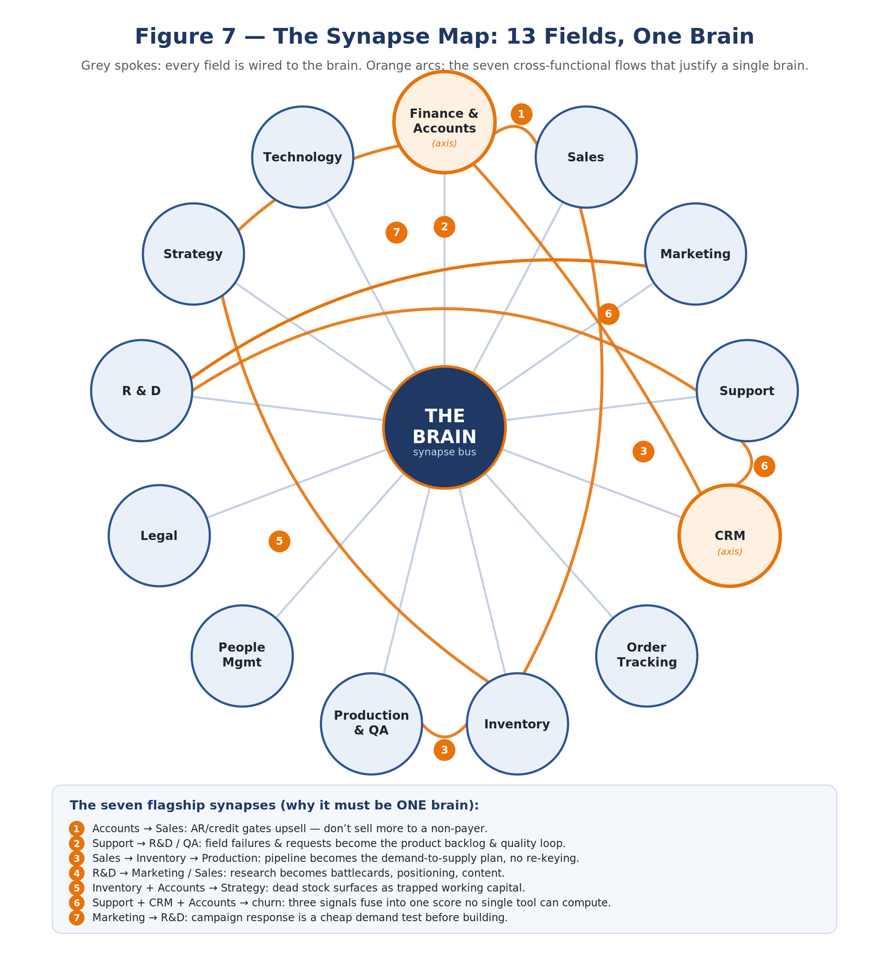
Figure 7 — The synapse map: 13 fields wired to one brain. Grey spokes connect every field to the brain; orange arcs are the seven cross-functional flows.
EVENT invoice.overdue {customer: "Dev Colour", amount: 420000}
-> Accounts workflow: confirm overdue, worsening pattern [auto]
-> Sales workflow: pause upsell to this customer [auto]
-> CRM workflow: lower account health score [auto]
-> Strategy workflow: flag concentration risk in weekly review [auto]
ONE event, FOUR fields, no human relay — impossible for separate tools,
because each tool would hold only one link of the chain.

The seven flagship synapses
# | Cross-functional flow | Why it needs one brain
1 | Accounts → Sales | AR/credit gates upsell — don't sell more to a non-payer.
2 | Support → R&D / QA | Field failures + requests become the product backlog and quality loop.
3 | Sales → Inventory → Production | Pipeline becomes the demand-to-supply plan, no re-keying.
4 | R&D → Marketing / Sales | Research becomes battlecards, positioning, content.
5 | Inventory + Accounts → Strategy | Dead stock surfaces as trapped working capital.
6 | Support + CRM + Accounts → churn | Three signals fuse into one score no single tool can compute.
7 | Marketing → R&D | Campaign response is a cheap demand test before building.
First synapse to ship: Accounts → Sales
It is the first synapse to prove: the data already exists, it is the lowest-effort, and "stop extending credit to customers who haven't paid" is a result an owner feels immediately. Prove one synapse end-to-end (with the action gated to a human confirm) and the case for the whole brain makes itself. The brain graph view — fields as nodes, synapses as edges, lit up as events flow — is the UI rendering of this map.

Part 7 — The Marketing Engine
For a manufacturer, marketing is not ads or social media — their buyers are dealers and businesses they already know. Marketing here means one thing: systematically extracting more revenue from the customer base they already have. Their own invoice history quietly knows who buys on what rhythm, who has gone silent, who buys product A but never tried B, and which stock the season is about to demand. Four engines read that notebook every morning and turn what it says into owner-approved messages — each measured against a hold-back group so the revenue caused is proven, not claimed.
The revenue identity
Revenue = customers × order frequency × order value. Every engine below defends or grows exactly one of those three levers.
Live numbers from kbrushes (July 2026): 32 active customers · 124 SKUs, average customer buys only 6.4 of them · 7 customers have a measurable buying rhythm and 6 are past their reorder window today · 15 customers silent 60+ days, including one worth Rs 21L lifetime (silent since 31 March). The promise is pitched as "provably increases revenue — we show you the number" rather than "definitely": a guarantee invites argument; a measured number ends it.

7.1 Engine 1 — Reorder Radar (defends ORDER FREQUENCY)
Every regular buyer has a rhythm, and a broken rhythm is invisible at every individual step: a 35-day buyer slipping to 45 days alarms no one, but it is 10 orders a year becoming 8 — a 20% cut with zero drama. Worse, a skipped cycle is often a competitor's trial order. The radar computes each customer's own median gap (and per-product gaps) and flags anyone more than 1.5× past it, the same day.
Aspect | Detail
Trigger | Daily scan, automatic
Audience rule | Customers with 4+ orders and a stable rhythm; days-since-last-order > 1.5 × their own median gap. Per-SKU variant catches "still buys from us, stopped buying THIS item".
Message | Personal nudge listing their usual items and last order — never generic blasts
Human gate | Owner approves every message (batch approve, edit any, reject any)
Success metric | Skipped cycles recovered per month · Rs value of nudged orders
Live today | 6 of kbrushes' 7 rhythm-regular customers are past their window right now

7.2 Engine 2 — Win-Back (defends CUSTOMER COUNT)
B2B churn has no event. A dealer never cancels; he just stops calling, and absence generates no paperwork. Win-back is the cheapest revenue in commerce because every acquisition cost is already sunk: one well-timed, well-informed message versus months of sales visits for an equivalent new account.
Aspect | Detail
Trigger | Weekly scan
Audience rule | Silent longer than max(2 × own median gap, 60 days). Ranked by trailing-12-month revenue × recency decay — a Rs 21L customer silent 3 months outranks a Rs 50K customer silent a year.
Message | Relationship tone, references what they used to buy; any incentive is typed by the owner — the system never invents discounts
Human gate | Owner approves each; can add a personal line for big relationships
Success metric | Customers reactivated · their revenue in the following 90 days
Live today | 15 lapsed accounts; top three worth Rs 21L, Rs 5.9L and Rs 3.6L lifetime

7.3 Engine 3 — Cross-Sell (grows ORDER VALUE)
The average kbrushes customer buys 6.4 of its 124 products. The co-purchase pattern across customers ("buyers of A almost always also use B") is the closest thing to a sales insight the data can generate by itself, and in B2B it lands well: consolidating suppliers means one delivery, one credit line, one relationship.
Aspect | Detail
Trigger | Monthly scan (patterns move slowly)
Audience rule | Customer buys A (2+ orders), never bought B, where lift(A→B) ≥ 2 across the base and at least 3 customers support the pattern
Message | Specific suggestion with the reason ("most PA-14 buyers also take the 2-inch handle") — never a catalogue dump
Human gate | Owner approves; can veto product pairs that don't make trade sense
Success metric | New product lines added per customer · Rs revenue in promoted categories
Live today | 124 SKUs, average basket 6.4 — the widest untapped lever. v1 works at category level (15 categories); SKU-level precision comes as the base grows.

7.4 Engine 4 — Stock & Season Push (grows ORDER VALUE, frees TRAPPED CAPITAL)
Dead stock is money frozen on a shelf (the finance dashboard already flags it). This engine turns that flag into a revenue action: match every slow item to the customers who historically buy its category, and put an owner-priced clearance or pre-season offer in front of exactly them.
Aspect | Detail
Trigger | Monthly, plus pre-season windows from the business profile
Audience rule | Customers with past purchases in the pushed category, weighted by recency and volume
Message | Concrete offer on named items; price/discount always set by the owner
Human gate | Owner sets the incentive and approves the batch — the system never discounts on its own
Success metric | Dead-stock value cleared · Rs revenue from push campaigns
Live today | Dead-stock list already live on the dashboard — this engine gives it hands

7.5 The proof layer — hold-back testing
Every marketing claim meets the same objection: "they would have ordered anyway." The answer is built into every campaign: a random 20% of each audience is deliberately held back and the other 80% messaged. The revenue difference between the two groups is — by construction — the revenue the messages caused. Both numbers are reported, always: raw ("Rs 11.4L ordered by messaged customers") and incremental ("about Rs 6.2L would not have come without the nudges"). The second number is the product.
The two-plants analogy
How do we know a customer wouldn't have ordered anyway? For one customer, we can't. So we do what a gardener does to test a fertilizer: feed one plant, don't feed the other, compare. Messaged customers ordered Rs 100 on average; held-back customers Rs 40. The Rs 60 difference is what the messages caused — it cannot be the season, the market, or luck, because both groups lived through the same season, market and luck.
What the owner sees each month: one page — messages approved (34) → customers who ordered (19) → raw revenue (Rs 11.4L) → incremental revenue (Rs 6.2L) → best engine this month → next month's suggested audiences. This page is also the sales deck for the next customer: no testimonial, just a number another owner can verify against his own books.

Rollout & prerequisites
Step | What | Time
1 | Contact capture: emails/WhatsApp for ~34 customers (accountant task) — the single hard prerequisite; TranzAct stores no contact data | 30 min
2 | Engines 1 + 2 live on email, owner approving every message | Week 1–2
3 | First monthly report with hold-back proof | Week 6–8
4 | WhatsApp channel (Business API + DLT registration — start paperwork now) | 2–4 wks lead
5 | Engines 3 + 4; tone earned autonomy for routine nudges | Month 3

Part 8 — The Build Plan (Engineering)
The single rule that governs everything
Build the four layers in order — Layer 0 (parser) → Layer 1 (storage) → Layer 2 (memory) → Layer 3 (reasoning). The dashboard is the hook and is copyable in a weekend. The moat is the canonical schema, the adapters, and the memory loop. Never polish the cockpit before the parser underneath it is solid.

8.1 Current baseline (what exists today)
Layer | Status | What's there / missing
0 — Parser | ~25% | 10 Tranzact pipelines map into tz_* tables (not canonical). Content-hash upsert + dedup done. Missing: canonical objects, ingest_issues log, second source.
1 — Storage/Aggregation | ~80% | PostgreSQL (Supabase) + ~30 pre-aggregated query functions, multi-tenant company_id scoping, date windows, dual-basis revenue. Missing: materialized views / Redis / pgvector / audit log.
2 — Context/Memory | 0% | No business profile questionnaire; no memory_fact store; no correction loop.
3 — Reasoning/Interface | ~40% | Dashboard strong: KPI cards, charts, detail tables, sync watchdog, notifications. No AI, no chat, no confidence gates, no LLM integration.

8.2 The phased build (Phase 0 → 7)

Phase 0 — Decisions to lock (1–2 days)
Remove ambiguity that would force rework. Lock scope to one source + one vertical first — the #1 way this product dies is building the abstract universal version before the concrete one ships.
- 0.1 Choose the Slice-1 vertical: Trading/Distribution; document what is out of scope (manufacturing BOM, production orders → Slice 2).
- 0.2 Confirm first-cut canonical objects: SalesInvoice, Customer, InventoryItem, Payment for Slice 1; defer PurchaseOrder, GLEntry to Slice 2.
- 0.3 Confirm go-to-market: Path A — white-glove onboarding (not self-serve). Cap onboarding at 3 weeks now, target 3 days by customer 10.
- 0.4 Pick the sandbox company: the Agarwal company with the cleanest Tranzact data and an owner who makes a recurring monthly decision; export 12 months of every report type.
- 0.5 Write the first 10–15 owner questions verbatim — the reasoning design target and the first ground-truth eval set.

Phase 1 — Canonical schema + Tranzact as an adapter
The dashboard reads from a source-independent model; adding a future ERP means writing one adapter and touching zero query functions. Define canonical tables with the universal envelope; create the ingest_issues log; define the SourceAdapter contract; refactor the 10 pipelines into the first adapter (add map() and load()); repoint the ~30 query functions to canonical (identical signatures, totals reconcile within rounding); build the data-quality view before the AI chat.

Phase 2 — Business profile + the memory loop
Seed the business profile at onboarding; build the memory_fact store; ship the capture loop v1 (intercept every correction, persist as a structured fact, reload on subsequent queries) and decay & re-validation in the same release — a fact that contradicts the data is re-asked, not repeated.

Phase 3 — AI reasoning pipeline + calibrated confidence
The AI answers questions where every statement is provably a computed fact, a flagged inference, or an honest "I can't know that" — and it physically cannot state a number it wasn't given.
# | Stage | What happens
1 | Intent parser | Classify: metric lookup, trend, anomaly, recommendation, what-if.
2 | Domain router | Route to sales / inventory / finance / cross-domain.
3 | Context loader | Load business profile + relevant memory + pre-aggregated data for the domain.
4 | Data gate | Is data complete and recent enough? If not — ask, don't guess.
5 | Rule gate | Does a defined business rule exist? If not — flag UNCERTAIN.
6 | Confidence scorer | Classify CERTAIN / PROBABLE / UNCERTAIN.
7 | LLM generator | Generate grounded response from the structured payload.
8 | Memory writer | If the owner corrects/adds context, persist a fact.
Make "say no" structural (retrieve / reason / validate separated so the model cannot invent a number); Claude API with prompt caching (~80% cheaper on repeat); register queries.py as tools (function calling); chat UI with trust affordances (three claim classes rendered distinctly, freshness indicator, "that's wrong" correction feeding the memory loop).

Phase 4 — The validation harness (your synthetic compiler)
Business advice has no compiler — build an approximate one. Four datasets: Ground-truth Q&A (50 hand-computed); Confidence calibration (20 answerable + 20 unanswerable); Memory test (10 corrections); Edge cases (stale data, missing months, partial imports, duplicates). Track three metrics release-over-release: Bucket accuracy (computed vs inference vs unknown), Unsupported-claim rate (no change ships if it rises), Correct-refusal rate.

Phase 5 — First owner session + finish Slice 1
Onboard the sandbox company end-to-end (connect Tranzact → canonical ingest → profile questionnaire → dashboard → AI chat); run the owner session and record every failure (each becomes a memory fact and a new eval case); start tracking onboarding-days-per-customer.

Phase 6 — Slice 2: Tally + Manufacturing
Prove the engine generalizes: build a TallyAdapter (Tally XML over HTTP / ODBC — the hardest integration and biggest footprint in Indian SMB); extend the canonical schema additively (PurchaseOrder, ProductionOrder, BOM, GLEntry) with versioning; add inventory intelligence (dead-stock, reorder point, turnover); win the first outside paying customer. The success test is brutal — how little of the query/memory/AI layer changed?

Phase 7 — Slice 3: Busy + Retail / multi-location
Busy adapter (multi-location stock, daily sales summary, GST view); cross-source intelligence (the same business on Tally + Busy — reconcile and answer across sources); industry benchmark layer (with hard domain filters — never mix vertical benchmarks); assess self-serve readiness only after 8–10 white-glove customers.

8.3 Build order & dependency rule
The dependency rule: data before intelligence, intelligence before action, rails before autonomy. The one deliberate exception is the read/dashboard layer in the middle, which delivers value early and doubles as the AI's read surface. Because the surface and analyst were built first for an early demo, the correction now is to invert the priority: scoreboard, then substrate, then memory.
# | Build | Because | Gate before next
1 | Trust harness skeleton + ground-truth set | Nothing below can be judged without a scoreboard and a baseline to beat | Baseline number + frozen Q&A set exist
2 | Canonical hardening: LLM map() + deterministic load() + reconciliation | The substrate is the moat; everything reads from it | ≥95% rows reconcile; rest in ingest_issues
3 | Formalise the tool catalog (repoint query fns; add specs + provenance) | The AI's only door; must be stable before the orchestrator | All tools return capped data + citations; tenancy injected
4 | Tools-only AI orchestrator (retrieve→reason→validate) | Turns the substrate into answers, honestly | Fabrication test blocked; beats baseline on correctness + refusal
5 | Memory entity-synthesis + capture/decay loop | Compounding moat; tailors answers to the business | A correction changes the next answer; contradictions re-asked
6 | Knowledge plane (sources→RAG→KG) + learn-evolve loop | Adds semantic/relational knowledge once structured truth is solid | A study can be uploaded, retrieved, cited; numbers still only from structured plane

8.4 Learning curriculum (5 pillars)
Philosophy: be a builder who understands enough to make correct architectural decisions and debug what breaks — not a researcher. Learn each pillar just before the phase that needs it.
- Pillar 2 — Data Engineering & Parsers (powers Phases 1–2): PostgreSQL deeply (window functions, CTEs, materialized views, JSONB, indexing); canonical schema / normalization with versioning; ETL design with validation at ingestion; Tally XML/TDL + ODBC; Excel chaos handling (pandas + openpyxl). Tools: PostgreSQL (+ pgvector), Python/pandas/SQLAlchemy, Celery + Redis, dbt.
- Pillar 1 — Context Engineering (most important; powers Phase 3): RAG; token-budget management; and four failure modes with business equivalents — citation poisoning (stale data shown as current → freshness gate), lost in the middle (key anomaly buried in 40 metrics → pre-aggregate and rank), jurisdiction confusion (retail vs manufacturing benchmarks → hard domain filters), instruction clash ("cut costs" vs a "grow revenue" goal → unified intent assembly).
- Pillar 3 — LLM Integration & Prompt Design (alongside Phase 3): Claude API (messages, system prompts, tool use, streaming); structured JSON output with confidence fields; multi-turn conversation with persistent context.
- Pillar 4 — Backend & API Design (mostly have): FastAPI, versioned REST, multi-tenant isolation; background job queues (Celery + Redis); webhooks; rate limiting; Claude cost management + caching. Service shape: Orchestrator, Ingestion, Query, Memory.
- Pillar 5 — Frontend & Dashboard (strongest already): React (components, hooks, state); Recharts/Chart.js; real-time streaming UI (SSE/WebSockets); mobile-responsive; UX for trust (confidence, freshness, "what I don't know" without alarming the user).

8.5 Risk register — what kills you, ordered by probability
# | Failure mode | How it happens | Prevention
1 | Consulting firm in SaaS costume | Onboarding pain grows per customer; every deployment custom | Track onboarding-days/customer; cap 3 weeks now, 3 days by customer 10
2 | Confident-wrong AI destroys trust in one session | CERTAIN answer on bad data → owner makes a real wrong decision | The three gates ship before any owner uses the AI; never skip
3 | Abstract universal version before the concrete one ships | Beautiful framework, zero users | Next code is the Tranzact slice; no generalization until Slice 1 is live
4 | Data quality kills AI quality | Custom Tally setups, Excel chaos → garbage in, garbage out | Every adapter logs what it can't map; data-quality dashboard before AI chat
5 | LLM cost surprises at scale | Rs 5/query × 500/day × 100 businesses | Prompt caching day 1; pre-aggregate aggressively; small payloads

8.6 Infrastructure & scaling
The governing idea: stateless app tiers behind a load balancer, reads served from cache + pre-aggregation, and all heavy work (ERP syncs, LLM calls) pushed off the request path.
Layer | Technology | Notes
API backend | Python + FastAPI | One monolith; split into services when it hurts
Database | PostgreSQL + pgvector | Canonical schema + embeddings in one DB; Pinecone at scale
Cache | Redis | Pre-aggregated KPI cache; invalidate on ingestion
Job queue | Celery + Redis | Async sync; never blocks the dashboard
LLM | Claude API (Sonnet) | Do not self-host; implement prompt caching
Frontend | React + Recharts + Tailwind | Dashboard + AI chat
Auth | Clerk or Supabase Auth | Multi-tenant from day 1; isolated namespace per business
Hosting | AWS/GCP (start small) | EC2 + RDS for Slice 1; containerize; ECS at Slice 2
Monitoring | Datadog or Grafana | Track LLM latency, confidence distribution, memory hit-rate

Will the stack take 1000 users × 10 APIs? Three things break first
- Postgres connections — 1000 concurrent requests exhaust the pool long before CPU. Fix: a connection pooler (Supabase Supavisor pooled string, or PgBouncer). Highest-leverage change.
- In-process sync — competes with request handling. Fix: move to a separate worker pool; the API only enqueues.
- Inline AI calls — slow and metered, tie up workers. Fix: queue + per-tenant rate-limit + prompt caching + streaming.
No Kafka: your needs are a task queue (Celery + Redis now, RabbitMQ later) for background ERP syncs, and SSE/WebSockets from FastAPI for live AI chat. Consider Kafka only for continuous high-volume events (POS streams across hundreds of stores). Dockerize both apps now so tiers become stateless and horizontally scalable; avoid raw Kubernetes at this stage. Keep Railway + Supabase through Slice 1–2; plan a GCP (Cloud Run) or DigitalOcean move at Slice 2; reserve AWS for a specific enterprise/compliance requirement.

Hardening checklist (provider-agnostic)
- H1 — Enable the Postgres connection pooler (bounded connection count under a 1000-request load test).
- H2 — Add a Redis cache for the 10 KPI endpoints (cache-hit > 80%, DB read QPS drops).
- H3 — Move ERP sync to Celery workers (triggering a sync returns instantly; dashboard stays responsive).
- H4 — Dockerize + autoscale the app tiers (throughput scales linearly with replica count).
- H5 — Read replicas + route reads (primary CPU dominated by writes/ingest only).
- H6 — Guard the LLM path (per-tenant rate limits, prompt caching, optional queue; bursts degrade gracefully; cost-per-query logged).

8.7 Cost model (budget early)
Item | Estimate | Optimization
Claude Sonnet (per query) | ~Rs 2–8 | Prompt caching cuts system+profile by ~80%
PostgreSQL (RDS small) | ~Rs 3,000–5,000/mo | Start db.t3.medium; upgrade as you grow
Redis (ElastiCache) | ~Rs 2,000/mo | Cache KPI aggregates; TTL = freshness window
EC2 (app servers) | ~Rs 4,000–6,000/mo | t3.medium × 2; auto-scale later

8.8 Long-term technology decisions
Concern | Recommendation | Why / when to revisit
LLM provider | Anthropic (Claude), two-tier routing (fast vs smart) | Tier by task to control cost; keep a thin provider abstraction
Agent orchestration | Raw Anthropic SDK tool-use first | Full control of the loop + gate. ADK/LangGraph/Agent Framework only when multi-agent handoffs justify it
Tool protocol | In-process tools now; MCP later | MCP adds value only when external/other-app clients must reuse tools
Event/queue | Postgres-backed event table + worker first | Fine to thousands of events/day. Redis/Temporal when volume demands
Vector store | pgvector (Postgres extension) first | Keeps one database. Dedicated vector DB only at large corpus scale
Auth | Self-issued JWT; add reset/invite | Managed provider (Clerk/WorkOS) when SSO/SCIM/enterprise arrives
Frontend | Next.js (App Router) — keep | Already powers the BFF security boundary
The build sequencing rule
Don't build the universal brain in the abstract — it becomes a beautiful platform nobody needs. Ship one vertical deep (manufacturing, with a live design partner) until it beats the tools it replaced; the reusable bricks and the brain spine fall out as a by-product of having shipped it well. Then point those bricks at a second vertical.

Part 9 — Go-to-Market: The Stagewise Business Plan
The one rule the whole plan follows
We do not wait to finish the full product. We launch the smallest version a real business will pay for, put it in their hands, listen to them, and let their feedback decide what we build next. A stage ends when its goals are hit — not when its features are finished.
Where we are today: we pull data from TranzAct, clean it, show dashboards, and the owner can ask questions in plain language and get honest answers with real numbers. What does not exist yet: the system cannot DO anything — no email, no order, no action. Still, "ask your business anything and get true numbers" plus "know exactly who to chase for money" is already sellable.

9.1 The opening move (the wedge)
- Who: small manufacturers and distributors who use TranzAct (later, Tally users too).
- Problem: their money is stuck with customers who have not paid, and they keep giving goods on credit to people who already owe them.
- Promise: "See every rupee owed to you, chase the right customers at the right time, and stop selling on credit to defaulters — without hiring anyone."
Sell the outcome, build the platform
We never say "AI business brain" to a customer. We show them THEIR overdue number from THEIR data in the first demo, and we sell that. The big brain vision is for investors and for us — not for the sales pitch.

9.2 The stages
Stage | Goal | Done when
Stage 0 — MVP ready (now → ~6 weeks) | Turn the read-only product into one that can take exactly ONE action safely: drafting a payment-reminder email. Build: chat follow-up memory, one action (draft chase), an approval page, a record of every action, security clean-up + tests (including "must refuse to act"). | Full loop works on real data (overdue → drafted → approved → sent → recorded); tests pass incl. "must refuse"; at least 1 business agreed to a paid trial.
Stage 1 — First paying testers (months 2–4) | Prove one real business pays, uses it weekly, and collects money faster. Behave like a service behind the scenes; anything done by hand twice gets built into the product. | 2–3 businesses paying real money; owner/accountant opens it 3+ days/week; ≥1 tester measurably collects faster (written up); ≥7/10 drafted emails approved without edits.
Stage 2 — Grow inside one industry (months 4–9) | 8–12 paying customers, same type; a second feature (likely a credit warning or low-stock alert — chosen by customers); the agentic engine swap; Tally only if 3+ prospects blocked; easier setup. | 8–12 paying (half via referral); ₹1–2 lakh/mo; no 3+-month customer has cancelled; second feature used by 5+; first cross-connection live; setup < 1 day of our time.
Stage 3 — Make it sell itself (months 9–18) | Product sells, sets up, and runs mostly without us, within one industry. Feature packages from real usage; a proper approval centre with roles + notifications; document search; reliability work. | 30–50 paying · ₹3–5+ lakh/mo; >9/10 renew for a second year; known CAC & demo→sale; 4+ features; 3+ cross-connections.
Stage 4 — Expand (after 18 months) | A second industry (mostly mapping, not a rebuild); more connections (Busy, email, banking); proper plans/bundles; possibly letting other software connect to the brain. The full 13-department vision lives here. | —

9.3 Pricing (trial)
- One-time setup fee (₹25,000–50,000): connecting their system, cleaning data, onboarding — also filters out non-serious people.
- Monthly fee (₹5,000–15,000 per company, by size): dashboards, question-answering, payment-chasing. Charged per company, never per user.
- Trial terms: 3-month commitment, direct founder support on WhatsApp, cancel anytime after. New customers later pay more (₹10,000–25,000/mo); early testers keep their price.

9.4 Rules we never break (all stages)
- No custom versions — one shared product; differences are settings, never separately-maintained code.
- No second industry before Stage 3 is done — going deep in one industry beats going shallow in five.
- Money never moves without a human. Ever. A promise we advertise, not a limitation we apologise for.
- No AI feature ships without a test. If the AI can get something wrong, a test guards it first.
- Sell the outcome, build the platform.

9.5 The numbers we check every week
Number | Why it matters | Who
Companies using it weekly | The single truth: is the pain real and weekly? | Both
Emails approved without edits | Is the AI actually good? | Ayush
Days-to-get-paid, before vs after | The number that sells the next customer | Shourya
Monthly income & cancellations | Business health | Shourya
Automatic tests passing | Nothing broke in the latest release | Ayush
Our days spent per new customer | Are we building a product or doing consulting? | Both
The whole plan in one line
Ship the payment-chasing assistant in six weeks, get two manufacturers to pay for it, prove one number (they collected money faster), and from then on let paying customers pull the product forward — instead of us pushing a roadmap.

Part 10 — Stage 0 → Stage 1: A Productized MSME Growth System
This is a distinct but adjacent productized offering: a repeatable, productized system that takes any Indian MSME from zero online presence to a permanent, instrumented lead engine in 12 months. It contains four things — the Process (an 11-step, 4-phase playbook), the Pitch (a 12-slide deck), the Flow (a lead-lifecycle state machine), and the Tools (eleven buildable automation tools).
The core design principle
Automate the pipes, the memory, and the discipline; keep humans on judgment and relationships. MSME digitization rarely fails on strategy — it fails on response speed, follow-up decay, and owner attention, all discipline problems, and discipline is precisely what software does best.

10.1 The problem and the opportunity
Ninety-nine percent of Indian MSMEs are functionally invisible online. SIDBI's 2025 survey: over 90% accept digital payments, but only 13% use digital marketing or e-commerce, and nearly 70% still depend on in-person referrals, print ads, and trade events. Digitally enabled small businesses grow revenue ~2× faster than offline peers, and MSMEs integrated with online commerce report ~65% turnover increase. The channel infrastructure already exists and is underused: IndiaMART hosts ~165M registered buyers against 7.4M supplier storefronts, only ~194,000 paying for premium visibility; ~two-thirds of consumers who start a WhatsApp conversation with a business go on to purchase; 88% who search for a local business on mobile call or visit within 24 hours, and the top three Google Maps results capture over 40% of clicks.
Why MSMEs don't cross the gap alone: skill (~40% cite lack of skilled resources), trust (burned by agencies selling vanity metrics), and — most decisive — discipline (any campaign generates leads for a month; almost nobody maintains 15-minute response times and third follow-ups for a year). The offer is engineered against all three: done-with-you, revenue-relevant reporting only, and discipline encoded in software.

10.2 Stage 0 vs Stage 1 (definition and exit criteria)
Dimension | Stage 0 (before) | Stage 1 (after)
Online presence | None, or a dead listing | Conversion website, complete Google Business Profile with 25+ reviews, active WhatsApp Business API, optimized marketplace listings
Lead generation | Referrals and walk-ins only | 3+ active channels producing 100+ qualified enquiries/month with known cost per lead
Sales process | Owner's memory | Defined pipeline stages, 15-min first response, mandatory 3-touch follow-up, quotation within 24 hours
Data | Tally, notebooks, phone contacts | Every enquiry in a CRM with source, product interest, stage, lost reason; weekly owner report auto-generated
Dependence on owner | Total | One trained inside-sales person runs the daily engine; owner reviews one page per week
The 60-day persistence clause: Stage 1 is reached when all criteria are simultaneously true and have been for at least 60 consecutive days. A launch is an event; Stage 1 is an operating state — complete when the machine has demonstrably run without heroics for two months. This is the contractual definition of done, written into the agreement.

10.3 The four phases, eleven steps
- Phase 0 — Diagnosis (Week 0). Step 0: classify on two axes (buyer type: many small buyers → marketplaces/search; few large accounts → direct outreach; local → Google Business Profile) and inventory offline data. Output: a one-page brief that gates the engagement.
- Phase 1 — Foundation (Weeks 1–4, ~₹1.0–1.5 lakh). Step 1 offline data extraction (300–2,000 CRM records at zero acquisition cost — highest-ROI activity); Step 2 positioning & trust kit (GST/Udyam, certifications, factory photos, capacity); Step 3 conversion website (5–7 pages, WhatsApp click-to-chat, 3-field form, mobile-first, <3s on 4G); Step 4 Google Business Profile (20+ photos, review drive: 20 in month one, 50+ by month six); Step 5 WhatsApp Business API + CRM core (source, timestamp, product interest, pipeline stage, lost reason).
- Phase 2 — Ignition (Weeks 4–8): revenue before ad spend. Step 6 reactivation campaign (personalized WhatsApp + call to the extracted base; 5–15% response; first attributable revenue within 30 days); Step 7 referral system (5–15 enquiries/month at near-zero cost).
- Phase 3 — Channel Engine (Months 2–6, ₹40k–80k/mo). Step 8 marketplace (paid IndiaMART, BuyLead response within 10–15 min owned by one named person; 100–300 enquiries/mo); Step 9 paid search (Google Search Ads only at first, UTM-tagged, ₹30–50k/mo, kill/scale weekly; then Meta Click-to-WhatsApp, ~30% lower CPL); Step 10 account track (100–200 target companies, capability PDF, 3–9 month cycles); Step 11 content flywheel (one buying-intent article/week + factory videos; 20–30 pages rank in 4–8 months, lowest-cost source thereafter).
- Phase 4 — Permanent Sales Operating System. 15-minute response rule (software-guaranteed acknowledgment); three-question qualification then a clean PDF quote within 24 hours; mandatory follow-up at day 2/5/10 (no lead closed until three touches logged — recovers 30–40% of otherwise-lost deals); weekly one-page owner review.

10.4 The lead lifecycle (state machine)
Every enquiry, regardless of channel, enters the same lifecycle — the contract between marketing and sales that the automation enforces:
- CAPTURED → instant WhatsApp acknowledgment with catalog; parser extracts product/quantity/location.
- QUALIFIED → three questions (quantity, location, timeline) within 15 minutes; junk marked DISQUALIFIED with a reason, not deleted.
- QUOTED → quotation PDF from the price master, human-approved, sent within 24 hours.
- FOLLOW-UP LOOP → automatic touches at day 2/5/10, pausing on any reply; cannot advance to CLOSED-LOST until three touches are logged.
- NEGOTIATING → human-owned; the system surfaces full history on one screen.
- CLOSED-WON / CLOSED-LOST → won triggers onboarding, review request, referral ask; lost requires a mandatory lost-reason field (the most valuable dataset after six months).
- NURTURE → lost and dormant leads recycle into a low-frequency broadcast list — the flywheel closes: today's lost lead is next year's Step 6.

10.5 The automation tool suite (eleven tools)
The guiding boundary: machines own pipes, memory, and discipline; humans own judgment and relationships. Anything customer-facing that involves pricing, negotiation, or relationship nuance is draft-and-approve, never autonomous.
Tool | Automates | Autonomy | Effort | Pri
T1. Ingestion & Dedup Pipeline | Step 1: Tally/WhatsApp/VCF/email → canonical contact schema; confidence-gated merge | Full | 5–8 d | P0
T2. Omni-channel Lead Capture Hub | Step 5: all channels → one CRM write path with source attribution; eliminates leakage | Full | 4–6 d | P0
T3. Instant Acknowledgment Bot | Sales OS: instant WhatsApp template + catalog; response in seconds, 24/7 | Full | 1 d | P0
T4. Follow-up State Machine | Sales OS: enforces day 2/5/10 touches; blocks closed-lost until 3 logged | Full | 2–3 d | P0
T5. Monday Report Generator | Sales OS: one-page WhatsApp/PDF every Monday 9 AM | Full | 1–2 d | P0
T6. BuyLead Parser & Reply Drafter | Step 8: parse marketplace leads, score, pre-draft reply | Draft+approve | 3–4 d | P1
T7. Reactivation Campaign Engine | Step 6: segment base, LLM-draft personalized messages, replies to human | Send auto, replies human | 3–4 d | P1
T8. Quotation Generator | Sales OS: 3-question flow → quote from price master → human approves | Draft+approve | 4–5 d | P1
T9. Review & Referral Trigger | Steps 4, 7: post-delivery review link; post-payment referral ask | Full | 1 d | P1
T10. Content Pipeline | Step 11: keyword research, LLM drafts, publishing, GBP posts | 80% auto, 20% review | 4–6 d | P2
T11. Ads Copilot | Step 9: weekly CPL analysis → pause/scale/negative-keyword recommendations | Recommend only | 3–4 d | P2
Build order: P0 first (T1–T5, ~13–20 engineering days) encodes the three failure modes out of existence — leakage (T2), response collapse (T3), follow-up decay (T4), owner attention (T5) — and T1 unlocks Ignition's early revenue. A deployment with only P0 live is already a defensible product. Every tool reads and writes one canonical Postgres store through one API layer; redeploying for the next client is configuration, not re-engineering — which is what makes this a product rather than a service.

10.6 Commercials
Component | Contents | Pricing
Foundation build (one-time) | Diagnosis, data extraction, website, GBP, WhatsApp API + CRM, trust kit, reactivation campaign | ₹1.0–1.5 lakh
Operating retainer (monthly) | Channel management, automation suite operation, content, weekly reporting, operator training | ₹25k–50k
Pass-through channel spend (monthly) | IndiaMART subscription, Google/Meta ad budget — paid by client directly, fully transparent | ₹35k–70k
Year-one client total lands at ₹8–15 lakh all-in, anchored against the fully loaded cost of one salesperson: the system costs about the same, answers in 15 minutes at midnight, and never forgets a follow-up. Three trust mechanics: revenue-first sequencing (reactivation before ad spend), radical attribution (client pays channels directly; every lead carries its source), and contractual exit criteria (Stage 1 sustained for 60 days, in writing).

Appendix A — Consolidated Glossary
Terms from across all documents, in one place.
Term | Meaning
Adapter | Code that pulls data from one source (TranzAct, Tally, email) into our system. The moat.
Canonical model | The one source-independent schema (Customer, Invoice, SKU…) every layer above the adapter speaks.
Tool | A function the AI is allowed to call, described so the model can choose to invoke it.
MCP | Model Context Protocol — a standard for exposing tools as a shareable service. Optional; in-process tools work without it.
Evidence / Claim | A retrieved number with an id (evidence); a statement that must cite evidence to assert a number (claim).
Confidence gate / authorizer | Deterministic rules that decide auto / confirm / escalate for each action. The safety core.
Synapse | A cross-functional flow where one event in one field triggers workflows in others. The reason for one brain.
Event bus | The mechanism that publishes events and lets workflows subscribe — how synapses fire.
BFF | Backend-for-Frontend: the Next.js proxy so the browser never touches the backend directly.
JWT | A signed session token; ours, in an httpOnly cookie, carrying the user + brand.
Backend / Frontend | The kitchen that does the real work and holds the data / the dining room you see and click.
Database / PostgreSQL | A giant, very organised filing cabinet where all information is stored (ours is PostgreSQL).
API | A waiter: a fixed list of things you are allowed to ask the kitchen for.
Password hash (bcrypt) | A scrambled version of a password that can't be un-scrambled — so even we can't see it.
Cookie (httpOnly) | A note in your browser in a locked pocket that scripts can't read — so your name tag can't be stolen.
Multi-tenant / Workspace | One system safely serving many separate businesses, each seeing only its own data. A workspace is one business.
Sync | Fetching the latest data from the outside systems and storing our own copy.
Cache / cupboard | Our own stored copy of the data, so we can answer instantly without bothering the outside systems.
Pydantic / validation | A bouncer that checks each piece of data looks right before letting it in; bad pieces are set aside.
Pipeline | An assembly line: fetch the data, check it, store it — in the same safe order every time.
Scheduler | An alarm clock that runs the fetching jobs automatically (APScheduler; e.g. hourly).
LLM / Claude | The large language model — the AI that understands and writes language. Claude is the one we use.
Agent / agentic | When the AI chooses its own steps (which tools, in what order) instead of following a fixed recipe.
Vector store | A search-by-meaning library — finds documents that mean the same thing (pgvector).
Encryption (Fernet) | Scrambling secret data (like a source password) so a stolen file can't be read.
Eval / harness | An exam run on the AI automatically. If it states a number it can't prove, the exam fails and the version isn't released.
Idempotent | "Safe to repeat" — doing the same action twice has no extra effect (so a reminder is never sent twice).
Goods value (ex-tax) | Value of goods sold before tax.
Invoice total (incl. tax) | Printed invoice grand total, including tax and freight.
Page-walk / Cursor | Reading a report by requesting successive ~50-row pages; the cursor is the saved position (enables resume).
MVP / MRR / Churn | Smallest version a customer will pay for / monthly recurring revenue / customers cancelling.
DSO / CAC / PMF | Days Sales Outstanding / Customer Acquisition Cost / Product-Market Fit.
Wedge / Land and expand | The one narrow problem you enter with (chasing overdue payments) / win small, then grow inside the account.

Appendix B — Figure Index
Every diagram in this document, in order of appearance.
Figure | What it shows | Part
1 · The universal loop | The six-beat loop (Trigger → Gather → Reason → Gate → Act → Remember) every workflow is an instance of. | 0
2 · The layered architecture | The twelve-layer stack (0–11) with build status and the substrate / action-half brackets. | 1
3 · The confidence gate | The execution authorizer routing actions to CERTAIN / PROBABLE / UNCERTAIN, with the money/regulator rule. | 0
4 · Login & the BFF boundary | The request path Browser → Next.js BFF → FastAPI, and the security model. | 1
5 · The canonical data flow | source → adapter → raw → canonical → consumed by the read path and the brain, with the ingest_issues branch. | 2
6 · The agent core | The model proposes tool calls in a loop; the confidence authorizer (deterministic) routes each action. | 4
7 · The synapse map | All 13 fields wired to the brain (grey spokes) and the seven cross-functional synapses (orange arcs). | 6
8 · The base-layer flow | The end-to-end vertical flow from sources to owner, with learning flowing back up. | 2
9 · The tool interface | The seven-step single tool call, the tool contract, and the three-family catalog. | 4
10 · The tools-only AI | retrieve → reason → validate, with the numeric guard and the three gates. | 4
11 · The surface | The request path, dashboard panels, chat with claim classes, and the security model. | 5

