**UPlan4 Training – Worksheet 1: Installing UPlan, creating a UPlan Geodatabase, and Adding Layers**

This worksheet presents the steps needed to install UPlan4. You will then create a UPlan Geodatabase and add data layers to it. The layers that a UPlan Geodatabase requires are: Base Geometry, Constraint(s), Attractor(s), General Plan, Sub Areas.

Install UPlan4

1. Unzip UPlan4Toolbox.zip
   1. Found at C:\UPlan4
2. Open ArcCatalog and navigate to the unzipped folder
   1. Found at C:\UPlan4\UPlan4Toolbox

Note: When using your own workstation, you’ll need to install ArcGIS 10.3 (or 10.3.1) with the Spatial Analyst Extension. After ArcGIS is installed, there is an additional step for installing NumPy and Pandas to your ArcGIS’s Python installation. This is outlined in section 4.1.1 of the User Manual.

Creating a UPlan Geodatabase

1. Create a new folder on your computer to hold model runs
   1. For Example: C:\UPlan4\ModelRuns
2. Navigate to the UPlan4 toolbox in ArcCatalog
3. Expand the *A.Data Loading* toolset
   1. 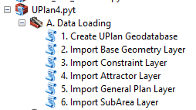
4. Double click in the *1. Create UPlan Geodatabase* tool
   1. In the top box, input the directory path to a folder you want to create a new UPGDB in. We created this folder in step 1 above. Do this by either dragging it from ArcCatalog or using the folder button to the right of the box. The location is a folder, and shouldn’t be the UPlan4Toolbox folder that contains the python scripts.
   2. Type in a name for the UPGDB. The name should not contain spaces (you can use an underscore instead) or special characters (!,@,#,\,/, etc.).
5. Click OK
6. Navigate to the folder you choose in the first box of the tool and it will contain a UPlan Geodatabase.
   1. This geodatabase contains all of the required tables for a UPlan run
7. Congratulations, you have created a UPlan Geodatabase!
   1. We’ll be referring to it as UPGDB from now on

Adding Layers to a UPlan Geodatabase (UPGDB)

1. Navigate to the UPlan4 toolbox in ArcCatalog
2. Expand the *A.Data Loading* toolset
   1. 
3. Now use tools 2-6 to import the various datasets
   1. To use my example data, these are found at C:\UPlan4\Training\ExampleData
4. Import a Base Geometry Layer
   1. The base geometry layer is a polygon feature class that provides the minimum mapping units that UPlan will track. This layer must have a field in its attribute table that has a unique ID for each polygon of type Integer.
   2. Use tool: *2. Import Base Geometry Layer*
      1. Input the UPlan Geodatabase created in the first tool of this tool. Input the directory path into the top box of the toolbox by either dragging it from ArcCatalog or using the folder button to the right of the box.
      2. Input the base geometry layer into the second box by either dragging it from ArcCatalog or using the folder button to the right of the box.
      3. In the third box, type in a descriptive name for the base geometry layer you inputted in the second box. This name may contain spaces.
   3. Example Dataset: apnhum51sp_CANAD83.shp (parcels)
5. Now all of the other layers are added in a similar manner
6. Import one or more Constraint Layers
   1. A constraint reduces the available space for development as a percent of the land area
   2. Use tool: *3. Import Constraint Layer*
   3. Example datasets: NWI_poly_Hum.shp (Wetlands), CAML_URB2.shp (Developed Land), PublicLands2.shp (Public Lands)
7. Import one or more Attractor Layers
   1. Attractors are used to prioritize where growth occurs
   2. Use tool: *4. Import Attractor Layer*
   3. Example datasets: cities2sp.shp (City Boundaries), MajorRoads_prj.shp (Major Roads), FloodHazardAreas.shp (Flood Hazard Areas)
8. Import a General Plan Layer
   1. A general plan layer defines where land uses are permitted to develop
   2. Use tool: *5. Import General Plan Layer*
   3. Example dataset: humgplu23sp_prj.shp
9. Import a SubArea Layer
   1. A subarea is a subsection of the model’s geographic coverage that can have distinct control totals for population and employment assigned to it. The SubArea layer must contain 2 fields: one that has a unique ID for each SubArea and one that has a descriptive name for each SubArea. ***SubArea codes must start with a letter.***
   2. Use tool: *5. Import SubArea Layer* 
      1. SubAreas have 3 additional inputs
         1. Click in this box and select the field that contains the SubArea IDs. There should be a unique ID for each SubArea stored in this field.
            1. Example dataset: said
         2. Click in this box and select the field that contains the descriptive name for the SubArea IDs. There should be a 1 to 1 relationship between this field and the one selected in the box above.
            1. Example dataset: FMNAME_PC
         3. Type in the maximum distance allowed between a Base Geometry centroid and the extent of the SubArea layer in order for that Base Geometry feature to be assigned to a SubArea. If the centroid is more than this distance, the Base Geometry feature will not be allocated future growth.
            1. Example dataset: 100
      2. Example dataset: I actually don’t want to use SubAreas, so the ‘SubArea’ layer is just the county boundary. All polygons have the same SubArea ID.
10. You have now imported all layers required to perform a UPlan run!

**UPlan4 Training – Worksheet 2: Configuring a UPlan Run and Setting up a Scenario**

This worksheet presents the steps required for configuring and setting up the scenario settings for a UPlan run. To configure UPlan, you set the number of time steps, add land uses, and set the order that they will be allocated. To set up a scenario: you assign attraction layers to land uses and set their weights; you assign constraint layers to land uses and set their weights; you assign a general plan to a time step and create a crosswalk between land use codes and general plan categories; and finally, if you’d like to use mixed use, you set the combinations of land uses that are allowed to allocate on top of each other.

1. Navigate to the UPlan4 toolbox in ArcCatalog
2. Expand the *B. Model Configuration* toolset
   1. 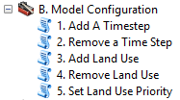
3. Add a Time step
   1. A time step allows the specification of almost all UPlan settings to be applied for a specific range of years
   2. Use tool: *1. Add A Timestep*
      1. Input the UPlan Geodatabase. Input the directory path into the top box of the tool by either dragging it from ArcCatalog or using the folder button to the right of the box.
      2. In the second box, type in a descriptive name for the time step you want to add. This name may contain spaces.
         1. Example dataset: Time Step 1: 2010-2030
      3. In the third box, type in a code for the time step you want to add. The code should start with a letter and not contain any spaces or special characters (!,@,#,\,/, etc.).
         1. Example dataset: ts1
      4. In the fourth box, type in the numerical position of the time step you are adding. If this is the first time step you are adding to a UPlan run, the position is 1. If this isn’t the first time step you are adding to a UPlan run, enter the number that represents the chronological order you want to add this time step at, relative to the existing time steps.
         1. Example dataset: 1
      5. In the fifth box, select the general plan layer to be used for this time step. If the general plan layer you want to use is not listed, add it to the UPGDB using the Import General Plan Layer tool.
         1. Example dataset: humgplu23sp_prj (General Plan) Added: 2016-03-28
      6. In the sixth box, select a field within the general plan layer selected in the fifth box that contains the general plan codes you want to use for this time step.
         1. Example dataset: GP2030
4. Add a Land Use
   1. A land use is either residential or employment and allows for some portion of vacant space
   2. Use tool: *3. Add Land Use*
      1. Input the UPlan Geodatabase. Input the directory path into the top box of the tool by either dragging it from ArcCatalog or using the folder button to the right of the box.
      2. In the second box, type in a code for the land use you want to add. The code should start with a letter and not contain any spaces or special characters (!,@,#,\,/, etc.).
      3. In the third box, type in a descriptive name for the land use you want to add. This name may contain spaces.
      4. In the fourth box, selected the type of land use you are adding, either residential or employment.
      5. In the fifth box, select the allocation mode for this land use. Normal means that the land use will be allocated based on net attraction, random means that the land use will be allocated randomly.
   3. Example dataset:
   4. 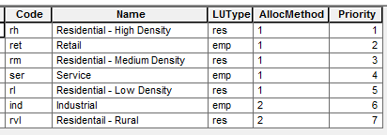



1. Set Land Use Priority
   1. This tool is used to set the order in which land uses are allocated
   2. Use tool: *5. Set Land Use Priority*
      1. After adding the UPGDB, all of the land use names will be displayed. Highlight the land use you want to change and use the up and/or down arrows to change its priority. Do not use the add or remove buttons. The land use on top of the list has the highest priority and will be allocated first; the land use on the bottom of the list has the lowest priority and will be allocated last.
      2. Example dataset: set the order however you’d like
2. Expand the *c. Model Configuration* toolset
   1. 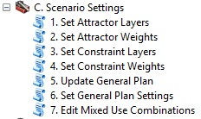
3. Set Attractor Layers
   1. This tool is used to determine which attractors are available to each time step
   2. Use tool: *1. Set Attractor Layers*
      1. Input the UPlan Geodatabase. Input the directory path into the top box of the tool by either dragging it from ArcCatalog or using the folder button to the right of the box.
      2. In the second box, select the time step you’d like to edit the available attractor layers for.
      3. After selecting a time step, all attractors and their availability will be listed. To change the availability, type either “No” or “Yes” in the 3rd column. Do not use the add or remove buttons.
   3. Example dataset: Set all layers to “Yes”
4. Set Attractor Weights
   1. This tool is used to set weights for attractor layers
   2. Use tool: *2. Set Attractor Weights*
      1. Input the UPlan Geodatabase. Input the directory path into the top box of the tool by either dragging it from ArcCatalog or using the folder button to the right of the box.
      2. In the second box, select the time step you’d like to edit.
      3. In the third box, select the land use you’d like to edit the weights for.
      4. In the fourth box, select the attraction layer you’d like to edit the weights for. If the attraction layer you want to edit isn’t listed, use the Set Attractor Layers tool to make it available (section 4.4.1)
      5. After selecting an attractor layer, the attraction weights will be displayed in the table on the bottom of the tool. You can edit the values in the table by clicking on them. To add a new weight, type a distance in the box above the table and click on the ‘+’ button. To remove a weight, highlight the weight you’d like to remove and click on the ‘x’ button.
   3. Example dataset: Set any weights that you would like, just be sure to set at least one for each land use (except rvl because it is randomly allocated). To check this, look at the upc_weights table in your UPGDB, there should be at least one row for every land use code.
      1. The weights I used:
      2. 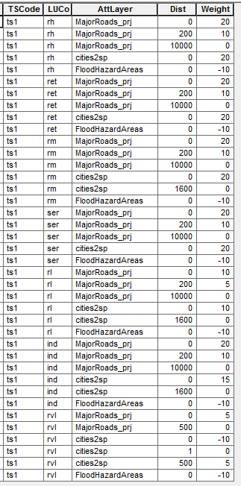
5. Set Constraint Layers
   1. This tool is used to determine which constraints are available to each time step
   2. Use tool: *3. Set Constraint Layers*
      1. Input the UPlan Geodatabase. Input the directory path into the top box of the tool by either dragging it from ArcCatalog or using the folder button to the right of the box.
      2. In the second box, select the time step you’d like to edit the available constraint layers for.
      3. After selecting a time step, all constraints and their availability will be listed. To change the availability, type either “No” or “Yes” in the 3rd column. Do not use the add or remove buttons.
   3. Example dataset: Set all layers to “Yes
6. Set Constraint Weights
   1. This tool is used to set the weight for constraint layers
   2. Use tool: *4. Set Constraint Weights*
      1. Input the UPlan Geodatabase. Input the directory path into the top box of the tool by either dragging it from ArcCatalog or using the folder button to the right of the box.
      2. In the second box, select the time step you’d like to edit.
      3. In the third box, select the land use you’d like to edit the weight(s) for.
      4. After selecting a land use, the constraint layer(s) and their weight(s) will be displayed in the table at the bottom of the tool. If the constraint layer you want to edit isn’t listed, use the Set Constraint Layers tool to make it available (section 4.4.3). You can edit the values in the table by clicking on them. A constraint value of 100 means that 100% of the area is constrained (and therefore, no new development is allowed). A constraint value of 25 means that 25% of the area is constrained (and therefore, only 75% of the area can be developed). Do not use any of the buttons to the right of the table.
   3. Example dataset: Set any weights that you would like, just be sure to set at least one for each land use. To check this, look at the upc_cweights table in your UPGDB, there should be at least one row for every land use code.
      1. The weights I used:
      2. 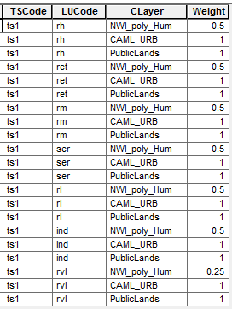
7. Set General Plan Settings
   1. This tool sets the general plan categories that a given land use can be assigned to
   2. Use tool: *6. Set General Plan Settings*
      1. Input the UPlan Geodatabase. Input the directory path into the top box of the tool by either dragging it from ArcCatalog or using the folder button to the right of the box.
      2. In the second box, select the time step you’d like to edit.
      3. In the third box, select the land use you’d like to edit the available general plan categories for.
      4. After selecting a land use, all general plan categories will be listed in the table at the bottom of the tool. Set the availability of each general plan category by typing ‘No’ or ‘Yes’ in the availability column.
   3. Example dataset: Choose any General Plan categories that you would like, just be sure to set at least one for each land use. To check this, look at the upc_gplu table in your UPGDB, there should be at least one row for every land use code.
      1. The Crosswalk I used:
      2. 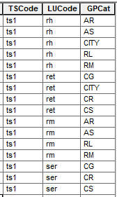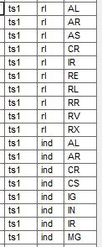 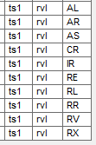
8. Optional: Setting up Mixed Use
   1. For each general plan category, this tool creates or edits a set of land uses that may be allocated on top of each other. These land uses will not block each other during allocation.
   2. Use tool: *7. Edit Mixed Use Combinations*
      1. Input the UPlan Geodatabase. Input the directory path into the top box of the tool by either dragging it from ArcCatalog or using the folder button to the right of the box.
      2. In the second box, select the time step you’d like to edit.
      3. In the third box, select the general plan code you’d like to edit the allowable mixed use land uses for.
      4. After selecting a general plan category, existing mixed use combinations will be listed in the 4th menu. To edit an existing combination, select it from the drop down menu; to create a new combination, select ‘Ceate a New Combination’ from the drop down menu.
      5. After selecting a mixed use combination to edit, set the availability of each land use type by typing ‘No’ or ‘Yes’ in the availability column. Land uses with a ‘Yes’ will be allowed to allocate on top of each other. Putting ‘No’ for all LUNames will remove that mixed use combination from the UPGDB.
   3. Example dataset: Set up any mixed use combinations that you’d like. If you don’t want to model mixed use this tool can be skipped.
      1. I just set up one mixed use combination. I allowed Residential High Density (rh) and Retail (ret) into General Plan Category CITY
9. You have now configured your Uplan run and set up a scenario!

**UPlan4 Training – Worksheet 3: Setting UPlan Land Use Demand**

This worksheet presents the steps required for setting up the land use demand settings for a UPlan run. This is all done within the Land Use Demand Toolset. In this toolset, the first tool sets population growth and the conversion factors to convert future population to number of households and employees. Tools 2-3 set the space requirements for each land use type; tool 2 for residential types and tool 3 for employment types. The 4th tool sets the percentage of future households and employees that will be allocated into each SubArea. Tool 5 sets the percentage of future households that will be allocated into each residential land use type. Tool 6 sets the percentage of future employees that will be allocated into each employment land use type. After tools 1-6 have been run for all time steps, the 7th tool takes all of the UPlan demand settings and calculates space demanded in each SubArea by land use type and time step.

1. Navigate to the UPlan4 toolbox in ArcCatalog
2. Expand the *D. Land Use Demand* toolset
   1. 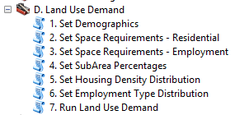
3. Set Demographics
   1. This tool is used to set the basic demographic inputs for each time step
   2. Use tool: *1. Set Demographics*
      1. Input the UPlan Geodatabase. Input the directory path into the top box of the tool by either dragging it from ArcCatalog or using the folder button to the right of the box.
      2. In the second box, select the time step you’d like to edit the demographic settings for.
      3. In the third box, input or edit the base population. This is the population at the beginning of the time step.
      4. In the fourth box, input or edit the future population. This is the population at the end of the time step.
      5. In the fifth box, input or edit the persons per household conversion factor. This is the average number of people per household.
      6. In the sixth box, input or edit the employees per household conversion factor. This is the average number of employees per household
   3. Example dataset
      1. 
4. Set Residential Space Requirements
   1. This tool sets the space requirements for all residential land use types
   2. Use tool: *2. Set Space Requirements – Residential*
      1. Input the UPlan Geodatabase. Input the directory path into the top box of the tool by either dragging it from ArcCatalog or using the folder button to the right of the box.
      2. In the second box, select the time step you’d like to edit or set the residential space parameters for.
      3. After selecting a time step, all residential land use types will be listed in the table at the bottom of the tool. To the right of the column containing the land use codes, are 3 columns displaying the settings for each land use type. Click into these columns to edit the values. Do not use the buttons to the right of the table. The 3 settings for residential space requirements are:
         1. Acres Per Unit – The average number of acres per unit/household within the land use
         2. Percent Vacant – The average percentage of vacant housing units within the land use
         3. Percent Other Space – The average percentage of other space within the land use
   3. Example dataset
      1. 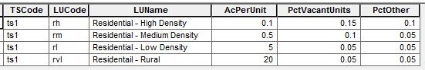
5. Set Employment Space Requirements
   1. This tool sets the space requirements for all employment land use types
   2. Use tool: *3. Set Space Requirements – Employment*
      1. Input the UPlan Geodatabase. Input the directory path into the top box of the tool by either dragging it from ArcCatalog or using the folder button to the right of the box.
      2. In the second box, select the time step you’d like to edit or set the employment space parameters for.
      3. After selecting a time step, all employment land use types will be listed in the table at the bottom of the tool. To the right of the column containing the land use codes, are 3 columns displaying the settings for each land use type. Click into these columns to edit the values. Do not use the buttons to the right of the table. The 3 settings for employment space requirements are:
         1. Square Feet Per Employee – The average number of square feet per employee within the land use
         2. FAR – The average Floor Area Ratio within the land use
            1. The total area of a building divided by the total area of the lot the building is located on
         3. Percent Other Space – The average percentage of other space within the land use
   3. Example dataset
      1. 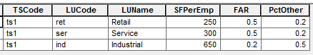
6. Set SubArea Percentages
   1. This tool sets the percentage of the future population and the percentage of the future employees that will be allocated into each SubArea
   2. Use tool: *4. Set SubArea Percentages*
      1. Input the UPlan Geodatabase. Input the directory path into the top box of the tool by either dragging it from ArcCatalog or using the folder button to the right of the box.
      2. In the second box, select the time step you’d like to edit.
      3. After selecting a time step, all SubAreas will be listed in the table at the bottom of the tool. Edit the percentages of people and employees to distribute between the SubAreas. Do not use the buttons to the right of the table. The columns must sum to 100.
   3. Example dataset: We added the county boundary as our ‘SubArea’ so just set both percentages to 100%.
7. Set Housing Density Distribution
   1. This tool sets the percentage of households to be allocated into each residential land use type for each sub area. The percentage of households column must sum to 100 for each SubArea.
   2. Use tool: *5. Set Housing Density Distribution*
      1. Input the UPlan Geodatabase. Input the directory path into the top box of the tool by either dragging it from ArcCatalog or using the folder button to the right of the box.
      2. In the second box, select the time step you’d like to edit.
      3. After selecting a time step, the table at the bottom of the tool will be updated with the current distributions. For each SubArea, edit the values in the third column to set the percentage of future households that will be assigned to each land use class; these percentages should sum to 100. Do not use the buttons to the right of the table.
   3. Example dataset
      1. 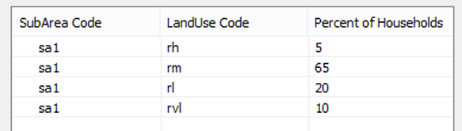
8. Set Employment Type Distribution
   1. This tool sets the percentage of employees to be allocated into each employment land use type for each sub area. The percent of employees column must sum to 100 for each SubArea.
   2. Use tool: *6. Set Employment Type Distribution*
      1. Input the UPlan Geodatabase. Input the directory path into the top box of the tool by either dragging it from ArcCatalog or using the folder button to the right of the box.
      2. In the second box, select the time step you’d like to edit.
      3. After selecting a time step, the table at the bottom of the tool will be updated with the current distributions. For each SubArea, edit the values in the third column to set the percentage of future employees that will be assigned to each land use class; these percentages should sum to 100. Do not use the buttons to the right of the table.
   3. Example dataset
      1. 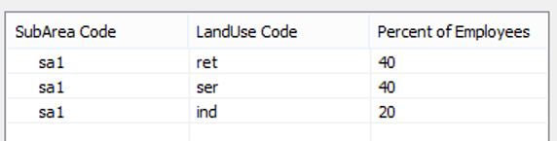
9. Run Land Use Demand
   1. This tool will calculate the number of employees and number of households demanded for each SubArea within each time step. Run this tool after you have completed tools 1-6 in this section for each time step, or if you have made a change to the demand inputs in tool(s) 1-6.
   2. Use tool: *7.Run Land Use Demand*
      1. Input the UPlan Geodatabase. Input the directory path into the top box of the tool by either dragging it from ArcCatalog or using the folder button to the right of the box.
10. Congratulations, you have now determined how many acres UPlan needs to allocate to each land use type. You can see this in the upc_demand table.

**UPlan4 Training – Worksheet 4: Running UPlan and displaying the results**

This worksheet presents the steps required for running UPlan and displaying the results. To accomplish this the Precalculations Toolset is ran first, and then the UPlan Run Toolset. You then join allocation tables to the Base Geometry layer to display the results.

1. Navigate to the UPlan4 toolbox in ArcCatalog
2. Expand the *E. Precalculations* toolset
   1. 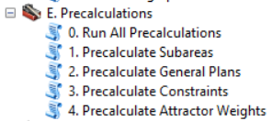
3. The Precalculations Toolset
   1. This toolset contains the tools needed to do the precalculations before performing allocation. The first tool runs all of the calculations UPlan requires, so if this tool is run none of the others in the toolset need to be ran. The other 4 tools break out the 4 main calculations. The second tool assigns all base geometry polygons to a SubArea. The third tool determines which land use types are allowed to be allocated into each base geometry polygon based on the general plan codes and settings. The fourth tool calculates the constraints on the base geometry polygons. The fifth tool calculates the net attraction for each base geometry polygon.
   2. Since we are running this toolset for the first time, you only need to run the first tool
      1. Use tool: *0. Run All Precalculations*
         1. Input the UPlan Geodatabase. Input the directory path into the top box of the tool by either dragging it from ArcCatalog or using the folder button to the right of the box.
4. Expand the *F. UPlan Run* toolset
   1. 
5. The UPlan Run Toolset
   1. This toolset contains the tool to run allocation
   2. Use tool: *Run Allocation*
      1. Input the UPlan Geodatabase. Input the directory path into the top box of the tool by either dragging it from ArcCatalog or using the folder button to the right of the box.
6. You now have 3 tables for each timestep
   1. They contain the acres allocated, by land use type, to each Base Geometry polygon. There are tables that report the acres allocated during each time step (upo_ts_alloc_<TSCode>) and the cumulative acres allocated at the end of each time step (upo_cum_alloc_<TSCode>,). If the model is unable to allocate all of the acres demanded, these underallocated acres are reported in a third table for each time step (upo_und_alloc_<TSCode>).
   2. Review these 3 tables now
      1. Was there space to allocate all of the demanded acres?
         1. Hint: Check the upo_und_alloc_<TSCode> table
7. Display the allocation results on a map
   1. Open ArcMap
   2. Add your Base Geometry layer
      1. Example dataset: apnhum51sp_CANAD83
   3. Add your Cumulative Allocation table
      1. upo_cum_alloc_<TSCode>
   4. Join the Allocation table to the Base Geometry layer based on the Base Geometry ID field
      1. R-Click on the Base Geometry layer
      2. Select: Joins and Relates > Join…
      3. In the second box, select the cumulative allocation table if it isn’t already selected for you
      4. In the first box, select the Base Geometry ID field
         1. Example dataset: up_polyid
      5. If the third box doesn’t populate automatically, select the same Base Geometry ID field
   5. Symbolize the Base Geometry layer with the land use it was allocated
      1. R-Click on the Base Geometry layer
      2. Select: Properties…
      3. Click on the Symbology tab
      4. In the left panel, select Categories > Unique Values
      5. Set Value Field = LUDesc
      6. Click on: Add All Values
      7. Select Colors for the different land use types
         1. If you are using a Base Geometry layer with small polygons, turn off the boundary color or set the width equal to 0
         2. Uncheck the box next to <all other values>
         3. Set the fill color of the blank value equal to No Color
      8. Click OK to the Layer Properties window

**UPlan4 Training – Worksheet 5: Running Zonal Summaries**

This worksheet presents the steps required to run zonal summaries for UPlan allocation outputs. Users may want to know how much development is happening at different locations across their study site. If they have a shapefile that represents those different areas, then the zonal statistics tool can be run to report back to them the allocation results for those areas. In the example dataset, I split the county into 3 zones.

1. Navigate to the UPlan4 toolbox in ArcCatalog
2. Expand the *G. Analysis* toolset
   1. 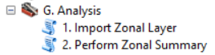
3. Import Zonal Layer
   1. This tool is used to add a zonal layer to the UPGDB. This can be any zonal layer. The layer must include a field that has a unique ID for each zone.
   2. Use tool: *1. Import Zonal Layer*
      1. Input the UPlan Geodatabase. Input the directory path into the top box of the tool by either dragging it from ArcCatalog or using the folder button to the right of the box.
      2. Input the zonal layer into the second box by either dragging it from ArcCatalog or using the folder button to the right of the box.
      3. In the third box, type in a descriptive name for the zonal layer you inputted in the second box. This name may contain spaces.
   3. Example dataset: SumZones.shp
4. Perform Zonal Summary
   1. This tool is used to summarize the number of people, number of households, and number of employees by Zone along with the amount of acres they consume. The user can do this for all time steps or choose just one. They may also choose to report what was allocated during that time step, what was allocated during that and all previous time steps, or both. A table will be created for each option the user chooses.
   2. Use tool: 2*. Perform Zonal Summary*
      1. Input the UPlan Geodatabase. Input the directory path into the top box of the tool by either dragging it from ArcCatalog or using the folder button to the right of the box.
      2. Select a time step that you would like to summarize or choose ‘All Timesteps’ to create summaries for all time steps.
      3. Select the type of summary you’d like to create
         1. Timestep Allocation Only – Only the acres allocated during the time step or time steps selected above will be reported.
         2. Cumulative Allocation – Only the cumulative acres allocated at the end of the time step or time steps selected above will be reported.
         3. Both Timestep and Cumulative Allocation – The acres allocated during and the acres allocated at the end of the time step or time steps selected above will be reported.
      4. Select the layer with the zones you want to summarize by. If you don’t see the layer you want, add it using the previous tool – Import Zonal Layer (section 4.8.1).
      5. Choose the field within the layer selected above that contains unique IDs for each zone.
         1. Example data: ZoneID
5. Review your zonal summary tables
   1. upa_ZoneXWalk
      1. The crosswalk table between ZoneID and BaseGeomID
   2. upa_sum_cum_alloc_<TSCode>
      1. Cumulative allocation
   3. upa_sum_ts_alloc_<TSCode>)
      1. Timestep Allocation