Q) Realize 2 input CMOS NAND and verify the truth table. Realize 2 input XOR using CMOS NAND symbol and verify the truth table using transient analysis also find the delay of the output with respect to input signal (any one input signal).

Ans:

CMOS NAND:

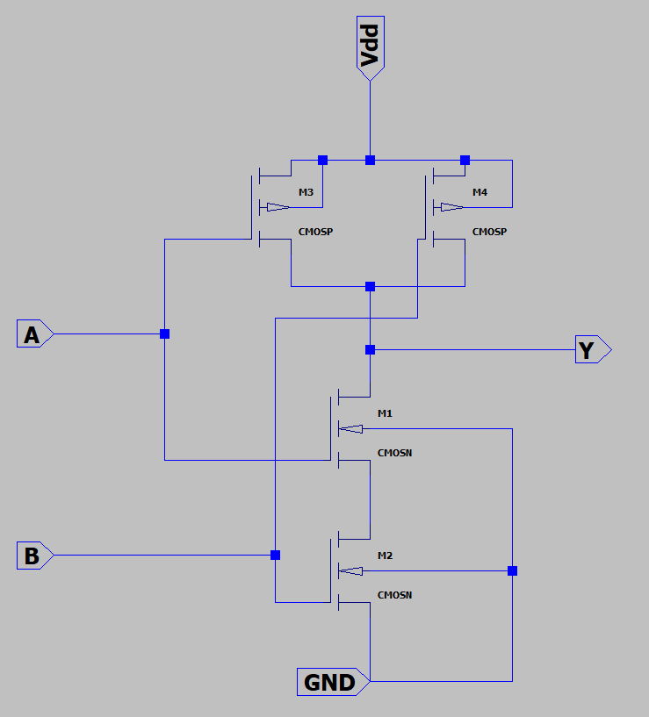

CMOS NAND Symbol:

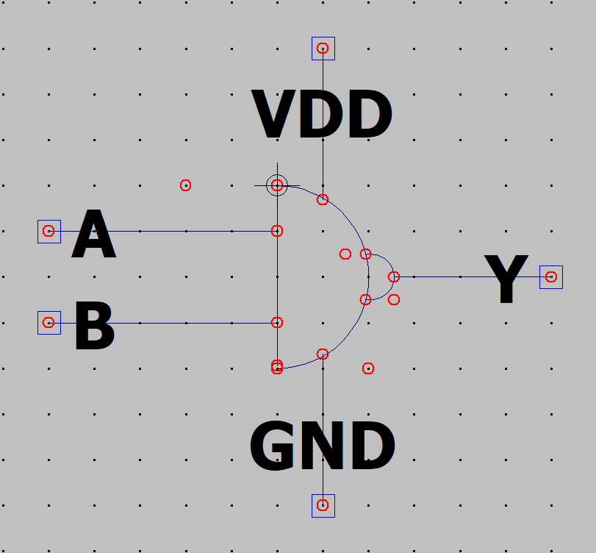

Truth Table for NAND Gate:

|  |  |  |
| --- | --- | --- |
| A | B | Y |
| 0 | 0 | 1 |
| 0 | 1 | 1 |
| 1 | 0 | 1 |
| 1 | 1 | 0 |

This can be verified with transient analysis of NAND gate.

XOR equivalent with NAND Gates:

Diagram:

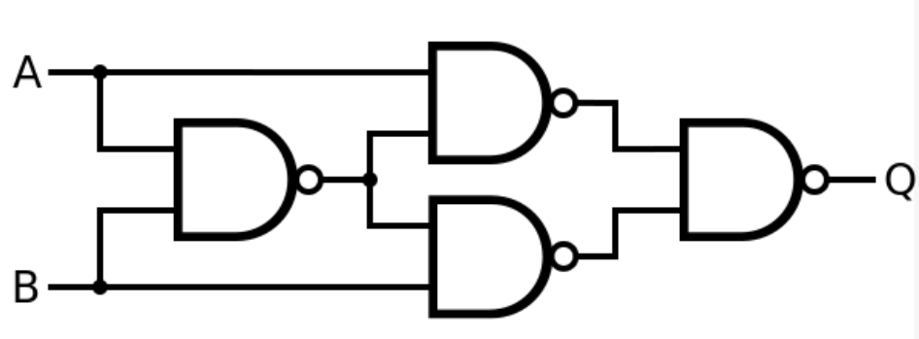

Implementation:

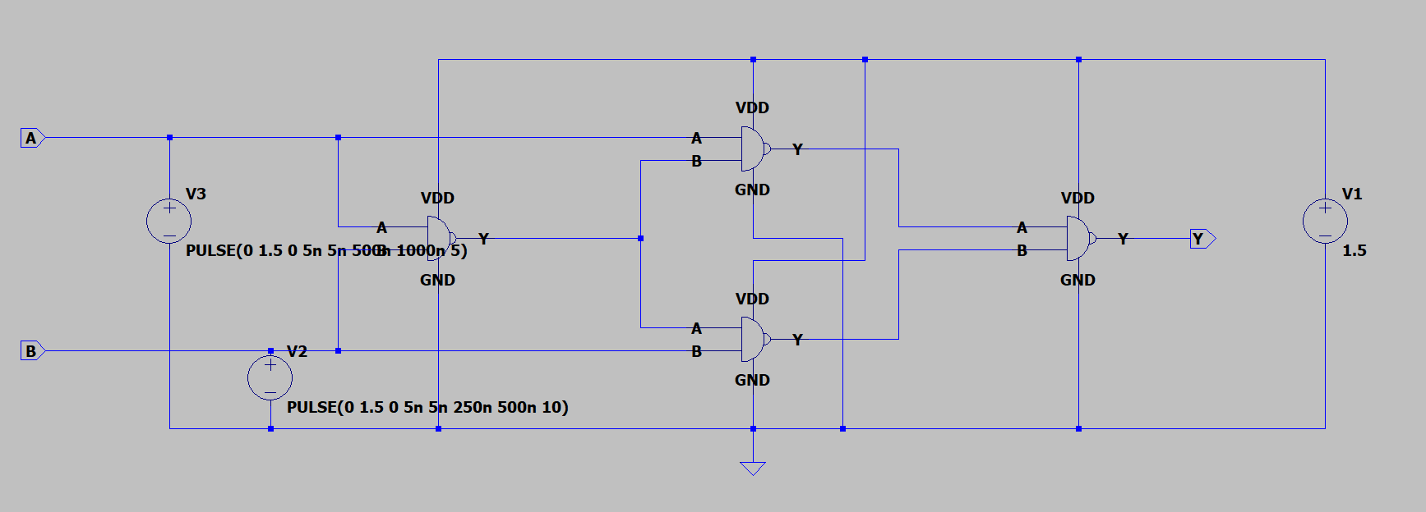

Transient Waveforms (A, B and Y):

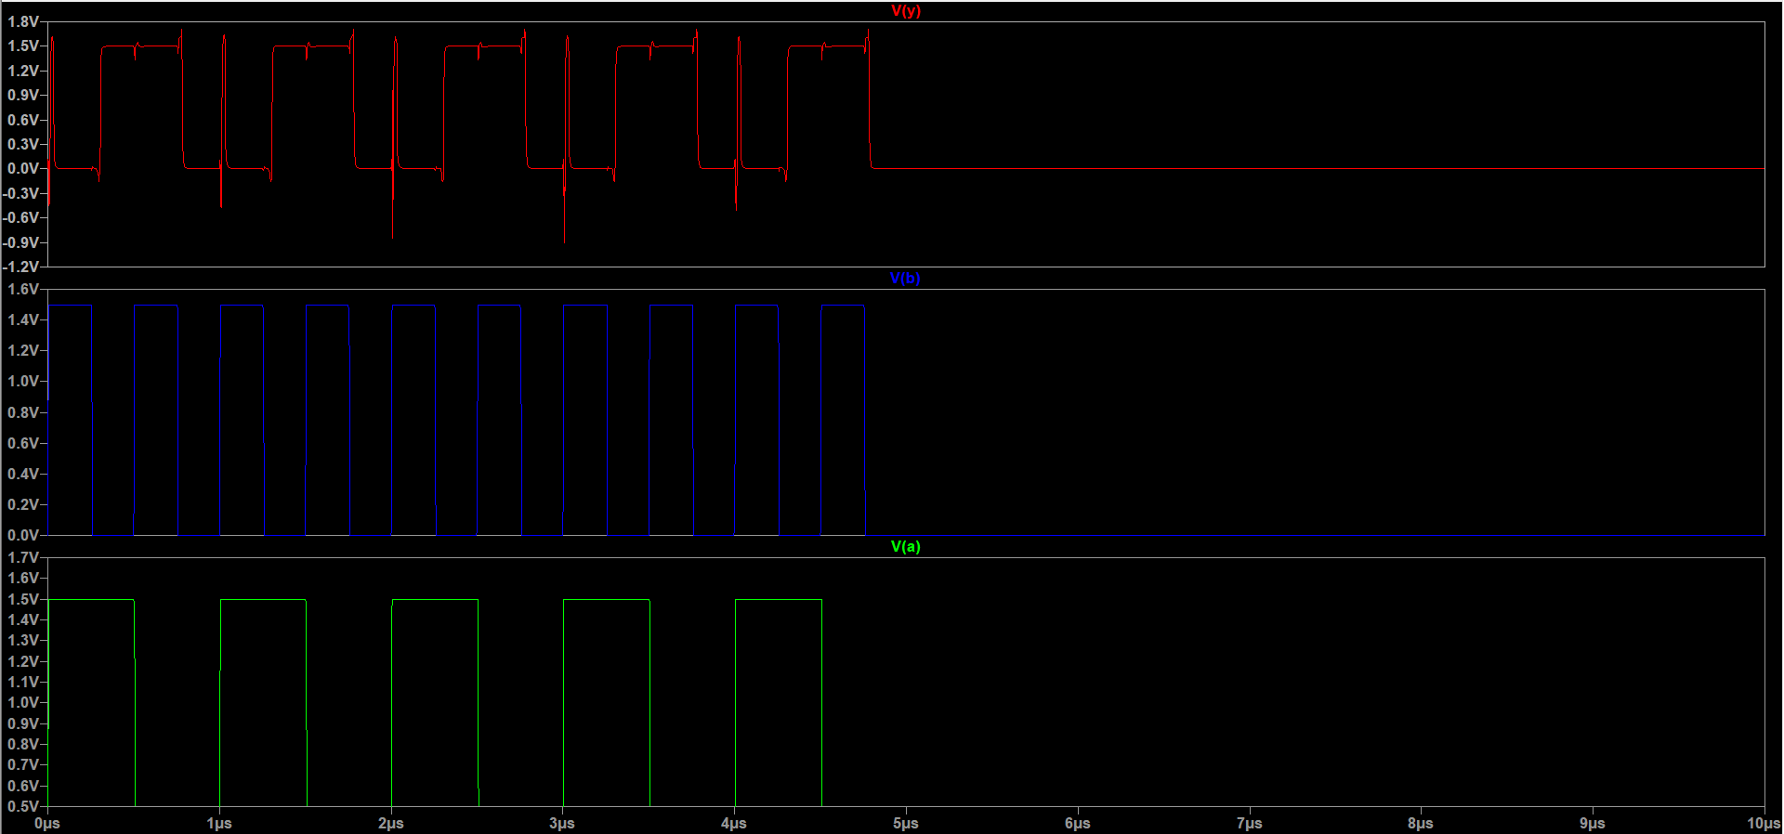

Delay time(with respect to input B):

2.42963 x 10-7s (from 2.57x10-7 to 1.45369x10-8).

Truth Table for XOR Gate:

|  |  |  |
| --- | --- | --- |
| A | B | Y |
| 0 | 0 | 0 |
| 0 | 1 | 1 |
| 1 | 0 | 1 |
| 1 | 1 | 0 |

This can be validated with the transient analysis graph.