03

Enterprise
Architecture
  - Book 3 Strategy governance and transformation
Prepared for Clifford Valiente
Vendor neutral concepts with Azure and AWS examples
16 chapters 58 exercises One transformation programme
A ten week route from enterprise analysis to a three year roadmap
Academic revision · Review edition
October 2026

Contents
How to study enterprise architecture 3
01 The enterprise architecture problem 4
02 Business capabilities value streams and requirements 8
03 Operating models and strategic alignment 10
04 Application portfolios and rationalisation 12
05 Enterprise information and data governance 14
06 Technology strategy and shared platforms 16
07 Governance decision rights and exceptions 19
08 Enterprise risk security and assurance 22
09 Investment economics benefits and uncertainty 24
10 Roadmaps dependencies and transition architectures 27
11 Organisational change adoption and architecture leadership 29
12 Sourcing procurement and supplier ecosystems 33
13 Measuring enterprise outcomes and architecture value 35
14 Innovation AI and sustainable technology decisions 38
15 Frameworks modelling and academic synthesis 41
16 Capstone transformation programme and board defence 44
Exercise answers and assessment guidance 47
Experiments templates and further study 52
References 53

How to study enterprise architecture
This third book develops the organisational side of IT architecture: deciding which capabilities to improve, how applications and data should support them, who may make consequential decisions, and how a feasible transformation programme creates measurable value. It builds on the technical foundations of Book 1 and the solution-design practice of Book 2. Your business information systems background is particularly relevant to the analysis of processes, incentives, investment and governance.
The intended level is advanced undergraduate to postgraduate professional study. The course uses original cases, worked numerical examples, research critiques and a transformation capstone. It is not an accredited qualification, a TOGAF certification course or an independently peer-reviewed publication. Frameworks are studied as tools for thinking and coordination, with their limits made explicit.

The continuing case
Helios Services Group is a fictional organisation with three business units: Industrial Maintenance, Retail Distribution and Digital Services. Acquisitions have left it with forty-three applications, fragmented customer identities and inconsistent service reporting. Annual IT operating expenditure is assumed to be twelve million euros. The board authorises a separate three-year transformation envelope of nine million euros, subject to staged decisions and evidence. These figures are teaching assumptions, not benchmarks or actual vendor quotations.
The board wants more reliable service handoffs, a coherent customer view, less avoidable application duplication and a platform on which teams can introduce new digital services. Business units retain accountability for their own performance. Some processes differ for legitimate reasons, so “one system for everything” is not an agreed requirement.
The enterprise architect must propose a three-year roadmap that is affordable, operable at each intermediate state and responsive to new evidence. A later change card reduces the transformation envelope by twenty percent. Another introduces an acquisition with a different data model. Your final submission must explain how the programme changes without hiding its consequences.

A ten week study route
Use five days per week at four to five hours per day, approximately 200–250 hours including reading, modelling, numerical work and revision. These are planning estimates, not required completion times. Preserve the version of your enterprise model before each change card so that you can explain the evolution of your decisions.
Week | Focus | Main output
1 | Chapters 1 and 2 | Enterprise problem and capability model
2 | Chapters 3 and 4 | Operating model and application portfolio
3 | Chapters 5 and 6 | Data authority and platform policy
4 | Chapters 7 and 8 | Decision rights and risk assurance
5 | Chapters 9 and 10 | Investment model and dependency roadmap
6 | Chapters 11 and 12 | Adoption and supplier strategy
7 | Chapters 13 and 14 | Measurement and controlled innovation
8 | Chapter 15 | Framework critique and research synthesis
9 | Chapter 16 | Three-year transformation dossier
10 | Change cards and defence | Revised programme and board presentation

Evidence and reference practice
IEEE numbering starts again in this book. Research papers, institutional research summaries, standards, official guidance and original course analysis have different evidential roles. A model of how enterprise architecture might create value is not proof that a particular programme will realise that value. A case study can illuminate mechanisms without establishing the same effect in every organisation.
The book's numerical models use explicitly fictional inputs. Discount rates, costs and benefit estimates are not investment recommendations. Legal and contractual questions are framed as requirements to establish for the organisation; the course does not invent universal retention periods, procurement rules or compliance outcomes. Before real implementation, verify the applicable policy and current primary sources.

Academic revision study and evidence route
Read the advanced sections alongside their host chapters, then attempt exercises numbered .4 and .5 before consulting the advanced answers. For this revision of Book 3, allow an estimated 16 to 24 additional hours beyond the ten-week route for full-paper reading, evidence comparisons and the four new exercises. These are planning estimates, not measured completion times. The practice files contain local teaching programs with stated limits.
This review edition has an accompanying claim-to-source record, change record and external-review package. Full-text verification means checking the passages supporting a specified claim in an accessible full source; it does not imply that every sentence in every cited publication has been audited. The three previously abstract-only supporting references have been replaced; the evidence history records the unavailable originals and the inspected alternatives. Actual architect, academic and learner feedback is still pending. The edition must not be represented as independently peer-reviewed.
CHAPTER 1

The enterprise architecture problem

Learning objectives
Distinguish enterprise decisions from individual solution decisions, connect architecture work to organisational outcomes, and evaluate claims of business value critically.

Local quality does not guarantee enterprise coherence
A well-designed solution can still create an enterprise problem. A business unit may introduce a new customer database that fits its workflow but conflicts with group reporting. A cloud deployment may be secure in isolation while depending on an identity process nobody owns. A low-cost application can preserve an expensive manual reconciliation process between divisions.
Enterprise architecture examines these relationships across capabilities, processes, information, applications, technology and decision rights. Its purpose in this course is to help the organisation choose and sequence coherent change. The enterprise boundary is a decision: it may include a group of companies, a public agency, a division or an ecosystem of partners. State which entities the architect can influence and which remain external authorities.
MIT CISR connects enterprise architecture to the integration and standardisation needs of an organisation's operating model. [1] This is a useful research perspective because it asks what the business needs to share before choosing a universal platform. It does not imply that every process or application should be centralised.

Helios needs a causal argument
The board's phrase “reduce duplication” could mean reducing licences, inconsistent data, repeated engineering effort or redundant business steps. Those problems have different mechanisms. Retiring a CRM might reduce subscription cost but increase work for a division whose process is poorly supported by the replacement. A shared customer model might improve reporting without requiring immediate CRM consolidation.
Construct an explicit chain from intervention to outcome. A governed customer identifier can reduce ambiguous matching; clearer matching can reduce manual reconciliation; reduced reconciliation can release capacity or improve report timeliness. Each link needs an owner and evidence. The existence of a master-data tool does not establish the final benefit.
Van de Wetering and colleagues analyse 299 usable survey responses using partial least squares modelling and fuzzy-set qualitative comparative analysis. They associate EA-driven capabilities with benefits through innovativeness. Their capabilities concern sensing opportunities, mobilising resources and transforming arrangements. Recruitment through a Dutch university's professional-student network, self-reported measures and a single observation period limit causal and population inference. The authors acknowledge that longitudinal and archival evidence would strengthen the study. [2] A capability to change an organisation is a different claim from possession of an architecture repository; Helios must demonstrate the relevant work.
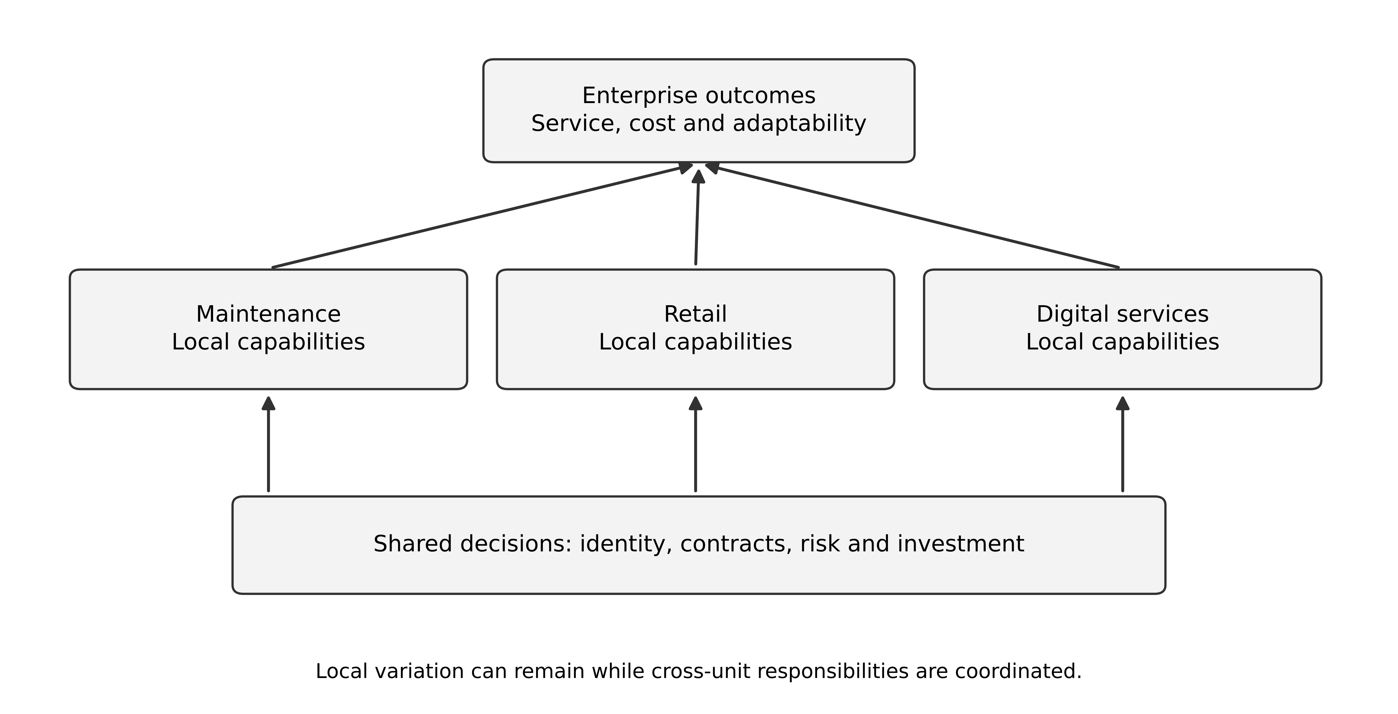
Figure 1 Enterprise architecture connects organisational choices to capabilities systems and measured outcomes

Architecture is advice embedded in decisions
An enterprise model has value when it informs a decision: whether to consolidate two applications, fund a shared capability, accept an exception or delay a migration. A complete repository that is never consulted may have less practical value than a small accurate model used in a consequential investment review.
Identify the decision audience. The board needs choices, costs, consequences and uncertainty. A capability owner needs process and data implications. Delivery teams need boundaries, standards and transition responsibilities. Operations needs the service dependencies and recovery ownership. One giant diagram is unlikely to serve all of them well.
The architect does not acquire authority over every business decision by drawing the model. Clarify where the role advises, where it sets an agreed standard and where an accountable executive decides. A recommendation can be technically sound yet fail because the decision rights and incentives were never addressed.

Define the enterprise baseline honestly
Helios's forty-three applications are an initial inventory count, not a complete model of its operating reality. Record business purpose, owner, users, cost scope, information authority, interfaces, criticality, lifecycle and evidence confidence. A system without a known owner is an investigation item, not automatically a retirement candidate.
Distinguish the current state from the desired state. If the group wants a shared customer identity but currently has separate division identifiers, show both and the mapping uncertainty. A future-state label placed on a current-state diagram can conceal the work that transformation must perform.

A worked first decision
The board asks whether to mandate one CRM immediately. A defensible first response proposes a short capability and information analysis before a group-wide procurement decision. Compare the divisions' service processes, necessary shared customer facts, contract constraints and change capacity. Meanwhile, improve the most consequential unreliable handoffs using the solution reasoning from Book 2.
This is not indefinite analysis. Give the investigation a decision deadline and defined outputs: a process-variation assessment, a customer-authority proposal, a feasible consolidation option and a staged alternative. If the divisions genuinely share the same process and a product satisfies it, consolidation may be justified. If their differences are material, common contracts and governance may create more value initially than one application.

Separate a definition a mechanism and a causal claim
An enterprise architecture definition tells the reader what a researcher includes in the subject. A mechanism explains how one change could produce another. A causal claim states what would happen to an outcome if an intervention were made, compared with an appropriate alternative. These are different intellectual tasks. Agreement on the definition of a capability map does not establish that producing one reduces operating cost.
For Helios, write the proposed mechanism with observable intermediate states. A common customer identifier could make previously ambiguous matches resolvable. Resolvable matches could reduce manual reconciliation. Less reconciliation could permit a team to process more requests with its current staffing. Only a further decision about staffing, contracts or productive redeployment would turn that released capacity into a specified financial benefit. Each could is a proposition to investigate, not a promised consequence of buying a master-data platform.
Now construct rival explanations. Reconciliation may decline because a source system stops sending difficult records, because staff quietly stop checking, or because the sample shifts toward easy cases. Those observations can resemble improvement while undermining the intended outcome. Retain denominators, exclusions, unresolved cases and service quality alongside time saved. An architecture evaluation that measures only the number of completed mappings can reward a narrower service rather than a better one.
A useful academic question is not whether enterprise architecture is good in general. It is which intervention, for which organisation, under which conditions, changes which outcome through which mechanism. The unit of analysis matters: a team, a programme and a whole enterprise have different exposures and time horizons. Findings about software module coupling do not directly estimate profit effects from application consolidation. Chapter 6 uses such research to form a bounded design hypothesis instead.
For your portfolio, maintain three layers of statement. Record what an inspected source actually argues or observes; write your inference about Helios separately; then define the proposed experiment or decision. This prevents a citation at the end of a paragraph from appearing to validate an entire fictional business case. The accompanying claim record uses the same distinction and records the replacement of previously abstract-only support.

Worked mechanism and rival explanation
The following is an original evaluation design for Helios, not a finding from the survey. Define the intervention narrowly: a verified customer-link service plus a staffed correction process for two participating divisions. Define the outcome as the proportion of eligible service requests requiring reassignment because the customer or service site was misidentified. Keep the unit of observation at the service request; the funding decision remains at programme level.
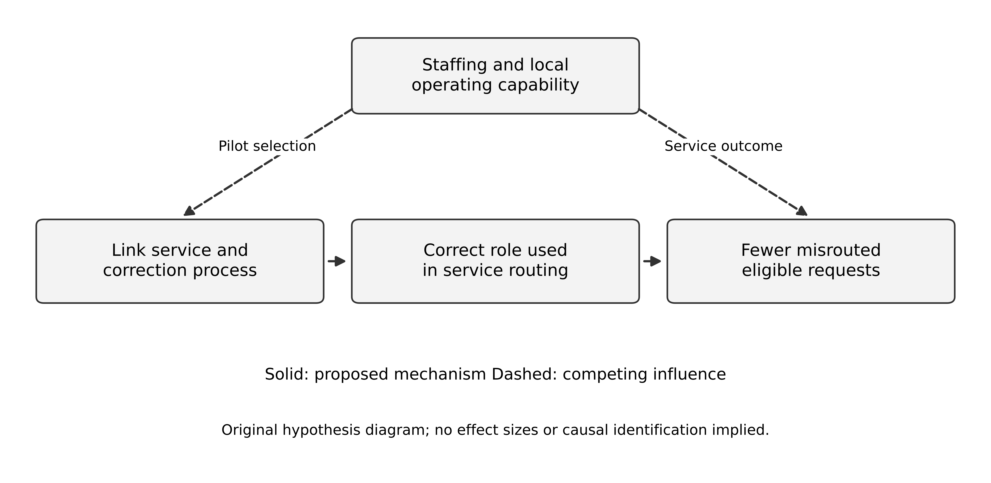
Figure 2 Proposed benefit mechanism and a competing influence in the fictional Helios pilot
Read the diagram as hypotheses, not measured effects. Solid arrows show the proposed route from an intervention through changed work to fewer misrouted requests. Dashed arrows show how staffing could influence both the choice of pilot division and its outcome. If the best staffed division receives the pilot first, its later performance cannot be attributed automatically to the link service. The diagram deliberately omits numerical weights: none has been estimated.
Work backwards from a failed prediction. If verified links increase but misrouting does not decline, inspect whether service routing actually consumes the links. If it does, inspect whether the link captures the relevant role: an accurate legal-party match can still select the wrong maintenance site. If routing is correct but resolution remains slow, the binding constraint may be technician availability. These diagnoses lead respectively to an integration change, a semantic correction and a capacity decision. Buying a larger identity platform would address none of them automatically.
Now compare a cheaper alternative. Keep the local identifiers and introduce a manual cross-division correction desk with an agreed response time. It might deliver an adequate service at low volume, while producing evidence about ambiguity and demand. Its continuing labour cost, coverage and handoff risk must be counted. The automated alternative needs implementation and stewardship cost, error monitoring and a fallback when matching is unresolved. Choose between them using volume, consequence and observed correction effort; automation is an option, not the definition of enterprise maturity.
Before collecting data, record the eligible workflows, observation period, treatment of unresolved cases and quality checks. Preserve all eligible requests in the denominator even if some cannot be matched. Otherwise a team could apparently improve accuracy by excluding the difficult population. Agree a decision rule: expand only when the measured service improvement and sustainable support burden justify the next commitment. A small pilot may instead justify further investigation, particularly when serious errors are rare.

Exercises
1.1 Give an example of a technically good local solution that increases enterprise cost or risk. Explain the mechanism.
1.2 Translate “reduce duplication” into three different measurable outcomes for Helios.
1.3 Build a benefit chain for governed customer identity and identify one observation that would challenge each link.
Key points. Enterprise architecture should improve decisions about relationships and change across the organisation. Its value must be explained through mechanisms and observed outcomes, not inferred from the existence of models.
CHAPTER 2

Business capabilities value streams and requirements

Learning objectives
Build a capability map without confusing it with an organisation chart, connect capabilities to value delivery, and turn strategic language into testable requirements.

Capability describes an organisational ability
A capability states what the organisation must be able to do, such as manage customer identity, fulfil service commitments or reconcile financial records. A process describes how work is performed. An application supports some of that work. A department groups people and accountability. These can change at different rates, so do not treat them as interchangeable boxes.
For Helios, “manage service requests” can remain a capability while a division changes its process, application or reporting structure. A capability map provides a stable discussion structure when the organisation is deciding what to improve. It should be stable enough to compare investments, but it is still a model that may need revision when the business changes.
Use clear boundaries and a useful level of detail. “Run the business” is too broad to guide investment. “Call endpoint POST /case” is too technical. A level such as customer management, service management, fulfilment, financial management and enterprise information can organise the first discussion. Decompose only where a real decision needs more detail.

Connect the map to a value stream
A value stream follows the stages through which an outcome is delivered to a stakeholder. For a maintenance customer, the path may move from recognising a need through requesting service, agreeing entitlement, scheduling, completing work and resolving payment. Several capabilities contribute to each stage, and one capability can support several streams.
The stream exposes handoffs that a departmental chart may hide. Helios's service team can process its own queue quickly while a request waits days for entitlement confirmation elsewhere. Improving the fastest local step will not necessarily improve the customer's end-to-end outcome. Measure waiting and exception handling as well as active processing.
Avoid assuming that every stage has one application or one owner. The purpose is to identify responsibilities and dependencies. Where ownership is shared, define the coordination mechanism and the person accountable for the overall outcome. Otherwise each team can meet its local measure while the value stream fails.

Use heat maps with evidence
A capability heat map can compare strategic importance, current performance, risk, information quality or investment need. These are different dimensions. Combining them into one unexplained red colour creates ambiguity: is the capability important, failing, expensive or merely poorly understood?
For each rating, record the criterion, source and confidence. “High integration risk because three critical handoffs lack reconciliation and incidents occurred in the last quarter” is more useful than “integration maturity two”. A subjective scale can support discussion, but it should not be presented as an objective measurement unless it has a defined measurement method.
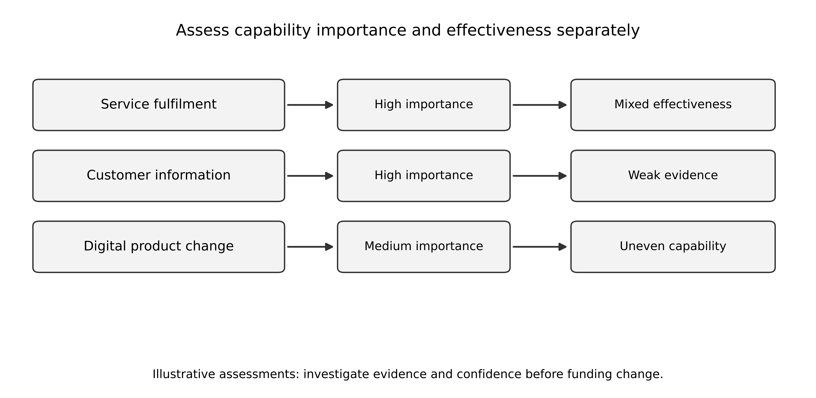
Figure 3 Capability assessment separates importance from effectiveness and evidence confidence
Prioritisation should connect the rating to an action. A high-risk capability may need an immediate control, a discovery task or a replacement programme. A low-confidence assessment may justify investigation before investment. Do not automatically send every red area into the largest transformation programme.

Translate strategy into observable requirements
The board's objective “a coherent customer view” needs a defined user and purpose. A service agent may need to recognise the same customer across divisions while seeing only authorised cases. Finance may need consolidated revenue under a governed legal-entity mapping. Marketing may propose a different use with different permissions and data requirements.
One enterprise requirement could state: authorised service staff can resolve a customer organisation to a governed identifier and see the permitted cross-division service history within an agreed response time, with ambiguous mappings visible. This requirement implies identity mapping, access policy, source authority, freshness and an exception process. It does not by itself require one CRM.
Requirements should have owners and measurable acceptance evidence. Some policy questions remain open, such as whether staff may see another division's cases. The architecture should surface that decision before implementing a broad data join. A technical ability to combine records is not permission to use them for every purpose.

Worked capability comparison
Industrial Maintenance needs asset entitlement and technician scheduling. Retail Distribution needs order allocation and shipment tracking. Digital Services needs subscription entitlement and digital usage support. All three need customer identity, case accountability and financial reconciliation, but their fulfilment capabilities differ.
A sensible first map therefore identifies shared information and selected shared controls while preserving distinct fulfilment processes. Later evidence may justify common application components. The map makes that decision discussable without declaring either total centralisation or total independence in advance.

Exercises
2.1 Distinguish a capability, process, application and department using service management examples.
2.2 Design a two-dimension capability assessment for Helios and state the evidence behind each rating.
2.3 Turn “a coherent customer view” into a requirement that includes authorised scope, ambiguity and source freshness.
Key points. Capabilities provide a business-oriented structure for investment discussion. Value streams and explicit requirements connect that structure to customer outcomes and reveal dependencies that local measures can miss.
CHAPTER 3

Operating models and strategic alignment

Learning objectives
Distinguish process standardisation from information integration, analyse central and local responsibilities, and connect technology choices to organisational change.

Sharing data and sharing processes are different choices
Two divisions can share customer identity while operating different fulfilment processes. They can also use the same process template while keeping customer data separate for legitimate business reasons. Integration concerns coordination and shared information across boundaries; standardisation concerns the degree to which work follows common definitions and procedures.
MIT CISR's published overview identifies integration and standardisation requirements as the dimensions of an operating model. [1] This is an institutional definition, not an estimated effect of adopting a particular model. The course applies those dimensions to individual capabilities instead of assuming one uniform answer for all of Helios. A group may standardise financial reporting strongly while allowing differentiated service delivery.
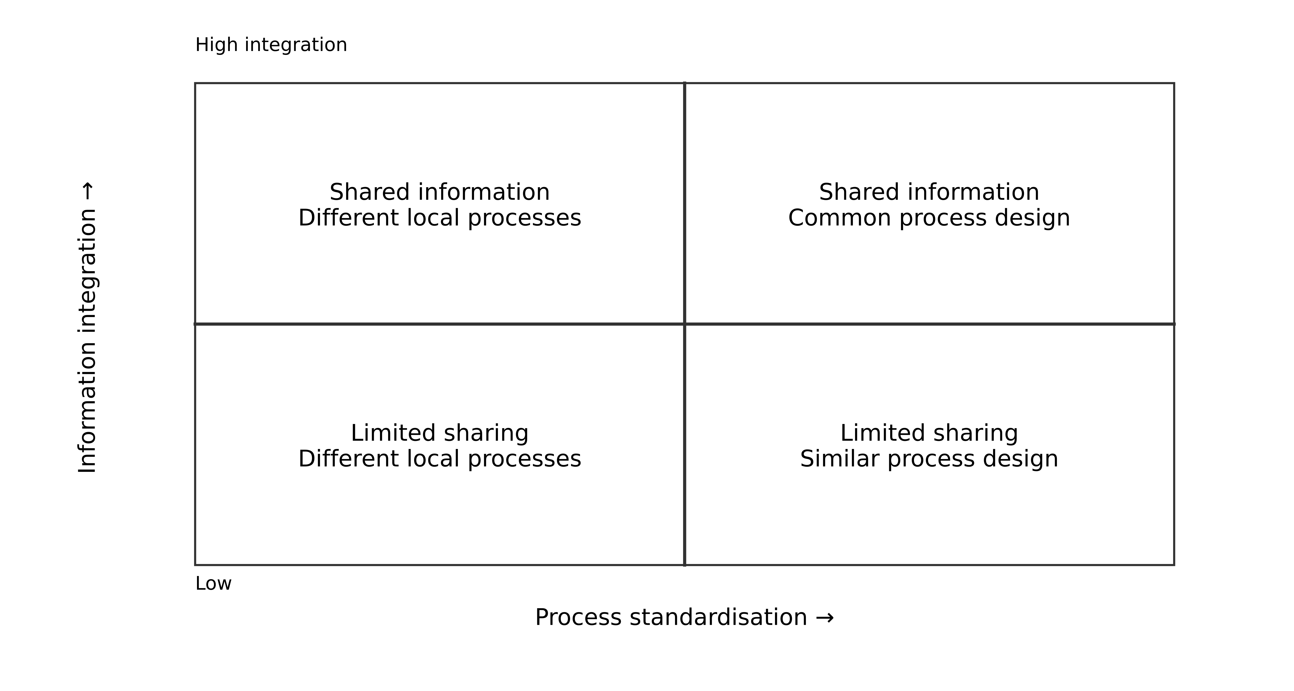
Figure 4 Integration and standardisation are separate dimensions of an operating model
If the board asks for one platform, ask what operating model it intends to create. Does it want shared data, common processes, central decision rights, common technology operations or all of these? A platform purchase cannot settle unresolved organisational choices. Conversely, some technology can enable a new operating model that was previously impractical, so alignment is not merely IT receiving fixed instructions.

Build an explicit responsibility model
For Helios, group leadership may set customer-identity standards, minimum security requirements and consolidated reporting definitions. Business units may own their service processes, local product features and approved exceptions. Shared platform teams may provide identity, integration and observability services under defined contracts. These are original case choices, not a universal governance prescription.
The design should say who funds shared work and how priorities are resolved. If every division expects another to pay for the customer mapping service, a technically sound shared capability may never be maintained. If the central team controls all priorities without understanding local needs, divisions may create unofficial alternatives.
A responsibility boundary should match the consequence. A local user-interface change may remain within a product team. A change to the enterprise customer identifier affects reporting and integrations across units and requires broader coordination. Centralising both decisions equally can create unnecessary delay; decentralising both can create incompatible facts.

Analyse the cost of standardisation
A common process can reduce variation, simplify training and make shared data more comparable. It can also remove useful local differentiation or force exceptions into manual work. Evaluate the variation before eliminating it. Some variation is accidental legacy; some reflects a distinct product, customer promise or contractual obligation.
Suppose two divisions close a service case at different events. One closes when a technician completes work; another closes after customer acceptance. Forcing both into the same status code without changing the process makes reporting appear standard while preserving different meaning. Either agree a common business boundary or retain distinct events and map them transparently for the required measure.
Standardisation also has transition cost. Training, data conversion, temporary dual operation and changes in accountability may exceed the licence savings initially. Include these in the programme and measure whether the common process is actually adopted. A process diagram approved by executives is not evidence that daily work follows it.

Make alignment a recurring test
At each major investment, ask whether the proposed capability, process, information model and operating responsibility support the current strategic objective. If the objective changes, revisit the assumptions rather than mechanically preserving the old target architecture. A roadmap should contain review points and alternatives for uncertain future conditions.
For example, Helios may initially pursue cross-selling across divisions. That increases the value of governed customer matching and permitted information sharing. If it later decides to sell one division, separability and data partitioning become more important. The architecture should expose the cost of each strategic direction instead of pretending one target is optimal for both.

A worked choice for Helios
Choose shared customer identity and financial definitions, common minimum security and integration contracts, and differentiated fulfilment processes for the first year. Pilot the shared identity service with two divisions before mandating application consolidation. Fund it as an enterprise capability with named data and service owners.
This choice preserves room to learn. If the pilot shows that processes are sufficiently similar and a common application supports them, consolidation becomes a later option. If the differences are fundamental, the group can still obtain reporting and service-coordination benefits through common information contracts. The decision should state the evidence that would change the next step.

Work through competing operating designs
Consider three alternatives for Helios's service operations. Central consolidation puts all divisions onto one CRM and one common closure process. Federated coordination retains the local CRMs and fulfilment processes while standardising customer identity, selected event contracts and group measures. Local autonomy with periodic reporting keeps operational decisions local and reconciles group reporting at defined intervals. These alternatives are deliberately sharper than a vague promise of one platform with flexibility.
Central consolidation can reduce some duplicate configuration and make one process easier to enforce. It also concentrates change decisions and makes the quality of the common process crucial. If customer acceptance is required in one division but technician completion is sufficient in another, a single undifferentiated closed status loses meaning. A genuinely common process requires an authorised business change, not merely a field mapping.
Federated coordination permits differentiated work but needs durable ownership of shared contracts. Ross's accessible MIT teaching material describes coordination through shared data visibility alongside local service customisation and stresses disciplined data use. [3] Applied to Helios, a shared identity service without funded stewardship can become an unreliable dependency. Each division must agree how to resolve disputed matches and how quickly it will publish the events on which others rely.
Local autonomy can fit a strategy in which divisions have independent customers and limited cross-selling. Its cost is delayed or manual consolidation and weaker real-time group visibility. That cost may be acceptable for a specified reporting product. It becomes harder to defend if the business promises a single cross-division service journey. State what the organisation gives up instead of presenting autonomy as free flexibility.
Decision dimension | Central consolidation | Federated coordination | Local autonomy
Process policy | Common process owner | Local owners within shared contracts | Local owners
Customer meaning | One governed operational definition | Shared matching and explicit local meanings | Local definitions with reporting reconciliation
Change dependency | Central product and process capacity | Contract and platform coordination | Mainly local delivery capacity
Main failure to investigate | Common process misfits local obligations | Shared contracts lack stewardship | Group promises exceed reconciliation capability

An original decision for year one selects federated coordination because Helios has a known need for group visibility but has not demonstrated equivalent local fulfilment policies. This conclusion is conditional. If analysis shows that process variation is accidental and one product supports the obligations, central consolidation may become preferable. If a division is being sold, a narrower integration boundary may be better. A university-level answer should explain what evidence changes its conclusion.
Avoid collapsing funding, process ownership, data authority and deployment into one centralisation label. A centrally funded identity service can support locally owned applications. A shared cloud account does not prove common process semantics. A diagram should show each relationship explicitly so reviewers can identify the exact point of agreement or conflict.

Exercises
3.1 Give one Helios capability needing high integration with limited process standardisation, and justify the choice.
3.2 Explain how one common status code can hide different business meanings across divisions.
3.3 The board plans to divest a division in two years. Identify three assumptions in the shared-platform strategy that need review.
3.4 Compare all three operating designs for a planned divestiture. Identify which shared dependencies can remain contractual and which need separation.
Key points. Operating-model choices determine what the organisation must share and where it should preserve autonomy. Technology, process, funding and decision rights need to support the same intended arrangement.
CHAPTER 4

Application portfolios and rationalisation

Learning objectives
Create a decision-useful application inventory, compare rationalisation options, and separate avoidable duplication from justified diversity.

Inventory for a decision
An application portfolio record should identify business purpose, accountable owner, users, supported capabilities, data authority, interfaces, criticality, operating cost scope, lifecycle and planned changes. Record the evidence date and confidence. An old inventory can be misleading after acquisitions, supplier changes or informal departmental development.
Helios's forty-three applications include six representative systems shown below. The fictional costs are annual attributable operating costs for those applications and are already included in the twelve-million-euro group baseline. They are not additional expenditure and do not describe all forty-three applications.
Application | Main responsibility | Annual operating cost EUR | Initial issue
CRM North | Industrial service cases | 420,000 | Weak handoff reconciliation
CRM Central | Distribution service cases | 360,000 | Similar customer data with different identifiers
ERP Core | Financial and asset records | 900,000 | Shared critical dependency
Legacy Orders | Order intake and state | 600,000 | Hosting exit deadline
Analytics Warehouse | Group reporting | 300,000 | Inconsistent metric definitions
Identity Platform | Workforce access | 240,000 | Incomplete account lifecycle integration

The sample totals 2.82 million euros. Do not extrapolate that average to the whole estate without evidence about the remaining applications. The cost model should distinguish licences, infrastructure, internal support and allocated shared services so that consolidation does not double-count savings.

Compare options beyond retire or retain
Possible dispositions include retain, improve, consolidate, replace, rehost and retire. A system can be strategically useful but technically fragile, suggesting targeted improvement. Another can be technically healthy but serve a process the business no longer needs. A third may be redundant in function but expensive to exit because of data, contracts and hidden dependencies.
Use explicit criteria rather than one opaque score. Business value, technical condition, risk, cost, dependency complexity and strategic fit can conflict. Mandatory obligations and service continuity should be assessed before preferences. Record uncertainty: a suspected unused system needs dependency investigation before retirement approval.
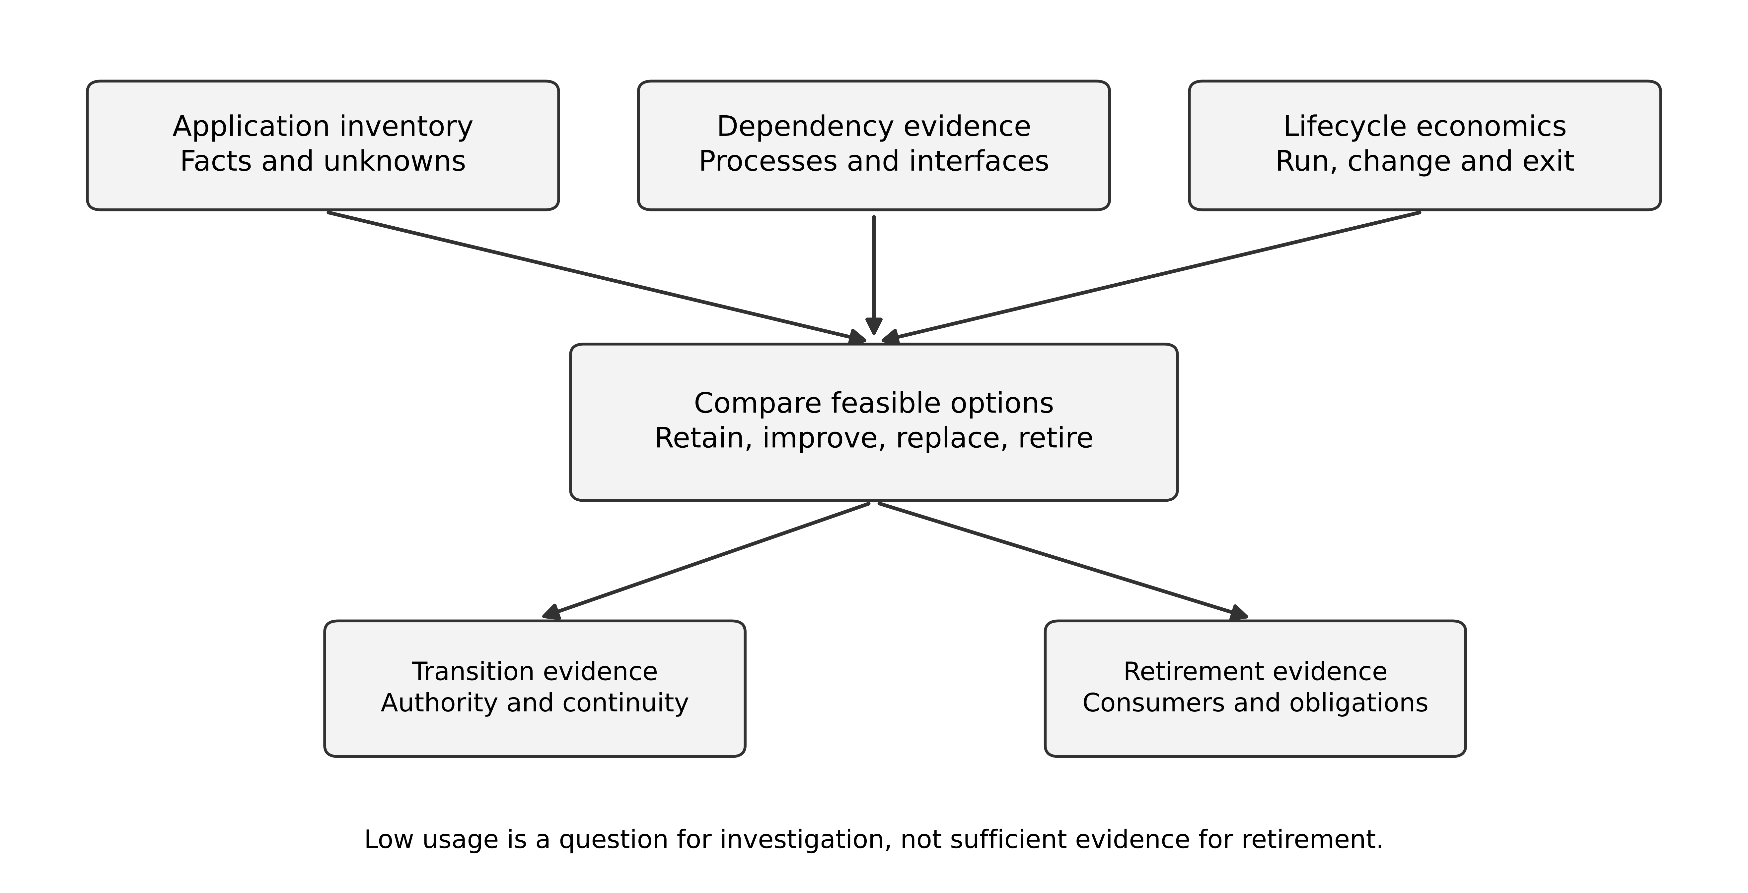
Figure 5 Portfolio decisions combine business purpose technical condition dependencies and exit evidence
An application count is a poor standalone success metric. Reducing forty-three applications to thirty may still increase cost if the remaining products are more expensive and integration work grows. Conversely, a new shared service can increase the count while reducing duplicated logic and risk. Measure the outcome the rationalisation is meant to create.

A worked CRM comparison
CRM North and CRM Central both support service cases, but their fulfilment processes differ. Compare three options: keep both with common customer mapping and reliable integration; consolidate into one product while preserving necessary process variation; or replace both through a broader process redesign.
The first option can deliver some shared-data benefits sooner but retains two operating estates. The second may reduce platform cost but requires migration, process fit and a tested separation model for access. The third offers greater redesign freedom while carrying the largest scope and adoption risk. None should be ranked solely by licence price.
Before selecting, test representative workflows and exports. Include attachments, historical status, identifiers and audit evidence. A demonstration of a new case form does not prove that the product can preserve the existing business history or support the required exception process.

Retirement is a project with evidence
A retirement plan identifies migrated users, replacement functionality, data retention or archival treatment, removed integrations, stopped jobs, revoked access and cancelled contractual costs. It also defines a period for detecting missed dependencies and a response if one appears. A system marked “retired” in the repository while still running and billed has not realised the intended saving.
Some records may require continued controlled access without keeping the original application fully operational. Evaluate whether an archive can preserve meaning and retrieval needs. A CSV of current rows may omit relationships, attachments or historical interpretation. The archival design must fit the actual business and policy requirements.

Prioritise the first actions
For Helios, the Legacy Orders hosting deadline is a time constraint, identity lifecycle gaps are a cross-cutting risk, and inconsistent reporting undermines programme measurement. Those may justify early work even if CRM consolidation promises larger eventual savings. Sequence investments by dependencies and risk as well as projected benefit.
Produce a portfolio decision record for each major disposition. State the reason, options, evidence, transition cost, owner, timing and review trigger. This creates a traceable link from the enterprise model to funded action.

Exercises
4.1 Verify the sample operating-cost total and explain why it must not be added to the group baseline.
4.2 An application has few users and high cost. Give three reasons it might still be unsafe or uneconomic to retire immediately.
4.3 Compare retaining two CRMs with shared data contracts against consolidating them. Identify the evidence most likely to change the decision.
Key points. Portfolio rationalisation is a set of business and transition decisions. Application counts and licence prices are useful facts, but they do not establish value, feasibility or completed savings.
CHAPTER 5

Enterprise information and data governance

Learning objectives
Assign authority at the level of business facts, distinguish integration from universal data centralisation, and design governance that supports correction and authorised use.

A shared entity can contain several authorities
“Customer” can mean a legal organisation, a service account, a billing party, a contact person or a commercial relationship. Different systems may legitimately own different facts. ERP may own the billing relationship; an identity platform owns credentials; a service system owns case progress; a governed master process owns cross-system organisation mapping.
An enterprise data model should make those distinctions explicit. It need not force every application to store one enormous customer object. Define the shared identifiers and meanings necessary for coordination, then preserve local models where their semantics differ. A mapping is a governed relationship, not proof that two records describe the same thing in every context.
For Helios, create a customer-organisation identifier with source-qualified aliases, legal-entity relationships, provenance and match status. An ambiguous match remains unresolved until the designated process establishes it. Merging records can expose information across organisational boundaries, so the resolution process needs both data-quality and access-policy controls.
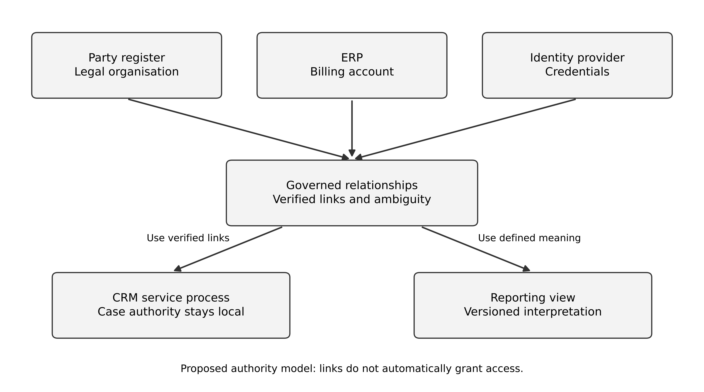
Figure 6 Authority is assigned to specific facts while governed identifiers connect local models

Ownership includes decisions and service
A data owner is accountable for business meaning, approved use and consequential quality decisions. A steward may maintain definitions and coordinate correction. A technical custodian operates storage and access mechanisms. One person may hold several roles in a small organisation, but the responsibilities remain distinguishable.
A dataset offered to other teams needs a contract: meaning, grain, identifiers, freshness, quality expectations, access, lifecycle, change policy and support owner. Calling it a “data product” does not automatically supply those properties. Consumers should know what happens when the source is late or a definition changes.
The contract should also state what the dataset does not establish. A customer match with medium confidence may be useful for an analyst's investigation but unsuitable for automatically granting cross-division access. Reuse requires fitness for the consuming purpose, not merely technical availability.

Central and federated governance
A central team can define shared identifiers, interoperability rules and minimum controls. Domain teams can remain responsible for their data meaning and quality. This combines common coordination with local expertise, but it needs a way to resolve cross-domain disagreements and fund shared work.
Excessive centralisation can create a bottleneck for every local schema change. Uncontrolled decentralisation can create incompatible definitions and duplicated sensitive data. Choose decision boundaries based on who bears the consequence. A local optional field may be a domain decision; changing the meaning of enterprise revenue requires broader governance.
An enterprise catalogue should connect these decisions to actual systems and owners. Its value depends on currency and use. A catalogue entry that says “trusted” without a quality contract or enforcement path gives little evidence to a consumer.

Correction and lifecycle are enterprise processes
If a customer mapping is wrong, the organisation must identify affected downstream records, correct authorised copies and explain changed reports. A shared identifier that cannot be corrected safely can spread errors more efficiently than separate systems did. Preserve lineage and versioned decisions where they are needed to investigate the consequences.
The GDPR's principles and data-protection-by-design requirements inform the need to establish purposes, minimise data and implement appropriate controls throughout processing. [4] Exact obligations depend on the processing and organisational roles. Helios must obtain approved retention, access and transfer policies; this course does not infer them from a diagram or a cloud region.
A lifecycle request may affect operational systems, analytical stores, exports and backups. Recovery procedures should prevent an old copy from silently undoing a later approved restriction or deletion. Where some records must be retained, the design should support that policy explicitly rather than assuming every request means immediate erasure everywhere.

Worked first-year data programme
Begin with a limited set of customer-organisation attributes needed for service coordination and group reporting. Assign authority, define matching and correction workflows, and pilot with two divisions. Measure unresolved matches, false merges discovered, correction lead time and consumer usefulness. Do not ingest every available personal field merely because the platform can store it.
Publish one governed service metric with a declared grain and correction policy before attempting a universal enterprise dashboard. The data studio in Book 2 supplies the technical reasoning. The enterprise contribution is to establish who owns the definition, who may use it, which divisions must adopt it and how disagreements are resolved.

Exercises
5.1 Create a fact-authority table for customer organisation, billing account, credentials and service-case progress.
5.2 Explain why a probabilistic customer match suitable for analysis may be unsuitable for authorisation.
5.3 Design an enterprise correction workflow for a mistaken merge that has reached two CRMs and a reporting platform.
Key points. Enterprise data governance connects meaning, authority, use and correction across systems. Shared infrastructure helps only when those responsibilities and contracts are clear.
CHAPTER 6

Technology strategy and shared platforms

Learning objectives
Define technology standards with a business rationale, evaluate shared platforms as services, and preserve feasible exit and recovery choices.

A standard should solve an identified problem
A technology standard can reduce support variation, improve interoperability or provide a tested control. It should state scope, rationale, permitted use, owner and exception route. “Use the preferred cloud” is incomplete if it does not explain which workloads are covered and which constraints justify another choice.
For Helios, a common identity integration contract, logging structure and deployment evidence policy may provide value before selecting one runtime for every application. Standardise the properties that need coordination. A single programming language across fundamentally different products may create less value than common security and observability interfaces.
Separate principles, standards, reference designs and project decisions. A principle states direction, such as assigning one authority for each business fact. A standard defines an agreed requirement or preferred technology within scope. A reference design is a reusable arrangement with conditions. A project ADR applies those ideas to a specific context. Confusing these levels can make a local experiment appear to violate an enterprise principle when it merely uses a different implementation.

Treat a shared platform as a service
A platform team provides capabilities to other teams: identity integration, deployment, telemetry, secrets, network access or data processing. Its users need documentation, support, predictable change and an escape route for legitimate needs. A mandatory platform with long provisioning delays can push teams toward unsupported alternatives.
Define service objectives around the platform's actual users. Measure time to obtain a working environment, success of standard deployments, incident recovery and the effort required to meet baseline controls. Counting platform features or registered teams does not establish that it improves delivery.
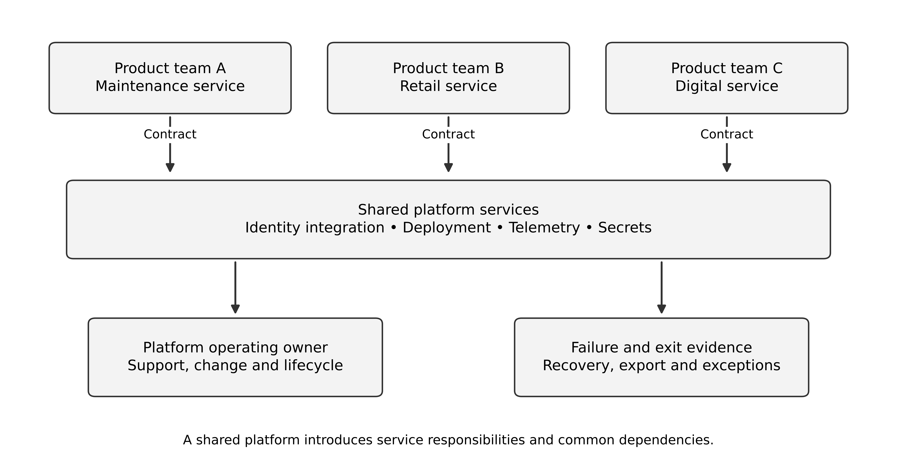
Figure 7 Shared platform services support product teams through contracts and operating responsibility
A platform also creates dependencies. If every application depends on one deployment control plane, identity configuration or shared network component, failures can propagate broadly. Identify the failure domains and recovery paths. Standardisation can reduce variation while increasing common-mode risk; the architecture should evaluate both effects.

Cloud strategy is a set of workload decisions
Vendor-neutral architecture begins with responsibilities and guarantees. It does not require identical implementation on every provider. Azure and AWS both provide managed compute, storage, databases, identity and monitoring, but service semantics, configuration and operating responsibilities differ. Their Well-Architected guidance provides structured questions for evaluating workloads; it is provider guidance, not independent proof that a chosen deployment is optimal. [5] [6]
For Helios, compare a preferred-provider strategy with a selective multi-provider strategy and a more extensive dual-provider operating model. Include skills, contracts, data transfer, identity, observability, recovery and exit. A second provider can reduce some dependencies while increasing complexity and introducing new shared components. It does not automatically create effective disaster recovery.
One defensible policy chooses a preferred platform for ordinary new workloads, permits exceptions for material constraints, and requires tested data export and documented exit for strategic dependencies. A workload needing a different provider can present its case through the exception process. This is a governance choice, not a claim that one vendor is universally best.

Portability has several meanings
Code portability concerns whether the application can run elsewhere. Data portability concerns extracting information with usable semantics and relationships. Operational portability concerns deployment, identity, monitoring, skills and recovery in the new environment. Commercial portability concerns licences, contracts and exit costs. A container image addresses only part of this picture.
For a critical customer service, a useful exit rehearsal may export representative data, rebuild a small workload in a separate environment and verify the business journey. A policy demanding theoretical portability without funding any test provides weak evidence. Conversely, avoiding every managed feature can impose substantial operating cost without a credible exit benefit.

Lifecycle and technical debt
Standards need review dates and a process for obsolete technologies. Record support status, upgrade dependencies and the business consequence of delay. Technical debt should be connected to future change or operating cost, not used as a label for every technology an architect dislikes.
Fund necessary platform maintenance alongside product change. If the enterprise mandates a shared component but provides no capacity to patch, upgrade or support it, the standard creates unmanaged responsibility. The roadmap must include the work required to keep the foundation usable.

Product architecture and organisation structure
MacCormack, Baldwin and Rusnak examine the mirroring hypothesis using five matched pairs of software products. Their coupling analysis finds more modular designs in the loosely coupled organisations in their sample. They also identify limits, including the small software sample and imperfect control of functional equivalence; their design does not isolate every organisational influence. [7] This is empirical support for a relationship in the studied context, not a universal rule that changing an organisation chart will improve a system.
For Helios, use this perspective to investigate an observed problem: three application teams need a central database team to approve every change because their applications directly modify shared tables. One response is to reorganise people into product teams. Another is to establish stable data ownership and service contracts. Either change alone can fail. Product teams with unrestricted shared writes still depend on each other. New service APIs managed by a central team with an overloaded approval queue can preserve the old delivery bottleneck.
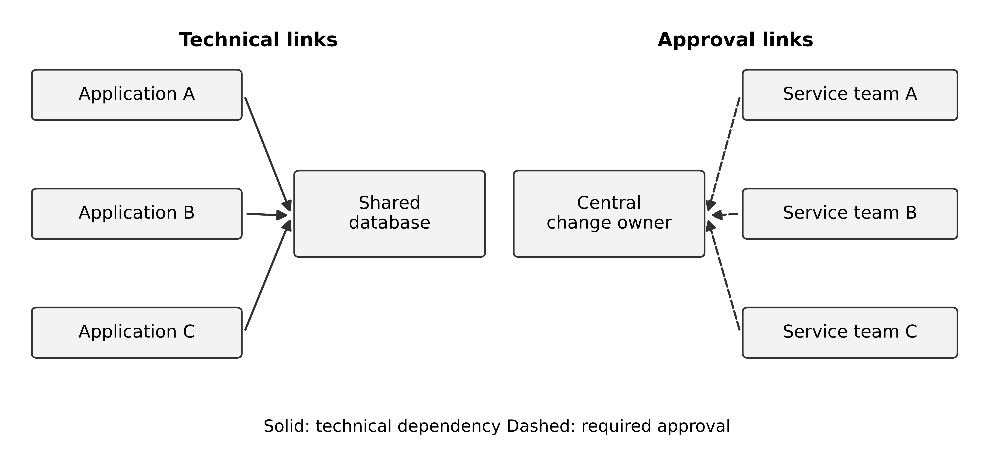
Figure 8 Technical dependencies and decision dependencies must be examined together
The figure is an original diagnostic view. Solid arrows represent technical dependency; dashed arrows represent required approval. It is not a reproduction of the study's measurement method. Ask whether a change request has to cross the same boundary for a sound reason, such as shared semantics, or because the current organisation has no delegated rule. The goal is to distinguish necessary coordination from accidental waiting.
Alternative A forms a shared platform service. Give it a published contract, a funded backlog, service ownership and a defined change process. Application teams can use supported operations without individual database permission requests. This can reduce repeated implementation work. It also makes platform prioritisation, capacity and incident response an enterprise dependency. A platform whose contract does not serve a division's workflow may encourage shadow integrations.
Alternative B separates data ownership by capability. Each team owns its authoritative data and publishes explicit events or APIs. Cross-capability operations use the distributed coordination methods studied in the first two books. This can reduce shared-write coupling but adds integration, duplication and reconciliation. It is not a free organisational fix. If an invariant genuinely needs one immediate transaction boundary, forcing it across teams and databases may be worse.
A first investigation can examine ten recent changes. For each, record changed components, shared tables, required approvals, waiting time and rework. This is a small diagnostic sample, not a causal study. If most delay comes from unclear ownership rather than technical coupling, clarify authority before building a new platform. If the same shared-schema changes repeatedly force coordinated releases, the technical boundary deserves investigation. Retain counterexamples where the present arrangement works well.
The study's generalisation limit is useful rather than embarrassing: it tells the architect which additional evidence to collect. Helios is not one of the sampled organisations, and a cloud service is not the same analytical object as a source-code dependency matrix. The supported inference is to examine organisational and technical design together. A numerical benefit forecast still requires local evidence.

Exercises
6.1 Write a technology standard with scope, rationale, owner, evidence requirement and exception route.
6.2 Compare code, data and operational portability for a managed database application.
6.3 Give one common-mode failure introduced by a shared platform and a recovery requirement that addresses it.
6.4 Use the mirroring study to justify an investigation, then explain why it cannot by itself prove that reorganising Helios will improve delivery performance.
Key points. Technology strategy should make coordination and operation easier under explicit conditions. Shared platforms need service ownership, lifecycle funding and evidence that their benefits exceed their new dependencies.
CHAPTER 7

Governance decision rights and exceptions

Learning objectives
Allocate decision rights, design proportionate architecture review, and manage exceptions without making policy either rigid or meaningless.

Governance determines who may decide
In this course, governance is the arrangement through which people provide input, decide, implement and remain accountable for consequences. The following decision categories are a proposed design for Helios. Their quality must be assessed through observable decisions and outcomes, rather than inferred from the existence of a review board.
For Helios, a local product team can choose internal module structure within agreed controls. A business capability owner decides process policy. A shared data council resolves enterprise identifier semantics. An investment body allocates the transformation envelope. Security and privacy specialists advise on applicable requirements, while the accountable risk owner accepts residual business risk within delegated authority.
Do not assign “the architecture board” every responsibility. A committee can review evidence and recommend a decision, but accountability must still be clear. Equally, an architect should not claim authority to accept a financial or legal risk merely because it appears in an architecture diagram.

A decision-rights matrix
Decision | Primary input | Accountable decision role | Evidence expected
Local implementation within standards | Product engineering and operations | Product owner within delegated scope | Tests and relevant ADR
Shared customer identifier meaning | Domain owners and data stewards | Enterprise data owner | Semantic and consumer-impact analysis
Strategic application consolidation | Business units finance and architects | Investment sponsor or board | Options costs transition and benefits
Exception to a platform standard | Delivery platform and risk specialists | Delegated standard owner | Constraint rationale and compensating controls
Acceptance of material residual risk | Security operations legal and business | Authorised business risk owner | Consequence evidence and treatment options

The matrix is an original teaching proposal, not a prescribed organisational chart. In a real organisation, roles and delegations must reflect its governance and obligations. The useful property is that participants can identify the decision path before a dispute blocks delivery.
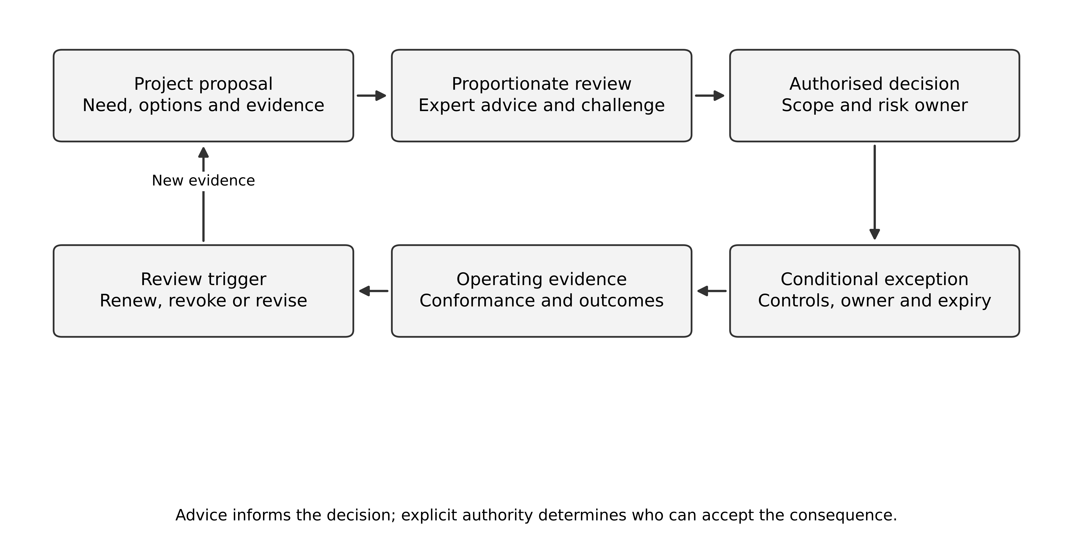
Figure 9 Decision scope determines the accountable route and the evidence needed

Review in proportion to consequence
A small reversible implementation choice should not wait for the same forum as a change to enterprise customer authority. Define triggers for review: cross-unit impact, new sensitive-data use, material spend, strategic supplier dependency, a changed recovery promise or an exception to a mandatory control. Teams should know when they may proceed autonomously.
Use early consultation for uncertain choices and a release gate for verified conditions. If the only architecture interaction happens immediately before deployment, the review may discover consequential problems too late to address economically. Conversely, requiring detailed approval before every experiment can prevent the evidence needed for a good decision.
Record review scope and limits. A board's approval of a target architecture is not approval of every later configuration. Tie release evidence to the implementation version and maintain change control over the assumptions that matter.

Exceptions are governed decisions
An exception record should state the affected standard, reason, scope, duration, owner, risk, compensating measures and review trigger. It should also state the path to compliance or the condition under which the standard itself should change. An exception without an owner or end condition can become invisible permanent policy.
Suppose an acquired application cannot use the preferred identity integration before the first migration deadline. A time-bounded exception might permit a restricted interim access arrangement with additional monitoring and a funded remediation plan. Whether it is acceptable depends on the actual risk and obligations. The record must not label an unimplemented control as mitigation.
Repeated similar exceptions are evidence about the standard. The platform may not meet a common business need, the migration schedule may be unrealistic or the policy may be outdated. Governance should learn from those patterns rather than simply issuing more waivers.

Measure governance as a service
Track decision lead time by category, rework caused by late findings, overdue exceptions and evidence quality. Faster approval is not automatically better if it hides defects; more findings are not automatically better if reviews create unnecessary friction. Examine outcomes and stakeholder experience together.
Publish decisions and their rationale in a form teams can use. A repository of inaccessible meeting minutes encourages repeated debate. A concise standard, example and decision record can reduce coordination effort while preserving accountability.

Governance alternatives create different incentives
Suppose the group mandates a common integration platform while each division pays only for its own delivery team. The platform team asks divisions to fund shared reliability work. Each division prefers another to pay because all will benefit. Conversely, a platform funded centrally without visible demand can optimise adoption counts instead of useful service. These are original incentive scenarios; a responsibility matrix should reveal who experiences the benefit, bears the cost and can make the decision.
Compare a central investment allocation with a consumption-based contribution. Central allocation can fund capabilities whose benefits are shared and difficult to attribute, but needs an accountable sponsor and explicit outcome measures. Consumption charges can expose demand and cost, but a poorly chosen unit can discourage desirable behaviour. Charging per published event, for example, might encourage teams to suppress events needed for reliable reconciliation. The charge design should not contradict the architecture's correctness requirements.
Use a decision scenario rather than a debate about centralisation in principle. A division needs a new field in a shared customer event within four weeks. Who determines its meaning, who funds implementation, who tests consumers and who accepts migration risk? If every participant can veto but nobody can resolve conflict, the process has distributed accountability without a decision. If one central owner can decide without consulting affected consumers, it may create an incompatible contract.
One defensible Helios arrangement delegates compatible additions to a named contract owner under published rules and consumer tests. Changes to identity meaning require a broader business decision. Exceptions have a deadline, compensating measures and an owner. This allocates autonomy according to consequence and makes the expensive decision path explicit. The arrangement is a proposal to evaluate, not a governance framework certified by a citation.
Review whether the mechanism produces its intended behaviour. Measure the time from a complete request to a decision, avoidable rework after approval, overdue exceptions and consumer incidents. Investigate a reduction in approval time accompanied by more compatibility failures. Governance quality concerns the combination of decision speed and consequence, not a single favourable metric.

Research critique: mechanisms can help or obstruct coordination
Jöhnk and colleagues study two bimodal IT organisations through fourteen semi-structured interviews, supporting documents and iterative coding. Their analysis distinguishes structural, procedural and relational mechanisms, including mechanisms that impede coordination and others used to cope with it. Examples include overlapping committees and collaboration across boundaries. The authors identify the two contrasting cases and contextual variation as limitations. [8] This is an exploratory account of organisations separating traditional and agile work, not a causal estimate or evidence that Helios should adopt that separation.
The following comparison is our own application. Helios needs to add a service-site role to its customer event contract. Retail can use its existing buyer identifier; Maintenance needs a separate site identifier because entitlement depends on the location. The request is therefore a change in meaning, even if the implementation adds only one field. Calling it a small schema change does not make it eligible for an automatic approval path.
Arrangement | How the decision works | What could defeat it
Central committee | A single forum resolves meaning, priority and transition conditions | Meeting delay; local specialists absent; approval without funded implementation
Delegated contract owner | Owner may approve compatible additions under published semantic and consumer rules | Delegation exceeds expertise; affected consumers omitted; unresolved conflict has no escalation
Independent local change | Each division publishes its own interpretation and adapters | Same field acquires incompatible meanings; reconciliation cost shifts to consumers

A defensible initial choice delegates genuinely compatible changes but escalates this semantic change to the enterprise data owner with both business roles represented. Keep the three mechanisms distinct. Structure: name the decision owner and escalation authority. Procedure: require example records, consumer-impact tests, a migration window and a versioned decision. Relationship: bring the service staff who resolve disputed cases into the design discussion. A diagram or committee alone does not perform all three functions.
Compare evidence before and after the change in governance. Record arrival of a complete request, requests for missing information, decision time, implementation completion and consumer incidents. A shorter approval queue is weak success evidence if teams now spend longer repairing mismatches. Conversely, longer deliberation can be justified when it prevents a consequential semantic error. Classify requests by consequence so that a different mix of work is not mistaken for a governance improvement.
The choice also needs a failure path. If the contract owner cannot obtain a decision on meaning before the delivery deadline, retain the existing contract and publish an explicitly provisional interface to a bounded pilot, if its controls and funding are authorised. Do not silently repurpose a field in production. The accountable sponsor must choose whether to delay, narrow scope or fund a separate bridge. An architect makes those consequences visible; the role does not remove the business trade-off.

Exercises
7.1 Distinguish the right to advise from the right to accept risk in a platform exception.
7.2 Draft a time-bounded exception for an acquired application's identity integration, without inventing controls already in place.
7.3 Three teams request the same exception. Identify two explanations and the evidence needed before changing the standard.
7.4 Compare the three governance arrangements for the proposed service-site role. Choose one decision path, specify the structural, procedural and relational work, and explain what the two-case study can and cannot support.
Key points. Good governance makes decision paths and accountability clear while matching scrutiny to consequence. Exceptions should remain visible, bounded and capable of improving the underlying policy.
CHAPTER 8

Enterprise risk security and assurance

Learning objectives
Connect system risks to business services, distinguish governance outcomes from control evidence, and design assurance across suppliers and shared dependencies.

Begin with the service the organisation must preserve
A critical business service may depend on several applications, identity systems, networks, data stores, suppliers and people. Assess the combined service rather than treating each application as an isolated risk register. Helios's maintenance operation may be unable to schedule urgent work even when its portal is available if entitlement, technician identity or ERP access fails.
Map the dependency and the consequence. Ask which functions can continue in a degraded mode, what information must remain trustworthy and who can authorise manual operation. A fallback spreadsheet may be useful for a bounded interruption, but it creates reconciliation, access and recovery responsibilities. It should not be treated as a complete continuity plan merely because it exists.
NIST CSF 2.0 organises cybersecurity outcomes under Govern, Identify, Protect, Detect, Respond and Recover. Its Govern function connects cybersecurity strategy, responsibilities, policy and oversight to enterprise risk management. [9] The framework is not a universal implementation checklist; the organisation must choose appropriate controls and evidence for its context.
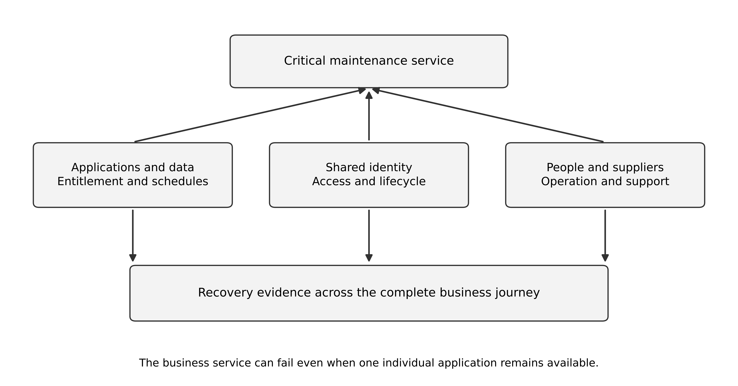
Figure 10 A business service depends on technical suppliers people and recovery capabilities

Separate risk statements from control lists
A useful risk statement identifies a condition, an event and a consequence. For example: incomplete account removal across acquired systems may allow a former worker to retain service-data access, causing unauthorised disclosure. The controls then follow from the mechanism: authoritative lifecycle events, integration coverage, denied-access tests, monitoring and an exception process.
“Use encryption” is not a complete response to that risk because an authorised application account may still decrypt the data. Control selection needs a threat and an access path. The Zero Trust guidance rejects implicit trust based only on network location or ownership, which reinforces the need to examine identity and resource decisions. [10]
Avoid treating a numerical risk score as a measured probability. If likelihood is uncertain, show the evidence and a range or qualitative judgement. A severe but poorly quantified risk may still deserve action. A precise multiplication of unsupported inputs does not make the decision more scientific.

Assurance follows claims through evidence
For each consequential claim, identify the requirement, control, responsible implementation and evidence. A policy stating that privileged access is reviewed does not prove that reviews occurred or that stale access was removed. A test result from a different environment may not support the production claim. Evidence should state scope, date, configuration and exceptions.
Use several kinds of evidence: design review, configuration inspection, automated tests, restoration exercises, supplier documentation and operating observations. Each answers a different question. A certification or audit report can be useful within its scope, but it does not automatically cover the customer's configuration or every service used.

Shared and supplier dependencies
Helios's identity platform is a shared dependency. Its failure can affect many applications simultaneously, so multiplying individual application availability estimates as if failures were independent is misleading. Identify common credentials, network paths, administrators, software releases and supplier control planes that can correlate failure.
Supplier assessment should include the service contract, data use, subcontractors where relevant, incident communication, recovery evidence, export and exit. A supplier's promised recovery time may refer to infrastructure rather than the complete Helios business service. The enterprise must account for its own detection, decision, access restoration and reconciliation time.
Design the response to supplier failure before signing a long-term dependency. Options include tested export, alternate operating procedures, recoverable copies under policy and a realistic transition plan. A second supplier is useful only if the organisation can actually switch the business responsibility safely.

A first-year assurance plan
Prioritise identity lifecycle coverage, recovery of critical service data, reliable handoffs and incident ownership. Establish a baseline of known gaps, then connect remediation to roadmap milestones. Do not label the programme compliant merely because it adopts a framework.
For each release, preserve evidence that critical access and recovery controls work in the deployed configuration. Reassess when an acquisition, new data use or shared-platform change alters the risk. Enterprise assurance is a continuing relationship between business promises and operating evidence.

Exercises
8.1 Write a risk statement for incomplete identity removal and derive two controls with corresponding evidence.
8.2 Explain why three applications hosted in different environments can still share a common failure mode.
8.3 A supplier advertises a fifteen-minute recovery objective. Identify the questions needed before applying that number to Helios's full business service.
Key points. Enterprise risk analysis follows business services across technical and organisational dependencies. Frameworks organise the discussion; concrete controls and current evidence support the actual assurance claim.
CHAPTER 9

Investment economics benefits and uncertainty

Learning objectives
Construct a discounted cash-flow comparison, distinguish cash savings from capacity and risk benefits, and test whether a recommendation survives changes to its assumptions.

A business case is a model of consequences
Architecture changes cash flows through delivery cost, operation, transition, retirement, revenue and losses. A credible business case identifies who experiences each effect and when. Moving expenditure from one business unit to another is not necessarily a saving for Helios. Reducing staff effort creates capacity; it becomes a cash saving only when an actual cash outflow is avoided or reduced under a defensible plan.
Compare options against a realistic baseline. “Do nothing” still includes operation, necessary maintenance, supplier renewal and known end-of-life consequences. A baseline that assumes free continuation forever makes replacement look unattractive; a baseline that assumes certain catastrophic failure makes almost any proposal look attractive. Explain uncertainty in both.
Separate incremental future cash flows from sunk expenditure. Money already spent cannot be recovered by choosing a new architecture, although existing assets may have future disposal, contractual or transition consequences. State the decision date and identify which future cash flows differ between the options.

Discounting a fictional modernisation project
Net present value discounts future cash flows to a common valuation date and subtracts the initial investment. The OpenStax finance text explains the method and the importance of the timing and discount rate. [11] For this teaching example, use NPV = −I + Σ CF_t/(1+r)^t, where I is time-zero investment, CF_t is incremental net cash flow at year-end t, and r is the annual discount rate. All amounts must use a consistent currency and inflation convention.
Consider a €3 million project within Helios's €9 million transformation envelope. Assume €1.2 million of incremental net cash benefit at the end of each of three years and no terminal value. These are fictional cash flows, not a forecast, supplier quote or recommended hurdle rate. At 8%, the discounted benefits are approximately €1.111 million, €1.029 million and €0.953 million. Their sum is €3.093 million, giving NPV of about €92,516.
A positive result this small depends heavily on the assumptions. Keep the full precision in calculation and round only the reported result. A displayed difference of a few thousand euros should not be treated as decisive when migration costs are uncertain by hundreds of thousands.
Scenario | Explicit change | NPV rounded to euros
Lower discount rate | Same flows at 4% | €330,109
Base case | Same flows at 8% | €92,516
Higher discount rate | Same flows at 12% | −€117,802
Lower benefits | €0.96 million in years 1–3 at 8% | −€525,987
Delayed benefits | €1.2 million in years 2–4 at 8%; investment remains at time zero | −€136,559

The delayed case changes the evaluation horizon to year four to preserve three benefit payments. It does not include an extra year of transition cost. A real delayed project might incur that cost as well, making the outcome worse. Sensitivity analysis identifies dependence; it does not assign probabilities to the scenarios.
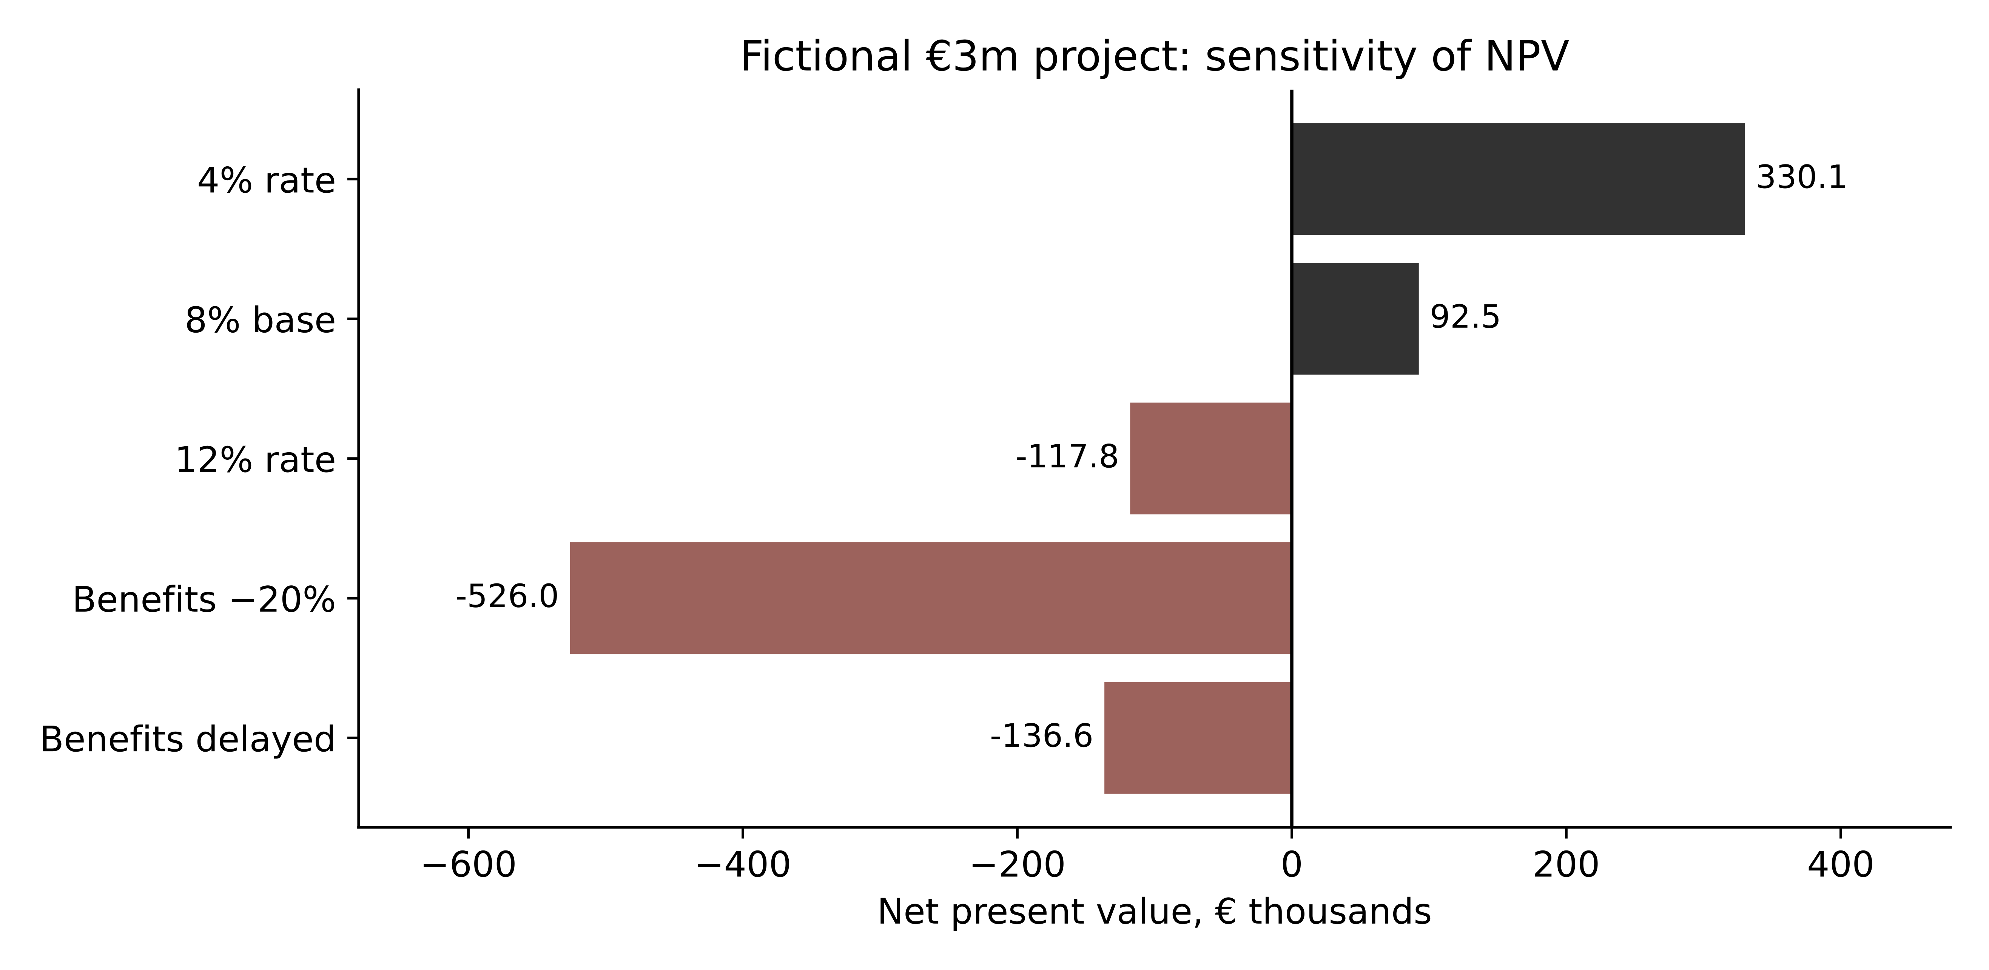
Figure 11 Small changes in assumptions can reverse the investment conclusion

Benefits need owners and non-overlapping definitions
Create a benefits register with baseline, intended change, mechanism, measure, owner, timing and evidence. For example, removing a paid legacy licence after verified retirement can be a cash benefit. Redeploying service staff from reconciliation to customer work is a capacity benefit. Improved customer response may have business value, but converting it into additional revenue requires evidence about demand, conversion and attribution.
Avoid double counting. If reduced contractor hours are included in lower operating cash costs, do not also count the same hours as a separate cash benefit. If customer retention improves, distinguish incremental contribution from gross revenue and explain what other changes could have caused the improvement.
Risk reduction may justify investment even when a simple cash NPV is weak. Describe the exposure, control mechanism and uncertainty. An expected-loss calculation needs defensible probabilities and consequences; an invented probability multiplied by a dramatic loss is not sufficient evidence. Present non-monetised benefits explicitly instead of forcing every concern into an unsupported euro value.

Stage investment around learning
A staged programme can purchase information before committing to an expensive transition. Helios might fund an identity and data-quality pilot before deciding whether to consolidate customer processes. The pilot should resolve a specific uncertainty and have a decision consequence. A pilot that cannot lead to stopping or changing the programme is largely a demonstration.
Staging also has costs: repeated procurement, temporary interfaces and delayed benefits. Compare those costs with the value of avoiding a mistaken commitment. This book uses the idea qualitatively; it does not claim that a simple pilot budget is a formal financial valuation of an option.

Work an investment decision with an imperfect pilot
The following is an original decision-analysis exercise. It is separate from Helios's three-million-euro NPV example and does not add another budget commitment. All values are already expressed at the same valuation date, in millions of euros. Discounting is therefore embedded in the stated option values; do not discount them again. Net present value supplies the common-date comparison, while the conditional probabilities and pilot design below are hypothetical. [11]
Helios can expand a shared customer service or retain the current arrangement. Expansion has incremental value +1.0 if adoption is high and -0.6 if adoption is low. The illustrative prior probability of high adoption is 0.5. Retaining the current arrangement has incremental value zero in this deliberately simplified model. Without more information, expansion has expected value 0.5 times 1.0 plus 0.5 times -0.6, or 0.20. A risk-neutral decision maker would prefer that to zero, subject to constraints omitted from the model.
A pilot costs 0.05 at the valuation date. Suppose a favourable pilot result occurs with probability 0.8 when adoption would be high and 0.2 when it would be low. The probability of a favourable result is 0.5. Bayes' rule gives a probability of high adoption of 0.8 after a favourable result and 0.2 after an unfavourable result. These are conditional probabilities under the assumed test performance, not measured facts about Helios.
After a favourable result, expansion's expected value is 0.8 times 1.0 minus 0.2 times 0.6, or 0.68. After an unfavourable result, it is 0.2 times 1.0 minus 0.8 times 0.6, or -0.28, so choose the zero-value alternative. The pilot policy has expected value 0.5 times 0.68 plus 0.5 times zero minus 0.05, or 0.29. Its improvement over immediate expansion is 0.09. The expected value of sample information before pilot cost is 0.14; a pilot costing more than that would fail this comparison if everything else remained unchanged.
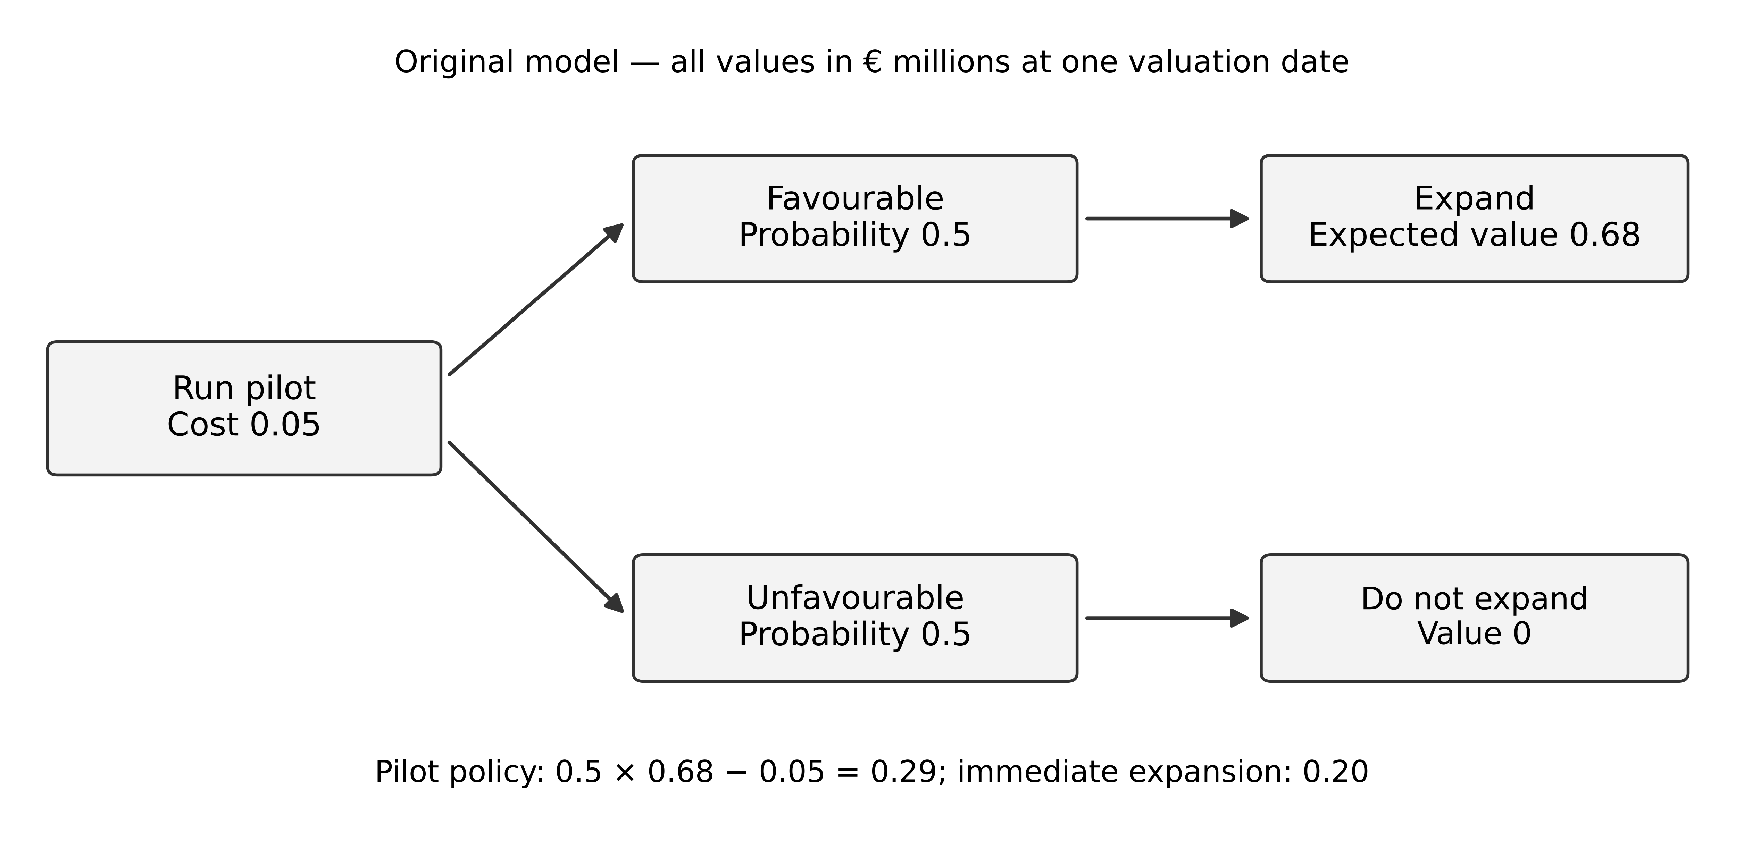
Figure 12 A pilot creates value only when its result can change the subsequent decision
The figure uses decision branches for the chosen action and chance branches for the assumed outcomes. It is a worked calculation, not a financial recommendation or an estimated return on the overall programme. Its value is that it makes the information requirement visible. If Helios cannot cancel expansion after an unfavourable pilot because the procurement contract is already irrevocable, the assumed decision benefit disappears.
Now weaken the pilot: it reports a favourable result with probability 0.5 in both adoption states. The result contains no information about adoption. Expected expansion value remains 0.20 after either result, so paying 0.05 for this pilot reduces value to 0.15. A polished demonstration can therefore be a poor experiment when it does not distinguish the uncertainty that drives the decision.
Other omissions can change the choice. A pilot may delay benefits, change staff behaviour, teach the team how to implement the service or fail to represent later divisions. A low-adoption outcome may have a downside the board cannot tolerate even when expected value is positive. Budget and delivery capacity may make the zero-value alternative unavailable or force a different comparison. Do not hide those concerns inside an arbitrary discount rate. State them and rework the decision model where material.
Run pilot_and_outcomes.py in the advanced practice files. It reproduces the informed and uninformative pilot calculations, checks the posterior probabilities, and demonstrates the outcome comparison in Chapter 13. Change one assumption at a time and identify the decision threshold. This is stronger evidence of understanding than reproducing the expected value without explaining why the pilot is allowed to change the action.

Exercises
9.1 Recalculate the base-case NPV and the 20% benefit-shortfall case. State the cash-flow timing and explain why the sign changes.
9.2 A proposal claims €200,000 from reduced contractor invoices and another €200,000 from the same released hours. Correct the benefits register.
9.3 The board requires a decision despite uncertain migration cost. Propose a bounded investigation and a decision rule that uses its findings.
9.4 Recalculate the pilot policy if its cost rises to 0.16. Then explain what happens if the pilot cannot change the expansion decision.
Key points. Investment analysis makes assumptions visible. Compare incremental cash flows, separate cash from capacity and risk benefits, and test timing and sensitivity before presenting a single financial result.
CHAPTER 10

Roadmaps dependencies and transition architectures

Learning objectives
Turn a target direction into feasible intermediate states, distinguish precedence from resource constraints, and revise a programme when funding or evidence changes.

A roadmap is a sequence of commitments and dependencies
A target architecture describes a desired arrangement. A roadmap explains how the organisation can reach useful intermediate states while continuing to operate. Every transition creates temporary ownership, data movement, support and retirement responsibilities. “Replace the CRM in year two” is incomplete unless it names what can migrate, which integrations change and how existing customers remain served.
Begin with outcomes and constraints, then identify work packages and dependencies. A dependency can be technical, informational, contractual, organisational or regulatory. A data migration may depend on an agreed meaning of customer identity, an export right, trained stewards and a reconciled source extract. Buying the target platform satisfies only one part of that dependency chain.

The Helios funding envelope
Use the following fictional allocation as a starting scenario. It totals the authorised €9 million programme envelope, separate from the €12 million annual operating baseline. Some programme work will later change operating expenditure, but no operating saving is assumed merely from allocating capital or project funds.
Work package | Three-year allocation | Intended decision or outcome
Identity and data foundations | €1.5m | Verified identity lifecycle and governed cross-system identifiers
Integration capability | €1.2m | Reusable contracts monitoring and recovery support
Legacy modernisation | €2.4m | Safe transition from selected unsupported responsibilities
Analytics improvement | €0.9m | Reproducible governed reporting for agreed decisions
CRM and process pilot | €1.2m | Evidence about shared customer processes before wider consolidation
Adoption and assurance | €0.9m | Training service ownership testing and transition assurance
Contingency | €0.9m | Controlled response to identified uncertainty

Contingency is part of the envelope, not an extra €0.9 million on top. Release it through a documented decision. A rough annual spending constraint of €3.0 million, €3.5 million and €2.5 million also totals €9 million; the detailed schedule must satisfy both the work-package totals and the annual limits. These are planning assumptions, not a claim that every dependency can fit without further scheduling.
Figure 13 A dependency path identifies necessary predecessors without proving resource feasibility

Worked precedence analysis
Consider a small pilot with durations in weeks: A, agree identity semantics, four weeks; B, implement shared identifiers, six weeks after A; C, define integration contracts, three weeks after A; D, pilot a customer handoff, four weeks after both B and C; E, assess results and decide rollout, two weeks after D. Assume unlimited resources for this calculation and finish-to-start dependencies with no lag.
Earliest completion is sixteen weeks: A finishes at week 4; B at week 10; C at week 7; D at week 14; E at week 16. The longest dependency path is A–B–D–E. C has three weeks of scheduling slack in this model because it may finish by week 10 without delaying D. A shared expert needed by both B and C could remove that apparent flexibility. The precedence result is a lower-bound schedule under its assumptions, not a delivery promise.

Design each intermediate operating state
For a transition from separate identifiers to governed group identifiers, specify at least three states. Initially, each business unit remains authoritative for its existing customer records. During the pilot, a mapping service publishes verified links while local records remain in place. After evidence supports the change, selected workflows use a group identifier with clear correction and exception procedures.
For each state, name the authority for every fact, allowed writers, supported integrations, access controls, reconciliation rules and operational owner. A temporary bridge needs a retirement condition and a funded removal task. Otherwise the temporary state can become the permanent architecture by default.
Do not schedule retirement solely by a calendar date. Require evidence that consumers have migrated, retained records remain accessible under policy, interfaces are no longer used and contractual termination is possible. A system can have zero interactive users and still supply a critical monthly extract.

Respond to a 20% funding reduction
The changed envelope is €7.2 million, a reduction of €1.8 million. Cutting every package by 20% is arithmetic, not a credible architecture. Some packages contain indivisible safety or dependency work. Reducing assurance while preserving all delivery commitments may increase exposure without reducing the actual scope.
One defensible scenario is to defer the €0.9 million analytics improvement and €0.9 million of legacy scope that has no fixed hosting exit deadline, subject to evidence that continued operation is acceptable. This leaves the full €0.9 million contingency and preserves the pilot, foundations and assurance. It is not automatically the best choice: if the deferred legacy responsibility cannot continue safely, another scope reduction or an explicit funding decision is required.
Recalculate benefits, contracts, annual cash needs and dependencies. A reduced programme must make fewer promises or change how they are achieved. Preserve the rejected alternatives and the reason for choosing the revised sequence.

Exercises
10.1 Calculate the earliest completion and C's slack for the pilot. Explain how one shared implementation team could change the answer.
10.2 Specify authority and retirement evidence for the pilot transition state between local customer identifiers and a governed group identifier.
10.3 Produce a €7.2 million roadmap alternative. State one dependency and one risk that prevent treating the reduction as a uniform percentage cut.
Key points. A roadmap is credible when its intermediate states can operate, its dependencies and resources fit, and its commitments change honestly when funding changes.
CHAPTER 11

Organisational change adoption and architecture leadership

Learning objectives
Analyse how responsibilities and incentives affect a design, plan adoption as part of delivery, and facilitate decisions across stakeholders with different legitimate objectives.

Technical deployment is only one transition
A shared customer identifier is useful only if people and applications use it correctly. Local staff must know how to create, correct and dispute links. Support teams must know who can resolve an ambiguous match. Reports must explain which definition they use. These operating changes need ownership, practice and time.
Map the affected work before planning training. Identify the current task, proposed task, decision authority, information needed and exception path. If a new process adds three approval steps to a service representative's work, resistance may reveal a poor process rather than a lack of commitment. Treat observed work as evidence about the design.
For Helios, the business units have different customer relationships. Industrial Maintenance works with asset owners and service sites; Retail Distribution works with buyers and delivery addresses; Digital Services works with subscription administrators and end users. A single field labelled customer may conceal several roles. Adoption planning must preserve the distinctions that make local work valid.
Figure 14 Adoption connects a changed responsibility to support and observable use

Incentives can oppose the enterprise objective
Suppose the central platform team is measured on the number of applications migrated, while business units are measured on uninterrupted service and local delivery speed. The platform team may push early migration; local managers may delay it. Both responses can be rational under their incentives. An enterprise decision needs a shared outcome and an agreed way to bear transition cost.
Make participation concrete. Allocate time for local specialists, include them in acceptance criteria and fund the support responsibility after go-live. A programme that depends on unpaid local effort has hidden costs and an unreliable resource plan. Record disagreements about priorities instead of disguising them as technical incompatibility.
Do not assume centralisation is the only way to coordinate. A federated arrangement can use shared contracts, common identity rules and local implementations. Its success still depends on enforcement, change management and operational accountability. Distributing implementation does not remove the need for common decisions.

Plan adoption as an observable progression
Use a sequence of readiness, supervised use, independent use and sustained operation. Each stage needs evidence. Readiness may include trained support staff and reconciled pilot data. Supervised use can reveal confusing tasks and exceptions. Independent use demonstrates that normal work can continue without the project team. Sustained operation requires performance over an appropriate period and ownership of recurring problems.
Choose measures connected to the business purpose. Training attendance is an input; correct use of the identifier in eligible workflows is a behaviour; reduced misrouted service work is an outcome. A high login count does not prove that users stopped maintaining a shadow spreadsheet. Observe the work and investigate why parallel processes persist.
Avoid equating compliance with understanding. A mandatory field can force users to enter data while lowering its quality. The design should make the correct action feasible and the exception visible. When staff cannot resolve a customer match, a governed pending state may be more accurate than a forced false match.

Facilitate a consequential disagreement
Prepare a decision brief with the problem, mandatory conditions, options, evidence and unresolved questions. During the meeting, distinguish facts from preferences and authority from expertise. An experienced engineer may understand a failure mode; a business owner may be responsible for accepting its operational consequence. Both contributions matter, but they are different roles.
For a disagreement over group identifiers, ask each stakeholder to state the consequence they are trying to prevent. The maintenance unit may fear incorrect entitlement; the analytics team may need consistent grouping; the platform team may need a stable contract. A design that separates legal party, service account and reporting group may resolve the conflict more effectively than debating which team owns the word customer.
Record the decision, dissent where material, conditions, owner and review date. A clear decision record allows someone who missed the meeting to understand what is authorised. It also protects the organisation from repeatedly reopening the same question without new evidence.

Leadership includes changing a recommendation
An architect should explain when evidence weakens a previous position. If a pilot shows that consolidated workflows slow urgent service work, revise the scope or design. Acknowledging a failed assumption is part of responsible judgement. Preserve what was learned and identify the next discriminating question.
Build learning into the programme through short review cycles and explicit feedback routes. Do not expand the programme merely because the initial pilot was popular. Examine whether its users, data, dependencies and support conditions represent the next rollout group. Scaling an operating model is an evidence question as well as a technical one.

Research critique: adoption unfolds across levels
Dang and Pekkola analyse EA adoption in one Vietnamese provincial government. Their interpretive study uses thirteen interviews conducted during 2015–2017, documents and observation; documents from sixteen other provinces provide secondary context. They trace change across organisational, subsystem and sector levels and describe interaction between top-down direction and bottom-up implementation. The authors call for investigation in other countries and contexts. [12] The chapter explains a situated process, not a universal rollout sequence or a controlled estimate of EA's benefit. Its 2023 publication citation and 2022 online date refer to the same chapter.
For Helios, derive a question rather than copy the case: when local operating evidence contradicts the authorised target, who can revise the target and with what evidence? A mandate can start work without settling every workflow detail. Conversely, local practice can reveal a problem without authorising teams to change a shared identifier unilaterally. The next example is a fictional extension of the course case.

Worked adoption episode and alternatives
Assume the board approves a shared identifier, but the first Maintenance pilot reveals that staff choose the legal customer when the task needs a service site. The original acceptance test checked whether a non-empty identifier existed; it did not check whether the selected entity could legitimately receive the service. Staff introduce a spreadsheet to preserve site distinctions. The spreadsheet is an operating signal to investigate, not by itself proof of resistance or proof of a better architecture.
Figure 15 Operating evidence can revise both a local workflow and the enterprise contract
Follow both routes in the figure. Local support can clarify labels and improve training within the current contract. A missing service-site concept changes shared semantics and must reach the data owner, consumer teams and risk owner where relevant. The revised contract returns through a controlled release and an operating trial. Training cannot repair a schema that cannot express the required fact; a schema change cannot ensure that staff know which fact to enter.
Proposed response | Testable rationale | Evidence before expansion
Enforce the original form | Required distinctions already exist; staff need usable guidance | Staff correctly resolve representative ambiguous cases without project-team rescue
Revise the shared contract | Site and party distinctions are absent or ambiguous | Agreed semantics, reconciled example records, consumer tests and authorised migration
Narrow the rollout | The current model fits Retail but not Maintenance | Explicit eligibility boundary, funded interim workflow and a dated decision for the excluded unit

Choose provisionally to revise the contract while narrowing rollout. Keep Retail within its demonstrated scope and prevent the Maintenance work from being labelled fully migrated. Assign a business data owner to resolve meanings, a product team to implement the change and an operating steward to handle ambiguous records. The sponsor must fund their time and accept the revised schedule. These responsibilities are design decisions in this example, not recommendations measured in the research case.
Collect observations that could overturn the decision. If representative records show that the existing contract already expresses site relationships correctly, the intervention should focus on form design or operating practice. If correct site selection still produces invalid entitlement, examine the entitlement service's authority and synchronisation. If only unusually skilled pilot users succeed, repeat the trial with the intended operating team and normal support conditions. Expansion needs evidence about that population.
Preserve a short event record: the authorised assumption, observed contradiction, affected parties, alternatives considered, decision owner and resulting revision. Include a dissenting interpretation and the observation that would distinguish it. This creates an inspectable account of change without retroactively portraying every adjustment as the original plan. Learner feedback on this book should be handled with the same discipline: record an actual difficulty, revise the affected explanation or task, and verify whether the revision addresses it.

Exercises
11.1 Build an adoption evidence chain for group customer identifiers, separating an input, a behaviour and a business outcome.
11.2 Identify the conflict between a migration-count target and uninterrupted local service. Propose a shared acceptance condition.
11.3 A pilot succeeds only because the project team resolves every exception manually. Explain what must change before wider rollout.
11.4 In the fictional Maintenance pilot, compare enforcement, contract revision and narrowed rollout. Identify a finding that would reverse your preference and explain why the public-sector case cannot establish the best choice for Helios.
Key points. Architecture changes responsibilities and work. Adoption requires usable processes, aligned commitments, funded support and evidence that the new arrangement works beyond the project team.
CHAPTER 12

Sourcing procurement and supplier ecosystems

Learning objectives
Compare build buy and hybrid choices, distinguish mandatory procurement conditions from scored preferences, and include transition and exit in supplier evaluation.

Source a responsibility rather than a feature list
Begin with the business responsibility to be supported. A customer platform may need account relationships, identity integration, service history, data export, recovery and operational support. A feature checklist that omits data authority or exit can select a product that works in a demonstration but does not fit the enterprise.
Build, buy and hybrid are families of choices. Building gives control over selected design decisions but requires enduring engineering and operational capacity. Buying transfers some implementation work while retaining configuration, integration, governance and supplier-dependence responsibilities. A hybrid design may buy a core service and build the interfaces or domain behaviour that distinguish Helios's work.
Compare the lifecycle, not only the initial implementation. Include discovery, licences, implementation, migration, integration, operation, support, training, upgrades, data retention and exit. Identify who pays each cost and which assumptions depend on volume, contract renewal or organisational change. Do not label a subscription cheaper merely because its first-year invoice is lower than a build estimate.
Figure 16 Procurement tests eligibility before comparing value and negotiating conditions

Apply mandatory conditions before weights
Suppose three fictional suppliers are evaluated for a customer workflow. A tested export that preserves required identifiers and relationships is mandatory. Supplier C cannot demonstrate it, so C is ineligible under the current requirement. It must not win because a low price compensates numerically for the missing export.
For eligible suppliers A and B, use illustrative scores from 1 to 5, where higher is better. The scores are judgement based on stated evidence, not interval measurements of objective quality. Weighted totals help expose preferences but do not eliminate judgement.
Criterion | Weight | A score | B score
Functional fit | 0.40 | 4 | 3
Operability | 0.35 | 3 | 5
Cost suitability | 0.25 | 4 | 3

The weighted totals are 3.65 for A and 3.70 for B. A difference of 0.05 on this scale is fragile. If the weights change to 0.50, 0.25 and 0.25, A scores 3.75 and B scores 3.50. This reversal shows that the ranking depends on the importance assigned to operability; it is not a stable discovery that B is intrinsically superior.
Document the evidence behind each score and examine decisive differences directly. If operability is the main discriminator, a realistic recovery and support exercise may be more useful than adding twenty minor criteria. Retain unresolved assumptions as conditions rather than rounding them into a confident total.

Contract and architecture must describe the same service
Translate consequential assumptions into questions for procurement and legal specialists. Which data can be exported, in what structure, within what time and at what cost? What happens after termination? Which interfaces are supported and how are breaking changes communicated? Who can authorise subcontractors or changes to data processing where relevant? What evidence supports the supplier's recovery claim?
This course does not supply jurisdiction-specific contract clauses. The architect's contribution is to identify the technical and operational consequence that the contract needs to address. A legal right to export data is incomplete if the export cannot be reconciled with the receiving system; a technical export is insufficient if the organisation lacks the right to use it after exit.
A service credit may compensate for an outage under agreed terms without restoring the business service. Assess detection, response, restoration and data correction separately. Also examine customer responsibilities: configuration, identity, application design and backup choices can materially affect the service actually experienced.

Test exit before dependence becomes deep
Define an exit scenario early: transfer a representative customer dataset, preserve identifiers and history, reconcile record counts and relationships, and rebuild a required report. Measure the effort and document unsupported fields. A small export test can reveal dependence that a generic portability statement hides.
Consider concentration across suppliers. Several apparently separate products may depend on the same identity provider, cloud region or implementation partner. Supplier diversity on a procurement spreadsheet is not necessarily operational independence. Conversely, deliberately shared services may simplify control when the common dependency is recognised and managed.

Exercises
12.1 Recalculate the two weighted comparisons and explain why neither establishes a universally best supplier.
12.2 Supplier C is cheapest but fails the mandatory export condition. Write the decision and the evidence that would permit reconsideration.
12.3 Design an exit test for a customer platform that checks meaning and relationships rather than only file download success.
Key points. Sourcing decisions allocate enduring responsibilities. Establish eligibility, compare lifecycle consequences, test the decisive assumptions and make exit a demonstrable capability.
CHAPTER 13

Measuring enterprise outcomes and architecture value

Learning objectives
Create a measurement model that connects architectural change to business outcomes, detect misleading aggregation, and distinguish observed improvement from demonstrated causation.

Measure the consequence the programme promised
Architecture activity is easier to count than enterprise value. Numbers of diagrams, standards, review meetings or migrated applications describe work performed. They do not by themselves establish better service, lower cost or reduced risk. Keep activity measures for managing work, but connect the programme to outcomes that stakeholders care about.
For Helios, a useful chain might be: verified customer links enable accurate routing; accurate routing reduces reassignment; reduced reassignment shortens service resolution. Each link needs evidence and may be affected by other factors. More reliable links might have little effect if staffing or supplier availability remains the main constraint.
Create a measurement contract: name, purpose, unit, population, numerator, denominator, observation point, time window, exclusions, owner and known limitations. Preserve the version of the definition. If the denominator changes, a trend may reflect classification rather than improvement.
Figure 17 Measurement separates delivered capability observed behaviour and business outcome

Worked aggregation trap
Suppose Unit A initially processes 100 requests with 10 failures, while Unit B processes 900 with 45 failures. Their failure rates are 10% and 5%; the pooled rate is 55/1000 = 5.5%. After the change, A processes 900 requests with 72 failures and B processes 100 with 4 failures. Each unit improves: A falls to 8% and B to 4%. Yet the pooled rate rises to 76/1000 = 7.6% because the workload shifts towards the higher-failure unit.
This original synthetic example shows why an enterprise average can obscure improvements or deterioration within groups. Report both the pooled outcome experienced by the actual population and the stratified rates. For a like-for-like comparison using the original 10% A and 90% B mix, the later standardised rate is 0.1 × 8% + 0.9 × 4% = 4.4%.
The standardised rate answers what the later unit-specific rates would imply under the original mix. It does not replace the actual 7.6% experienced by the later population. Neither calculation alone explains why demand moved between units or whether the architecture caused the improvement.

Attribution needs a credible comparison
A before-and-after improvement can coincide with staffing changes, seasonality, a different customer mix or altered reporting. Record concurrent changes and preserve the baseline. Where feasible, compare similar workflows or staged rollout groups and explain how they differ. Randomised rollout may be impractical or inappropriate; its absence does not prohibit learning, but it limits causal confidence.
Use several kinds of evidence. Operational data can establish what changed; interviews can explain how work changed; incident analysis can reveal mechanisms; financial records can confirm realised cash effects. Agreement across sources strengthens an interpretation, while disagreement deserves investigation. Do not discard inconvenient evidence to protect the programme narrative.
Use the survey critique in Chapter 1 as a prompt to separate reported organisational capability from observed operating performance. A favourable questionnaire response is evidence about the respondent's assessment. It is not a transaction record, an invoice reduction or an independently measured service outcome. The architecture's local contribution still needs its own evaluation.

Technical measures retain their own scope
Software delivery measures can help teams improve a particular application or service. DORA's current guidance emphasises context and warns against misleading comparisons across unlike services. [13] They should not become a universal score for the enterprise architecture team or a substitute for customer and financial outcomes.
A reduction in deployment lead time can support a digital-service objective when slow delivery was a meaningful constraint. It may have limited business effect if prioritisation, procurement or customer adoption dominates the elapsed time. Connect local measures to the relevant process instead of assuming every technical improvement has equal enterprise value.

Use measures to change decisions
For each measure, define who reviews it and what action it can trigger. A rising unresolved-identity queue could lead to more stewardship capacity, better source validation or a narrower rollout. A target that remains red without any decision consequence becomes a reporting ritual.
Protect against distortion by pairing measures. Faster case handling should be considered with rework and customer outcomes. Lower cloud expenditure should be considered with service demand and reliability. A retirement count should be considered with residual interfaces and support burden. The pairing follows the mechanism that could create a misleading apparent success.

A comparison group changes the interpretation
Consider an original pilot outcome. In the participating division, reconciliation errors fall from 10 percent to 6 percent. In a comparison division, errors fall from 8 percent to 7 percent during the same period. The participating division's change is -4 percentage points; the comparison's change is -1. Subtracting these changes gives -3 percentage points. This arithmetic removes a common one-point change in this simplified example. It does not, by itself, prove that the architecture intervention caused the remainder.
Figure 18 A before and after comparison is strengthened by an explicit counterfactual argument
Huntington-Klein explains the comparison and parallel-trends assumption for difference-in-differences. [14] To interpret the difference causally, the untreated trajectory of the participating division would need to be represented adequately by the comparison. Examine prior trends, customer mix, policy changes, staffing and measurement definitions. If the pilot division simultaneously adds experienced staff, the estimate combines interventions. If both divisions share the new customer-matching service, the comparison is exposed too. A pilot chosen because it has unusually bad recent performance can also improve without the proposed mechanism being responsible.
The example deliberately gives percentages without sample sizes. It supports arithmetic, not a statement about statistical precision. Ten errors in one hundred cases and one thousand errors in ten thousand cases have the same proportion but different sampling information. Repeated records from the same customer or operator may not be independent. To estimate uncertainty, first define the unit of observation and dependence structure; do not attach a generic confidence interval to whatever aggregate is easiest to export.
A practical evaluation protocol can predefine the primary outcome, eligible population, timing, exclusions, comparison, expected mechanism and important side effects. Preserve the initial definitions alongside justified amendments. Measure both error rate and unresolved workload so an apparent improvement cannot come merely from excluding hard cases. Use interviews and incident traces to test the proposed mechanism, while recognising that participants' explanations can be incomplete or influenced by programme incentives.
If a credible comparison is unavailable, report a descriptive change and its plausible competing explanations. That is still useful evidence for a bounded decision. The architecture board may choose a reversible next step while uncertainty remains. Academic quality requires matching the strength of the conclusion to the evidence, not refusing every decision until perfect identification is possible.

Worked measurement choices for a disputed benefit
Suppose Helios's sponsor claims that the programme has created an adaptable enterprise because leaders report greater confidence in changing systems. This is an original evaluation problem. Define the claimed construct before choosing a metric. Confidence in change, ability to execute a change, and realised benefit from that change are different outcomes. A survey may be appropriate for the first, a witnessed change exercise for the second, and service or financial records for the third.
Design three complementary observations. Ask relevant roles the same clearly defined questions before and after the programme, retaining role and participation information. Rehearse a consequential change, such as adding a new service-site relationship, recording actual effort, dependencies and unresolved defects. Finally, observe the relevant service population over a stated period, including exceptions and concurrent staffing changes. These observations answer different questions; do not average them into an unexplained maturity score.
Consider three rival accounts. Better leadership could both sponsor the architecture work and improve service independently. Better performing divisions could have more resources to invest in architecture, reversing the assumed direction of influence. A respondent enthusiastic about the programme could rate both capability and performance favourably. In each case the same positive association could appear without the intervention producing the claimed effect. A larger response count alone would not identify which account explains Helios.
Predefine what the evidence changes. A positive confidence survey but failed change rehearsal warrants investigation of capability, not an announcement of realised savings. A successful rehearsal with no business improvement could justify fixing a downstream constraint. A service improvement accompanied by changed case exclusions demands a denominator audit. An invoice reduction after removing a paid licence supports that particular cash saving, subject to transition and replacement costs; it does not establish a general profit effect of enterprise architecture.
A strong report can say: “The participating team completed the specified change with fewer cross-team handoffs, but the available comparison does not isolate the programme's effect on service outcomes.” This remains useful to a sponsor deciding on a bounded next step. Preserve the numerical observations and the limitation together so later summaries do not turn a cautious conclusion into a causal claim.

Exercises
13.1 Recalculate all rates in the worked example. Explain how both units improve while the pooled result worsens.
13.2 Define a measurement contract for unresolved customer-identity links and one decision it can trigger.
13.3 Service resolution improves after the pilot while staffing also increases. State what can be concluded and propose additional evidence to investigate the architectural contribution.
13.4 Calculate the difference in error-rate changes for the two divisions. Give three conditions that would undermine a causal interpretation.
13.5 A sponsor treats favourable leadership survey responses as proof of both adaptability and cash savings. Design one observation for each claim, identify two rival explanations and write a conclusion that the available survey alone could support.
Key points. Enterprise measurement needs stable definitions, relevant populations and a plausible causal account. Report actual outcomes and comparison limits, and use the evidence to revise decisions.
CHAPTER 14

Innovation AI and sustainable technology decisions

Learning objectives
Balance improvement of existing capabilities with exploration, design a bounded AI experiment, and evaluate sustainability claims with explicit measurement boundaries.

Exploration competes with current delivery
March distinguishes exploration of new possibilities from exploitation of existing knowledge and capabilities. His model examines how their different returns and learning dynamics affect organisational adaptation. [15] It does not prescribe a universal innovation budget or prove that one allocation fits every enterprise.
Apply the distinction to Helios. Improving the reliability of an existing integration is exploitation; testing a new way to assist service diagnosis is exploration. The categories describe a learning purpose, not whether a technology is fashionable. Adopting a familiar product in an unfamiliar business process may still involve substantial exploration.
Define an experiment portfolio around uncertainties. An experiment should state the decision it informs, cost limit, evidence to collect, stop conditions and possible next actions. Protect time for learning, but make continued investment conditional on what is learned. A succession of demonstrations with no decision record can consume resources without reducing uncertainty.
Figure 19 A bounded experiment connects evidence to stop revise or scale decisions

An AI-assisted service case
Assume Helios proposes an assistant that drafts a service summary from authorised maintenance records. Start by defining the task and the authority boundary. In the pilot, the system may suggest text but may not change entitlement, dispatch technicians or send instructions to a customer without an authorised person's action. These are fictional design constraints, not claims that human review eliminates all risk.
Separate data retrieval, model generation, validation, user review and the final business action. Access checks must apply to retrieved records and outputs. A plausible summary can still contain an unsupported statement, omit a crucial condition or mix records from different customers. A disclaimer does not repair an incorrect source selection or an excessive permission.
NIST AI RMF 1.0 groups risk-management work under Govern, Map, Measure and Manage. [16] For this case, use that structure to assign accountability, define the use context, evaluate relevant harms and decide how to respond. This is a limited application of the framework, not a certification or a claim of legal compliance.

Evaluate against an appropriate baseline
Compare the assistant with the existing workflow and, where useful, a simpler retrieval or template approach. Use representative cases, including ambiguous and incomplete records. Keep evaluation material separate from examples used to tune the system. Record the model, prompt, retrieval configuration and data version so the result can be interpreted after change.
Define error categories that matter to the task: unsupported claim, wrong customer, omitted safety-relevant condition, misleading chronology and unauthorised disclosure. Measure time and correction effort as well as apparent completion. A faster draft that requires extensive checking may provide less benefit than its generation time suggests.
A small pilot can reveal defects without establishing a rare-error rate for all future use. State the population tested and the limits of inference. Review may also fail when a user over-trusts fluent output or lacks time to inspect it. The operating design needs escalation, traceability and a way to withdraw the feature when evidence changes.

Sustainability requires a defined system boundary
A claim that one design is greener needs a comparison basis. Specify the functional unit, such as one completed service request of a defined quality, and the boundary of included activity. A computation-only estimate omits other possible contributors such as storage, networking, user devices and hardware manufacture. The appropriate boundary depends on the decision and available evidence.
For a simple operational teaching calculation, assume an operation uses 0.02 kWh and the electricity-emissions factor is 0.25 kg CO2e per kWh. Multiplication gives 0.005 kg, or 5 g CO2e, per operation within that narrow boundary. Both inputs are fictional. This is not a cloud-provider measurement or a complete lifecycle assessment.
If an optimisation halves energy per operation but demand triples, total operational energy rises by 50%: 0.5 × 3 = 1.5 relative to the baseline. Efficiency and total impact answer different questions. Report both when demand can change. Also preserve reliability and data-residency requirements; a lower estimated emissions figure does not automatically make a design eligible.

Decide what to scale
Scale only the capability supported by the evidence. A successful summary-drafting pilot does not authorise autonomous diagnosis or service dispatch. Wider use may change the data population, consequence of error, permissions, cost and support needs. Treat each material change as a new decision with proportionate evidence.
For sustainability, prefer transparent estimates with sensitivity ranges to precise unsupported comparisons. For innovation, prefer a clear learning result to a claim that every experiment succeeded. Enterprise architecture creates value when it makes these commitments understandable and revisable.

Organisational learning can conflict with standardisation
March's mutual-learning model allows individuals to learn an organisational code while the code learns from individuals. The model shows how convergence and learning rates can affect longer-run knowledge; it is a stylised mechanism, not an empirical estimate of a best innovation budget. [15] The following Helios application is an inference to test rather than a result measured in that paper.
Suppose the architecture group standardises one customer-matching method after a successful pilot. Reuse may reduce repeated experimentation and make support easier. Yet a new acquisition may identify customers by service site and contract, unlike the original pilot's legal-party view. Enforcing the old rule without investigation can create systematic mismatches. The organisation needs a way for contrary local evidence to alter the standard without making every preference an exception.
Compare two policies. A strict reuse policy permits only the approved matching method and measures compliance. A bounded learning policy requires the approved method by default but permits a time-limited experiment with a documented hypothesis, isolated data, explicit costs and a decision on whether to change the standard. The second policy spends coordination effort and risks uncontrolled variation if the bounds are weak. The first risks preserving a mistaken assumption if its feedback path is ineffective.
Define evidence that distinguishes useful variation from accidental divergence. For the acquisition, measure false matches, missed matches and the downstream harm of each under an agreed review process. A single overall accuracy number can conceal a dangerous minority of false customer merges. Compare the alternative on the same eligible cases. A local team's confidence is a reason to investigate, not sufficient evidence to change an enterprise identity contract.
After the experiment, choose among adoption, rejection and further investigation, with reasons. If the alternative is better only for site-based contracts, the standard may need a conditional rule rather than wholesale replacement. Preserve the counterexample and its scope in the architecture record. Otherwise the organisation may repeat the same debate after staff turnover.
This tension connects enterprise and solution architecture. Standards make dependencies more predictable; experiments reveal when a dependency contract is inadequate. The operating responsibility is to maintain both the current service and a controlled route for learning. No fixed split of budget or headcount follows from the theory without local assumptions and evidence.

Exercises
14.1 Design an experiment that could lead Helios to reject or narrow the service-summary assistant. Include a baseline and two consequential error categories.
14.2 Recalculate the fictional emissions example and the total-energy effect of halved energy per operation with tripled demand. State the excluded boundary.
14.3 Explain why a successful drafting assistant pilot does not justify automatically dispatching technicians.
14.4 Design a bounded experiment for the acquired division's customer matching. Include a stopping rule and evidence that could change the enterprise standard.
Key points. Innovation needs bounded authority and discriminating evidence. AI evaluation must examine task consequences, while sustainability comparisons require explicit units, boundaries and demand assumptions.
CHAPTER 15

Frameworks modelling and academic synthesis

Learning objectives
Choose a framework or notation for a stated purpose, maintain a coherent model across enterprise and solution views, and critically synthesise research without overstating its evidence.

Separate method language and evidence
A method organises work; a modelling language provides concepts and relationships; a repository stores the model; evidence supports a claim about the world. These functions complement each other but are not interchangeable. A complete repository can contain outdated facts. A well-formed diagram can describe an infeasible target. A recognised method does not guarantee a successful transformation.
The TOGAF Standard provides an enterprise architecture methodology and framework. [17] ArchiMate provides a modelling language for enterprise architecture. [18] C4 focuses on communicating software architecture at different levels of structural detail. [19] These brief descriptions establish their different purposes; this book does not reproduce the standards or claim that its original diagrams conform to ArchiMate notation.
Select the smallest set of views that supports the decision. Helios's board needs outcomes, investment, dependencies and risk. A data steward needs definitions, authorities and correction processes. A delivery team needs contracts, deployment responsibilities and failure behaviour. One crowded diagram is unlikely to serve all three audiences well.
Figure 20 Different views answer different questions while sharing stable model identifiers

Maintain meaning across views
Give important elements stable identifiers and definitions. A capability called Service Fulfilment may be realised by several processes and supported by several applications. It is not identical to the application with the most visible user interface. An application service should trace to the business responsibility it supports and to the data and technology on which it depends.
Record the type and direction of each relationship. “Supports,” “owns,” “depends on,” “reads” and “writes” mean different things. An unlabelled arrow can hide whether it represents data movement, control, responsibility or a planned migration. Keep a small legend and explain the scope of each diagram in its caption.
Use traceability selectively. Start with consequential outcomes and decisions, then connect the capabilities, systems, controls and roadmap work needed to assess them. A model that attempts to capture every possible relationship may become too costly to maintain. Establish who updates an element and which changes trigger review.

Read academic sources as arguments
For each paper, record its question, concepts, method, evidence, conclusion and limitations. Distinguish a conceptual model, mathematical analysis, controlled experiment, survey and case study. Ask whether the conclusion is descriptive, explanatory or prescriptive. A recommendation may extend beyond the evidence presented.
Consider alternative explanations and transfer conditions. An enterprise architecture programme in one organisational setting may depend on leadership support, investment, skills or decision rights that Helios does not yet have. An observed association between an architectural capability and performance does not establish that purchasing a modelling tool causes the performance improvement.
Read the full source when evaluating its method. If only an abstract or institutional summary is available, limit the claim to what it supports and record that access limitation. Do not reconstruct detailed findings, sample properties or causal conclusions from a title. A bibliography is a record of intellectual support, not a list of impressive names.

A worked synthesis structure
Take the question: “Under what conditions could shared customer information improve Helios's service outcomes?” Begin with the operating-model decision about necessary integration and standardisation. Add a model of possible enterprise-architecture value mechanisms. Then examine the case's specific identity, routing and organisational constraints.
The synthesis should separate three layers. The source states a concept or finding within its own scope. The analyst infers how it may apply to Helios. The proposed design makes a conditional commitment that can be tested. For example, verified links may reduce misrouting if the consuming process uses the right customer role and staff can resolve exceptions. The research concept alone does not prove those conditions hold.
A useful conclusion names the strongest supported recommendation, the unresolved assumption and the evidence that would change it. This is more academically defensible than combining several citations into an unconditional claim that centralisation improves performance.

Research assignment
Write a 1,500–2,000 word critical synthesis using at least four relevant sources, including two original research papers that you can read in full. Suitable starting points include the foundational research in Book 1 and the enterprise research references here. Keep official documentation for implementation claims and distinguish it from research evidence.
Include a source matrix and one counterargument to your preferred recommendation. Use IEEE numbering in first-citation order within your submission. If a proposed source is inaccessible, replace it with an accessible primary source relevant to the question rather than pretending it was read. Assess your argument for traceability and limitations, not merely citation count.

Compare theoretical lenses without pretending they are interchangeable
For the customer-platform decision, different sources answer different questions. The operating-model perspective asks what the business must share. The mirroring study examines the relationship between organisational form and technical coupling in a particular software sample. March's model examines learning dynamics. A benefits model proposes intermediate mechanisms connecting architecture activity to outcomes. These perspectives can complement each other, but they do not constitute multiple independent proofs that the same investment will succeed.
Write one rival explanation for your preferred design. If federated coordination is recommended because the divisions need different processes, test whether the supposed difference reflects a legal or customer obligation, a temporary workaround or simply habit. If a shared platform is recommended to reduce duplicated engineering, test whether its contract and funding actually let teams stop doing that work. If experimentation is recommended to preserve learning, define what decision the result can change and what stops an unsuccessful experiment.
An original synthesis might conclude: Helios should initially share customer identity contracts while preserving local fulfilment, because process equivalence remains unproven; assign funded stewardship because shared meaning otherwise lacks an owner; use a bounded pilot because adoption uncertainty can change the expansion decision. Each clause has a different evidential basis. The result is an argument whose assumptions can be challenged, not a universal framework extracted from a paper.

Compare methods before combining conclusions
Use the following reading map with the research critiques in Chapters 1, 6, 7, 11 and 14. It is a map of evidential roles, not a ranking in which a larger sample automatically defeats a smaller study.
Reading | Question it can inform | Transfer question for Helios
EA capability survey, Chapter 1 | Relationships among measured organisational constructs | Do its measures represent the capability we propose to fund?
Mirroring analysis, Chapter 6 | Organisational and technical coupling in sampled products | Are our dependency and decision boundaries comparable?
Governance cases, Chapter 7 | How coordination mechanisms operate in context | Which tensions are present here, and which are absent?
Adoption case, Chapter 11 | How decisions and operating changes unfold over time | What differs in authority, incentives and institutional setting?
Learning model, Chapter 14 | Consequences under a stylised set of learning assumptions | Which model assumptions resemble our standard-setting process?

Begin a synthesis with the decision, not a collection of abstracts. If the decision concerns funding customer stewardship, a paper about source-code modularity does not directly estimate its return. It can motivate investigation of boundaries, while the funding case needs local demand, correction effort and consequence data. Similarly, an adoption narrative can suggest where to look for a stalled transition without supplying an expected percentage improvement.
Do not treat different analyses of the same observations as independent replications. A survey analysed in two ways still draws on the same respondents and measurement choices. Two papers discussing the same original case may also share evidence. Record the data origin alongside the citation so the apparent breadth of a literature review does not overstate its independent support.
Where sources appear to disagree, first compare the units, constructs, outcome and time period. A shared platform could improve the consistency of routine deployments while slowing an unusual local change. Those findings can coexist. Formulate the trade-off explicitly and identify the operating circumstances under which it matters. A synthesis should preserve such conditions instead of forcing every paper to endorse one preferred design.

Evidence access and this academic revision
The earlier edition relied on abstracts for Tamm and colleagues' 2011 benefits paper, Weill and Ross's 2004 governance paper and Ross's 2005 briefing. Those full texts remained unavailable during this revision. Their supporting role has been removed from this book; the evidence history records replacement, not retrospective full-text verification. The benefits and governance discussions now use inspected primary research, while the operating-model definition cites the accessible MIT CISR page and its coordination example cites the separate 2009 teaching slides.
The claim-to-source record identifies the supporting passage and its scope. The record covers selected central academic, method and standards claims; it is not a sentence-by-sentence certification of the entire literature. Original Helios figures, assumptions, alternatives and calculations are marked as teaching material and evaluated for internal consistency. Official product and framework descriptions retain their narrower evidential role.
The accompanying review forms are ready for an experienced architect, an academic reviewer and learner testing. No completed independent review or learner feedback has been supplied. Any resulting revision must identify the affected passage, exercise or figure and be checked in the exported files. This edition is ready for those reviews; it must not be represented as independently peer-reviewed.

Exercises
15.1 Explain the difference between a method, a modelling language, a repository and evidence using one Helios decision.
15.2 Trace a service-handoff outcome through a capability, process, application, data authority and roadmap work package. Label each relationship.
15.3 Critique the claim: “A research paper associates architecture maturity with performance, so buying an architecture tool will improve Helios's profit.” Identify the missing causal steps.
15.4 Write a 600-word synthesis comparing operating-model, mirroring and organisational-learning perspectives for the shared customer service. Separate source findings, local inference and required evidence.
15.5 Choose two empirical studies discussed in this book. Compare their unit of analysis, recruitment or case selection, evidence and limitations. Use them to support a conditional Helios decision and identify one observation that could overturn it.
Key points. Frameworks and diagrams support disciplined thinking when their purpose and meaning are clear. Academic synthesis distinguishes source findings, contextual inference and testable recommendations.
CHAPTER 16

Capstone transformation programme and board defence

Learning objectives
Integrate enterprise and solution reasoning into a feasible transformation programme, respond coherently to material changes, and defend a conditional recommendation to a board-level audience.

The assignment
Act as Helios's enterprise architect. Recommend a three-year transformation programme within the initial €9 million envelope while explaining its relationship to the separate €12 million annual operating baseline. The programme must improve selected capabilities, preserve valid local differences and maintain business service through each transition.
Your task is to make a defensible set of commitments, not to select one product for every capability. Identify what will change, why, who owns the consequence, what it costs, what must happen first and how success or failure will be recognised. Draw on the technical depth developed in Books 1 and 2 when a business promise depends on a specific integration, data or recovery mechanism.

Required dossier
Use the following structure. Keep the board brief concise and place technical evidence in appendices that can be traced from it. Suggested lengths support planning rather than a grading rule; a clear model may replace several pages of prose.
Deliverable | Required content
Board decision brief | Two pages covering problem recommendation commitment cost major risks and requested decisions
Enterprise baseline | Capabilities processes six representative applications dependencies and known evidence gaps
Target and transitions | Data authority shared versus local responsibilities platform policy and two viable intermediate states
Governance and assurance | Decision rights exception process risk ownership and evidence plan
Investment and roadmap | Cash-flow model benefits register dependencies annual constraints and retirement conditions
Adoption and sourcing | Changed work service ownership supplier eligibility and tested exit scenario
Measurement and research | Defined outcome measures baseline comparison limits and critical source synthesis
Technical appendix | One detailed integration or migration design with invariants failure behaviour and operational evidence

The six representative applications are a subset of forty-three, not a complete discovered portfolio. Identify what further inventory work is required before an enterprise-wide retirement commitment. Do not invent unknown interfaces merely to fill a diagram; label hypotheses and assign discovery work.
Figure 21 A coherent dossier links the board commitment to technical and organisational evidence

Initial review gates
At the first gate, assess whether the problem and scope are evidenced sufficiently to fund discovery and the pilot. At the second, examine whether pilot results support the selected transition. At the third, assess whether service ownership, recovery, data correction and adoption evidence support rollout. At each gate, name what can be approved and what remains conditional.
A gate is useful when it can change the decision. Define the evidence that would stop, narrow or delay work. Avoid making every gate a ceremony that approves the original plan regardless of findings. Preserve the cost of delay and the consequence of continuing the baseline so that caution is evaluated honestly.

Change card A funding reduction
After your first complete dossier, reduce the programme envelope by 20% to €7.2 million. Preserve the original version. Produce a revised allocation that sums correctly, identifies deferred outcomes and updates dependencies, benefits, annual cash needs and risks.
Use Chapter 10's deferral scenario as one possible answer, then challenge its assumption that selected legacy responsibilities can continue. If that assumption fails, propose another scope choice. Do not silently remove contingency, assurance or support and pretend the original promises still hold.

Change card B acquisition
A newly acquired business records customer relationships by service site and contract, while Helios's pilot currently links records primarily by legal party. Some sites share a parent company but have different permissions, entitlements and billing arrangements. The acquisition's data quality has not yet been measured.
Revise the data model and integration scope. A parent-company match must not automatically confer access to every site. Introduce explicit relationships, authority and review of uncertain links. Reassess the benefits and migration schedule. The acquisition may strengthen the need for shared identity semantics while weakening the case for immediate process consolidation.
Do not assume the original €9 million or revised €7.2 million envelope automatically includes acquisition integration. State whether you absorb a defined scope by deferring other work or request a separate investment decision. Both can be defensible when costs, dependencies and consequences are explicit.

Assessment guide
The following weights are a course assessment rubric, not an empirical measure of professional competence. Use them to review the completeness and reasoning of your submission. A plausible alternative design can earn full credit when its evidence and commitments are coherent.
Dimension | Weight | Strong evidence
Business problem and capability reasoning | 15% | Clear outcomes legitimate variation and scope boundaries
Architecture and transition coherence | 20% | Consistent authority interfaces intermediate states and retirement evidence
Economics and roadmap feasibility | 20% | Correct arithmetic explicit assumptions dependencies and honest scope changes
Governance risk and adoption | 15% | Accountable decisions operational ownership and proportionate assurance
Research and measurement | 15% | Relevant sources critical synthesis stable measures and attribution limits
Communication and revision | 15% | Traceable board brief clear defence and coherent response to both change cards

Fundamental contradictions require correction regardless of the total: unauthorised data access, unsupported claims of safe retirement, hidden double counting or a roadmap that exceeds its stated funding. Treat the rubric as feedback for revision rather than a way to average away a serious defect.

Prepare the defence
Give a ten-minute board presentation followed by questions. Lead with the decision required and its consequence. Be ready to explain one rejected option, one assumption that could reverse the recommendation, one business risk during transition and one concrete piece of evidence that supports rollout.
Then conduct a technical defence of the appendix. Trace an important operation through identity, data authority, failure, recovery and measurement. Explain where a contractual or organisational condition is necessary for the technical design to work. This connects enterprise architecture to the systems that ultimately carry out the promise.

Exercises
16.1 Reconcile the work-package totals, annual limits and revised €7.2 million envelope. Identify the scheduling evidence still missing after arithmetic agrees.
16.2 Respond to the acquisition without merging legal party, service site, contract and access entitlement into one identifier.
16.3 Write a board recommendation of no more than 250 words that names one conditional approval and the evidence required to release the next investment stage.
Key points. A strong enterprise architecture recommendation connects strategy to systems through explicit responsibility, feasible transitions, evidence and revisable investment commitments.

Exercise answers and assessment guidance
Use these answers after completing your own work. Numerical answers follow the stated fictional assumptions. Open design answers illustrate defensible reasoning; alternatives are valid when their authority, evidence and consequences are explicit. Check the mechanism rather than copying the vocabulary.

Chapter 1
1.1 A division can deploy a reliable local customer store that duplicates identity records without a correction contract. Its own service may work well while group reporting and cross-division handoffs require expensive reconciliation. The enterprise problem arises from incompatible authority and identifiers, not necessarily poor local implementation. A shared contract may address it without replacing the local system.
1.2 Possible outcomes are fewer paid licences after verified retirement, fewer hours spent reconciling duplicate customer records, and fewer failed handoffs caused by inconsistent identifiers. Each needs a baseline, population, owner and time window. Application count alone is weaker because consolidation can leave interfaces, support work or contractual expenditure in place.
1.3 A proposed chain is verified identity links → correct routing → fewer reassignments → faster resolution. Challenge the first link with audited false matches; the second with routes that ignore the verified identifier; the third with unchanged reassignment rates; the fourth with evidence that technician availability dominates elapsed time. These observations help locate where the benefit mechanism fails.

Chapter 2
2.1 Service fulfilment is a capability: the ability to deliver the required service outcome. Triage, entitlement checking, scheduling and closure form a process. A service-management application supports some of that process. A customer-operations department supplies people and authority. None of these four concepts is interchangeable, and a capability can span several departments and applications.
2.2 Assess business importance and current effectiveness separately. Importance might use service criticality, revenue exposure and strategic dependency; effectiveness might use observed handoff failures, recovery performance and user workarounds. Define the rating scale and confidence. A high-importance, low-effectiveness capability is a candidate for investigation, not automatic proof that a new application is required.
2.3 An example requirement is: an authorised service agent can view verified links between the relevant customer, site and service accounts within their permitted scope; uncertain links remain marked for review, and every displayed fact identifies its authority and last confirmed update. Add a measurable freshness target after studying the workflow. Do not invent a universal target unrelated to the business decision.

Chapter 3
3.1 Customer identity coordination can require high information integration while allowing different maintenance, retail and subscription processes. Shared identifiers and relationship meanings support cross-unit work, but the sequence and rules of fulfilment may remain local. The answer should explain which facts must agree and which process differences remain legitimate.
3.2 “Closed” could mean a technician completed work, a retail order was delivered, or a subscription case was administratively resolved. A shared code without semantic mapping can produce false comparisons. Define source meanings and map them to an explicit reporting concept, preserving distinctions when there is no valid equivalence.
3.3 Review assumed long-term sharing of identity and data, the allocation and recoverability of platform investment, and contractual/data-separation rights. Also examine whether the divested unit can operate without group services and whether records can be separated by authority and permitted use. The decision may justify temporary integration with a funded exit rather than deep consolidation.

Chapter 4
4.1 The six annual costs sum to €420,000 + €360,000 + €900,000 + €600,000 + €300,000 + €240,000 = €2,820,000. They are already included in the €12 million group baseline. Adding them would double count the subset. The remaining €9.18 million cannot be allocated to particular systems without further evidence.
4.2 The application may support a legally or operationally necessary low-volume process, supply an undiscovered batch interface, or have expensive contractual and data-retention consequences. A replacement may also cost more than continued operation. Investigate dependencies, obligations and lifecycle economics before treating low usage as retirement evidence.
4.3 Retention preserves local fit and reduces immediate migration but requires governed contracts and continuing dual support. Consolidation may reduce some duplication while introducing process change, migration and concentration risk. Evidence about actual semantic differences, operating costs, interface dependencies, contract terms and user work is likely to change the choice. A pilot should target the most consequential uncertainty.

Chapter 5
5.1 A defensible proposed table assigns legal-party identity to a governed party register, billing accounts and invoices to the ERP, credentials and authentication lifecycle to the identity provider, and service-case progress to the responsible CRM. These are proposed responsibilities to validate, not discovered Helios facts. Distinguish a customer organisation from its billing account and from a user's credential; a copied value does not become a new authority.
5.2 A probabilistic match can tolerate a known error rate for some aggregate analysis, subject to its purpose. Authorisation may disclose one customer's information to another after a single false match. The consequence and decision threshold differ. Use verified, governed relationships for permission decisions and route ambiguity to review rather than silently upgrading a statistical match into an access grant.
5.3 Freeze or constrain affected automated propagation, identify the original merge and downstream versions, determine the authoritative correction, and publish an auditable split or superseding relationship. Reconcile both CRMs and rebuild or version affected reports. Review permissions and any disclosures that resulted. Preserve history and completion evidence; changing only the master record does not undo downstream effects.

Chapter 6
6.1 Example: new customer-facing services within the agreed group scope must integrate with the approved identity contract to support account lifecycle and auditable access. The identity service owner maintains the contract; release evidence includes access-removal and recovery tests. A project with a material constraint requests a time-bounded exception from the named decision owner. Specify scope and evidence without claiming that adoption alone proves security.
6.2 Portable application code may still depend on provider-specific database features. Data portability needs a usable export with relationships, types and identifiers. Operational portability needs deployment, credentials, backup, monitoring and recovery in the destination. Demonstrate the business journey after transfer; a successfully built container or downloaded file proves only a narrower property.
6.3 A faulty identity configuration can block access across all platform consumers. A corresponding requirement could demand a tested restoration path, protected administrative access and a bounded degraded business procedure for critical workflows. The numerical recovery target must come from the service need and measured capability. Separate runtime dependence from deployment-control dependence when analysing impact.

Chapter 7
7.1 An architect or security specialist can advise on consequences and controls. The authorised risk owner decides whether the residual consequence is accepted within organisational policy. A review board may have delegated decision rights, but that authority must be explicit. Technical expertise alone does not automatically confer permission to accept enterprise exposure.
7.2 Name the application, affected identity functions, reason integration cannot yet occur, observed gaps, proposed interim controls, accountable owner, expiry date and integration milestone. Mark untested controls as conditions requiring evidence before approval. Define revocation or escalation triggers. The exception must not describe desired account reviews or logging as if they are already operating.
7.3 Repeated exceptions may reveal a standard that does not fit legitimate needs, or a shared implementation/support problem that prevents compliance with a sound standard. Compare the use cases, consequences, effort and control evidence. Change the standard only after understanding the pattern; alternatively improve the platform or guidance and retain the requirement.

Chapter 8
8.1 Incomplete removal across acquired systems may leave former workers able to access service data. One control is an authoritative lifecycle feed with coverage monitoring; evidence includes a reconciled application inventory and measured removal events. Another is denied-access testing for removed accounts; evidence records the identity, resource, configuration, result and exceptions. A policy document alone is insufficient.
8.2 Different hosting environments can share an identity provider, DNS configuration, administrator account, software release or supplier control plane. A single failure can therefore affect all three. Test the shared path and its recovery; physical or provider separation does not establish independence by itself.
8.3 Ask which service and failure scenario the objective covers, when its clock starts, what restoration means, what data-loss objective applies, and what evidence supports it. Include Helios's detection, decision, access restoration, integration catch-up and reconciliation. Determine customer configuration duties and exclusions before making an end-to-end promise.

Chapter 9
9.1 At 8%, NPV = −3,000,000 + 1,200,000/1.08 + 1,200,000/1.08² + 1,200,000/1.08³ = €92,516.38. With €960,000 at each year-end, NPV is −€525,986.89. The same initial expenditure is offset by smaller discounted future benefits. The base case has a small positive margin, so the shortfall reverses the conclusion under these assumptions.
9.2 Record the €200,000 reduction in contractor invoices once as an incremental cash saving if the reduction is actually achievable. The associated released hours explain the mechanism; they are not a second independent €200,000 cash benefit. If some hours are redeployed rather than removed from invoices, split the population and classify those hours as capacity, with any additional value separately evidenced.
9.3 Fund a bounded migration rehearsal on representative data and the riskiest interface. Set a cost/time limit and collect reconciliation defects, throughput, specialist effort and rollback feasibility. Re-estimate migration cost from the result and approve the next stage only if the revised economics and mandatory continuity conditions remain acceptable. Define what would lead to narrowing or stopping the project.

Chapter 10
10.1 A finishes at week 4, B at 10, C at 7, D at 14 and E at 16. C may start as late as week 7 and finish at 10, giving three weeks of total slack under the stated model. If one indivisible team must perform both B and C sequentially, their combined nine weeks after A delay D until week 13 and completion until week 19, assuming no other changes.
10.2 Local systems remain authoritative for their original customer facts while a governed mapping service owns verified cross-system links. Consumers use the mapping under explicit correction and ambiguity rules. Before retiring a bridge or local responsibility, demonstrate migrated consumers, reconciled records, accessible retained history, no required remaining interfaces and an operational owner for the replacement.
10.3 One allocation keeps all original packages except analytics improvement, reduced by €0.9 million to zero, and legacy modernisation, reduced from €2.4 million to €1.5 million. The total is €7.2 million. It depends on the deferred legacy scope remaining supportable; an impending hosting exit may invalidate it. Preserve the dependency foundations and test other scope reductions if that condition fails.

Chapter 11
11.1 Training and support preparation are inputs. Correct use of verified identifiers in eligible workflows is a behaviour. Fewer misrouted service requests is an outcome. Define the eligible population and audit for false links and shadow processes. The chain can fail if staff complete training but the workflow still encourages an incorrect customer selection.
11.2 A migration-count target rewards movement even when local service is unready. A shared condition could require a reconciled dataset, tested recovery, trained support, acceptable service performance and ownership of exceptions before a migration counts as complete. Include a funded transition window and realistic resource commitments so the condition can actually be met.
11.3 Determine the exception volume, causes, required skills and resolution time. Improve the design or fund and train a sustainable operating team, then repeat the pilot without routine project-team rescue. A controlled support process can remain part of the architecture, but its capacity and cost must be explicit. The original pilot did not demonstrate independent operation.

Chapter 12
12.1 Base weights give A = 0.40×4 + 0.35×3 + 0.25×4 = 3.65 and B = 0.40×3 + 0.35×5 + 0.25×3 = 3.70. Revised weights give A = 3.75 and B = 3.50. The ranking reverses because the preference for operability changes. Scores also depend on evidence and judgement; the matrix is a decision aid, not a universal quality measurement.
12.2 C is ineligible while the mandatory export condition is unmet. Reconsider after a representative export preserves required identifiers, relationships and history and can be reconciled in a usable destination under acceptable contractual terms. Alternatively the authorised requirement owner may explicitly change the requirement after evaluating consequences. Price alone does not silently waive it.
12.3 Export representative parties, sites, accounts, relationships and case history; load them into a separate test environment; reconcile counts, keys, nulls, relationships and selected business journeys. Rebuild a required report and inspect historical meaning. Record missing fields, effort, duration and rights to continued use. Download success alone does not prove a feasible exit.

Chapter 13
13.1 Before: A 10/100 = 10%, B 45/900 = 5%, pooled 55/1000 = 5.5%. After: A 72/900 = 8%, B 4/100 = 4%, pooled 76/1000 = 7.6%. The higher-risk unit now carries 90% of demand instead of 10%. Standardising the later rates to the original mix gives 4.4%. Report both the changed actual experience and the like-for-like comparison.
13.2 Define unresolved links as proposed cross-system relationships awaiting an authorised decision, measured by count and age at a daily observation time within a named system scope. Specify treatment of duplicates, reopened items and withdrawn proposals. An age threshold can trigger capacity review or a pause in rollout, but set it from business consequence and observed demand rather than an arbitrary industry claim.
13.3 The observed improvement is real if measurement is stable, but the architecture's causal contribution is not isolated. Compare similar workflows with different rollout timing, examine reassignment mechanisms, stratify by staffing and case mix, and review interviews and incidents. State remaining confounding and avoid assigning all benefit to either staffing or architecture without supporting evidence.

Chapter 14
14.1 Compare authorised staff using the existing workflow, a retrieval/template baseline and the assistant on representative held-out cases. Measure unsupported assertions, wrong-customer content, omitted critical conditions, total correction effort and completion quality. Define stop conditions for severe errors and a rule for narrowing scope. Keep consequential business actions outside the pilot's authority and record configuration changes.
14.2 The narrow operational estimate is 0.02 kWh × 0.25 kg CO2e/kWh = 0.005 kg = 5 g CO2e per operation. Halving energy per operation while tripling demand gives 1.5 times baseline total energy, a 50% rise. The example excludes unmeasured lifecycle and system components; fictional inputs do not establish actual provider emissions or a complete environmental comparison.
14.3 Drafting and dispatch have different authority and consequences. Dispatch changes real work and may affect safety, entitlement, cost and service commitments. The drafting pilot does not test those decisions, integrations or failure modes. A new proposal needs a bounded action model, appropriate controls, evaluation and authorised responsibility before its scope can expand.

Chapter 15
15.1 A method structures how Helios develops and governs its target and transitions. A language expresses capabilities, applications and relationships. A repository stores versions of those elements. Evidence includes observed dependencies, tests and operating data supporting the proposed change. A repository entry saying an export exists is a claim until the relevant evidence is examined.
15.2 A possible chain is: fewer failed handoffs is enabled by reliable service fulfilment; that capability is realised through a validated handoff process; the process uses the integration application; the application reads customer relationships from their named authority; the integration work package delivers the contract and recovery controls. Label each relation and include evidence and owners rather than relying on arrows alone.
15.3 The association does not establish causality or identify which component of maturity matters. A tool purchase may not change decision rights, data quality, operating practice or use of the model. Helios may differ from the studied organisations, and profit has many causes. The missing argument must connect the tool to changed behaviour, relevant mechanisms and measured business outcomes under local conditions.

Chapter 16
16.1 The original packages sum to €9 million and the annual limits €3.0m + €3.5m + €2.5m also sum to €9 million. The reduction is €1.8 million, leaving €7.2 million. Matching totals does not prove a schedule: allocate work to years, verify resources and dependencies, model transition overlap and include contractual timing. Recalculate the annual profile for the revised scope rather than keeping unsupported commitments.
16.2 Model legal parties, sites, contracts and access entitlements as distinct concepts with explicit relationships and authorities. A site can belong to a party without sharing every contract or permission. Profile acquisition data, review uncertain matches and reconcile pilot links before extending access. Stage integration and state how its cost fits, displaces or changes the authorised programme.
16.3 One defensible recommendation is: “Approve the identity and customer-handoff pilot within the agreed initial allocation, conditional on a named business owner and verified access controls. Retain local customer processes while testing governed cross-system links. Release rollout funding only after representative records reconcile, ambiguous matches have an operating process, recovery succeeds and service users can complete work without project-team intervention. The pilot must report actual cost and observed effects on misrouting, alongside remaining uncertainty. Revisit consolidation if evidence shows that shared identifiers cannot support the required semantics or if the transition cost exceeds the approved range.” A strong alternative can choose another first stage when its rationale and conditions are explicit.

Advanced exercises
3.4 Central consolidation needs a plan for extracting data, process and operating responsibility from the common application. Federated coordination needs separable identity mappings, permissions, contracts and platform dependencies. Local autonomy may simplify some separation but can leave group reporting and shared supplier obligations. Identify data rights and transition agreements without assuming every shared service must be physically duplicated. Award credit for a consequence-specific boundary rather than a universal preference for decentralisation.
6.4 The study motivates examining technical and organisational dependencies together. Its five software-product pairs, limits in matching functionality and bundled organisational differences do not isolate the effect of a Helios reorganisation. Inspect actual change dependencies, shared writes, approval delays and alternative causes. Propose a bounded change with outcome measures. A claim that an organisation chart alone guarantees modular software overstates the evidence.
9.4 The pilot policy's gross expected value remains 0.34; after cost 0.16 it is 0.18, below immediate expansion's 0.20. If the action is fixed regardless of result, the informational benefit is zero in this model; the pilot only subtracts cost unless it creates separately specified learning or implementation value. The 0.14 cost threshold follows from 0.34 minus 0.20, under the stated payoffs, prior and signal accuracy.
13.4 The pilot changes by -4 percentage points and comparison by -1, producing -3 percentage points. Different underlying trends, concurrent staffing or process changes, exposure of the comparison to the new service, changed inclusion criteria or changing case mix can undermine attribution. Sample sizes and dependence are also needed for uncertainty estimation. The arithmetic alone is descriptive and must not be labelled a measured causal effect without the additional argument.
14.4 Define the eligible site-contract records, independently adjudicated match outcomes, false-merge and missed-match consequences, protected data scope and budget. Compare against the current method on the same cases. Stop for unacceptable false merges or a defined resource limit; adopt only if the agreed evidence supports the target decision. A result limited to one contract type can justify a conditional standard. Accept alternative thresholds only with explicit business rationale; none is prescribed by March's model.
15.4 A strong synthesis identifies three distinct questions, accurately bounds each source, applies them to one coherent Helios option and presents a credible counterargument. It should specify what sharing is needed, how ownership and coupling might affect delivery, and how controlled experimentation can revise an inadequate standard. It must avoid treating a stylised model, a small empirical sample and a practitioner teaching framework as equivalent causal proof. Evaluate traceability, assumptions and discriminating evidence rather than the number of citations.

Academic revision exercises
7.4 A defensible path escalates the change in customer meaning to the data owner while retaining delegated approval for genuinely compatible additions. Name the owner and escalation route; require semantic examples, consumer tests and migration evidence; involve affected service staff in resolving the meaning. A central forum is also defensible when it can make timely, informed decisions. The two-case study supplies sensitising questions about coordination, not proof of an optimal Helios organisation. Award credit for linking each proposed mechanism to a specific failure and assessing decision time together with consequences.
11.4 Contract revision with a narrower rollout is defensible when the current representation cannot express the required site relationship. Enforcement is preferable only if the necessary semantics already exist and usable guidance addresses the defect. Evidence that the contract is adequate would reverse the first diagnosis; evidence of missing entitlement authority would redirect the investigation. The research case is situated in another institutional setting, so transfer needs argument. Award credit for a funded operating path, a discriminating observation and an explicit limit on inference.
13.5 Confidence can be assessed by a clearly defined survey; adaptability by a representative change rehearsal with effort, dependency and quality observations; cash savings by realised incremental cash flows with replacement and transition costs. Rival explanations include leadership quality, reverse direction of influence and shared respondent optimism. Survey data alone can support a claim about respondents' reported perceptions within the observed sample. It cannot establish realised savings. Award credit for separating constructs, selecting appropriate observations and retaining scope and uncertainty.
15.5 Compare, for example, a cross-sectional organisational survey with a process-oriented adoption case. The former investigates relationships across responses; the latter develops a contextual account over time. Neither identifies the effect of Helios's proposed intervention by itself. A conditional decision could fund a bounded customer-stewardship pilot while collecting workflow and outcome evidence. Contradictory cases, an unsustainable exception workload or no change in the intended mechanism could overturn expansion. A strong answer inspects both full sources and distinguishes their observations from the learner's proposal. Do not award extra credit merely for preferring one method; assess fit to the question and handling of rival explanations.

Experiments templates and further study

Local numerical experiments
The practice archive contains four standard-library Python programs for this book. Run them with Python 3 in a local working directory. They do not require credentials, cloud accounts, network access or paid services. Each program prints its results and checks the worked numbers with assertions. Their inputs are fictional; successful execution verifies the arithmetic or algorithm under those inputs, not a real enterprise forecast.
File | Purpose | Extension task
investment_model.py | Reproduce the five NPV scenarios in Chapter 9 | Add an explicit transition-cost year and a consistent inflation assumption
roadmap_dependencies.py | Calculate earliest and latest times for Chapter 10 | Add a shared-team constraint and compare with the precedence-only result
supplier_sensitivity.py | Apply eligibility then compare two weight sets | Identify the operability weight at which the ranking changes under a stated allocation of other weights
outcome_measurement.py | Reproduce Chapter 13 aggregation and Chapter 14 unit calculations | Change demand mix and explain actual versus standardised outcomes

Keep the original output before changing an assumption. For each extension, record the question, inputs, method, result and limit. If a changed result alters your recommendation, update the decision record and the affected roadmap or benefits register.

Editable dossier templates
The supporting Markdown templates provide an enterprise brief, capability assessment, application inventory, fact-authority register, decision-rights record, exception record, benefits register, roadmap state and evidence log. CSV files supply the six representative applications and the fictional programme allocation. These are starting points for analysis; blank fields are intentionally unknown rather than invented facts.

Further study and professional transfer
After completing the capstone, select one real but appropriately sanitised work problem. Define the decision and gather authorised evidence. Reuse the course's reasoning structure while replacing fictional inputs and verifying current technical, legal and contractual conditions. Preserve confidentiality and avoid assuming that a classroom design can be deployed unchanged.
For deeper academic work, compare two accessible original research papers addressing the same enterprise question. Analyse their constructs, methods, contexts and limits before synthesising a recommendation. For deeper technical work, return to Book 2 and implement the most consequential boundary in a controlled environment. For deeper organisational work, study how the proposed decision rights and incentives operate in practice.

Self-assessment before moving on
You should be able to explain why a capability needs change, identify the authority for its information, compare feasible options, calculate a conditional investment case, sequence operable transitions and name the evidence that would change your mind. If one of these remains weak, revisit the corresponding chapter and revise the dossier. The objective is defensible judgement supported by systems knowledge and evidence.

References
References are numbered in order of first citation. Online sources were accessed on 4 October 2026. Product documentation should be checked again before implementation.
[1] MIT Sloan Center for Information Systems Research, "Classic topics enterprise architecture," Accessed: Oct. 4, 2026. [Online]. Available: https:/​/​cisr.mit.edu/​content/​classic-​topics-​enterprise-​architecture
[2] R. van de Wetering, T. Hendrickx, S. Brinkkemper, and S. Kurnia, "The impact of EA-driven dynamic capabilities, innovativeness, and structure on organizational benefits: A variance and fsQCA perspective," Sustainability, vol. 13, no. 10, art. 5414, 2021, doi: 10.3390/su13105414. Accessed: Oct. 4, 2026. [Online]. Available: https:/​/​doi.org/​10.3390/​su13105414
[3] J. W. Ross, "Merrill Lynch and the coordination operating model," MIT OpenCourseWare, 15.571 Generating Business Value from Information Technology, class 7, Spring 2009. Accessed: Oct. 4, 2026. [Online]. Available: https:/​/​www.ocw.mit.edu/​courses/​15-​571-​generating-​business-​value-​from-​information-​technology-​spring-​2009/​25dc18cd7da31587f26105c0e6804c03_MIT15_571s09_lec07.pdf
[4] European Parliament and Council of the European Union, "Regulation EU 2016/679," Official Journal of the European Union, L 119, pp. 1-88, May 4, 2016. Accessed: Oct. 4, 2026. [Online]. Available: https:/​/​eur-​lex.europa.eu/​eli/​reg/​2016/​679
[5] Microsoft, "Microsoft Azure Well-Architected Framework pillars," Accessed: Oct. 4, 2026. [Online]. Available: https:/​/​learn.microsoft.com/​en-​us/​azure/​well-​architected/​pillars
[6] Amazon Web Services, "The pillars of the framework," Accessed: Oct. 4, 2026. [Online]. Available: https:/​/​docs.aws.amazon.com/​wellarchitected/​latest/​framework/​the-​pillars-​of-​the-​framework.html
[7] A. MacCormack, C. Baldwin, and J. Rusnak, "Exploring the duality between product and organizational architectures: A test of the mirroring hypothesis," Research Policy, vol. 41, no. 8, pp. 1309-1324, 2012, doi: 10.1016/j.respol.2012.04.011. Accessed: Oct. 4, 2026. [Online]. Available: https:/​/​www.hbs.edu/​ris/​Publication%20Files/​Research%20Policy%2041%20(2012)%201309%E2%80%93%201324_c5c2350e-​013c-​4065-​a2f9-​d95eb32177d5.pdf
[8] J. Jöhnk, S. Oesterle, T. J. Winkler, J. Nørbjerg, and N. Urbach, "Juggling the paradoxes—Governance mechanisms in bimodal IT organizations," in Proceedings of the 27th European Conference on Information Systems, Stockholm and Uppsala, Sweden, 2019. Accessed: Oct. 4, 2026. [Online]. Available: https:/​/​www.fim-​rc.de/​Paperbibliothek/​Veroeffentlicht/​925/​wi-​925.pdf
[9] C. Pascoe, S. Quinn, and K. Scarfone, "The NIST Cybersecurity Framework CSF 2.0," NIST CSWP 29, Feb. 26, 2024. Accessed: Oct. 4, 2026. [Online]. Available: https:/​/​doi.org/​10.6028/​NIST.CSWP.29
[10] S. Rose, O. Borchert, S. Mitchell, and S. Connelly, "Zero trust architecture," NIST SP 800-207, Aug. 2020. Accessed: Oct. 4, 2026. [Online]. Available: https:/​/​doi.org/​10.6028/​NIST.SP.800-​207
[11] J. Dahlquist and R. Knight, "Net present value NPV method," in Principles of Finance, Houston, TX: OpenStax, 2022, sec. 16.2. Accessed: Oct. 4, 2026. [Online]. Available: https:/​/​openstax.org/​books/​principles-​finance/​pages/​16-​2-​net-​present-​value-​npv-​method
[12] D. Dang and S. Pekkola, "Organizational change and enterprise architecture adoption: A case study in the public sector," in Information Systems Research in Vietnam: A Shared Vision and New Frontiers, N. H. Thuan, D. Dang-Pham, H.-S. Le, and T. Q. Phan, Eds. Singapore: Springer, 2023, pp. 49–64, first online Sep. 22, 2022, doi: 10.1007/978-981-19-3804-7_4. Accessed: Oct. 4, 2026. [Online]. Available: https:/​/​doi.org/​10.1007/​978-​981-​19-​3804-​7_4
[13] N. Harvey, "DORA's software delivery performance metrics," Accessed: Oct. 4, 2026. [Online]. Available: https:/​/​dora.dev/​guides/​dora-​metrics/​
[14] N. Huntington-Klein, "Difference-in-differences," in The Effect: An Introduction to Research Design and Causality, online version, ch. 18. Accessed: Oct. 4, 2026. [Online]. Available: https:/​/​theeffectbook.net/​ch-​DifferenceinDifference.html
[15] J. G. March, "Exploration and exploitation in organizational learning," Organization Science, vol. 2, no. 1, pp. 71-87, Feb. 1991, doi: 10.1287/orsc.2.1.71. Accessed: Oct. 4, 2026. [Online]. Available: https:/​/​strategy.sjsu.edu/​www.stable/​pdf/​March,%20J.%20G.%20(1991).%20Organization%20Science%202(1)%2071-​87.pdf
[16] E. Tabassi, "Artificial Intelligence Risk Management Framework AI RMF 1.0," NIST AI 100-1, Jan. 2023. Accessed: Oct. 4, 2026. [Online]. Available: https:/​/​doi.org/​10.6028/​NIST.AI.100-​1
[17] The Open Group, "The TOGAF Standard," 10th ed. Accessed: Oct. 4, 2026. [Online]. Available: https:/​/​www.opengroup.org/​togaf
[18] The Open Group, "ArchiMate certification program," Accessed: Oct. 4, 2026. [Online]. Available: https:/​/​www.opengroup.org/​certifications/​archimate
[19] S. Brown, "The C4 model for visualising software architecture," Accessed: Oct. 4, 2026. [Online]. Available: https:/​/​c4model.com/​

