项目名称：DotConnect Wallet

项目立项日期：2022.11

项目整体简介：

**Background**：

As more and more people are crazy about NFT, there are super related demand emerged. So a wallet with NFT features is needed.

**The problems to be solved**:

First of all, there are too many NFT phishing websites stealing users’ assets;

Secondly, to make NFT cross-chain transfer is not easy;

Thirdly, customized transfer NFT way is not existed;

Fourthly, NFT cannot be sold easily through wallets;

Fifthly, DID and wallets lack connection;

Lastly, transaction without main-net token is not convenient.

**Introduction:**

DotConnect is an NFT-friendly wallet with multiple chains such as polkadot, web3games and EVM chains.

There are several features about the wallet.

The following ones have been fulfilled already.

Firstly, we support multiple chains especially polkadot and web3games. And further, we support transfer through different chains like ETH transferred from ETH chain to BNB chain.

Secondly, NFTs are listed according different classification like trend, collection, ranking, game, mint, etc to help users find suitable NFTs.

Thirdly, users could sell their own NFTs directly to different markets like Opensea, Looksrare, etc with simple set.

However, there are still other features will be fulfilled afterwards.

One point is security. We will give tips to users towards the phishing websites.

Another point is customized transfer. It means to send in a regular or customized way. For example, user A wants to send NFTs to a fixed address on a fixed time every week. He may set once without sending every time.

Another point is DID. DID is an identity data aggregator, powered by smart contract, NFT and privacy protection decentralized protocol, to provide identity services to users. What’s more, it helps to gather people to build the Dao to construct the DID area.

Last point is no main-net gas fee. No matter where you want to send or exchange your asset, main-net gas fee is never needed. For example, user A wants to buy an NFT on ETH chain, but he only has BNB token. He can still trade successfully by paying BNB as gas fee because, meanwhile, we have exchanged BNB to ETH as gas fee behind.

**DEMO**：https://share.lanhuapp.com/#/invite?sid=qxVo2nAa

**PPT:** https://docs.google.com/presentation/d/1-Ov6EAyXfNrz-eti5c6BpQYQAWkTiKhVxjzLZ4uMXXU/edit#slide=id.p

技术架构：<https://github.com/funplaygroup/DotConnect/blob/main/architecture.svg>

**LOGO**：

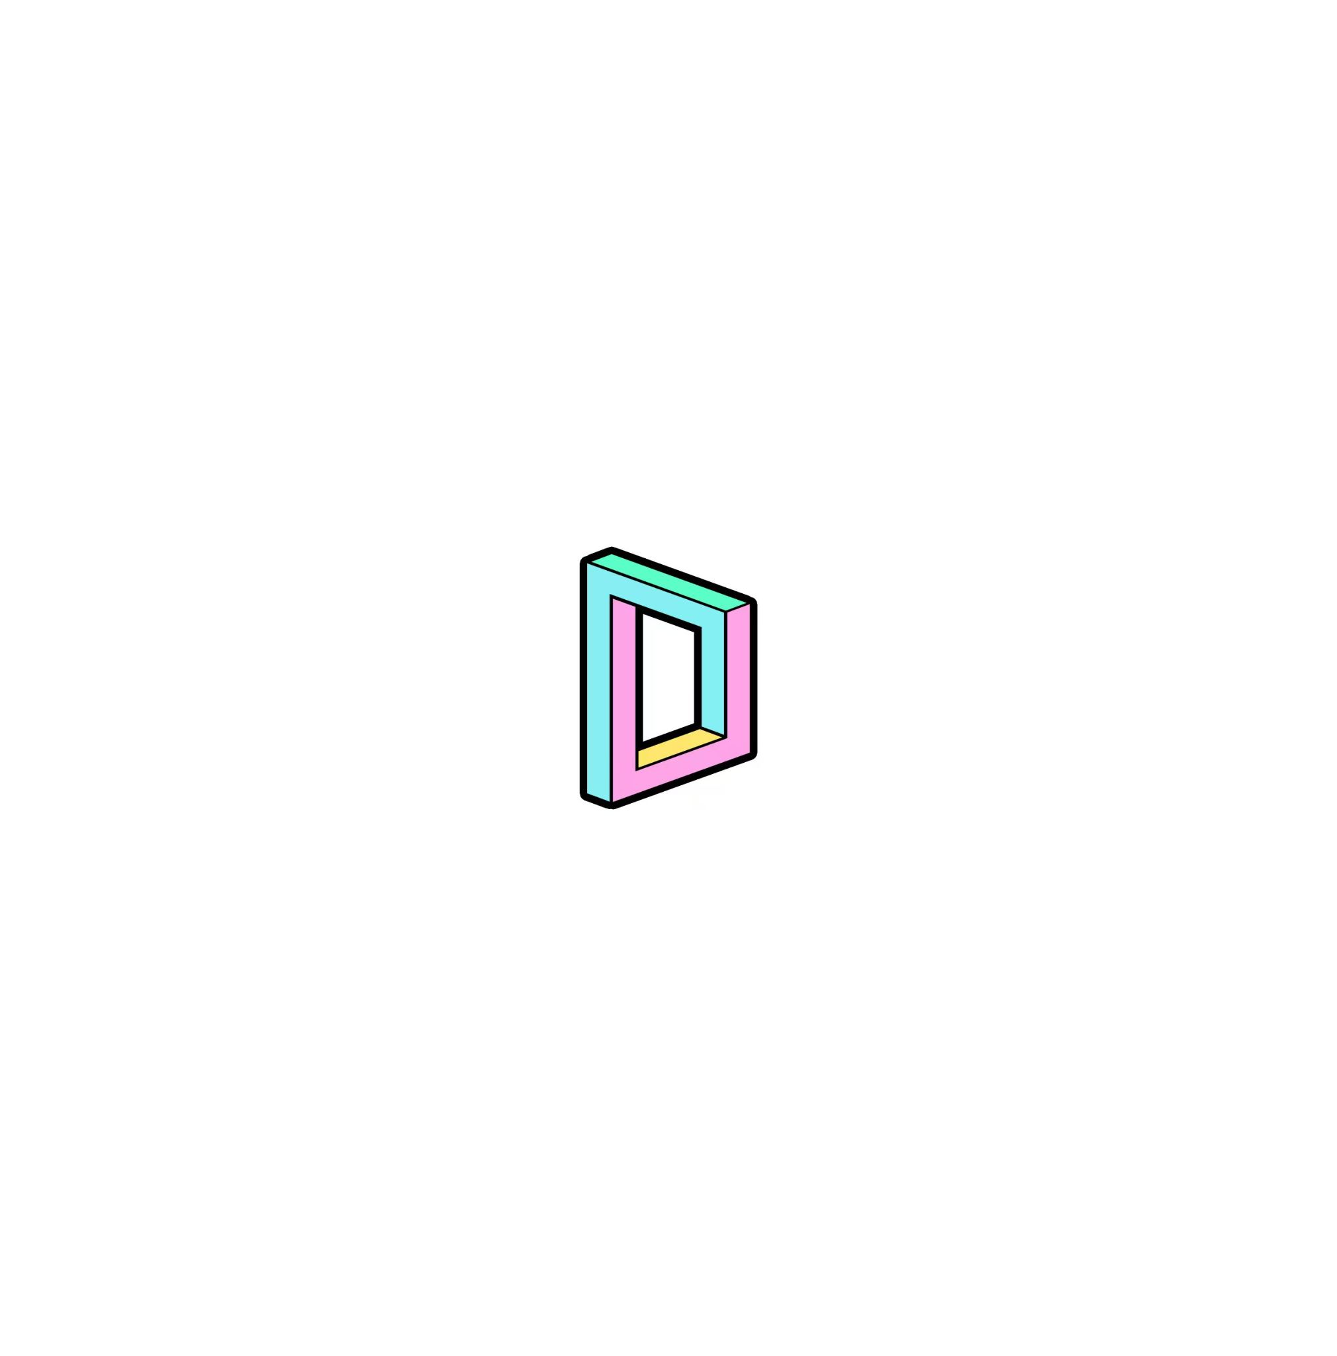

黑客松计划完成是事项：

1.User Login；

2. Import and Create wallet;

3. NFT display in different classification ( trend, collection, ranking, game…);

4. Support multiple chain(polkadot, web3games, EVM chains);

5. NFT sold in Opensea, etc;

6. Warn phishing sites;

7. Cross-chain transfer;

8. DID

9. Customized transfer

10. No main-net gas fee

黑客松期间已完成事项：

1.User Login；

2. Import and Create wallet;

3. NFT display in different classification ( trend, collection, ranking, game…);

4. Support multiple chain(polkadot, web3games, EVM chains);

5. Support Token and NFT transfer and transaction;

队员信息：jasmine88888888/russell.lrg@gmail.com/min8528@163.com/metalitagtm@gmail.com/532398960@qq.com/shenzhen-arrom