TECHNICAL DOCUMENTATION
MediFlow AI
An Intelligent Integrated Healthcare Ecosystem for Seamless Patient–Physician–Laboratory–Pharmacy Coordination
System Design, AI/ML Engineering, Security and Clinical Safety Specification
Covers: problem definition · objectives · clinical gap analysis · existing systems · methodology · architecture · data standards (HL7 FHIR R4) · DFD · UML sequence · AI/ML pipeline · RBAC · risk management · clinical fallback
Document type | R&D / System design specification
Version | 1.0
Date | October 2026
Status | Final draft for review

Contents
1. Executive Summary
2. Research & Development Context
3. Clinical Gap Analysis
4. Existing Systems and Comparative Analysis
5. Proposed Solution and Novelty
6. Methodology (flowchart, features, modules)
7. System Architecture Specification
8. Data Flow and Behavioural Models (DFD 0, DFD 1, UML sequence)
9. Data Standards and Interoperability
10. AI / ML Engineering
11. Security and Privacy (RBAC matrix)
12. Risk Management and Failure Handling
13. Clinical Fallback and Safety
14. Technical Specification Summary
15. Testing and Validation Plan
16. Expected Outcomes and KPIs
17. Limitations and Future Work
18. Conclusion
References
Appendix A – Glossary

1. Executive Summary
MediFlow AI is an integrated, AI-assisted healthcare coordination platform that connects patients, physicians, laboratories and pharmacies on a single digital system. It replaces handwritten prescriptions, manual scheduling and disconnected laboratory records with a unified workflow covering patient registration, appointment booking, consultation, laboratory testing, e-prescription, pharmacy dispensing and follow-up care.
The platform is designed around four ideas that distinguish it from conventional hospital-management software:
- An AI pipeline for manual prescriptions – handwritten or typed drafts are converted into structured, standards-based (HL7 FHIR R4) medication orders using OCR, entity extraction and drug-name normalisation.
- Draft contradiction detection – every draft is checked against the patient’s allergies, history, active medicines and vital signs before it can be signed.
- Vitals classification with history – vital signs are automatically classified (normal / borderline / critical) and stored as a longitudinal record that physicians can trend.
- Clinical safety gate – an AI result is accepted only when overall confidence is ≥ 85 % and no critical conflict exists; anything below falls back to manual entry. A doctor always confirms, and a pharmacist independently validates.
The system is built on a security-first stack (Spring Boot backend and server-rendered frontend, Spring Security, role-based access control, encryption and full audit logging) with a separate asynchronous Python ML pipeline to keep AI latency away from the clinical user interface.
Document purpose
This document is the complete technical specification of MediFlow AI: problem definition, clinical gap analysis, architecture, data standards, data-flow and sequence models, AI/ML engineering, security and RBAC, risk management, and clinical fallback rules. All diagrams are included as figures. Numeric targets are design targets to be validated during implementation and testing.

2. Research & Development Context

2.1 Problem definition
Effective healthcare delivery depends on seamless coordination among patients, physicians, laboratories and pharmacies. In Bangladesh this coordination is largely absent: manual, paper-based processes dominate and no unified digital system connects the stakeholders. Handwritten prescriptions, manual scheduling, disconnected laboratory records and the absence of adaptive emergency prioritisation together cause medication errors, treatment delays, delayed diagnoses and poor continuity of care.
The core problem can be stated as: there is no safe, interoperable, intelligent channel that carries a patient’s clinical information from registration, through consultation, laboratory and prescription, to dispensing and follow-up.

2.2 Objectives
- Digitise appointment and prescription workflows end to end.
- Integrate patient, physician, laboratory and pharmacy services on one platform.
- Improve medication adherence and follow-up through smart reminders.
- Enhance communication among all healthcare stakeholders with real-time notifications.
- Reduce prescription errors using an AI pipeline with a safety threshold and human-in-the-loop review.
- Establish a scalable, standards-based (HL7 FHIR R4), AI-ready healthcare framework for future clinical decision support.

2.3 Stakeholders and scope
Table 1. Stakeholders and their primary needs
Stakeholder | Primary needs | Main platform functions
Patient | Easy booking, readable prescription, test reports, reminders | Profile, booking, e-prescription, report access, reminders
Physician | Complete history at a glance, safe prescribing, less paperwork | Consultation, vitals history, AI-assisted prescription, test ordering
Laboratory | Clear test orders, tracked samples, fast report release | Order queue, sample tracking, report upload and verification
Pharmacy | Legible, validated prescriptions; dispensing record | Prescription validation, dispensing, stock query
Nurse / front desk | Fast registration, triage and queue control | Registration, vitals entry, emergency priority
Administrator | Governance, configuration, audit | User management, thresholds, analytics, audit review

In scope: outpatient care coordination, e-prescription with AI assistance, laboratory coordination, pharmacy dispensing, follow-up reminders and adaptive emergency queue management. Out of scope (this phase): inpatient bed management, medical billing/insurance claims, radiology image (DICOM) storage, and autonomous diagnosis. The AI assists clinicians; it never makes final clinical decisions.

3. Clinical Gap Analysis
The table compares the current outpatient workflow with the clinical risk it creates and shows how MediFlow AI closes each gap.
Table 2. Clinical gap analysis
Clinical area | Current state | Consequence / risk | MediFlow AI response
Prescription writing | Handwritten, often illegible, no structure | Dispensing and dosing errors | AI OCR → structured FHIR MedicationRequest; mandatory doctor e-sign
Safety checking | Depends on memory of doctor/pharmacist | Missed allergies and drug interactions | Automated contradiction check against history before signing
Vital signs | Noted on paper, rarely trended | Deterioration missed; no history | Automatic classification + longitudinal vitals history
Scheduling | Manual, first-come queues | Long waits; unfair emergency handling | Online booking + adaptive emergency priority queue
Laboratory records | Paper reports, disconnected from doctor | Repeated tests; delayed diagnosis | Digital orders, sample tracking, reports linked to encounter
Medication adherence | No reminders or follow-up tracking | Missed doses and visits | Smart reminders for medicines, follow-ups and reports
Continuity of care | Records scattered across facilities | Inconsistent treatment | Single patient record with consent-based sharing
Communication | Phone calls, verbal messages | Delays, lost information | Real-time notifications to all stakeholders
Data protection | Physical files, no access log | Privacy breach, no accountability | RBAC, encryption, immutable audit trail

4. Existing Systems and Comparative Analysis
Existing approaches fall into a small number of categories. None of them combines coordination across all four stakeholders with an AI safety layer designed for the local context of handwritten prescriptions.
Table 3. Comparison of existing approaches with MediFlow AI
Capability | Paper-based practice | Standalone hospital software | Consumer appointment / telemedicine apps | Global EHR suites | MediFlow AI
Patient–doctor–lab–pharmacy in one flow | No | Partial | Partial | Yes | Yes
Handwritten prescription digitisation (AI) | No | Rare | No | Rare | Yes
Draft contradiction check | No | Partial | No | Yes | Yes
Adaptive emergency queue | No | Rare | No | Partial | Yes
Confidence threshold + manual fallback | n/a | No | No | Varies | Yes (≥ 85 %)
Standards-based interoperability (FHIR) | No | Varies | Rare | Yes | Yes (R4)
Low cost / suited to local clinics | Yes | Medium | Yes | No | Yes (open stack)

Note: the comparison reflects general characteristics of each category, not a benchmark of specific commercial products. The relevant literature on digital transformation in pharmacy practice [1] and the opportunities and challenges of digital health [2] supports the need for integrated platforms.

5. Proposed Solution and Novelty

5.1 Solution overview
MediFlow AI is a modular, web-based platform. Each stakeholder works in a role-specific interface, while a single FHIR-aligned patient record and an event-driven back end keep every party in sync. The AI services run as a separate asynchronous pipeline so that model inference never blocks the user interface.

5.2 Novelty
Table 4. Novel contributions
# | Novelty | What is new | Benefit
N1 | AI pipeline for manual prescriptions | Handwritten or typed drafts become structured, coded FHIR medication orders with per-field confidence | Removes illegibility; enables automated safety checks
N2 | Draft contradiction detection | Checks the draft (before signing) against allergies, active medicines, history, age/pregnancy and vitals | Catches errors at the cheapest point
N3 | Vitals classification with history | Rule-based + ML classification of each vital set, stored as a trended history | Early warning; context for the doctor
N4 | Threshold-gated clinical fallback | ≥ 85 % confidence and no critical conflict to proceed; otherwise manual path | AI can never silently lower safety
N5 | Adaptive emergency queue | Triage score re-orders the queue in real time with nurse override | Faster care for critical patients
N6 | Async ML pipeline | Queue-based AI services with caching and optimised models | Predictable latency; resilience to AI downtime

6. Methodology

6.1 Development approach
The system will be developed with an iterative Agile process in short sprints, with a clinician advisor reviewing each safety-relevant feature. The phases are: (1) requirements and clinical workflow mapping, (2) architecture and data-model design, (3) core platform build (registration → dispensing), (4) AI pipeline build and offline validation, (5) integration, security hardening and usability testing, (6) pilot deployment and monitoring.

6.2 End-to-end process flowchart
Figure 1 shows the complete patient journey. The flow has 8 numbered stages, three decision points (emergency check, lab test needed, AI confidence gate) and two alternative paths (priority vs. standard queue; AI-accepted vs. manual fallback).
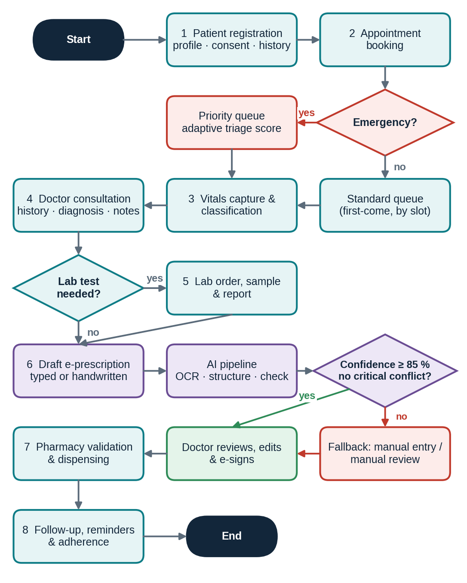
Figure 1. End-to-end methodology flowchart with decision points and the 85 % confidence gate

6.3 How each feature works
Table 5. Feature behaviour: trigger, processing and output
Feature | Trigger | How it works | Output
Patient registration | New user | Collect demographics and consent; verify phone/email; create FHIR Patient; assign role | Authenticated profile
Appointment booking | Patient selects doctor and slot | Slot availability check → create Appointment → notify both parties | Confirmed slot + reminder
Adaptive emergency queue | Emergency flag or critical vitals | Triage score (symptom severity + vitals class + wait time) re-ranks queue; nurse may override | Updated queue; priority alert to doctor
Vitals capture | Check-in | Nurse enters BP, pulse, temperature, SpO₂, respiratory rate; classifier labels each; saved as Observations | Classified vitals + trend chart
Doctor consultation | Patient called | Doctor sees history, allergies, vitals trend; records diagnosis (ICD-10) and notes | Encounter record
Laboratory coordination | Doctor orders test | ServiceRequest to lab → sample collected → report uploaded and verified → linked to encounter | DiagnosticReport
AI e-prescription | Doctor submits draft or photo | Async pipeline: OCR → entity extraction → normalisation → contradiction check → confidence score | Structured draft + flags
Pharmacy dispensing | Prescription signed | Pharmacist validates, checks stock, dispenses; status returned | MedicationDispense
Follow-up & reminders | Prescription / follow-up date | Scheduler creates medicine, visit and report reminders via SMS/email/push | Reminder + adherence log

6.4 Module decomposition
The platform consists of 10 modules in 4 branches (Figure 2). Module M4 is the AI engine; M7, M9 and M10 form the shared platform services.
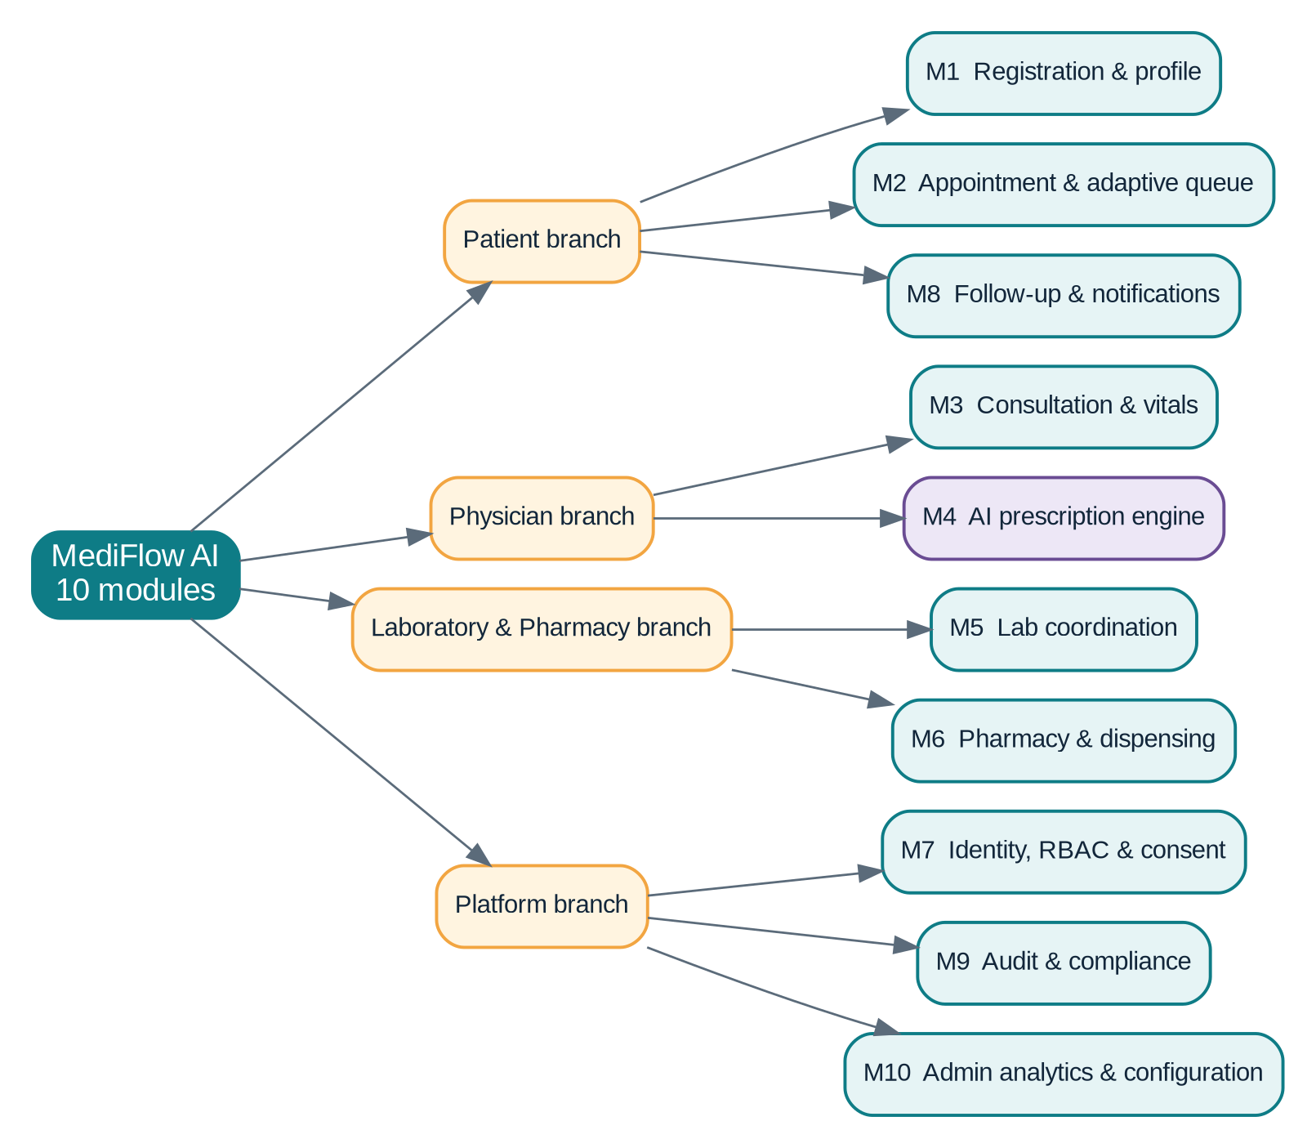
Figure 2. Technical specification: 4 branches and 10 modules
Table 6. Module specification
ID | Module | Branch | Key responsibilities
M1 | Registration & profile | Patient | Account, demographics, consent, document upload
M2 | Appointment & adaptive queue | Patient | Slots, booking, emergency re-ranking, notifications
M3 | Consultation & vitals | Physician | History view, vitals classification, diagnosis, notes
M4 | AI prescription engine | Physician | OCR, extraction, normalisation, contradiction check, scoring
M5 | Lab coordination | Laboratory & Pharmacy | Test orders, sample tracking, report management
M6 | Pharmacy & dispensing | Laboratory & Pharmacy | Validation, stock query, dispensing record
M7 | Identity, RBAC & consent | Platform | Authentication, MFA, roles, consent management
M8 | Follow-up & notifications | Patient | Reminders, adherence tracking, real-time alerts
M9 | Audit & compliance | Platform | Immutable audit log, access reports, retention
M10 | Admin analytics & configuration | Platform | Thresholds, rule sets, dashboards, user management

7. System Architecture Specification

7.1 Architecture overview
MediFlow AI uses a layered modular-monolith application (Spring Boot) for transactional healthcare workflows, plus separate FastAPI AI services connected through a message queue. A modular monolith is preferred over microservices at this stage because it reduces operational complexity and attack surface, while the clear module boundaries (M1–M10) allow later extraction into services.
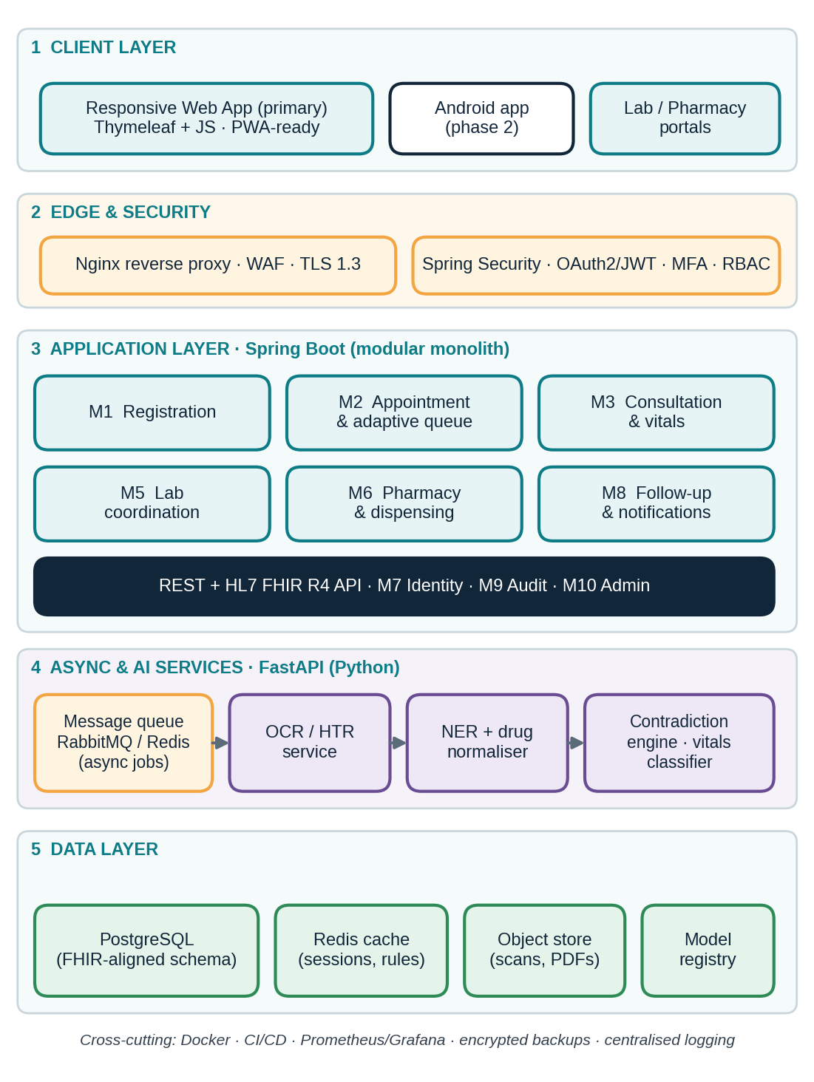
Figure 3. Layered system architecture

7.2 Technology stack
Table 7. Technology stack (all components are required)
Layer | Technology | Purpose / reason
Backend | Java 21 LTS, Spring Boot 3.x, Spring Data JPA, HAPI FHIR library | Mature, strongly typed, secure-by-default framework; FHIR resource handling
Frontend | Spring Boot with Thymeleaf (server-side rendering), Bootstrap, minimal JavaScript | Reduces client-side attack surface; session cookies (HttpOnly, SameSite) and built-in CSRF protection
Security | Spring Security 6, OAuth2/JWT for service calls, TOTP/SMS MFA, BCrypt/Argon2 | Authentication, authorisation, RBAC and method-level security
AI services | Python 3.11, FastAPI, PyTorch, ONNX Runtime, OpenCV, Transformers/spaCy | OCR, NER, normalisation, contradiction and vitals models
Messaging | RabbitMQ (or Redis Streams) | Asynchronous AI jobs, retries, notifications
Database | PostgreSQL 16 (FHIR-aligned schema, JSONB for resources) | ACID transactions, row-level security, auditing
Cache | Redis | Sessions, rule sets, drug dictionary cache
Object storage | MinIO / S3-compatible | Prescription images, report PDFs (encrypted)
Notifications | SMS gateway, SMTP, push (FCM) | Reminders and alerts
DevOps | Docker, GitHub Actions CI/CD, Nginx, Prometheus + Grafana | Reproducible deploys, monitoring and alerting
Testing | JUnit 5, Testcontainers, pytest, OWASP ZAP | Unit, integration and security testing

7.3 Web-based or Android-based?
Table 8. Platform decision matrix
Criterion | Web-based (Spring Boot + responsive / PWA) | Native Android app
Security surface | Smaller: no tokens stored in browser JS; centrally patched | Larger: device storage, rooted devices, app tampering
Reach in Bangladesh | Any phone, tablet or PC with a browser; no installation | Android only; install and storage needed
Updates | Instant for all users | Store release cycle; users on old versions
Development cost | One code base for all roles | Separate app plus web portals for lab/pharmacy
Camera / OCR upload | Supported via browser camera/file upload | Better camera control
Offline support | Limited (PWA cache) | Better

Decision
Web-first with a Spring Boot backend and Spring Boot–served frontend, chosen mainly for security and reach. An Android client is a phase-2 option that consumes the same REST/FHIR API, so no back-end change is required.

8. Data Flow and Behavioural Models

8.1 DFD Level 0 (context diagram)
The context diagram shows MediFlow AI as one process exchanging data with five external entities.
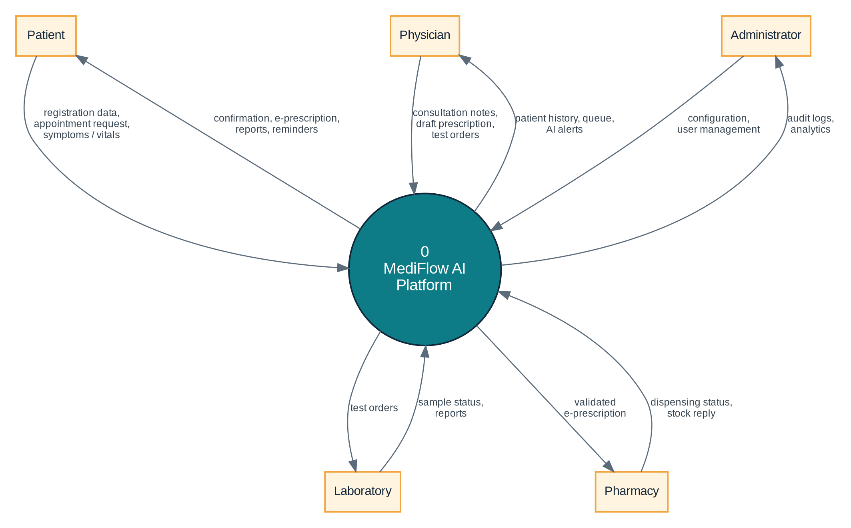
Figure 4. DFD Level 0 – context diagram

8.2 DFD Level 1
Level 1 decomposes the platform into seven processes and five data stores. Process 4.0 is the AI Prescription Engine; every process also writes events to D5 (audit log).
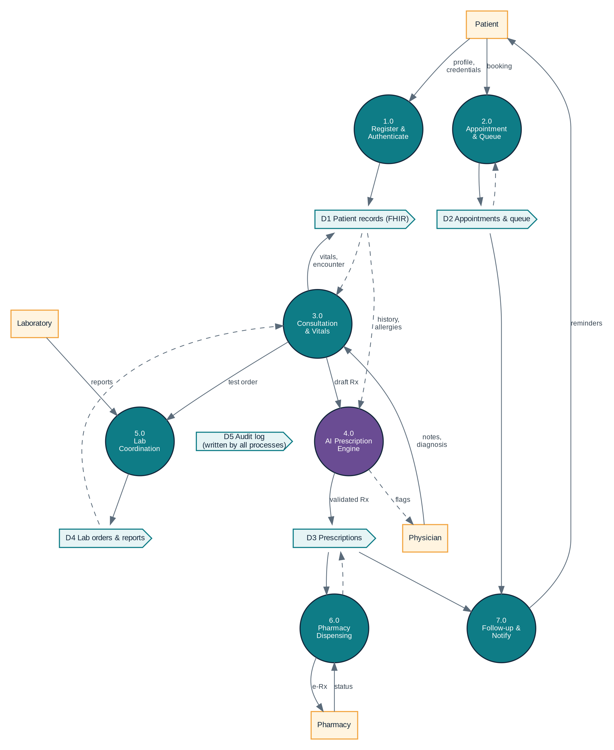
Figure 5. DFD Level 1 – processes and data stores
Table 9. Data stores
Store | Content | Main readers / writers
D1 Patient records | Demographics, history, allergies, vitals, encounters (FHIR) | 1.0, 3.0, 4.0 read/write
D2 Appointments & queue | Slots, bookings, queue state, priority score | 2.0 write; 7.0 read
D3 Prescriptions | Drafts, signed e-prescriptions, AI flags, dispensing status | 4.0, 6.0 write; 7.0 read
D4 Lab orders & reports | Service requests, samples, diagnostic reports | 5.0 write; 3.0 read
D5 Audit log | Append-only record of every access and change | All processes write; admin reads

8.3 UML sequence diagram – AI-assisted e-prescription
The sequence shows the main scenario: a doctor submits a draft, the API authenticates the request and enqueues an AI job, the AI service returns a structured result with a confidence score, and the doctor signs before the pharmacist dispenses.
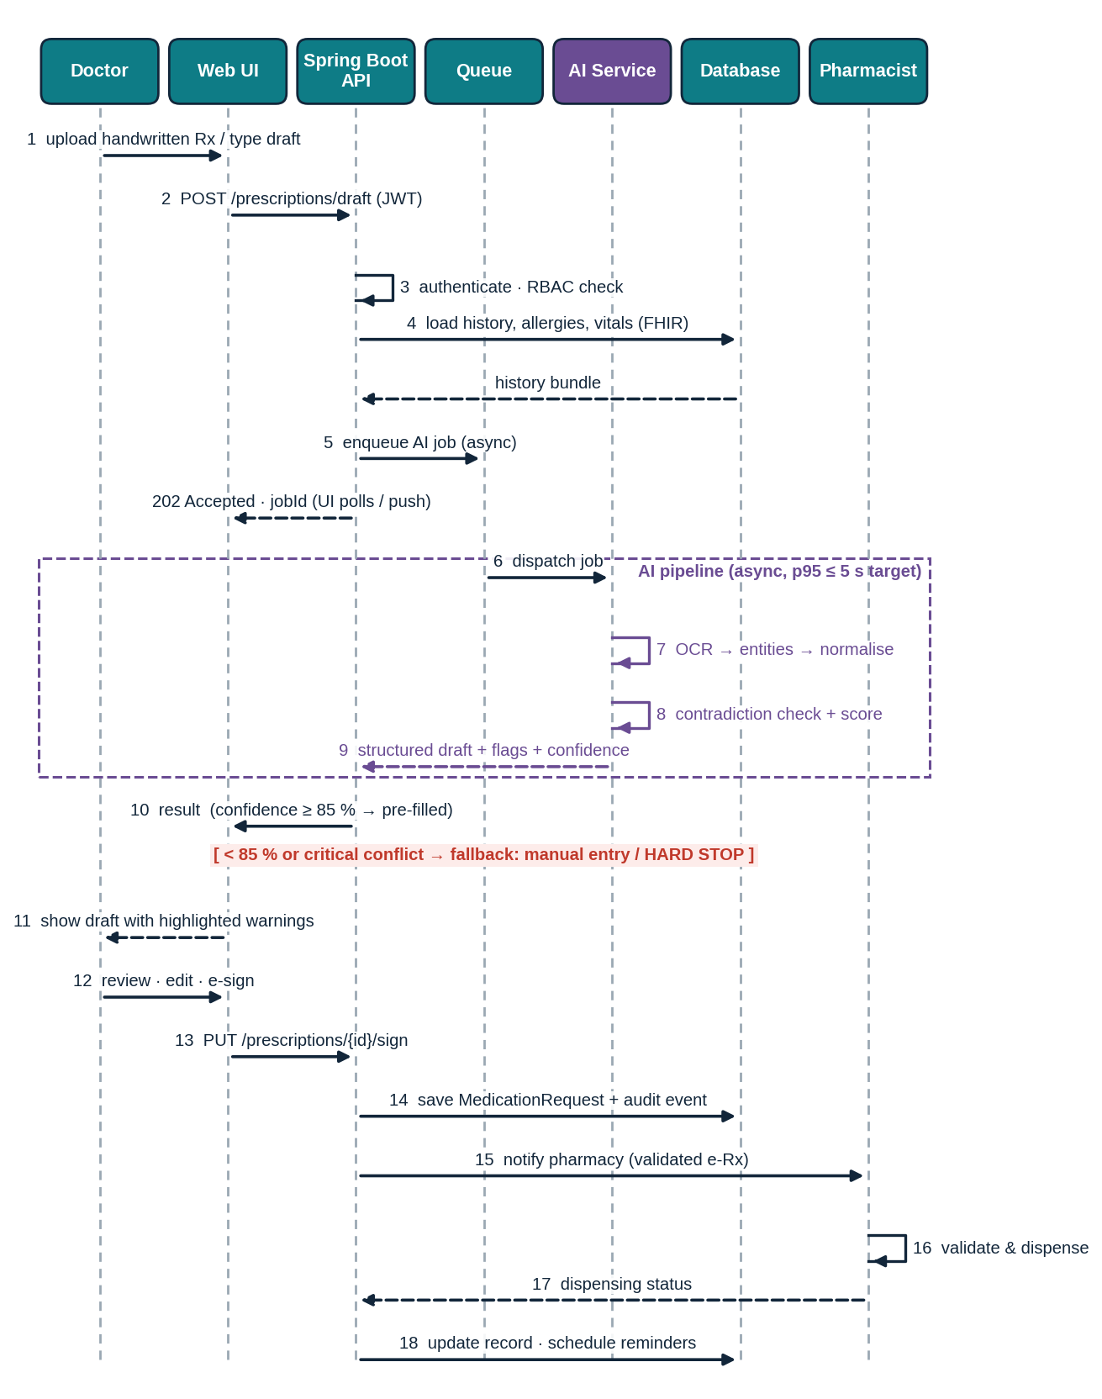
Figure 6. UML sequence diagram – AI-assisted prescription from draft to dispensing

9. Data Standards and Interoperability
MediFlow AI adopts HL7 FHIR Release 4 (R4) as its data-exchange architecture and common clinical terminologies, so that records remain portable between facilities and future national or international systems. Internal tables are FHIR-aligned and the API exposes FHIR resources for external interoperability.
Table 10. Mapping of platform data to FHIR R4 resources and terminologies
Platform data | FHIR R4 resource | Terminology / standard
Patient profile | Patient | National ID / MRN identifiers
Doctor, pharmacist, lab staff | Practitioner, PractitionerRole | Registration / licence number
Appointment and slot | Appointment, Schedule, Slot | –
Visit / consultation | Encounter | –
Vital signs | Observation (vital-signs profile) | LOINC codes, UCUM units
Diagnosis | Condition | ICD-10 (WHO); SNOMED CT optional
Allergy | AllergyIntolerance | SNOMED CT / RxNorm / ATC substance codes
Prescription | MedicationRequest | RxNorm, WHO ATC; local brand mapping
Dispensing | MedicationDispense | ATC; batch/expiry
Lab order | ServiceRequest | LOINC
Lab report | DiagnosticReport + Observation | LOINC, UCUM
Consent | Consent | Purpose-of-use codes
Audit trail | AuditEvent, Provenance | –
Reminders | Communication, Task | –

Table 11. Global and local standards adopted
Area | Standard | Use in MediFlow AI
Exchange | HL7 FHIR R4 (REST/JSON) | API and data model
Clinical summary | International Patient Summary (IPS) | Cross-facility patient summary
Diagnosis coding | ICD-10 (WHO) | Condition coding
Observation / lab coding | LOINC, UCUM | Vitals and lab results
Medicine coding | WHO ATC, RxNorm; national drug registry brand-to-generic mapping | Normalisation of drug names
Information security | ISO/IEC 27001 controls; OWASP ASVS | Security design and testing
Privacy | HIPAA and GDPR principles; applicable Bangladeshi data-protection and digital-health regulations at deployment | Consent, minimisation, rights of the data subject

10. AI / ML Engineering

10.1 Pipeline overview
The AI pipeline (Figure 7) turns a handwritten photo or typed draft into a structured, coded and safety-checked FHIR MedicationRequest, with a confidence score for each field.
Figure 7. AI/ML pipeline for prescription processing
Table 12. Pipeline stages
Stage | Method | Output
1 Pre-processing | Deskew, denoise, contrast normalisation, binarisation (OpenCV) | Clean image
2 OCR / HTR | Handwriting-capable OCR (e.g. TrOCR-class transformer; PaddleOCR / Tesseract as baselines); English + Bangla numerals | Text with per-token confidence
3 Entity extraction | Fine-tuned clinical NER: drug, strength, route, frequency, duration | Typed entities
4 Normalisation | Fuzzy / embedding match to the drug dictionary (brand → generic → ATC/RxNorm) | Coded medicine
5 Contradiction check | Deterministic rules + ML anomaly detector (see 10.3) | Flags with severity
6 Confidence scoring | Calibrated per-field scores; overall = minimum of critical fields (drug, dose, frequency) | Score 0–100 %

10.2 Prescription OCR
- Input: photo of a handwritten prescription or a typed draft; images are stored encrypted and linked to the encounter.
- Training data: consented, anonymised prescription images plus synthetic handwriting augmentation; held-out test set from unseen writers.
- Safety design: the OCR never writes to the record directly – its output is a *draft* shown beside the original image so the doctor can verify.
- Language: English medicine names with Bangla/English numerals and common prescribing abbreviations (e.g. OD, BD, TDS).

10.3 Draft contradiction detection
Table 13. Contradiction types checked on every draft
Check | Example | Severity | Action
Allergy conflict | Penicillin prescribed to a penicillin-allergic patient | Critical | Hard stop
Severe drug–drug interaction | Two interacting drugs on active list | Critical | Hard stop; doctor must change or override with reason
Dose out of range | Paediatric dose exceeds age/weight limit | Critical | Hard stop
Duplicate therapy | Same generic under two brand names | Warning | Warn; confirm
Condition contraindication | NSAID with documented renal impairment | Warning | Warn; confirm
Vitals mismatch | Antihypertensive dose escalation with low BP | Warning | Warn; confirm
Pregnancy / age caution | Drug unsuitable in pregnancy | Warning | Warn; confirm
Unknown / unreadable item | Drug name not found in dictionary | Unknown | Treated as failure → fallback

Rule: unknown is never safe. If the engine cannot verify an item it reports it as unverified; it never silently passes.

10.4 Vitals classification and history
Each vital set is classified by a clinician-approved, configurable rule table (adult defaults shown; paediatric and pregnancy tables are separate). An ML model may add trend-based early-warning on top of the rules. Every classified reading is stored as a FHIR Observation, so the doctor sees a trend, not only the latest value.
Table 14. Adult vital-sign classification (default, configurable; reviewed by a clinician)
Vital sign | Normal | Borderline / abnormal | Critical
Systolic / diastolic BP (mmHg) | < 120 / < 80 | 120–179 / 80–119 | ≥ 180 / ≥ 120, or systolic < 90
Heart rate (beats/min) | 60–100 | 50–59 or 101–129 | < 40 or ≥ 130
Respiratory rate (/min) | 12–20 | 9–11 or 21–24 | ≤ 8 or ≥ 25
Temperature (°C) | 36.1–37.2 | 37.3–39.4 or 35.1–36.0 | ≥ 39.5 or ≤ 35.0
SpO₂ (%) | ≥ 95 | 91–94 | ≤ 90

Critical readings trigger an immediate alert to the nurse and doctor and raise the patient’s queue priority (module M2).

10.5 AI latency and the ML pipeline
AI inference is slow compared with normal web requests. Running OCR synchronously inside the web request would freeze the doctor’s screen and make the system unreliable. MediFlow therefore uses an asynchronous ML pipeline:
- The API returns 202 Accepted with a job ID immediately; the UI shows progress and receives the result by push/polling.
- Jobs run on dedicated AI workers through a message queue with retries, time-outs and a circuit breaker.
- Models are exported to ONNX, quantised and served with dynamic batching; GPU is optional.
- Redis caches the drug dictionary and rule sets; the deterministic rule engine runs in memory (target ≤ 300 ms).
- If the AI service is down or too slow (time-out > 10 s), the UI switches to manual prescription entry automatically.
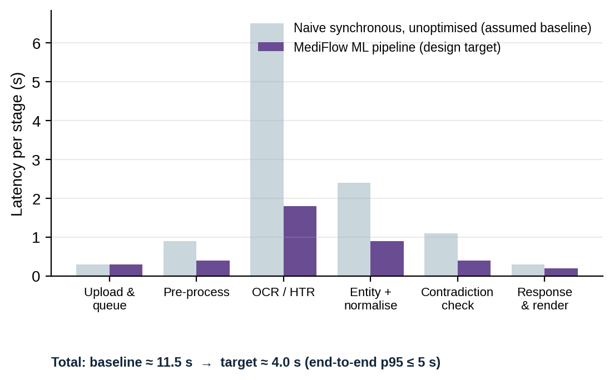
Figure 8. Latency budget per stage: unoptimised synchronous baseline (assumed) vs. design target. Illustrative; to be replaced by measured values.

10.6 Evaluation methodology
Models are evaluated offline on a held-out, writer-independent test set, then in shadow mode (AI runs, results hidden) in the pilot before any clinical use. Acceptance targets below are design targets to be confirmed by validation.
Table 15. Evaluation metrics and acceptance targets
Component | Metric | Target | Method
OCR / HTR | Character error rate (CER) | ≤ 2 % printed; ≤ 10 % handwritten | Held-out images, unseen writers
Drug normalisation | Top-1 / Top-3 exact-match accuracy | ≥ 95 % / ≥ 98 % | Labelled drug-name set
Entity extraction | F1 for drug, dose, frequency | ≥ 0.92 | Annotated prescriptions
Contradiction engine | Recall on critical conflicts | ≥ 98 % (safety priority) | Curated conflict test set + clinician review
Contradiction engine | Precision overall | ≥ 80 % (limits alert fatigue) | Same
Vitals classifier | Agreement with clinician labels (weighted κ) | ≥ 0.90; critical sensitivity ≥ 99 % | Labelled vitals set
Confidence calibration | Expected calibration error (ECE) | ≤ 0.05 (so “85 %” means about 85 %) | Reliability diagram
Latency | End-to-end p95 / rule engine p95 | ≤ 5 s / ≤ 300 ms | Load tests

10.7 Confidence threshold policy
The operating threshold is 85 %. A result with overall confidence below 85 % is rejected and the doctor continues manually; only results at or above 85 % (and with no critical conflict) are shown as a pre-filled draft. The threshold can be raised, never lowered, by an administrator and only with clinical approval. It is validated on the held-out set so that auto-accepted critical fields meet the precision target.
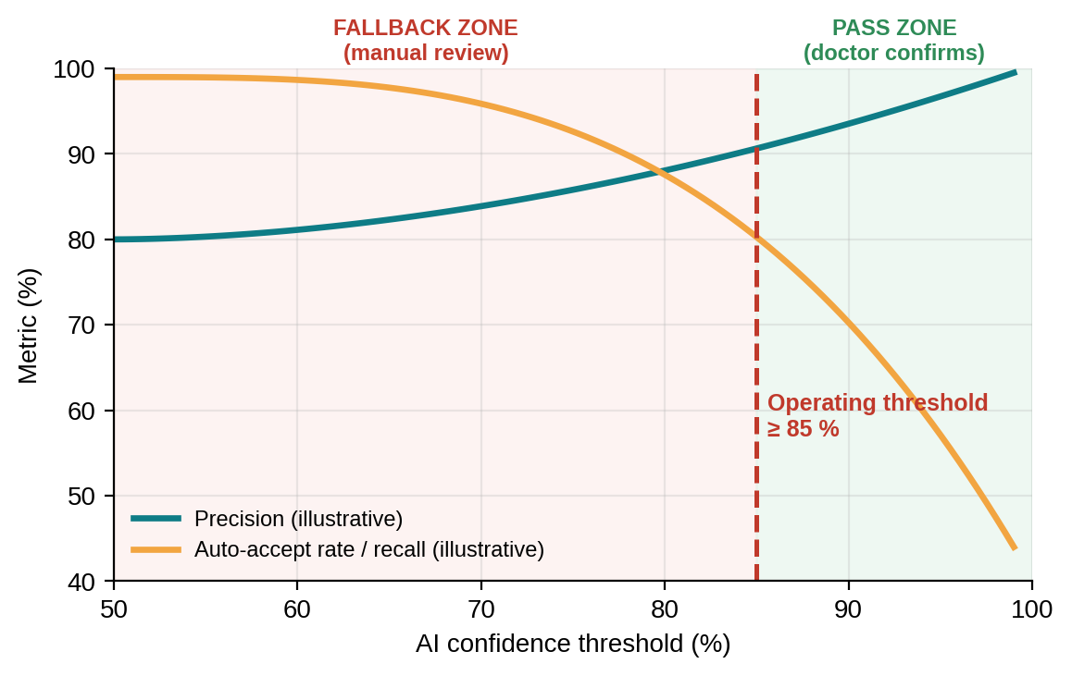
Figure 9. Effect of the confidence threshold. Illustrative curves showing the trade-off between precision and the share of drafts accepted; the 85 % operating point will be confirmed on real validation data.

11. Security and Privacy

11.1 Security controls
Table 16. Security and privacy controls
Area | Control
Authentication | Password hashing (Argon2/BCrypt), MFA for doctors, pharmacists and admins, account lock-out, session time-out
Authorisation | Role-based access control (RBAC) enforced at method level plus “assigned-patient” rule; deny by default
Data in transit | TLS 1.3 everywhere; HSTS; internal service traffic over mTLS
Data at rest | AES-256 disk/database encryption; field-level encryption for national ID and contact; encrypted object storage
Application security | CSRF protection, input validation, parameterised queries, secure headers, dependency scanning, OWASP ASVS testing
Audit | Append-only audit log (FHIR AuditEvent) of every read/write; tamper-evident hashing; patients can view who accessed their record
Privacy | Consent management, data minimisation, purpose limitation, retention policy, pseudonymised data for model training
Emergency access | Break-glass access with mandatory justification, instant alert and post-hoc review
AI-specific | Images and text never sent to third-party AI services; models run in the private network; prompt/output logging without personal identifiers
Resilience | Encrypted backups, restore drills, rate limiting and WAF against abuse

11.2 RBAC matrix
Roles: Patient, Doctor, Lab technician, Pharmacist, Nurse / front desk, Administrator. The scope rules below apply to every cell.
- Patient – own record only. Doctor – assigned patients only (checked-in appointment or referral); emergencies via break-glass.
- Lab technician and pharmacist – only the data linked to an order or prescription they handle (minimum necessary).
- Administrator – manages users and configuration, with no access to clinical content.
Table 17. RBAC matrix (R = read, C = create, U = update, S = e-sign, D = dispense, V = verify, O = override with reason, — = no access)
Resource | Patient | Doctor | Lab tech | Pharmacist | Nurse / front desk | Admin
Demographics | R U¹ | R | R* | R* | R C U | —
Medical history & allergies | R C² | R C U | — | R† | — | —
Vital signs | R C² | R C U | — | — | R C | —
Appointments & queue | R C | R U | — | — | R C U | R‡
Consultation notes & diagnosis | R³ | R C U | — | — | — | —
Draft prescription | — | R C U | — | — | — | —
Signed e-prescription | R | R S | — | R D | — | —
Lab orders | R | R C | R U | — | R | —
Lab reports | R | R | R C U V | — | — | —
Dispensing record | R | R | — | R C U | — | —
AI flags & override log | — | R O | — | R | — | R‡
Audit log | R⁴ | — | — | — | — | R
System configuration & users | — | — | — | — | — | C U⁵

¹ Contact details only; name/date of birth changes need a verified request. ² Self-reported and flagged as “unverified” until a doctor confirms. ³ Patient-readable summary only. ⁴ Own-record access history only. ⁵ Changes to clinical rules or the confidence threshold require dual approval (administrator + clinical approver). R* minimum necessary (name, age, sex, ID). R† allergies and active medicines only. R‡ aggregated or anonymised data.

11.3 Consultation rights
The doctor has read-only access to demographics (corrections go through the front desk) and full clinical read/write access for assigned patients.
Table 18. Consultation and prescription rights
Action | Who | Rule
Open consultation | Assigned doctor | Patient must be checked in or have a valid referral
View full history and vitals trend | Assigned doctor | Every view is audit-logged
Record diagnosis and notes | Assigned doctor | ICD-10 coded; edits create new versions
Order laboratory tests | Assigned doctor | Creates ServiceRequest visible to the lab
Draft prescription (typed / photo) | Assigned doctor | Triggers the AI pipeline
Override an AI warning | Assigned doctor | Reason mandatory; critical conflicts need a second confirmation
Sign (e-sign) prescription | Assigned doctor | Requires registered licence number and MFA re-prompt
Amend after signing | Assigned doctor | Addendum only; original stays immutable; pharmacy notified
Prescribed medicine visible | Patient, pharmacist | Read-only; pharmacist can dispense but not edit
Share with another doctor | Patient consent | Time-limited referral access

12. Risk Management and Failure Handling
Table 19. Risk register
ID | Risk | Mitigation | Fallback
R1 | AI misreads drug name or dose (wrong medicine) | Per-field confidence; 85 % gate; original image shown beside result; doctor review; pharmacist second check | Manual entry; incident logged
R2 | Allergy or interaction missed | Deterministic rules from a versioned drug database; unknown = unverified | Hard stop; manual review
R3 | AI service down or slow | Queue with retries, circuit breaker, health checks, 10 s time-out | Automatic switch to manual prescription
R4 | Data breach or insider misuse | Encryption, RBAC, MFA, audit alerts, least privilege | Incident response, access revocation, notification
R5 | Wrong patient identity | Two-identifier match (ID + date of birth); QR token at pharmacy | Block until identity confirmed
R6 | Emergency mis-prioritised | Rule-based triage score; nurse override; all changes logged | Manual queue control
R7 | Notification not delivered | Multi-channel (SMS, email, push) with retries and escalation | Staff phone call list
R8 | Model drift or handwriting bias | Monitoring, periodic re-validation, shadow-mode testing for new models | Roll back to previous model version
R9 | Network loss at clinic | Short-term local cache and deferred sync (planned) | Paper downtime procedure, back-entry later
R10 | Medicine out of stock | Real-time stock query; substitute only with doctor approval | Patient directed to alternative pharmacy

12.1 If the AI reads a wrong medicine – defence in depth
The central safety question is what happens if the AI outputs the wrong medicine. No single layer is trusted; the error must pass six independent barriers:
- Confidence gate: unreadable or uncertain items (< 85 %) never reach the draft.
- Dictionary check: the medicine must exist in the drug dictionary; unknown items fail.
- Contradiction engine: allergy, interaction and dose rules catch clinically implausible results.
- Doctor review: the draft is shown beside the original photo; low-confidence fields are highlighted and must be confirmed one by one.
- Pharmacist validation: an independent second check before dispensing; any doubt is sent back to the doctor.
- Patient copy: the patient receives a readable e-prescription with generic and brand names to spot mismatches.
If an error is found after issue
The prescription is revoked (status = entered-in-error); doctor, pharmacy and patient are notified immediately; if medicine was dispensed, the clinician is alerted to contact the patient; the case enters an incident review within 24 hours, is added to the model-improvement set, and the model can be rolled back or the threshold raised.

13. Clinical Fallback and Safety
The safety rule is simple: AI output is accepted only if confidence is 85 % or higher. Below 85 % the AI result is discarded and the doctor writes the prescription manually. A critical conflict stops the process regardless of confidence. Even when the gate is passed, the doctor must confirm and e-sign and the pharmacist validates independently.
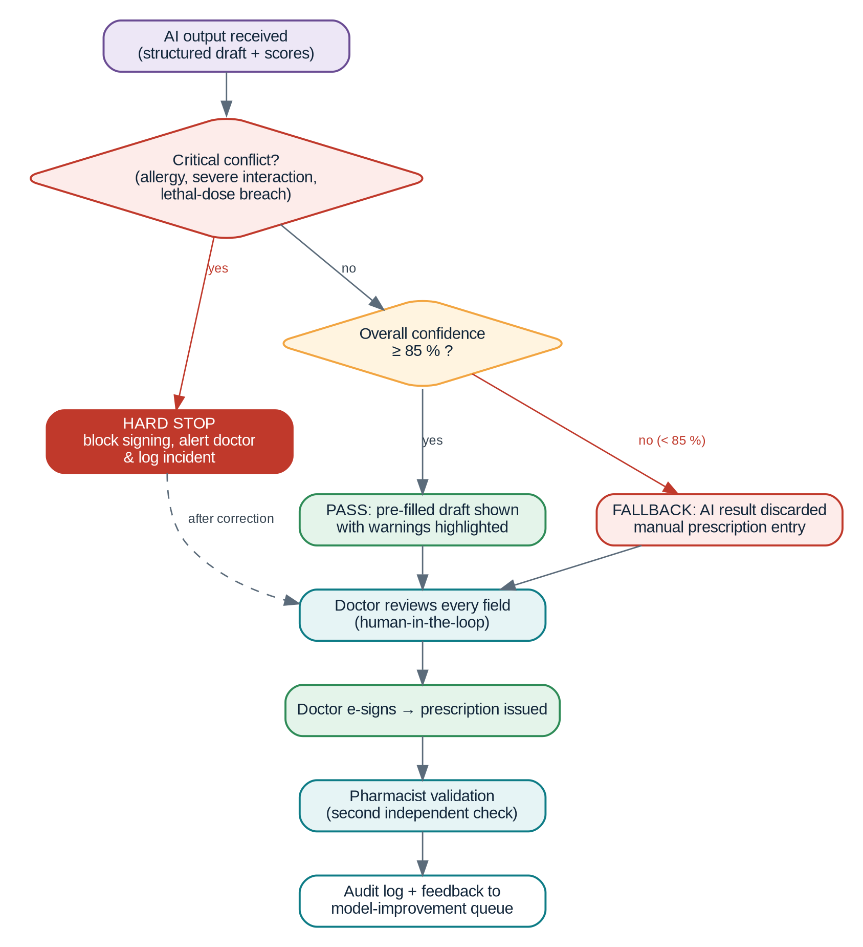
Figure 10. Clinical fallback and safety decision flow with the 85 % threshold
Table 20. Safety rules
Rule | Condition | Result
S1 Confidence gate | Overall confidence < 85 % | Fallback to manual entry
S2 Pass | Overall confidence ≥ 85 % and no critical conflict | Pre-filled draft with warnings; doctor must still confirm
S3 Critical conflict | Allergy, severe interaction or lethal-dose breach at any confidence | Hard stop; signing blocked until corrected
S4 Unknown item | Medicine or dose not verifiable | Treated as < 85 %
S5 Human in the loop | Always | No auto-signing and no auto-dispensing
S6 Service failure | AI time-out or error | Automatic manual mode; user is told clearly
S7 Threshold governance | Change request | Only upward; dual approval; versioned and audited

14. Technical Specification Summary
Table 21. Key technical figures
Item | Specification
Modules / branches | 10 modules in 4 branches (Patient, Physician, Laboratory & Pharmacy, Platform)
Process flow | 8 numbered stages, 3 decision points, 2 alternative paths
User roles | 6 (patient, doctor, lab technician, pharmacist, nurse/front desk, administrator)
Architecture | Modular-monolith Spring Boot + asynchronous FastAPI AI services
Client | Web-first (server-rendered, responsive); Android as phase 2
Data standard | HL7 FHIR R4; ICD-10, LOINC, UCUM, ATC/RxNorm
AI confidence threshold | ≥ 85 % to pass; < 85 % manual fallback; critical conflict always stops
Latency targets | AI end-to-end p95 ≤ 5 s; rule engine ≤ 300 ms; API p95 ≤ 500 ms
Security | TLS 1.3, AES-256, MFA, RBAC, append-only audit
Data stores | PostgreSQL, Redis, object storage; 5 logical data stores (D1–D5)

15. Testing and Validation Plan
Table 22. Test levels
Level | Scope | Tools / evidence
Unit and integration | Services, rule engine, FHIR mapping | JUnit 5, Testcontainers, pytest
Security | Authentication, RBAC matrix, injection, access control | OWASP ZAP, role-based test cases for every matrix cell
AI offline validation | Metrics from Section 10.6 on held-out data | Confusion matrices, reliability diagrams
Shadow mode | AI runs silently next to manual workflow | Agreement rate, error review by clinician
Load and latency | Concurrent users, queue under load | k6 / JMeter; p95 latency
Usability | Doctors, pharmacists and patients | Task success time, SUS score
Failure drills | AI outage, DB failover, notification failure | Documented recovery times

16. Expected Outcomes and KPIs
Table 23. Expected outcomes and how they will be measured
Expected outcome | Indicator (KPI)
Improved healthcare coordination and continuity of care | Appointment-to-consultation time; share of visits with complete linked record
Reduced treatment delays and prescription errors | Prescriptions needing pharmacist clarification; errors caught before dispensing
Efficient laboratory workflow and report management | Order-to-report turnaround time
Adaptive emergency queue handling with real-time notifications | Time from arrival to triage for critical cases
Enhanced medication adherence through smart reminders | Reminder acknowledgement and follow-up attendance rate
Scalable AI-ready ecosystem | Concurrent users supported; share of data in FHIR format

17. Limitations and Future Work
- AI accuracy depends on the quality and variety of handwriting data; pilot validation is required before clinical use.
- Drug-interaction knowledge needs licensed or curated sources and regular updates.
- Offline operation for clinics with unreliable connectivity is only partly covered.
- Future work: Android client, clinical decision support beyond prescription safety, integration with national health information systems, tele-consultation, analytics for population health, and federated learning to improve models without sharing raw data.

18. Conclusion
MediFlow AI presents a unified, intelligent healthcare ecosystem that integrates patients, physicians, laboratories and pharmacies within a single platform. By combining digital appointments, adaptive emergency queue management, AI-assisted e-prescriptions with contradiction detection, vitals classification, pharmacy connectivity and intelligent follow-up, it improves coordination, strengthens patient safety and ensures continuity of outpatient care. Its security-first architecture, global data standards and a strict 85 % confidence gate with manual fallback make the AI a safe assistant rather than an unchecked decision-maker, and provide a scalable, AI-ready foundation for future clinical decision support and digital healthcare innovation.

References
- A. Almeman, “The Digital Transformation in Pharmacy: Embracing Online Platforms and the Cosmeceutical Paradigm Shift,” Journal of Health, Population and Nutrition, vol. 43, no. 60, 2024.
- Y. S. Alqarni, “The Opportunities and Challenges for Digital Health in Pharmacy Practice: A Systematic Review,” Pharmacy Practice, vol. 24, no. 2, Art. 3542, 2026.
- HL7 International, “HL7 FHIR Release 4 (R4) Specification.”
- World Health Organization, “International Classification of Diseases (ICD-10)” and “ATC/DDD Index.”
- Regenstrief Institute, “LOINC” and “UCUM – Unified Code for Units of Measure.”
- OWASP Foundation, “Application Security Verification Standard (ASVS).”

Appendix A – Glossary
Term | Meaning
ATC | Anatomical Therapeutic Chemical classification of medicines
CER | Character error rate – OCR accuracy measure
DFD | Data flow diagram
ECE | Expected calibration error – how well confidence matches reality
FHIR | Fast Healthcare Interoperability Resources (HL7 standard)
HTR / OCR | Handwritten text recognition / optical character recognition
MFA | Multi-factor authentication
NER | Named-entity recognition
RBAC | Role-based access control
ONNX | Open Neural Network Exchange – portable model format for fast inference

