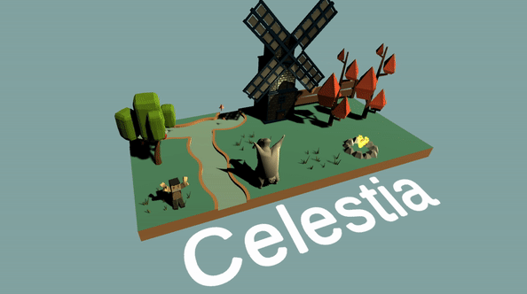
Introduction
For this project it was my idea to make a very casual game like Farmville. As well as this, I decided to implement a simple economy and interaction system. Below I discuss technical and testing issues that I faced with the project.

Research / Project Idea
For this project, I started by testing the current state of the game and seeing what mechanics it seemed to provide. The three primary mechanics I found that the game seemed to be focused on was mouse-based interaction, random item placement and pathfinding with obstacle avoidance. These core features and the provided water tile models I decided to try and make a game that uses Perlin noise to generate a dynamic terrain and create a casual farming game, like Stardew valley, Harvest moon or Farmville.
For the players interaction, my idea was to keep with the mouse movement and incorporate other actions. With this I came across an issue before even starting regarding how I would handle tiles that have multiple actions, such as a Plain land tile, you could walk to it, but also plant seeds in it. In the end I opted for a similar selection menu to Rust where you hold the mouse button the tile you want to select and a popup menu appears, then you can drag your mouse to your selection.
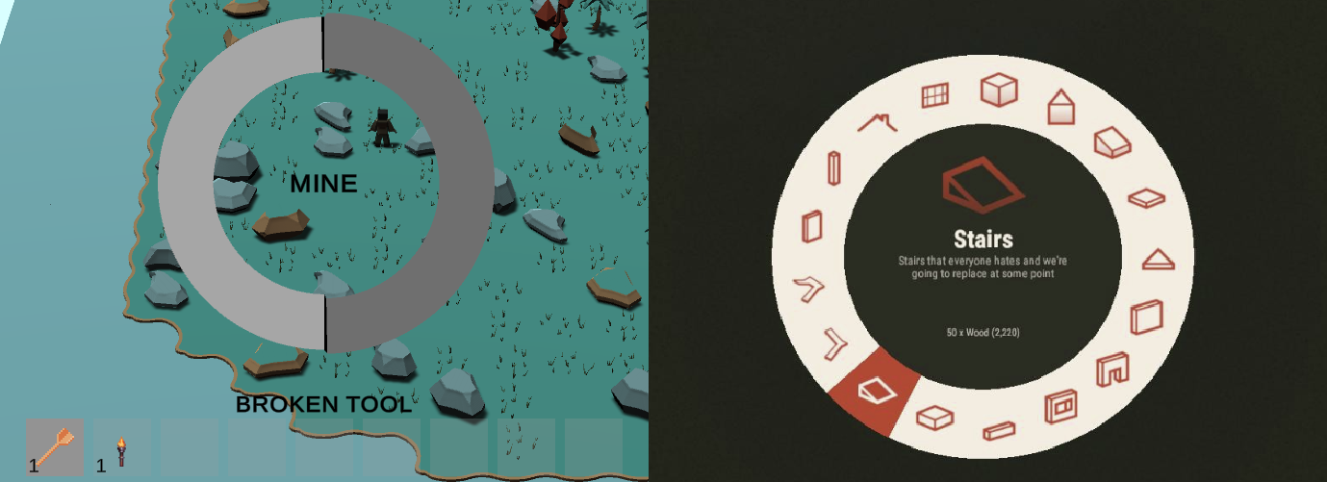

There were several features I highlighted that I also wanted from my game and they were
- Animals with harvestable goods and breeding
- Plants and trees that can grow
- Modifiable terrain
- Economy

Mechanics
Day Night Cycle
For the game, I wanted it to have a dynamic day night cycle that modified systems within the game to give the sense of day/night. With this I added changes to several systems such as music, lighting and animals. Depending on the time of day, the game light changes as well as modifying shadows that go across the screen. As well as this, as the sun sets, the main game music fades out and the sound of cicadas come in to make night-time have a different feel. Modifications were made to animals as well where they produce items slower in the night-time as they are “sleeping”.
Animation System
For the project we received a rigged model but not animations associated with them. Initially I attempted to create my own animations by hand but quickly turned to the website Mixamo. Using there animations I was able to quickly import the model and attach around 14 unique animations to the character. Because of the quality of the animations, I was able to implement animations for the following scenarios as well as randomly chosen alternate animations.
Walking: 2x animations
Gathering: 6x animations
Idle: 3x animations
Digging 1x animation
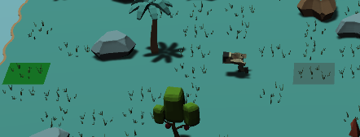
World Generation
For the world generation, I used a noise algorithm to define if a tile is a land tile or not a land tile and based on that generate a coastline.
Beyond this, enabling the user to dynamically edit the world was also added enabling them to place and remove land tiles and maintain a valid pathing mesh.
Farming / Gathering Resources
I added gathering of resources by creating a polymorphic “Action” class that you can extend and as long as the component is attached to the tile or item, it can be performed. For example, the “TileActionCollection” script can perform several actions. It can pause several seconds as the action is preformed, it can add, remove and check to see if you have items in your inventory, replace tiles and use a animation. Using these features we are able to produce a action such as wood cutting, where it gives the user X item’s based on what axe they are holding, preforms the axe swing animation and replaces the tree with felled logs, they then it can recursively pick up without the users input.
Animals and breeding
Animals have two purposes in the game, you can keep them on your island and they will wander around producing items (chickens produce eggs, etc). These items can be picked up by clicking on the animal. But if you leave the animals and they are near another animal of the same type, they have a chance x seconds to produce a new animal. Because of this you can collect resources from animals but also breed them, pick them up and sell them.

Challenges
World Generation
World generation become one of the hardest parts of the development of the game for several reasons. I started by choosing a noise algorithm to base my world generation on and opted for Perlin noise and unity has a built-in function to generate the noise for us. Next I had to decide how to stitch the water tiles together and toiled with different ideas for hours before scrapping the feature and restarting. I restarted by defining a list of rules that the generator had to follow and defined a simple system for registering new tiles.
Firstly, I created a registering system that the end developer would to add new tiles to the game. To add a new tile to the generator, we are provided a array of 8 bools, each bool, starting from 0 (North) we go around clockwise checking if a part of a tile is water or not.
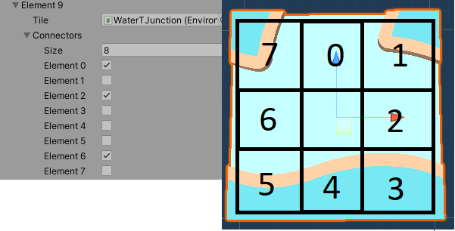
Next using the Perlin noise generated I created a water map, this map defines that all values generated by Perlin noise (values 0 – 1) at what point they are water and when they are land, for example, we could say anything above 0.5 is considered land. After this we can stitch together the land with bitwise & operations.
To calculate what each water tile needs to be, we start by checking what its neighbour tiles to see if they are land or not land.
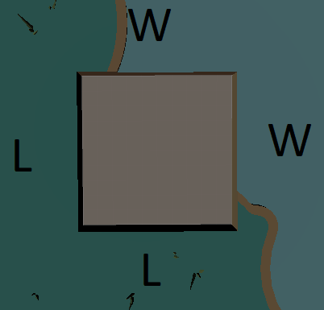
Once we have this information (information provided by the water map) we need to generate a 8 long bool array like for our tile registering so we can do some comparisons to find a matching tile.
So we know 4 of the values, we know index, 0,2,4 and 6 as they are the raw values pulled from the water map, in this case {W,W,L,L}, but we need to figure out the corner values. To do this we need to define some rules.
- If two touching sides are land (for example South and West), then the corner needs to be land.
- If one of the two sides are water, and the corner on the water map is land, then we need a land.
Using these rules, we can deduce that the land tile we need, needs to fit this pattern { w,w,w,l,l,l,l,l}

Lastly there is one more issue with the world generation and that is handling rotation of blocks. Since we only register the block in one rotation, the generator needed to be able to rotate the block in all 4 axis during the evaluation step and see if the rotated variants of the tile would also fit. The reason this is needed so much is otherwise we would need to register each tile in every possible rotation, and it would increase the amount of UI configuration time n*4.

Testing & Bug fixing
Original Bugs
With the original brief there were several bungs found through introductory testing that were fixed.
Shadows
Initially shadows seems like they don’t work, but this is due to the fact that the world scaling is so large and that the camera is so far away from all models that the max distance of the shadows was too low. There were two solutions two this, I could opt for reducing the size of the models and the world scaling, but then I thought about the time it would take for this to be done, because of this and the fact that I did not know the original scaling requirements of the game, I instead opted for increasing the shadow ranges fixing the shadows.
Pathfinding twitching
For the pathfinding when you pressed the walk button several tiles, it would cause the player to reset back to the start of the current tile they were on, because of this I modified the pathfinding code to instead of resetting, base the first pathing node from the players world position rather than the initial tiles world position.

World Generator
When developing the world generator I found that there were times where the generator would cut out and crash, after a look as well as manually drawing out a small scenario I realised that several water tiles were missing, this could have been due to a error in the initial creation of the assets or some other mistake. Because of this, I had to go onto blender and create the models myself I was not able to locate the original assets and see if I could find the missing ones, the missing tiles were.
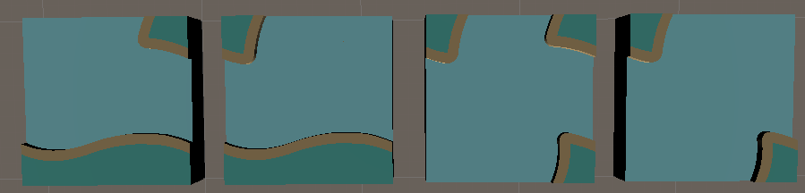
Summary
Overall, I had a lot of fun making this game as it exposed me to parts of unity that I have never played around with, such as the animator and SchedualedTasks. I feel like I have achieved a lot of what I aimed to do, but a big regret is that I did not add too much to make the game look nice.
If I was to have restarted the project today, I would have added more detail to the pathfinding and would have used the string pull algorithm as well as making the world generator better through having a height based terrain as well.

Assets
www.Mixamo.com – Animations
www.humblebundle.com/
- HUMBLE 8-BIT PIXEL GAME DEV BUNDLE
https://www.humblebundle.com/software/8bit-pixel-game-dev-software
- HUMBLE MUSIC AND SOUND EFFECTS FOR GAMES, FILMS, AND CONTENT CREATORS BUNDLE
https://www.humblebundle.com/software/sound-fx-software

https://assetstore.unity.com/
- VertexColorFarmAnimals
https://assetstore.unity.com/packages/3d/farm-animals-set-97945
- Nature pack extended https://assetstore.unity.com/packages/3d/environments/landscapes/nature-pack-extended-66146
- LowpolyVegetationPackFree
https://assetstore.unity.com/packages/3d/vegetation/lowpoly-vegetation-season-pack-lite-96083
- Ensenasoft
https://assetstore.unity.com/packages/3d/environments/fantasy/village-buildings-5-99911
- BrokenVector
https://assetstore.unity.com/packages/3d/props/exterior/low-poly-fence-pack-61661
- Acorn Bringer Assets
https://assetstore.unity.com/packages/3d/environments/simplistic-low-poly-nature-93894

